


The University of Azad Jammu and Kashmir

Department of Software Engineering

Student Name | Afzal Ali Ahmed Shah
Roll no | 2024-SE-04
Semester | 5th
Instructor Name | Engr. Fahad Nisar
Subject | Digital Image processing
Course Code | CS-3112
Credit Hours | 2+1
Lab | 03
Date | 09-Nov-2026

Software Engineering

Screenshot checklist (taken from the notebook)
Step | Screenshots needed from the notebook (section heading)
0 | Loading and Validating the Image: shape / dtype / min / max line and the original image
1 | 1.1 figure (original, +40, −40); 1.3 verification output (loop equals NumPy); clipped-pixel count output
2 | Linear contrast figure; mean brightness and clipped-pixel output with the clipped-highlight image
3 | Four-image figure (original, linear, centered 1.5, centered 0.5); mean / std output
4 | Original vs negative figure; negative-of-negative output
5 | Gamma figure; 5.1 output (dark-pixel means and 0 / 255 fixed)
6 | Histogram plot; dark / mid / bright share output
7 | Original vs equalized images; both histograms; 7.1 neighbour-difference output. NEW: small OpenCV check cell for Dry run 7
8 | Original / global / CLAHE figure; CLAHE histogram and neighbour-difference output
9 | Fixed-threshold output (unique values, white pixels) and binary image
10 | Otsu output (returned threshold, mask comparison) and figure. NEW: small OpenCV check cell for Dry run 10
11 | Adaptive output (white-pixel percentages) and four-image figure (11 × 11 image task; the dry run uses the 3 × 3 example)
Final | Final check output: img identical to the backup copy

Step 0: Input Image, Validation and Numeric Safety
The input is a personally selected photograph (image.jpg, a peacock) read with cv.imread(..., cv.IMREAD_GRAYSCALE). The array img is the original and is never modified; every result is stored in a new variable. Final check in the notebook: img is identical to the backup copy = True.
Property | Value
Shape (rows × columns) | 678 × 452 (≥ 300 × 300, valid)
dtype | uint8 (8-bit grayscale, 1 channel)
Minimum / Maximum | 0 / 255
Mean / Std | 89.41 / 41.34
Display rule | imshow(..., cmap="gray", vmin=0, vmax=255) for every image

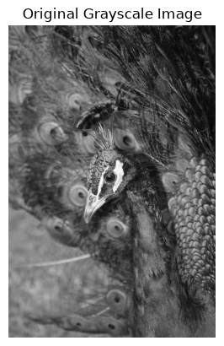
Figure 0: Original grayscale image
Notebook output — section “Loading and Validating the Image”:
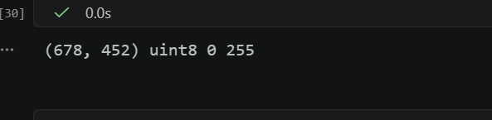

Safe arithmetic rule used everywhere: widen the type (int16 or float32/float64) → compute → np.clip(..., 0, 255) → astype(np.uint8). astype truncates fractions, as the task requires.

Step 1: Brightness Adjustment

Dry run 1 — s = r + β, β = +40 and −40, pixels [30, 80, 128, 180, 240]
r | r + 40 (raw) | Clip 0–255 | uint8 | r − 40 (raw) | Clip 0–255 | uint8
30 | 70 | 70 | 70 | -10 | 0 (clipped) | 0
80 | 120 | 120 | 120 | 40 | 40 | 40
128 | 168 | 168 | 168 | 88 | 88 | 88
180 | 220 | 220 | 220 | 140 | 140 | 140
240 | 280 | 255 (clipped) | 255 | 200 | 200 | 200

Lost detail: 240 + 40 = 280 exceeds 255 and is clipped to 255 (saturation); 30 − 40 = −10 is clipped to 0. Clipped pixels all take the same value, so any difference between them is lost. For example, original values 240, 250 and 255 would all become 255 after +40 and could no longer be told apart. Without widening to int16 or clipping, uint8 would wrap around (280 → 24, −10 → 246), which is the overflow error.

Required screenshots (from the notebook)
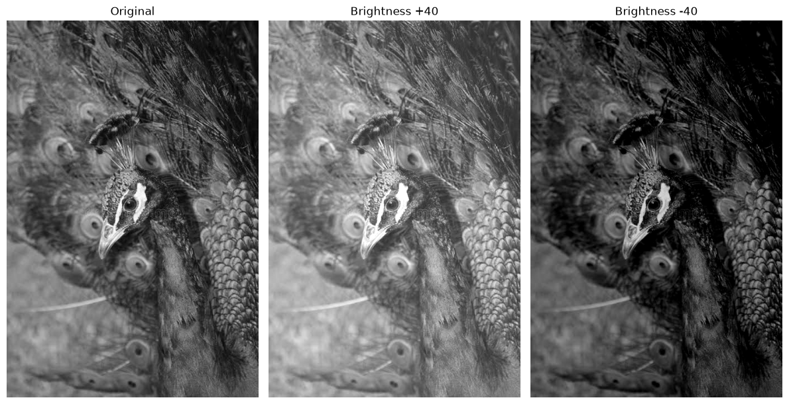
Figure 1: Original, brightness +40, brightness −40
Notebook output — section “1.3 Verification: does the nested-loop result match the NumPy result?”:
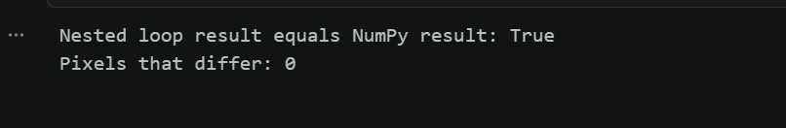
Notebook output — section “1.3 Verification: does the nested-loop result match the NumPy result?”:
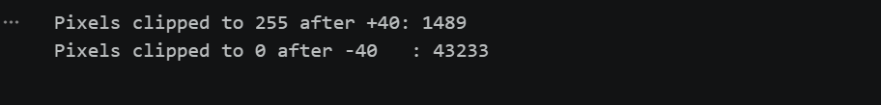
Observation: +40 makes the whole image lighter and −40 darker. Clipped pixels merge into one value, so detail is lost. The loop gives the same image as NumPy but is much slower.

Step 2: Linear Contrast from Zero

Dry run 2 — s = 1.5r (α = 1.5, β = 0), pixels [30, 80, 128, 180, 240]
r | 1.5 × r | Clip 0–255 | Truncate (uint8) | Saturated?
30 | 45.0 | 45 | 45 | No
80 | 120.0 | 120 | 120 | No
128 | 192.0 | 192 | 192 | No
180 | 270.0 | 255 | 255 | Yes
240 | 360.0 | 255 | 255 | Yes

Saturated pixels: r = 180 and r = 240 (1.5r > 255 whenever r > 170). Both become 255, so the 60-level difference between them disappears.

Required screenshots (from the notebook)
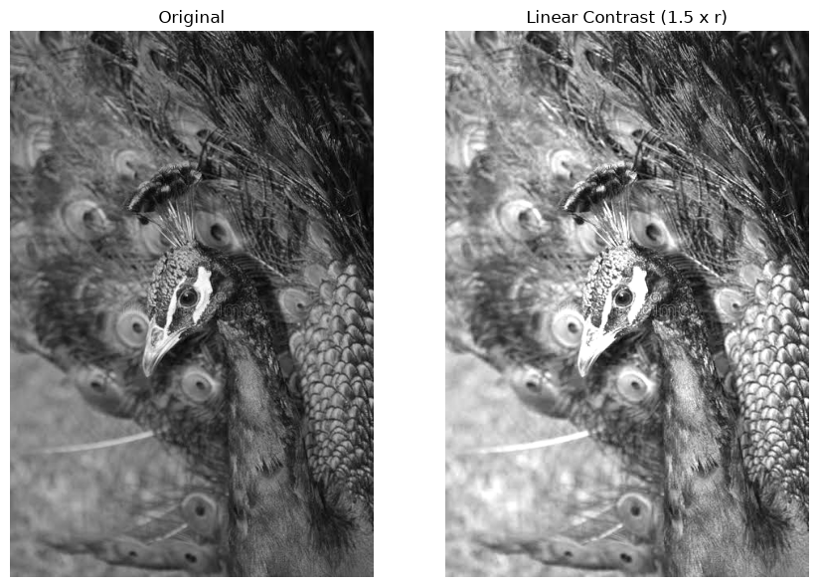
Figure 2a: Original vs linear contrast 1.5 × r
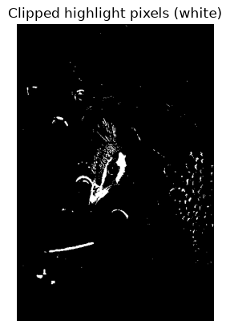
Figure 2b: Clipped highlight pixels (white)
Notebook output — section “2. Linear contrast from zero”:
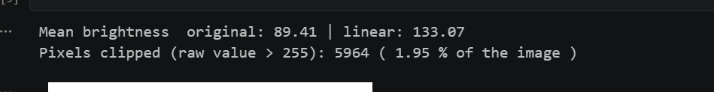
Observation: multiplying by 1.5 raises every non-zero pixel, so the image is clearly brighter. About 2 % of pixels (the brightest highlights) are clipped and their detail is lost.

Step 3: Contrast Centered at 128

Dry run 3 — s = (r − 128)α + 128, α = 1.5 and 0.5, pixels [30, 80, 128, 180, 240]
r | r − 128 | × 1.5 | + 128 (raw) | Clip → final | × 0.5 | + 128 (raw) | Final
30 | -98 | -147 | -19 | 0 (clipped) | -49 | 79 | 79
80 | -48 | -72 | 56 | 56 | -24 | 104 | 104
128 | 0 | 0 | 128 | 128 | 0 | 128 | 128
180 | 52 | 78 | 206 | 206 | 26 | 154 | 154
240 | 112 | 168 | 296 | 255 (clipped) | 56 | 184 | 184

Result at r = 128: r − 128 = 0, so s = 0 × α + 128 = 128 for every α. The midpoint is the fixed pivot; values above 128 move up and values below 128 move down when α > 1, and the opposite toward 128 when α < 1.
Comparison with 1.5r from zero: 1.5r gives [45, 120, 192, 255, 255] (mostly brighter), while centered α = 1.5 gives [0, 56, 128, 206, 255] (darks darker, lights lighter, mid stays).

Required screenshots (from the notebook)
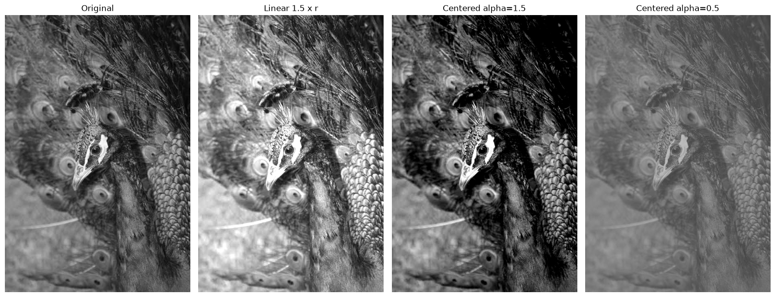
Figure 3: Original, linear 1.5r, centered α = 1.5, centered α = 0.5
Notebook output — section “3. Contrast centered at 128”:
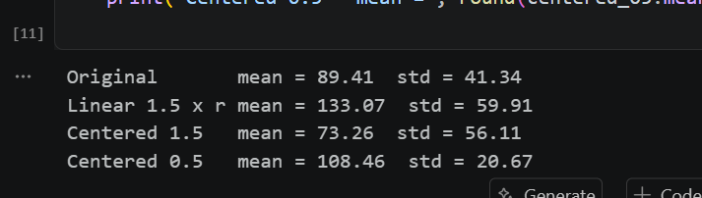
Observation: α = 1.5 raises the standard deviation (more contrast). The mean falls from 89 to 73 because this image is darker than 128, so stretching around 128 pushes most pixels further down; linear-from-zero instead raises the mean to 133. α = 0.5 squeezes values toward 128 (std 20.67) and the image looks flat and gray.

Step 4: Image Negative

Dry run 4 — s = 255 − r, pixels [30, 80, 128, 180, 240]
r | s = 255 − r | 255 − s (negative again) | Equals original?
30 | 225 | 30 | Yes
80 | 175 | 80 | Yes
128 | 127 | 128 | Yes
180 | 75 | 180 | Yes
240 | 15 | 240 | Yes

Applying the negative twice gives 255 − (255 − r) = r, so the original is restored exactly. Note that 128 maps to 127 (no pixel is its own negative because 255 is odd).

Required screenshots (from the notebook)
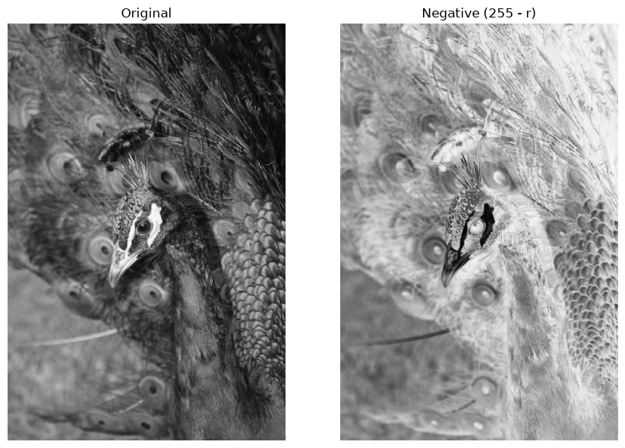
Figure 4: Original and negative (255 − r)
Notebook output — section “4. Image negative”:


Observation: the negative reverses all intensities and the double negative equals the original (True). It helps inspection when important detail is dark on a dark background, for example a bone or tissue structure in an X-ray, because inverted dark-gray detail becomes easier to see.

Step 5: Gamma Correction

Dry run 5 — s = 255(r/255)^γ, pixels [0, 64, 128, 192, 255]
Full precision is kept in every step; only the final output is truncated (the rounded column is shown only for comparison with the slide).
γ = 0.5 (brightens)
r | r/255 | (r/255)^0.5 | × 255 | Truncated | Rounded
0 | 0.000000 | 0.000000 | 0.0000 | 0 | 0
64 | 0.250980 | 0.500979 | 127.7498 | 127 | 128
128 | 0.501961 | 0.708492 | 180.6654 | 180 | 181
192 | 0.752941 | 0.867722 | 221.2691 | 221 | 221
255 | 1.000000 | 1.000000 | 255.0000 | 255 | 255

γ = 2.0 (darkens)
r | r/255 | (r/255)^2.0 | × 255 | Truncated | Rounded
0 | 0.000000 | 0.000000 | 0.0000 | 0 | 0
64 | 0.250980 | 0.062991 | 16.0627 | 16 | 16
128 | 0.501961 | 0.251965 | 64.2510 | 64 | 64
192 | 0.752941 | 0.566920 | 144.5647 | 144 | 145
255 | 1.000000 | 1.000000 | 255.0000 | 255 | 255

Difference from the rounded slide example: the lecture slide rounds the intermediate values to 3 decimals (64/255 ≈ 0.251, square root ≈ 0.501) and rounds the final answer to the nearest integer, giving 128, 181, 221 for γ = 0.5. Here full precision is kept (127.7498, 180.6654, 221.2691) and only the final value is truncated, giving 127, 180, 221. The 1-level differences at r = 64 and r = 128 come from rounding versus truncating (the Rounded column above matches the slide). 0 and 255 stay fixed for any γ because 0^γ = 0 and 1^γ = 1.

Required screenshots (from the notebook)
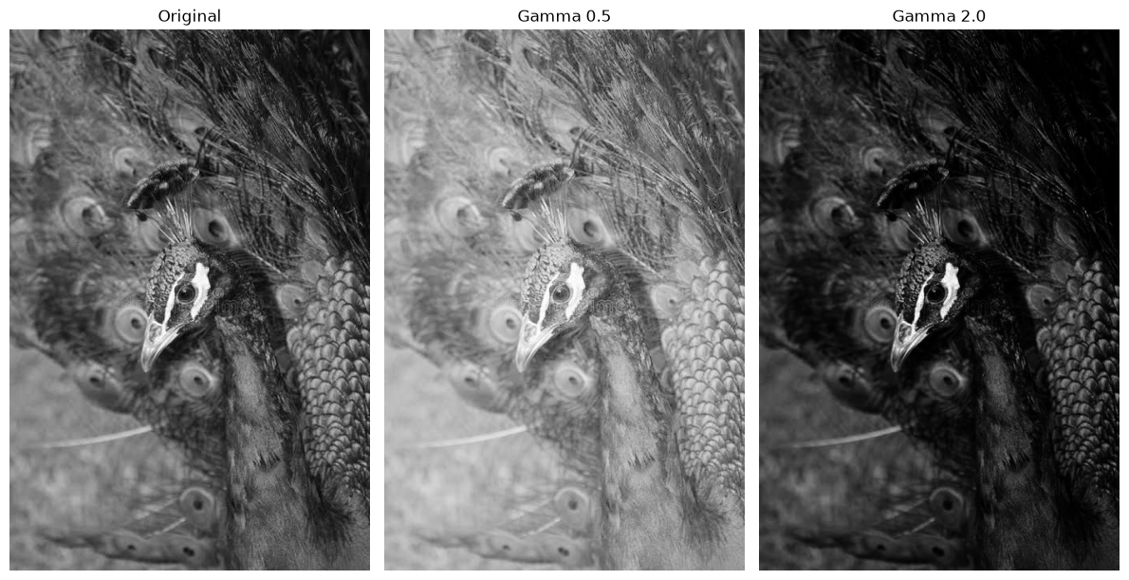
Figure 5: Original, gamma 0.5, gamma 2.0
Notebook output — section “5.1 Effect on dark regions and check that 0 and 255 stay fixed”:
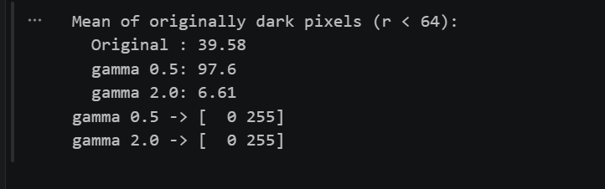
Observation: in this convention γ < 1 brightens and γ > 1 darkens. γ = 0.5 lifts the dark regions strongly (mean 39.6 → 97.6) while γ = 2.0 pushes them even lower (6.6). The check on [0, 255] shows both stay at 0 and 255.

Step 6: Grayscale Histogram

Dry run 6 — A = [[0, 50, 50, 100], [100, 150, 200, 255]]
Intensity | 0 | 50 | 100 | 150 | 200 | 255 | Total
Frequency | 1 | 2 | 2 | 1 | 1 | 1 | 8
Probability | 1/8 = 0.125 | 2/8 = 0.25 | 2/8 = 0.25 | 0.125 | 0.125 | 0.125 | 1.000

Total pixel count = 2 × 4 = 8 and the probabilities add up to 1. All other intensities (1–49, 51–99, …) have frequency 0.
Why a histogram does not show positions: it only counts how many pixels have each intensity. The shuffled image [[255, 200, 150, 100], [100, 50, 50, 0]] has exactly the same counts but a completely different arrangement, so many different images share one histogram.

Required screenshots (from the notebook)
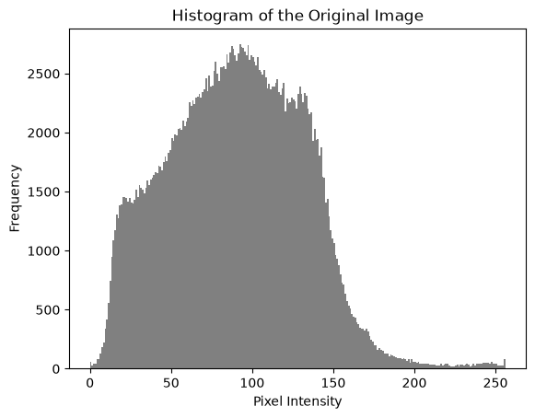
Figure 6: 256-bin histogram of the original image (range 0–256)
Notebook output — section “6. Grayscale histogram”:
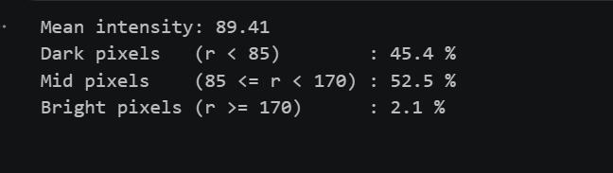
Interpretation: the pixels are concentrated in the low and middle intensities (mean 89.41; 45.4 % below 85, 52.5 % in 85–169 and only 2.1 % at 170 or above). The image is therefore fairly dark and uses very little of the bright end of the range.

Step 7: Global Histogram Equalization

Dry run 7 — pixels [50, 50, 100, 150]
Intensity | Frequency | Cumulative count | CDF | Method 1: 255 × CDF | Method 2: 255(CDF − CDFmin)/(1 − CDFmin)
50 | 2 | 2 | 2/4 = 0.50 | 127.5 → 128 | (0.5 − 0.5)/0.5 = 0 → 0
100 | 1 | 3 | 3/4 = 0.75 | 191.25 → 191 | (0.75 − 0.5)/0.5 = 0.5 → 127.5 → 128
150 | 1 | 4 | 4/4 = 1.00 | 255 → 255 | (1 − 0.5)/0.5 = 1 → 255

CDFmin = 0.5 (lowest nonzero CDF). Rounding is to the nearest integer with .5 rounded upward.
Output list, Method 1: [128, 128, 191, 255]
Output list, Method 2: [0, 0, 128, 255]
Comparison with OpenCV: cv.equalizeHist on [50, 50, 100, 150] returns [0, 0, 128, 255], which matches Method 2. Method 1 does not map the darkest value to 0, so it never uses the full range; OpenCV subtracts CDFmin so the lowest value becomes 0 and the highest 255.
Python verification (Dry run 7) — compare the second output list with OpenCV:
# Dry run 7: compare the hand result with OpenCV
dry = np.array([[50, 50, 100, 150]], dtype=np.uint8)
opencv_out = cv.equalizeHist(dry).ravel().tolist()
print("Hand result, method 1 (255 x CDF) :", [128, 128, 191, 255])
print("Hand result, method 2 (CDF - CDFmin) :", [0, 0, 128, 255])
print("OpenCV cv.equalizeHist :", opencv_out)
print("Method 2 matches OpenCV:", opencv_out == [0, 0, 128, 255])
Output:
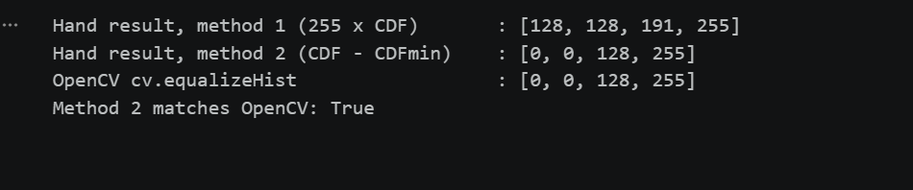

Required screenshots (from the notebook)
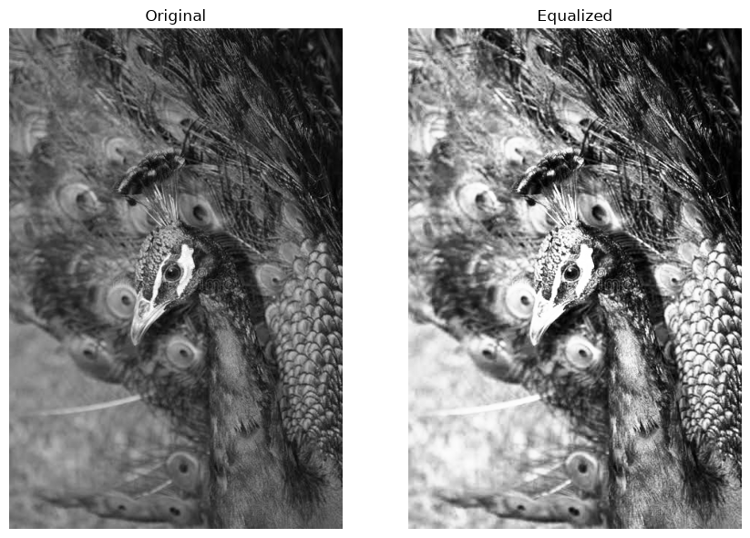
Figure 7a: Original vs equalized image
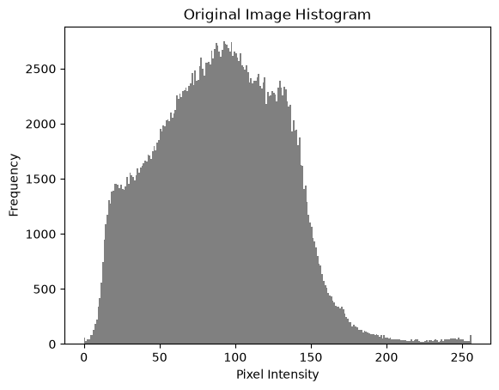
Figure 7b: Original histogram
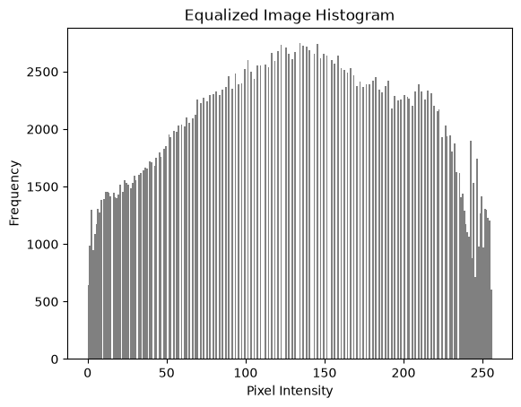
Figure 7c: Equalized histogram
Notebook output — section “7.1 Does noise become stronger?”:
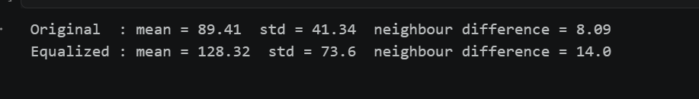
Discussion: equalization spreads the intensities over the whole range, so contrast rises (std 41 → 74) and dark feather detail becomes visible. The average brightness changes and the picture looks less natural. The neighbour difference rises from 8.09 to 14.0, so local variation, including noise and the grass texture, is amplified.

Step 8: CLAHE

Dry run 8 — histogram [6, 2, 0, 0], absolute bin cap = 4
Bin | Original | After clipping at 4 | Add excess/4 = 0.5 | Cumulative | New CDF | Old CDF (no clip)
0 | 6 | 4 (excess 2) | 4.5 | 4.5 | 4.5/8 = 0.5625 | 6/8 = 0.75
1 | 2 | 2 | 2.5 | 7.0 | 7/8 = 0.875 | 1.00
2 | 0 | 0 | 0.5 | 7.5 | 7.5/8 = 0.9375 | 1.00
3 | 0 | 0 | 0.5 | 8.0 | 8/8 = 1.00 | 1.00

Only bin 0 exceeds the cap: 6 − 4 = 2 counts of excess. Shared equally over the four bins this adds 2/4 = 0.5 to each bin (fractions allowed), and the total stays 8. The first CDF value drops from 0.75 to 0.5625, so the mapping is flatter and contrast amplification is limited.
Why neighbouring tiles need interpolation: every tile has its own mapping, so the same input intensity would be mapped to different outputs on either side of a tile border, producing visible blocks. CLAHE therefore blends the mappings of the neighbouring tiles bilinearly, so values change smoothly across the borders.
Note: this simplified model differs from OpenCV’s integer redistribution, and the absolute cap of 4 is not the clipLimit parameter (clipLimit = 2.0 is a multiple of the average bin count).

Required screenshots (from the notebook)
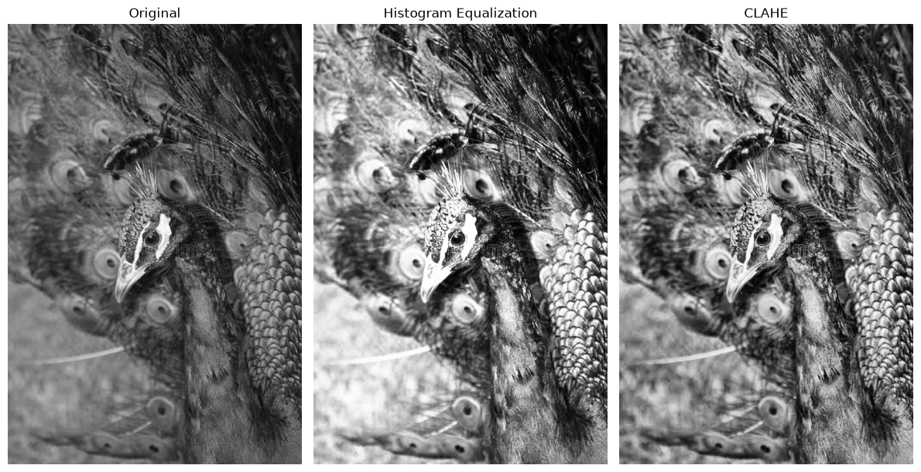
Figure 8a: Original, global equalization, CLAHE (clipLimit 2.0, tileGridSize (8, 8))
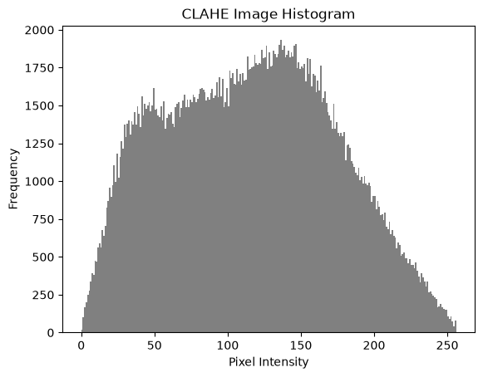
Figure 8b: CLAHE histogram
Notebook output — section “8. CLAHE”:
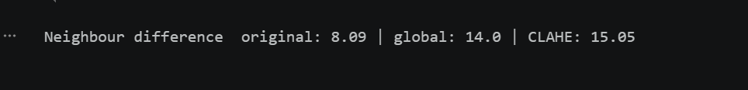

Discussion: tileGridSize = (8, 8) means the image is divided into 8 × 8 = 64 tiles, not tiles of 8 × 8 pixels. CLAHE adapts to uneven lighting (bright feathers versus the shadowed neck and background) and looks more natural than global equalization, but the neighbour difference shows it also increases fine detail and noise.

Step 9: Fixed Binary Thresholding

Dry run 9 — pixels [0, 80, 127, 128, 180, 255], rule: output 255 if r > T else 0
r | r > 127 ? | Output (T = 127) | r > 180 ? | Output (T = 180)
0 | False | 0 | False | 0
80 | False | 0 | False | 0
127 | False (127 is not > 127) | 0 | False | 0
128 | True | 255 | False | 0
180 | True | 255 | False (180 is not > 180) | 0
255 | True | 255 | True | 255

White-pixel counts: T = 127 → 3 white pixels (128, 180, 255); T = 180 → 1 white pixel (255). Raising T makes fewer pixels white; pixels exactly equal to T stay black because the test is strictly greater than.

Required screenshots (from the notebook)
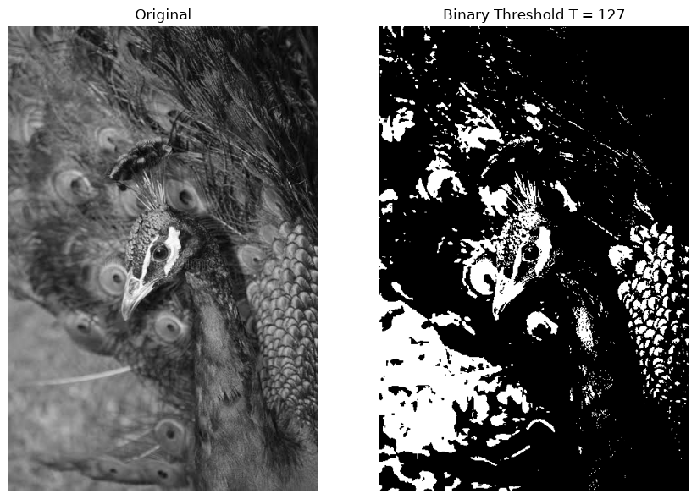
Figure 9: Original and fixed binary threshold T = 127
Notebook output — section “9. Fixed binary thresholding”:
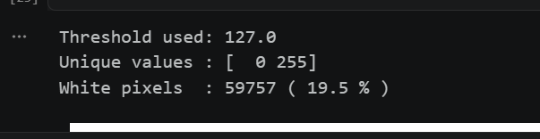
Observation: unique values are [0, 255]; 59,757 pixels (19.5 %) are white. A fixed threshold ignores the image content, so the result depends entirely on the chosen T; because the image is dark, T = 127 keeps few pixels white.

Step 10: Otsu Thresholding

Dry run 10 — pixels [0, 1, 4, 5], no rescaling, score = w0·w1·(μ0 − μ1)²
T | Class 0 (r ≤ T) | Class 1 (r > T) | w0 | w1 | μ0 | μ1 | (μ0 − μ1)² | w0·w1·(μ0 − μ1)²
0 | {0} | {1, 4, 5} | 0.25 | 0.75 | 0 | 3.3333 | 11.1111 | 0.1875 × 11.1111 = 2.0833
1 | {0, 1} | {4, 5} | 0.50 | 0.50 | 0.5 | 4.5 | 16 | 0.25 × 16 = 4.0
2 | {0, 1} | {4, 5} | 0.50 | 0.50 | 0.5 | 4.5 | 16 | 4.0
3 | {0, 1} | {4, 5} | 0.50 | 0.50 | 0.5 | 4.5 | 16 | 4.0
4 | {0, 1, 4} | {5} | 0.75 | 0.25 | 1.6667 | 5 | 11.1111 | 0.1875 × 11.1111 = 2.0833

Choice: the maximum score 4.0 is tied at T = 1, 2 and 3 (no pixel has intensity 2 or 3, so these thresholds split the pixels identically). The smallest tied value is chosen, so T = 1.
Predicted mask (r > 1): [0, 0, 255, 255]. OpenCV returned threshold 1.0 and mask [0, 0, 255, 255], which matches.
Python verification (Dry run 10) — predict the mask and verify with OpenCV:
# Dry run 10: verify the hand-calculated Otsu result with OpenCV
dry = np.array([[0, 1], [4, 5]], dtype=np.uint8)
t, mask = cv.threshold(dry, 0, 255, cv.THRESH_BINARY + cv.THRESH_OTSU)
print("Hand result : T = 1, mask [0, 0, 255, 255]")
print("OpenCV T :", t)
print("OpenCV mask :", mask.ravel().tolist())
print("Matches the hand prediction:", t == 1 and mask.ravel().tolist() == [0, 0, 255, 255])
Output:
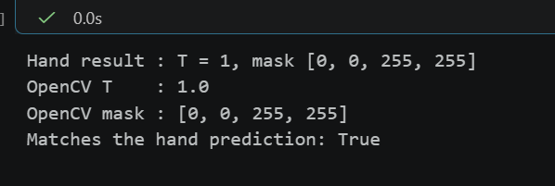

Required screenshots (from the notebook)
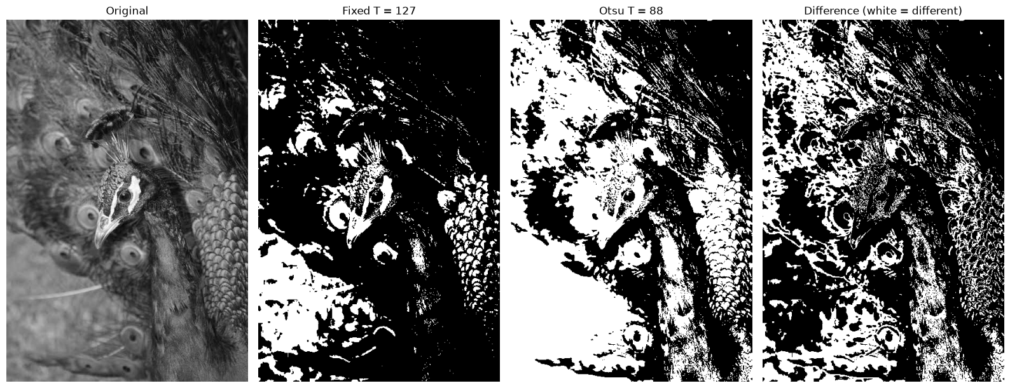
Figure 10: Original, fixed T = 127, Otsu T = 88, and the difference mask
Notebook output — section “10. Otsu thresholding”:
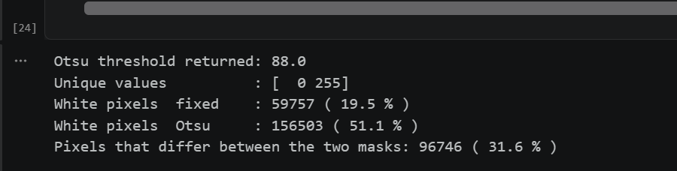
Observation: Otsu chooses the threshold from the image’s own histogram by maximizing the separation of the two classes. For this dark image it picks 88, lower than 127, so it marks many more pixels white (51.1 % against 19.5 %); the two masks disagree on 31.6 % of the pixels.

Step 11: Adaptive Gaussian Thresholding

Dry run 11 — 3 × 3 neighbourhood with weights [[1, 2, 1], [2, 4, 2], [1, 2, 1]]/16
Row | Pixels | Weights | Weighted sum | ÷ 16
1 | 100, 100, 100 | 1, 2, 1 | 100 + 200 + 100 = 400 | 25
2 | 100, 120, 140 | 2, 4, 2 | 200 + 480 + 280 = 960 | 60
3 | 140, 140, 140 | 1, 2, 1 | 140 + 280 + 140 = 560 | 35
Total |  |  | 1920 | 120

Weighted mean = 1920 / 16 = 120; T = mean − C = 120 − 2 = 118.
- Center pixel (120): 120 > 118 is True, so the output is 255 (white).
- Pixel equal to T (118): 118 > 118 is False, so the output is 0 (black), because the rule is strictly greater than.
This 3 × 3 example is only for the dry run; the image task uses blockSize = 11 (an 11 × 11 neighbourhood with Gaussian weights generated by OpenCV).

Required screenshots (from the notebook)
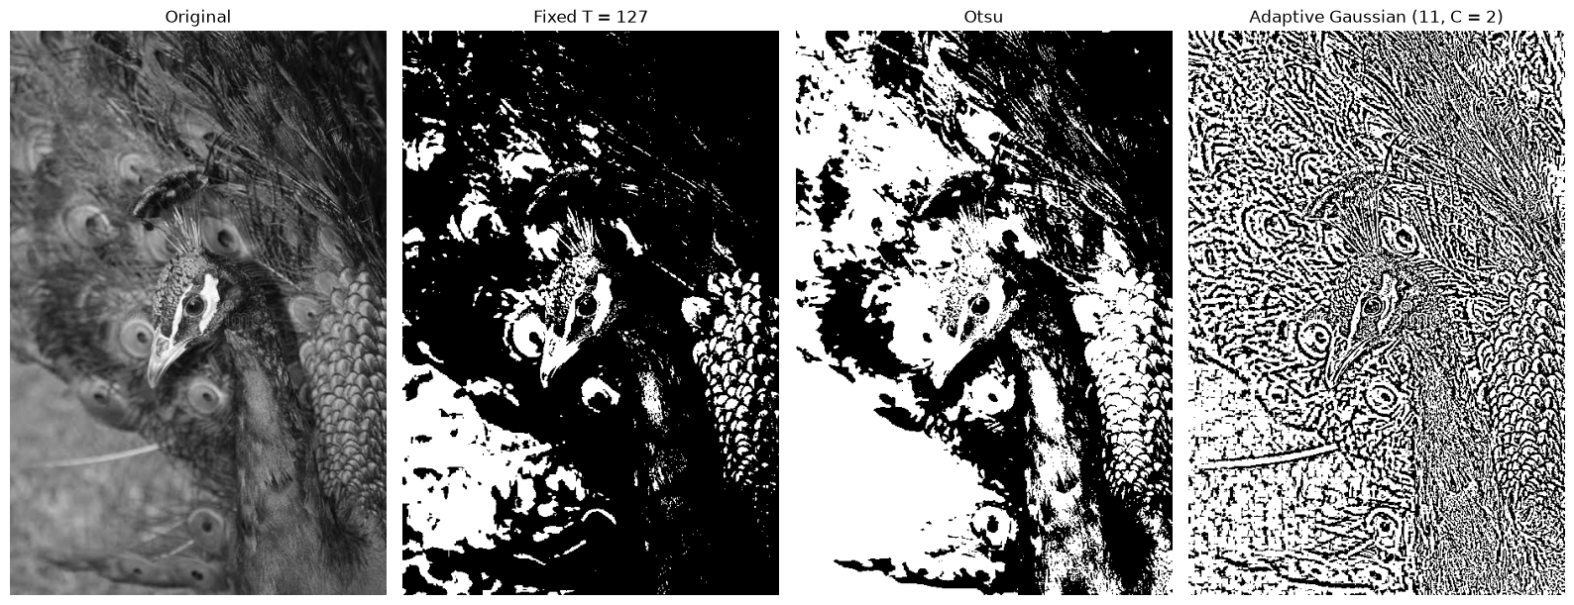
Figure 11: Original, fixed T = 127, Otsu, adaptive Gaussian (blockSize 11, C = 2)
Notebook output — section “11. Adaptive Gaussian thresholding”:
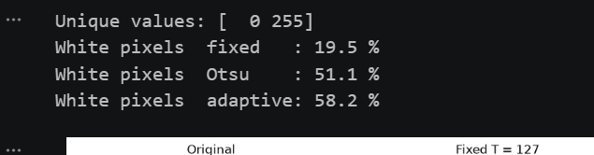
Observation: the adaptive method keeps local edges and texture (the feather pattern) even where the lighting changes, while fixed and Otsu use one value for the whole image and give large uniform black or white areas. Local thresholds help for unevenly lit scenes such as shadowed documents; on a natural photo they also pick up fine texture and noise.

Final Check
Notebook output — section “Final Check: the original image was never changed”:


Explanations Required by the Lab
- Clipping: limiting a computed value to 0–255 (values below 0 become 0, values above 255 become 255). Clipped pixels lose their differences, so detail in shadows or highlights disappears.
- Overflow: uint8 can only store 0–255 and wraps around (280 becomes 24, −10 becomes 246). To avoid it the image is first converted to int16 or float, the result is clipped, and only then converted back to uint8; astype truncates the fractional part.
- Brightness versus contrast: brightness adds a constant (β) and shifts all intensities; contrast multiplies by α and changes the distance between intensities. Contrast about 128 keeps the midpoint fixed, while 1.5r from zero also brightens.
- Gamma convention: s = 255(r/255)^γ with normalization to 0–1. γ < 1 brightens (mostly dark and mid tones), γ > 1 darkens, and 0 and 255 never change.
- Global versus local enhancement: global equalization is simple and works when lighting is even, but it can look unnatural and amplify noise. CLAHE works per tile with a clip limit, so it handles uneven lighting better.
- Thresholding: a fixed T is fast but needs a good manual value; Otsu picks one global T automatically for images with two classes; adaptive Gaussian uses a local T for each pixel and suits uneven illumination.

