

The University of Azad Jammu and Kashmir
Department of Software Engineering

LAB 3 REPORT
Student Name | Afzal Ali Ahmed Shah
Roll no | 2024-SE-04
Semester | 5th
Instructor Name | Engr. Asma Javaid
Subject | Software Construction and Development
Course Code | SE-3101
Credit Hours | 2+1
Lab | 03
Date | 2-Nov-2026
Department of Software Engineering

Lab 3: Sequence Diagrams
Software Construction & Development (Lab) | Semester: Fall 2026

Q1: ATM Cash Withdrawal
The customer inserts a card and PIN. The ATM Controller verifies them with the Bank Server, checks balance and limits, debits the account, and then instructs the Cash Dispenser to hand out the cash. Failed authentication and insufficient funds are handled as alternative flows.
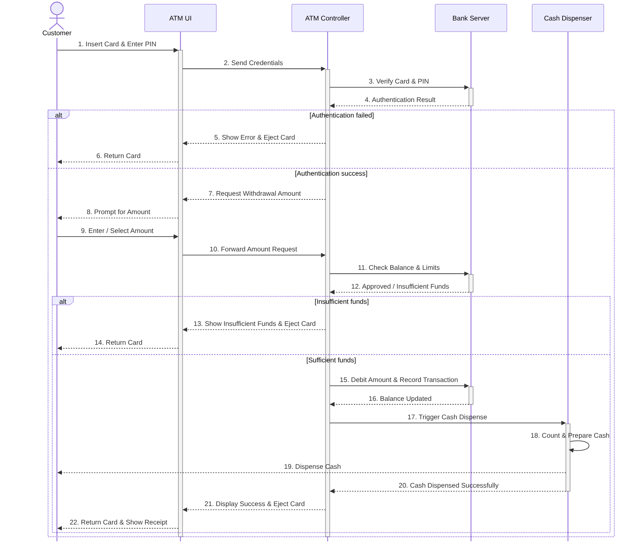
Figure 1: Sequence diagram for ATM cash withdrawal

Q2: Online Ticket Reservation
The customer selects an event and seats. The Reservation Controller checks and locks the seats in the Database, takes payment through the Payment Gateway, and saves the booking and e-ticket. Unavailable seats and declined payment (seats released) are handled as alternative flows.
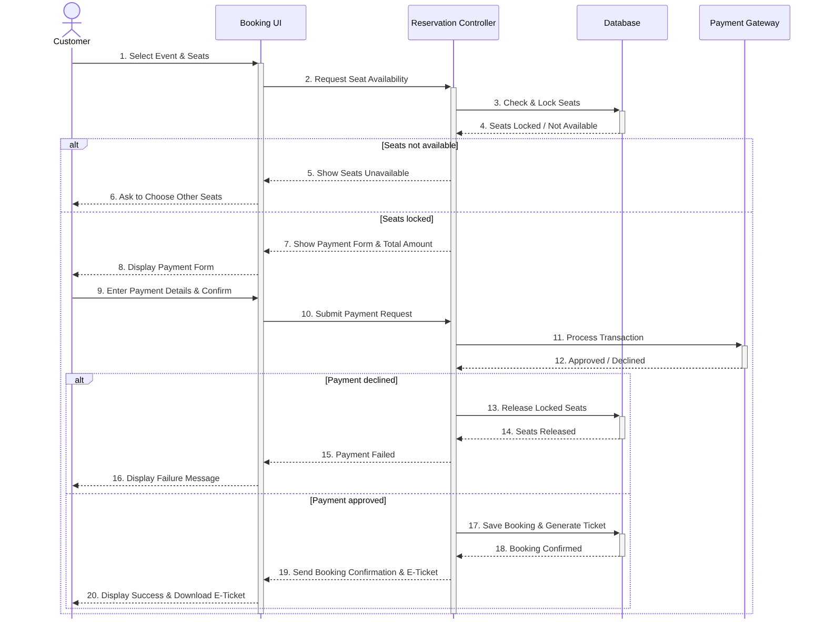
Figure 2: Sequence diagram for the online ticket reservation system

