


The University of Azad Jammu and Kashmir
Department of Software Engineering

Student Name | Afzal Ali Ahmed Shah
Roll no | 2024-SE-04
Semester | 5th
Instructor Name | Engr. Asma Javaid
Subject | Software Construction and Development
Course Code | SE-3101
Credit Hours | 2+1
Lab | 04
Date | 2-Nov-2026
Department of Software Engineering

DEPARTMENT OF SOFTWARE ENGINEERING
Software Construction & Development (Lab) | Lab 4 Report
Course: Software Construction & Development (Lab) | Semester: Fall 2026
Instructor: Engr. Dr. Asma Javaid | Student ID: 2024-SE-04

Question 1: Online Doctor Appointment Management System
System Overview & Class Identification:
- Patient: Represents the system user seeking medical consultation. Responsible for account creation, submitting appointment requests, viewing confirmation messages, and managing patient details.
- Doctor: Represents the health specialist. Responsible for viewing incoming requests, managing schedule availability, and accepting or rejecting appointment slots based on hospital/clinic hours.
- Appointment: Represents the core interaction between a patient and a doctor. Contains attributes for date, time, location (hospital/clinic), and status (Pending, Accepted, Rejected, Cancelled).
UML Class Diagram
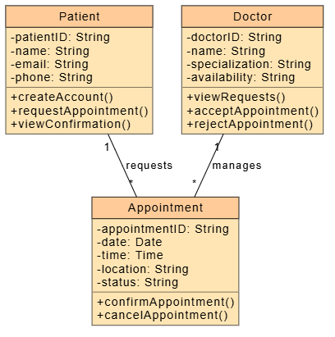
Relationships: One Patient can request many Appointments (1 to *), and one Doctor can manage many Appointments (1 to *). Each Appointment belongs to exactly one Patient and one Doctor.

Question 2: Animal Superclass and Subclasses (Cat & Dog)
Overview: Demonstrates object-oriented inheritance. The Animal superclass defines base behaviors (eat, sleep), while Cat and Dog inherit from Animal and implement their respective sound behaviors (meow, bark).
UML Class Diagram
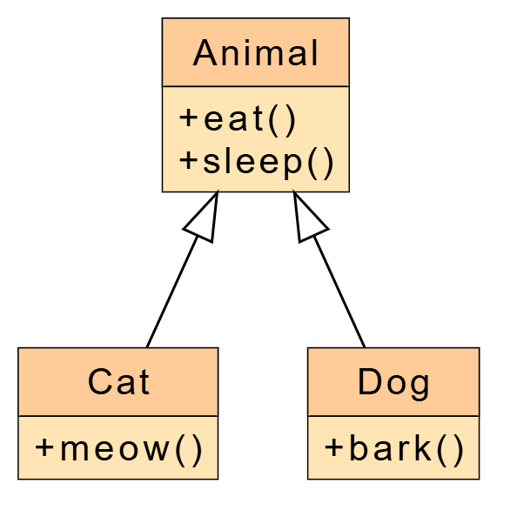

C++ Source Code
#include <iostream>
using namespace std;
// Superclass
class Animal {
public:
virtual ~Animal() {} // virtual destructor for safe inheritance
void eat() const {
cout << "This animal is eating." << endl;
}
void sleep() const {
cout << "This animal is sleeping." << endl;
}
};
// Subclass Cat
class Cat : public Animal {
public:
void meow() const {
cout << "Cat says: Meow! Meow!" << endl;
}
};
// Subclass Dog
class Dog : public Animal {
public:
void bark() const {
cout << "Dog says: Woof! Woof!" << endl;
}
};
int main() {
Cat myCat;
Dog myDog;
cout << "=== Cat Actions ===" << endl;
myCat.eat();
myCat.sleep();
myCat.meow();
cout << "\n=== Dog Actions ===" << endl;
myDog.eat();
myDog.sleep();
myDog.bark();
return 0;
}
Question 3: Shape Superclass and Subclasses (Triangle & Rectangle)
Overview: Demonstrates polymorphism and abstract classes. The Shape superclass contains a pure virtual method calculateArea(). Subclasses Triangle and Rectangle override both methods: inputDimensions() reads and validates the dimensions entered by the user, and calculateArea() returns the area. A virtual destructor in Shape ensures objects are cleaned up safely through a base-class pointer.
UML Class Diagram
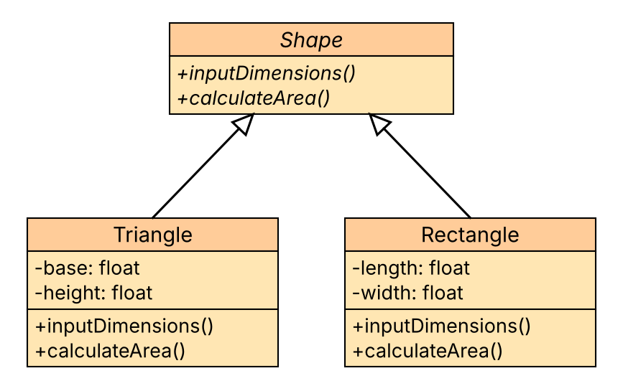

C++ Source Code
#include <iostream>
#include <limits>
#include <string>
#include <cstdlib>
using namespace std;
// Helper: keeps asking until the user enters a positive number
float readPositive(const string& prompt) {
float value;
while (true) {
cout << prompt;
if (cin >> value && value > 0)
return value;
if (cin.eof())
exit(1); // no more input available
cin.clear(); // reset error state
cin.ignore(numeric_limits<streamsize>::max(), '\n');
cout << "Invalid input. Enter a positive number.\n";
}
}
// Abstract superclass
class Shape {
public:
virtual ~Shape() {} // virtual destructor
virtual void inputDimensions() = 0; // read dimensions from the user
virtual float calculateArea() const = 0; // pure virtual function
};
// Subclass Triangle
class Triangle : public Shape {
private:
float base, height;
public:
Triangle() : base(0), height(0) {}
void inputDimensions() override {
base = readPositive("Enter base of the triangle: ");
height = readPositive("Enter height of the triangle: ");
}
float calculateArea() const override {
return 0.5f * base * height;
}
};
// Subclass Rectangle
class Rectangle : public Shape {
private:
float length, width;
public:
Rectangle() : length(0), width(0) {}
void inputDimensions() override {
length = readPositive("Enter length of the rectangle: ");
width = readPositive("Enter width of the rectangle: ");
}
float calculateArea() const override {
return length * width;
}
};
int main() {
Triangle t;
Rectangle r;
cout << "=== Triangle Area Calculation ===" << endl;
t.inputDimensions();
cout << "Area of Triangle = " << t.calculateArea() << endl;
cout << "\n=== Rectangle Area Calculation ===" << endl;
r.inputDimensions();
cout << "Area of Rectangle = " << r.calculateArea() << endl;
return 0;
}

