Screenshotweek12

<http://3.94.125.15:8000/docs#/default/get_prediction_predict_post>

https://github.com/gillesbouyer/stock-predictor

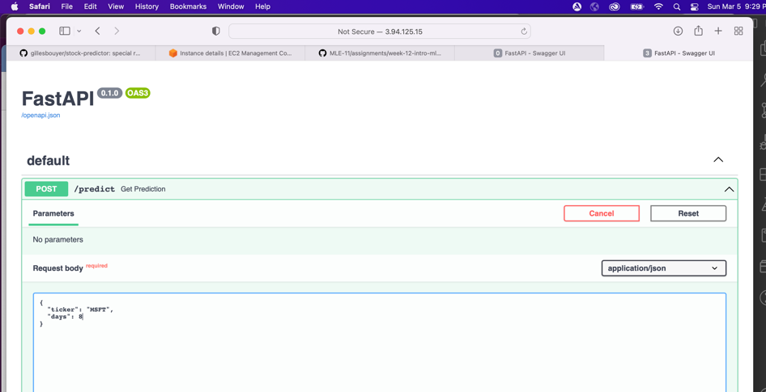

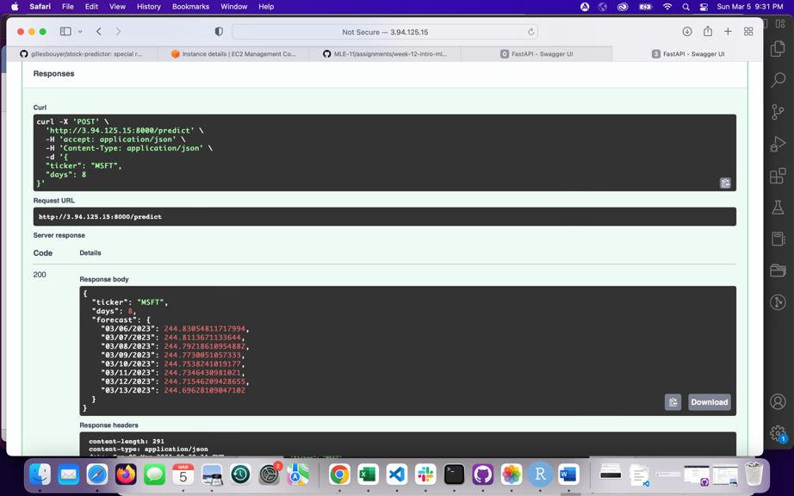

Questions:

**-1- a** **How does the Prophet Algorithm differ from an LSTM?**

The prophet algorithm is a classical time series algorithm which is going to split the trends, seasonality and errors that can be identified in the series and predict the next values based on the evolution of these three main group of data.

LSTM – long short term memory – predict the next values based on the sequences of data that that were identified across time and is more valuable as it incorporate all past values and their relationships.

**-1- b Why does an LSTM have poor performance against ARIMA and Profit for Time Series?**

If there is not a lot of data, Arima (Auto regressive Integrated Moving Average) will do better than LSTM because it can learn the characteristics of the time series (assumed to decompose in what is repeating – regressive and the moving average) with less data

than LSTM. I assume profit = prophet, same type of logic on explanation. Less data are needed to do the forecast.

-**2- What is exponential smoothing and why is it used in Time Series Forecasting?**

Exponential smoothing associates a weight to the past observations of a time series. The older the observation the smaller the weight. The weight are calculating using an exp formula. It is used in Time series forecasting because it is a simple idea that can be applied to the different components of the time series.

**-3- What is stationarity? What is seasonality? Why Is Stationarity Important in Time Series Forecasting?**

In a Time series, stationary refers to the values which are constant in the time series like the mean and the variance. Seasonality refers to a period of time where a pattern of change repeats itself.

**-4- How is seasonality different from cyclicality? Fill in the blanks:**

Seasonality repeats itself by time period (day, week, month) and cyclicality repeats themselves because of non predictable patterns that do happen again and again (economic crisis, recessions, elections, earthquakes)  
Seasonality is predictable, whereas cyclicality is not**.**