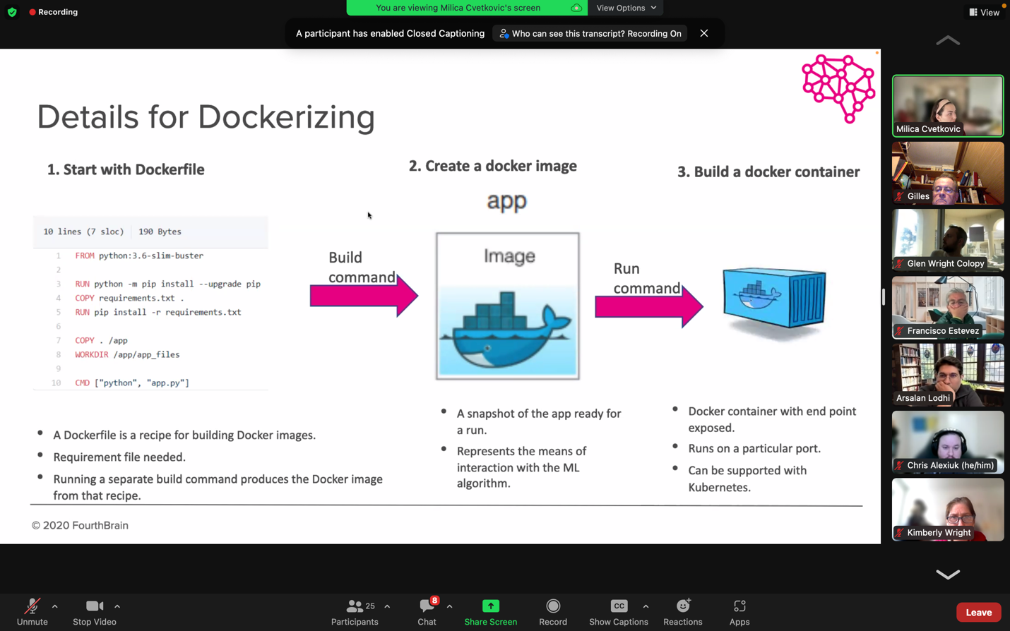

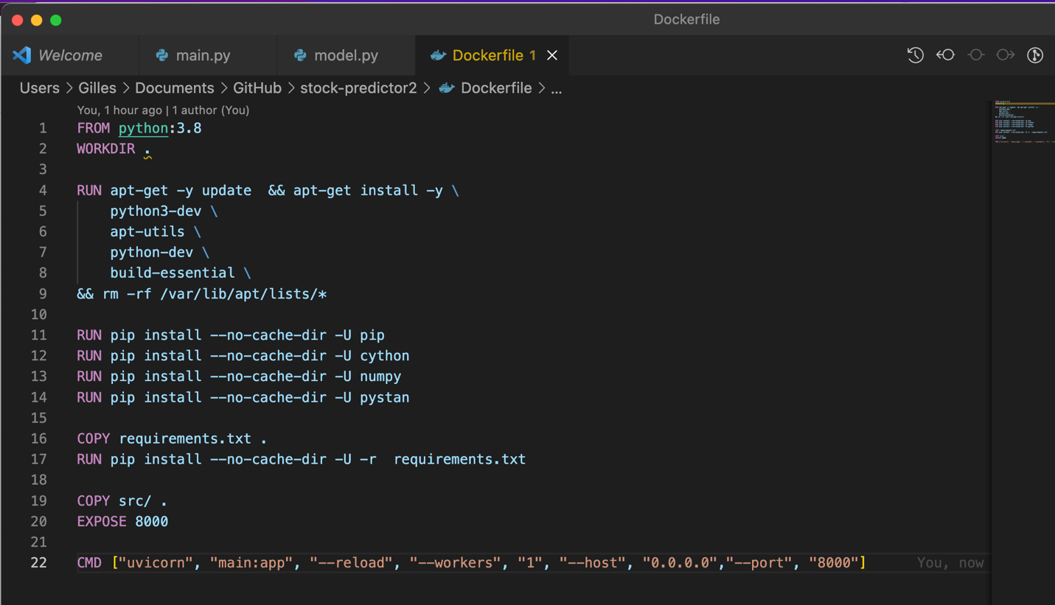

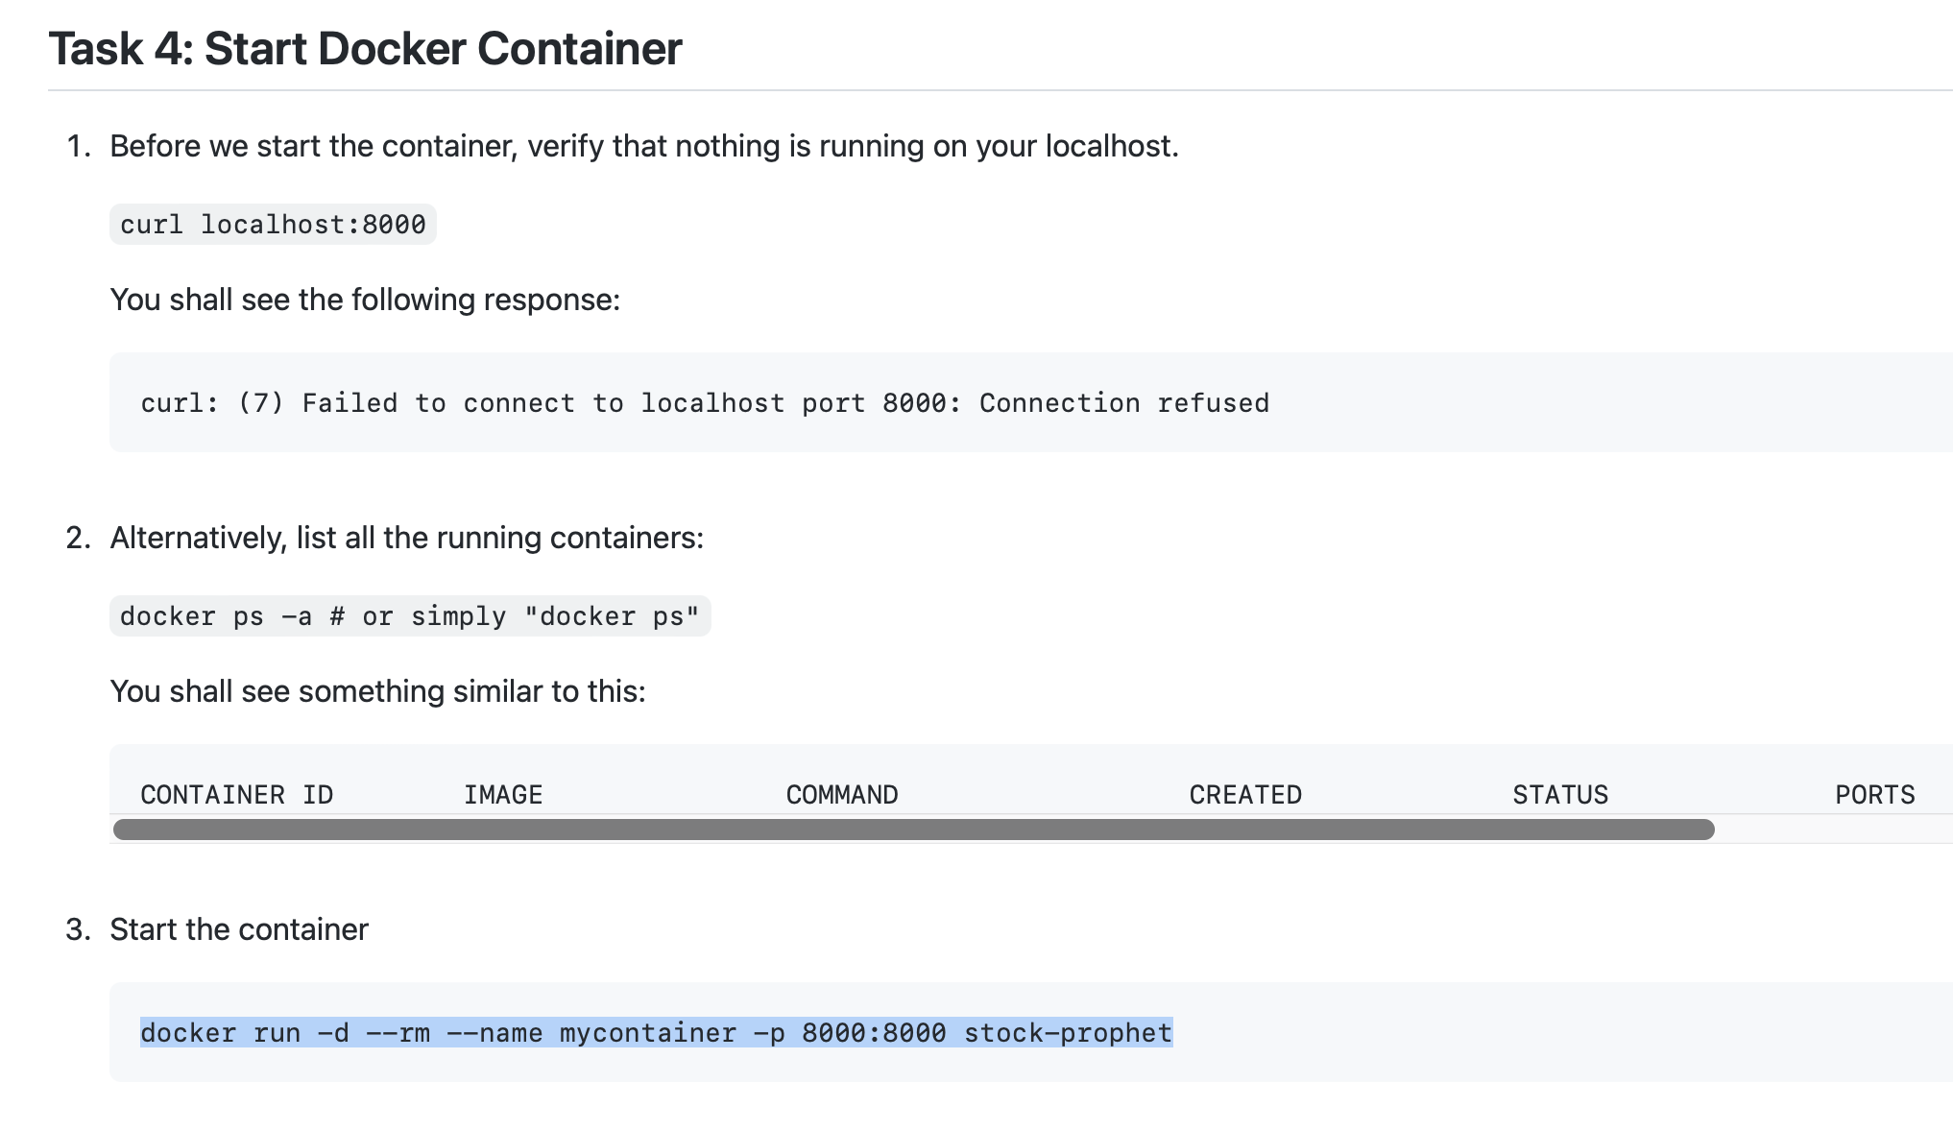

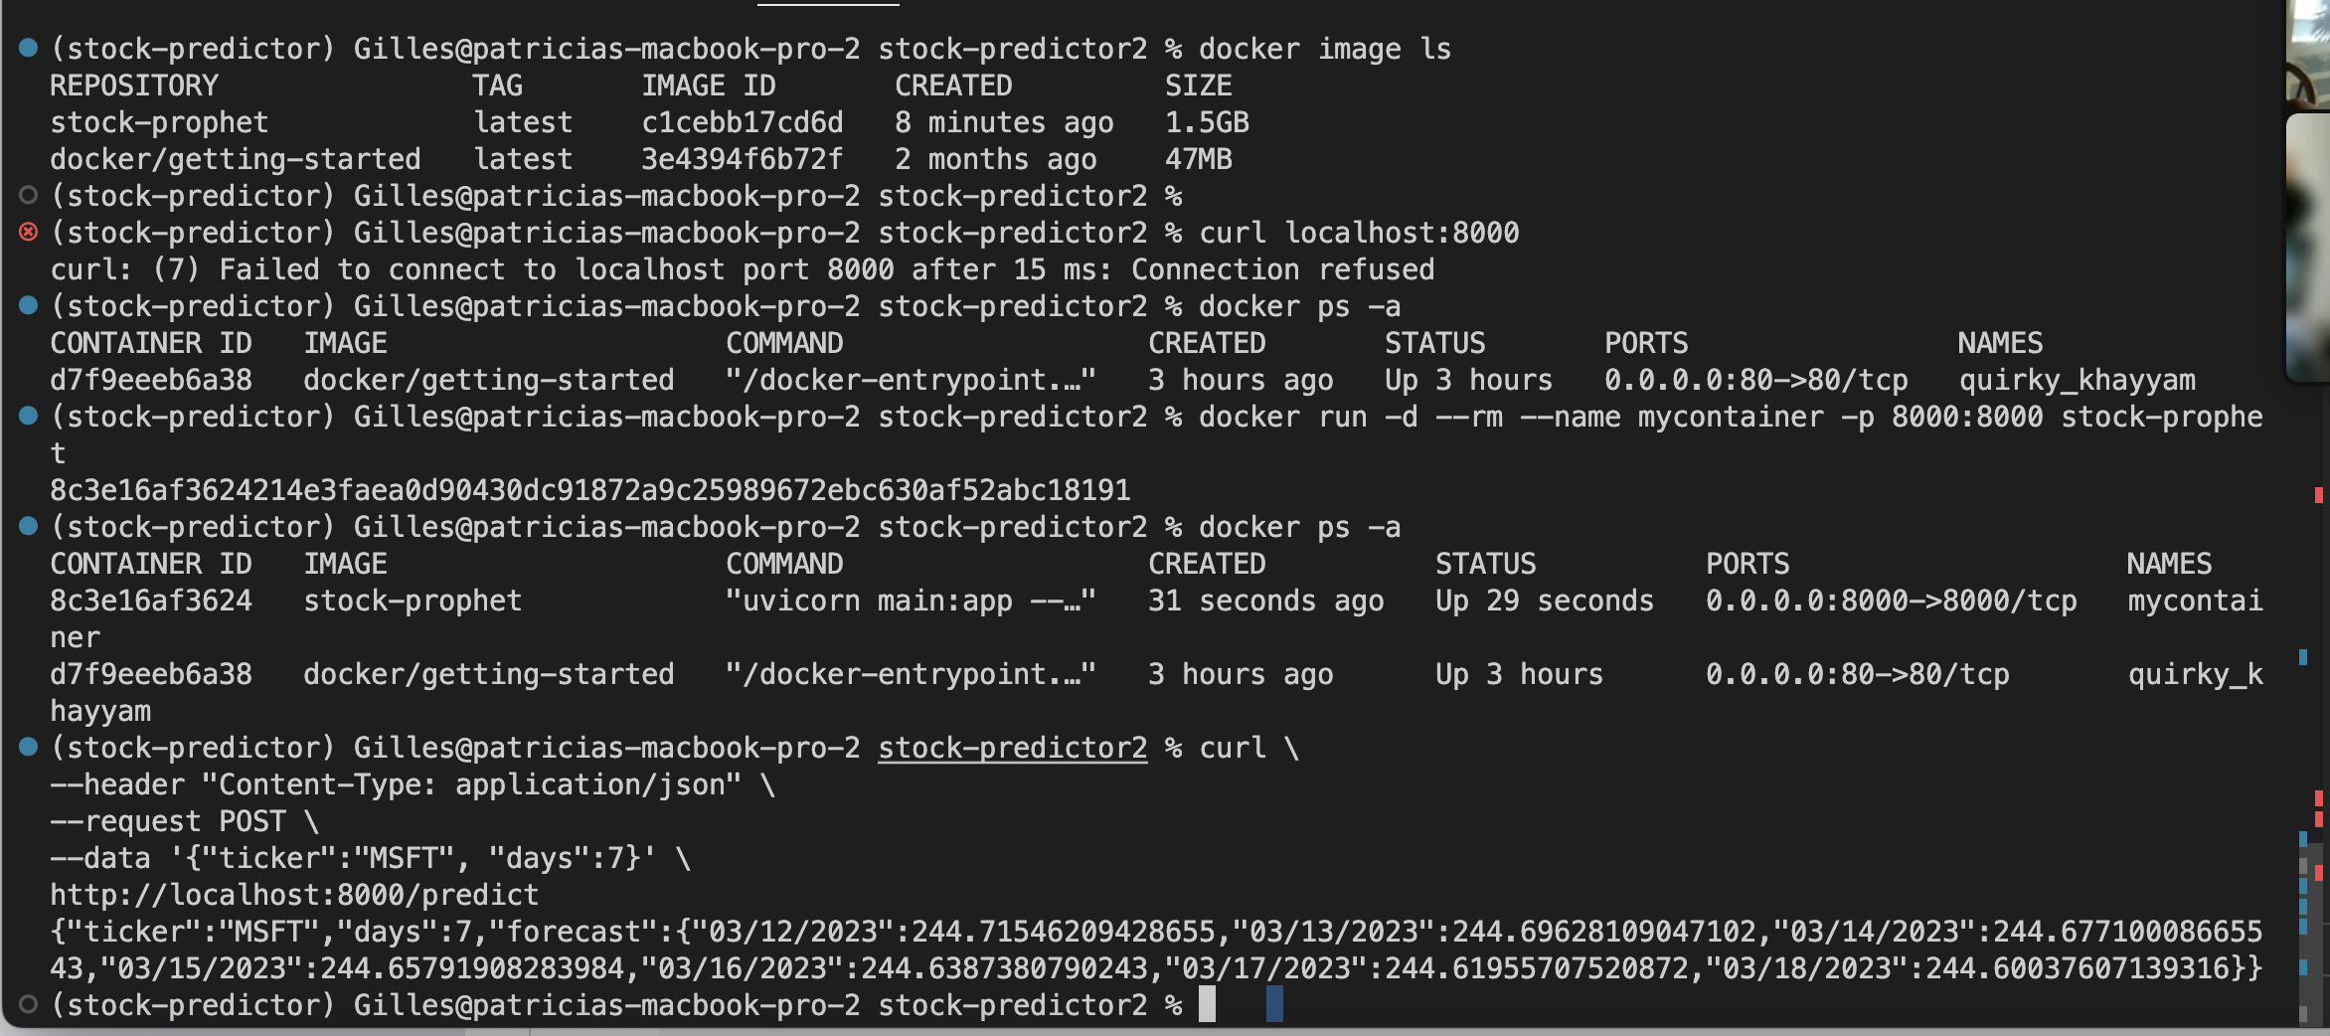

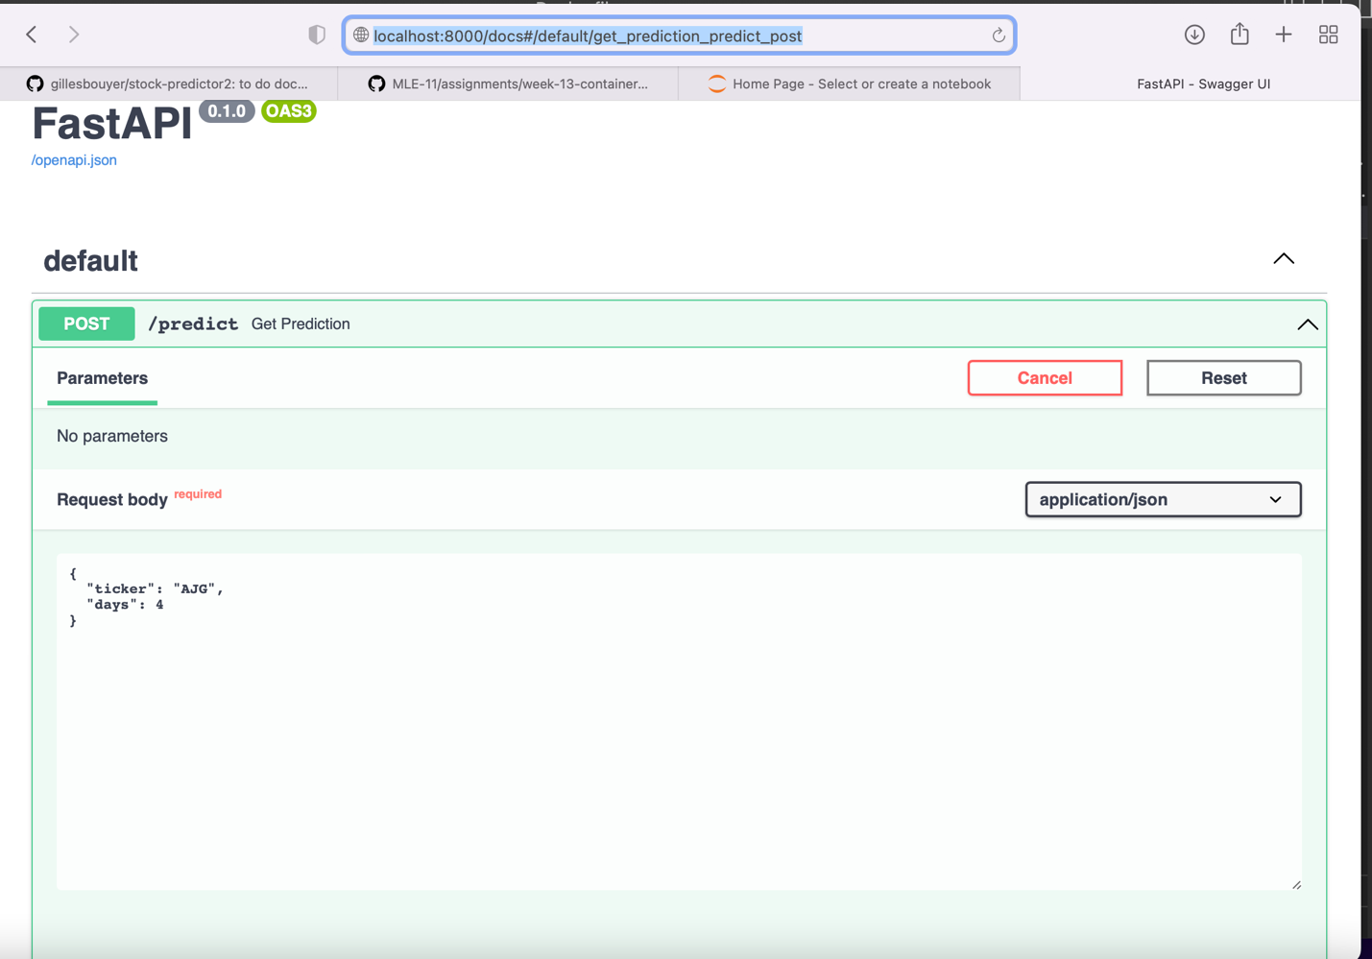

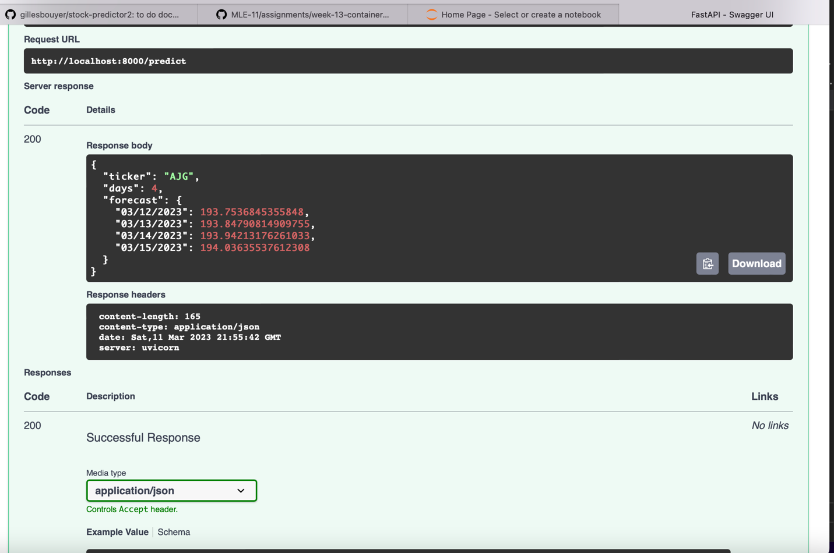

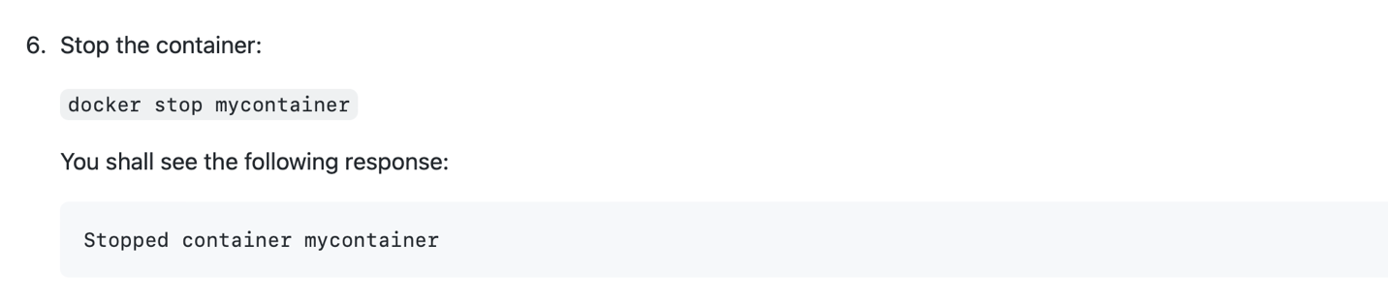

(stock-predictor) Gilles@patricias-macbook-pro-2 stock-predictor2 % docker stop mycontainer

mycontainer

(stock-predictor) Gilles@patricias-macbook-pro-2 stock-predictor2 % docker ps -a

CONTAINER ID IMAGE COMMAND CREATED STATUS PORTS NAMES

d7f9eeeb6a38 docker/getting-started "/docker-entrypoint.…" 3 hours ago Up 3 hours 0.0.0.0:80->80/tcp quirky_khayyam

(stock-predictor) Gilles@patricias-macbook-pro-2 stock-predictor2 % docker run -d --rm --name mycontainer -p 8000:8000 stock-prophet

5439d9cb2c6247905b1a2b49f293f7c68fc184e9df2819439df4b2f108b774c1

(stock-predictor) Gilles@patricias-macbook-pro-2 stock-predictor2 % docker ps -a

CONTAINER ID IMAGE COMMAND CREATED STATUS PORTS NAMES

5439d9cb2c62 stock-prophet "uvicorn main:app --…" 6 seconds ago Up 5 seconds 0.0.0.0:8000->8000/tcp mycontainer

d7f9eeeb6a38 docker/getting-started "/docker-entrypoint.…" 3 hours ago Up 3 hours 0.0.0.0:80->80/tcp quirky_khayyam

(stock-predictor) Gilles@patricias-macbook-pro-2 stock-predictor2 % docker stop quirky_khayyam

quirky_khayyam

(stock-predictor) Gilles@patricias-macbook-pro-2 stock-predictor2 % docker stop mycontainer

mycontainer

(stock-predictor) Gilles@patricias-macbook-pro-2 stock-predictor2 % docker ps -a

CONTAINER ID IMAGE COMMAND CREATED STATUS PORTS NAMES

d7f9eeeb6a38 docker/getting-started "/docker-entrypoint.…" 3 hours ago Exited (0) 10 seconds ago quirky_khayyam

(stock-predictor) Gilles@patricias-macbook-pro-2 stock-predictor2 % docker ps -a

CONTAINER ID IMAGE COMMAND CREATED STATUS PORTS NAMES

d7f9eeeb6a38 docker/getting-started "/docker-entrypoint.…" 3 hours ago Exited (0) 6 minutes ago quirky_khayyam