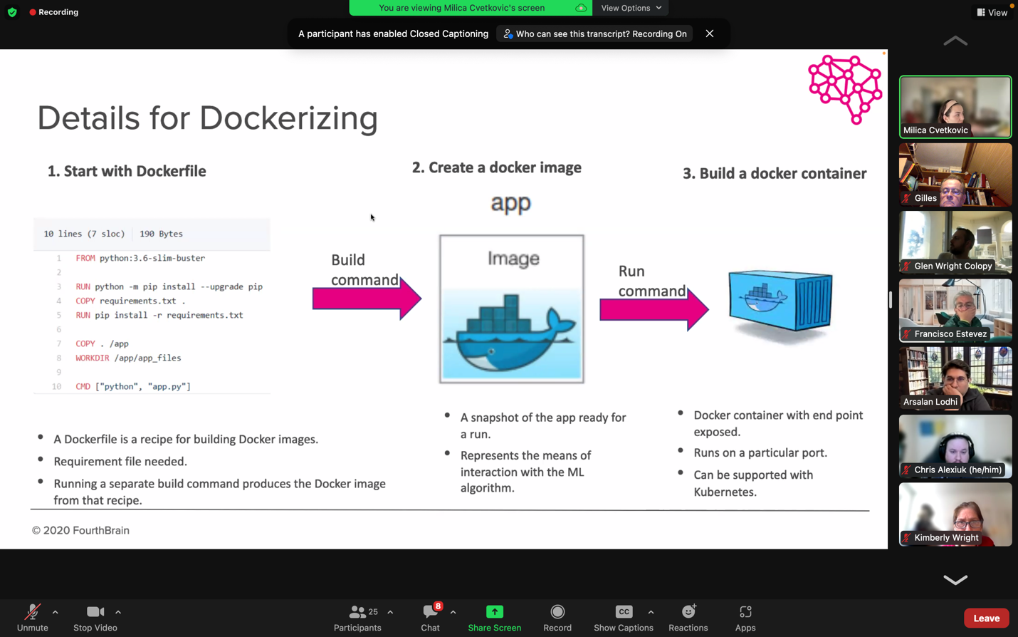

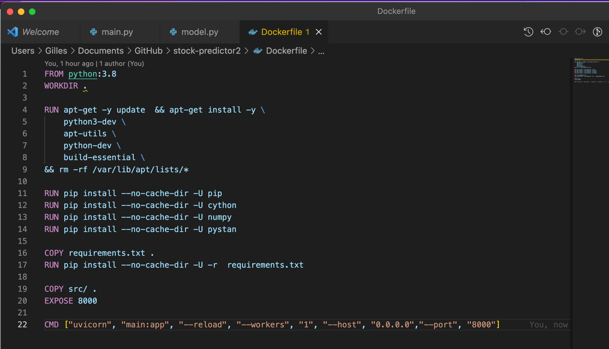

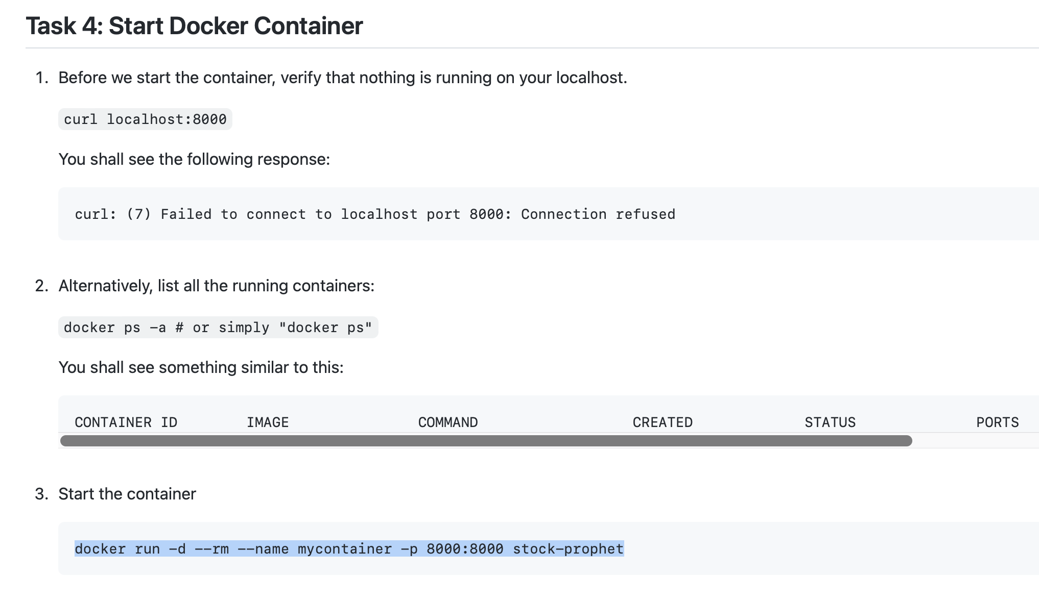

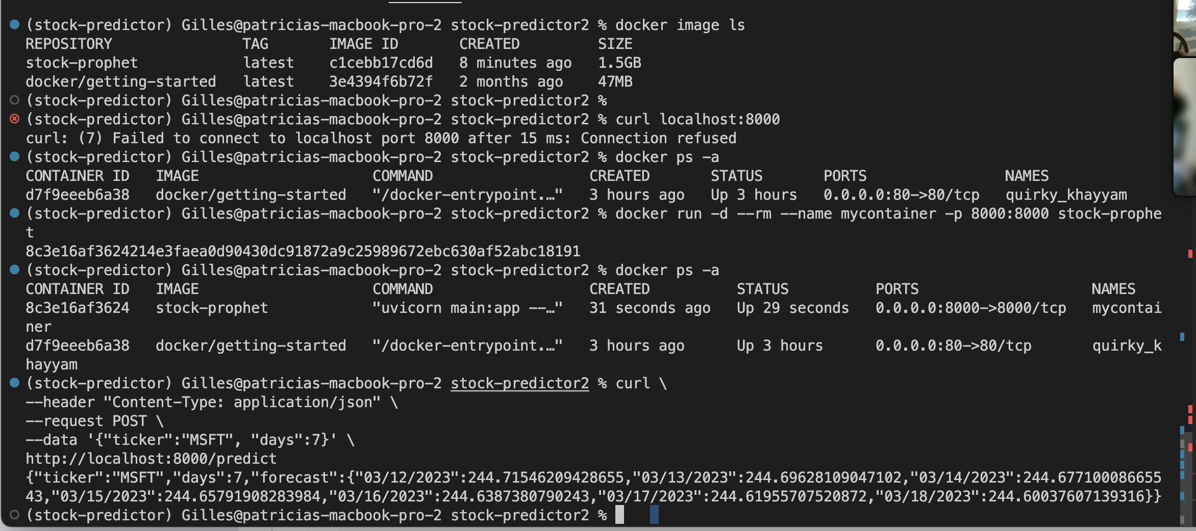

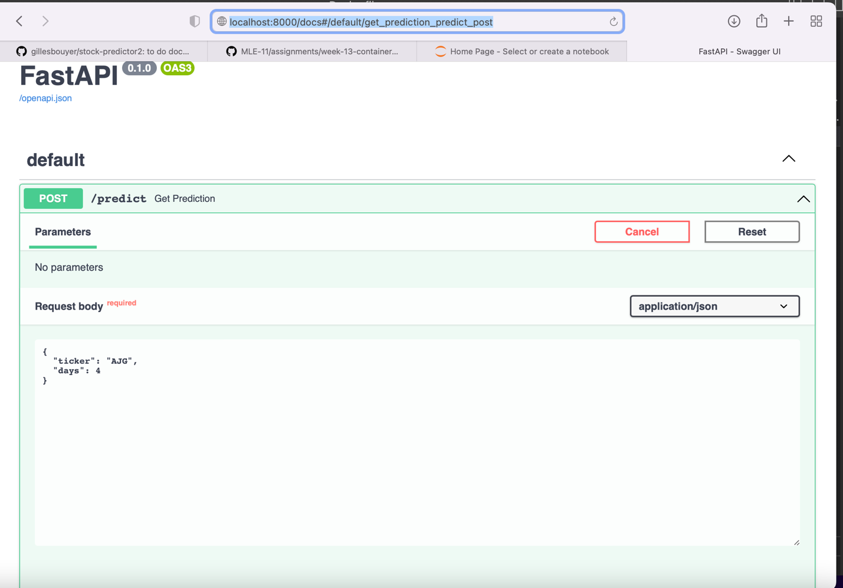

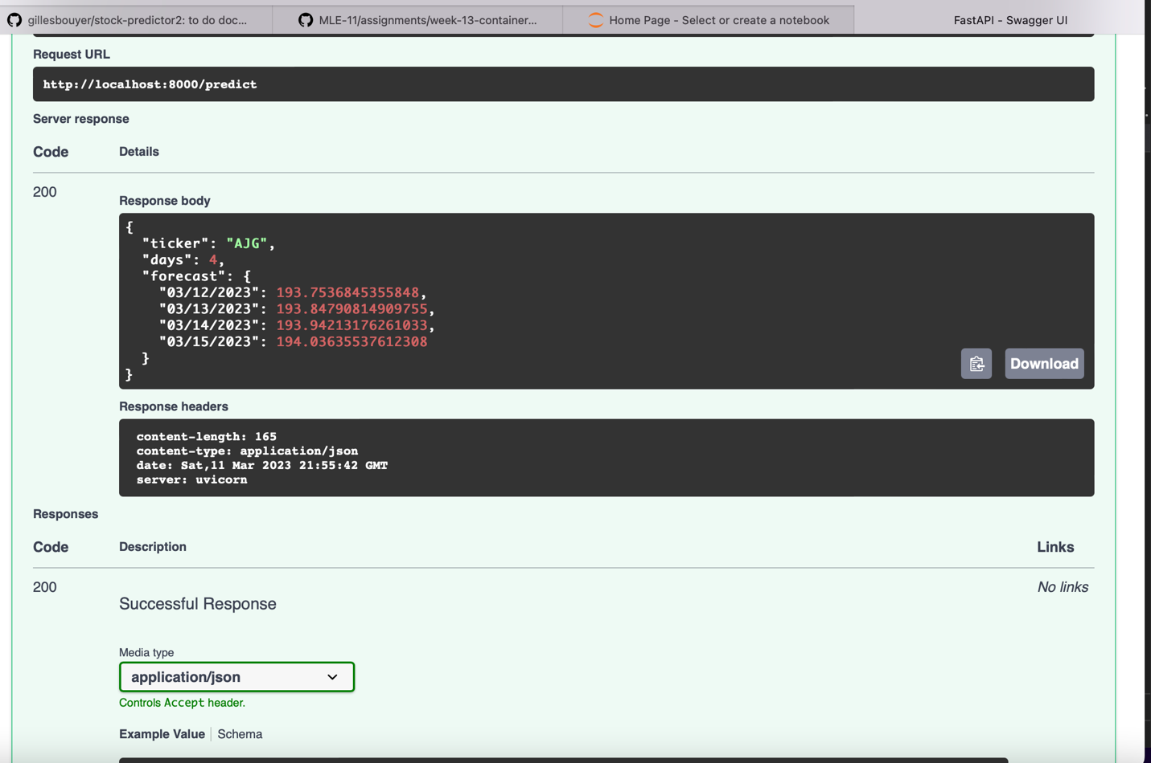

Question1: **What does it mean to create a Docker image and why do we use Docker images?**

A docker image is a representation that contains everything needed to run a program. Creating it means creating an object that can run standalone. The object is creating from a file called “Dockerfile” that includes the piece of software needed (for python the python version and libraries listed in the requirements.txt file and a command line that will start the application. An example is at the bottom of page 1. The image is created with a “docker build” command.

Question2: **Please explain what is the difference from a Container vs a Virtual Machine?**

Virtual machine is made of an operating system libraries and application. A container shares operating systems with other containers and is defined only to run a specific application under specific configuration making it a less complex solution to deploy.

Question 3: **When there are many containers to manage, you need an orchestration software**. Most famous are Kubernetes, Amazon Elastic Container Services (ECS), OpenShift, Nomad and Mesos Apache

Question4: **How does a Docker image differ from a Docker container?**

The image is what is build running “docker build” from the Dockerfile. The container is what is running after the command “docker run” starts the image.