ScreenshotsWeek15

-1- Grafana: Regression

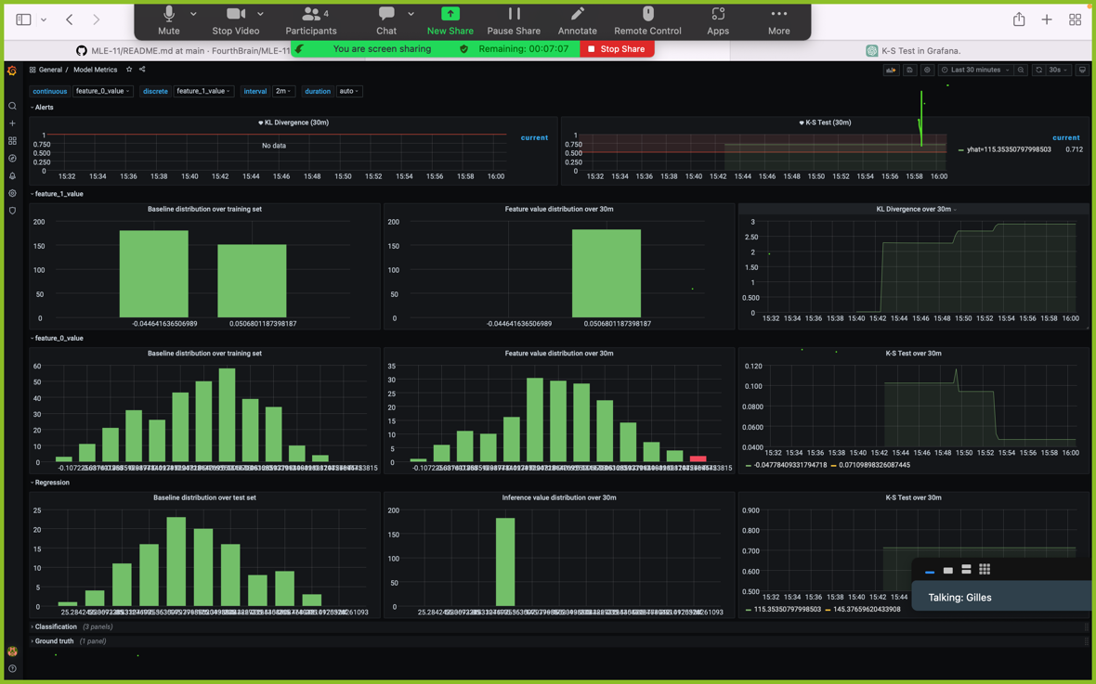

-2- Grafana: Classification

