A software to compute resolution trees of any 2-string tangles.
There are two kinds of programs. One works with Mathematica using
MathLink on only Windows machines and another is a standalone program on Windows machines, Macintosh, and UNIX(Sun Micro).
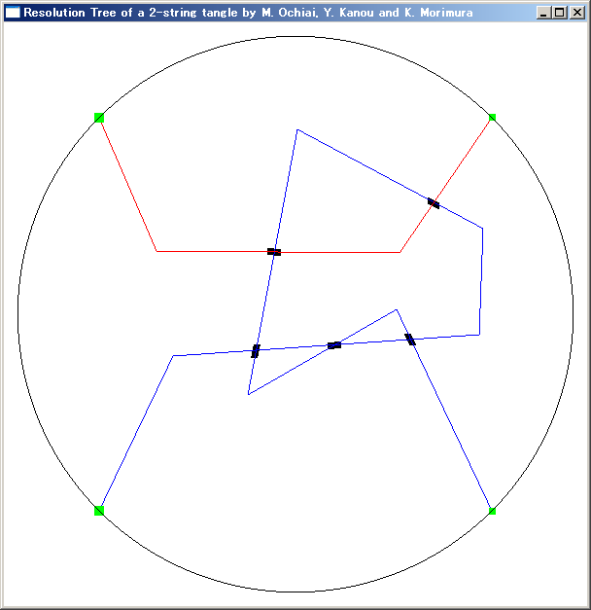
How to use:
- On Mathematica, execute the following command,

Later, you will get an output.
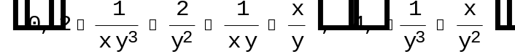

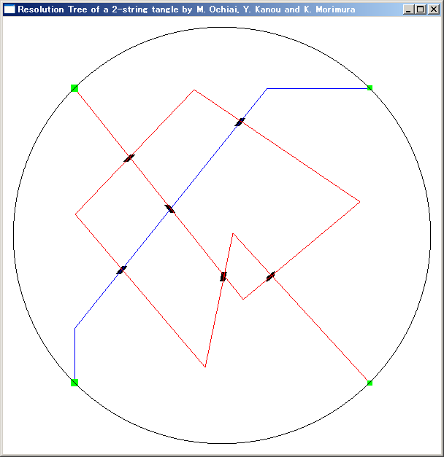

These two examples was obtained from 2 tangles which give the
Terasaka-Kinoshita’s knot.

Type base tangle
0 0,3,1,2,
1 0,3,2,1,
2 0,1,3,2,
3 0,1,2,3,
4 0,2,1,3,
5 0,2,3,1
Four numbers 0, 1, 2, and 3 are dividing points on a unit circumference, and are counterclockwise located in it. The base tangle of type 0 is the one such that one string connects point 0 and 3, and another string does point 1 and 2. In the all cases, a starting point is point 0. The 2 base tangles of type 4 and 5 are trivial tangles with one crossing point with plus sign and all another are trivial tangles without crossing points.

This forks the standalone load module to display tangles on another windows.

1’. In the case of standalone, double click a load module WinTangle.

- You can input any tangle using mouse-tracking.
- After has inputted, you modify any crossing by clicking the crossing point.
- Keyboard:
ESC-key -> quit
‘c’ or ‘C’-key -> copy a tangle to the output file "LastTangle.tgl"
‘p’ or ‘P’-key -> paste a tangle from the input file "LastTangle.tgl"
‘r’-key -> read a tangle from "LastTangle1.tgl"
‘R’-key -> read a tangle from "LastTangle2.tgl" and this is always performed to the next of ‘r’-keyin. These two tangles must be given by a tangle decomposition of a knot or link. These two actions is followed with the pulldown menu "Compute HOMFLY polynomial". As a result, you will get a HOMFLY polynomial of a given knot.
‘w’-key -> write a current tangle to "LastTangle1.tgl"
‘W’-key -> write a current tangle to "LastTangle2.tgl"
‘1’-key -> the standard mutation
‘2’-key -> the vertical mutation
‘3’-key -> the horizontal mutation
‘d’ or ‘D’-key -> undo operation

- Pulldown (or PopUp on Macintosh) menu:
"MirrorImage" -> the mirror image
"Compute Resolution Tree" -> to compute base polynomials about 2 base tangles
"Compute HOMFLY polynomial" -> to compute a HOMFLY polynomial of knots and links (‘r’ + "Compute Resolution Tree" +‘R’+"Compute Resolution Tree"+"Compute HOMFLY polynomial").
"Clear" -> clear the window and the work area
"Quit" -> quit
The current version is 2-dimensional display although using OpenGL graphics Library but the future version will be 3-dimensional display and the final version can do n-string tangles of n up to 6.
I have needed to perform sufficient test, and although I am sure that the bugs was eradicated, but supposing you will find them, please notify immediately by e-mail to ochiai@ics.nara-wu.ac.jp.
Welcome your request and question.
I deeply appreciate precious advice and cooperation of Prof. J. Murakami and Prof. T. Kanenobu.
Sincerely yours
Dr. Mitsuyuki OCHIAI

