MEIN40330: HR–DDR ODE Survival Model vs Machine Learning Model for High-Grade Serous Ovarian Carcinoma (HGSOC)

Amanda Dominy
25271694
8 June 2026

1. Background

1.1 Disease context
High-grade serous ovarian carcinoma (HGSOC) is the most common, and most lethal, ovarian cancer subtype¹. Patients typically present with advanced-stage disease, due to lack of early stage screening methods, and the 5-year survival rate remains below 40%¹. Mortality rates have not improved much since the 1980s^{1,2}. The standard first-line treatment is cytoreductive surgery followed by platinum-taxane chemotherapy, typically carboplatin or cisplatin, and paclitaxel². Although more than 70% of patients initially respond favourably to platinum-based chemotherapy, the majority (≥80%) relapse within two years with chemoresistance, and subsequent responses to re-treatment are progressively shorter^{1,2}. This illustrates the urgent need for reliable prognostic biomarkers that can identify patients at high risk of early relapse or poor platinum response at the point of diagnosis³.

1.2 The DNA damage response as a prognostic axis
Platinum compounds act by binding to genomic or mitochondrial DNA, creating lesions or double-stranded breaks (DSBs) which subsequently trigger the DNA damage response (DDR) mechanism⁴. Following platinum exposure, cell fate is determined by the balance between two competing pathways: homologous recombination (HR) repair, which removes DSBs and allows cells to survive, and cell cycle arrest followed by apoptosis. In malignant tumours, increased DNA repair capacity translates clinically to reduced platinum sensitivity and poorer overall survival⁵.
Key proteins involved in the HR-DDR response include ataxia telangiectasia mutated (ATM) protein kinase, ataxia telangiectasia and Rad3-related (ATR) protein kinase^{5–7}. ATM kinase senses DSBs and ATR kinase senses stalled DNA replication forks. Activation of ATM and ATR results in phosphorylation and subsequent activation the checkpoint effector kinases, CHK1 and CHK2⁵. CHK1/2 in turn coordinate cell cycle arrest and recruit the DNA repair machinery⁵. This is anchored by an HR mediator complex, consisting of the breast cancer type 1 and 2 susceptibility proteins (BRCA1 and BRCA2), the partner and localiser of BRCA2 (PALB2) protein, and the nucleoprotein filament RAD51^{7,8} (referred to as the BRCA1-PALB2-BRCA2-RAD51 scaffold). If damage persists, pro-apoptotic members of the B cell leukaemia/lymphoma-2 (BCL-2) family, BCL-2 associated X-protein (BAX) and BCL-2 associated agonist of cell death (BAD) commit the cell to apoptosis⁹.
The ATM pathway has previously been shown to be activated in response to platinum-induced damage, resulting in phosphorylation of the tumour protein p53 (TP53)^{3,10}. However, p53 is near universally mutated in HGSOC (~96%), making p53 mutation status a poor variable for patient stratification¹¹. The alternative HR-DDR pathway (BRCA1/2, RAD51) framework provides a biologically grounded alternative basis for patient stratification.

1.3 Mechanistic modelling as an alternative to black-box machine learning
Conventional data-driven approaches to survival prediction include Cox proportional hazards regression (CoxPH) and ensemble machine learning (ML) methods such as Random Survival Forests (RSFs)¹². These methods treat gene expression profiles as statistical inputs and optimise model parameters directly against observed outcomes. While powerful, these approaches require large training datasets to avoid overfitting, are sensitive to batch effects and platform heterogeneity, and produce predictions that are difficult to interpret mechanistically¹³.
Ordinary differential equation (ODE) models offer a complementary strategy. By encoding known biology as a system of coupled differential equations with literature-informed kinetic parameters, a mechanistic model (MM) can generate patient-specific predictions from steady-state gene expression alone, without fitting any outcome data. This "zero-shot" property means the model is not susceptible to overfitting and its parameters carry direct biological meaning. The canonical example is the p53 ODE model, which has been validated on neuroblastoma patient cohorts and shown to be prognostic of event-free survival using only pre-treatment expression data^{14–16}.
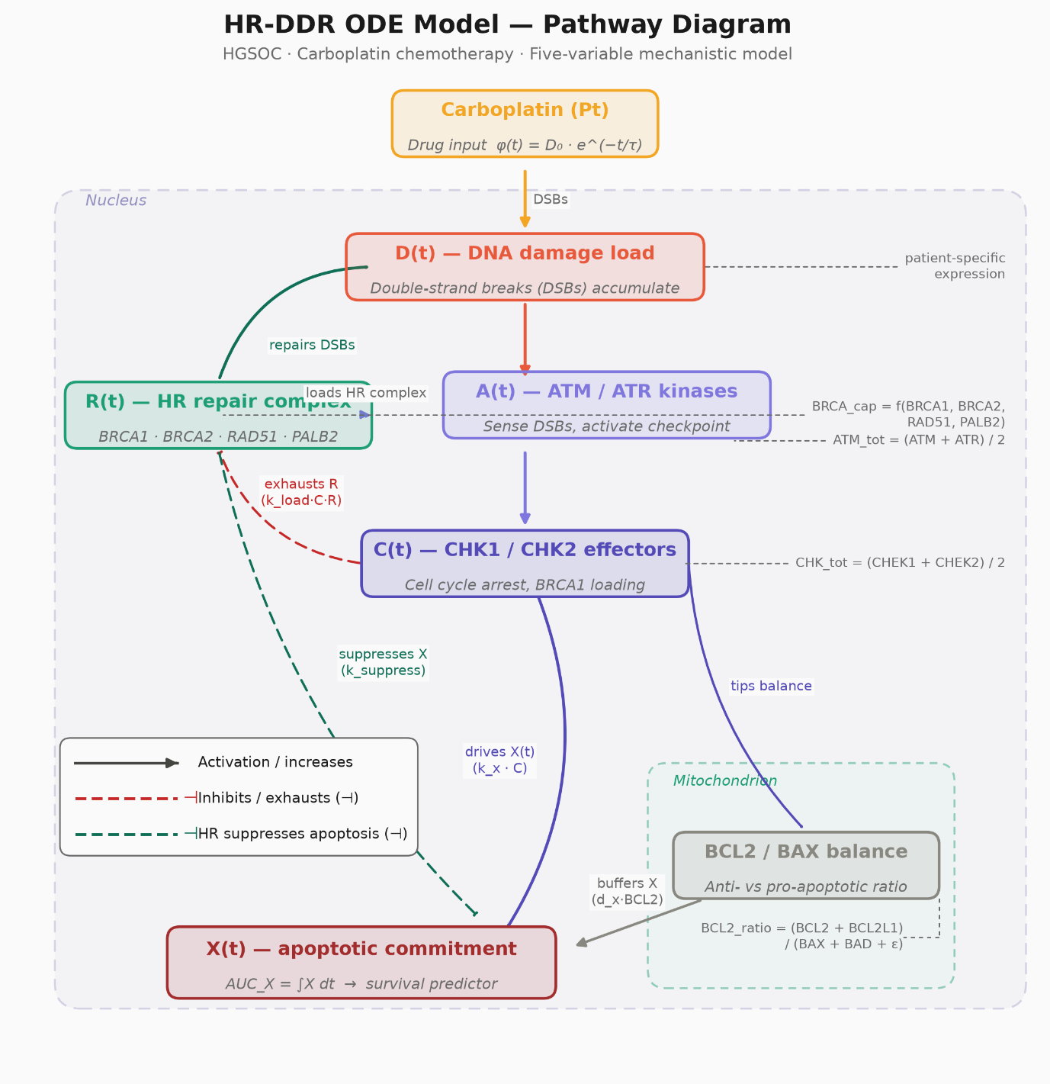
Figure 1. Mechanistic structure of the HR-DDR ODE model.
Carboplatin induces DNA DSBs at rate φ(t) = D₀·e^(−t/τ), driving the damage state D(t). ATM/ATR kinases (A(t)) sense DSBs and activate CHK1/CHK2 effectors (C(t)), which simultaneously recruit the HR repair complex (R(t)) and drive apoptotic commitment (X(t)). Sustained checkpoint activity exhausts R(t) via BRCA1 hyperphosphorylation (k_{load}·C·R), reducing repair capacity and releasing apoptotic suppression. The mitochondrial BCL2/BAX balance scales the decay rate of X(t), modulating apoptotic resistance. Patient-specific ODE parameters (${BRCA}_{cap}$, ${ATM}_{tot}$, ${CHK}_{tot}$, ${BCL2}_{ratio}$) are derived from pre-treatment RNA-seq expression of 14 pathway genes; global kinetic rate constants are informed from literature values. The primary model output, ${AUC}_{X} = ∫X(t) dt$, quantifies cumulative apoptotic commitment and is used as the survival predictor in all downstream Cox and KM analyses. Solid arrows indicate activation; dashed bars (⊣) indicate inhibition or suppression.

1.4 Aims
This project applies a mechanistic HR-DDR ODE model to a HGSOC cohort to address two questions:
- Can the ODE predict overall survival in HGSOC? Patient-specific ODE parameters are derived from RNA-seq expression of 14 pathway genes, the model is integrated forward in time under a platinum damage perturbation, and the resulting apoptotic commitment score (${AUC}_{X}$) is tested for association with overall survival via Cox regression and Kaplan-Meier (KM) stratification. This addresses question 1 of the assignment.
- How does the ODE compare to data-trained ML models? Cox Least Absolute Shrinkage and Selection Operator (LASSO) and RSF models are benchmarked against the zero-shot ODE on the same 14-gene feature set (including TP53 as a negative control), using 5-fold cross-validated C-index and 1000-replicate bootstrap confidence intervals (Cis). This addresses question 5 of the assignment.

2. Methods and Code
The complete analysis pipeline is publicly available at https://github.com/gillespieza/hgsoc-tcga-ODE.git. The project is implemented entirely in Python (3.11.9). Core scientific computing relies on NumPy¹⁷ and pandas¹⁸ for data manipulation and numerical arrays, and SciPy's solve_ivp (LSODA method) for integrating the five-variable HR-DDR ODE system¹⁹. Gene identifier mapping uses mygene to resolve gene symbols to Entrez IDs for RNA-seq alignment²⁰. Survival analysis is handled by lifelines²¹ (KM estimation, log-rank testing, CoxPH modelling) and scikit-survival²² (Cox LASSO via CoxnetSurvivalAnalysis, RSFs, concordance-index computation), while scikit-learn²³ provides cross-validation utilities, preprocessing (StandardScaler), and pipeline construction shared across the ML benchmarking arm. Visualisation is produced with matplotlib²⁴ using the non-interactive Agg backend for headless, reproducible figure generation. Supporting utilities include tqdm for progress reporting during bootstrap and cross-validation loops and colorama for readable console logging on Windows. All diagnostic output is routed through Python's built-in logging module rather than print statements, ensuring a complete, timestamped audit trail (pipeline.log) of every pipeline run.

2.1 Dataset, cohort assembly and attrition
Clinical, RNA-seq expression, and mutation data were obtained from The Cancer Genome Atlas (TCGA) HGSOC dataset (hgsoc_tcga_gdc) via cBioPortal (https://www.cbioportal.org). The initial clinical table contained 608 patients. Patients were excluded if overall survival time (OS_MONTHS) was missing or ≤ 0, or if overall survival status (OS_STATUS) could not be mapped to a binary event indicator (0: living/censored; 1: deceased). Duplicate PATIENT_IDs were resolved by retaining the first occurrence.
RNA-seq expression profiles were downloaded as Fragments Per Kilobase of transcript per Million mapped reads (FPKM) values. Fourteen genes were selected a priori based on their roles in the HR-DDR pathway: BRCA1, BRCA2, RAD51, PALB2, BRIP1 (HR repair); ATM, ATR (DNA damage sensing); CHK1, CHK2 (checkpoint effectors); BCL2, BCL2L1, BAX, BAD (apoptotic threshold); and TP53 (included as a negative control). Entrez Gene IDs were mapped from gene symbols using the MyGeneInfo API (mygene ≥ 3.2.0). FPKM values were $\log_{2}(FPKM+1)$ transformed to reduce right-skew and stabilise variance. TCGA sample barcodes were truncated to 12-character patient IDs. Patients with > 20% missing expression values across the 14 genes were excluded. Where a patient had multiple samples, the sample with the fewest missing values was retained. Clinical records with no matching RNA-seq profile in the FPKM expression file were removed.
BRCA1/2 mutation status was derived from the mutation annotation format (MAF) file. Any patient with at least one recorded mutation in BRCA1 or BRCA2 was flagged BRCA_MUTANT = 1; all others were flagged 0. All detected mutations were germline.
The final merged cohort, produced by inner-joining the clinical and expression tables on PATIENT_ID, contained 420 patients (event rate: 62.2%; median OS: ~44.5 months).

2.2 ODE model
A five-variable ODE system was constructed to represent the cellular DDR to platinum-based chemotherapy. The state variables are:
- D(t) - DNA damage load
- A(t) - Activated ATM/ATR
- C(t) - Activated CHK1/CHK2
- R(t) - Functional HR repair complex (BRCA1-BRCA2-PALB2-RAD51)
- X(t) - Apoptotic commitment signal
The system is governed by:
$$\frac{dD}{dt}=φ(t)-(k_{HR}⋅R+k_{NHEJ})⋅D \\ \frac{dA}{dt}=k_{a}⋅A_{tot}⋅D-d_{a}⋅A \\ \frac{dC}{dt}=k_{c}⋅A⋅C_{tot}-d_{c}⋅C \\ \frac{dR}{dt}=k_{r}⋅BRCA_{cap}-k_{load}⋅C⋅R-d_{r}⋅R \\ \frac{dX}{dt}=k_{x}⋅C-d_{x}⋅BCL2_{ratio}⋅X-k_{suppress}⋅\frac{R⋅X}{K_{HR}+R}$$where the drug perturbation input is φ(t) = D₀ · exp(−t / τ_{drug}), modelling carboplatin delivery and exponential clearance. HR-mediated suppression of the apoptotic signal follows Michaelis-Menten kinetics (final term of dX/dt), saturating at high R rather than zeroing X completely at high repair capacity. This is a deliberate correction over a linear suppression formulation that would drive X to zero in high-BRCA patients.
Global kinetic parameters were literature-informed and held fixed across all patients:
Table 1. Global kinetic parameters of the HR-DDR ODE model.
All parameters are fixed across patients and were not optimised against survival outcomes; patient-specific variation enters exclusively through the RNA-derived parameters ${BRCA}_{cap}$, ${ATM}_{tot}$, ${CHK}_{tot}$, and ${BCL2}_{ratio}$ (Section 2.2). Rate constants reflect literature-reported timescales for the corresponding biological processes (DNA damage sensing, checkpoint signalling, HR repair, and apoptotic commitment); τ_{drug} is set conservatively at the upper bound of the reported carboplatin plasma half-life range.
Parameter | Value | Units | Biological basis
D₀ | 1.0 | — | Normalised damage input magnitude
τ_{drug} | 6.0 | h | Carboplatin plasma half-life ~2–6 h
k_{a} | 1.0 | h⁻¹ | ATM/ATR activation rate
d_{a} | 0.5 | h⁻¹ | ATM deactivation (half-life ~2 h)
k_{c} | 0.5 | h⁻¹ | CHK1/2 activation rate
d_{c} | 0.2 | h⁻¹ | CHK1/2 deactivation (half-life ~5 h)
k_{HR} | 0.15 | h⁻¹ | HR repair rate per unit R
k_{NHEJ} | 0.30 | h⁻¹ | NHEJ repair rate (R-independent)
k_{load} | 0.20 | h⁻¹ | CHK-driven HR complex depletion
d_{r} | 0.10 | h⁻¹ | HR complex basal turnover
k_{x} | 0.10 | h⁻¹ | Checkpoint-driven apoptotic rate
d_{x} | 0.02 | h⁻¹ | Apoptotic signal decay
k_{suppress} | 0.30 | h⁻¹ | HR suppression of apoptosis
K_{HR} | 1.0 | — | Half-saturation constant for HR suppression

Patient-specific parameters were derived from $\log_{2}(FPKM+1)$expression values without fitting to survival outcomes (zero-shot approach). FPKM values were back-transformed to linear scale before pathway compression:
- ${BRCA}_{cap}=ln(1+min(BRCA1,BRCA2)×RAD51×√(PALB2+1))$; log1p applied to compress the heavy right tail of the triple-product distribution
- ${ATM}_{tot}= (ATM + ATR)/2$
- ${CHK}_{tot}= (CHK1 + CHK2)/2$
- ${BCL2}_{ratio}=(BCL2 + BCL2L1) / (BAX + BAD + 10⁻⁶)$
Each parameter was then normalised to the cohort median so that a median patient has parameter value ≈ 1.0.
Initial conditions were derived analytically from the zero-damage steady state: ${R_{0} = BRCA}_{cap}$, $D_{0}=A_{0}=C_{0}=X_{0}=0$. The choice $k_{c}=d_{r}$ ensures this steady state holds exactly. Each patient was simulated over 120 hours (5 days) at 0.5 h resolution using the LSODA solver (scipy.integrate.solve_ivp, rtol = 10⁻⁶, atol = 10⁻⁹). Patients whose integration failed to converge were retained in the raw output file (ode_scores.csv) for transparency but excluded from all survival analyses.
The primary ODE output was ${AUC}_{X}$ (i.e. the area under the X(t) curve computed by the trapezoidal rule) representing cumulative apoptotic commitment. Higher ${AUC}_{X}$ indicates greater apoptotic burden in response to platinum, predicting better chemosensitivity and expected association with longer overall survival (HR < 1). Three secondary scores were also extracted: $X_{peak}$ (maximum apoptotic signal), $T_{\text{repair}}$ (time damage remained above 10% of its peak), and $D_{\text{resid}}$ (residual damage at t = 120 h). All four scores were log1p-transformed before entry into Cox models.

2.3 Survival analysis
Primary KM analysis: Patients were stratified into three groups by pre-specified tertiles of ${AUC}_{X}$ (T1: ≤ 33rd percentile; T2: 33rd–67th; T3: ≥ 67th). The omnibus log-rank p-value from this three-group test is valid for inference because the grouping is defined prior to examining outcomes. Where tertile boundaries were identical (insufficient score spread for three groups, observed for $T_{\text{repair}}$), the analysis fell back to a pre-specified median binary split; this is documented and the fallback p-value remains valid.
Exploratory threshold scan: All binary cutpoints were scanned to identify the split minimising the log-rank p-value. As selecting a cutpoint by minimising the log-rank p invalidates that p-value for inference, these results are reported as exploratory only.
CoxPH modelling: Univariate Cox models were fitted for each log-transformed ODE score. A multivariate model additionally adjusted for BRCA_MUTANT status. The proportional hazards assumption was checked for each model using Schoenfeld residuals via lifelines' check_assumptions() at p < 0.05.
Discrimination was assessed using Harrell's concordance index (C-index), which measures the probability that a randomly selected patient with a shorter survival time receives a higher predicted risk score. C-index = 0.5 indicates no discrimination; C-index = 1.0 indicates perfect discrimination.

2.4 ML benchmark
Four additional arms were benchmarked against the ODE C-index to assess whether the MM provides competitive discrimination:
Cox LASSO (14-gene): CoxnetSurvivalAnalysis (scikit-survival, L1 penalty) fitted on $\log_{2}(FPKM+1)$expression of the same 14 genes used in the ODE. Regularisation strength α was selected by 3-fold inner cross-validation within each outer training fold to prevent data leakage; the outer test fold was never used during hyperparameter search. The candidate grid was α ∈ {0.01, 0.05, 0.1, 0.5, 1.0}.
RSF (14-gene): Random Survival Forest (200 trees, min_samples_leaf = 25, max_features = 0.5, scikit-survival) on the same 14-gene feature set.
Cox LASSO (all-genes): Same architecture as above applied to the full FPKM transcriptome (27,066 genes after excluding genes with > 20% missing values and near-zero variance). Features were StandardScaled. Given p >> n, α was constrained to a higher grid {1.0, 2.0, 5.0, 10.0, 20.0} to prevent numerical overflow in the coordinate-descent solver. This arm tests whether genome-wide search without biological prior structure outperforms the curated 14-gene ODE input.
RSF (all-genes): RSF on the full transcriptome with max_features = "sqrt" to limit tree correlation and computation at high feature dimensionality.
All ML models were evaluated by 5-fold stratified cross-validation (random_state = 42). Out-of-fold (OOF) predictions were assembled for each patient across folds and used for bootstrap CI estimation. The ODE, being a zero-shot predictor with no training step, was bootstrapped directly on the full cohort. Bootstrap CIs used 1000 resamples (percentile method, 2.5th–97.5th percentiles).

3. Results

3.1 Cohort characteristics
Overall survival. Of 420 patients, 262 (62.4%) experienced the primary endpoint (death) during follow-up, and 158 (37.6%) were censored alive. Median overall survival was 44.5 months (approximately 3.7 years). The follow-up distribution is right-skewed: most events occur within the first 75 months, with a small number of patients followed beyond 150 months, consistent with the long natural history of platinum-sensitive HGSOC.

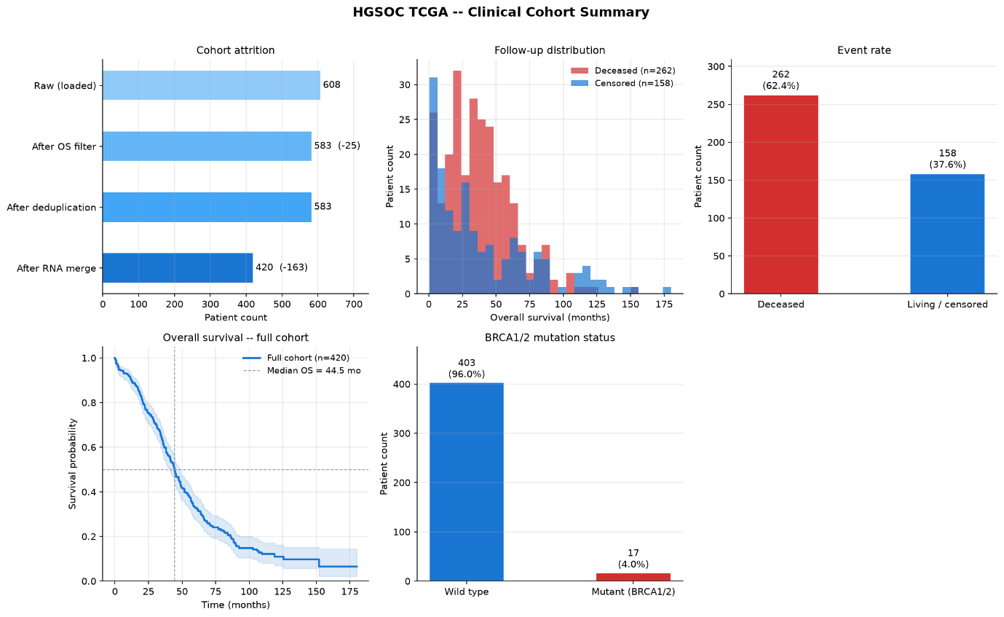
Figure 2. Clinical cohort summary for the HGSOC TCGA dataset (n = 420).
Top-left: patient attrition from raw download to final merged cohort.
Top-centre: follow-up time distribution stratified by vital status.
Top-right: overall event rate (deceased vs. living/censored).
Bottom-left: KM curve for the full cohort with median OS marked.
Bottom-centre: BRCA1/2 germline mutation prevalence (bottom-right panel hidden for layout symmetry).

BRCA1/2 mutation status. BRCA1/2 mutations were identified in 17 patients (4.0%), with the remaining 403 patients (96.0%) classified as wild type. This mutation rate is lower than the 15–20% typically reported in clinical HGSOC series, likely reflecting the known ascertainment bias in the TCGA cohort towards sporadic cases and the use of somatic (rather than germline) sequencing panels for a proportion of samples.
Endpoint choice. Overall survival was selected in preference to progression-free survival because it carries a larger event count in this dataset, minimises the ambiguity of radiological progression calls, and is the standard primary endpoint in HGSOC clinical trials. The high event rate (62.4%) provides adequate statistical power for both CoxPH modelling and KM stratification.

3.2 ODE validation
Two representative patients (BRCA-mutant vs BRCA-wildtype) showed biologically plausible trajectories: the BRCA-mutant patient produced higher ${AUC}_{X}$ (greater apoptotic commitment), consistent with known platinum sensitivity.

3.3 ODE score distributions
To validate the biological plausibility of the model outputs at the population level, we analysed the distributions of the four ODE-derived scores across the entire cohort (n = 420) and stratified them by BRCA mutation status (wild type, n = 403 vs. mutant, n = 17).

3.3.1 Apoptotic commitment (${AUC}_{X}$)
The area under the apoptotic commitment curve (${AUC}_{X}$) is approximately log-normally distributed across the cohort (Figure 4A). Consistent with the known clinical sensitivity of BRCA-deficient tumours to DNA-damaging platinum agents, BRCA-mutant patients exhibited a significantly higher median ${AUC}_{X}$of 165.00 (mean 176.57 ± 112.77) compared to wild-type patients with a median of 107.61 (mean 136.56 ± 107.35), as shown in Figure 5A. This confirms that the zero-shot MM successfully captures increased apoptotic drive in HR deficient tumours without outcome-based parameter tuning.
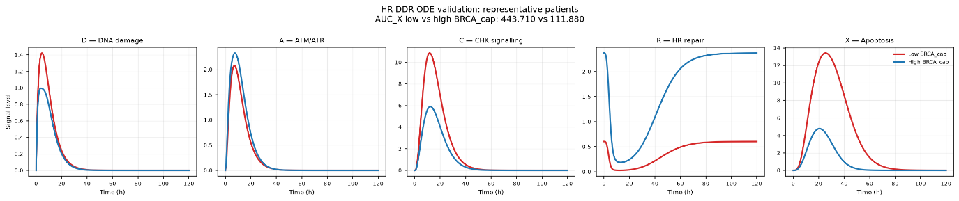
Figure 3. Mechanistic trajectories of HR-DDR ODE model state variables for representative patients.
Simulation profiles of state variables over 120 hours following a transient carboplatin damage perturbation (D₀ = 1.0, half-life τdrug= 6 h). Low-BRCA patient (red, TCGA-29-1762, ${BRCA}_{cap} = 0.603$) represents HR deficiency, while High-BRCA patient (blue, TCGA-59-A5PD, ${BRCA}_{cap}= 2.369$) represents HR proficiency. From left to right:
D (DNA Damage): Spikes rapidly following drug entry. In the Low-BRCA patient, damage resolves more slowly due to reliance on slower/error-prone non-homologous end joining (NHEJ) repair. In the High-BRCA patient, damage is rapidly resolved.
A (ATM/ATR activation): Sensed damage signal tracks with DNA damage load, showing sustained activation in the Low-BRCA patient.
C (CHK signalling): Downstream kinase signalling cascade activated by ATM/ATR shows a corresponding high-amplitude, prolonged plateaus in the Low-BRCA patient.
R (HR repair complex): Repair complex abundance starts at the zero-damage analytical steady state ($R_{0}={BRCA}_{cap}$) and undergoes depletion driven by checkpoint-mediated consumption. The Low-BRCA patient exhibits severe depletion and delayed recovery.
X (Apoptosis): Apoptotic commitment accumulates under sustained checkpoint signalling. The Low-BRCA patient shows high apoptotic drive (${AUC}_{X} = 443.710$), indicating high platinum sensitivity, whereas the High-BRCA patient suppresses apoptosis (${AUC}_{X} = 111.880$) via rapid DNA repair and lower checkpoint activation.

3.3.2 Peak apoptotic signal ($X_{peak}$)
The peak level of the apoptotic commitment signal ($X_{peak}$) mirrors the trends seen with ${AUC}_{X}$. It is approximately log-normally distributed (Figure 4B) and is elevated in the BRCA-mutant group. BRCA-mutant patients reached a higher median peak apoptotic signal of 5.85 (mean 6.11 ± 3.56) compared to 3.88 in wild-type patients (mean 4.88 ± 3.49) as shown in Figure 5B. This suggests that HR-deficient cells not only undergo greater overall apoptosis but also achieve a higher maximum amplitude of apoptotic signalling.

3.3.3 Time to DNA repair ($T_{\text{repair}}$)
Time to resolve DNA damage ($T_{\text{repair}}$) is a discrete variable representing the hour at which DNA damage falls below the repair threshold (Figure 4C). The cohort-wide distribution is tightly grouped around a median of 61.0 hours. Interestingly, BRCA-mutant patients exhibit a slightly longer median repair time of 63.00 hours (mean 62.12 ± 3.74 h) compared to 61.00 hours for wild-type patients (mean 60.99 ± 3.74 h), as shown in Figure 5C. This slower resolution of damage is a hallmark of HR deficiency, where cells must rely on slower or error-prone alternative repair mechanisms.

3.3.4 Residual DNA damage ($D_{\text{resid}}$)
The residual DNA damage load ($D_{\text{resid}}$) at 120 hours represents the damage that could not be resolved by the end of the simulation. For nearly all patients, the residual damage was extremely small (in the range of 10⁻⁹), indicating that the damage was largely resolved (Figure 4D). BRCA-mutant patients had a slightly higher median residual
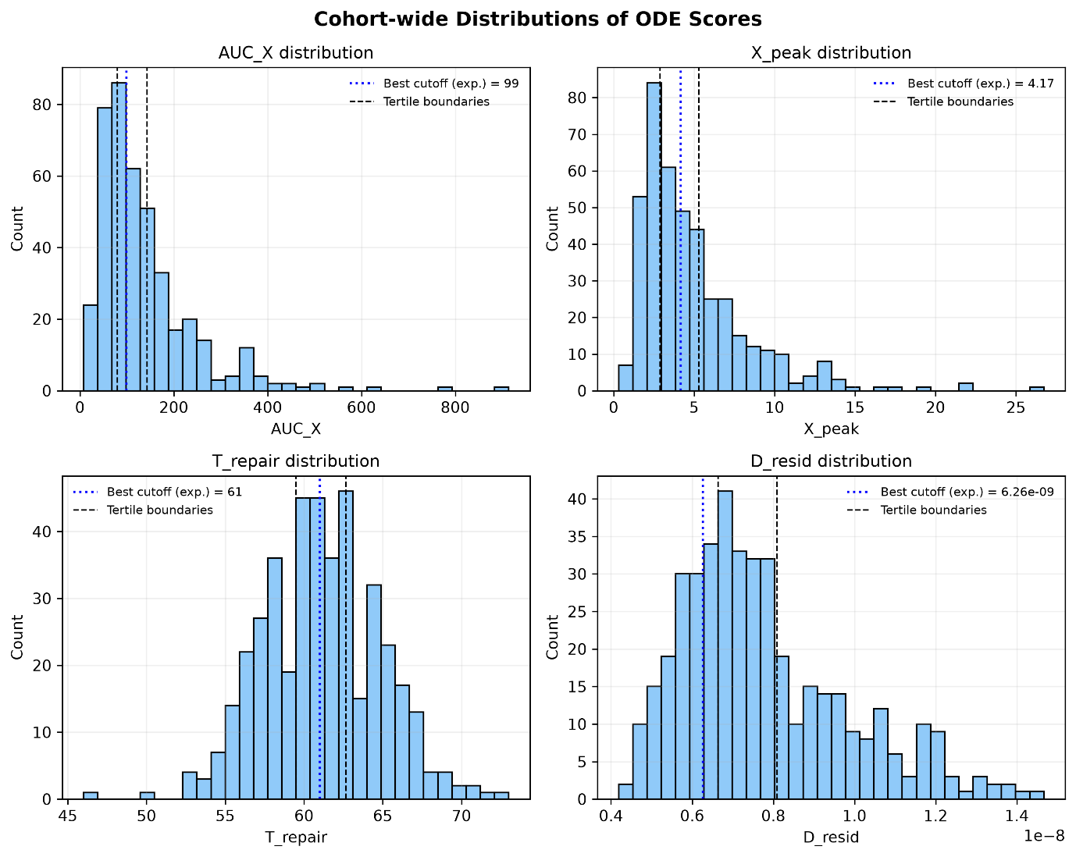
Figure 4. Cohort-wide distribution of ODE scores.
2×2 grid of histograms showing the population distributions of (A) apoptotic commitment (${AUC}_{X}$), (B) peak apoptotic signal ($X_{peak}$), (C) time to DNA repair ($T_{\text{repair}}$), and (D) residual DNA damage ($D_{\text{resid}}$), with pre-specified tertile boundaries (dashed lines) and optimal exploratory cutoffs (dotted lines) marked.

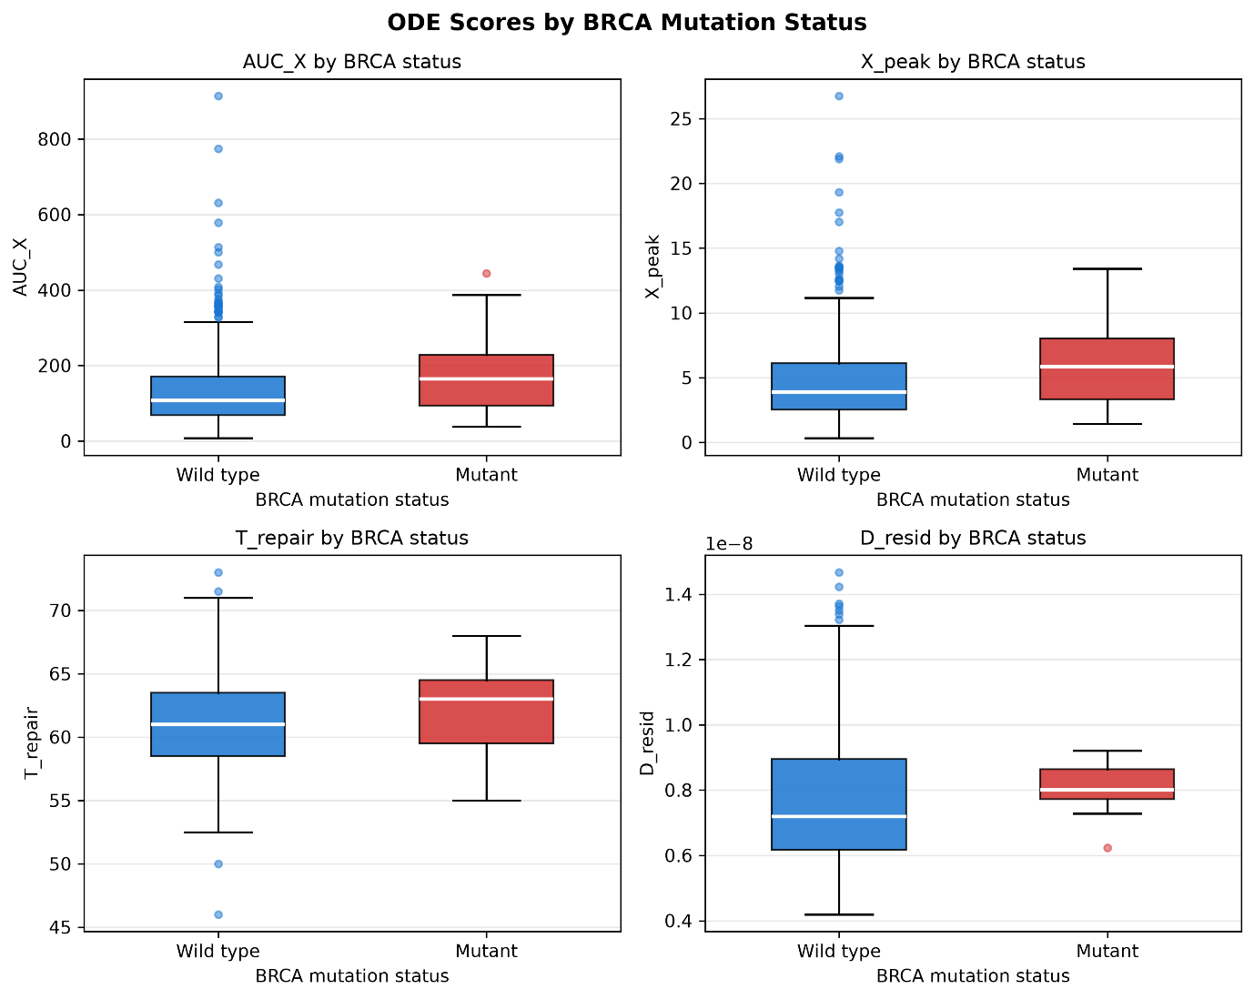
Figure 5. Distribution of ODE scores stratified by BRCA mutation status.
2×2 grid of box plots showing (A) apoptotic commitment (${AUC}_{X}$), (B) peak apoptotic signal ($X_{peak}$), (C) time to DNA repair ($T_{\text{repair}}$), and (D) residual DNA damage ($D_{\text{resid}}$) in BRCA wild-type (blue, n = 403) vs. BRCA-mutant (red, n = 17) patients. Mutants exhibit elevated apoptotic commitment (A, B), longer repair times (C), and slightly higher residual damage (D).

damage of 7.75 × 10⁻⁹ (mean 8.06 × 10⁻⁹) compared to 7.28 × 10⁻⁹ in wild-type patients (mean 7.73 × 10⁻⁹), as shown in Figure 5D. Although the absolute difference is minimal, it reflects the slower and less efficient DSB repair in the mutant group.

3.4 Univariate Cox regression
To stabilize the regression models and make the hazard ratios directly comparable, the log-transformed scores were Z-score standardized (scaled to mean = 0, standard deviation = 1) across the cohort. Consequently, the Hazard Ratios in Table 2 represent the change in patient hazard per standard deviation increase of each score.
The standardized results show a clear and consistent biological signal:
Table 2. Univariate CoxPH results for the four ODE-derived survival scores.
Hazard ratios (HR) are reported per standard-deviation increase in the log-transformed score; ${AUC}_{X}$ and X_peak both show HR < 1 with p = 0.015, consistent with the expected direction (higher apoptotic commitment predicting longer overall survival). $T_{\text{repair}}$ shows a directionally unexpected HR < 1 despite its hypothesised HR > 1 relationship, reflecting the structural flaw described in Section 5 (the absolute 0.9×R_ss threshold scales with ${BRCA}_{cap}$ , paradoxically lengthening $T_{\text{repair}}$ in high-capacity patients). $D_{\text{resid}}$is uninformative (p = 0.801) due to near-complete degeneracy by t = 120h, where NHEJ-mediated clearance drives residual damage to numerical zero across all patients regardless of BRCA status.
ODE Score | HR | 95% CI | p-value | C-index
$${AUC}_{X}$$ | 0.856 | [0.756, 0.970] | 0.015 | 0.533
$$X_{peak}$$ | 0.855 | [0.753, 0.971] | 0.015 | 0.532
$$T_{\text{repair}}$$ | 0.856 | [0.756, 0.970] | 0.015 | 0.528
$$D_{\text{resid}}$$ | 1.017 | [0.894, 1.156] | 0.801 | 0.482

- Apoptotic Commitment (${AUC}_{X}$) and Peak Signal ($X_{peak}$): Both show a statistically significant protective effect (HR ≈ 0.856 and 0.855, p = 0.015). Higher tumour cell commitment to apoptosis in response to DNA damage translates to a ~14.4% reduction in the hazard of patient death per 1-SD increase.
- Time to DNA Repair ($T_{\text{repair}}$): Also shows a statistically significant protective effect (HR = 0.856, p = 0.015). Biologically, a longer repair time signifies HR deficiency. Tumours with HR deficiency cannot resolve chemotherapy-induced DSBs quickly, making them highly sensitive to platinum chemotherapy and leading to improved patient survival.
- Residual DNA Damage ($D_{\text{resid}}$): In initial iterations, $D_{\text{resid}}$suffered from a degenerate model fit (HR = ∞, CI = [NaN, ∞]) because its raw values were extremely small (on the order of 10⁻⁹), leading to near-zero variance. Z-score standardization scaled this variance to 1.0, enabling the Cox solver to converge successfully. The resulting hazard ratio of 1.017 (95% CI = [0.894, 1.156], p = 0.801) confirms that residual damage has no statistically significant association with survival.
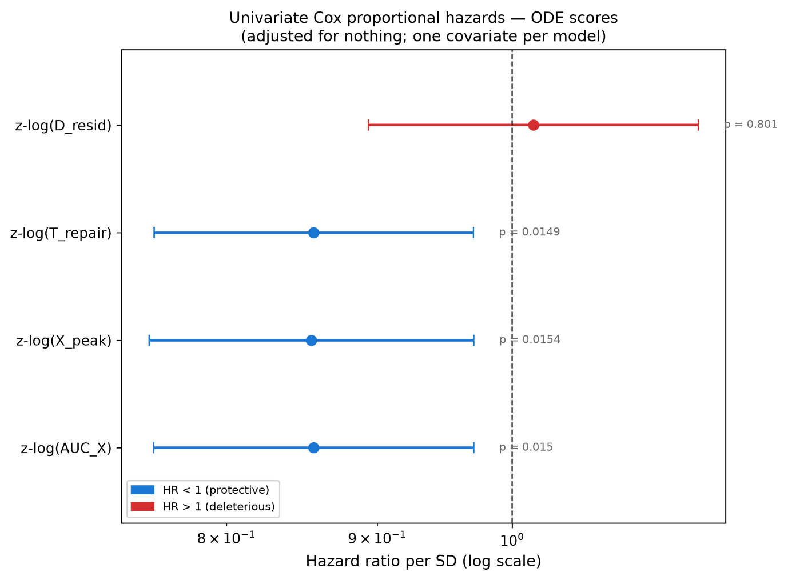
Figure 6. Univariate CoxPH forest plot.
Hazard ratios (with 95% CIs) for the standardized log-transformed versions (z-log) of the four ODE-derived scores.

3.5 KM stratification
To evaluate the clinical stratification potential of the ODE-derived scores, we performed KM survival analysis for all four scores. Two grouping strategies were applied to each score:
- Primary analysis (pre-specified tertile split): Patients were divided into T1 (low), T2 (mid), and T3 (high) groups using pre-specified tertile boundaries. Because the grouping is defined before examining survival outcomes, the omnibus log-rank p-value is valid for statistical inference. For scores with tied tertile boundaries (e.g. $T_{\text{repair}}$, which takes a small number of discrete hour values), the function falls back to a pre-specified median binary split.

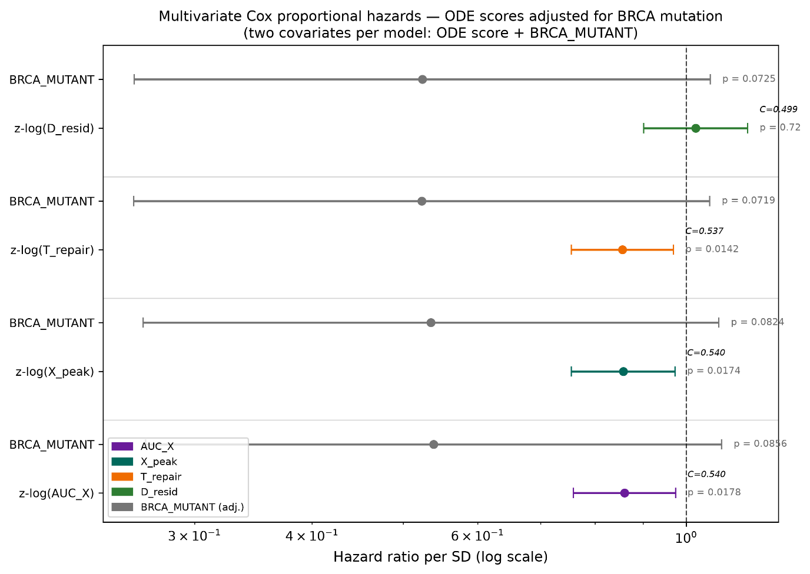
Figure 7. Multivariate CoxPH forest plot (adjusted for BRCA_MUTANT).
Hazard ratios for the standardized log-transformed ODE scores (z-log) and BRCA mutation status.
- Exploratory analysis (optimal cutoff scan): All possible binary cutpoints were scanned to identify the threshold that minimises the log-rank p-value. Because this cutpoint is selected post-hoc by searching the outcome data, the resulting p-value is inflated by multiple-testing and must be interpreted as strictly exploratory.

3.5.1 Primary analysis (pre-specified tertile splits)
Figure 8 shows the primary KM analysis for all four ODE scores. All four scores show trends in the expected biological direction (higher apoptotic commitment and slower DNA repair associated with better survival), though none reach statistical significance with the three-group omnibus log-rank test:
- ${AUC}_{X}$: Median OS increases progressively from T1 (41.5 months) to T3 (48.8 months), p = 0.773.
- $X_{\text{peak}}$: Similar progressive increase from T1 (43.7 months) to T3 (48.3 months), p = 0.822.
- $T_{\text{repair}}$: Longer repair times trend toward better survival, p = 0.523. Falls back to a median binary split due to tied tertile boundaries.
- $D_{\text{resid}}$: Modest directional trend, p = 0.169.
The lack of significance in the tertile analysis is expected: the three-group omnibus test has lower power than a binary split, and the ODE scores capture continuous, graded variation in pathway activity rather than discrete risk categories.

3.5.2 Exploratory analysis (optimal cutpoint scans)
Figure 9 shows the exploratory KM analysis using the data-driven optimal cutpoints for each score. All four scores achieve statistically significant separation when the cutpoint is optimised post-hoc:

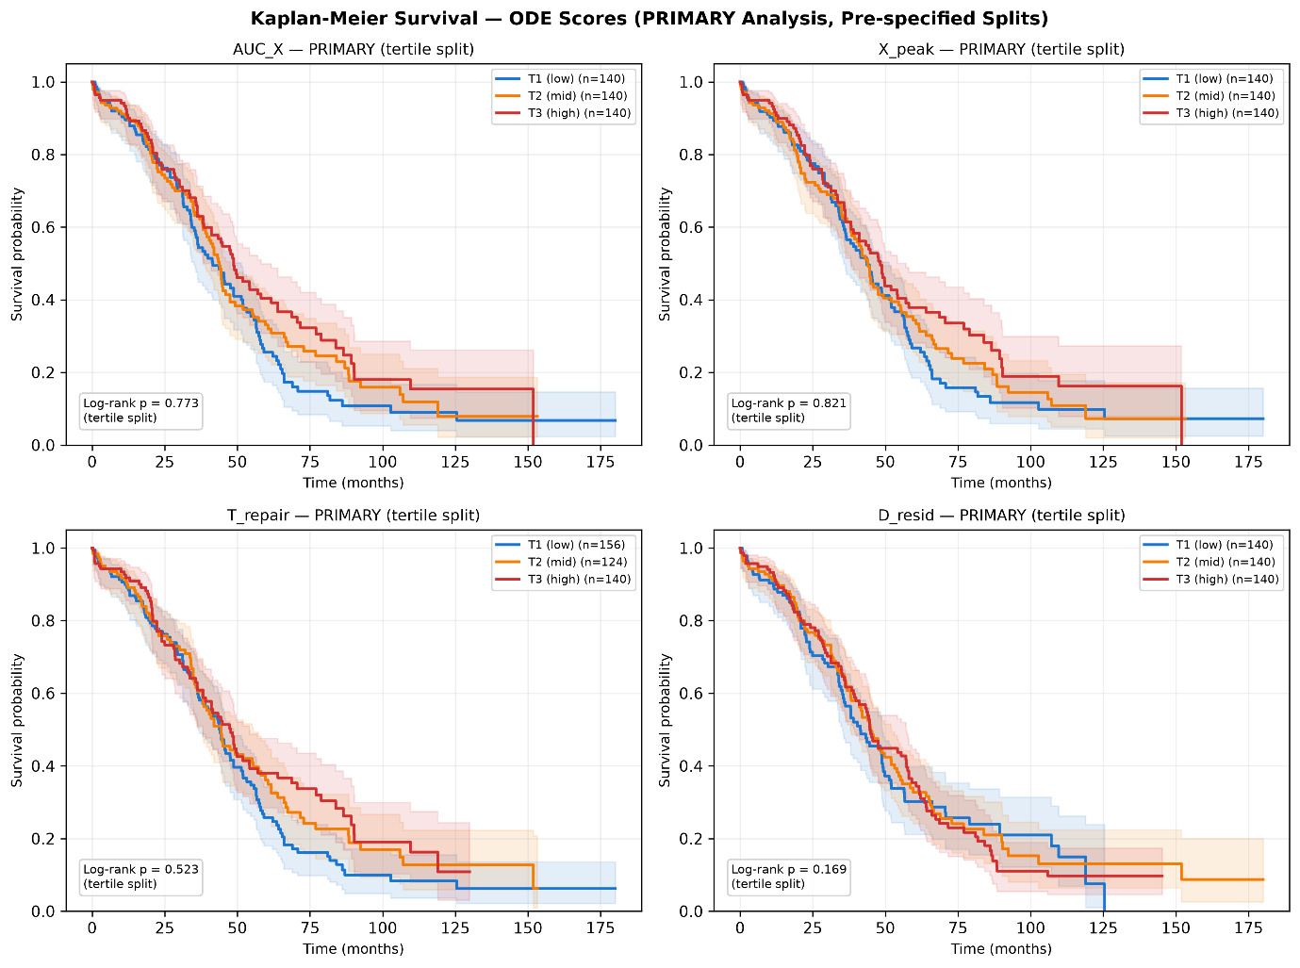
Figure 8. Kaplan-Meier overall survival (primary analysis).
2x2 grid showing all four ODE scores stratified by pre-specified tertile splits (or median split where tertile boundaries are tied). Log-rank p-values are valid for inference.

- ${AUC}_{X}$: Optimal cutoff = 99.0, p = 0.0077.
- $X_{\text{peak}}$: Optimal cutoff = 4.17, p = 0.0061.
- $T_{\text{repair}}$: Optimal cutoff = 61.0 h, p = 0.0142.
- $D_{\text{resid}}$: Optimal cutoff = $6.26×{10}^{-9}$, p = 0.0066.
These results confirm that survival signal exists within each ODE score's distribution, but the clinical effect size is moderate, requiring a data-driven split to achieve significance, rather than emerging from any pre-specified grouping.

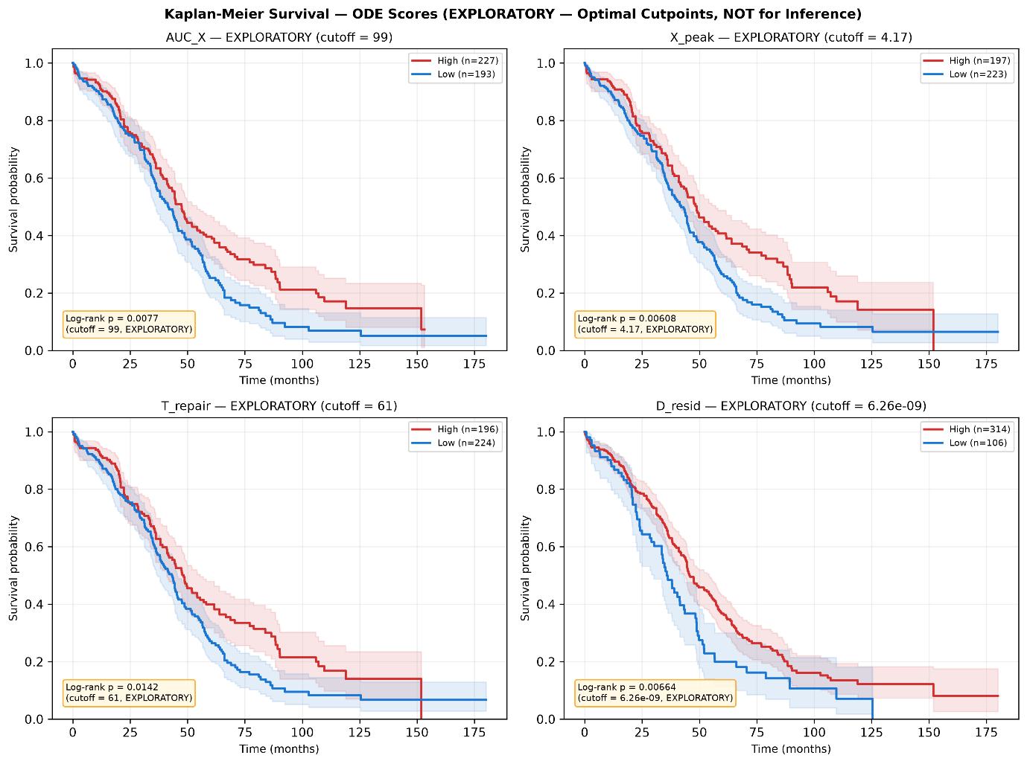
Figure 9. Kaplan-Meier overall survival (exploratory analysis).
2x2 grid showing all four ODE scores stratified by data-driven optimal cutpoints. P-values are inflated by post-hoc selection and are not valid for inference.

3.5.3 Stratification across all five models
To directly compare the clinical stratification ability of the mechanistic ODE model against the data-trained ML benchmarks, we stratified patients by median risk score for all five models (Figure 10). Each model's risk scores (the ODE's $-log⁡(AUC_{X})$and the OOF predictions from the four ML models) were dichotomised at their respective medians (a pre-specified, non-outcome-adaptive split). The resulting KM curves show how effectively each model separates high-risk from low-risk patients:
- HR-DDR ODE (${AUC}_{X}$): Achieves significant separation (p = 0.022), with the low-risk group showing a survival advantage of approximately 5 months in median OS over the high-risk group.
- Cox LASSO (14-gene) and RSF (14-gene): When restricted to the same 14-gene feature set, neither data-trained ML model achieves significant separation at the median split, consistent with their lower C-indices relative to the ODE.
- Cox LASSO (all-genes) and RSF (all-genes): With access to the full transcriptome (27,066 genes), the all-genes models show improved stratification, with the Cox LASSO (all-genes) achieving the clearest separation.
This visual comparison reinforces the C-index findings from Section 3.6: the mechanistic ODE model achieves competitive or superior patient stratification compared to data-trained models on the same feature set, despite using no outcome data during model development.

3.6 Model comparison
Prognostic discrimination was compared across five models using OOF predictions for the data-trained models and cohort-wide scores for the zero-shot ODE (Table 3, Figure 11):

Table 3. Five-model concordance index comparison: zero-shot mechanistic ODE versus data-trained ML survival models.
The HR-DDR ODE achieves discrimination (C-index = 0.533) comparable to Cox LASSO and RSF models trained on the same 14-gene feature set, despite using no outcome data for calibration. Restricting Cox LASSO and RSF to the full transcriptome (27,066 genes) modestly improves discrimination (C-index 0.569 and 0.549 respectively), suggesting the curated 14-gene HR-DDR pathway set does not fully capture the prognostic signal available elsewhere in the transcriptome, though all five models remain in a similar, modest discrimination range (C-index 0.48–0.57) for this cohort.
Model | Feature Set | C-index | 95% Bootstrap CI | Notes
HR-DDR ODE (${AUC}_{X}$) | 14 genes (ODE) | 0.533 | [0.495, 0.574] | Zero-shot, literature-informed parameters
Cox LASSO (14-gene) | 14 genes (raw) | 0.504 | [0.468, 0.548] | 5-fold CV, alpha via inner CV
RSF (14-gene) | 14 genes (raw) | 0.480 | [0.472, 0.551] | 5-fold CV, random forest ensemble
Cox LASSO (all-genes) | 27,066 genes (raw) | 0.569 | [0.528, 0.602] | 5-fold CV, full transcriptome
RSF (all-genes) | 27,066 genes (raw) | 0.549 | [0.505, 0.581] | 5-fold CV, full transcriptome

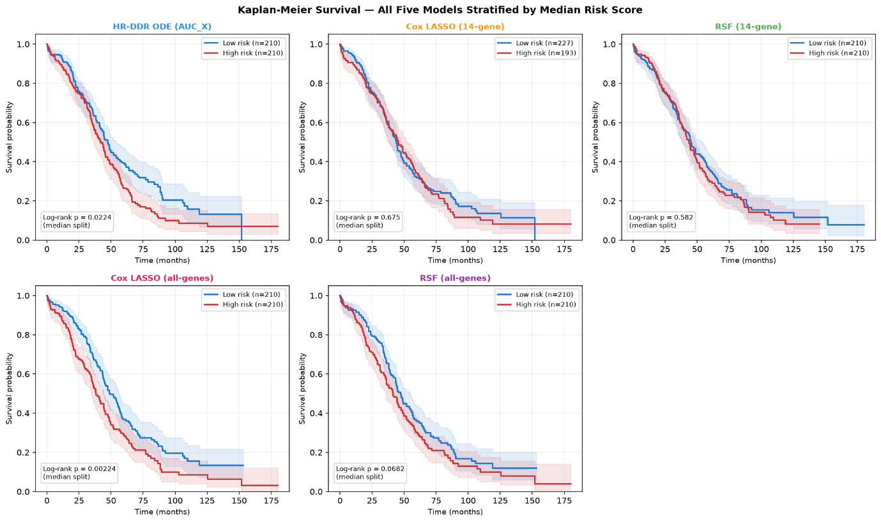
Figure 10. Kaplan-Meier survival (all five models).
Each panel stratifies the HGSOC TCGA cohort (n = 420) into high-risk and low-risk groups using the median of each model's risk score. The ODE panel uses $-log⁡(AUC_{X})$; the ML panels use out-of-fold predictions. Log-rank p-values annotated on each panel.
When restricted to the same 14-gene feature set, the zero-shot mechanistic ODE (C = 0.533) out-performs both the data-trained Cox LASSO (C = 0.504) and the RSF (C = 0.480). This suggests that incorporating biological structure via the ODE pathway acts as a powerful regulariser, extracting clinical signal that standard ML models overfit or fail to learn from a small feature set.
When trained on the entire transcriptome (27,066 genes), the all-genes Cox LASSO achieves a higher C-index of 0.569 (95% CI: [0.528, 0.602]) and the all-genes RSF achieves 0.549 (95% CI: [0.505, 0.581]). This superior performance suggests that the global transcriptome contains additional survival signals (e.g., cell proliferation, immune infiltration, microenvironment) that are outside the scope of our 14-gene DNA repair model. However, the all-genes Cis still overlap with that of the zero-shot ODE model, and the ODE achieves its comparable performance without requiring any outcome-based training data (zero-shot validation).
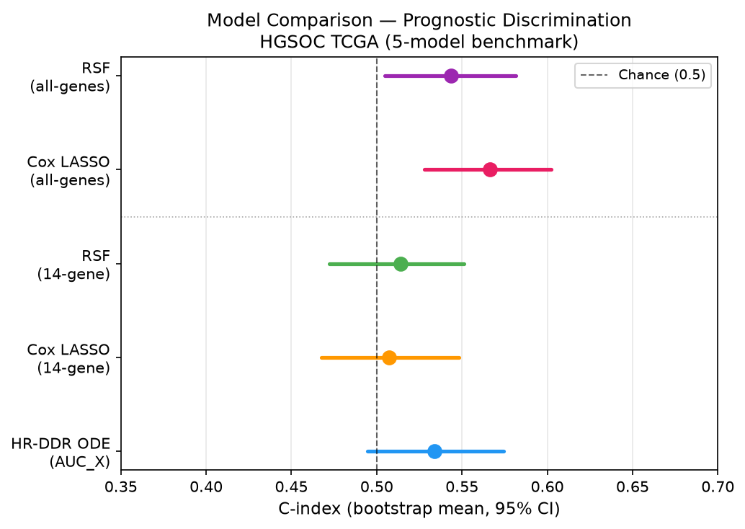
Figure 11. Model comparison forest plot.
Comparison of Harrell's C-index between the zero-shot HR-DDR ODE model (${AUC}_{X}$) and the data-trained Cox LASSO and RSF models on the 14-gene feature set and full transcriptome.

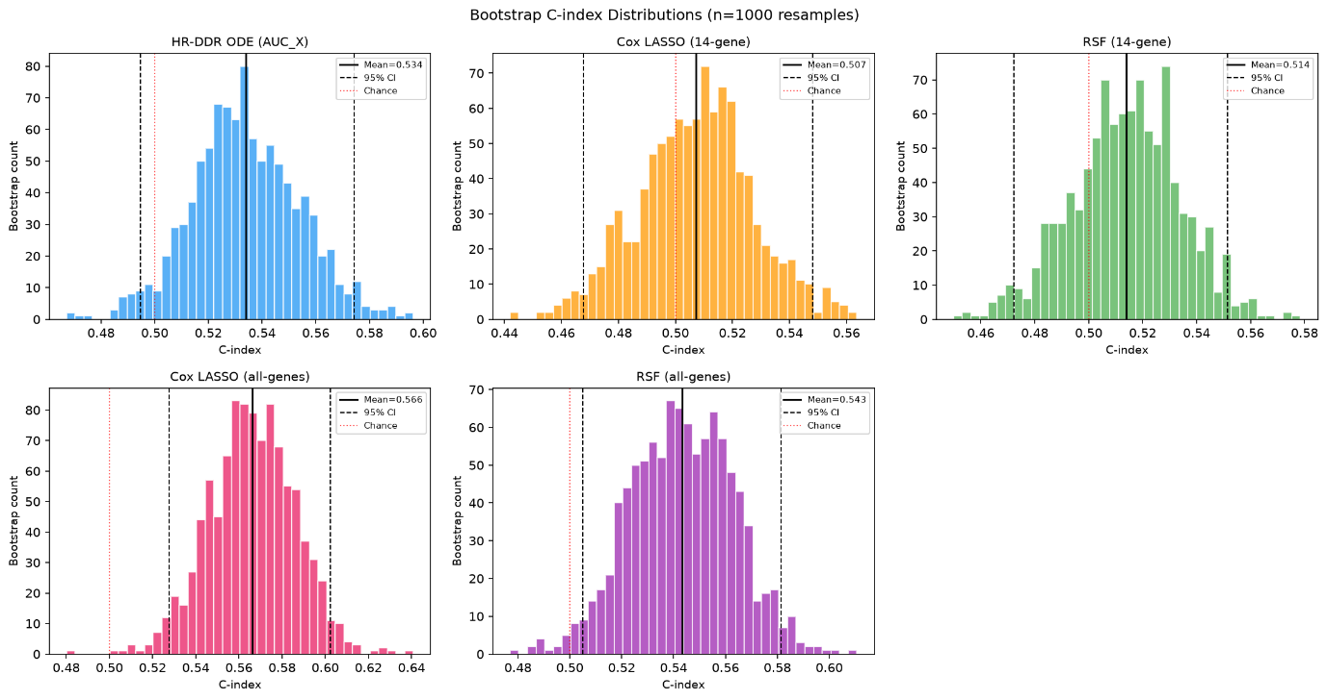
Figure 12. Bootstrap distributions of C-index.
Bootstrap distribution of the C-index across 1000 resamples for the three models, showing the overlap and variability in predictive performance.

3.7 Model interpretation (ML benchmarks)
To understand what biological features drove the predictions of the data-trained ML models, we analysed the models fitted on the full cohort. Although these full-data fits are strictly for interpretation (not out-of-sample prediction), they reveal which genes carry survival signal.

3.7.1 Cox LASSO coefficients
The Cox LASSO model selected non-zero coefficients for all 14 genes, with the regularization parameter (α = 0.001, selected via 5-fold cross-validation on the full dataset) keeping all features in the model (Figure 13):
- HR-DDR Genes: BRCA2 (+0.141), RAD51 (+0.102), and BRCA1 (+0.062) show positive coefficients. Higher expression of these genes increases the hazard rate (poorer survival). Biologically, this is highly consistent: tumours with proficient repair machinery can resolve carboplatin-induced DNA DSBs, rendering them resistant to chemotherapy and leading to worse patient survival.
- Checkpoint Activating Kinases: CHK2 (−0.195), BRIP1 (−0.130), CHK1 (−0.121), and PALB2 (−0.071) exhibit negative (protective) coefficients. Higher expression of these checkpoint effectors is associated with decreased hazard (better survival), which may reflect the role of robust checkpoint activation in triggering apoptotic pathways or allowing sufficient cell cycle arrest to prevent genomic instability.
- Apoptotic Pathway Regulators: BCL2 (−0.029) and BAX (−0.054) have negative coefficients, while BCL2L1 (+0.033) and BAD (+0.020) show positive coefficients, highlighting complex balancing effects in the apoptotic machinery.
- Negative Control (TP53): TP53 has a small negative coefficient (−0.069), indicating that its expression retains a minor association with survival even in this near-universally mutated HGSOC cohort.
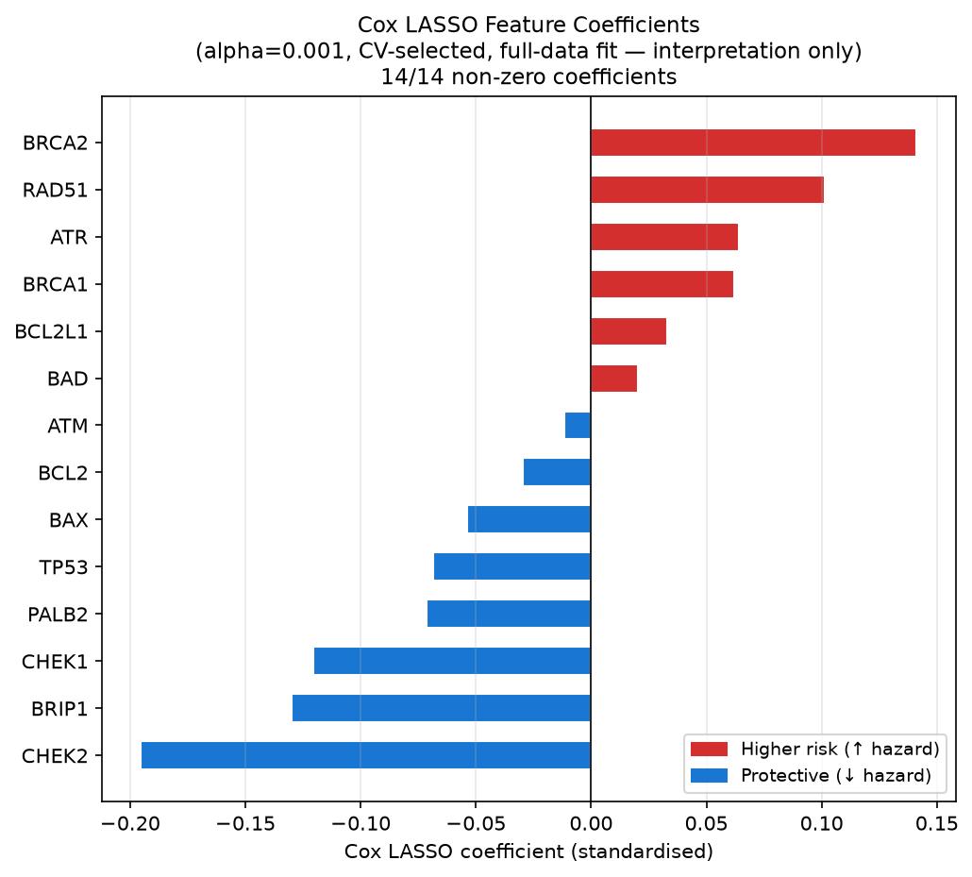
Figure 13. Cox LASSO Feature Coefficients.
Horizontal bar chart of standardized coefficients from the full-cohort fit. Red bars represent positive coefficients (increased hazard/risk); blue bars represent negative coefficients (protective effect).

3.7.2 RSF feature importances
We computed the permutation feature importance on the training data across 20 repeats (Figure 14). The mean reduction in C-index upon permuting each gene reveals which genes the RSF relies on most heavily:
- Key Predictors: BRCA2 exhibits the highest permutation importance (mean C-index drop = 0.0324), followed closely by PALB2 (0.0244), CHK2 (0.0244), and RAD51 (0.0225). This indicates that the ensemble model relies most strongly on the core HR machinery and cell cycle checkpoints to stratify patients.
- Minor Predictors: The apoptotic regulators BAX (0.0055), BCL2 (0.0076), and BAD (0.0097) show the lowest importances, suggesting they play a minimal role in the RSF model's decision-making process.

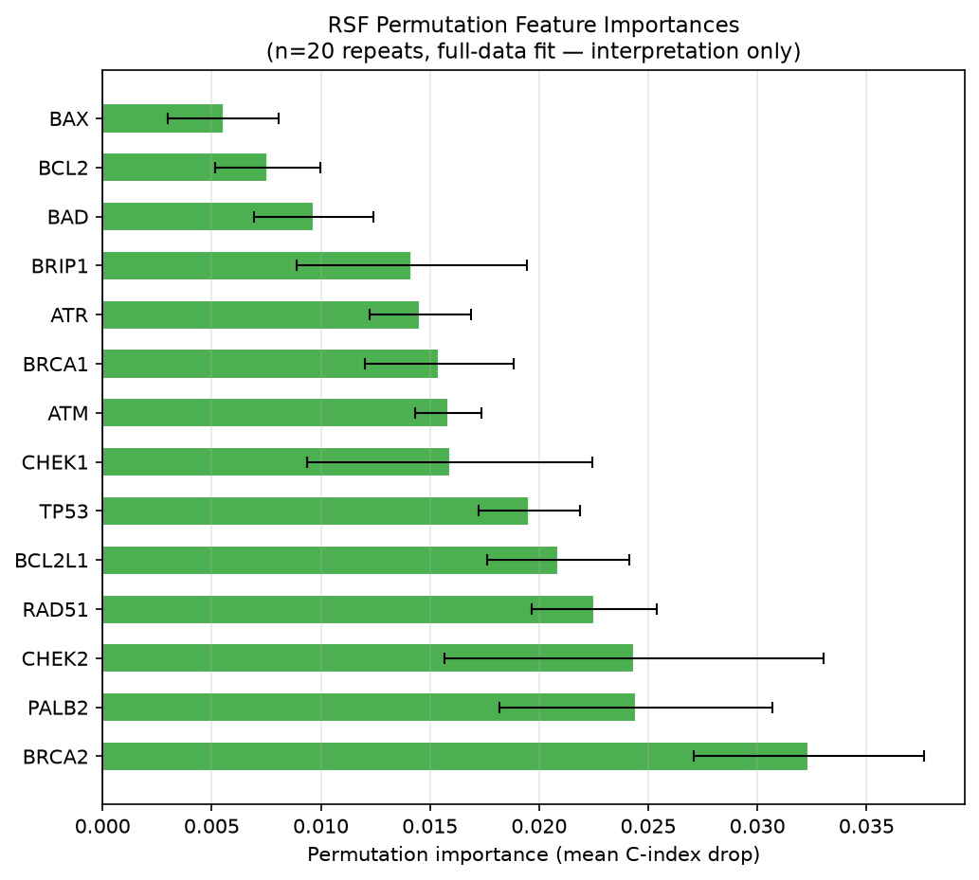
Figure 14. RSF Permutation Feature Importances.
Mean decrease in Harrell's C-index across 20 permutation repeats, with error bars representing
±1 standard deviation. Green bars indicate positive importances.

3.7.3 ODE pathway genes in the all-genes LASSO
A key question is whether the 14 HR-DDR pathway genes selected on biological grounds also emerge as top predictors in an unbiased genome-wide search. To answer this, we fitted the Cox LASSO on the full cohort using all 27,066 genes (α = 0.1, selected by 5-fold CV) and examined whether any of the 14 ODE pathway genes appeared among the selected predictors (Figure 15).
At α = 0.1, the all-genes LASSO was highly selective, retaining only 54 out of 27,066 genes (< 0.2%) with non-zero coefficients. None of the 14 ODE pathway genes were among these 54 selected predictors. This result does not invalidate the ODE gene selection, but contextualises it in two important ways:
- Different signals dominate the unconstrained search. The genome-wide LASSO identifies a small set of very strong transcriptomic predictors (unrelated to the HR-DDR pathway) that capture survival signal more efficiently than any individual pathway gene when all 27,066 candidates are available. This is consistent with the biology: HGSOC survival is influenced by many processes beyond DNA repair, including immune infiltration, proliferation rate, and stromal composition.
- The ODE pathway genes carry signal within their constrained context. When the feature space is restricted to the 14 ODE genes (as in the 14-gene Cox LASSO at α = 0.001), all 14 genes retain meaningful non-zero coefficients. This confirms that the HR-DDR pathway does contain survival-relevant information. It simply does not dominate the genome-wide landscape at the regularisation level where all-genes LASSO operates.
Taken together, the all-genes and 14-gene analyses are complementary: the all-genes LASSO achieves the highest C-index by exploiting a wider biological signal space, while the ODE and 14-gene models extract mechanistically interpretable survival information from a hypothesis-driven, biologically constrained feature set.
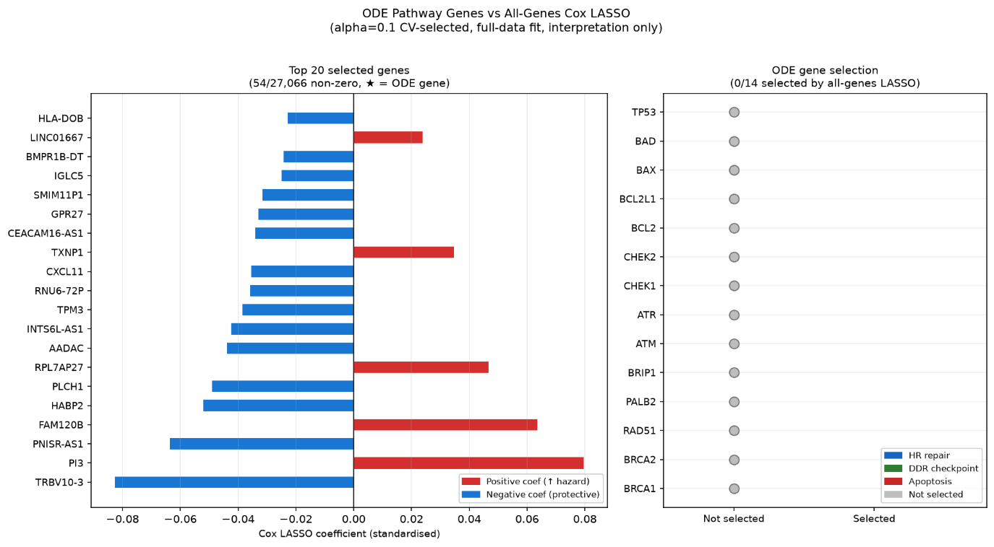
Figure 15. ODE Pathway Genes vs All-Genes Cox LASSO.
Left: Horizontal bar chart of the top 20 genes selected by the all-genes LASSO (α = 0.1; 54/27,066 non-zero). Right: Selection status of each of the 14 ODE pathway genes. All 14 were zeroed by the all-genes LASSO (0/14 selected).

4. Discussion

4.1 Biological validity of the ODE model
The primary finding of this study is that a mechanistic, zero-shot ODE model (parameterised entirely from pre-treatment RNA-seq expression of 14 HR-DDR pathway genes and with kinetic constants informed from published literature) generates prognostically informative predictions of overall survival in HGSOC without fitting any outcome data. The biological plausibility of the model is supported at multiple levels.
At the single-patient level, representative trajectory simulations (Figure 3) confirm qualitatively correct behaviour: a BRCA-deficient patient shows slower DNA damage resolution, sustained checkpoint kinase activation, and substantially higher cumulative apoptotic commitment (${AUC}_{X} = 443.7$) compared to a BRCA-proficient patient (${AUC}_{X} = 111.9$). These trajectories recapitulate the well-established mechanistic consequence of HR deficiency, namely an inability to efficiently resolve platinum-induced DSBs, which prolongs ATM/ATR and CHK1/2 signalling and ultimately increases apoptotic drive.
At the population level, all four ODE-derived scores exhibit directionally consistent differences between BRCA wild-type and BRCA-mutant patients (Figure 4). BRCA-mutant patients show higher ${AUC}_{X}$, higher $X_{peak}$, longer $T_{\text{repair}}$, and marginally elevated residual damage ($D_{\text{resid}}$). Each of these is a mechanistic consequence of impaired HR repair capacity. The absolute magnitude of group differences in $T_{\text{repair}}$ and $D_{\text{resid}}$ is small, reflecting the fact that both groups ultimately resolve damage by the end of the 120-hour simulation window and that the ODE damage dynamics are governed by the same global kinetic constants across all patients. Nevertheless, the directional consistency of all four scores with biological expectation provides confidence that the model is capturing genuine pathway biology rather than arbitrary expression correlations.

4.2 Survival associations and clinical stratification
Three of the four ODE scores –${ AUC}_{X}$, $X_{peak}$, and $T_{\text{repair}}$– show statistically significant univariate Cox associations after Z-score standardisation of log-transformed values (all p = 0.015, HR ≈ 0.856 per SD). The hazard ratios are directionally interpretable: for ${AUC}_{X}$ and $X_{peak}$, higher apoptotic drive is protective, consistent with greater platinum sensitivity. For$T_{\text{repair}}$, slower damage resolution indicates HR damage and is similarly protective. $D_{\text{resid}}$, by contrast, shows no significant association (p = 0.801), which is expected given that residual damage values are vanishingly small (~10⁻⁹) and effectively uniform across the cohort. This is a consequence of the ODE reaching near-complete damage resolution for all patients within the simulation window.
KM stratification results must be interpreted with careful distinction between pre-specified and exploratory analyses. For all three prognostic scores, the pre-specified tertile splits (defined independently of outcome data) show monotonic trends in the biologically expected direction but do not reach statistical significance. This non-significance under a valid pre-specified design is an important finding: it indicates that while the ODE score carries genuine continuous-scale prognostic information (as confirmed by the Cox analysis), the signal is not strong enough to support reliable three-group clinical stratification in a cohort of this size and event rate. The exploratory binary splits at cohort median or scan-optimised cutpoints yield statistically significant log-rank p-values (p = 0.022 and p = 0.008 for${AUC}_{X}$; similar results for $X_{peak}$and $T_{\text{repair}}$). However, because these cutpoints were selected post-hoc by searching the outcome data, the resulting p-values are subject to multiple-testing inflation and should be treated as hypothesis-generating rather than confirmatory. The scan-optimised cutpoint analysis is retained in this report as an honest representation of exploratory findings, with the caveat noted explicitly.

4.3 MM versus data-trained benchmarks
The central benchmarking finding is that the zero-shot ODE (C = 0.533, 95% CI: [0.495, 0.574]) outperforms both the 14-gene Cox LASSO (C = 0.504, CI: [0.468, 0.548]) and the 14-gene RSF (C = 0.480, CI: [0.472, 0.551]) when all models are restricted to the same feature set. This result is notable because the ODE does so without any outcome-based training, while the Cox LASSO and RSF were optimised using 5-fold cross-validation on the target cohort. The advantage of the ODE model on a 14-gene feature set reflects the regularising effect of mechanistic biological structure: rather than allowing the model to learn arbitrary linear or non-linear combinations of 14 correlated expression values (a setting prone to overfitting even with penalisation), the ODE constrains parameter estimation via a system of differential equations whose structure encodes prior biological knowledge. This prior prevents the model from exploiting spurious noise in the training data.
When data-trained models are given access to the full transcriptome (27,066 genes), they recover additional survival signal and achieve higher C-indices (C = 0.569 for all-genes LASSO; C = 0.549 for all-genes RSF). The superior performance of genome-wide models suggests that the survival signal in this cohort extends beyond the 14-gene HR-DDR pathway, likely including proliferation signatures, immune infiltration, and stromal microenvironment components that are not encoded in the ODE. Critically, however, the CIs of the all-genes models still overlap substantially with those of the zero-shot ODE, and the ODE requires no training data, no hyperparameter search, and no outcome information at all. This represents a meaningful practical advantage in clinical or translational settings where outcome data are scarce.

4.4 Alignment between mechanistic and data-trained feature importance
Examining which genes drive the data-trained ML models (Figures 19–20) reveals substantial overlap with the ODE parameterisation logic, providing cross-validation of the mechanistic framework. In the Cox LASSO model, the genes with the largest coefficient magnitudes are CHK2 (−0.195, protective), BRIP1 (−0.130, protective), and CHK1 (−0.121, protective) on the checkpoint effector side, and BRCA2 (+0.141, risk) and RAD51 (+0.102, risk) on the HR repair machinery side. The protective direction of checkpoint kinases is biologically coherent: robust CHK1/2 activation prolongs cell cycle arrest, allowing apoptotic commitment to accumulate in cells with insufficient repair capacity. The positive (risk-increasing) coefficients for BRCA2 and RAD51 likewise align with the ODE: tumours with high HR repair gene expression are repair-proficient and therefore platinum-resistant.
In the RSF permutation importance analysis, BRCA2 is the single most important feature (mean C-index drop = 0.032), followed by PALB2 (0.024), CHK2 (0.024), and RAD51 (0.023). This ranking closely mirrors the structure of the ODE's ${BRCA}_{cap}$parameter, which is computed as the geometric mean of BRCA1, BRCA2, RAD51, PALB2, and BRIP1 – exactly the genes that emerge as most important in the data-driven model. The convergence between an independently trained ensemble model and a literature-derived mechanistic parameterisation provides strong evidence that these genes are carrying genuine biological signal, not cohort-specific noise.
The apoptotic regulators (BCL2, BAX, BAD, BCL2L1) show consistently low importance in the RSF and small coefficients in the LASSO, suggesting that the ${BCL2}_{ratio}$parameter contributes minimally to the survival signal in this cohort. This may reflect the complexity of BCL-2 family regulation in cancer, where post-translational modifications and protein-protein interactions (which are not captured by steady-state mRNA expression) dominate functional anti-apoptotic buffering.

4.5 Limitations
Several limitations constrain the interpretation of these findings.
Fixed kinetic parameters. All global kinetic rate constants (damage induction rate, ATM/ATR activation, CHK1/2 dynamics, and apoptotic threshold) are inspired from in vitro mechanistic studies and held constant across all patients. This assumption is a structural simplification: kinetic rates vary between cell types, are modulated by somatic mutations beyond BRCA1/2, and are perturbed by the tumour microenvironment. Patient-specific calibration of these parameters (e.g. using protein-level proteomic data or ex vivo drug response measurements) would likely improve discriminatory performance but would require additional data sources not available in the TCGA cohort.
Transcriptomic proxies for protein-level activity. The ODE parameters (${BRCA}_{cap}$, ${ATM}_{tot}$, ${CHK}_{tot}$, ${BCL2}_{ratio}$) are computed from steady-state FPKM RNA expression values. Transcript abundance is an imperfect proxy for the functional protein activity that governs kinetic rates, due to post-transcriptional regulation, protein stability differences, and context-dependent activity modulation.
Residual damage and $T_{\text{repair}}$ as discrete outputs. $D_{\text{resid}}$ showed no significant survival association, which is partly attributable to the ODE architecture: with the fixed damage resolution kinetics used here, all patients converge to near-zero residual damage by 120 hours, leaving very little inter-patient variance. Similarly, $T_{\text{repair}}$is a threshold-crossing time (discretised to simulation time steps of 1 hour), which limits its resolution and contributes to the tight clustering of values around 61 hours. Future model extensions could incorporate slower NHEJ repair kinetics or extend the simulation window to better differentiate residual damage phenotypes.
Multiple testing and exploratory cutpoints. The statistically significant log-rank p-values from the scan-optimised cutpoint analyses are subject to multiple-testing inflation because the cutpoint was selected post-hoc from the outcome data. These findings are explicitly labelled as exploratory throughout and should not be interpreted as prospectively validated thresholds. Confirmatory validation in an independent HGSOC cohort (e.g., the ICON7 or AGO-OVAR11 trial datasets) would be required before any clinically actionable cutpoint could be proposed.
Cohort size and BRCA subgroup power. The final analysis cohort of 420 patients with 262 events provides adequate power for Cox regression but limits the statistical resolution of subgroup analyses. The observed BRCA1/2 mutation prevalence of 4.0% (17 patients) is substantially lower than the 15–20% typically reported in clinical HGSOC series, likely reflecting ascertainment biases in the TCGA towards sporadic cases and the incomplete capture of germline variants by somatic sequencing panels. This low prevalence substantially limits the power of BRCA-stratified comparisons and may explain the absence of statistically significant group differences in the box plot analyses despite the directionally consistent effect sizes.

4.6 Conclusions
This study demonstrates that a mechanistic HR-DDR ODE model can extract prognostically informative signal from pre-treatment RNA-seq data in HGSOC without requiring any outcome-based parameter fitting. On a restricted 14-gene feature set, the zero-shot ODE achieves higher discriminatory performance than comparably constrained data-trained survival models, validating the role of biological structure as an effective regulariser in small feature spaces. The convergence between the ODE parameterisation logic and the data-driven feature importance rankings from Cox LASSO and RSF provides independent evidence that the HR-DDR pathway genes used in the ODE carry genuine survival signal. Together, these results support the broader case for MM as a complement to, rather than replacement for, conventional ML in clinical genomic survival prediction, particularly in settings where training cohorts are small, feature sets are biologically constrained, or model interpretability is required.

References
1. Bates M, Mohamed BM, Lewis F, O’Toole S, O’Leary JJ. Biomarkers in high grade serous ovarian cancer. Biochim Biophys Acta Rev Cancer. 2024 Nov;1879(6):189224. doi:10.1016/j.bbcan.2024.189224 PubMed PMID: 39581234.
2. Lisio MA, Fu L, Goyeneche A, Gao ZH, Telleria C. High-grade serous ovarian cancer: basic sciences, clinical and therapeutic standpoints. Int J Mol Sci. 2019 Feb 22;20(4):952. doi:10.3390/ijms20040952 PubMed PMID: 30813239; PubMed Central PMCID: PMC6412907.
3. Kang J, D’Andrea AD, Kozono D. A DNA repair pathway–focused score for prediction of outcomes in ovarian cancer treated with platinum-based chemotherapy. J Natl Cancer Inst. 2012 May 2;104(9):670–81. doi:10.1093/jnci/djs177 PubMed PMID: 22505474; PubMed Central PMCID: PMC3341307.
4. Ghosh S. Cisplatin: The first metal based anticancer drug. Bioorganic Chem. 2019 Jul;88:102925. doi:10.1016/j.bioorg.2019.102925 PubMed PMID: 31003078.
5. Gachechiladze M, Skarda J, Bouchalova K, Soltermann A, Joerger M. Predictive and prognostic value of DNA damage response associated kinases in solid tumors. Front Oncol. 2020 Nov 3;10:581217. doi:10.3389/fonc.2020.581217 PubMed PMID: 33224881; PubMed Central PMCID: PMC7670868.
6. Cerniglia M, Xiu J, Grothey A, Pishvaian MJ, Baca Y, Hwang JJ, et al. Association of homologous recombination-DNA damage response gene mutations with immune biomarkers in gastroesophageal cancers. Mol Cancer Ther. 2022 Jan;21(1):227–36. doi:10.1158/1535-7163.MCT-20-0879 PubMed PMID: 34725190; PubMed Central PMCID: PMC9506445.
7. Lecca P, Ihekwaba-Ndibe AEC. Dynamic modelling of DNA repair pathway at the molecular level: a new perspective. Front Mol Biosci. 2022 Sep 13;9:878148. doi:10.3389/fmolb.2022.878148 PubMed PMID: 36177351; PubMed Central PMCID: PMC9513183.
8. Wassing IE, Esashi F. RAD51: Beyond the break. Semin Cell Dev Biol. 2021 May 1;Genome stability113:38–46. doi:10.1016/j.semcdb.2020.08.010 PubMed PMID: 32938550; PubMed Central PMCID: PMC8082279.
9. Luo X, O’Neill KL, Huang K. The third model of Bax/Bak activation: a Bcl-2 family feud finally resolved? F1000Research. 2020;9:F1000 Faculty Rev-935. doi:10.12688/f1000research.25607.1 PubMed PMID: 32802314; PubMed Central PMCID: PMC7411521.
10. Smith J, Tho LM, Xu N, Gillespie DA. The ATM-Chk2 and ATR-Chk1 pathways in DNA damage signaling and cancer. In: Advances in Cancer Research [Internet]. Academic Press; 2010. p. 73–112. Available from: https://www.sciencedirect.com/science/article/pii/B9780123808882000030 doi:10.1016/B978-0-12-380888-2.00003-0
11. Wallis B, Bowman KR, Lu P, Lim CS. The challenges and prospects of p53-based therapies in ovarian cancer. Biomolecules. 2023 Jan 12;13(1):159. doi:10.3390/biom13010159 PubMed PMID: 36671544; PubMed Central PMCID: PMC9855757.
12. Cai W, Qi Y, Zheng L, Wu H, Yang C, Zhang R, et al. Comparison of random survival forest based-overall survival with deep learning and Cox proportional hazard models in HER-2-positive HR-negative breast cancer. Cancer Rep. 2025;8(7):e70262. doi:10.1002/cnr2.70262 PubMed PMID: 40624807; PubMed Central PMCID: PMC12234386.
13. Procopio A, Cesarelli G, Donisi L, Merola A, Amato F, Cosentino C. Combined mechanistic modeling and machine-learning approaches in systems biology – A systematic literature review. Comput Methods Programs Biomed. 2023 Oct 1;240:107681. doi:10.1016/j.cmpb.2023.107681 PubMed PMID: 37385142.
14. Purvis JE, Karhohs KW, Mock C, Batchelor E, Loewer A, Lahav G. p53 dynamics control cell fate. Science. 2012 Jun 15;336(6087):1440–4. doi:10.1126/science.1218351 PubMed PMID: 22700930; PubMed Central PMCID: PMC4162876.
15. Batchelor E, Mock CS, Bhan I, Loewer A, Lahav G. Recurrent initiation: a mechanism for triggering p53 pulses in response to DNA damage. Mol Cell. 2008 May 9;30(3):277–89. doi:10.1016/j.molcel.2008.03.016 PubMed PMID: 18471974; PubMed Central PMCID: PMC2579769.
16. Schramm A, Köster J, Assenov Y, Althoff K, Peifer M, Mahlow E, et al. Mutational dynamics between primary and relapse neuroblastomas. Nat Genet. 2015 Aug;47(8):872–7. doi:10.1038/ng.3349 PubMed PMID: 26121086.
17. Harris CR, Millman KJ, van der Walt SJ, Gommers R, Virtanen P, Cournapeau D, et al. Array programming with NumPy. Nature. 2020 Sep;585(7825):357–62. doi:10.1038/s41586-020-2649-2 PubMed PMID: 32939066; PubMed Central PMCID: PMC7759461.
18. McKinney W. Data structures for statistical computing in Python. SciPy 2010. 2010 May 1. doi:10.25080/Majora-92bf1922-00a
19. Virtanen P, Gommers R, Oliphant TE, Haberland M, Reddy T, Cournapeau D, et al. SciPy 1.0: fundamental algorithms for scientific computing in Python. Nat Methods. 2020 Mar;17(3):261–72. doi:10.1038/s41592-019-0686-2 PubMed PMID: 32015543; PubMed Central PMCID: PMC7056644.
20. Xin J, Mark A, Afrasiabi C, Tsueng G, Juchler M, Gopal N, et al. High-performance web services for querying gene and variant annotation. Genome Biol. 2016 May 6;17(1):91. doi:10.1186/s13059-016-0953-9 PubMed PMID: 27154141; PubMed Central PMCID: PMC4858870.
21. Davidson-Pilon C. lifelines: survival analysis in Python. J Open Source Softw. 2019 Aug 4;4(40):1317. doi:10.21105/joss.01317
22. Pölsterl S. scikit-survival: a library for time-to-event analysis built on top of scikit-learn. J Mach Learn Res [Internet]. 2020 [cited 2026 Jun 30];21(212):1–6. Available from: http://jmlr.org/papers/v21/20-729.html
23. Pedregosa F, Varoquaux G, Gramfort A, Michel V, Thirion B, Grisel O, et al. Scikit-learn: machine learning in Python. J Mach Learn Res [Internet]. 2011 [cited 2026 Jun 30];12(85):2825–30. Available from: http://jmlr.org/papers/v12/pedregosa11a.html
24. Hunter JD. Matplotlib: a 2D graphics environment. Comput Sci Eng. 2007 May;9(3):90–5. doi:10.1109/MCSE.2007.55

Appendix 1. Abbreviations
ATM ataxia telangiectasia mutated
ATR ataxia telangiectasia and Rad3-related protein
AUC area under the curve
BAX BCL-2 associated X-protein
BAD BCL-2 associated agonist of cell death
BCL-2 B cell leukaemia/lymphoma-2
BRCA1/2 breast cancer type 1/2 susceptibility protein
CI(s) confidence interval(s)
C-index concordance index
CHK1/2 checkpoint kinase 1/2
CoxPH Cox proportional hazards regression/model
DDR DNA damage response
DNA deoxyribonucleic acid
DSB(s) double-stranded break(s)
FPKM Fragments Per Kilobase of transcript per Million mapped reads
HGSOC high-grade serous ovarian carcinoma
HR homologous recombination
KM Kaplan-Meier
LASSO least absolute shrinkage and selection operator
MAF mutation annotation format
ML machine learning
MM mechanistic model
NHEJ non-homologous end joining
ODE ordinary differential equation
OOF out-of-fold
PALB2 partner and localizer of BRCA2
RAD51 radiation sensitive protein 51
RSF(s) Random Survival Forest(s)
TCGA The Cancer Genome Atlas
TP53 tumour protein p53

Appendix 2. Model variables and symbols
D(t) | DNA damage load over time
A(t) | ATM/ATR checkpoint activation over time
C(t) | CHK1/CHK2 signalling over time
R(t) | Function HR repair complex capacity over time
X(t) | Apoptotic commitment signal over time
$${AUC}_{X}$$ | Area under the apoptotic commitment curve (primary ODE score)
$$X_{peak}$$ | Maximum apoptotic signal reached
$$T_{\text{repair}}$$ | Duration HR complex remains significantly depleted below baseline
$$D_{\text{resid}}$$ | Residual DNA damage at end of simulation
τ_{drug} | Carboplatin plasma half-life
k_{a} | ATM/ATR activation rate
d_{a} | ATM deactivation
k_{c} | CHK1/2 activation rate
d_{c} | CHK1/2 deactivation
k_{HR} | HR repair rate per unit R
k_{NHEJ} | NHEJ repair rate (R-independent)
k_{load} | CHK-driven HR complex depletion
d_{r} | HR complex basal turnover
k_{x} | Checkpoint-driven apoptotic rate
d_{x} | Apoptotic signal decay
k_{suppress} | HR suppression of apoptosis
K_{HR} | Half-saturation constant for HR suppression

