Job aid live streaming

Introduction
Live streaming is the transmission of video or audio, or both, in real time or near real time to the internet. While often referred to simply as streaming, the real-time nature of live streaming differentiates it from other non live broadcast forms of streamed media such as video on demand, video logs, and video sharing platforms such as YouTube.
St. Mary’s Church Bonita Springs uses professional audio equipment, video cameras, audio mixing hardware, and various software programs to create a live stream of the Holy Eucharist in its many forms. Our videos are available on our YouTube channel.
This job aid serves to set up and be ready to live stream on our YouTube channel.
Table of Contents
Job aid live streaming 1
Introduction 1
Turn on the equipment 3
Audio cabinet 3
Streaming desk 3
Start the streaming software 4
Set the recording settings 7
Set the title banner 7
Begin audio and video streaming 8
Cameras 9
Microphones 9
Set up the left preview screen 9
Camera control for the right preview 9
Holy Eucharist schedule 9
End the streaming and the recording 12
Presets 12
Add an external camera 12
Downloading a church video to a computer 12
Extracting audio and video from a church video 12
YouTube 12
Church account information 13
Preparing for a live stream in advance 13
Creating a post 13
Creating a short 14
Analytics 14
Uploading a video manually 14
References 16
Support 16

Turn on the equipment
The passcode to the equipment room is 1923.
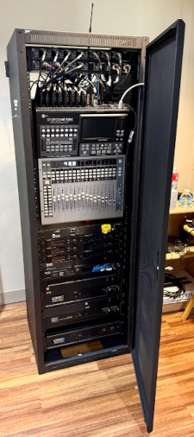

Audio cabinet
The tall cabinet in the room is the sanctuary sound control system. Flick up the ToggleSwitch on the outside left side of the cabinet if the system is not on. Do not touch any controls inside this cabinet.
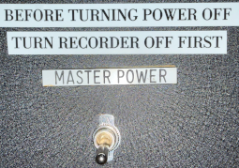

Streaming desk
The table in front of the window contains the PreSonus STUDIOLIVE 16.0.2 USB sound board, the monitor, headphones, keyboard, and mouse. Below the table on the left is the computer.
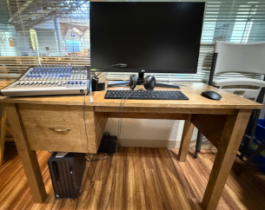
Press the Power I/O Switch, located on the back of the sound board on the right side.
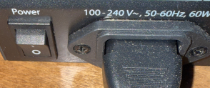
Press the Meters InputButton under the meters at the far left to see the recording levels.
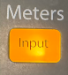
Press the PowerButton at the top on the front of the computer.

Wait about 15 s for the screen. Press the EnterKey. Type the password STMsanc#1 and press the EnterKey .
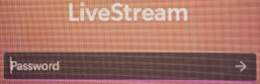

Start the streaming software
Double click the vMix (x64) icon on the left side of the screen. At the top of the screen, click the DownArrow to the right of the OpenButton and select the Preset Setup IV.vmix.
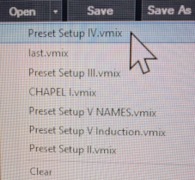
At the top of the screen, click the MaximizeIcon, the second icon from the right. This should make everything smaller. Click and drag the window to the left edge of the screen. Resize so that the window touches the top, left, and bottom edges of the screen.
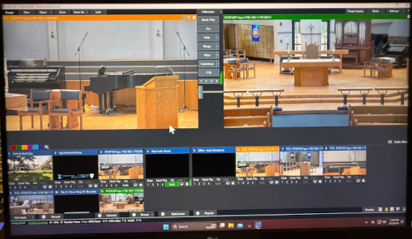
Click on the GearIconfor preset 11.
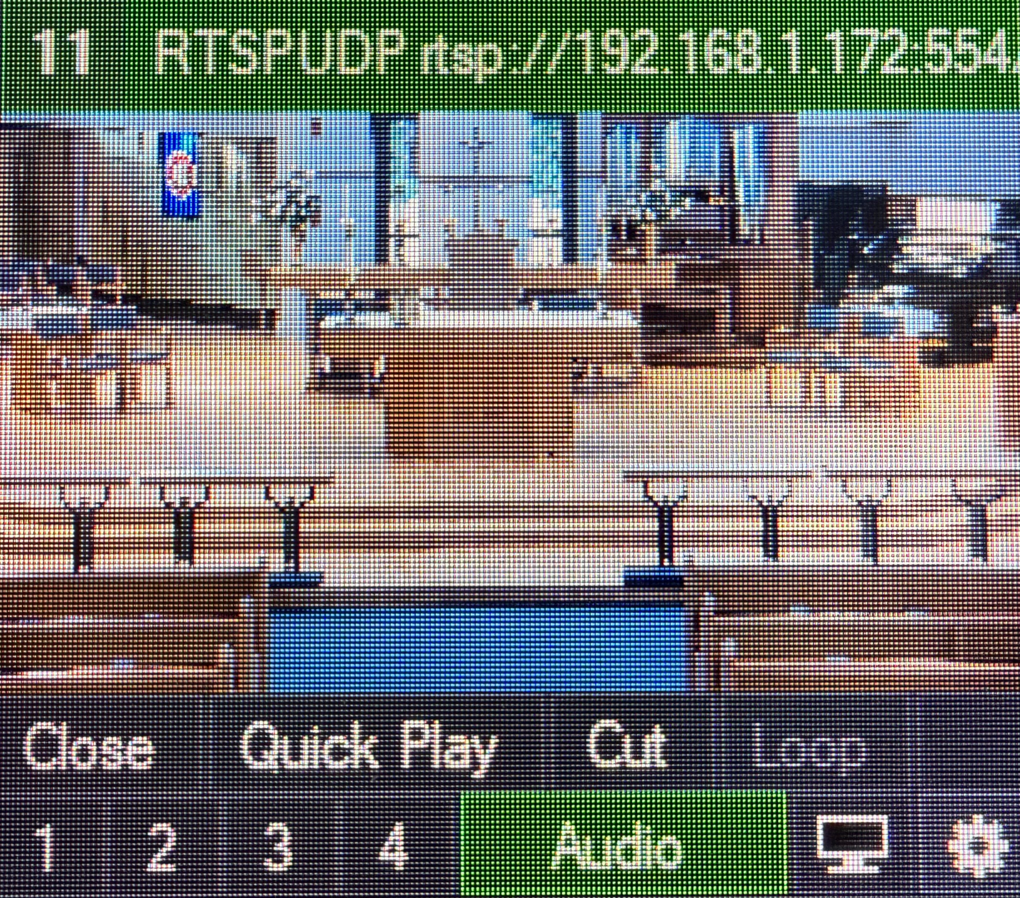
In the resulting window, left column, click on PTZ.
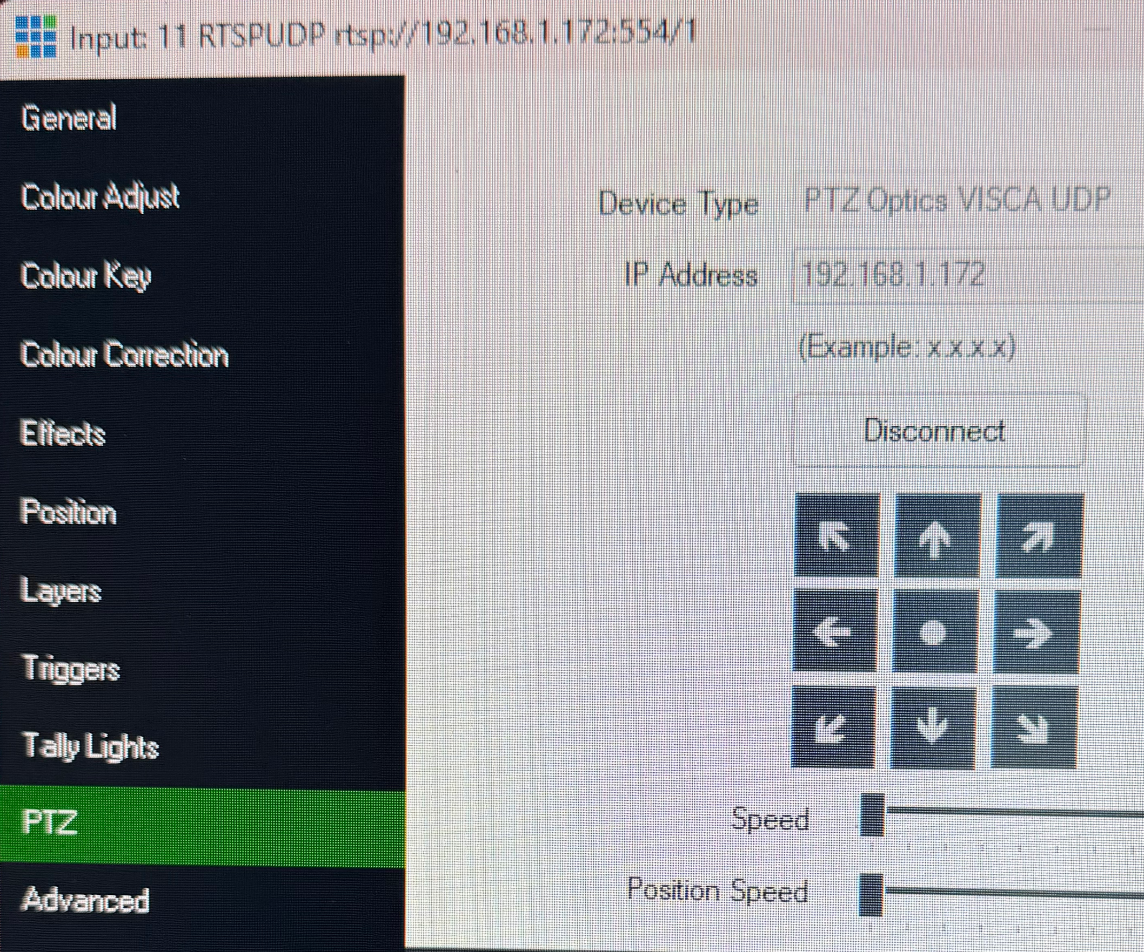
Resize this window as appropriate. Move this window to the right so that it does not overlap with the main window and the controls are accessible.
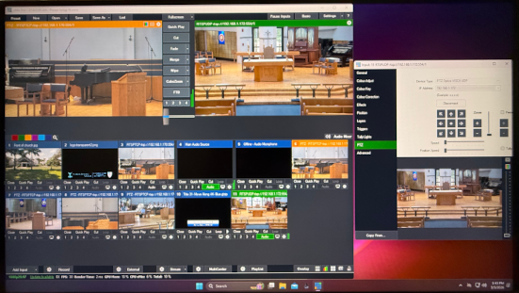
The left preview window should have an amber bar. The preset 6 window should have an amber bar. The right preview window should have a green bar. The preset 11 window should have a green bar.

Set the recording settings
At the bottom, click on the GearIcon next to the RecordButton.
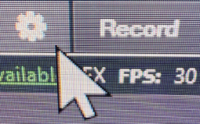
In the pop-up window file name, change only the date in Filename. Click the OKButton.
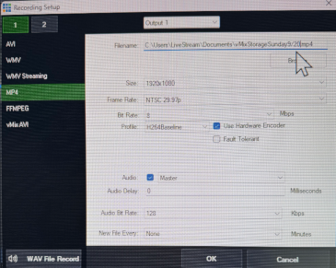

Set the title banner
Right click anywhere in the #10 preset window. Click on the Title Editor Button.
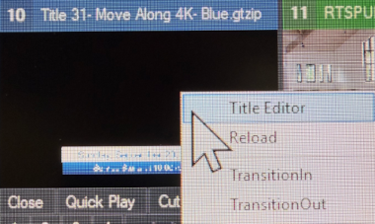
Change the date.
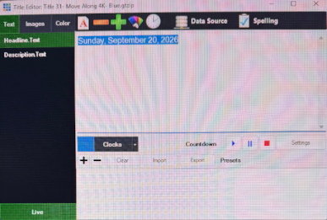
Click the x in the upper right corner to close the window. Click on the small box “1” at the bottom of the #10 preset window to turn on the overlay for the right preview window with the green bar.
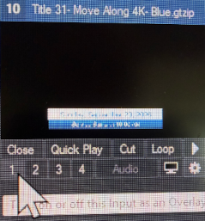

Begin audio and video streaming
Click on the StreamButton; the button bar turns red.
Click on the RecordButton; it will have a red STREAM2 & REC button by top preview.
The FADE button is used to transition between camera 1 and camera 2.
The active camera is on the right with a green bar.
The other camera preview is on the left with an amber bar.
If the streaming stops for any reason, do not restart it because of how YouTube is set up. Change the file name in the record button (if it has stopped) and restart recording only, not streaming. When the service is finished and you have stopped the recording, see uploading a video manually.

Cameras
Camera 1 is at the left side of the main aisle, near the front, and points to the right lectern, the organist, and the choir.
Camera 2 is at the back of the church and points up the center aisle.

Microphones
Fr. Bill uses the “wireless 5” microphone (slider 13/14 on the sound board). He occasionally forgets to turn it off. Be prepared to turn down the input setting.
Fr. Ryan uses the “wireless 6” microphone (slider 15/16 on the sound board). He is very good about how he uses his microphone.

Set up the left preview screen
The correct way to set the left preview screen is:
- Click on the left screen
- Click on the desired gear to control the camera
- Click on the desired preset

Camera control for the right preview
If the right preview screen does not have the correct camera controls:
- Click on the right screen
- Click the desired gear to control the camera

Holy Eucharist schedule
Moment | Camera | Preset | Gear | Notes
Gathering of the People | 2 | 11 | 11 | The title should be displayed.
Prelude | 1 | 6 | 3 | STREAM and Record just before the organist plays. These buttons turn red.
The organist has finished playing. FadeButton to switch to camera 2.
Processional Hymn | 2 | 11 | 11 | The bell rings three times. Turn off the banner by clicking on the 1 in preset 10 .
Opening Acclamation or The Penitential Order or The Absolution | 2 | 11 | 11
Kyrie | 1 | 6 | 3
The Liturgy of the Word
Collect of the Day | 2 | 11 | 11
First reading | 1 | 6 | 3 | Zoom in and move as required.
Psalm or Hymn | 1 | 6 | 3
Second reading | 1 | 6 | 3
The Gospel
Gospel Acclamation | 2 | 11 | 11 | Zoom in and move as required.
Gospel | 2 | 11 | 11 | Zoom in and move as required.
Homily | 2 | 11 | 11 | Zoom in and move as required.
Nicene Creed | 2 | 11 | 11
Prayers of the People
Celebrant | 2 | 11 | 11
Lector | 1 | 6 | 3
Celebrant | 2 | 11 | 11
Peace | 2 | 11 | 11
Announcements | 2 | 11 | 11 | or 1-9-3
Liturgy of the Eucharist
Offertory Anthem | 1 | 6 | 3
At the Presentation, Doxology | 1 | 6 | 3
The Eucharistic Prayer | 2 | 11 | 11
Sanctus | 1 | 6 | 3
Prayer of Consecration | 2 | 11 | 11
Memorial Acclamation from Mass of Hope | 2 | 11 | 11
Amen from Mass of Hope | 2 | 11 | 11
The Lord’s Prayer | 2 | 11 | 11
Agnus Dei, Lamb of God from Mass of Hope | 2 | 11 | 11
Invitation | 2 | 11 | 11
Prayers of Spiritual Communion | 2 | 11 | 11
Communion of the Faithful
Communion Anthem | 1 | 9 | 3
Communion Hymn | 1 | 9 | 3
Post Communion Prayer | 2 | 11 | 11
Recessional Hymn | 1 | 6 | 3
Blessing | 2 | 11 | 11
Dismissal | 2 | 11 | 11
Postlude | 1 | 6 | 3

End the streaming and the recording
Click on the StreamButton and click on OK.
Click on the RecordButton and click on OK.
Close vMix by clicking on the x at the top right corner of the window. If all went well, click the green SAVE CHANGES button OK. If not, click the red DON’T SAVE button.

Presets
#3 set-reset camera 1. Click the gear icon for #3 preset to switch control to any camera 1 preset; pan-tilt-zoom adjustments
#7 baptistry, left lectern wide view, camera 1. Use for the main Eucharist rite II. Zoom in for the left lectern if required.
#8 right lectern, camera 1. Zoom in for psalm readings and prayers for the people.
#9 Close-up of the communion rail, camera 1, in front of the altar,
#10 Title banner overlay. “Date” and “Service will start at 10:00 a.m.”
#11 Center aisle, broad view, camera 2. Click gear #11 to switch control to camera 2; pan-tilt-zoom adjustments.

Add an external camera
TBD
The DroidCam app on Android and iOS supports 1920x1080 (1080p29.97) resolution.

Downloading a church video to a computer
Exists but do I paste it here?

Extracting audio and video from a church video
Exists but do I paste it here?

YouTube
St. Mary’s has a nonprofit YouTube channel. This channel is managed by Fr. Ryan Wright, Ian Mitchell, Joanna Wragg, and Gilles Pilon. Videos are automatically saved after streaming. The church website only shows a live stream video. All other videos are archived on the YouTube channel. Content on the channel is managed using studio.youtube.com.
- Log into the church account at https://studio.youtube.com.
- In the upper right corner of the screen you should see our church icon. Click on the icon, click on Switch account and ensure you are on the St. Mary's Episcopal Church account.
- This should take you to the Channel dashboard.

Church account information
user ID: wVb_oy0lQmXWX3nrCVR-4g
channel ID: UCwVb_oy0lQmXWX3nrCVR-4g
stream key: u3qe-scf6-jdd1-seuv-cvsp to be used only in VMix.

Preparing for a live stream in advance
Navigate to the Channel dashboard.
There are three icons in the upper right corner. Click on the middle icon, the Go live icon.
This should take you to the Manage page. If not, click on the Manage icon on the left side.
click on the Schedule Stream icon on the right side of the page.
It will ask you if you want to Schedule with previous settings and has selected a previous service. This is the easiest way to set up a new service. Click on the Reuse settings button.
In the Title (required) window, change the date and other information as required.
In the Description window, change the information as required.
Click the Next button.
Click the Next button.
Change the schedule date.
Change the schedule time to 15 min before the service would start.

Creating a post
In a browser, type studio.youtube.com.
Ensure you are logged into the church account.
In the upper right corner click on Create and select Create post.
This will open a new tab.
Find the area Post an update to your fans and type a title and touch the EnterKey.
Add text as desired, either as one paragraph of multiple paragraphs.
If you want to add an image, click on the Image icon and then click on select from your computer. If you want to add more images, click on the icon below the small version of your image on the left. You can add up to ten images in this manner.
Click on the Post button to post it to the church account.

Creating a short
In a browser, locate the church video you wish to use to create a short.
Download the video to your downloads folder.
View the video to determine the starting and ending points of the short.
Extract the short from the video and save it to your downloads folder.
In a browser, type studio.youtube.com.
Ensure you are logged into the church account.
In the upper right corner click on Create and select Upload videos.
This will open a new tab.
Click on Select files.
Locate the short, click on it, and click on Open.
Fill in the various fields. In Playlists, select Shorts. Click on Next and complete all of the fields.
Finally, click on Publish.

Analytics
Log into https://studio.youtube.com.
In the upper right corner of the screen you should see our church icon. Click on the icon, click on Switch account and ensure you are on the St. Mary's Episcopal Church account.
This should take you to the Channel dashboard.
Click on Analytics on the left side.
This should take you to the Channel analytics.
There are four clickable tabs at the top of the window: Overview, Content, Audience, and Trends.

Uploading a video manually
Log into https://studio.youtube.com.
In the upper right corner of the screen you should see our church icon. Click on the icon, click on Switch account and ensure you are on the St. Mary's Episcopal Church account.
This should take you to the Channel dashboard.
In the top right corner, Create and Upload videos and Select files
Navigate to the file you wish to upload. Select it and Open
Title: May 17, 2026 10:00 Holy Eucharist Rite II
Description: The Seventh Sunday of Easter. The Sunday after Ascension Day.
Thumbnail: Ignore because YouTube will generate one and it’s usually acceptable. You can change this later.
Playlists: Select one if appropriate
Audience: No, it’s not made for kids
Age restriction: Ensure it is unchecked
Show more
Paid promotion: Ignore
Altered content: No
Collaboration: Ignore
Automatic chapter: Allow automatic chapters and key moments
Automatic concepts: Ensure it is unchecked
Tags: Ignore
Video language: English (United States)
Caption certification: Ignore
Recording date and location: Enter the date from the drop down calendar. Enter the location Bonita Springs, FL
License: Standard YouTube License
Allow embedding: Ensure it is unchecked
Publish to subscriptions feed and notify subscribers: Ensure is is checked
Shorts remixing: Ensure Don’t allow remixing is checked
Category: People & Blogs
Comments and rating:
- Comments: On
- Moderation: Strict
- Who can comment: Anyone
- Sort by: Top
- Show how many viewers like this video: Ensure it is checked
Next
Add subtitles: Ignore
Add an end screen: Ignore
Add cards: Ignore
Next
Checks: YouTube checks for copyright. Wait to see the result. This usually has no issues.
Next
Visibility: Public
Schedule: Select a date, time, and time zone (local)
Schedule. Select a date and time.

References

Support
Gilles Pilon | gillespilon13@gmail.com

