Sentiment Analysis for Swedish Data:

1) https://www.diva-portal.se/smash/get/diva2:1711488/FULLTEXT01.pdf

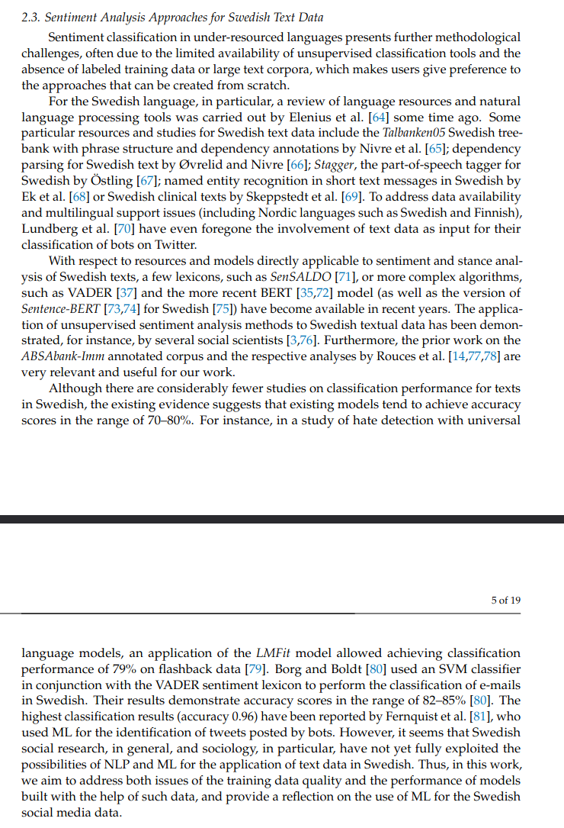
2) SenSaldo Lexicon (https://spraakbanken.gu.se/resurser/sensaldo)

https://www.sprakbruk.fi/-/vaccinskepsis-unders%C3%B6ks-med-hj%C3%A4lp-av-spr%C3%A5kteknologi

3) Vader (lexicon-based sentiment analysis) /+ SVM
https://github.com/cjhutto/vaderSentiment
https://github.com/AlexGustafsson/vaderSentiment-swedish

https://www.sciencedirect.com/science/article/pii/S0957417420305704
http://lnu.diva-portal.org/smash/get/diva2:1639731/FULLTEXT01.pdf
https://journals.sagepub.com/doi/10.1177/0267323120940909

https://tidsskrift.dk/sss/article/view/130068
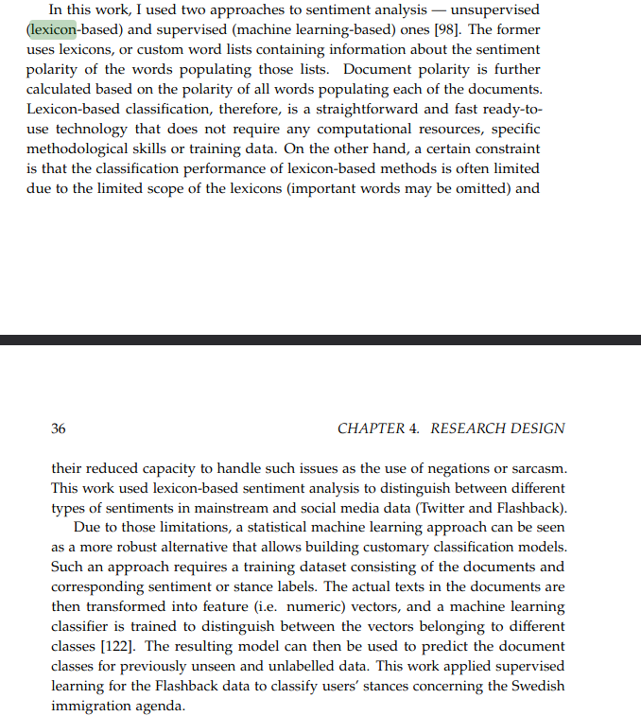

3) BERT fine-tuning on Trustpilot data

https://www.diva-portal.org/smash/get/diva2:1703709/FULLTEXT01.pdf

