DEPARTMENT OF

COMPUTER SCIENCE & ENGINEERING

Worksheet 3
Student Name: Sanjna Verma UID: 24BCS12051
Branch: BE-CSE Section/Group: 602-A
Semester: 4th Date of Performance: 12/03/2026 Subject Name: OOP using Java Subject Code: 24CSH-207

- Aim: (i) Java Exception Handling – Safe Division
Write a Java program that reads two inputs A and B and performs integer division A / B. The program must properly handle the following exceptions: If B = 0, print java.lang.ArithmeticException: / by zero If the input contains non-integer values, print java.util.InputMismatchException If no exception occurs, print the result of A / B. Use appropriate exception handling mechanisms in Java to prevent program termination.

Input Format
Two space-separated inputs representing integers A and B.

Constraints
−10⁹ ≤ A ≤ 10⁹ −10⁹ ≤ B ≤ 10⁹

Output Format
Print the result of A / B if the operation is successful. Otherwise print the appropriate exception message: java.lang.ArithmeticException: / by zero java.util.InputMismatchException

(ii) Java Exception Handling – String to Integer Conversion
You are given a string S. Your task is to convert the string into an integer. If the string contains non-numeric characters and cannot be converted into an integer, print: java.lang.NumberFormatException Otherwise print the integer value.

Input Format
A single string S.

Constraints
Length of string ≤ 100

Output Format
Print the integer value if conversion is successful. Otherwise print: java.lang.NumberFormatException

- Requirements (Hardware/Software): HackerRank

- Code: (i)
import java.io.*;
import java.util.*;

public class Solution {

public static void main(String[] args) {

Scanner sc = new Scanner(System.in);

try {
int A = sc.nextInt();
int B = sc.nextInt();

int result = A / B;
System.out.println(result);
}

catch (ArithmeticException e) {
System.out.println("java.lang.ArithmeticException: / by zero");
}

catch (InputMismatchException e) {
System.out.println("java.util.InputMismatchException");
}
}
}

(ii)
import java.io.*;
import java.util.*;

public class Solution {

public static void main(String[] args) {

Scanner sc = new Scanner(System.in);
String S = sc.next();

try {
int num = Integer.parseInt(S);
System.out.println(num);
}

catch (NumberFormatException e) {
System.out.println("java.lang.NumberFormatException");
}
}
}

- Output: (i)

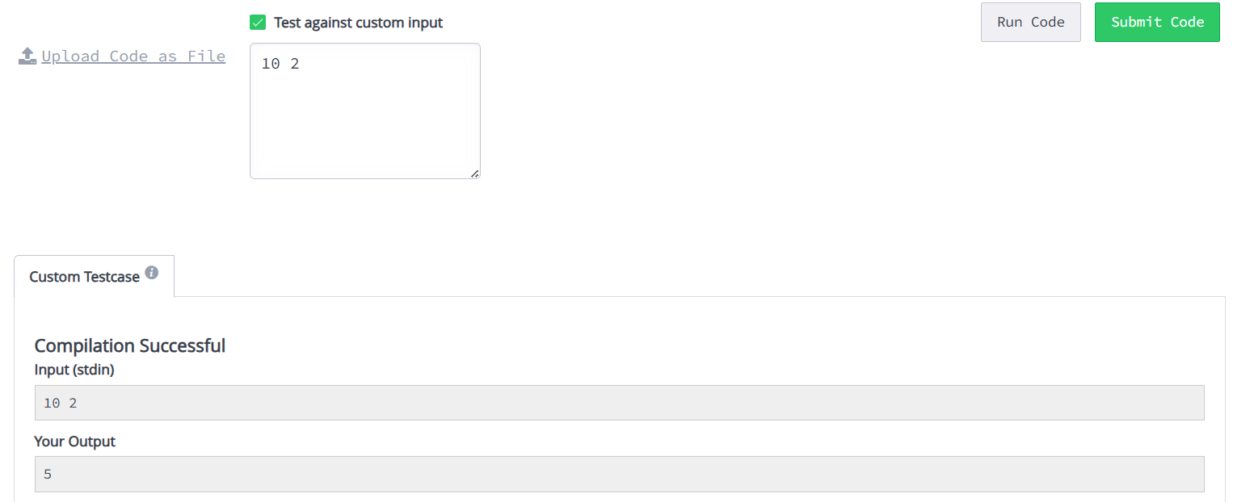

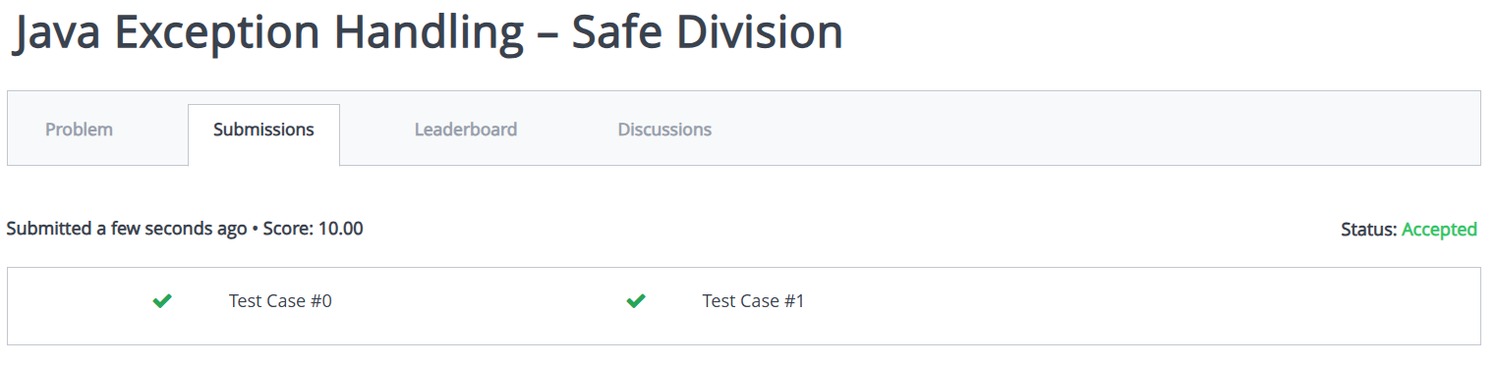

(ii)
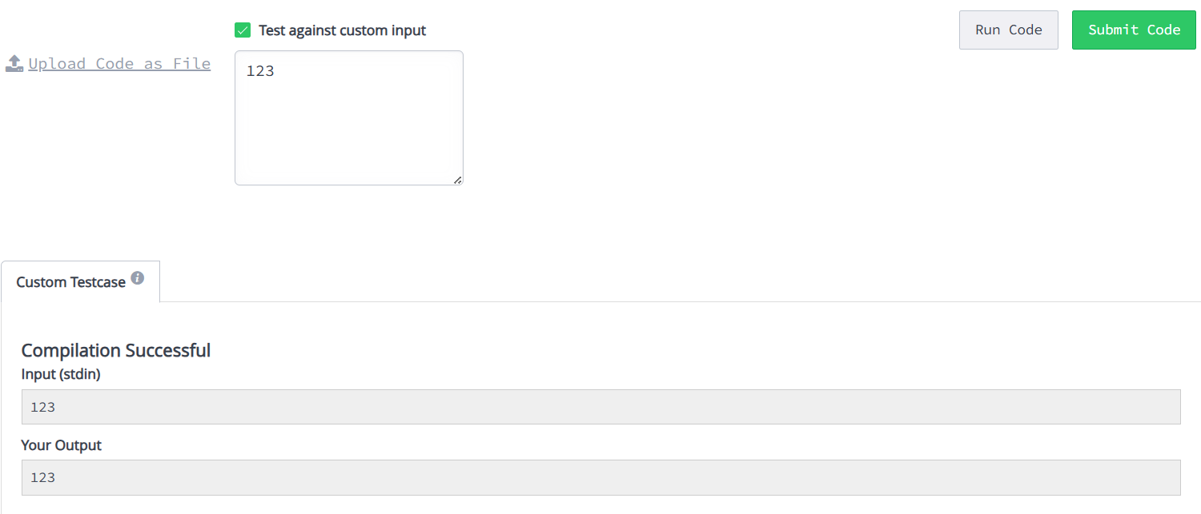

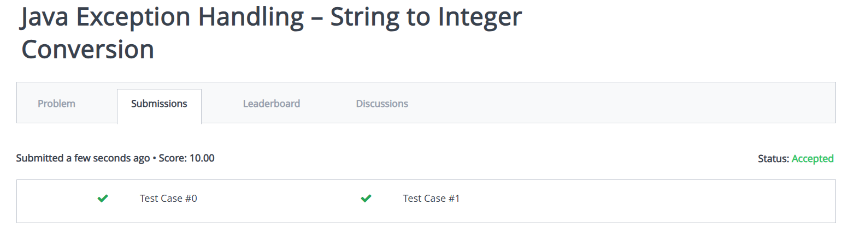

- Learning Outcome:
- I learnt to handle errors using try and catch.
- I learnt to handle division by zero.
- I learnt to handle invalid input.
- I learnt to convert string to integer.
- I learnt to prevent program crashes using exceptions.

