SMART PAPER MILL PRODUCTION MONITORING DASHBOARD
AN INDUSTRIAL TRAINING REPORT
Submitted by
Manreet Gill (UID: 24BCS10479)
in partial fulfillment for the award of the degree of
BACHELOR OF ENGINEERING
IN
COMPUTER SCIENCE & ENGINEERING
Industrial Training carried out at
SATIA INDUSTRIES LIMITED
Chandigarh University
June 2026

TABLE OF CONTENTS
[update field]
(Right-click and choose 'Update Field' to generate the contents and page numbers.)

LIST OF FIGURES
[update field]
(Right-click and 'Update Field' to populate the list of figures.)

LIST OF TABLES
[update field]
(Right-click and 'Update Field' to populate the list of tables.)

1. Abstract
This report presents the design, development and validation of the Smart Paper Mill Production Monitoring Dashboard, a web-based application developed during industrial training at Satia Industries Limited, a manufacturer of writing and printing paper from agricultural residue (wheat straw) and wood pulp. The system replaces fragmented, paper-based production logging with a single, real-time, role-based digital platform that consolidates production output, machine status, quality parameters, downtime and Overall Equipment Effectiveness (OEE). It is implemented as a Python (Flask) backend with an SQLite database, secured using bcrypt password hashing and JSON Web Token authentication with role-based access control, and a responsive HTML5/CSS3/JavaScript front-end using Chart.js. Live machine telemetry is delivered to the browser using Server-Sent Events. Because live plant-floor integration is outside the scope of an academic assignment, the system operates on realistic, internally consistent simulated data. The delivered solution includes secure login, an administrative panel for users, machines and thresholds, production and downtime data entry, automatic OEE computation, threshold-based alerts, analytical reports with CSV and PDF export, an audit trail and a dark-mode interface. The backend is validated by an automated suite of ninety-four tests, all passing.

2. Objectives
- Provide a centralized, role-based dashboard for real-time paper-mill production monitoring.
- Capture production data, including grammage, moisture and machine speed, and flag out-of-specification readings.
- Compute Overall Equipment Effectiveness automatically from availability, performance and quality.
- Deliver live machine telemetry to the browser without manual page reloads.
- Generate threshold-based alerts and present them in a dedicated panel.
- Provide analytical reports with date, shift and machine filters and CSV/PDF export.
- Provide an administrative panel for managing users, machines and thresholds, with an audit log.
- Build the solution with free, open-source tools and validate it with an automated test suite.

3. Problem Statement
Production data at the plant is recorded manually in shift registers, logbooks and disconnected spreadsheets maintained separately for each section. This gives rise to a lack of real-time visibility, laborious consolidation of scattered data, late detection of out-of-specification quality and an inability to compare the performance of different shifts, machines or time periods. The core problem is the absence of a single, real-time, role-based digital platform through which production, quality and downtime information can be recorded, monitored and analysed in a consistent and timely manner.

4. System Architecture
The system follows a three-tier architecture, shown in Figure 1.
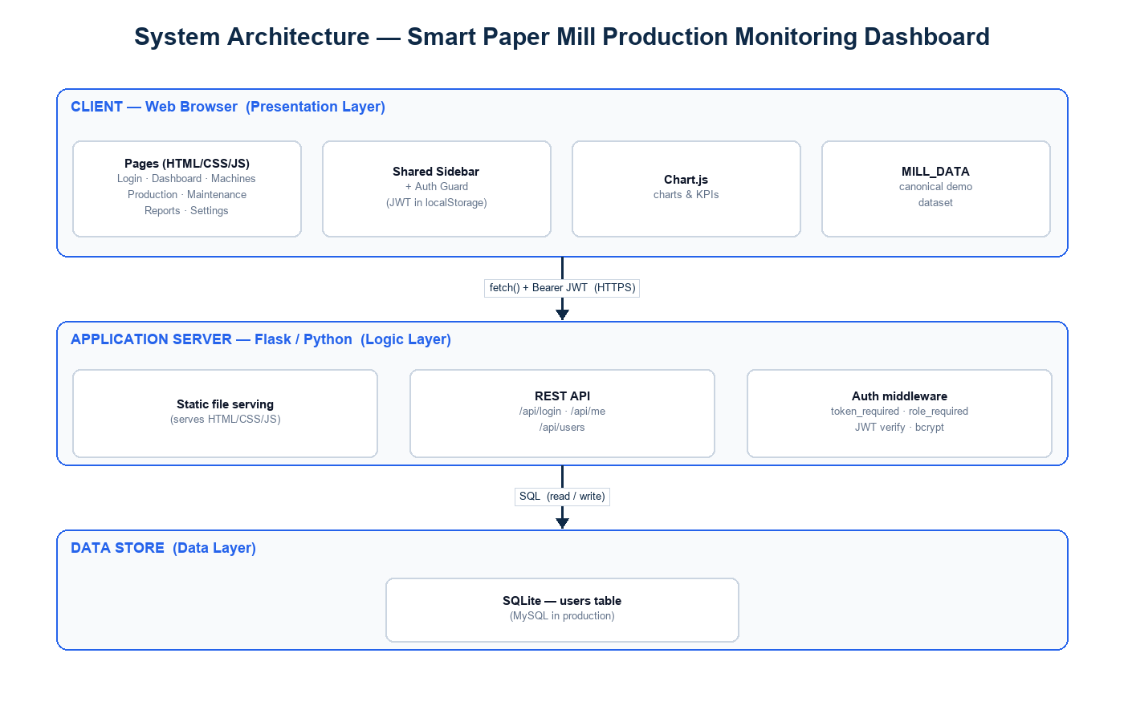
Figure : Three-tier system architecture
4.1 Presentation Layer. The user interface, implemented in HTML5, CSS3 and JavaScript, with Chart.js for visualization. A shared sidebar and a client-side authentication guard provide consistent navigation and access control across pages.
4.2 Application Layer. A Python (Flask) REST API that handles authentication, role-based authorization, data CRUD, OEE computation and live telemetry, and also serves the static front-end so that the whole application runs from a single origin.
4.3 Data Layer. An SQLite database storing users, production records, downtime events, maintenance logs, machines, thresholds and the activity log. A relational schema based on MySQL is provided as the production target; the entity-relationship design is shown in Figure 2.
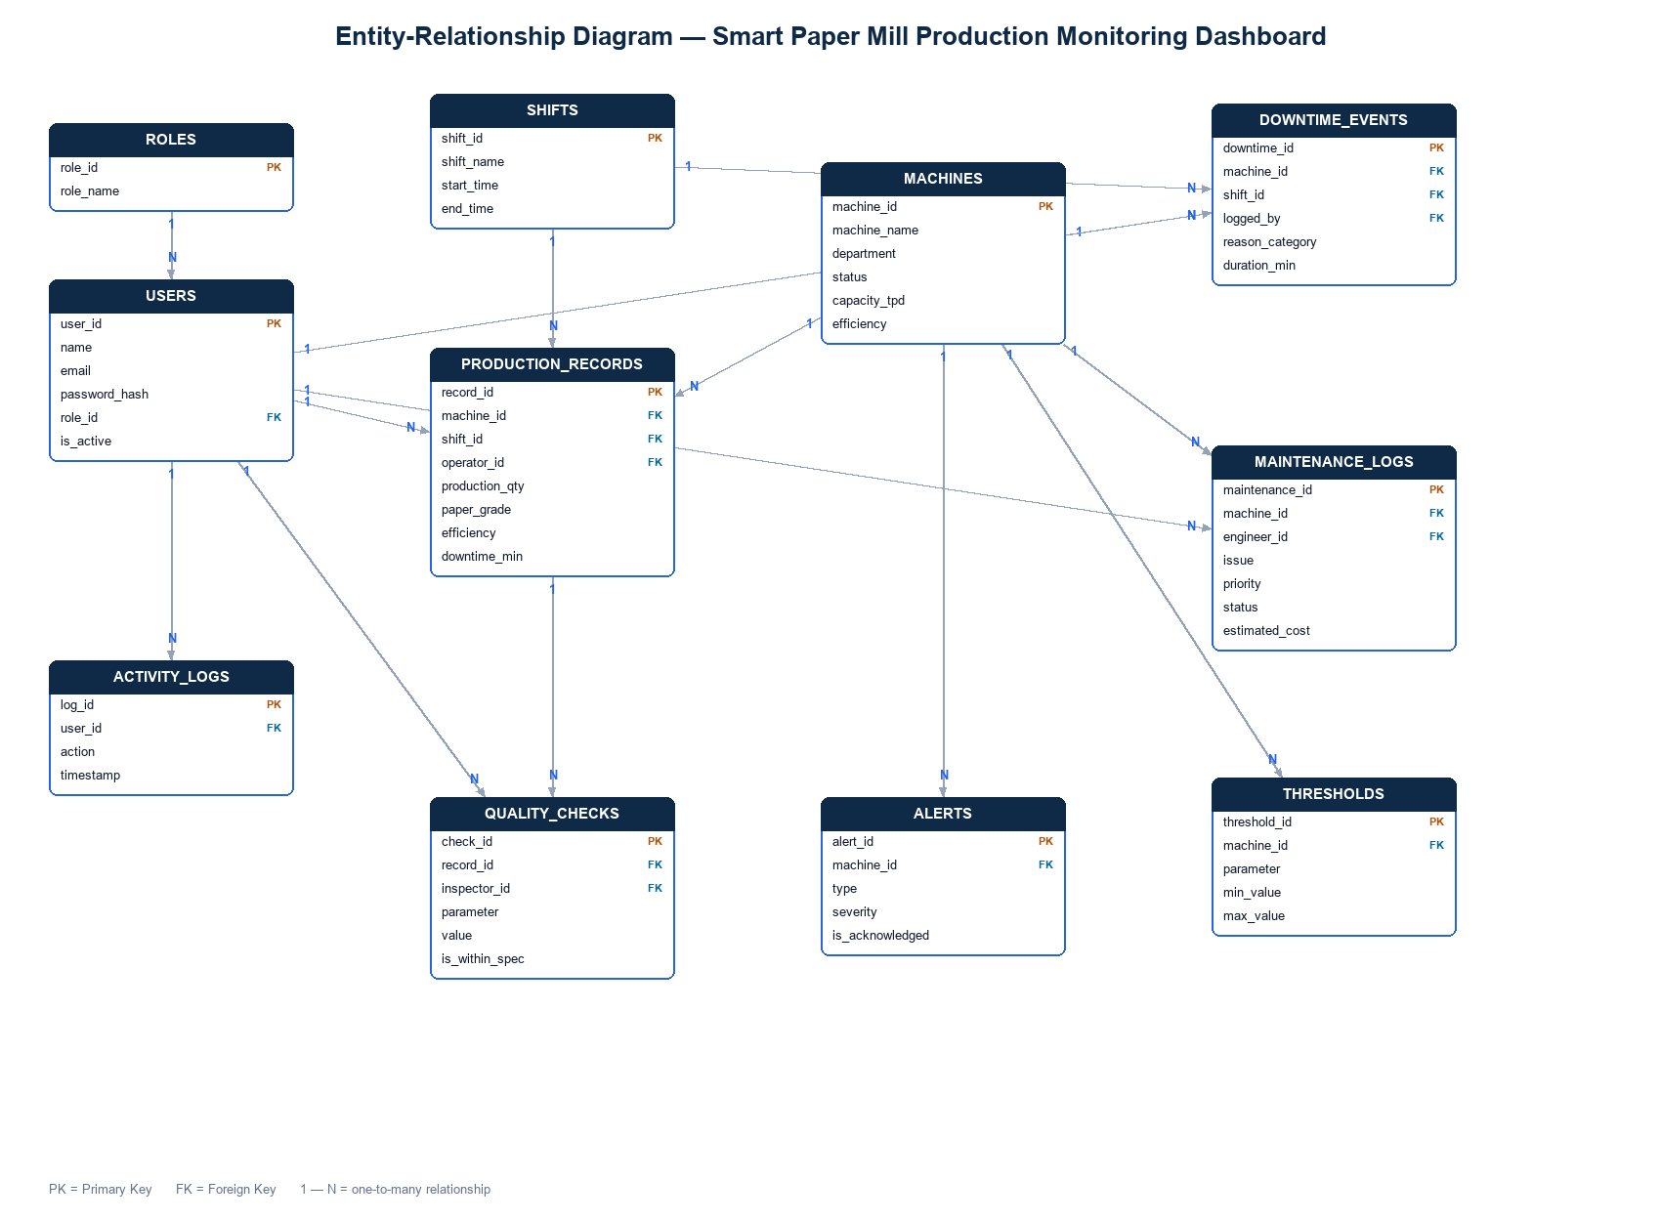
Figure : Entity-relationship diagram of the database schema
The technologies used are summarised in Table 1.
Table : Technology stack
Layer | Technology | Purpose
Front-end | HTML5, CSS3, JavaScript | Structure, styling, interactivity
Charts | Chart.js | KPI and trend visualisation
Backend | Python (Flask) | REST API and static file serving
Database | SQLite | Persistent storage
Security | bcrypt, PyJWT | Password hashing and token authentication
Real-time | Server-Sent Events | Live telemetry push
Testing | pytest | Automated backend tests

5. Modules
The application is organised into the following modules, listed in Table 2.
Table : Application modules
Module | Function
Authentication | JWT login, role-based access, session handling
Dashboard | KPI cards (incl. average OEE), trend and status charts, live efficiency feed
Machine Monitoring | Status board with live temperature and efficiency via SSE
Production Entry | Records output, GSM, moisture and speed; flags out-of-spec readings
Downtime Logging | Logs events with reason and automatically computed duration
Maintenance | Logs and tracks maintenance jobs by priority and status
Reports | Filterable charts, OEE by machine, CSV and PDF export
Alerts | Threshold-driven alert panel with acknowledgement
Admin Panel | Manage users, machines and thresholds; view the audit log

6. Working
On launching the application, the user signs in and a JSON Web Token is issued. Each protected request carries this token, and every protected route enforces a role check. After login, the dashboard presents summary indicators, charts and a live efficiency figure that is updated every few seconds from a Server-Sent Events stream pushed by the backend. Operators record production data, including grammage, moisture and speed, through validated forms; readings that fall outside the configured tolerance are flagged. Supervisors log downtime events, for which the duration is computed automatically. All data is persisted to the SQLite database, so it survives a server restart. The Reports module aggregates the data into charts that can be filtered by period, machine and shift and exported as CSV or PDF. Administrators manage users, machines and thresholds and review the audit trail through a dedicated administrative panel.

7. Advantages
- Consolidates production, quality, downtime and machine information within a single, secure interface.
- Presents information visually through charts and colour-coded indicators for rapid interpretation.
- Uses real authentication (bcrypt and JWT) with role-based access control and an audit trail.
- Delivers live data to the browser without manual page reloads.
- Built entirely with free and open-source tools and runs on standard hardware.
- Validated by an automated test suite, improving reliability and maintainability.

8. Limitations
- The system operates on simulated data and is not yet connected to live sensors or a plant control system.
- Persistence uses SQLite; migration to MySQL is required for a multi-user production deployment.
- The application has not yet been deployed to a public cloud host.
- Predictive and analytical capabilities, such as equipment-failure prediction, are not included.

9. Future Scope
- Integrate real sensors and PLCs using industrial protocols such as OPC-UA or Modbus.
- Add predictive maintenance using statistical or machine-learning techniques.
- Migrate the database to MySQL and deploy to a free cloud tier for a live demonstration.
- Add a dedicated quality-inspection module and a read-only viewer role.
- Provide a mobile application and automated report scheduling by electronic mail.

10. Conclusion
The industrial training project delivered a functional, secure and tested web-based dashboard for monitoring the production activities of a paper manufacturing plant. The system consolidates production, quality, downtime, maintenance and machine information within a single role-based interface, computes Overall Equipment Effectiveness, delivers live telemetry, raises threshold-based alerts, provides analytical reports with export and includes a complete administrative panel and audit trail. The principal deviation from the original specification is the absence of live plant instrumentation, which was deliberately replaced by a realistic simulator suitable for an academic setting. The modular design and accompanying database schema provide a clear path towards a full production deployment, and the project met the objectives established at its commencement.

