PROJECT REPORT
Automated Regression Testing of the SauceDemo Web Application
using Playwright and JavaScript
Submitted by: Manreet Gill
Roll No.: 24BCS10479
Course: BE-CSE
Date: 26 October 2026
Source code: https://github.com/gillmreet01/saucedemo-regression-tests

1. Introduction
Regression testing checks that features that worked before still work after the application changes. Doing this manually every time is slow and error-prone, so it is a good candidate for automation. This project builds an automated regression suite for SauceDemo (https://www.saucedemo.com), a public demo e-commerce website created for practising test automation. The suite is written in JavaScript using the Playwright Test framework.

2. Objectives
- Set up a clean, beginner-friendly Playwright + JavaScript project.
- Automate regression test cases for login, product listing and sorting, cart, checkout and logout.
- Use proper assertions to verify expected behaviour.
- Generate readable test reports, with screenshots, video and traces for failures.
- Keep the code simple so that it can be understood and explained easily.

3. Scope

3.1 In scope
- Login with valid, invalid, locked-out and empty credentials, and access protection of the inventory page.
- Product list display and two sort options (name A-Z, price low-high).
- Adding and removing items, cart badge, and cart page contents.
- Checkout form validation (first name, postal code), order overview and order completion.
- Logout.

3.2 Out of scope
- Performance, security and accessibility testing.
- Other demo users (problem_user, performance_glitch_user, error_user, visual_user).
- Cross-browser and mobile testing (only Chromium is configured).
- Product detail page, Continue Shopping and Cancel buttons, tax and total amounts.

4. Tools and Technologies
Tool | Purpose
JavaScript (Node.js) | Programming language and runtime
Playwright Test (@playwright/test) | Browser automation, test runner and assertions
Chromium | Browser used for execution
HTML reporter | Test report generation
VS Code, Git, GitHub | Development, version control and hosting

5. Project Structure
saucedemo-regression/
|-- playwright.config.js settings: base URL, reporters, screenshots
|-- package.json dependencies and npm scripts
|-- pages/ Page Object classes
| |-- LoginPage.js
| |-- InventoryPage.js
| |-- CartPage.js
| `-- CheckoutPage.js
|-- tests/ one test file per feature
| |-- login.spec.js
| |-- products.spec.js
| |-- cart.spec.js
| |-- checkout.spec.js
| `-- logout.spec.js
|-- utils/
| `-- testData.js users, products, customer details
`-- docs/ test plan and test cases

6. Design and Approach

6.1 Page Object Model
Each page of the application has a class in the pages folder. The class stores the locators of the elements on that page and the actions a user can perform (for example login(), addToCart(), sortBy()). The tests only call these methods. If the page layout changes, only the page class needs updating, which makes the suite easier to maintain.

6.2 Setup with beforeEach
Most tests need a logged-in user. Each spec file uses a beforeEach hook that opens the site and logs in with the standard user before every test. The checkout spec also adds the backpack to the cart and opens the checkout form. This keeps every test short and gives each one the same starting point.

6.3 Test data
Usernames, the password, product names and customer details are kept in utils/testData.js, so the tests contain no hard-coded values and data can be changed in one place.

6.4 Locators and assertions
Elements are located using stable data-test attributes. Assertions use Playwright web-first assertions such as toHaveURL, toHaveText, toContainText, toHaveCount and toBeVisible. These wait automatically (up to 5 seconds) until the condition is met, which avoids fixed sleeps and flaky tests.

6.5 Test independence
Playwright creates a fresh browser context for every test, so cookies, cart contents and sessions never leak between tests. This allows the suite to run in parallel.

7. Test Cases
A total of 17 test cases were automated. Each test case is identified by an ID in the test title.
ID | Feature | Scenario | Expected result | Status
TC01 | Login | Valid user logs in | URL contains inventory.html; page title is "Products" | Pass
TC02 | Login | Wrong password | Error says username and password do not match | Pass
TC03 | Login | Locked-out user | Error says the user has been locked out | Pass
TC04 | Login | Empty username | Error: "Username is required" | Pass
TC05 | Login | Empty password | Error: "Password is required" | Pass
TC06 | Login | Open inventory page without login | Error says you can only access it when logged in | Pass
TC07 | Products | Product listing | Exactly 6 products are shown | Pass
TC08 | Products | Sort by name A to Z | First product is "Sauce Labs Backpack" | Pass
TC09 | Products | Sort by price low to high | First product is "Sauce Labs Onesie" (the cheapest, $7.99) | Pass
TC10 | Cart | Add one item | Cart badge shows 1 | Pass
TC11 | Cart | Add two items | Cart badge shows 2 | Pass
TC12 | Cart | Remove item | Cart badge disappears | Pass
TC13 | Cart | View cart | Cart page lists the added item | Pass
TC14 | Checkout | Complete purchase end to end | Overview page opens; confirmation "Thank you for your order!" | Pass
TC15 | Checkout | First name missing | Error: "First Name is required" | Pass
TC16 | Checkout | Postal code missing | Error: "Postal Code is required" | Pass
TC17 | Logout | User logs out | Returns to login page; Login button visible | Pass

8. Execution and Results

8.1 How to run
npm install
npx playwright install chromium
npm test
npm run report

8.2 Result summary
Item | Result
Browser | Chromium (headless)
Workers (parallel) | 5
Total tests | 17
Passed | 17
Failed | 0
Total execution time | 18.6 seconds

All 17 tests passed against the live SauceDemo website. Screenshots of the run are shown in Section 9.

9. Screenshots
The screenshots below were taken while running the project on a Windows machine in VS Code.

9.1 Test execution in the terminal
npm test runs all 17 tests with 5 parallel workers. Every test shows a green tick and the summary reads "17 passed (18.6s)".
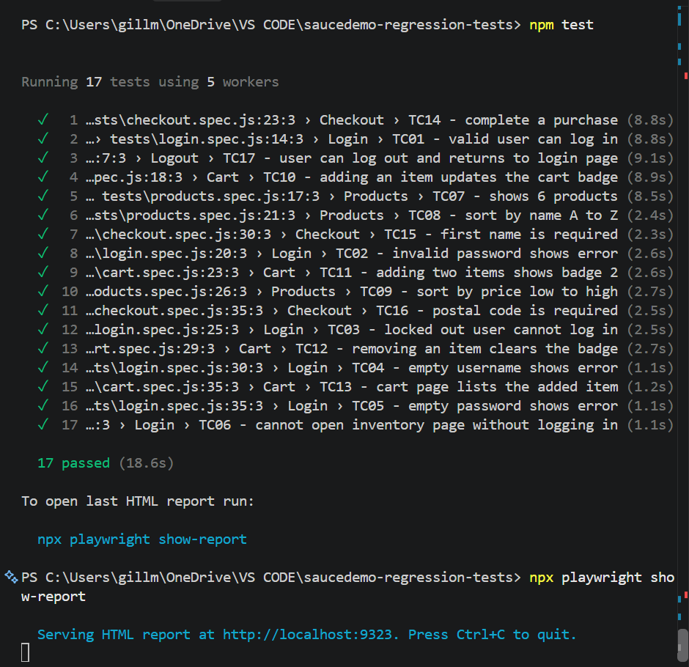
Figure 1: Terminal output of npm test, 17 passed

9.2 Generating the HTML report
After the run, npm run report starts a local server and serves the HTML report at http://localhost:9323. The report shows All 17, Passed 17, Failed 0, Flaky 0, Skipped 0, with the run time of 18.6 s and each test with its duration.
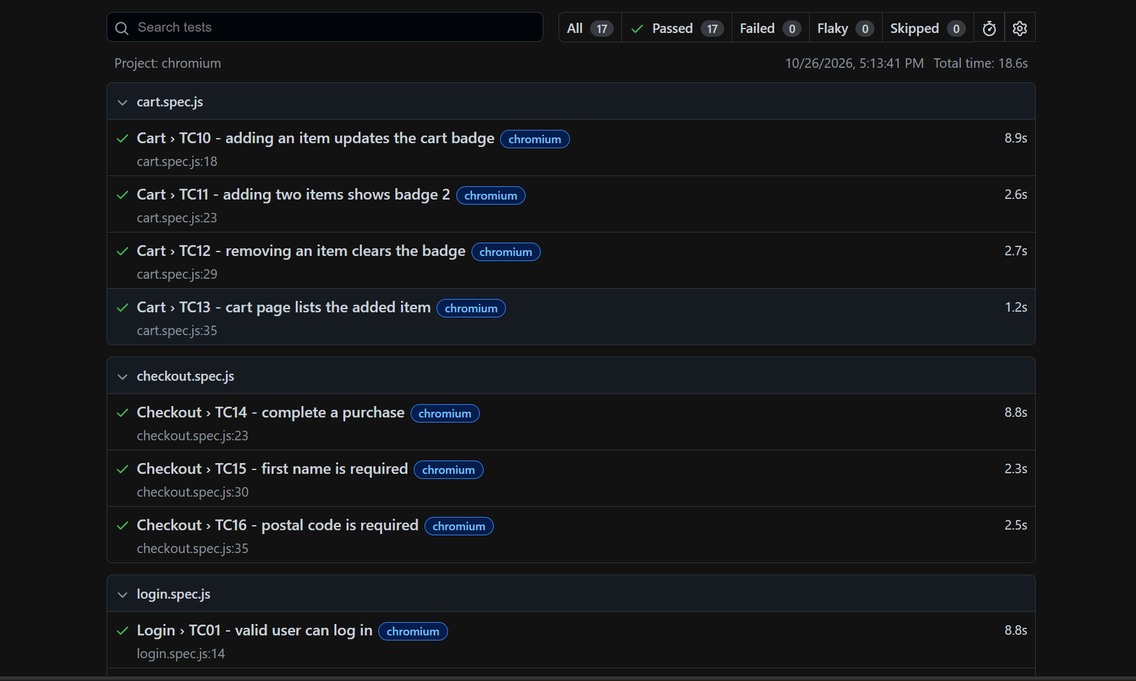
Figure 2: Playwright HTML report at localhost:9323 (17 passed, 0 failed, 18.6 s)

10. Reporting
The configuration uses two reporters. The list reporter prints each test result live in the terminal. The HTML reporter creates the playwright-report folder; it is opened with npm run report and shows every test with its status, duration and steps. For failed tests, a screenshot, a video and a trace are retained automatically in the test-results folder to help find the cause.

11. Challenges Faced
- Running npm commands from the wrong folder (the zip created a nested folder), which gave a package.json not found error. Solved by moving into the inner project folder.
- Choosing reliable locators. Solved by using data-test attributes.
- Avoiding repeated login code in every test. Solved with a beforeEach hook that logs in first.
- Publishing to GitHub: a placeholder repository URL and an existing remote commit caused push errors. Solved by correcting the remote URL and force-pushing the project.

12. Conclusion
The project delivers a working automated regression suite for the main user journeys of SauceDemo. It is built with a clear structure (Page Objects, beforeEach setup, separate test data), uses proper assertions, and produces reports. The suite can be re-run with a single command after any change, which demonstrates the value of test automation.

13. Future Scope
- Run on Firefox and WebKit by adding projects to the configuration.
- Add more tests: sort Z to A and high to low, last name validation, cart reset after an order, and the other demo users such as problem_user and performance_glitch_user.
- Run the suite automatically on every push using GitHub Actions.
- Add visual comparison and API tests.

14. References
- Playwright documentation: https://playwright.dev
- SauceDemo application: https://www.saucedemo.com
- Project repository: https://github.com/gillmreet01/saucedemo-regression-tests

