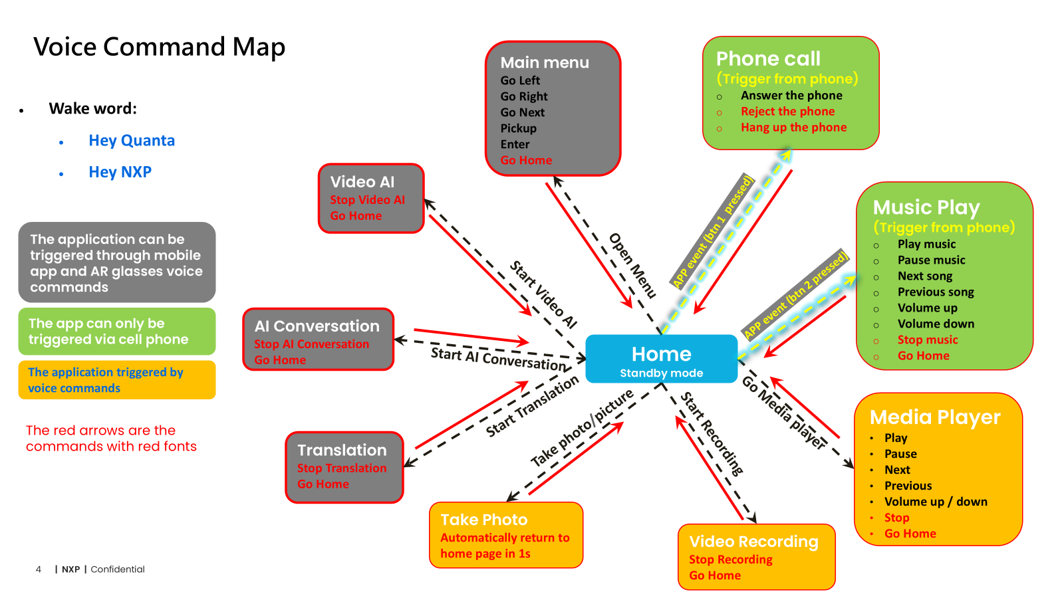

Memory map:

//first 0.5M Byte
0x00,0000, size 0x4,0000 --- AudioIO DMA buffer
0x04,0000, size 0x2,0000 --- DSP uncached
0x06,0000, size 0x2,0000 --- DSP uncached, shared mem with DSP

//next 1.5M Byte
0x08,0000, size 0x18,0000 --- MCU code and data (1.5M byte, covers os heap: 300K byte)

//next 2.5M Byte
0x20,0000, size 0x28,0000 --- DSP code and data (2.5M)

