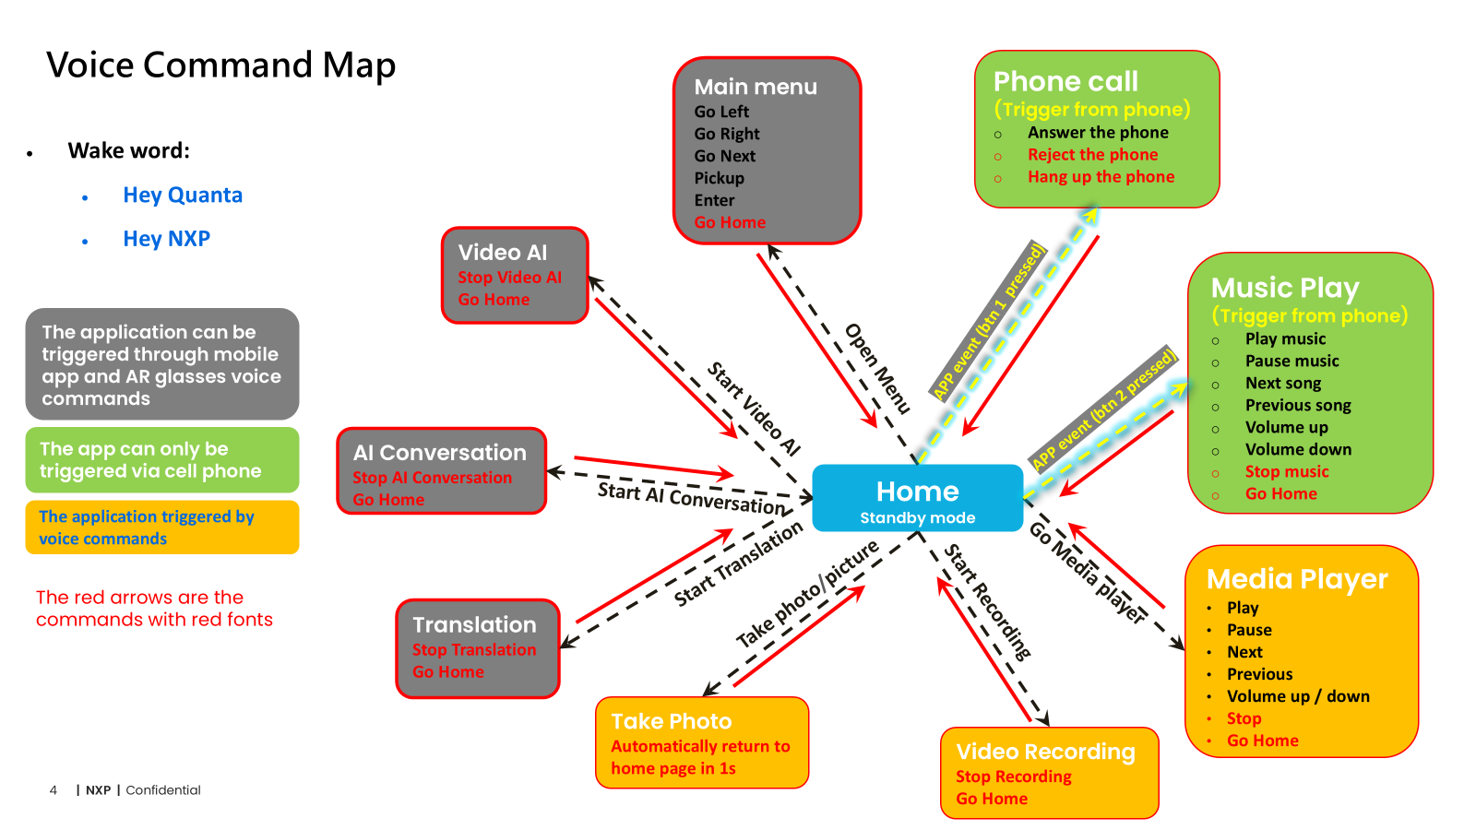

Memory map:

//first 0.5M Byte
0x00,0000, size 0x4,0000 --- AudioIO DMA buffer
0x04,0000, size 0x2,0000 --- DSP uncached
0x06,0000, size 0x2,0000 --- DSP uncached, shared mem with DSP

//next 1.5M Byte
0x08,0000, size 0x18,0000 --- MCU code and data (1.5M byte, covers os heap: 300K byte)

//next 2.5M Byte
0x20,0000, size 0x28,0000 --- DSP code and data (2.5M)

AudioPortI2SAndPdmCfg:
bit 0~1: I2S_Amp Fs: 0,1,2,3 -> 16K, 32K, 44.1K, 48K
bit 2~3: I2S_Amp Bit: 0,1,2 -> disabled, 16, 32bit

bit 4~5: I2S_Nvt Fs: 0,1,2,3 -> 16K, 32K, 44.1K, 48K
bit 6~7: I2S_Nvt Bit: 0,1,2 -> disabled, 16, 32bit

bit 8~9: PDM Fs: 0,1,2,3 -> 16K, 32K, 44.1K, 48K
bit 10~15: PDM ch enable

Call type:

HfpAppCall
Call out --- not answered
Call out --- answered
Call in --- not answered
Call in --- answered
HfpTelCall
Call out --- not answered
Call out --- answered
Call in --- not answered
Call in --- answered

A2dp play streaming: sbc frame 528, 20ms, seems to be always 44100KHz, but support
#define SBC_SAMPLING_FREQ_16000 0
#define SBC_SAMPLING_FREQ_32000 1
#define SBC_SAMPLING_FREQ_44100 2
#define SBC_SAMPLING_FREQ_48000 3

OPus file decoding:
Each time read 4096 byte, but consumed byte number is variable
Each time 20ms samples are generated. 20*48 or 20*16 samples (per channel)
16KHz: output 20*16 samples
44.1KHz: output 20*44.1 samples
48KHz: output 20*48 samples

Sbc file decoding:
Each time read variable length byte, but consumed byte number is variable

16KHz: output 128 samples, from decoding 129 bytes
44.1KHz: output 128 samples, from decoding 47 bytes
48KHz: output 128 samples, from decoding 43 bytes

Sbc stream (from BT) decoding:
Sbc frame： need to cut first 13 bytes, frame is mostly 581 bytes, but can be a little less.

Software Threads:

Mcu:
Audio DMA intr trigger Task_McuAudioFrameProc trigger DSP MU
Manager_Task

Dsp:
MU interrupt trigger Task_DspAudioFrameProc trigger Task_VitAndAudioDec trigger Mcu MU
|
trigger Task_AlgoContainerProc

MU interrupt trigger Task_DspAudioFrameProc trigger Task_VitAndAudioDec
|
trigger Task_AlgoContainerProc trigger Mcu MU

