# Design

What I want to use for my visualisations are graphs where I can compare seasons of a single competition with each other.

Like this example, there is a legend with this graph but it wouldn’t fit on the print screen.

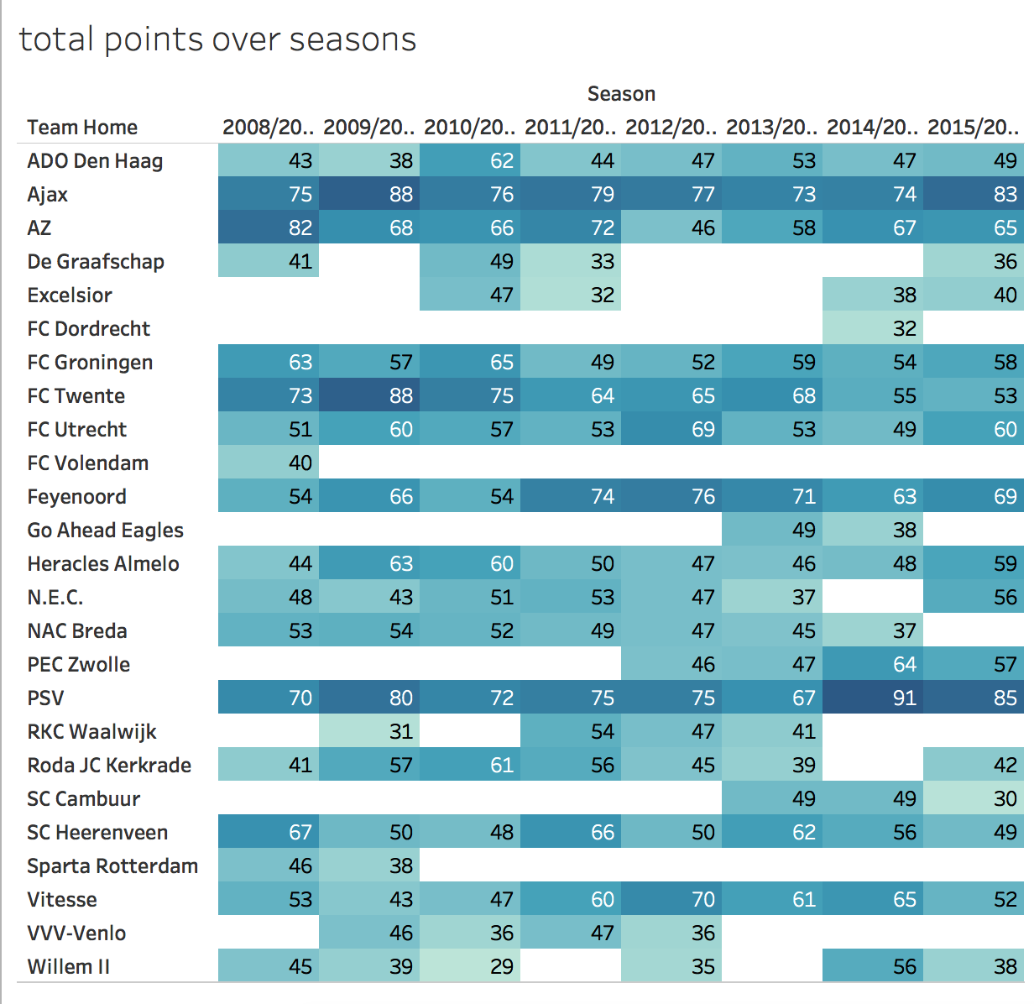

I want to give an overview off total points gathered over multiple seasons by a team. With information like this in comparison to home/away goals you could already give an indication whether playing at home or away would benefit you.

Like this graph.

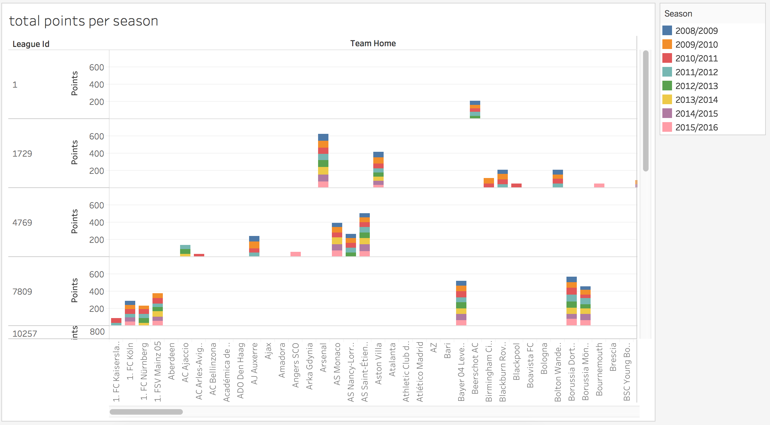

For the main conclusion of my question whether you’ll benefit from playing at home vs away, I want to draw a graph that will show comparisons between points gained from home games vs points gained from all games.

Like this graph.

