# Exploration

## Core message

The thing I want to proof with my visualisations is that there is an advantage of playing home games instead of away games.

## Visualisations

The circle diagram shows the total points of one season of the Belgium pro league and the circle parts are points gathered by one team.

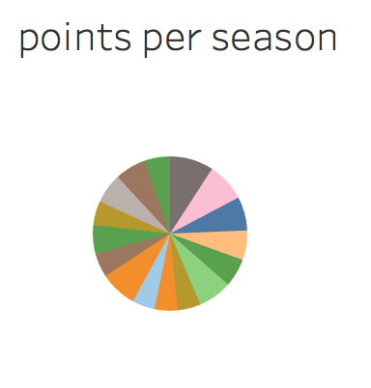

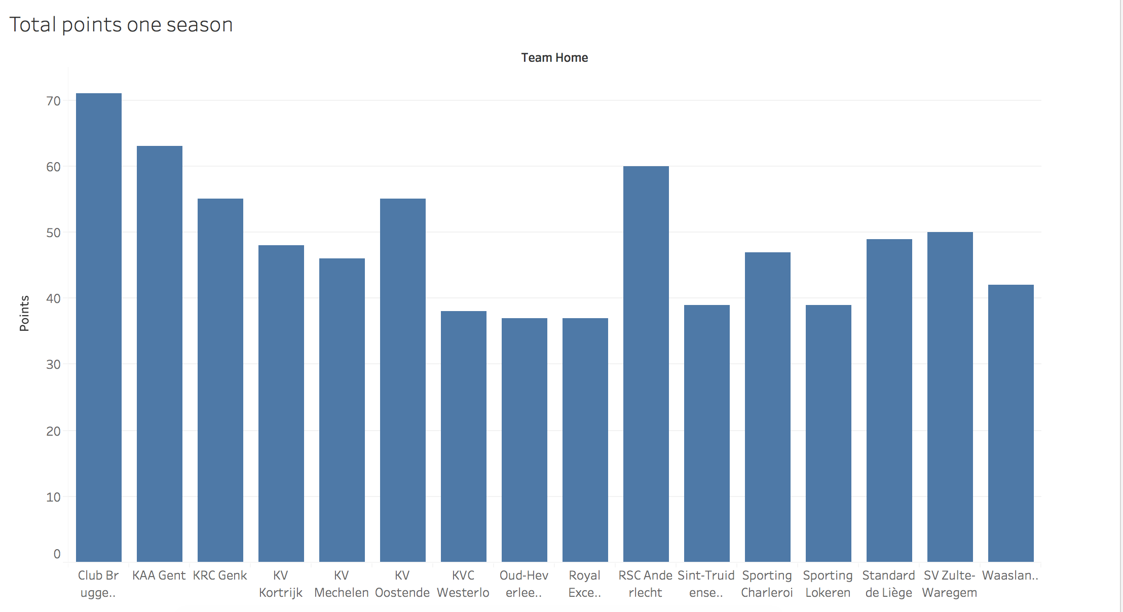  
This chart shows the same data only in another format.

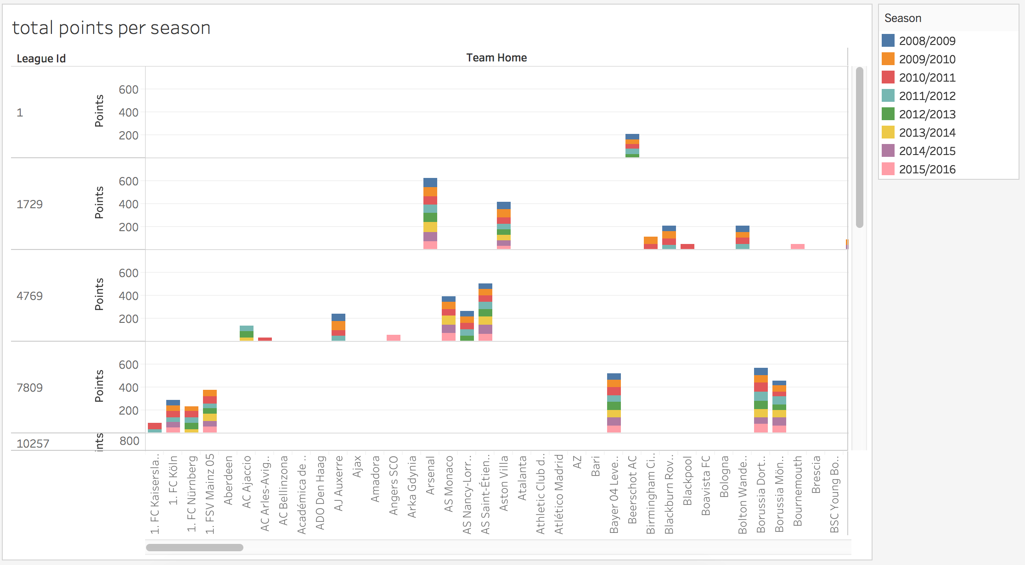

The graph above shows the total points of a team per season of all competitions.

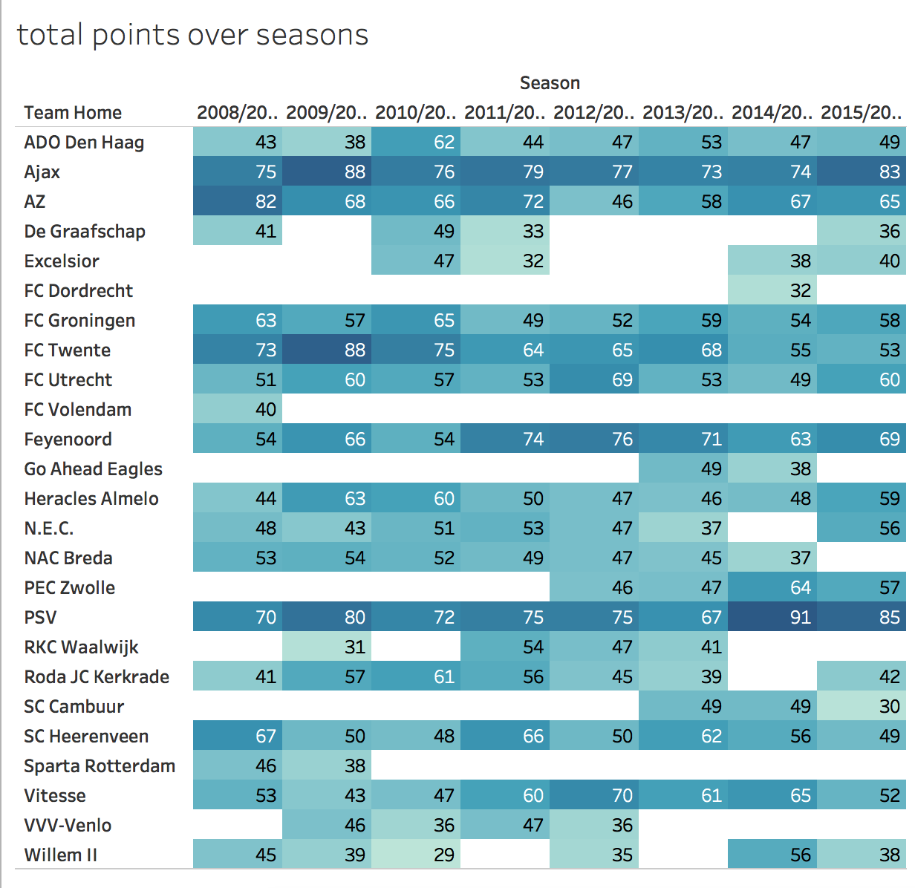

Another kind of overview of all points gathered by a team per season.

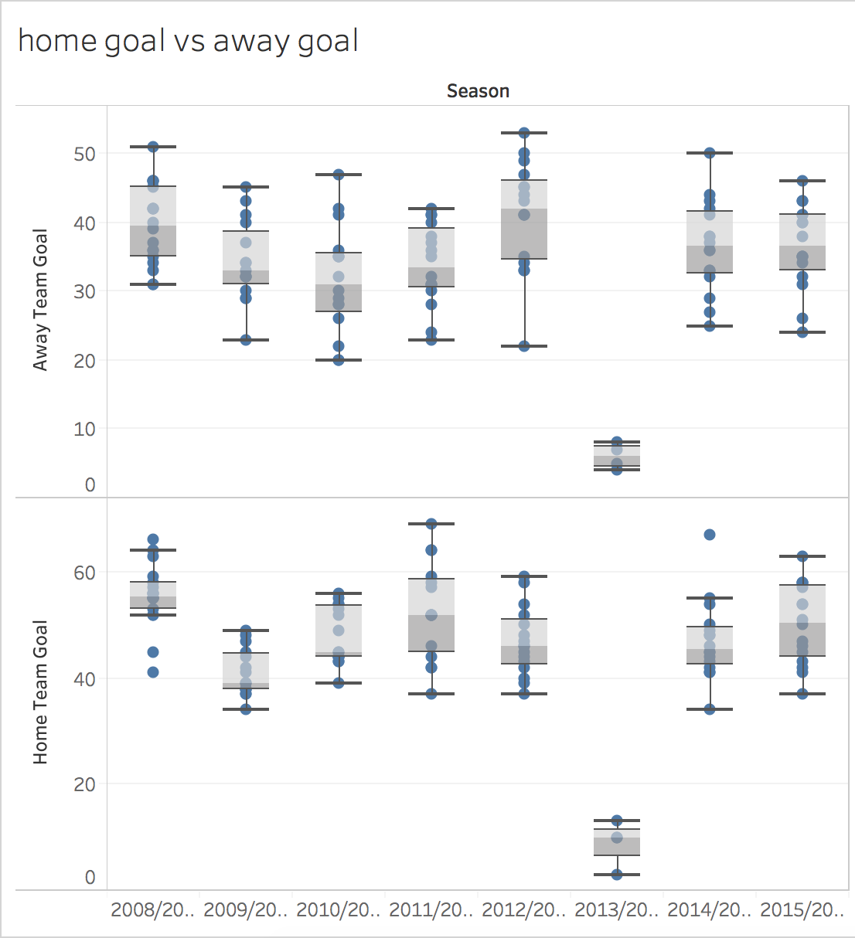

A graph that shows a complete difference between home and away goals per season.