THE PENNSYLVANIA STATE UNIVERSITY

SCHREYER HONORS COLLEGE

DEPARTMENTS OF BIOLOGY AND PSYCHOLOGY

ADULT OBSERVERS’ SENSITIVITY TO OPTIC FLOW VARIES

BY PATTERN AND SPEED

WILLIAM ADAMIAK

SPRING 2015

A thesis

submitted in partial fulfillment

of the requirements

for a baccalaureate degree

in Biology

for interdisciplinary honors in Biology and Psychology

Reviewed and approved* by the following:

Rick Owen Gilmore

Associate Professor of Psychology

Thesis Supervisor

Gong Chen

Professor of Biology

Honors Adviser

Richard Alan Carlson

Professor of Psychology

Honors Adviser

* Signatures are on file in the Schreyer Honors College.

ABSTRACT

In adults, radial optic flow evokes stronger brain activity than linear or rotational flow. Optic flow also evokes different activation patterns depending on motion speed (Fesi et al., 2014). This study examined whether the detection of optic flow in adult observers varies by pattern and speed in ways consistent with prior physiological evidence. Adult observers viewed two side-by-side, time varying optic flow displays that varied in pattern type and speed while judging which side contained coherent motion. As predicted, proportion correct judgments increased with motion coherence, and the response time of correct judgments declined. Observers more rapidly and accurately detected radial flow patterns, but there were no main effects of speed. Taken together the results suggest that behavioral sensitivity to detect optic flow in noise varies by pattern type and speed, in ways partially consistent with prior physiological results.

TABLE OF CONTENTS

ACKNOWLEDGEMENTS V

Chapter 1 Background 1

Chapter 2 Methods 7

Participants 7

Display 7

Procedure 8

Analysis 9

Chapter 3 Results and Data Analyses 10

Chapter 4 Discussion 12

Appendix A List of Figures 13

BIBLIOGRAPHY 22

**Table of Figures**

Figure 1: Types of Optic Flow Patterns. Linear is also known as translational. 17

Figure 2: Experimental Set Up. Translational Coherent Motion in Left Display 17

Figure 3: Graph of Individual Percent Correct by Coherence, Pattern, and Speed 20

Figure 4: Box Plots of Response Times by Coherence, Pattern, and Speed 21

List of Tables

Table 2: Descriptive Statistics of Response Time by Pattern, Coherence and Speed 18

Table 3: Descriptive Statistics of Percent Correct by Pattern, Coherence, and Speed 18

Table 4: Response Time ANOVA by Pattern, Coherence, and Speed 19

Table 5: Percent Correct ANOVA by Pattern, Coherence, and Speed 19

ACKNOWLEDGEMENTS

I would like to thank…

# Background

Mobile organisms must accurately determining their direction of self-motion, or ego-motion, as they move through an environment. In activities like driving, sports, or everyday ambulation, motion perception is vital. The visual system is constantly responsible for picking up details about objects in densely populated environment, like edges, contours, colors, and shades. The brain compiles these visual stimuli to supply an organism with its percept of an environment. These details alone are not sufficient for the brain to comprehend every feature of an environment. For full mapping of the 3D layout of a setting, more information much be gathered about depth. The addition of motion in an environment and the resulting perceived motion perception is what provides the necessary details about depth in a 3D environment.

A moving observer or object generates what is known as optic flow. Optic flow provides a depth map of 3D layout and allows perceivers to steer in complex environments and perceive events (Pan & Bingham, 2013). In a stationary visual environment, the only available perceptual input is image structure. Adding events, or motion, allows for the perception of change in an environment. The brain is able to extract spatial information from motion by comparing the differences between the distinct still frames that exist within events. From motion perception, organisms are able to perceive their direction of heading as they move through an environment. Perceived heading enables organisms to control body posture, avoid collisions, and quickly and efficiently move through their environments (e.g., Gilmore, Baker, & Grobman, 2004).

The concept of optic flow was originally intended to describe the pattern of motion that occurs on the retinae as an organism moves (Gibson, 1950). Optic flow consists of the various streams of motion that come from features of the surrounding environment during self-motion (Cutting et al., 1992). An organism’s perception of optic flow provides information about the direction and speed of the observer and the layout of surfaces in the environment (Gibson, 1979). Regional differences in optic flow create what is referred to as motion contrast, which allows for visual segmentation between different objects in an environment. Essential to the concept of optic flow are the concepts of local motion and global motion.

Local motion processing refers to the brain’s detection of direction and speed of motion at a particular point in space (Weinstein et al., 2012) and within a small region surrounding it. This can be understood by thinking about the motion of a single dot upon a screen. Perception of biological motion, which is the visual signal associated with a moving, animate object, requires the integration of local motion information over time and space (Freire et al., 2005). The integration of local motion signals gives rise to what is known as global motion. Global motion refers to the patterns generated by a group of points in space displaying coherent, synchronous motion. Computational analysis has been able to show that all optic flow patterns can be decomposed into a combination of basic vector fields of global motion (Koenderink, 1986). The basic patterns of optic flow that are generated by global motion detection include linear flow, radial flow, rotational flow, and shear flow or deformation (Figure 1). Radial flow is considered to be the dominant pattern of optic flow. Radial expansion would be associated with forward translation through depth (De Jong et al., 1994).

After being received by the eyes, visual inputs are processed differentially by specific brain areas. Numerous physiological and behavioral studies have been dedicated to learning which brain areas are activated during the various aspects of motion processing. In primates, motion signals are captured by motion direction selective cells in the primary visual cortex, or V1 (Hubel & Wiesel, 1968). This part of the cerebral cortex is responsible for processing the simple visual information received from the eyes. Much is still unclear about the how the brain conducts higher order motion processing. Past neurophysiological studies conducted on both monkeys and humans have helped to establish the importance of the middle temporal (MT) area of the macaque and its homologous area in humans, V5 or hMT. This brain area has been shown to play a vital role in motion integration (Born & Bradley, 2005; Britten et al., 1992). Experimental lesions to this area in the macaque causes selective impairment to the organism’s motion perception abilities (Newsome & Pare, 1988). A number of recent fMRI studies have implicated other brain regions in playing roles in motion perception. In response to viewing different types of global motion patterns, the areas V6 (Cardin & Smith, 2010; Cardin et al., 2012), human MST (Cardin et al., 2012), and the posterior cingulate (Fischer et al., 2012) have been shown to be differentially activated, depending on the stimulus type.

Another branch of research has focused on how these brain areas and their activation change over the course of human development. One method of doing this is comparing the steady-state visual evoked potential (SSVEPs) response profiles, which are measured using electroencephalography (EEG), of infants and adults. Current research suggests that there is a prolonged developmental period before the fully mature motion processing network is established. Adults and infants show similar SSVEP response profiles to local motion, but strongly differ in response to rotational optic flow patterns with temporally modulating motion coherence (Hou et al., 2009). Infants show the strongest brain responses to stimuli at large displacements/fast speeds, while adults show strongest responses at small displacements/slow speeds, indicating a clear developmental change in the motion perception brain network. Behavioral studies have been performed on both monkey (Kiorpes & Movshon, 2004) and human children (Hadad, Maurer, & Lewis, 2010) to support the physiological evidence of this sensitivity shift. For specific optic flow patterns, infants show the largest SSVEPs to direction-reversing linear flows and adults show the largest SSVEPs to radial flows (Gilmore et al., 2007). This finding verifies that the human visual system undergoes prolonged development in higher order motion processing.

To further understand motion processing within adults, Fesi et al., (2014) investigated the effects of pattern and speed of optic flow patterns on SSVEP response sensitivity. The results of the study indicated that the evoked cortical responses associated with the temporal modulation of coherent global motion do indeed differ across different patterns and speeds, although the effects of each vary by channel, or brain area. SSVEP responses in the medial and lateral channels were found to be stronger for radial optic flow patterns than for translation or rotation. The distribution of the brain responses to radial flow differed when speed was altered. At slow speeds, strong bilateral activation was seen, while more dorsomedial activation was seen at faster speeds. Similar shifts were seen in the other flow patterns as well but to a lesser degree. Across all three patterns, SSVEP amplitudes increased as speed increased. At faster speeds, responses to all patterns looked increasingly similar, indicating pattern general motion processing at high speeds. Taken together, these findings indicate differential recruitment of brain circuits sensitive to different speed and pattern combinations.

The lateral brain activation patterns seen in response to radial flow are likely associated with the activation of hMT or MST brain area. As previously stated, radial flow is the dominant pattern of optic flow and is representative of an observer experiencing forward translation through depth (De Jong et al., 1994). Many studies have already identified MST as being important in detecting the flow patterns associated with self-motion (Duffy & Wurtz, 1991, 1997; Huk, Dougherty, & Heeger, 2002; Komatsu & Wurtz, 1988).

The medial occipital cortex activation seen in response to slow rotation and translation likely represent less dominant optic flow components that are imposed by head and eye movements. The optic flow patterns associated with these movements are less likely to reflect the structure of the 3D environment in which the observer is immersed (Britten, 2008). The pattern ambiguous activation of the dorsomedial occipital brain regions likely reflects activity in area V3a. This area, and surrounding areas such as V7, regions of the intraparietal sulcus, V6, and the posterior cingulate, have been shown to be involved in various aspects of depth processing (Backus et al., 2012), spatial attention (Behrmann, Geng, & Shomstein, 2004), motor intentions (Andersen et al., 2012), and navigation (Bremmer, 2005). It is likely that these brain areas, being activated by slow rotation and translation, are sensitive to changes in depth structure of an environment, as opposed to forward translation through that environment.

Together, the results of Fesi et al. (2014) suggest that optic flow patterns engage a network a brain areas beyond lateral regions such as MT and MST, as had been assumed in prior studies (Hou et al., 2009; Wattam-Bell et al., 2010). This research is important as it contributes to the understanding of adult brain function and proper development of global motion sensitivity. Measuring SSVEP responses to optic flow stimuli has been used to evaluate perceptual deficits in patients with cerebral visual impairment (CVI) such as amblyopia and strabismus (Weinstein et al. 2012). Continued research into optic flow and associated brain activity could potentially lead to development of perceptual tests to supplement standard visual examinations.

The purpose of the current study is to extend the findings of Fesi et al. (2014) by testing whether behavioral evidence supports the physiological brain activation patterns caused by optic flow. In other words, this study investigates whether heightened brain activity corresponds to a facilitated identification of optic flow patterns. The study examines the effects of coherence level, pattern, and speed on how successful participants are at discriminating between global motion and random noise. It is predicted that coherence level will have a strong effect on participants’ success rates and also their response rates. Based on the findings that SSVEPs were stronger for radial than other flow patterns, and also at higher speeds, it is predicted that participants will have an easier time identifying radial flow at high speeds. An interaction effect between pattern and speed is also predicted due to the finding in Fesi (2014) that brain responses to all patterns became increasingly similar at high speeds.

# Methods

## Participants

30 adults (14 male, 16 female; age range: 18.7-23.9; mean age: 20.8 years) were recruited from the Pennsylvania State University campus to participate in the study. Subjects were recruited from an undergraduate subject pool for credit or were given $10 per hour for their participation. All participants had normal vision or wore glasses or contact lenses. One participant’s data was removed from analysis for failure to follow task instructions.

## Display

The stimulus was generated using the program MATLAB on an iMac desktop computer. The program produced a display that consisted of a fixation point in between two circular random dot kinematogram displays. Each trial, one of the dot displays exhibited a coherent global motion pattern while the other exhibited completely random (0% coherent) dot motion (Fig. 2). Two separate dot display programs were made. In one, the dots of the kinematogram display moved at 2 deg/s and in the other the dots moved at 8 deg/s. Each program consisted of 4 blocks of 16 trials each.

## Procedure

After securing informed consent, participants were guided to a dimly lit room for testing. Participants were given a brief explanation of local motion, global motion, and optic flow and then situated at a distance of 60 cm directly in front of the testing monitor. Participants were instructed to fixate on the dot in the center of the display and to use their peripheral vision to discern which of the displays was exhibiting an optic flow pattern. They were informed about the 10 second response limit and that their response times were being recorded. Participants used a keyboard to make their decisions, pressing the “z” key to choose the left and the “/ or ?” key to choose the right. Each participant was asked to complete two runs of 2 deg/s patterns and two runs of 8 deg/s patterns in an order that varied for each participant. Each run consisted of five testing blocks. The two optic flow patterns used were radial and translational motion. The four coherence levels used were 5%, 10%, 15%, and 20%. Each of the 8 combinations of coherence types and coherence levels appeared once on the left display and once on the right display for a total of 16 conditions within a block. A method of constant stimuli was used, and condition order varied randomly within a block. Participants were given the option to take a break half way through the experiment.

## Analysis

The MATLAB program delivered data outputs for each session that had both response times for each trial and percent chosen correctly. Custom R scripts merged and cleaned the files prior to analysis. RStudio was used for statistical analysis and generate summary plots. The effects of speed, pattern, and coherence were analyzed using repeated measures analysis of variance (ANOVA).

# Results

Prior to conducting statistical analyses, all data were plotted and evaluated visually. As a consequence, one participant's data (14) was eliminated from analysis for having chance or worse than chance performance even at the highest coherence levels. Table 1 shows the mean, standard error, and median response times by coherence, pattern, and speed. Figure 4 shows that response times decrease as coherence increases. Table 3 summarizes the results of a repeated measures analysis of variance (ANOVA) with pattern (linear and radial), coherence (0.05, 0.10, 0.15, and 0.20), and speed (2 and 8 deg/s) as fixed factors and reaction time as the response variable. There were significant main effects of coherence, *F* (1, 455) = 229.84, *p* < 2e-16 and pattern, *F* (1, 455) = 10.55, *p* = 1.25e-3, and a significant two-way interactions between pattern and coherence, *F* (1, 455) = 39.27, *p* = 3.85e-10. The interaction between pattern and coherence can be visualized in Figure 4 as a steeper decrease in mean response times to radial flow than to translational flow patterns as coherence level increases.

The means, standard errors, and medians of the total percent correct data are shown in Table 2. Individual success rates of the 30 participants by pattern, coherence, and speed are graphed in Figure 3. Repeated measures ANOVA tests were performed on the percent correct data in the same fashion as for response time. There were main effects of coherence *F* (1,471) = 423.42, *p* < 2e-16 and pattern *F* (1, 471) = 9.94, *p* = 1.72e-3, and a pattern by coherence interaction *F* (1, 471) = 19.48, *p* = 1.26e-5. At low coherence levels (0.05) participants were more successful at detecting linear flow (*M =* 0.54) than radial flow (*M=*0.49) patterns. As coherence levels increased, participants showed a steeper rate of improvement at identifying radial than linear flow. At high coherence levels (0.20), participants were more successful at identifying radial (*M*=0.96) than translational (*M*=0.86) patterns. This interaction effect can be summarized as an increased sensitivity to radial flow patterns compared to linear flow patterns, at high coherence levels.

# Discussion

Optic flow patterns and speeds influenced adult observers' abilities to detect coherent motion relative to noise. Participants were faster to detect coherent radial flow. A shorter response time indicates an easier time discerning between coherent global motion and random dot motion. Percent correct data offered parallel support to the response time data. Percent correct data analysis showed similar effects of coherence level and pattern type. Participants were more accurate in their identifications of global motion patterns for radial than translational flow. No main effect of speed was seen in either response time or percent correct data. This result indicates that adults are just as adept at identifying optic flow patterns at low speeds, 2 deg/s, as they are at high speeds, 8 deg/s under these unspeeded testing conditions.

The strong main effect of coherence level on response time and percent correct confirms prior predictions. The coherence level variable represents the percentage of dots in the display that are moving coherently. At the .05 coherence level, 95% of the dots in the display are still exhibiting random motion. The experimental data supports the logical assumption that it would be easier to detect optic flow patterns when a higher percentage of the display is exhibiting the pattern. The main effects of pattern type supported findings from a prior EEG study (Fesi et al. 2014). Fesi and colleagues found that radial global motion elicited stronger SSVEPs than linear motion responses in adults. The results of the current study provide evidence that human behavior in identifying different optic flow patterns varies in ways similar to brain responses. On the other hand, Fesi (2014) found an effect of speed, which was not seen in this experiment.

Interaction effects were found between pattern and coherence on both response time and percent correct data. Depending on pattern type, an enhancement of coherence level resulted in different rates of increase for success rate and decrease for response time. A faster increase was seen in success rate across coherence levels for radial than linear motion. Similarly, a faster decrease in response time was recorded across coherence levels for radial than linear motion. This interaction could possibly indicate that brain areas involved in radial motion perception, like hMT or MST, are more sensitive to increases in coherence level than are the brain areas involved in linear global motion perception, like V3a, V6, and V7. This is speculative since no predictions were made about this hypothesis because Fesi (2014) did not involve altering coherence.

Despite the prediction that speed would have an effect on response time and success rates, no main effects of speed were found. Fesi et al. (2014) found heightened dorsomedial channel activation to faster display speeds. According to the results of the current experiment, this heightened brain activity may not result in more accurate judgments or shorter response times to faster speeds. Fesi et al. (2014) also reported that at higher speeds, brain responses to different optic flow patterns became increasingly stereotyped. This finding would have been supported by an interaction effect between pattern and speed. At 8 deg/s, response times and percent correct would have become more similar than they were at 2 deg/s. This trend was not observed, however.

A possible reason for this disparity between the two studies on the effect of speed was the contrasting experimental conditions. The EEG study recorded the immediate brain responses that were evoked as a response to viewing optic flow. In the current study, each trial had a ten second response limit. Fesi (2014) measured optic flow responses that occurred over much shorter time periods, on the order of .5-1.5 s. Although we assume that similar brain responses were triggered by the displays in the current experiment, we recorded participants’ conscious, behavioral responses. It is possible that the conscious element involved in the task diminished the noticeable effects that speed has on global motion detection.

There are several other limitations to the experiment. While Fesi (2014) investigated the effects of three optic flow patterns (radial, linear, and rotational), the present study only tested radial and linear. Rotational flow, like linear flow, is highly associated with observer head and eye movements. The scope of the current study did not include rotational optic flow patterns, but the groundwork has been laid for future studies to include them. Other patterns, like shear, and other speeds could also be tested in a series of motion coherence studies, for which the baseline data now exists.

Another limitation to be considered is that the current study involved the use of a central fixation point and peripheral viewing of the stimuli, while Fesi (2014) utilized a central view and a single display. Optic flow perception may differ in the periphery of the eye from the center of the visual field. Participants were not monitored nor was an eye tracker used so there is no guarantee that focus was kept on the fixation point. The decision was made to use side by side displays to allow for direct comparison between the two displays. The experimental design will also allow for continued optic flow experimentation on infants and children to track the development of the brain areas involved in motion perception.

As with most tasks, there is a learning effect of performing it repeatedly. Since every participant completed four runs for the experiment, two at 2 deg/s and two at 8 deg/s, there was the risk that participants would be more adept at recognizing optic flow patterns in the later runs, regardless of conditions. To control for this, the order in which runs were delivered was systematically randomized and recorded. The effect of run order could be analyzed in future studies and if effects are found significant, steps could be taken to avoid this habituation to the study, such as voiding the first and last runs. This could also help to decrease the potential for the effect of participant tiring. The displays used in this experiment are perceptually draining, which poses the risk of participants becoming tired or losing interest as the experiment goes on.

Within a run of a program, it was decided to use a method of constant stimuli rather than a staircase procedure. In psychophysics, the method of constant stimuli dictates that stimuli are chosen from a constant fixed set, but are delivered in a completely random order. A staircase procedure, on the other hand, would begin with a high intensity stimulus, which is easy to detect, and decrease in intensity until the participant is incorrect. The trend repeatedly reverses and the values at which the reversals occur are recorded and averaged to determine the detection thresholds. The method of constant stimuli was used to prevent participant habituation to the order of stimuli and to enable movies to be generated in advance.

Another limitation to the current study is that kinematograms, or dot displays, may not tap the same perceptual abilities as optic flow in the real world does. These dot displays are designed to simulate the optic flow patterns that exist in nature, but they could still be perceived very differently. Navigation through an environment requires instantaneous motion perception. Ten seconds of every day visual input consists of hundreds of different optic flow patterns. In this study, participants were shown the same optic flow pattern for a ten second period, which is a period that rarely occurs in nature. Motion perception over a prolonged period such as that is very different from what the real world demands. As a consequence, this experiment is only assessing detection of the most rudimentary elements of optic flow.

Continuation of psychophysical experiments on motion coherence is an important endeavor. This experiment represents a major stepping stone in the field as it is very easy to replicate and build upon. Future researchers can easily modify the existing MATLAB program to include additional optic flow patterns or other parameters. All data collected has been uploaded to Databrary.com to allow for open data sharing and enable the continuation of the research. Further investigations into optic flow could potentially revolutionize perceptual screenings in the world. Optic flow kinematogram based perceptual tests could be used to evaluate if a person is capable of safely operating a car or being a fighter pilot in the military. Much still needs to be learned before this can become a reality, but this study provides a framework for how this can be achieved.

# Appendix A List of Figures

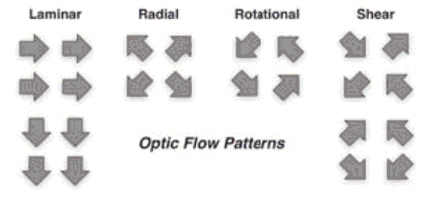

Figure 1: Types of Optic Flow Patterns. Laminar also known as translational/linear.

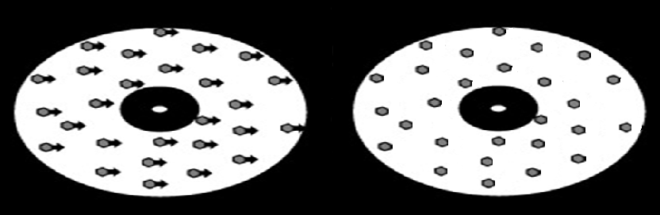

Figure 2: Experimental Set Up. Linear Coherent Motion in Left Display

Table 1: Descriptive Statistics of Response Time by Pattern, Coherence and Speed

|  |  |  |  |  |  |  |
| --- | --- | --- | --- | --- | --- | --- |
|  | Linear | | | Radial | | |
|  | Coh | Mean RT (SEM) | Median RT | Coh | Mean RT (SEM) | Median RT |
| 2 deg/sec | 0.05 | 3.9594 (0.0913) | 3.6198 | 0.05 | 4.0218 (0.0917) | 3.6451 |
| 0.10 | 3.3587 (0.0829) | 2.8690 | 0.10 | 3.2069 (0.0751) | 2.7704 |
| 0.15 | 2.5241 (0.0604) | 2.3109 | 0.15 | 2.0805 (0.0540) | 1.7182 |
| 0.20 | 2.4627 (0.0674) | 2.2019 | 0.20 | 1.8893 (0.0543) | 1.3847 |
| 8 deg/sec | 0.05 | 3.8079 (0.0930) | 3.3364 | 0.05 | 3.8049 (0.0931) | 3.2360 |
| 0.10 | 3.3632 (0.0852) | 2.7987 | 0.10 | 3.2144 (0.0812) | 2.6695 |
| 0.15 | 2.8362 (0.0769) | 2.4855 | 0.15 | 2.4746 (0.0691) | 2.0850 |
| 0.20 | 2.4655 (0.0715) | 2.0435 | 0.20 | 1.8115 (0.0503) | 1.3125 |

Table 2: Descriptive Statistics of Percent Correct by Pattern, Coherence, and Speed

|  |  |  |  |  |  |  |
| --- | --- | --- | --- | --- | --- | --- |
|  | Linear | | | Radial | | |
|  | Coh | Mean P. Corr (SEM) | Median P.Corr | Coh | Mean P.Corr (SEM) | Median P.Corr |
| 2 deg/sec | 0.05 | 0.5569 (0.0266) | 0.55 | 0.05 | 0.4759 (0.0227) | 0.45 |
| 0.10 | 0.7580 (0.0233) | 0.80 | 0.10 | 0.7132 (0.0359) | 0.75 |
| 0.15 | 0.8287 (0.0263) | 0.85 | 0.15 | 0.9305 (0.0124) | 0.95 |
| 0.20 | 0.8460 (0.0282) | 0.90 | 0.20 | 0.9477 (0.0141) | 0.95 |
| 8 deg/sec | 0.05 | 0.5305 (0.0276) | 0.50 | 0.05 | 0.5121 (0.02014) | 0.50 |
| 0.10 | 0.6414 (0.0343) | 0.70 | 0.10 | 0.7218 (0.0273) | 0.75 |
| 0.15 | 0.7615 (0.0274) | 0.80 | 0.15 | 0.8603 (0.0240) | 0.90 |
| 0.20 | 0.8586 (0.0241) | 0.90 | 0.20 | 0.9661 (0.0105) | 1.00 |

Table 3: Response Time ANOVA by Pattern, Coherence, and Speed

|  |  |  |  |
| --- | --- | --- | --- |
|  | df | F | p |
| Pattern | 1, 455 | 10.55 | 1.25e-3** |
| Coherence | 1, 455 | 229.84 | <2e-16*** |
| Speed | 1, 455 | 0.149 | 0.70 |
| Speed: Pattern | 1, 455 | 0.007 | 0.93 |
| Speed: Coherence | 1, 455 | 1.01 | 0.31 |
| Pattern: Coherence | 1, 455 | 7.60 | 6.09e-3** |
| Speed: Pattern: Coherence | 1, 455 | 0.001 | 0.97 |

Table 4: Percent Correct ANOVA by Pattern, Coherence, and Speed

|  |  |  |  |
| --- | --- | --- | --- |
|  | df | F | p |
| Pattern | 1, 471 | 9.94 | 1.72e-3** |
| Coherence | 1, 471 | 423.42 | <2e-16*** |
| Speed | 1, 471 | 3.26 | 0.07 |
| Speed: Pattern | 1, 471 | 2.73 | 0.10 |
| Speed: Coherence | 1, 471 | 0.05 | 0.83 |
| Pattern: Coherence | 1, 471 | 19.48 | 1.26e-5*** |
| Speed: Pattern: Coherence | 1, 471 | 1.50 | 0.22 |

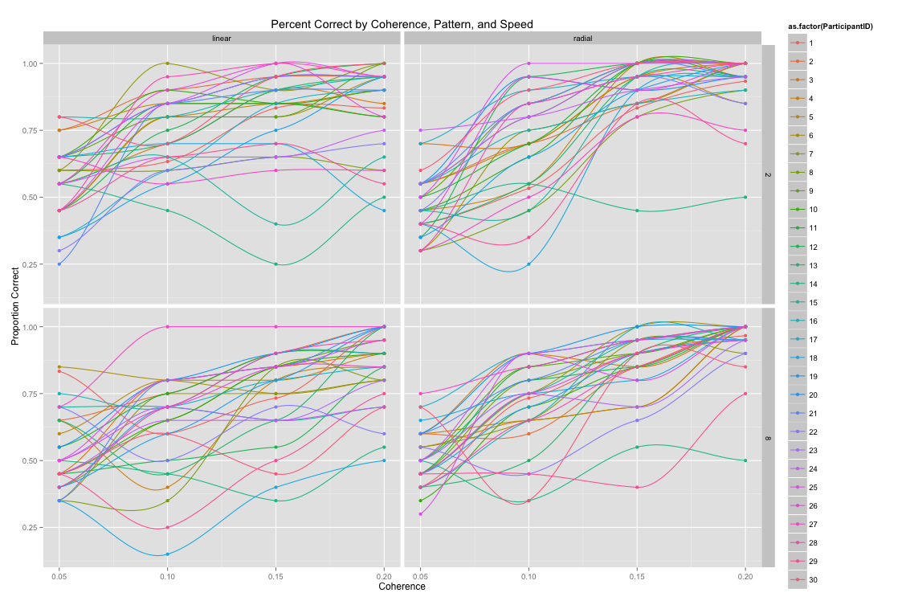

Figure 3: Graph of Individual Percent Correct by Coherence, Pattern, and Speed

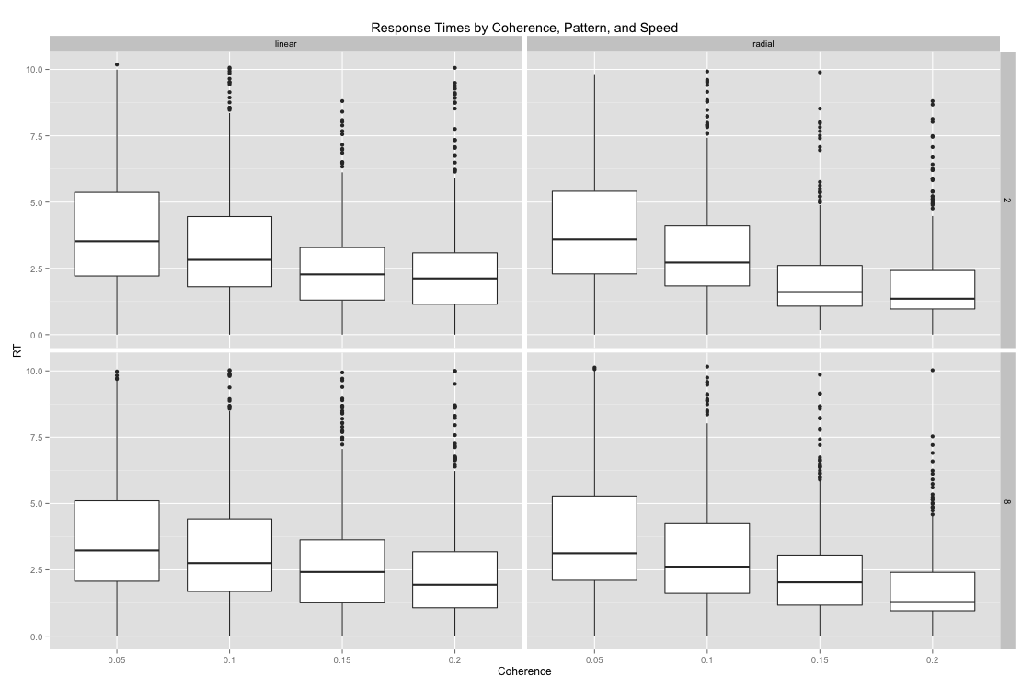

Figure 4: Box Plots of Response Times by Coherence, Pattern, and Speed

# BIBLIOGRAPHY

Andersen, R., Snyder, L. H., Bradley, D. C., & Xing, J. (1997). Multimodal representation of space in the posterior parietal cortex and its use in planning movements. *Annual Review of Neuroscience,* *20*, 303-330. http://dx.doi.org/ 10.1146/annurev.neuro.20.1.303.

Born, R. T., & Bradley, D. C. (2005). Structure and function of visual area MT. *Annual Review of Neuroscience,* *28*, 157-189. http://dx.doi.org/10.1146/annurev.neuro. 26.041002.131052.

Backus, B. T., Fleet, D.J., Parker, A. J., & Heeger, D.J. (2012). Human cortical activity correlates with stereoscopic depth perception. *Journal of Neurophysiology,* , 2054-2068.

Behrmann, M., Geng, J. J., & Shomstein, S. (2004). Parietal cortex and attention. *Current Opinion in Neurobiology.* http://dx.doi.org/10/1016/j.conb.2004.03.012.

Born, R. T., & Bradley, D. C. (2005). Structure and function of visual area MT. *Annual Review of Neuroscience,* *28*, 157-189. http://dx.doi.org/10.1146/annurev.neuro. 26.041002.131052.

Bremmer, F. (2005). Navigation in space – The role of the macaque ventral parietal area. *The Journal of Physiology,* *566* (Pt 1), 29-35. http://dx.doi.org/10.1113/ jphysiol.2005.082552.

Britten, K. H. (2008). Mechanisms of self-motion perception. *Annual Review of Neuroscience,* *31*, 389-410.

Britten, K. H., Shadlen, M. N., Newsome, W. T., & Movshon J. A. (1992). The analysis of visual motion: A comparison of neuronal and psychophysical performance. *Journal of Neuroscience,* *12* (12), 4745-4765.

Cardin, V., Sherrington, R., Hemsworth, L., & Smith, A. T. (2012). Human V6: Functional characterization and localization. *PLoS ONE,* *7* (10), e47685. http://dx.doi.org/10.1371/journal.pone.0047685.

Cardin, V., & Smith, A.T. (2010). Sensitivity of human visual and vestibular cortical regions to egomotion-compatible visual stimulation. *Cerebral Cortex,* *20* (8), 1964-1973. http://dx.doi.org/10.1093/cercor/bhp.

Cutting, J. E., Springer, K., Braren, P.A., & Johnson, S.H. (1992). Wayfinding on foot from information in retinal, not optical, flow. *Journal of Experimental Psychology: General,* *121*, 41–72. doi:10.1037/0096-3445.121.1.41.

De Jong, B. M., Shipp, S., Skidmore, B., Frackowiak, R. S. J., & Zeki, S. (1994). The cerebral activity related to the visual perception of forward motion in depth. *Brain,* *117*(5), 1039-1054. http://dx.doi.org/10.1093/brain/117.5.1039.

Duffy, C. J., & Wurtz, R. H. (1991). Sensitivity of MST neurons to optic flow stimuli. I. A continuum of response selectivity to large-field stimuli. *Journal of Neurophysiology,* *65*(6), 1329-1345.

Duffy, C. J., & Wurtz, R. H. (1997). Medial superior temporal area neurons respond to speed patterns in optic flow. *Journal of Neurophysiology,* *17*(8), 2839-2851.

Fesi, J. D., Thomas, A.L., & Gilmore, R.O. (2014). Cortical responses to optic flow and motion contrast across patterns and speeds. *Vision Research,* *100,* 56–71. doi:10.1016/j.visres.2014.04.004.

Fischer, E., Bulthoff, H. H., Logothetis, N. K., & Bartels, A. (2012). Visual motion responses in the posterior cingulate sulcus: A comparison to V5/MT and MST. *Cerebral Cortex,* *22*(4), 865-876.

Freire, A., Lewis, T.L., Maurer, D., & Blake, R. (2005). The development of sensitivity to biological motion in noise. *Perception,* *35*, 647–57.

Gibson, James J. *Perception of the Visual World*. Boston: Houghton-Mifflin, 1950.

Gibson, James J. *The Ecological Approach to Visual Perception*. Psychology Press, 1979.

Gilmore, R.O., Baker, T.J., & Grobman, K.H. (2004). Stability in young infants’ discrimination of optic flow. *Developmental Psychology,* *40*, 259–70. doi:10.1037/0012-1649.40.2.259.

Gilmore, R.O., Hou, C., Pettet, M.W., & Norcia, A.M. (2007) Development of cortical responses to optic flow. *Visual Neuroscience, 24,* 845–56. doi:10.1017/S0952523807070769.

Hadad, B.-S., Maurer, D., & Lewis, T. L. (2010). The development of contour interpolation: Evidence from subjective contours. *Journal of Experimental Child Psychology,* *106* (2-3), 163-176. http://dx.doi.org/10.1016/j.jecp.2010.02.003.

Hou, C., Gilmore, R. O., Pettet, M.W., & Norcia, A. M. (2009). Spatio-temporal tuning of coherent motion evoked responses in 4-6 month old infants and adults. *Vision Research,* *49*(20), 2509-2517. http://dx.doi.org/10.1016/j.visres.2009.08.007.

Hubel, D. H., & Wiesel, T.N. (1968). Receptive fields and functional architecture of monkey striate cortex. *Journal of Neuroscience, 21*(6)*,* 851-859. http://dx.doi.org/10.1017/S0952523804216054.

Huk, A. C., Dougherty, R. F., & Heeger, D. J. (2002). Retinotopy and functional subdivision of human areas MT and MST. *Journal of Neuroscience,* *22*(16), 7195-8205. http://dx.doi.org/20026661.

Kiorpes, L., & Movshon, J.A. (2004). Development of sensitivity to visual motion in macaque monkeys. *Visual Neuroscience,* *21* (6) 851-859. http://dx.doi.org/ 10.1017/S0952523804216054.

Koenderink, J. J. (1986). Optic flow. *Vision Research,* *26*, 161–79. doi:10.1016/0042-6989(86)90078-7.

Komatsu, H., & Wurtz, R. H. (1988). Relation of cortical areas MT and MST to pursuit eye movements. I: Localization and visual properties of neurons. *Journal of Neurophysiology,* *60*(2), 580-603.

Newsome, W., & Pare, E. (1988). A selective impairment of motion perception following lesions of the middle temporal visual area (MT). *Journal of Neuroscience,* *8* (6), 2201-2211.

Pan, J. S., Bingham, G. P. (2013). With an eye to low vision: optic flow enables perception despite image blur. *Optometry and Vision Science*, *90*, 1119-1127.

Wattam-Bell, J., Birtles, D., Hofsten, C. Von, Rosander, K., Anker, S., Atkinson, J., et al. (2010). Reorganization of global form and motion processing during human visual development. *Current Biology,* *20*, 411-415. http://dx.doi.org/10.1016/ j.cub.2009.12.020.

Weinstein, J. M., Gilmore, R.O., Shaikh, S.M., Kunselman, A.R., Trescher, W.V., Tashima, L.M., Boltz, M.E., Mcauliffe, M.B., Cheung, A., & Fesi, J.D. (2012). Defective motion processing in children with cerebral visual impairment due to periventricular white matter damage. *Developmental Medicine & Child Neurology,* *54*, e1–e8. doi:10.1111/j.1469-8749.2010.03874.x.

****ACADEMIC**** VITA