Conquest Tabletop
Complete guide to every feature
A shared battlefield in the browser for Conquest: The Last Argument of Kings
https://conquest-jd7p.onrender.com/
October 2026

Contents
Click any entry to jump to it. Every section ends with a link back here.
1 Getting started
1.1 Opening the site
1.2 Starting a battle
1.3 Joining and seats
1.4 Offline practice
2 The screen
2.1 Layout
2.2 Top bar
2.3 Moving around the board
2.4 Log and chat
3 Setting up the battlefield
3.1 Scenarios
3.2 Terrain layouts and pieces
3.3 Editing a terrain piece
3.4 Objective zones and markers
3.5 Board check
3.6 Locking the board and tokens
4 Armies
4.1 Adding regiments
4.2 The regiment inspector
4.3 Deploying and reserves
4.4 Characters
4.5 Army lists
4.6 Who can change what
5 Moving
5.1 Starting a move
5.2 The handles
5.3 Exact distances and the keyboard
5.4 Warnings
5.5 Align to target
5.6 Saving or cancelling
6 Measuring
6.1 Ruler
6.2 Closest distance
6.3 Range rings
6.4 Pinning
7 Facing arcs and line of sight
7.1 Facing arcs
7.2 Checking line of sight
7.3 Reading the result
8 Wounds and casualties
8.1 Applying wounds
8.2 The stand grid
8.3 Characters' wounds
9 Dice
9.1 Rolling
9.2 Where the dice come from, and Check
10 Command stacks
10.1 Command cards
10.2 Building and locking the stack
10.3 Flipping cards
10.4 Adding a reserve card
10.5 Corrections and the end of the round
11 Playing online
11.1 Seeing each other
11.2 Undo
11.3 Connection problems
12 Settings
13 Keyboard shortcuts
13.1 Accessibility
14 Troubleshooting
14.1 Hosting and updates

1 Getting started
Conquest Tabletop is a shared battlefield in the browser for Conquest: The Last Argument of Kings. It holds the table, moves the pieces and measures in inches. It is not a rules engine: you and your opponent apply the rules yourselves, exactly as with miniatures and a tape measure. Warnings never block anything, and line of sight is reported, never enforced.

1.1 Opening the site
Open https://conquest-jd7p.onrender.com/ in any modern browser (Chrome, Edge, Firefox or Safari), on a computer or a tablet.
Tip The server sleeps after 15 minutes with nobody connected. The first visit after that takes about a minute to load; it then runs normally. Open the site a minute before your opponent joins.

1.2 Starting a battle
- Type your name.
- Under New battle, pick a Scenario (the 12 scenarios of the tournament pack, or Custom board) and a Terrain layout (three sample layouts, or none).
- Choose Create battle. You arrive in the battle room; its address ends in a 6-character code, for example /E47E2W.
- Choose Player 1 (you deploy along the bottom edge).
- Press Copy link in the top bar and send the link to your opponent.
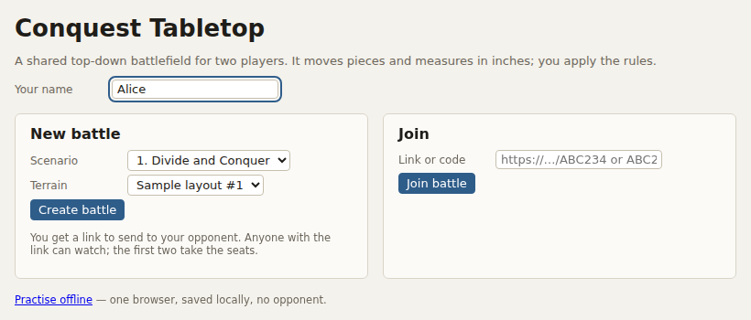
The home page: your name, scenario and terrain, Create battle

1.3 Joining and seats
Your opponent opens the link (or pastes the link or code under Join on the home page), types a name and picks Player 2 (top edge). Anyone else who opens the link can watch: spectators see everything live and can chat, but cannot change anything.
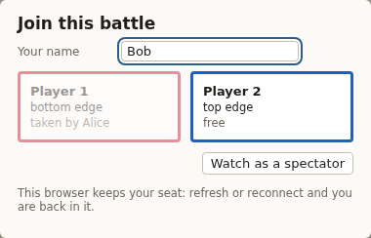
Joining by link: Player 1 is taken, Player 2 is free
- Your browser remembers your seat. Refresh the page or lose the connection and you come back in the same seat.
- The person who created the battle is the host and can free a seat in Settings (for example if a player switches computer).
- Use two different browsers (or a private window) to try both seats on one computer.

1.4 Offline practice
Practise offline on the home page (or the address /local) opens a battle that lives only in your browser: no opponent, saved automatically on this computer. Acting as in the top bar switches between Player 1 and Player 2. Offline you can also Save the whole battle to a file, Load one, and start a New battle.
↑ Back to contents

2 The screen

2.1 Layout
The board sits in the middle. Both armies are on the left, details of whatever you selected are on the right, and the log runs along the bottom.
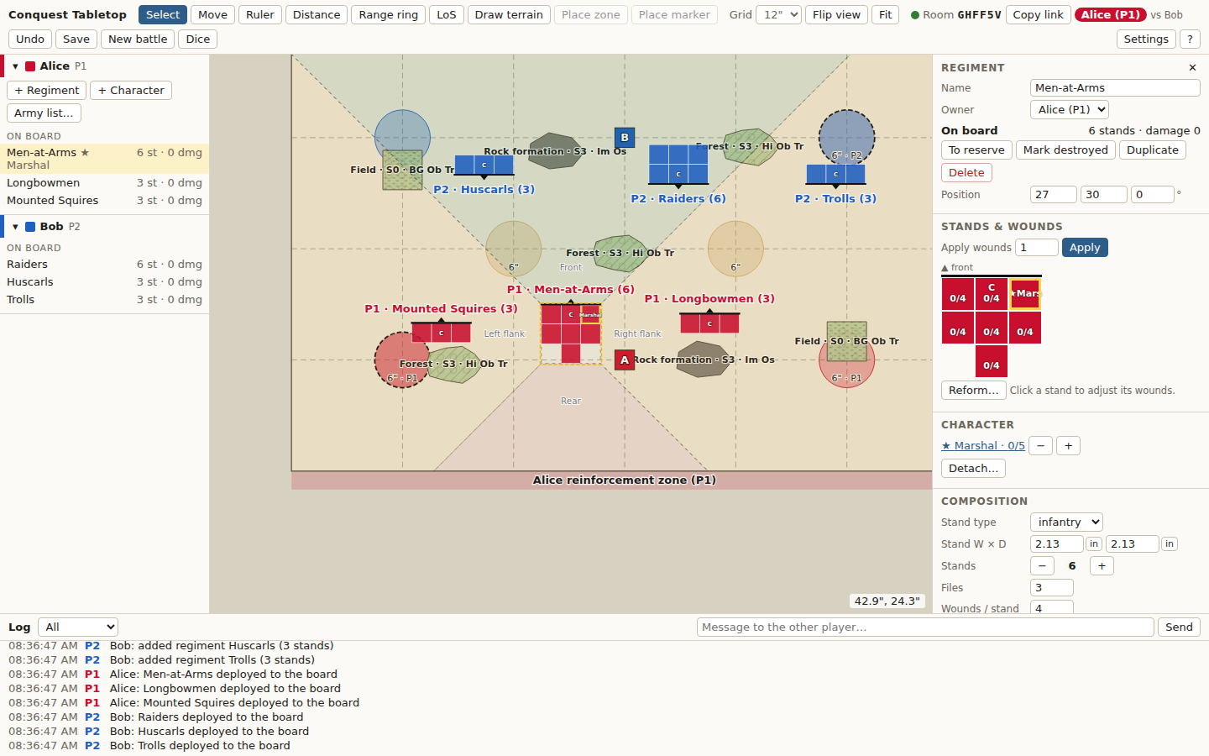
Alice's screen with her Men-at-Arms selected
Area | What it is for
Top bar | Tools, view controls, room and seat, Undo, Dice, Command, Settings and help
Left: rosters | Both armies, grouped On board / Reserve / Destroyed. Click a row to select the unit and centre the board on it; drag a reserve row onto the board to deploy it
Centre: board | 72" × 48", Player 1's edge at the bottom, reinforcement zones shaded along each edge. Pieces carry a P1 / P2 tag as well as their colour
Right: inspector | Everything about the selected piece. The move, measuring and line-of-sight panels also appear here. With nothing selected it shows the board panel (scenario, terrain, tokens)
Bottom: log and chat | Every change and roll, with time and player, filterable. Type in the box and press Send (or Enter) to chat

2.2 Top bar
Control | What it does
Select V | The normal tool: click to select, drag to move pieces
Move M | Start a move with the selected regiment
Ruler R · Distance D · Range ring G | Measuring tools
LoS L | Line of sight and arcs
Command C | Open the command stacks
Draw terrain T | Draw a terrain polygon point by point
Place zone · Place marker | Add objective zones and markers (custom board only)
Grid | Off, 1", 6" or 12" (the default)
Flip view | Turn the board 180° so your edge is at the bottom (view only)
Fit F | Zoom to show the whole board
Room badge | Connection dot (green = connected), room code, Copy link, your seat, your opponent and how many are watching
Undo Ctrl+Z | Undo your own last change
Save (offline: Load, New battle) | Save the battle as a file; offline, load one or start afresh. Online, New battle goes back to the home page
Dice X | Open the dice tray
Settings · ? | Rules settings and room options · the help screen with every shortcut

2.3 Moving around the board
- Zoom: scroll the mouse wheel (it zooms around the pointer), or press + and −.
- Pan: drag empty ground, hold Space and drag, drag with the middle mouse button, or use the arrow keys when nothing is selected (Shift for bigger steps).
- Fit: F shows the whole board again.
- Find a unit: click its roster row, or press ] and [ to step through the regiments on the board.
- The pointer position in inches is shown in the bottom-right corner of the board.

2.4 Log and chat
Every change is one line in the log, with the time and who did it, for example Alice: Men-at-Arms forward 2.0", wheel R 2.8" (total 4.8"). The menu on its left filters it (everything, moves, dice, chat). Line-of-sight results can be posted to it with Post to log.
↑ Back to contents

3 Setting up the battlefield
Click empty ground (or press Esc until nothing is selected) to see the board panel on the right. Until someone locks the board, either player can change the scenario, terrain and objectives.
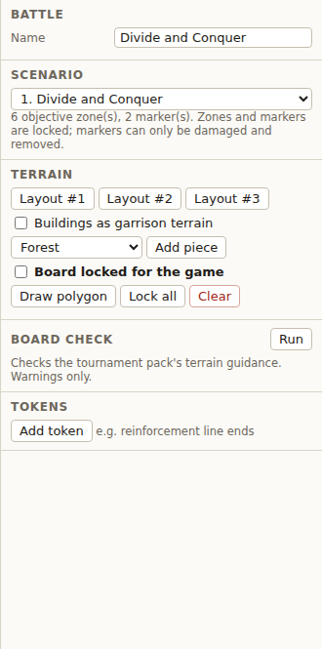
The board panel: battle name, scenario, terrain, board check and tokens

3.1 Scenarios
Pick one of the 12 scenarios of the tournament pack. Each places its objective zones and markers and its no-reinforcement strips; these are locked: they cannot be moved, resized or deleted, only damaged (markers). Custom board lets you set the board size, the no-reinforcement strips, and place your own zones and markers with Place zone and Place marker.

3.2 Terrain layouts and pieces
- Layout #1 / #2 / #3 place the pack's sample layouts. Tick Buildings as garrison terrain first to make their buildings garrisons.
- The preset menu and Add piece add one piece (forest, hill, field, building, rock formation…) in the middle of the board at its recommended Size.
- Draw polygon (or T): click the corners, Enter to finish, Backspace removes the last corner, Esc cancels.
- Lock all / Unlock all freezes every piece; Clear removes all terrain (asks first).

3.3 Editing a terrain piece
Select a piece to edit it in the inspector.
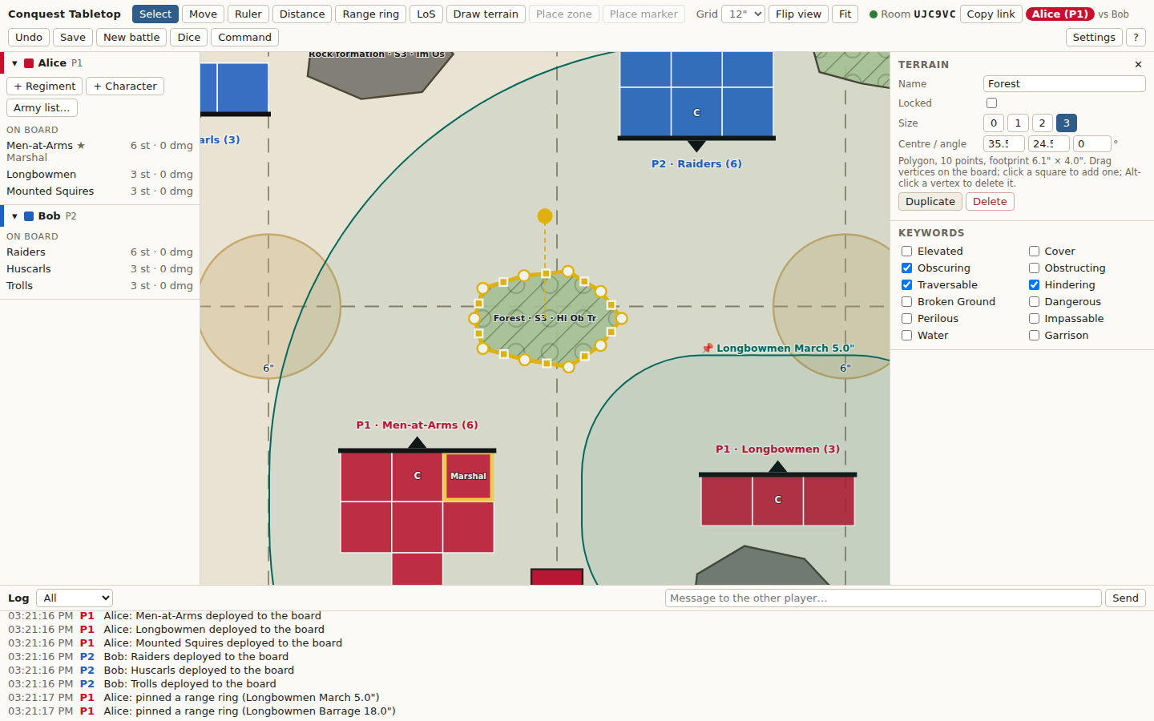
A forest selected: rotation knob above it, vertex handles around it, its fields on the right
Field | Meaning
Name | Shown on the board with the keyword initials
Locked | A locked piece cannot be moved or edited until unlocked
Size | 0 to 3 (the pack's Elevation). Presets start at the recommended Size
Centre / angle, W × D | Exact position and footprint in inches (rectangles and ellipses)
Keywords | Elevated, Cover, Obscuring, Obstructing, Traversable, Hindering, Broken Ground, Dangerous, Perilous, Impassable, Water, Garrison. The board shows them as two-letter initials (the help screen has the legend)
Garrison | Defense, capacity and which regiment occupies it
Duplicate · Delete | Copy the piece next to itself, or remove it

- Move: drag the piece.
- Rotate: drag the round knob (hold Shift for 15° steps).
- Reshape a polygon: drag its corners, click a small square to add a corner, Alt-click (or right-click) a corner to delete it.

3.4 Objective zones and markers
- Select a zone to see whether a stand is inside it (zones highlight when any stand touches them).
- Select an objective marker to add damage for each player. At 3 damage from either player, Remove marker takes it off the board; Restore in the board panel (or Undo) brings it back.
- Objective markers can always be damaged, even after the board is locked.

3.5 Board check
Run checks the layout against the pack's terrain guidance (spacing, pieces on objective zones…) and lists warnings. Click a warning to highlight the pieces involved. It only warns; the pack itself says to move the offending piece.

3.6 Locking the board and tokens
- Tick Board locked for the game once terrain and objectives are set. Nobody can then edit terrain, zones or markers (markers can still be damaged). Untick to change something.
- Tokens: Add token places a free, labelled marker (for example the ends of a reinforcement line). Drag it; select it to rename or delete.
↑ Back to contents

4 Armies

4.1 Adding regiments
- In your roster, press + Regiment.
- Type a name, choose the stand type (infantry, cavalry, brute, chariot, monster or custom) and set stands, files and wounds per stand.
- Press Add to reserve. The regiment appears under Reserve in your roster.
The automatic layout fills ranks front to back with the command stand in the middle of the front rank; an incomplete rear rank is centred.

4.2 The regiment inspector
Section | What you can do
Regiment | Name, owner, location (Deploy: Own edge / Left edge / Right edge, To reserve, Mark destroyed), Duplicate, Delete, exact position and facing
Stands & wounds | Apply wounds, the stand grid (click a stand for +/−, remove, set as command, label), casualties with Restore, Reform…
Character | The character with this regiment, its wounds, Detach…; or a menu to join a character
Composition | Stand type, stand width × depth (type inches, or switch the unit button to mm), stands, files, wounds per stand, LoS size and size override, All arcs are front, March, Barrage range
Tags · Notes | Short tags shown on the board (for example Light), and notes both players can read

4.3 Deploying and reserves
- In the inspector, Deploy: Own edge places the regiment off the table, its front rank touching your long edge, centred. Left edge / Right edge place it against that side edge at your end of the table, facing in. Left and right are as seen from your own edge. If the spot is taken, it slides along the edge to the nearest free place.
- Or drag a reserve row from the roster onto the board exactly where you want it.
- Fine-tune the position with a move, or type exact coordinates (front-left corner, angle 0 = facing up the board).
- Delete sends the selected regiment back to reserve (asks first). Mark destroyed moves it to the Destroyed group.

4.4 Characters
- + Character adds one to your reserve. Join it to a regiment with the menu in either inspector, or drag its roster row onto one of your regiments: it takes the slot next to the command stand (right by default, see Settings).
- A character never stands on the board alone. Detach… asks which regiment it moves to (nearest first) or sends it to the reserve; the regiment it leaves closes the gap for free, losing as few ranks as possible.
- A Rider has no stand of its own: it shows as a badge on its regiment with its own wound tracker.
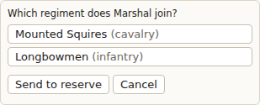
Detach asks which regiment the character joins

4.5 Army lists
Build your army once and load it in every game.
- Army list… → Save to file saves your regiments and characters at full strength (no positions, no damage) to your computer.
- Army list… → Load from file… adds a saved list to your reserve (it asks first if you already have units).
- The list loaded last in this browser appears as one button, Load "…" again.
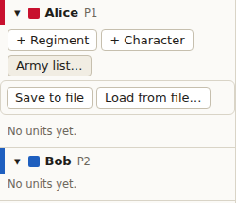
The Army list menu in a roster

4.6 Who can change what
What | Who
Move and edit regiments and characters | Their owner only
Apply wounds, remove or restore casualties, mark a character destroyed | Either player (the attacker often does it)
Terrain, scenario, zones and markers | Either player, until the board is locked
Damage objective markers | Either player, always
Grid, pinned measurements, tokens, chat | Everyone seated; spectators can only chat

Anyone can edit anything in Settings lifts the ownership rules for casual games.
↑ Back to contents

5 Moving
A move is built from steps and saved as one line in the log only when you press Enter.
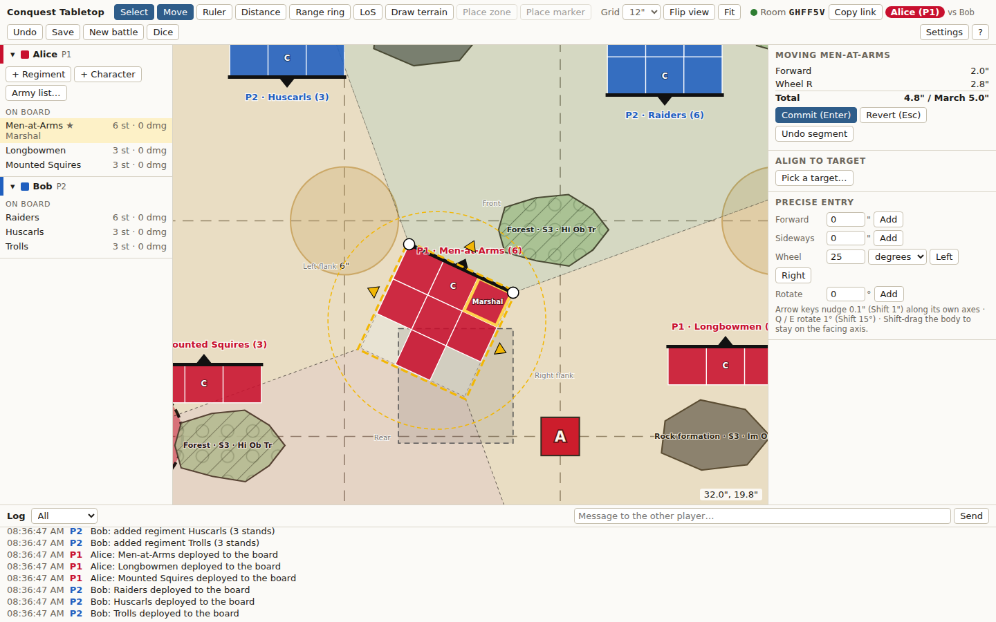
Moving the Men-at-Arms: 2" forward, then a wheel to the right; 4.8" of 5" March used

5.1 Starting a move
Select your regiment and press M, or simply start dragging it. A grey ghost stays where it started and the move panel opens on the right, listing each step with the running total against the regiment's March.

5.2 The handles
Handle | Movement
Front arrow | Forward or back along the facing
Side arrows | Sideways (all sideways steps are added up and compared with half the March)
Front corners | Wheel around the other front corner; the distance is the arc of the moving corner
Dashed ring | Turn on the spot around the centre; uses no movement, the angle is reported
The body | Free drag (hold Shift to stay on the facing line)

5.3 Exact distances and the keyboard
- Precise entry in the panel: forward (negative = back), sideways (negative = left), wheel in degrees or inches left/right, rotate. Type a value and press Add.
- Arrow keys nudge 0.1" along the regiment's own axes (Shift: 1"); Q / E turn 1° (Shift: 15°).

5.4 Warnings
Red chips in the panel and red outlines on the board flag: total over March, sideways over half March, within 1" of an enemy or of garrison terrain, overlapping another piece or objective marker, off the board, crossing Impassable terrain. They never stop you. Stands in contact are always outlined in orange.

5.5 Align to target
During a move press Pick a target…, then click near the front, a flank or the rear of an enemy regiment, or near a side of an objective marker. The app previews the pose that lines your front edge up with it and how far the front centre travels. Max contact (the default) slides along to the most contact closest to where you are; Centred centres on the target. Apply (Enter) adds it as a step.

5.6 Saving or cancelling
- Enter saves the whole move as one log line.
- Esc puts the regiment back where it started; Backspace removes the last step.
- After saving, Ctrl+Z undoes the move.
↑ Back to contents

6 Measuring
All measurements are in inches and stand to stand, never centre to centre. Your opponent sees your rulers, distances and rings live while you use them.

6.1 Ruler
Press R and drag from point to point. The ruler snaps to stand corners and edge midpoints; hold Alt to place it freely.

6.2 Closest distance
Press D and click two things: regiments, characters, terrain, objective markers or zones. A dashed line joins their closest points and the distance appears in the panel. For a zone it also says whether a stand is inside. With the Select tool, Ctrl-click a second thing does the same.
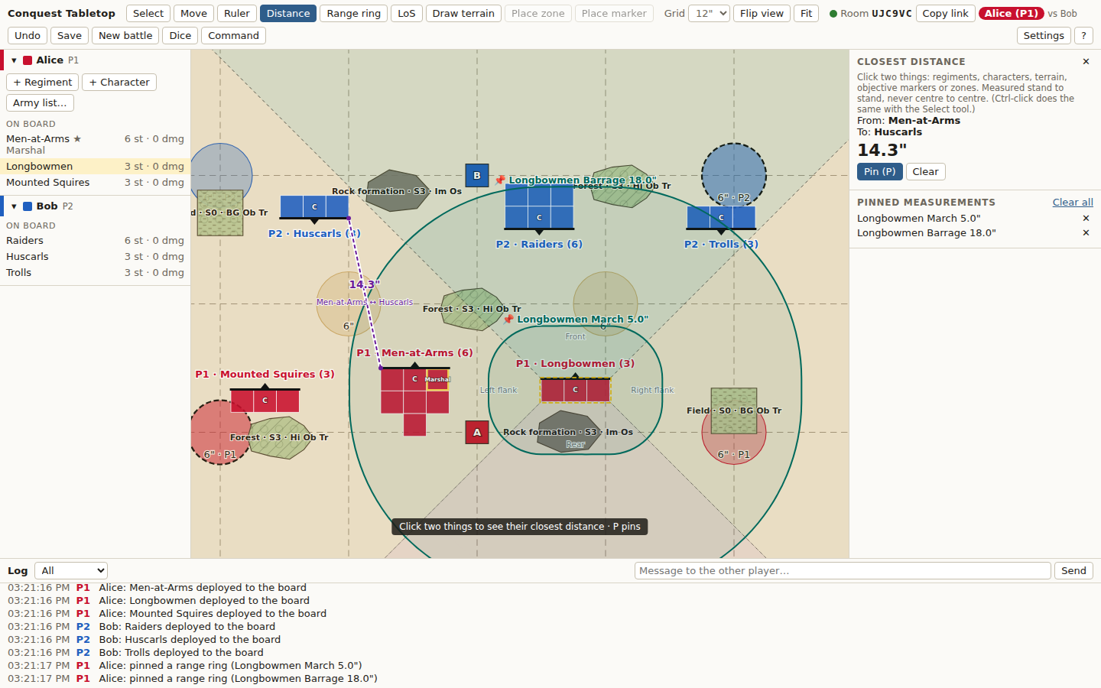
Closest distance from the Men-at-Arms to the Huscarls: 14.3"; two pinned range rings in the list on the right

6.3 Range rings
Press G with a regiment selected (or click one). Tick March, Barrage or Half Barrage, or type a custom range. Alt-click a single stand to measure from that stand alone. The ring is the exact set of points within that range of the footprint.
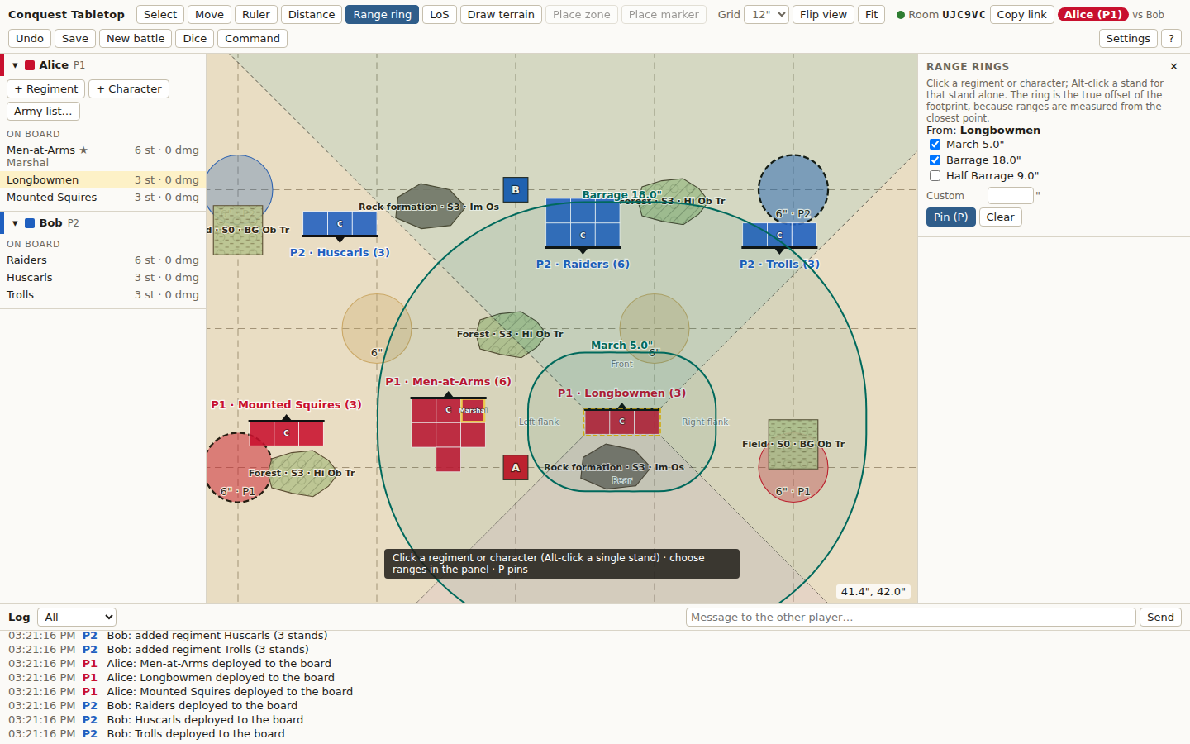
March (5") and Barrage (18") rings around the Longbowmen

6.4 Pinning
Press P (or Pin) to keep the current ruler, distance or rings on the board for both players. Pinned measurements follow the pieces as they move. Remove them one by one, or with Clear all, from the list in the right panel.
↑ Back to contents

7 Facing arcs and line of sight

7.1 Facing arcs
The selected piece shows its four arcs (front, left flank, right flank, rear) as faint wedges up to the board edge. Hold A to see every piece's arcs at once. A piece in an arc is any part of it inside the wedge.

7.2 Checking line of sight
- Select the regiment that is looking and press L (or choose LoS and click it). Shift-click picks a different one.
- Click the target: an enemy regiment or an objective marker. Keyboard: ] and [ step through the targets.
- Choose Sight (charges and general line of sight: front-edge centres to the centre of each target edge) or Volley (shooting: to any point of any target stand, the shortest clear line).
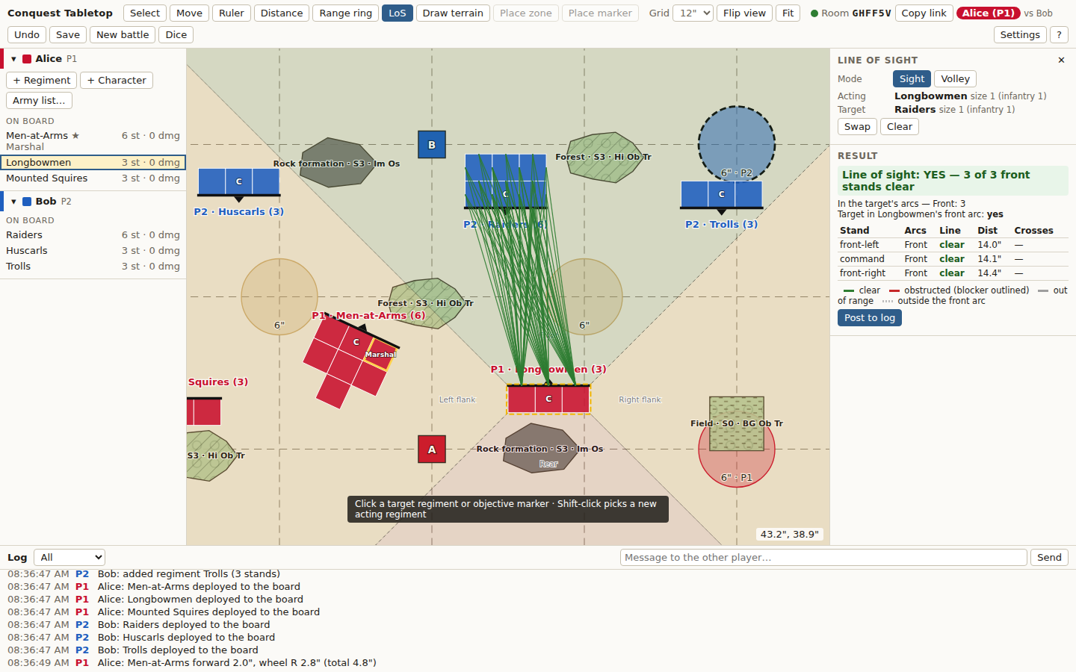
The Longbowmen can see the Raiders: 3 of 3 front stands clear, 14.0–14.4" away

7.3 Reading the result
- Lines: green clear, red blocked (the blocker is outlined), grey out of range, dotted grey outside the front arc. Tick show every tested line to see them all.
- Headline: for example Line of sight: YES — 3 of 3 front stands clear.
- Sizes: both effective sizes and why (stand type, Elevated terrain under every stand, override, garrison).
- Arcs: which of the target's arcs you are in, and whether it is in your front arc.
- Per stand: arcs, clear or blocked by what, distance, Barrage range, effective range, terrain crossed (Cover and Obscuring are flagged).
- Post to log records the result for both players. The checker never enforces anything.
How obstructing terrain and size comparisons work can be changed in Settings (see the Settings chapter).
↑ Back to contents

8 Wounds and casualties

8.1 Applying wounds
Select the regiment (yours or your opponent's), type the number under Apply wounds and press Apply. The app allocates the wounds one at a time and logs the result, for example Men-at-Arms: 6 wounds → rear-centre removed, rank 2-left 2/4.
Order | Rule
1 | A stand that is already wounded takes wounds until it is destroyed
2 | Then the rearmost rank, alternating ends, starting with the end farthest from the command stand; the centre stand goes last
3 | Stands engaged with an enemy (touching one, ⚔ in the grid) are kept until every unengaged stand is gone
4 | The command stand is always last

When two stands are equally far from the command stand, the app pauses: both pulse in the stand grid and whoever is applying the wounds picks one. (Settings can make it always take the left one.)
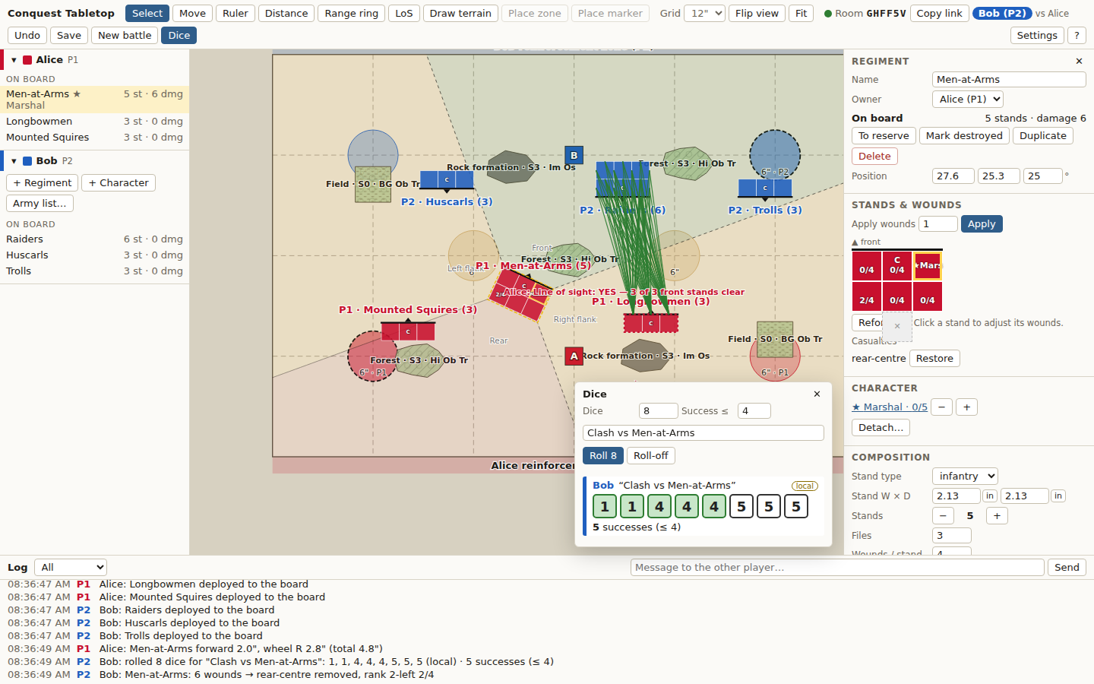
Bob rolls 8 dice and applies 6 wounds to the Men-at-Arms

8.2 The stand grid
- Click a stand to adjust its wounds (+/−), remove it, make it the command stand, or label it.
- Removed stands are listed under Casualties with Restore.
- With Ask before removing a destroyed stand on (Settings), destroyed stands stay at full damage until you press Remove now.
- Reform… changes the number of files, re-runs the automatic layout, or moves and swaps stands by hand.

8.3 Characters' wounds
A character has its own wound tracker (− / +) in the character inspector and next to its regiment's character section. Mark destroyed removes it.
↑ Back to contents

9 Dice

9.1 Rolling
- Press X (or Dice) to open the tray.
- Set the number of dice (1–60), an optional Success ≤ value and a label (what the roll is for).
- Press Roll. Both players see the result at the same moment, sorted low to high, with the successes counted and coloured.
- Re-roll: tick dice on your own roll and press Re-roll. Only the roller can, and each die only once.
- Roll-off: one die each; ties are re-rolled automatically and listed. The lowest is highlighted.
- The tray keeps the last 20 rolls; every roll is also in the log.

9.2 Where the dice come from, and Check
Dice come from drand, a free public randomness beacon run by Cloudflare, universities and others. Each roll waits for drand's next number (at most 3 seconds) and records which one it used, shown as drand #round. Press Check on a roll to fetch that number from drand in your own browser and recompute the dice: ✓ matches drand means nobody, the server included, could have chosen them.
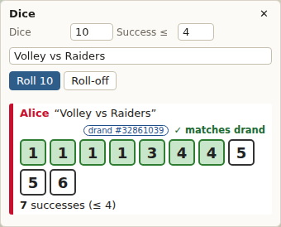
A checked roll: 10 dice, 7 successes, ✓ matches drand
A roll marked local came from the server's own random numbers, because drand could not be reached; Settings → Dice shows the reason. Offline practice always rolls locally in your browser.
↑ Back to contents

10 Command stacks
Each round you build your command stack in secret, lock it, then flip the cards one at a time. Your opponent sees how many cards you hold and each card as you flip it, never the order of the rest.

10.1 Command cards
You do not create cards: every regiment and every character in your army has one, reserves included. A character's card is separate from its regiment's.

10.2 Building and locking the stack
- Press C (or Command) to open the tray.
- Under Not in the stack, press + next to a card, or Add all. Leave out any card you do not want this round.
- Order the stack with the ↑ ↓ buttons or by dragging the rows; the top card flips first. ✕ takes a card out.
- Press Lock stack. Your opponent now sees your number of cards, face down.
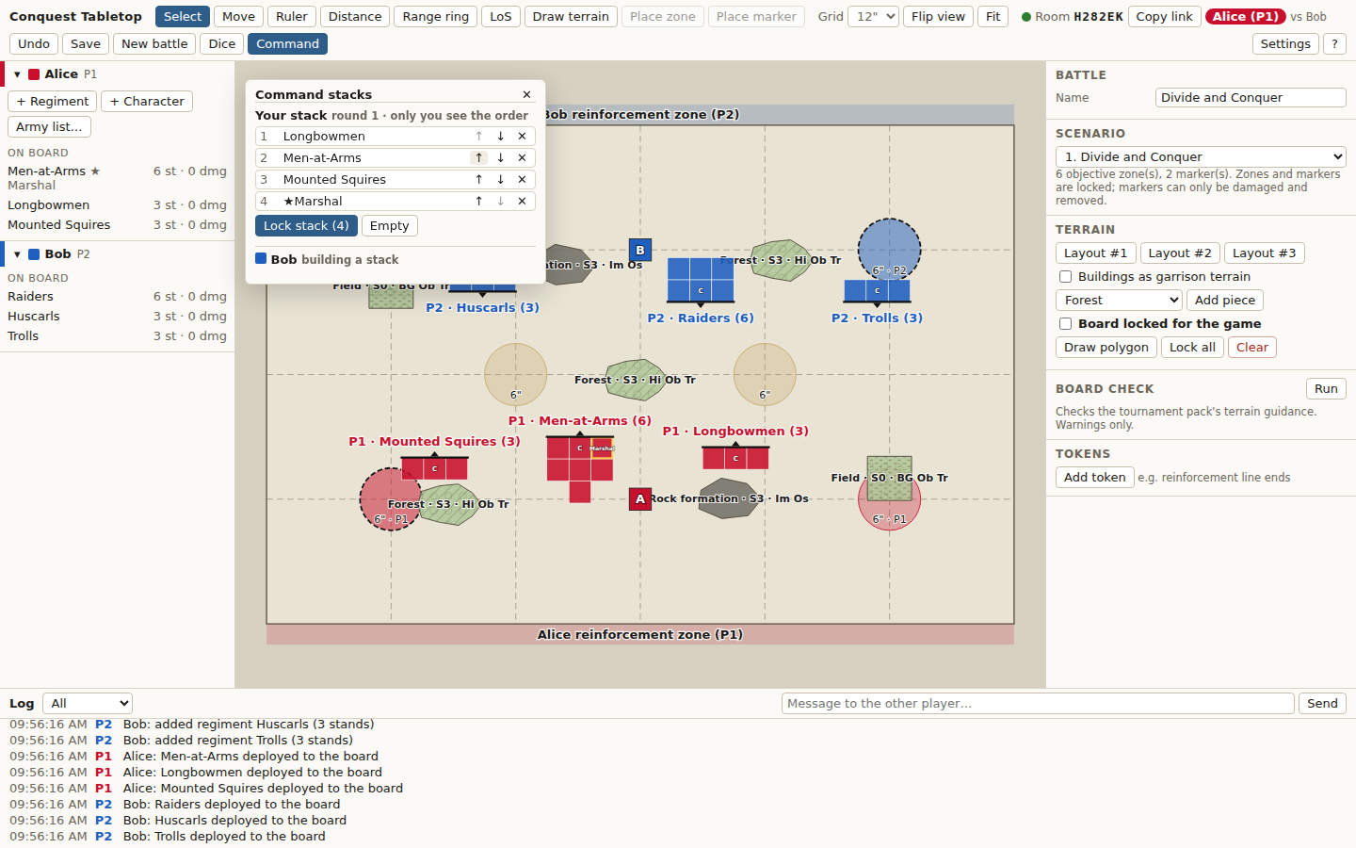
Building the stack: Longbowmen moved to the top, four cards ready to lock

10.3 Flipping cards
When it is your turn to activate, press Flip next card (or N while the tray is open). The card appears for both players under Now activating, goes in the log, and its regiment gets a pulsing outline in your colour on the board. Click a flipped card to find its unit.
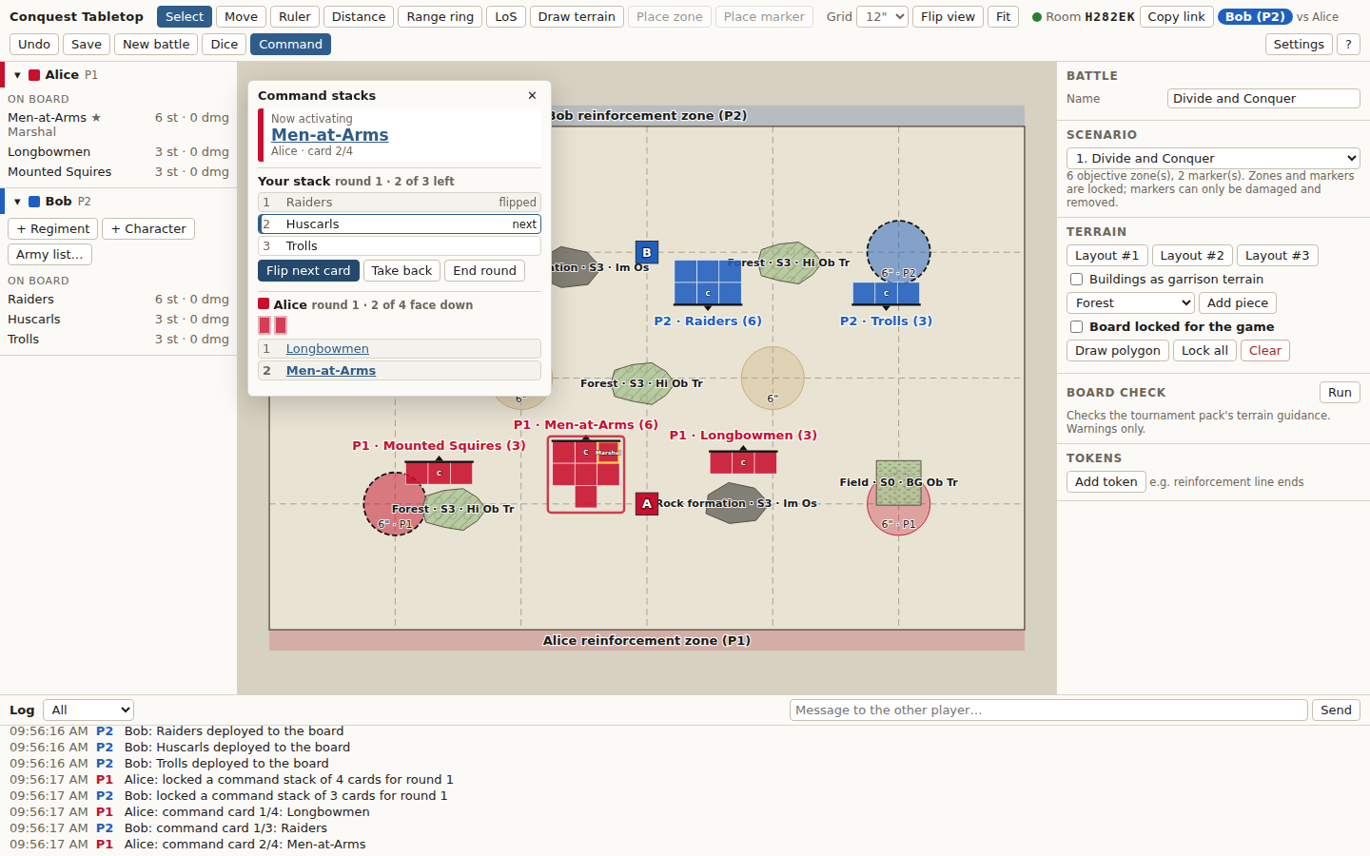
Bob's view after Alice's second flip: 2 of her 4 cards still face down, her Men-at-Arms activating

10.4 Adding a reserve card
A unit in reserve can join your locked stack at any point in the round. Under Add a reserve card, pick the unit and where it goes among your face-down cards (on top, after a given card, or at the bottom), then press Add. Your opponent only sees that a card was added and the new count.
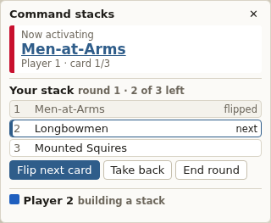
Adding the Longbowmen from reserve on top of the stack

10.5 Corrections and the end of the round
Button | Effect
Take back | Puts the last flipped card back on top (a flip by mistake)
Rebuild | Unlocks the stack to change it; only before its first card is flipped
End round | Clears the stack, ready to build the next round (asks first if cards are still face down)

The app does not enforce whose turn it is: you alternate as the rules say. Online, the order of your face-down cards is kept only by the server and sent only to your browser.
↑ Back to contents

11 Playing online

11.1 Seeing each other
Everything your opponent does appears live in their colour: their pointer and name, what they selected, a piece they are moving (outlined where it would go), their rulers, distances, range rings, Align target and sight lines. Changes reach the other player in a fraction of a second.

11.2 Undo
Ctrl+Z (or Undo) undoes your own last change. It is refused, with the reason, if your opponent has changed the same thing since. Dice rolls and command-card flips cannot be undone (use Take back for a flip).

11.3 Connection problems
What you see | What it means
Red banner Disconnected — reconnecting… | Your connection dropped. Changes pause; the page reconnects by itself and catches up
Banner The server restarted. Restoring the game… | The server restarted mid-game. The first seated player's browser puts the game back exactly as it was, and both players get their seats back. Needs one player to still have the page open
Room not found | The server slept or restarted after everyone left, so the game is gone. Create a new battle and load your army lists again

Tip Games are not kept between sessions: play each game in one sitting, and keep your army lists as files on your computer.
↑ Back to contents

12 Settings
Settings in the top bar. Changes apply to the whole battle, for both players.
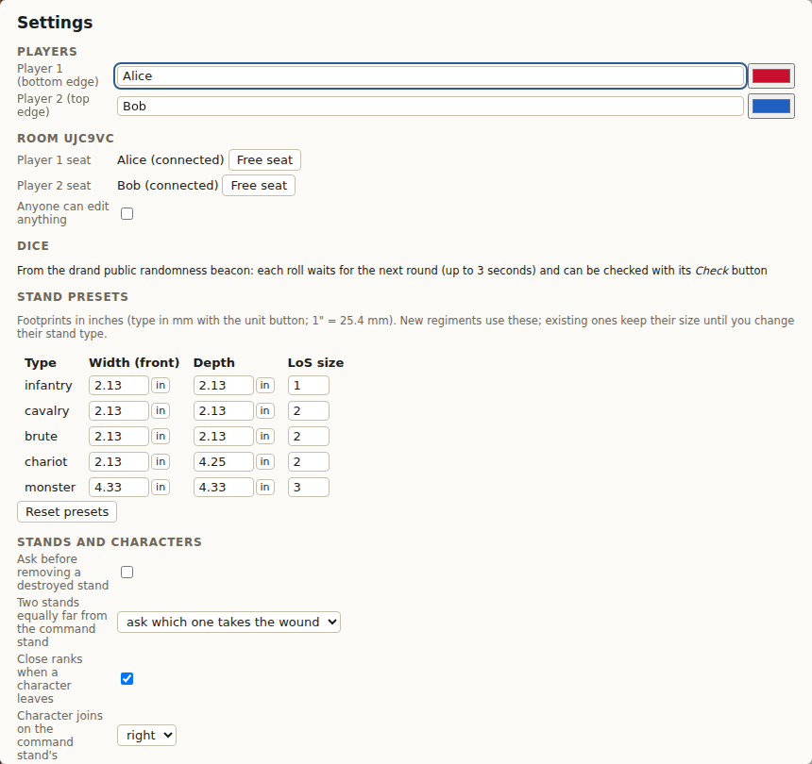
The Settings dialog
Setting | Options and effect
Players | Each player's name and colour. A warning appears if the two colours could be confused, including by colour-blind players
Room (online) | Seats and who holds them; the host can Free a seat
Anyone can edit anything | Casual play: either player can move and edit every piece
Dice | Where dice come from and the last problem, if any
Stand presets | Width, depth and LoS size for each stand type, used by new regiments; Reset presets
Ask before removing a destroyed stand | Off: destroyed stands are removed at once. On: they wait for Remove now
Two stands equally far from the command stand | Ask which one takes the wound (default), or always the left one
Close ranks when a character leaves | On (default): the regiment makes a free reform losing as few ranks as possible
Character joins on the command stand's | Right (default) or left
Obstructing terrain | Blocks every line (tournament pack, default), or only if its Size ≥ both sizes (core rules)
Size comparison | Other stands block when their size is ≥ both the acting and target sizes (default), or ≥ the acting size only
Volley sampling step | How finely Volley mode samples target edges (0.25" by default)

↑ Back to contents

13 Keyboard shortcuts
Press ? in the app for this list. Shortcuts are ignored while you type in a field.
Keys | Action
V | Select tool
M | Move the selected regiment
Arrows · Q E | Nudge 0.1" (Shift 1") · turn 1° (Shift 15°); with nothing selected the arrows pan
Enter · Esc · Backspace | Save the move · put it back / back out of anything · drop the last step
R · D · G | Ruler · closest distance · range rings
P | Pin the current measurement
L | Line of sight
[ · ] | Step through the regiments on the board (with LoS: through the targets)
A (hold) | Show every facing arc
X | Dice tray
C · N | Command stacks · flip your next card (tray open)
T | Draw terrain
+ · − · F | Zoom in · zoom out · fit the board
Space + drag | Pan
Delete | Send the selected regiment to reserve (asks first)
Ctrl+Z | Undo your last change
? | Help screen

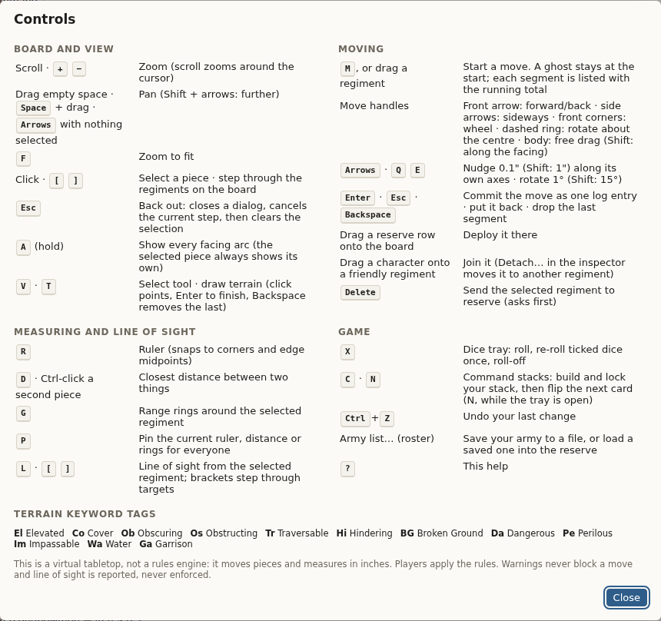
The help screen (?)

13.1 Accessibility
- Everything outside the board works with Tab, Enter and Space; roster rows can be focused and opened with the keyboard.
- Dialogs keep keyboard focus inside and give it back when closed; Esc closes them.
- Screen readers announce the selected piece; every control has a name.
- Pieces carry P1 / P2 tags as well as colours, and the default colours stay distinct for colour-blind players.
↑ Back to contents

14 Troubleshooting
Problem | What to do
The site takes about a minute to load | The server was asleep; it is waking up. Nothing to do
Room not found | The game ended when the server slept or restarted. Create a new battle
… belongs to the other player | You tried to move or edit your opponent's unit. Only wounds can be applied to either side
The board is locked for the game | Untick Board locked for the game in the board panel to edit terrain or objectives
A key does nothing | The cursor is in a text field: click the board or press Esc first
Dice say local | Settings → Dice shows why drand was not reached. Rolls keep working meanwhile
No Your stack in the command tray | You are watching: take a seat as Player 1 or 2
A character cannot be placed on the board | Characters always join a regiment: drop it on one of your regiments, or use the inspector
Undo is refused | Your opponent changed the same thing since; fix it by hand

14.1 Hosting and updates
The game runs on Render's free plan. It stays online by itself: it sleeps when unused and wakes on the next visit. To publish a new version of the code, open the service on Render and choose Manual Deploy → Deploy latest commit while nobody is playing. Full instructions are in docs/DEPLOY.md in the code repository.
↑ Back to contents

