Advanced makers course IDE installation guide.
Important notice! Please use Chrome browser to prevent any un-expected issues.
Step 1: Install Visual Studio 2022 (and up), please choose support for C\C++ code generation.
Step 2: Install the Arduino IDE, please use the bellow link and don’t install from the application store.
Link: https://www.arduino.cc/en/Main/OldSoftwareReleases#00xx
Choose: Windows installer.
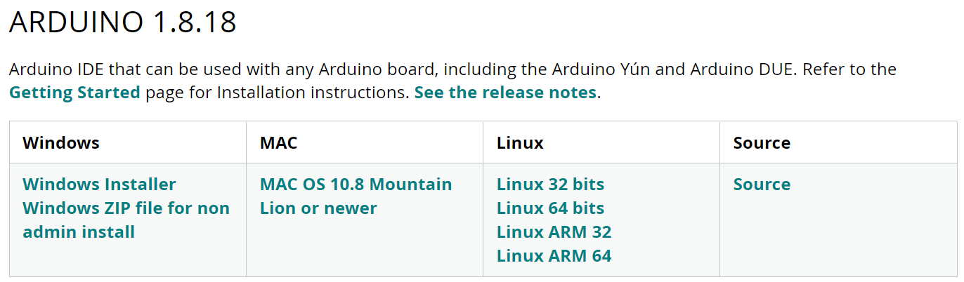
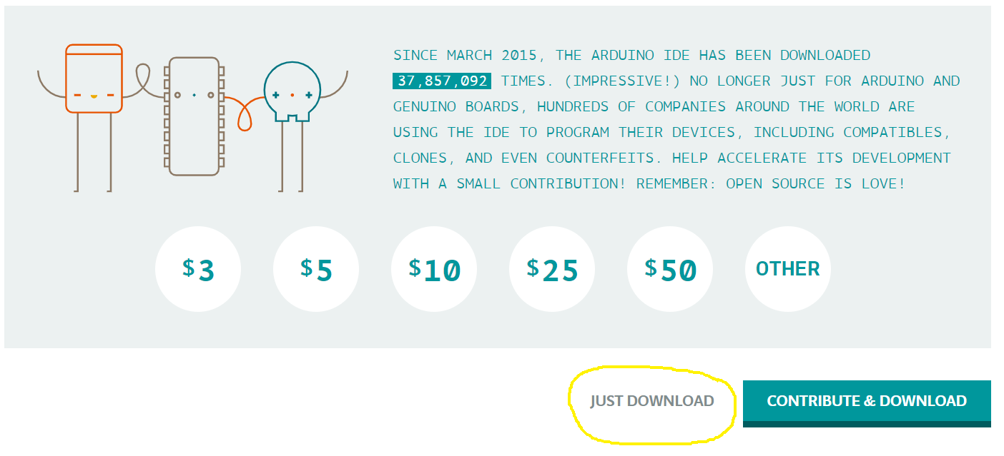

Step 3: Add packages for ESP32 or\and STM32 (STM is not needed for the course)
Open the Arduino application:
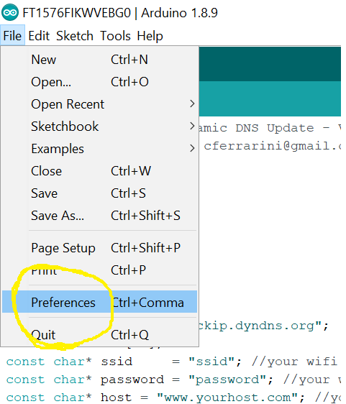

For ESP32: Copy this line into the additional boards manager URLs (see picture below), pay attention, different URLs are separated by “,”
https://raw.githubusercontent.com/espressif/arduino-esp32/gh-pages/package_esp32_index.json
For STM32:
https://github.com/stm32duino/BoardManagerFiles/raw/main/package_stmicroelectronics_index.json
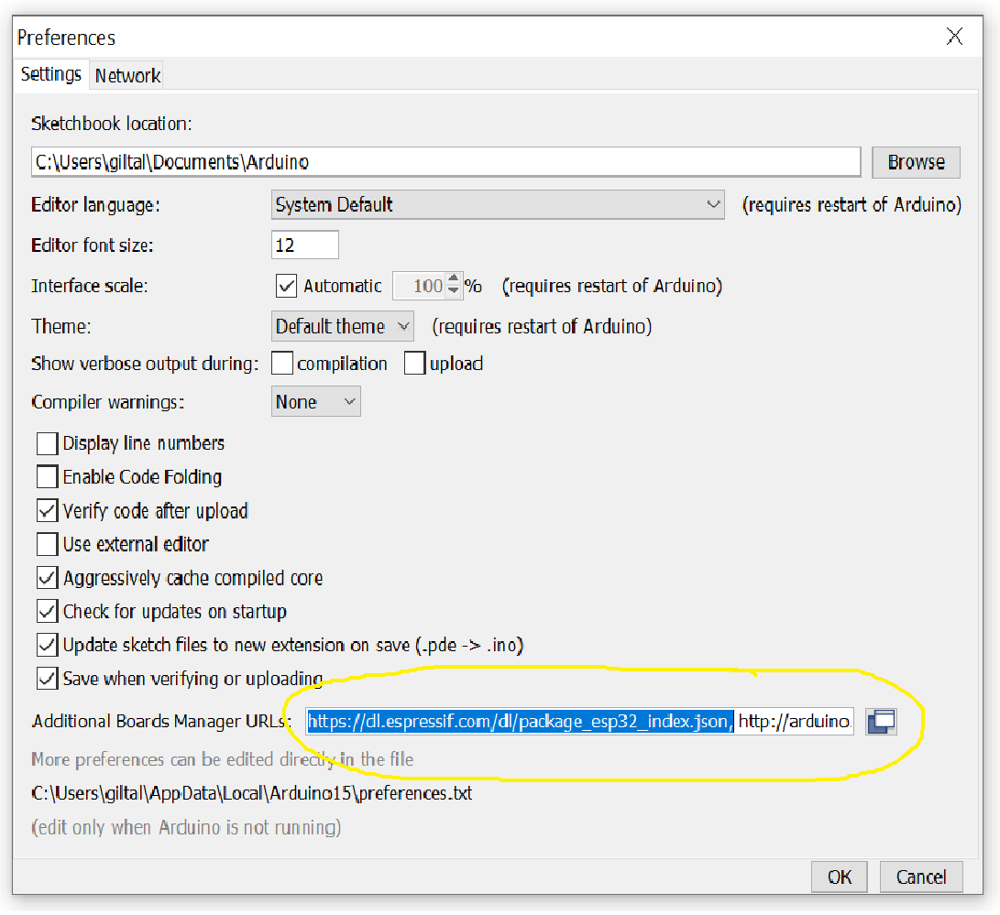
Press OK.

Step 4: In the Arduino application:
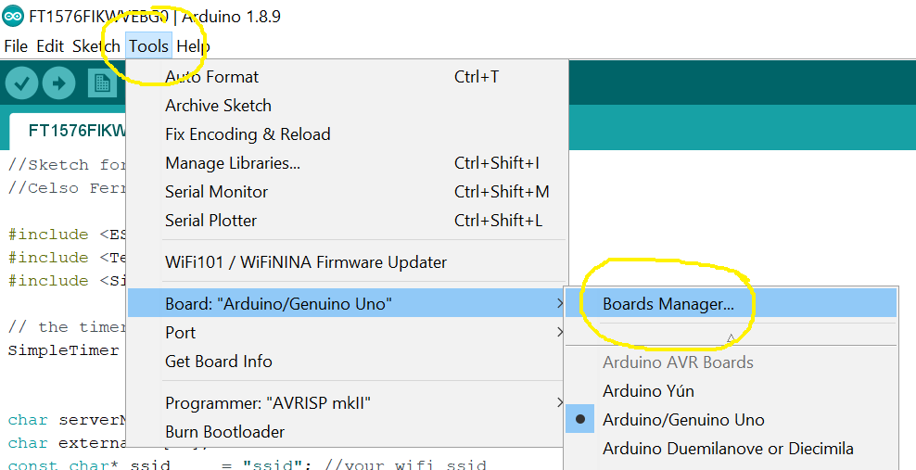

Type ESP32 or STM and press enter (Just like in the pictures bellow): Select the latest version and press install: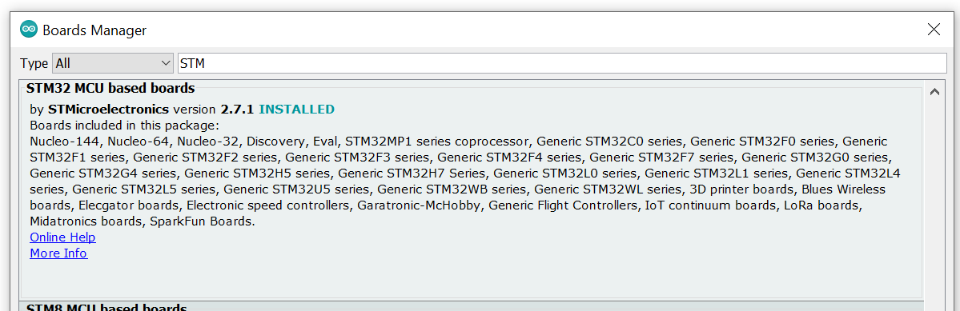
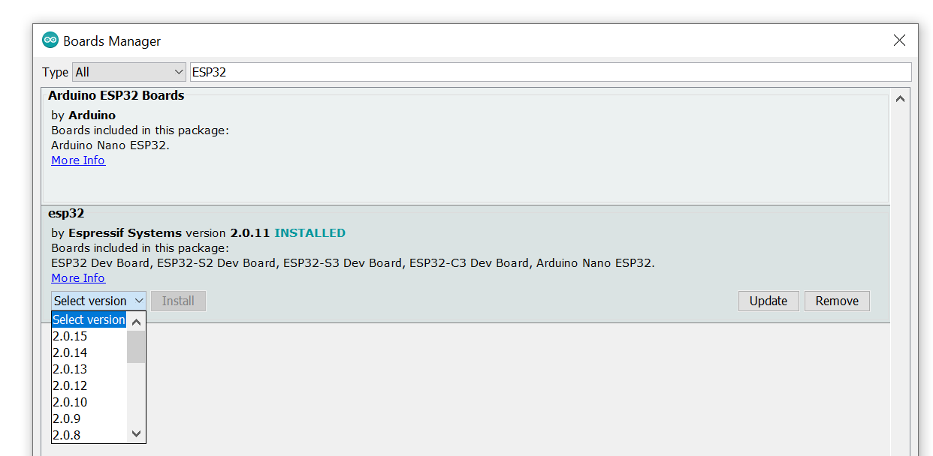
Step 5: Installing the Visual Micro plug in for Visual Studio:
Use this link: https://www.visualmicro.com/page/Arduino-Visual-Studio-Downloads.aspx
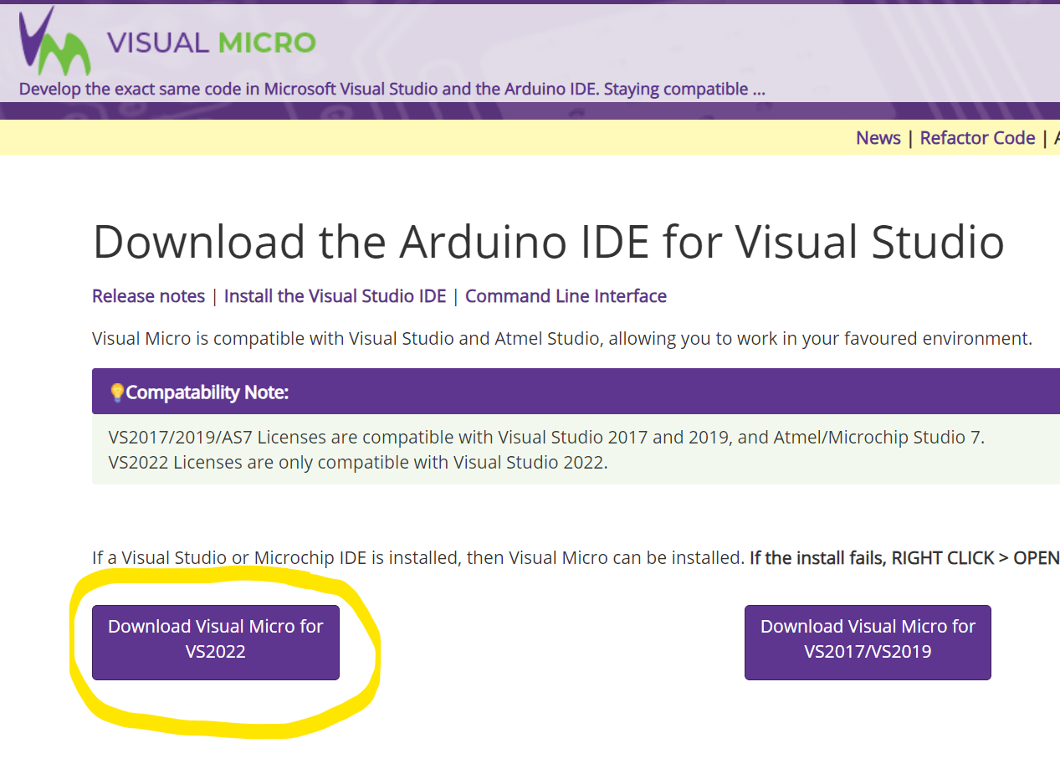

Now open visual studio, press on vMicro drop-box and follow the pictures bellow:
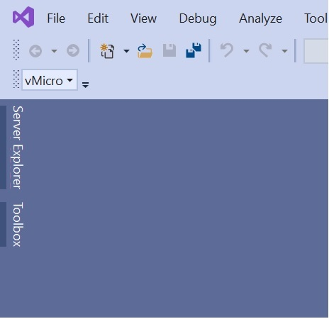
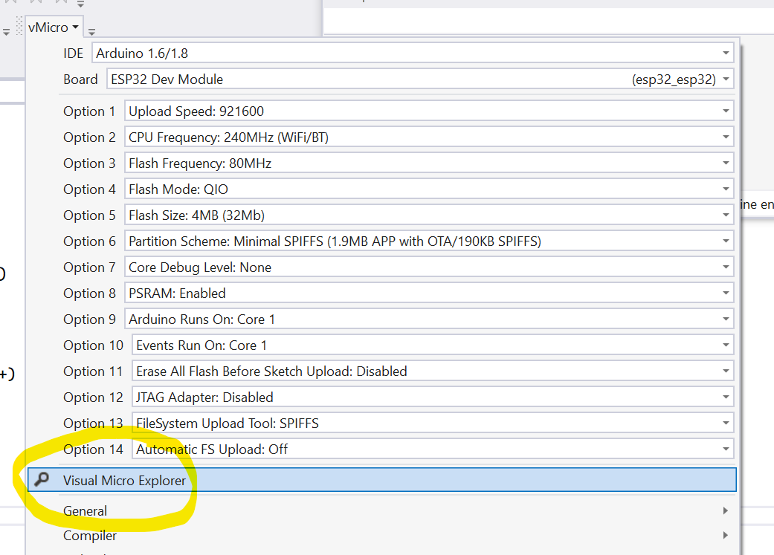
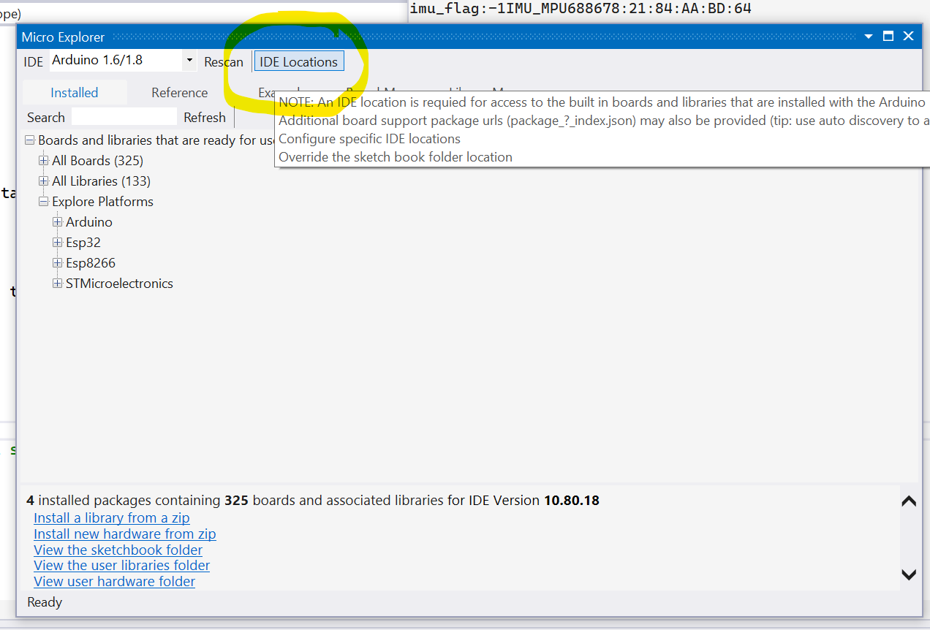
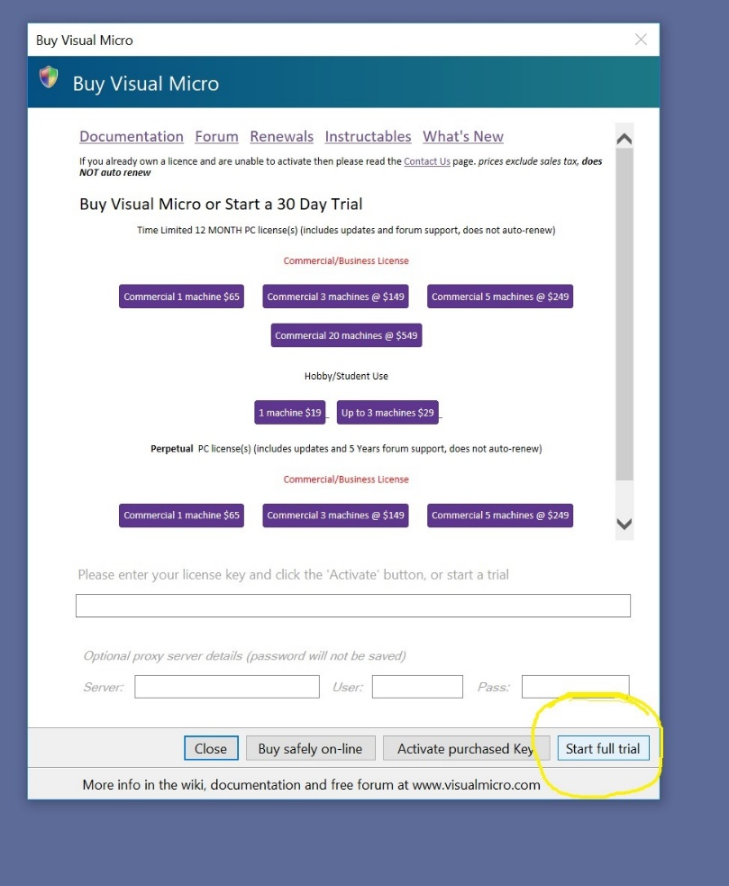

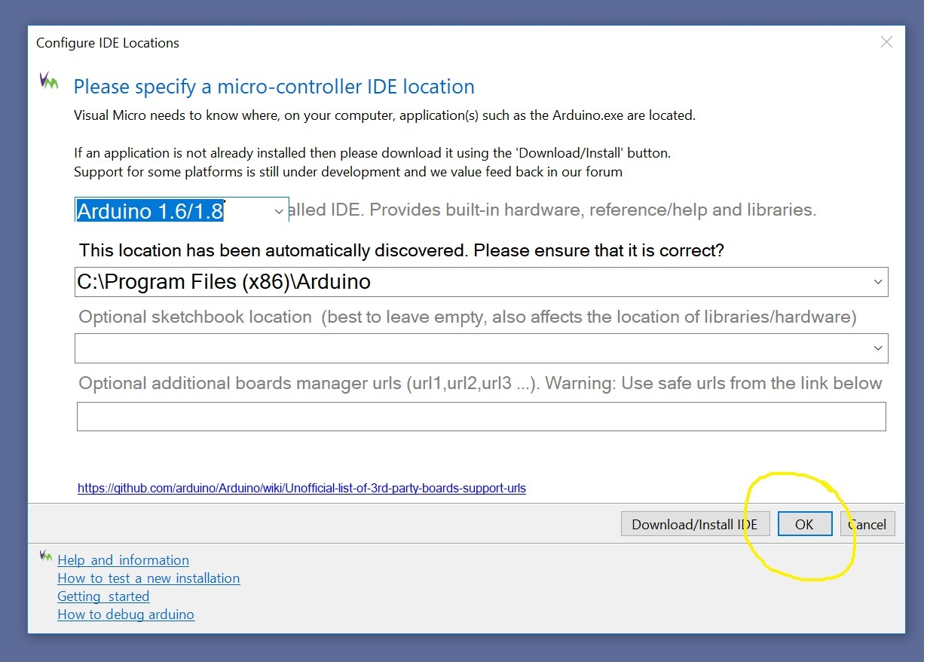

Step 6: Creating a new ESP32 project:
Follow the steps bellow:
Pay attention to choose the right board: ESP32 Dev Module
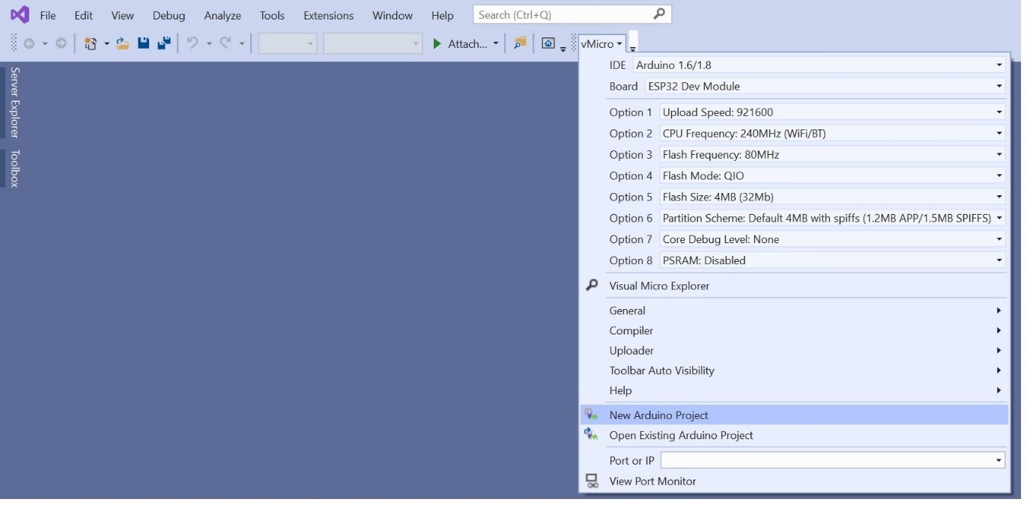

Give the project a name:
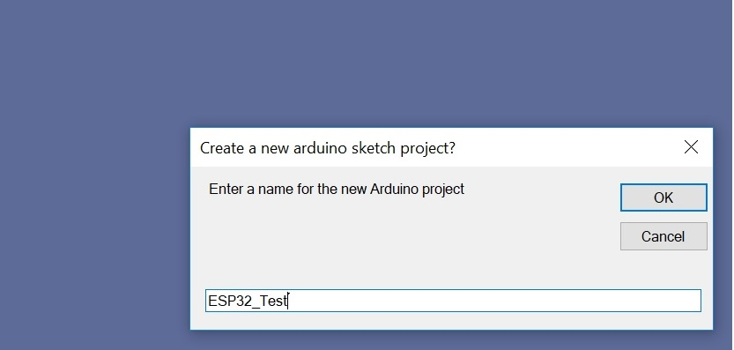
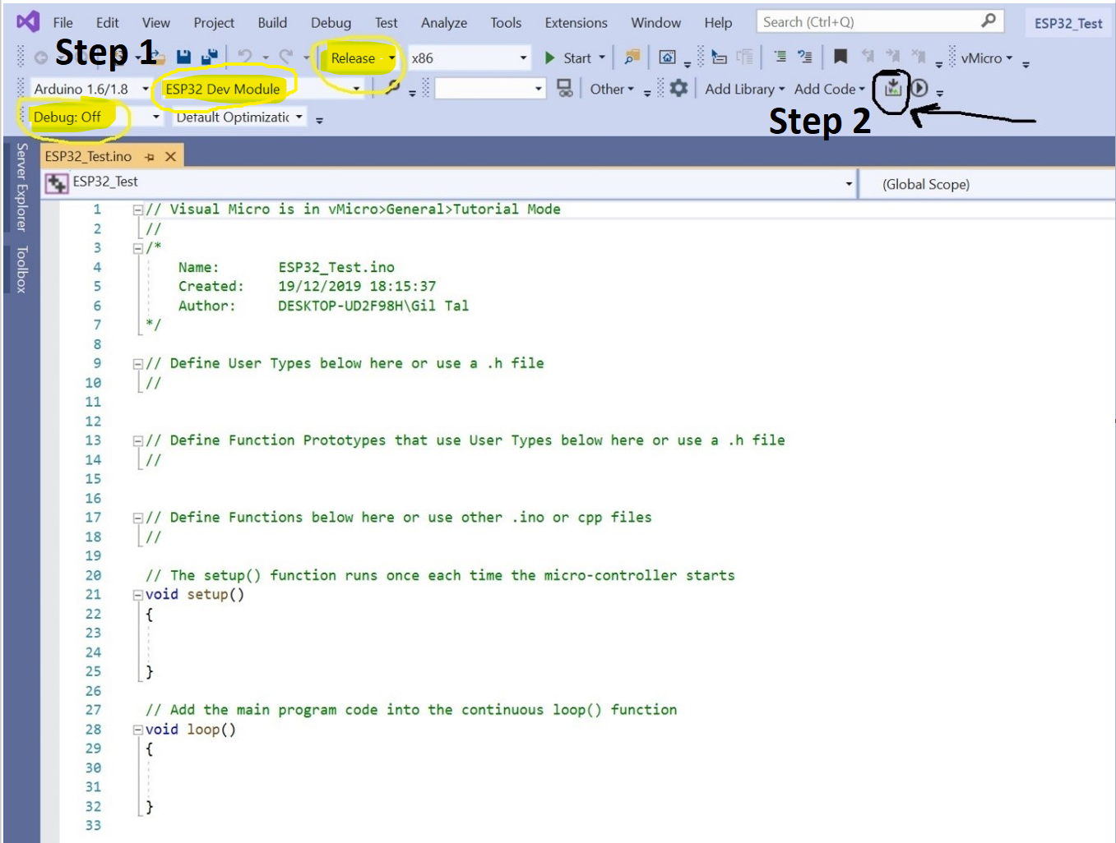

If everything goes well, you should get this output:
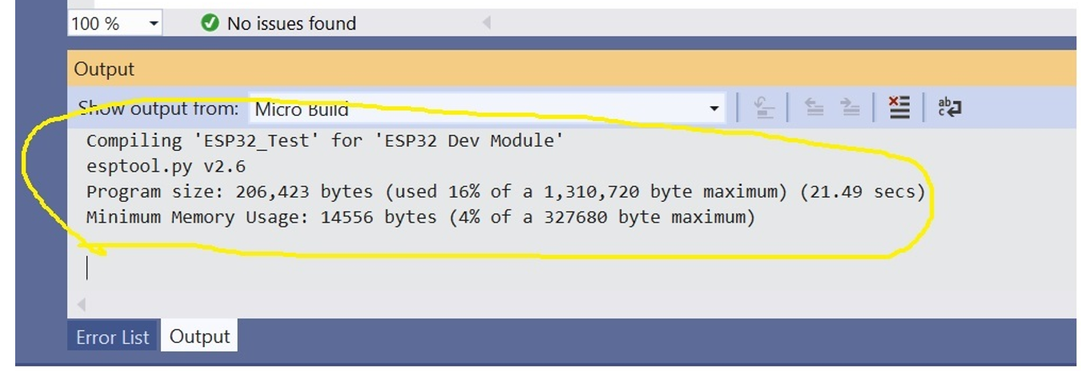
For STM32: (J-Link or ST-Link needed to upload the code directly from the IDE, otherwise look bellow to upload the code using CUBE IDE)
