Intel maker’s university: Blynk user guide

# Step 1:

Install the Blynk application from the application store on your phone

# Step 2:

Register to the service

# Step 3:

Download the Blynk Arduino library and place it the Arduino libraries folder

Link: <http://docs.blynk.cc/>

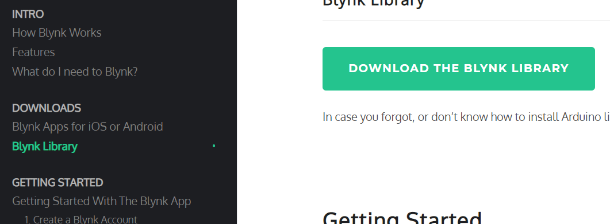

# Step 4:

Create a new ESP32 project called ESP32_Blynk and copy the code from the course GIT (ESP32_Blynk)

The code is good for both Wi-Fi and Bluetooth

This code line defines if to use Wi-Fi or Bluetooth

#define WIFI_BLYNK_DEMO

Change to: #define noWIFI_BLYNK_DEMO to use Bluetooth

In the application create a new project: **Watch video part one** placed in the GIT as how to do it properly, in the video we create a dashboard suitable for to the code

Update the authentication code you get when you create a new project in the application, the application sends the code to the mail for easy copy paste

char auth[] = "zaa_MIl8yw5ZstFcEfwUC1i93pPxTkeH";

Update the Wi-Fi hotspot details for W-Fi usage:

char ssid[] = "NETGEAR98";

char pass[] = "Password";

For Bluetooth give your ESP a unique name to be used to identify your device

Blynk.setDeviceName("Gil-Blynk");

The example code needs a to enable a joystick and 3 buttons on the application

The joystick is using virtual pin V0

The buttons are using V1-V3 and control RGB to set the color of the circle on the code

Important notice: The Bluetooth is using the **BLE** standard

Compile and load the code

Watch video part 2 and try it for your self 😊

# Step 5:

If you are interested in other examples, copy code from this wizard from the following link:

<https://examples.blynk.cc/?board=ESP32&shield=ESP32%20WiFi&example=GettingStarted%2FBlynkBlink>

The wizard supports only Wi-Fi, use our example to adapt to Bluetooth if needed