**Name: GILUANI LERMY B.  
Section & Year: IT3B  
Date: 09/28/24**

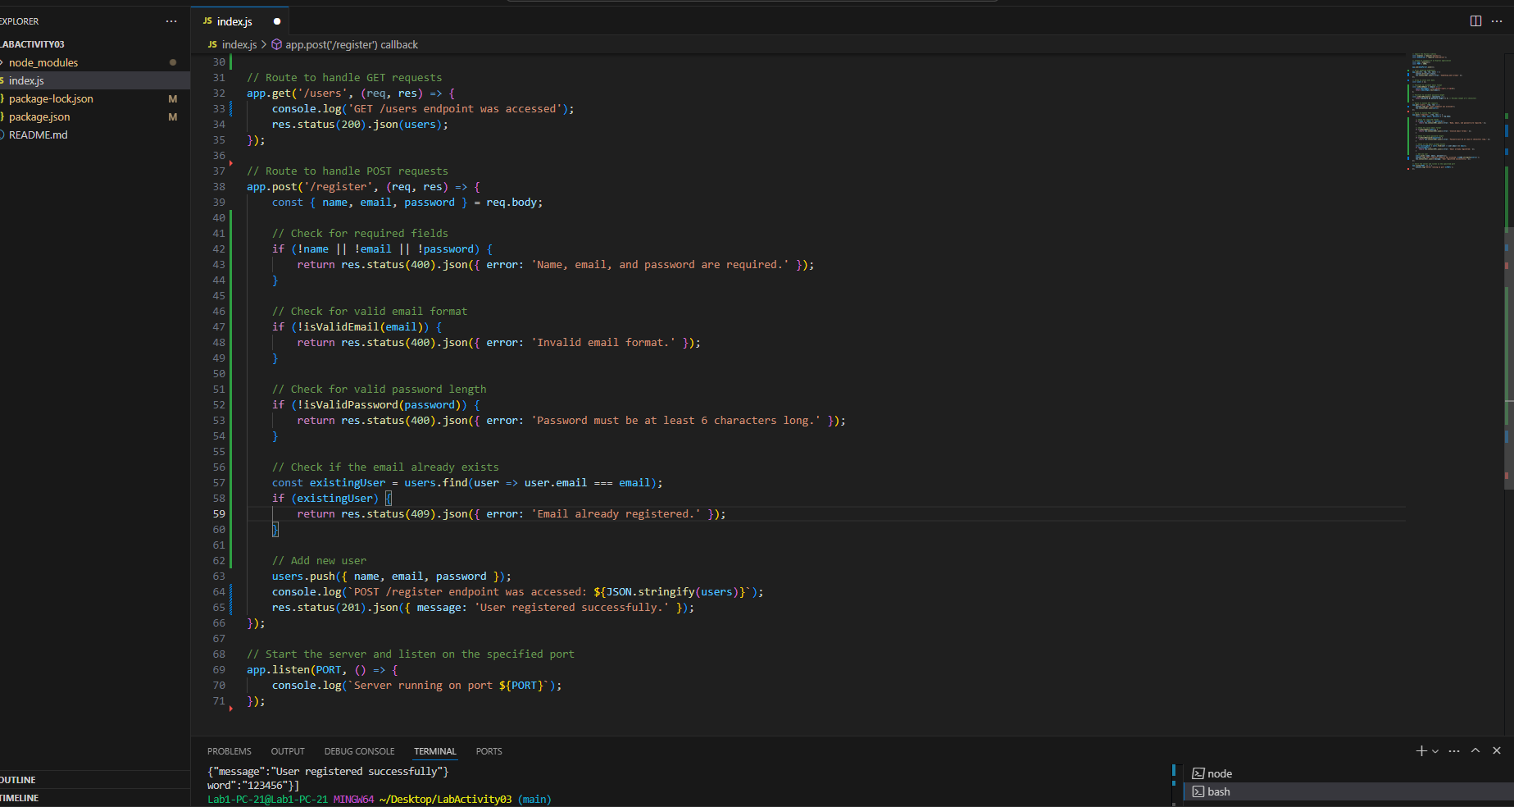

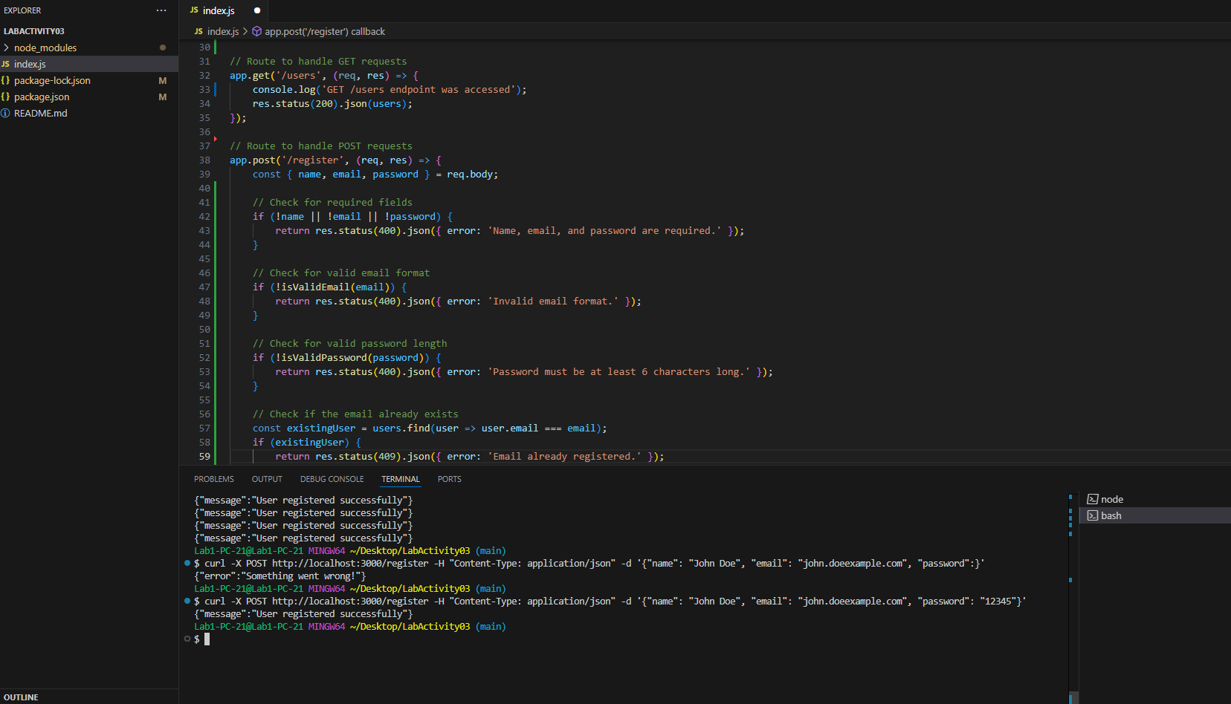

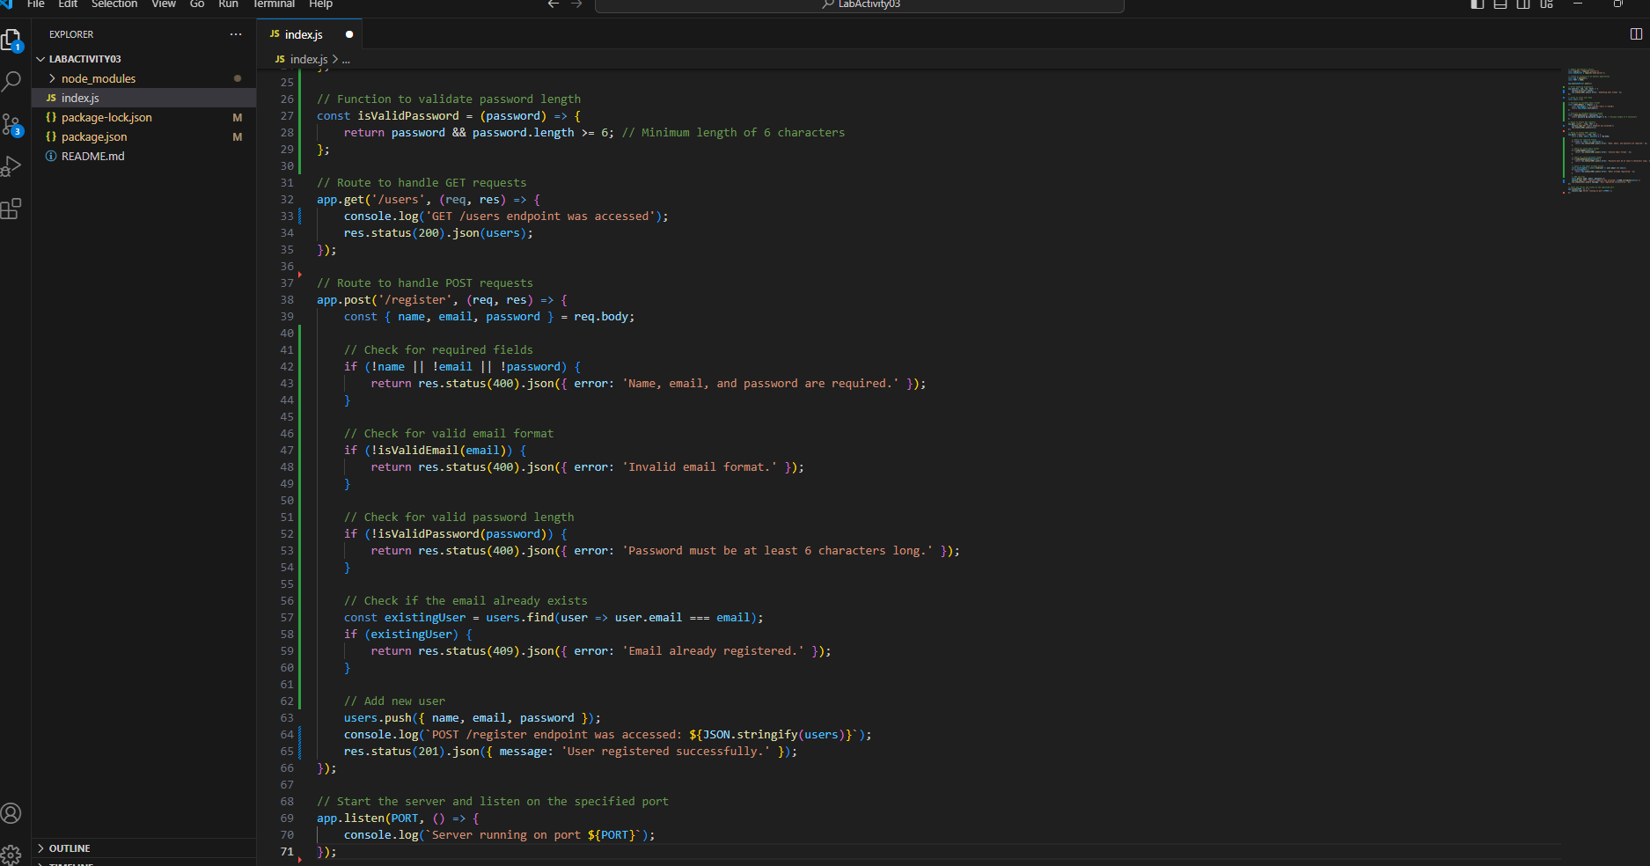

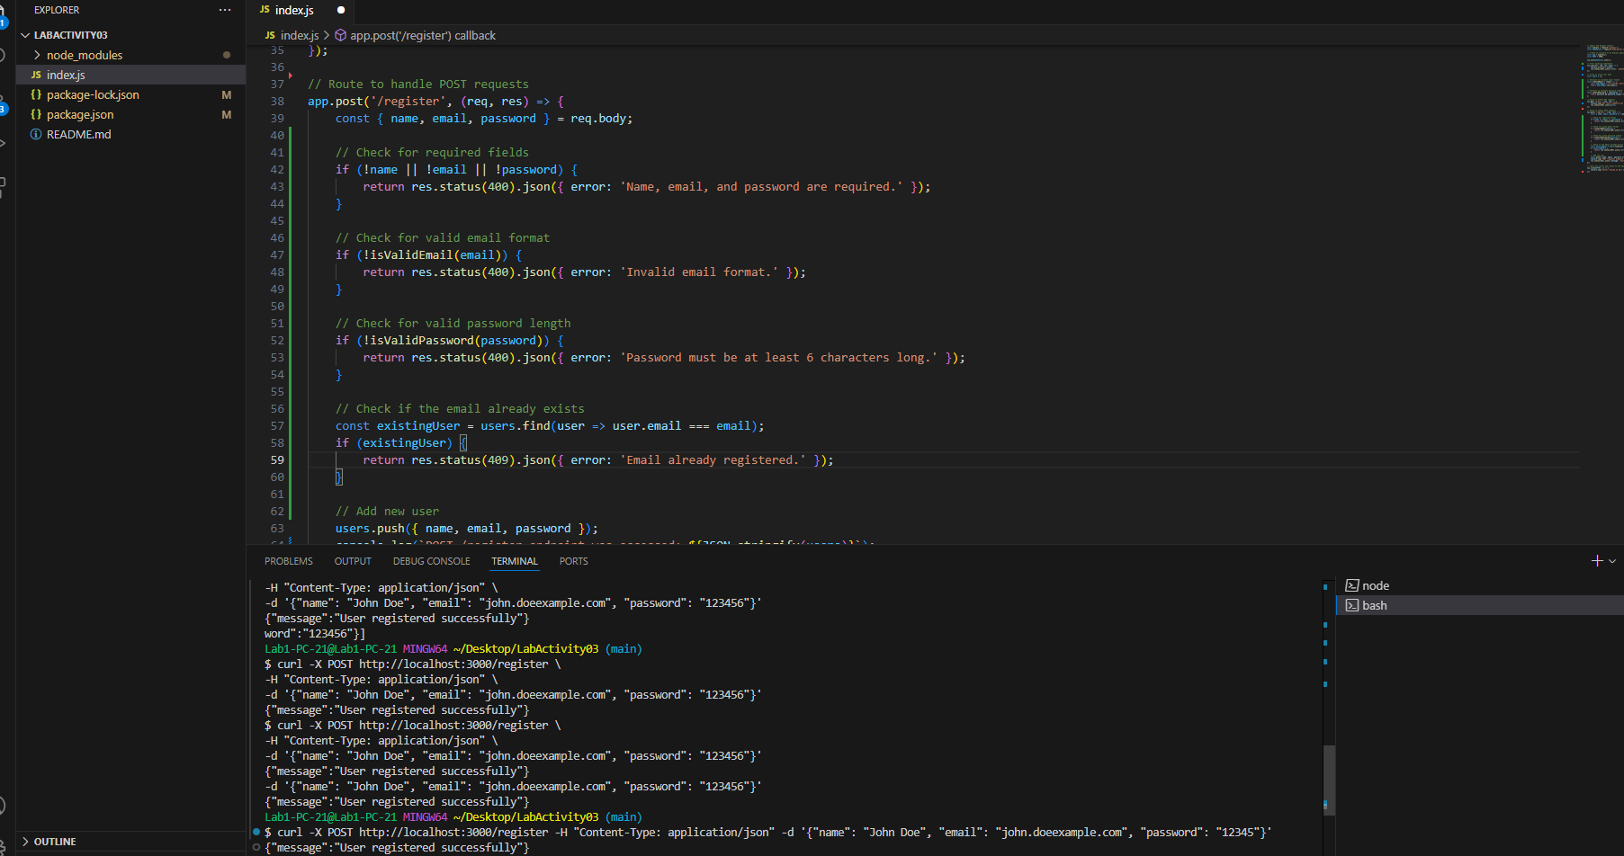

https://github.com/giluanilermy/LabActivity03.git