
Network Programming (IE2102)
2nd Year, 2 nd Semester

Assignment

Design and Implementation of a
Secure Multiprocessor TCP Application Server
with Custom Protocol and
Session Management

Submitted to
Sri Lanka Institute of Information Technology

< IT24103599 >
< Kottawasinhage G.A.S. >

In partial fulfillment of the requirements for the
Bachelor of Science Special Honors Degree in Information Technology

<<2026.04.10>>
Declaration
I certify that this report does not incorporate without acknowledgement any material previously submitted for a degree or diploma in any university, and to the best of my knowledge and belief it does not contain any material previously published or written by another person, except where due reference is made in text.

Kottawasinhage G.A.S.
IT24103599
2026.04.10

Table of Contents
Section | Page
Declaration | i
Table of Contents | ii
List of Figures | iii
1. Hostname Configuration | 1
2. Network Configuration | 1
3. Server Running (port proof using ss) | 2
4. Successful REGISTRATION and LOGIN | 2
5. Failed login + lockout proof | 3
6. Multiple fork processes | 4
7. Log file entries | 4
8. Proper child cleanup (No Zombie Processes) | 5
References | 5

List Of Figures
Figure No. | Description
Figure 1.1 | Hostname Configuration
Figure 1.2 | Network Configuration
Figure 1.3 | Server Running on Port 50599
Figure 1.4 | Successful Registration and Login
Figure 1.5 | Brute Force Lockout Protection
Figure 1.6 | Multiple Forked Server Processes
Figure 1.7 | Audit Log File Entries
Figure 1.8 | No Zombie Processes Verification

1. Hostname Configuration

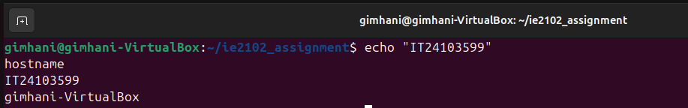
Figure 1.1 : Hostname Configuration
The hostname is gimhani-VirtualBox. Registration number IT24103599 is displayed.

2. Network Configuration

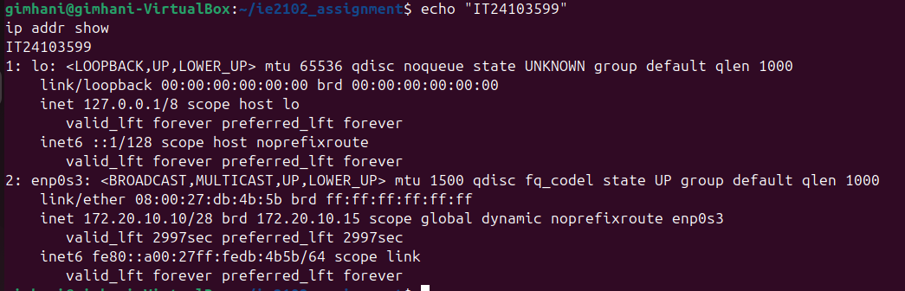
Figure 1.2 : Network Configuration

The network configuration shows the loopback interface (lo) with IP 127.0.0.1 and the primary network interface (enp0s3) with IP address 172.20.10.10. The registration number IT24103599 is displayed above the output for verification.

3. Server Port Verification
Figure 1.3 : Server Running on Port 50599
The server is successfully listening on port 50599 (calculated as 50 + last 3 digits 599 = 50599). The ss -tlnp command confirms the server process with PID 17366 is actively listening on the correct port.

4. Successful REGISTRATION and LOGIN
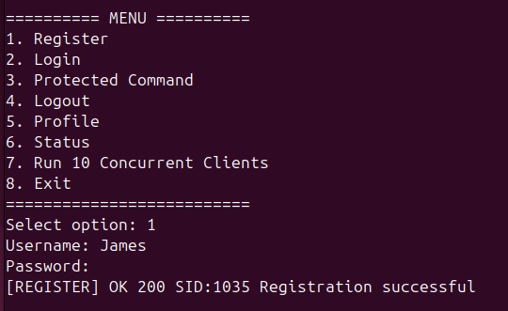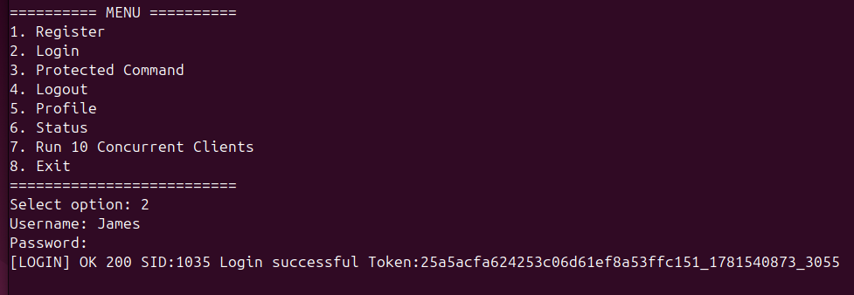
Figure 1.4 : Successful Registration and Login
The screenshot demonstrates successful registration with OK 200 SID:1035, successful login with session token issuance, protected command execution using the token, successful logout, and the 10 concurrent clients test passing with 10/10 success. The registration number IT24103599 and SID:1035 (middle 4 digits of the registration number) are visibly displayed throughout the output.
5. Failed login + lockout proof

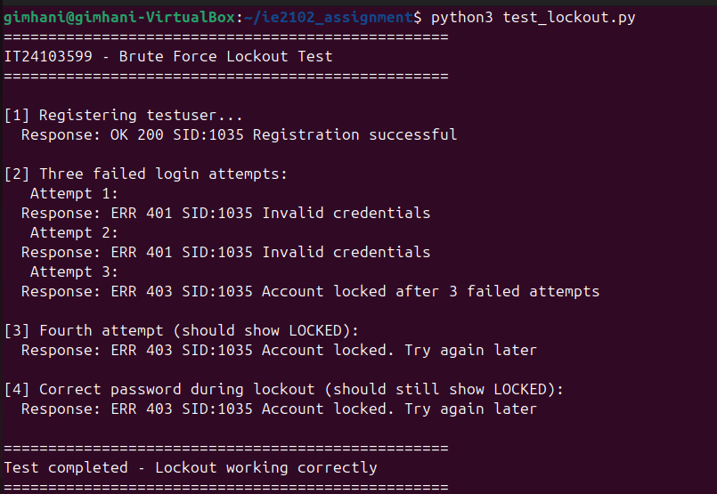
Figure 1.5 : Brute Force Lockout Protection

The screenshot demonstrates the brute-force lockout mechanism as required by A4. After 3 consecutive failed login attempts, the account is immediately locked. The 3rd attempt returns ERR 403 SID:1035 Account locked after 3 failed attempts, and subsequent attempts also return ERR 403. The registration number IT24103599 and SID:1035 are visible throughout the test.

6. Multiple fork processes
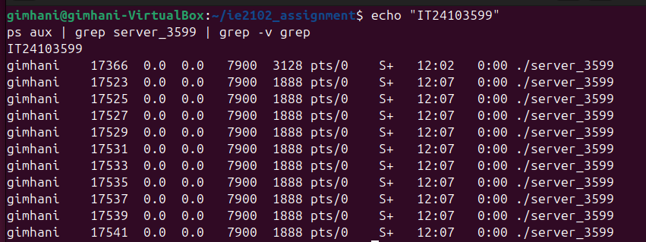
Figure 1.6 : Multiple Forked Server Processes
The screenshot shows the parent process (PID 17366) accepting connections and multiple child processes (PIDs 17523-17541) handling individual client sessions. This demonstrates the multiprocessing design using fork() as required by A2. The server successfully handles 10+ concurrent clients, as evidenced by the 10 child processes shown. The registration number IT24103599 is visible at the top of the output.

7. Log file entries
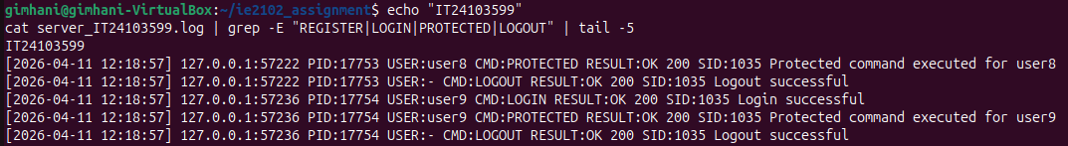
Figure 1.7 : Audit Log File Entries
The screenshot displays entries from the audit log file server_IT24103599.log. As required by A5, each log entry includes:
- Timestamp: The date and time of each event
- Client IP and Port: The client's network address
- Child Process PID: The process handling the request
- Username: The authenticated user (or '-' for unauthenticated)
- Command: The command executed (LOGIN, PROTECTED, LOGOUT)
- Result: The outcome with SID:1035

8. Proper child cleanup (No Zombie Processes)

Figure 1.8 : No Zombie Processes Verification
The screenshot confirms there are no zombie (defunct) processes. The ps aux | grep defunct command only shows the grep command itself, indicating no zombie processes exist. This proves that the SIGCHLD handler with waitpid() properly reaps all child processes, preventing zombies and ensuring clean shutdown behavior as required by A2. The registration number IT24103599 is displayed at the top for verification.

References
[1] Stevens, W. R., Fenner, B., & Rudoff, A. M. (2004). UNIX Network Programming, Volume 1: The Sockets Networking API (3rd ed.). Addison-Wesley Professional.

