Christopher Montani, comments by Chester Moses

Software Development

Bug Report

Bug Report (March Madness)

1. Please make the message look more appealing (nitpicking, I know), Ex: No user with the Username “Test” exists. A new account has been created.

We worked hard on this, let’s make it look appealing as well!

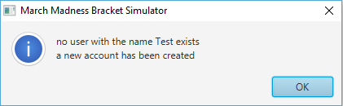

(Done)

1. When Filling out divisional brackets (East, West etc) the clear button has no functionality

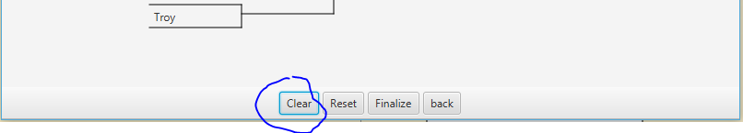

(Mostly done – does not work on Final Four)

1. Make this look grammatically correct with capitalization/punctuation

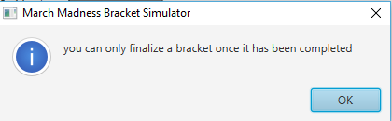

(Done)

1. Change the “back” button to read “Back”

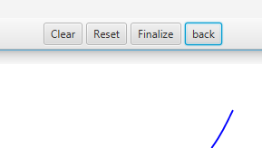

(Done)

1. Resize the size of the GUI window to be able to handle the entire size of a full bracket on launch

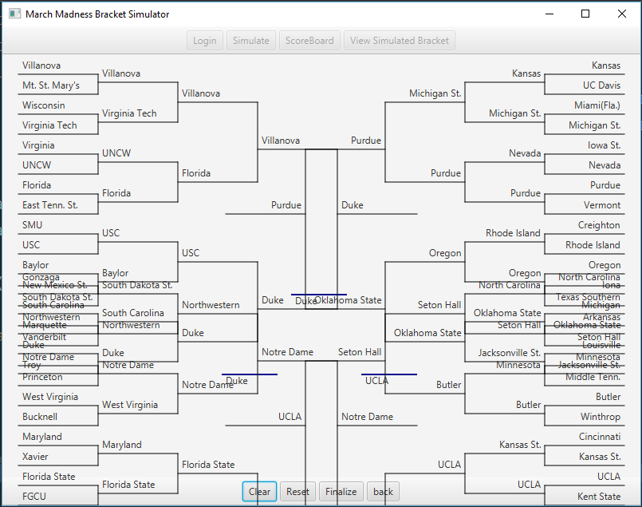

(done)

1. Make the individual bracket sizes larger so the school names will fit comfortably

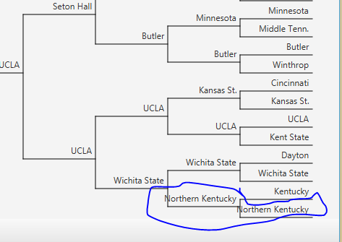

1. After selecting Simulate I am navigated to the scoreboard window but there are no scores, only dummy data.

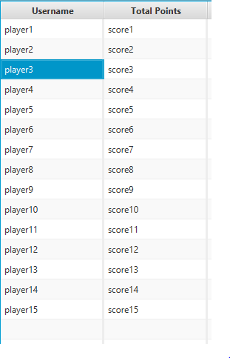

(done)

1. The user has no way of knowing which teams they selected were correct predictions, highlight the correctly predicted school names in green.

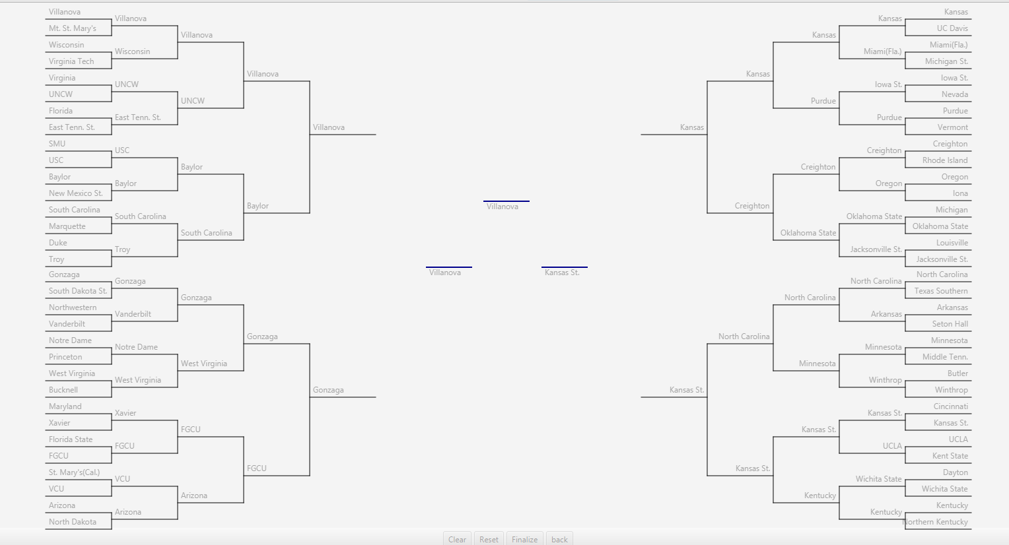

1. Make the table “Read-Only” so the user can not manipulate data

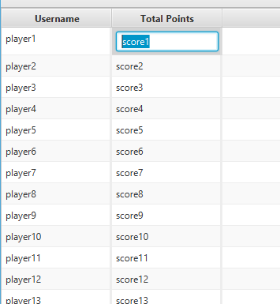

(done)

1. Let the Scoreboard pane be sortable as of now it does not allow this functionality

(done – you can sort by username or by score!)

1. There is no way for the user to view any college information about certain schools. Where is this being displayed?

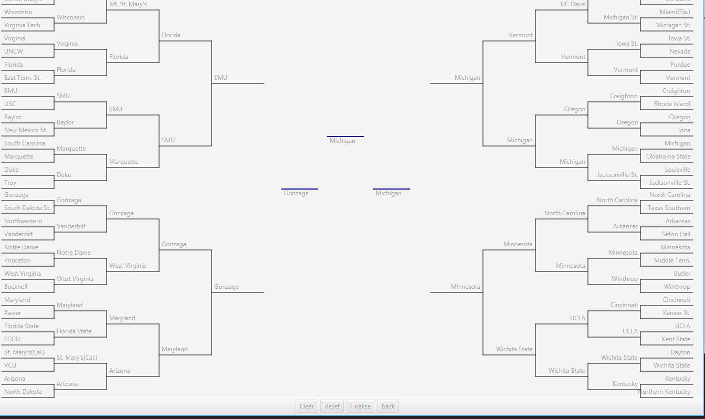

(done – right click)

1. Maybe add a “Log-Out” button

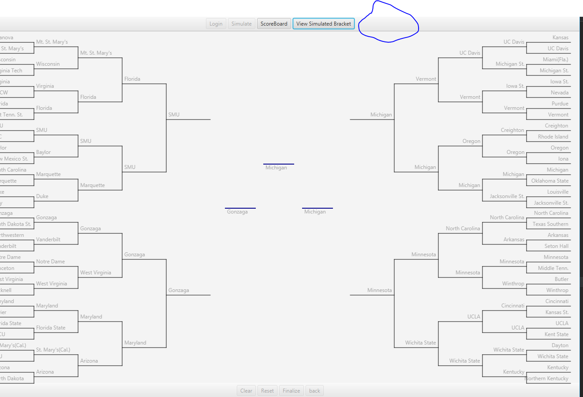

13.) Occasionally, brackets will fail to be saved when finalized.

14.) All Brackets are loaded when the program launches, and are scored when the simulation runs. As the program has a limit of 16 users, this could quickly run out of users. Brackets should only be loaded when a user attempts to log in.

15.) The clear button removes the first team from the Round of 64 - the team in index 63.

16.) There is no way to view a user’s bracket after the simulation occurs.

17.) There is no announcement of the winning player and team when the scoreboard is displayed.

18.) The simulated bracket does not display the generated scores when viewed.

19.) There is no way to view only the Final Four portion of the tournament.

20.) Passwords are stored in plaintext, and are visible by opening the serialized files in either a text editor or hex editor. They should be stored as a hash value, for a minimum of security.

21.) In general, the code does not conform to a single style, and comments on fields and methods are inconsistent.