OODP — 4th Iteration Report
Team A (Kim Jungwook, Lee Jaeho, Kim Gyeongdong). Korean Air Skypass Ticket Reservation System. ECE312 Object-Oriented Design Patterns, 2026 Spring. Date 2026-05-29.
Iteration 4 finishes the project along two axes. First, six design patterns are added (Composite, Singleton, Factory Method, Template Method, Adapter, Decorator), bringing the GoF total to nine, and all nine are actually exercised through the user interface. Second, the UI stack is fully migrated from Swing to JavaFX (FXML, CSS, MVC) without changing a single line of the Control or Domain layers. This is a cumulative report; Sections 13 to 15 recap Iterations 1 to 3.

Form #1 - Feature Inventory (Cumulative)

Category | Sub-feature | Implemented iteration (1 / 2 / 3 / 4)
Authentication | Member registration | 1, 4 (UI)
 | Login / Logout (Skypass member) | 1
 | Member profile and mileage balance lookup | 2
 | Guest verification (PNR + name + email) | 2
Flight Search and Selection | Flight search (origin, destination, date, trip type) | 1
 | Itinerary detail display (fare rule, seat info, fees) | 1
 | Direct-flight selection | 1
 | Connecting-flight selection with layover validation (MCT) | 3, 4 (UI)
 | Multi-city itinerary composition | 3, 4 (UI)
 | City-code search expanding to member airports (Composite) | 4
Booking Flow | Passenger info entry (name, contact, passport) | 1
 | Seat selection (aircraft seat map) | 2
 | Seat add-on upgrades: legroom / lounge (Decorator) | 4
 | 15-minute seat hold management | 3
 | Fare validation (FareRule-based) | 1
 | Payment processing (Payment Gateway) | 1
 | Multi payment-method routing: card / KakaoPay / ApplePay / bank / mileage (Factory Method) | 4
 | Auto-cancel on payment failure | 3
Mileage | Mileage balance lookup via Skypass (Adapter) | 3, 4 (UI)
 | Partial or full mileage redemption | 3, 4 (UI)
Reservation Lookup | Member reservation lookup | 2
 | Guest reservation lookup (after verification) | 2
Cancellation and Refund | Cancellation request intake (Confirmed / Ticketed only) | 2
 | Refund policy selection (Strategy) | 2
 | Automatic refund processing (FareRule-driven) | 2
 | Manual refund review queue (approve / deny) | 4
e-Ticket | e-Ticket issuance (PNR generation) | 2
 | Multi-format render: plain text / HTML / boarding pass (Template Method) | 4
Notifications | Linked bus-ticket offer on e-ticket issuance (Observer) | 3
Options and Settings | Global config: font, currency, theme (Singleton) | 4
User Interface | JavaFX migration (Swing replaced; FXML + CSS + MVC) | 4

Form #2 - Extension Inventory (Cumulative)

Base feature | Extension (additions / changes) | Status in Iteration 4
Itinerary composition (iter3) | Direct / Connecting / MultiCity each built via a dedicated factory | Done (DP#6 Factory Method: ItineraryFactory family)
Options and Settings | Font, currency, theme global config system-wide | Done (DP#5 Singleton AppConfig, live re-render)
Payment methods (iter1-3) | Add methods beyond card/mileage (KakaoPay, ApplePay, bank) | Done (DP#6 Factory Method: PaymentProcessorFactory)
e-Ticket issuance (iter2) | Multi-format rendering of the same ticket data | Done (DP#7 Template Method: TicketRenderer)
External Skypass System | Wrap external mileage API behind a domain interface | Done (DP#8 Adapter: SkypassAdapter over RemoteSkypassApi)
Seat selection (iter2) | Per-seat add-on options stacked at runtime with surcharge | Done (DP#9 Decorator: SeatView chain)
Connecting flight search (iter3) | Same-city different-airport grouping (NYC, TYO, LON) | Done (DP#4 Composite: AirportCity / Airport)
UI toolkit (iter1-3) | Replace imperative Swing with declarative FXML + CSS | Done (Refactoring#3; Boundary-only swap)
Exceptional refund processing | Admin review queue with manual override | Partial: review queue done; admin auth is a backend stub
Mileage payment - deduct only | Mileage accrual on completed ticket | Post-course
e-Ticket | PDF download with localized template | Post-course (render abstraction in place)
Reservation status tracking | Real-time push on every state transition | Post-course (reuses Observer)

Form #3 - Refactoring and Design Pattern Inventory (Cumulative)

Iteration | Refactoring / Design Pattern | Where applied / Summary
1st | DP#1 State | Reservation 8-state lifecycle. ReservationState interface + 8 concrete states + AbstractReservationState. Iter1 report Section 6.
2nd | Refactoring#1 | Extracted refund if/else from RefundHandler into RefundPolicy interface; groundwork for DP#2.
2nd | DP#2 Strategy | RefundPolicy family (Full / Partial / No); FareRule selects, RefundHandler executes. Iter2 report Section 4-6.
3rd | Refactoring#2 | Moved side-effect calls into a publisher-listener infrastructure; groundwork for DP#3.
3rd | DP#3 Observer | EventPublisher + EventListener + DomainEvent; subjects (SeatHoldMonitor, PaymentProcessor, FlightSchedule, TicketPurchasePublisher) and 4 listeners. Iter3 report Section 2-6.
4th | Refactoring#3 | UI stack migration Swing to JavaFX (FXML + CSS + MVC). Boundary-only; Control/Domain unchanged. Section 5.
4th | DP#4 Composite | AirportLocation (Component) / AirportCity (Composite) / Airport (Leaf). City-code search expansion. Section 8.1.
4th | DP#5 Singleton | AppConfig (double-checked locking) for global font / currency / theme with live listeners. Section 8.2.
4th | DP#6 Factory Method | PaymentProcessorFactory (5 payment methods) and ItineraryFactory (Direct / Connecting / MultiCity). Section 8.3.
4th | DP#7 Template Method | TicketRenderer (final render template) + PlainText / Html / BoardingPass. Section 8.4.
4th | DP#8 Adapter | SkypassAdapter wraps RemoteSkypassApi behind SkypassInterface. Section 8.5.
4th | DP#9 Decorator | SeatView + AbstractSeatDecorator + Window / Aisle / ExtraLegroom / Lounge. Section 8.6.
Note on numbering: in the Iteration 3 report the planned patterns were tentatively numbered DP#4 Singleton and DP#5 Factory Method. The implemented code adopts the canonical order above (DP#1 through DP#9), where Composite is DP#4 and Singleton is DP#5. This report follows the implemented numbering.

Section 4. Iteration 4 - Scope Overview

4.1 One-paragraph summary
Iteration 4 raises latent backend capability to the user interface and adds six patterns. Until Iteration 3 the Swing UI exposed only the core booking flow; payment-method choice, seat add-ons, e-ticket rendering, mileage payment, connecting search, and global settings were unreachable. Iteration 4 closes that gap and, in doing so, exercises Composite, Singleton, Factory Method, Template Method, Adapter, and Decorator, while replacing the entire UI toolkit with JavaFX.

4.2 Iteration 3 vs Iteration 4

Area | Iteration 3 | Iteration 4
Main pattern(s) | Observer | Composite, Singleton, Factory Method, Template Method, Adapter, Decorator
UI toolkit | Swing (imperative) | JavaFX (FXML + CSS + MVC)
Patterns exercised in UI | State, Strategy, Observer | All 9 GoF patterns
Build | Bare Eclipse, manual javac | Maven + javafx-maven-plugin + wrapper
Booking modes | Direct, connecting, multi-city (backend) | Same, now selectable in UI (one-way / round / multi-city / connecting)

4.3 Code change footprint

Layer | Change | Note
Boundary | Swing 19 files removed; app.fx package added | FXML + CSS + 13 controllers
Control | confirmPaymentWith, initiateConnectingBooking added | Thin glue to surface Factory
Domain | Unchanged | 9 patterns preserved
Build | pom.xml, mvnw added | tools/ excluded from Maven

4.4 ECB layer summary
Only the Boundary layer changed. The nine patterns live in Control and Domain and were untouched by the UI migration, which demonstrates the non-destructive boundary swap that ECB architecture is meant to allow.

Section 5. UI Stack Migration - Swing to JavaFX
Swing builds layout imperatively (GridBagConstraints arithmetic), which grew unwieldy and mixed style with logic. JavaFX separates structure (declarative FXML), style (CSS), and logic (Controller) under an MVC model. The migration deleted the 19-file app.swing package and added app.fx (FxApp launcher, AppContext shared state, Navigator screen-switch hub, ShellController for header and State badge, 13 screen controllers, FXML files and a Korean Air light-theme CSS). Because the nine patterns reside in Control and Domain, none were affected; this re-proves ECB non-destructiveness. Maven was introduced for dependency management and is run via the included wrapper with mvnw javafx:run.

Section 6. Iteration 4 - Feature Breakdown

# | Feature | Demo trigger | Pattern
1 | Payment-method routing | Choose a method on the payment screen | Factory Method
2 | Mileage balance + payment | Member payment screen shows balance, mileage charge | Adapter
3 | Seat add-on surcharge | Tick legroom / lounge on the seat screen | Decorator
4 | Multi-format e-Ticket | Toggle format on the confirmation screen | Template Method
5 | Global settings | Change font / currency in Settings | Singleton
6 | City-code search | Search by SEL / TYO / NYC / LON | Composite
7 | Connecting search | Tick "include connections" | Factory Method (Itinerary)
8 | Manual refund review | Request review then approve / deny | Strategy

Section 7. UML Diagrams

7.1 Full cumulative class diagram (every package, all 9 patterns)
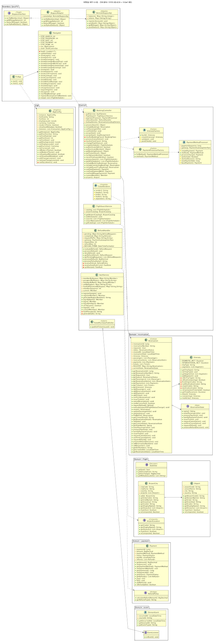

7.2 Per-pattern class diagrams - Iteration 4 additions
7.2.1 Composite
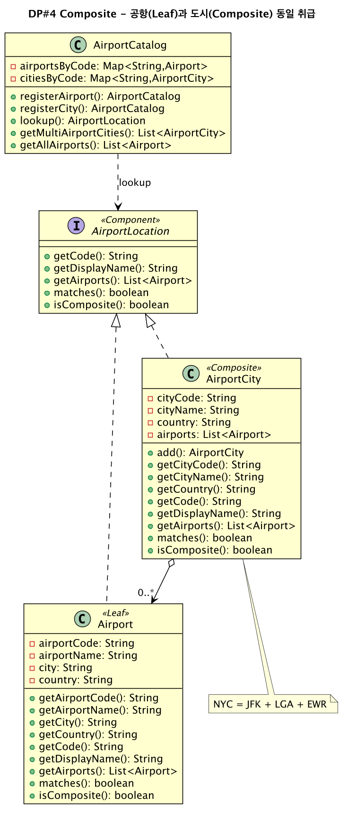
7.2.2 Singleton
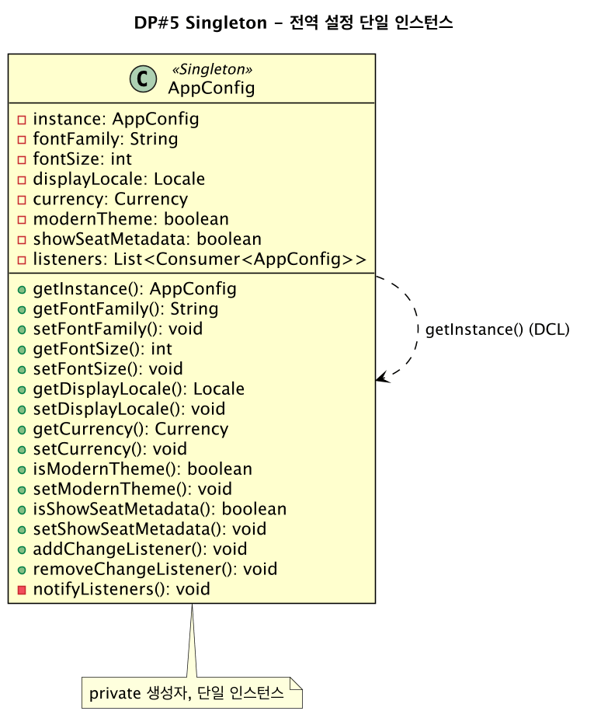
7.2.3 Factory Method
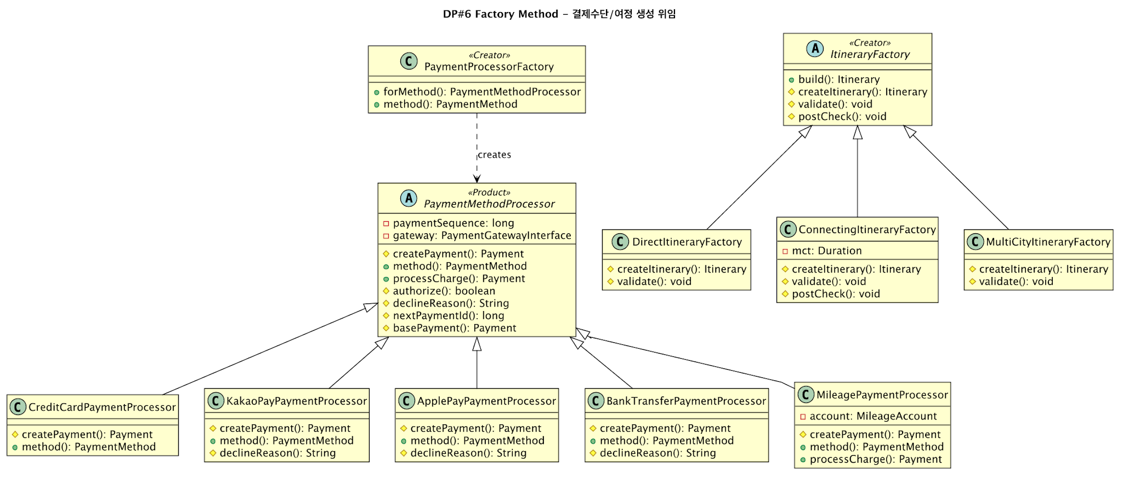
7.2.4 Template Method
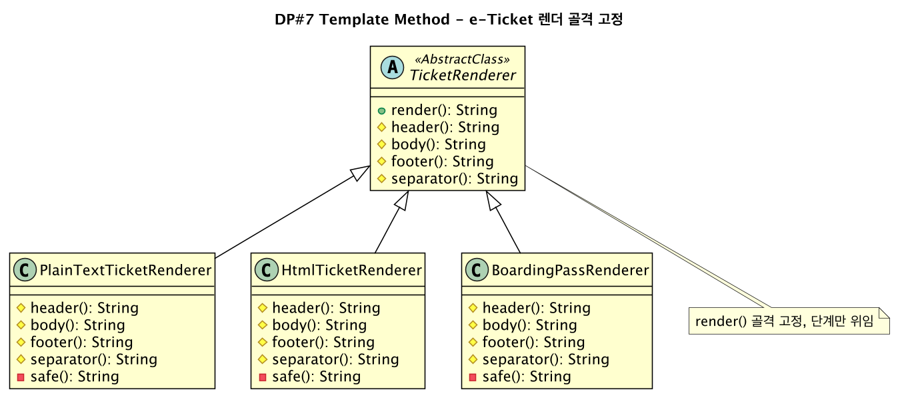
7.2.5 Adapter
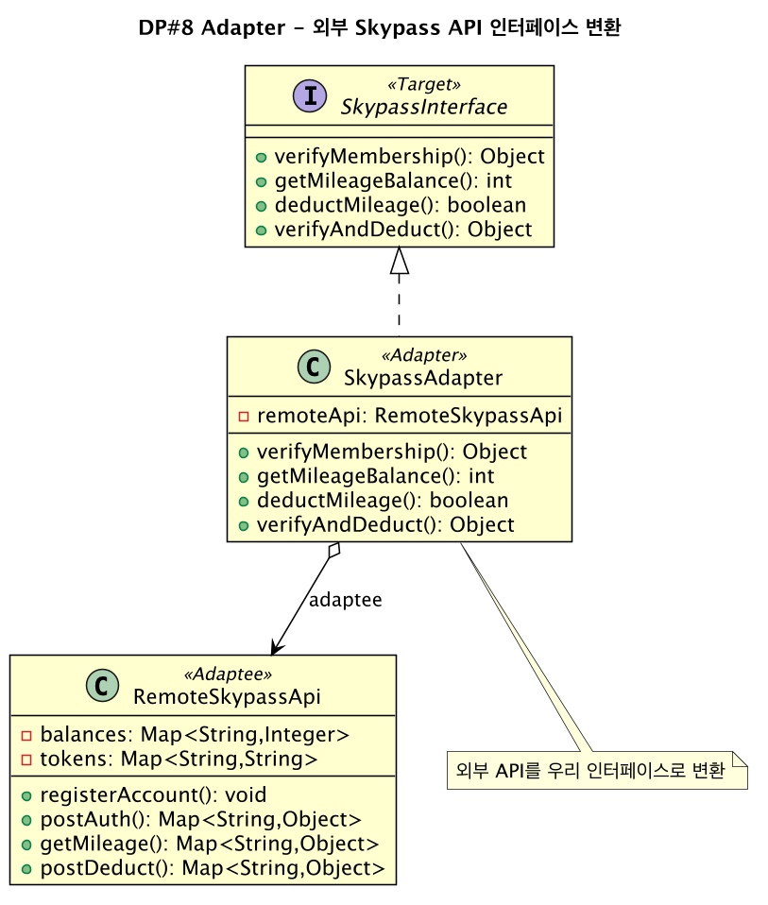
7.2.6 Decorator
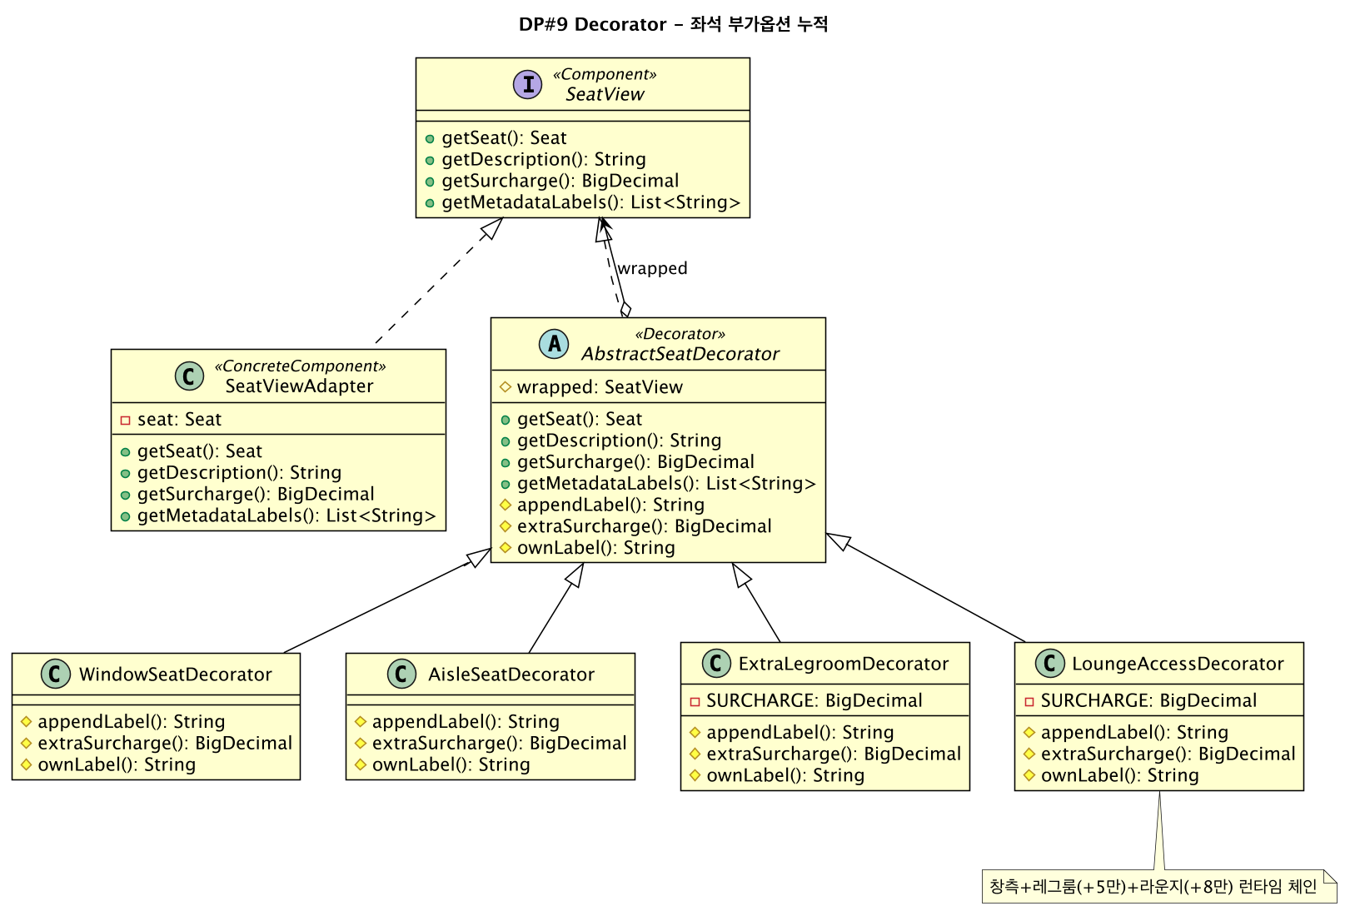

7.3 Per-pattern class diagrams - Iterations 1 to 3 (recap)
7.3.1 State (Iteration 1)
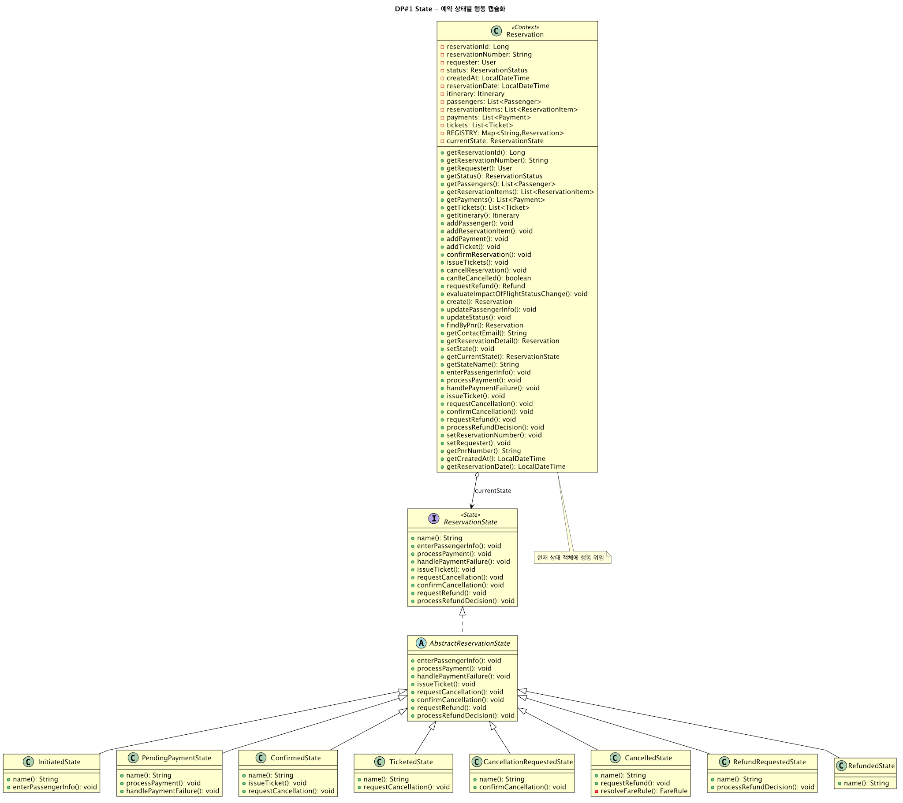
7.3.2 Strategy (Iteration 2)
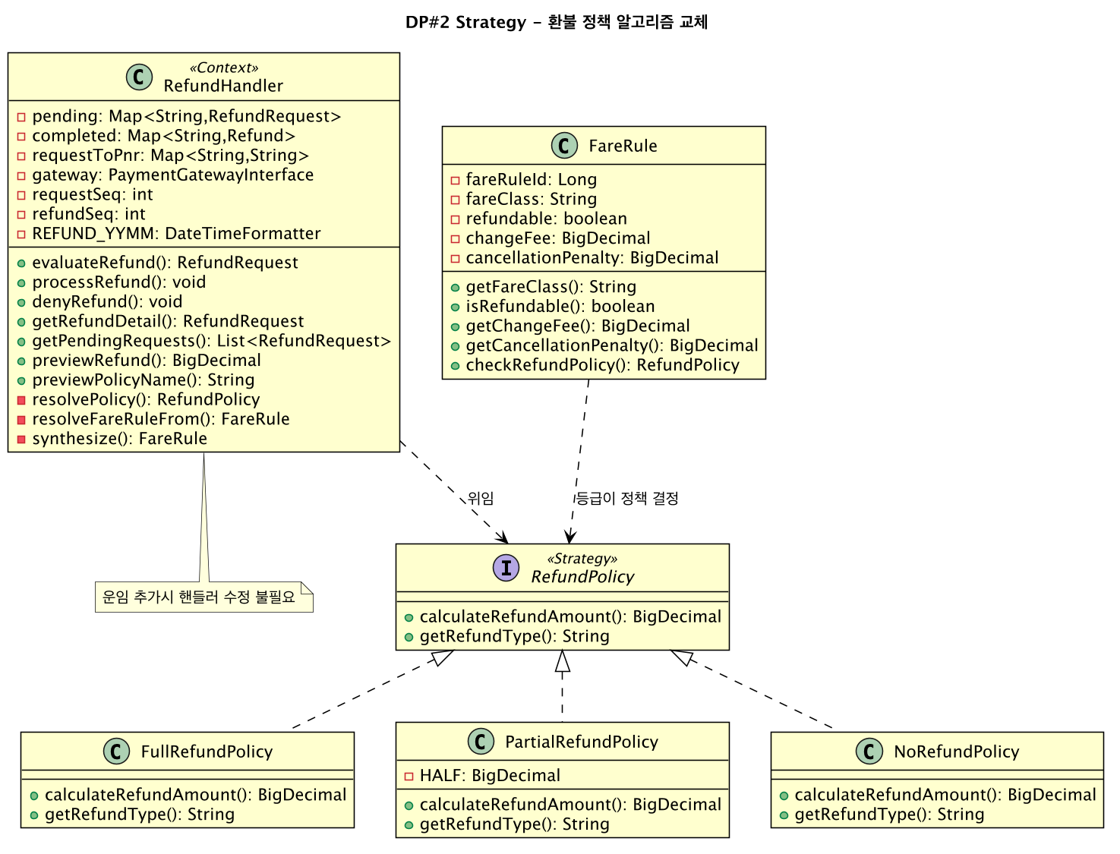
7.3.3 Observer (Iteration 3)
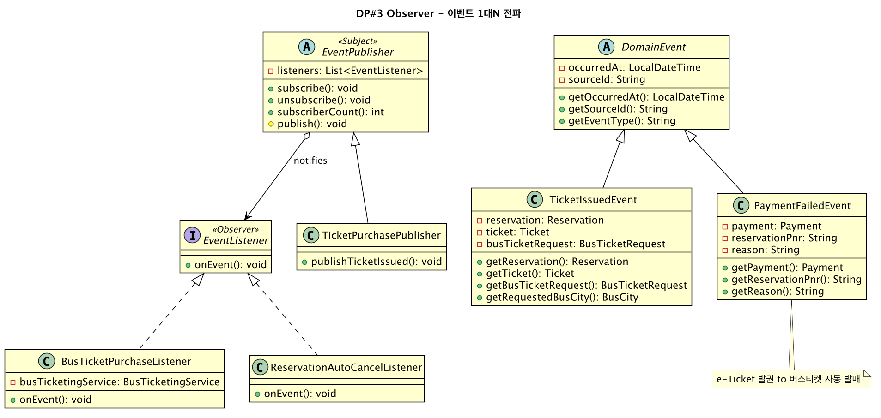

Section 8. New Patterns - Motivation and Structure

8.1 Composite (structural)
Problem: a search for New York must consider JFK, LGA, and EWR, yet the search logic wants to treat a city and an airport uniformly as origin or destination. Solution: individual airports (Leaf) and city groups (Composite) share the AirportLocation interface; getAirports() returns the airport itself for a Leaf and all member airports for a Composite, so search expands a city code without branching. See diagram 7.2.1.

8.2 Singleton (creational)
Problem: global settings (font, language, currency, theme) must read the same value from UI and domain; multiple instances would diverge. Solution: AppConfig is a single instance guarded by a private constructor and double-checked locking; on change it notifies registered listeners so the JavaFX scene re-renders immediately. See diagram 7.2.2.

8.3 Factory Method (creational)
Problem: payment methods and itinerary types each need different objects; direct new in the caller violates the open-closed principle. Solution: creation is delegated to factories (PaymentProcessorFactory, ItineraryFactory); the caller knows only the abstract type. confirmPaymentWith maps the chosen method to a processor via the factory. See diagram 7.2.3.

8.4 Template Method (behavioral)
Problem: e-tickets print as plain text, HTML, or boarding pass; the header-body-footer flow is identical and only the cells differ. Solution: the invariant skeleton (render) is fixed as a final method and the varying steps (header, body, footer, separator) are deferred to subclasses. See diagram 7.2.4.

8.5 Adapter (structural)
Problem: the external Skypass API does not match our expected shape and direct dependence couples us to it. Solution: SkypassAdapter converts the external RemoteSkypassApi to the SkypassInterface our code expects, hiding the external surface. See diagram 7.2.5.

8.6 Decorator (structural)
Problem: seat add-ons (window, aisle, legroom, lounge) combine; a class per combination explodes. Solution: decorators wrap the base seat view and accumulate label and surcharge at runtime; the accumulated surcharge flows into the payment total. See diagram 7.2.6.

Section 9. Demonstration Scenarios

ID | Scenario | Expected outcome | Pattern
SC-01 | Guest booking end-to-end | State badge transitions PendingPayment, Confirmed, Ticketed | State
SC-02 | Add legroom on seat screen | Surcharge 50,000 added to total (320,000 + 32,000 + 50,000 = 402,000) | Decorator
SC-03 | Change payment method | Payment routed to the matching processor | Factory Method
SC-04 | Toggle e-ticket format | Same data rendered as text then boarding pass | Template Method
SC-05 | Change font in Settings | All screens re-render immediately | Singleton
SC-06 | Select shuttle city on confirmation | Bus ticket auto-issued on e-ticket issuance | Observer

Section 10. Quality Assurance
An AI code review (codex, read-only) was run five times; all findings were fixed and the final result was no HIGH severity issues remaining. Key fixes are listed below. In addition, Maven clean compile produced 146 classes with no errors, all 13 FXML views loaded at runtime, and a manual run-through verified the booking flow and the pattern behaviors on screen.

Severity | Issue | Fix
HIGH | Double refund (auto refund plus review request) | Separated immediate cancel from manual review path
HIGH | Fare hardcoded for every reservation | Scaled fare and tax by itinerary segment count
HIGH | setPassengerInfo re-called on back navigation | Caught InvalidStateTransitionException and proceeded
HIGH | Approve double-refunded via processCancellation | Approve does explicit transitions plus a single processRefund
MED | Connecting flight booked as multi-city | Added ConnectingItineraryFactory path
MED | Skypass number not incremented | Post-increment the member sequence

Section 11. Intentional Limits

Limit | Reason
Admin console not built | authenticateAdmin, changeFlightStatus, createSchedule are empty backend stubs
Single adult, economy only | Booking flow is fixed to one adult, economy fare
Seat not shown on e-ticket | Seat is reserved in inventory but the ticket body link is a domain limitation

Section 12. Final Iteration Overview
With nine patterns implemented and exercised, the remaining work is documentation polish and optional post-course extensions (e-ticket PDF, mileage accrual, real Skypass HTTP client via the existing Adapter seam, indexed reservation lookup).

Section 13. Iteration 1 Recap - Walking Skeleton + State
Iteration 1 built the end-to-end happy path (login, search, passenger, payment, confirmation) and introduced DP#1 State: the Reservation lifecycle is modeled as 8 concrete state classes behind ReservationState, chosen over an enum-plus-switch so that each state owns its allowed transitions. Three transitions were live; the rest were stubs filled in later iterations.

Section 14. Iteration 2 Recap - Strategy (RefundPolicy)
Iteration 2 added cancellation, refund, e-ticket issuance, reservation lookup, and seat selection. Refactoring#1 extracted refund branching into the RefundPolicy interface, and DP#2 Strategy gave Full / Partial / No refund policies selected by FareRule and executed by RefundHandler, so new fare classes extend without modifying the handler.

Section 15. Iteration 3 Recap - Observer
Iteration 3 separated side effects from callers. Refactoring#2 moved seat-hold release, payment-failure auto-cancel, and flight-schedule propagation into a publisher-listener infrastructure, and DP#3 Observer let three subjects broadcast domain events to listeners, also enabling connecting and multi-city itineraries, mileage payment, and the linked shuttle-bus ticket.

Section 16. Pattern Reference vs Team Implementation (Textbook 1:1)
For each GoF pattern, the canonical reference structure (left, after Gamma et al. 1995) is placed 1:1 against our team implementation (right). The reference diagrams are redrawn canonical structures, not reproductions of the course textbook figures.

16.1 State (behavioral)

교과서 GoF 레퍼런스 구조 | 우리 팀 구현 (Korean Air)
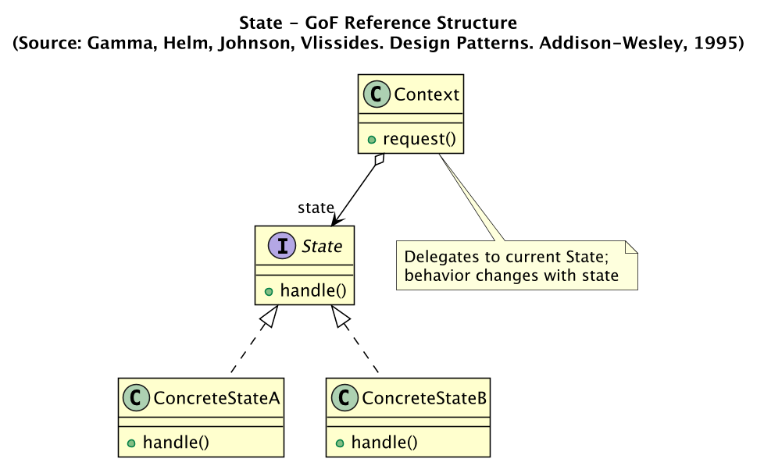 | 
Team: Context = Reservation, State = ReservationState; the GoF ConcreteStateA/B become 8 concrete states (Initiated ... Refunded).

16.2 Strategy (behavioral)

교과서 GoF 레퍼런스 구조 | 우리 팀 구현 (Korean Air)
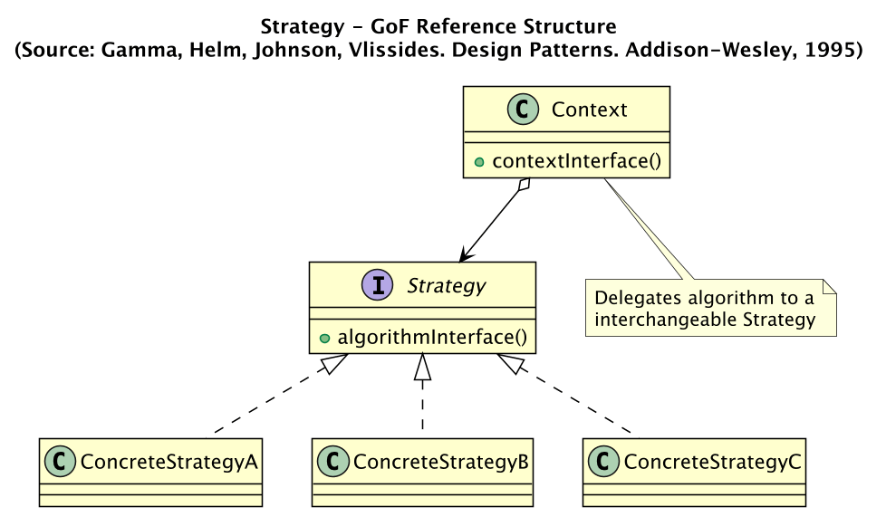 | 
Team: Context = RefundHandler, Strategy = RefundPolicy; concrete strategies are Full / Partial / No refund, selected by FareRule.

16.3 Observer (behavioral)

교과서 GoF 레퍼런스 구조 | 우리 팀 구현 (Korean Air)
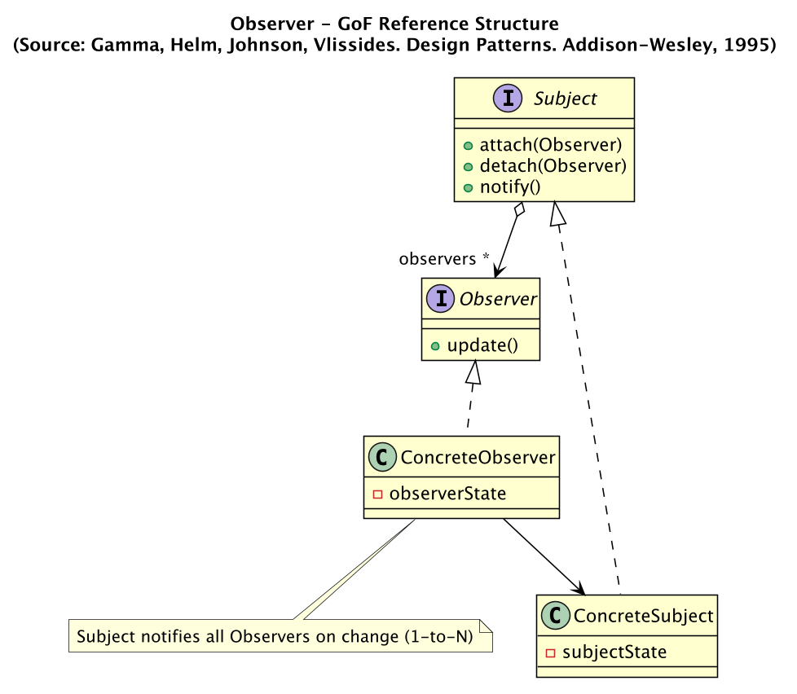 | 
Team: Subject = EventPublisher / TicketPurchasePublisher, Observer = EventListener; domain events broadcast 1-to-N to listeners.

16.4 Composite (structural)

교과서 GoF 레퍼런스 구조 | 우리 팀 구현 (Korean Air)
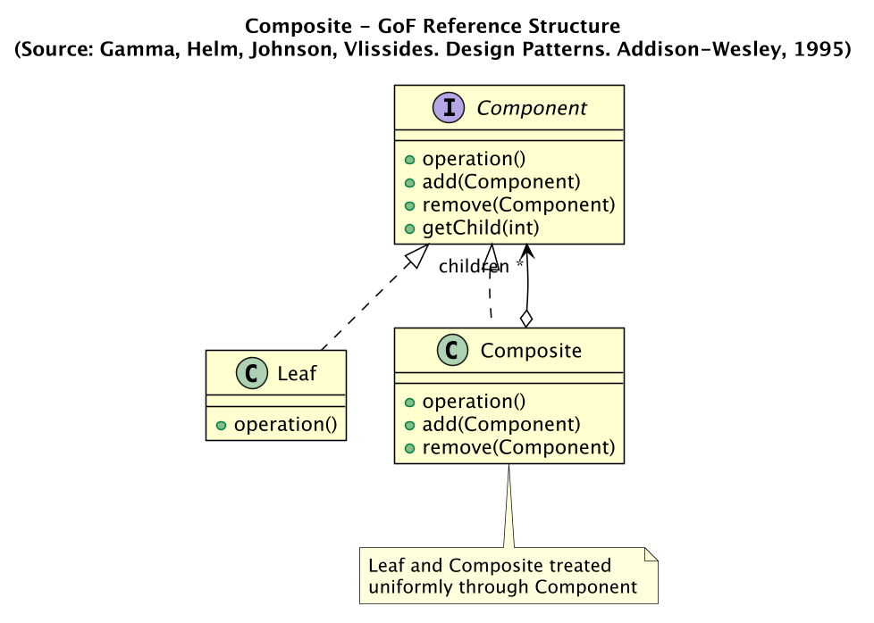 | 
Team: Component = AirportLocation, Composite = AirportCity, Leaf = Airport; a city expands to its member airports.

16.5 Singleton (creational)

교과서 GoF 레퍼런스 구조 | 우리 팀 구현 (Korean Air)
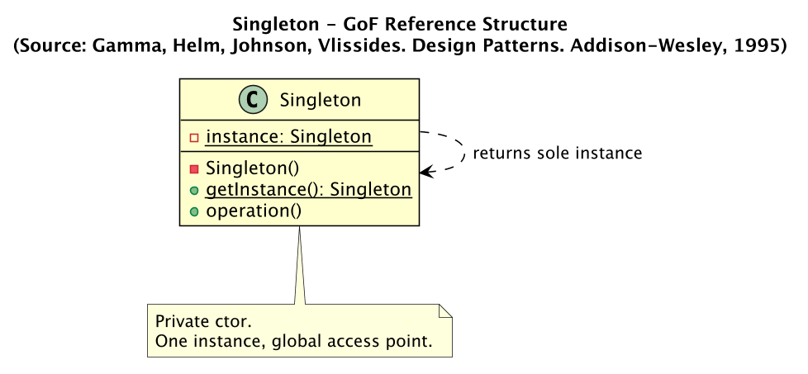 | 
Team: Singleton = AppConfig with a private constructor, double-checked locking, and change listeners for live re-render.

16.6 Factory Method (creational)

교과서 GoF 레퍼런스 구조 | 우리 팀 구현 (Korean Air)
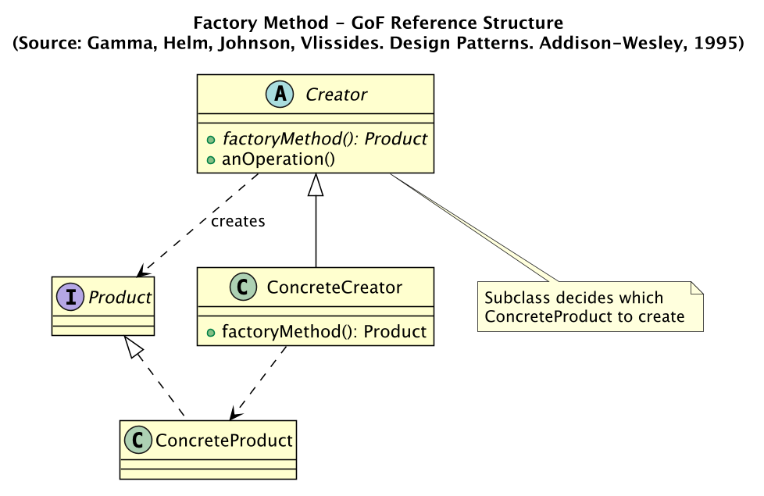 | 
Team: Creator = PaymentProcessorFactory and ItineraryFactory; Products = the 5 payment processors and Direct/Connecting/MultiCity itineraries.

16.7 Template Method (behavioral)

교과서 GoF 레퍼런스 구조 | 우리 팀 구현 (Korean Air)
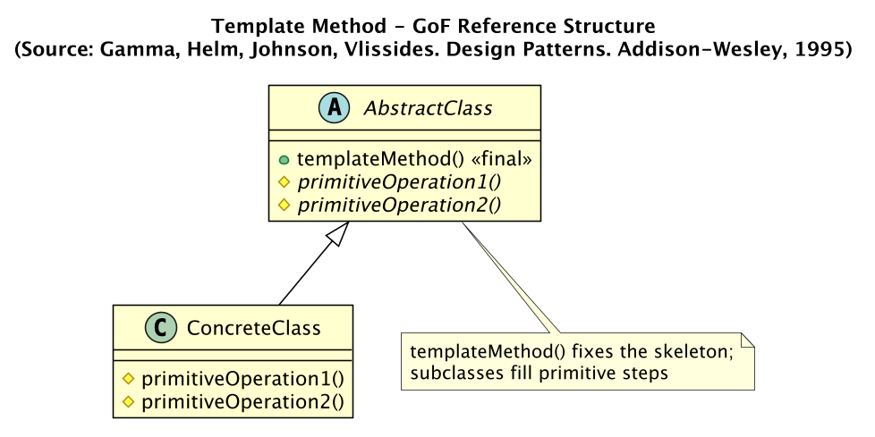 | 
Team: AbstractClass = TicketRenderer (final render); primitive steps = header / body / footer; concretes = PlainText / Html / BoardingPass.

16.8 Adapter (structural)

교과서 GoF 레퍼런스 구조 | 우리 팀 구현 (Korean Air)
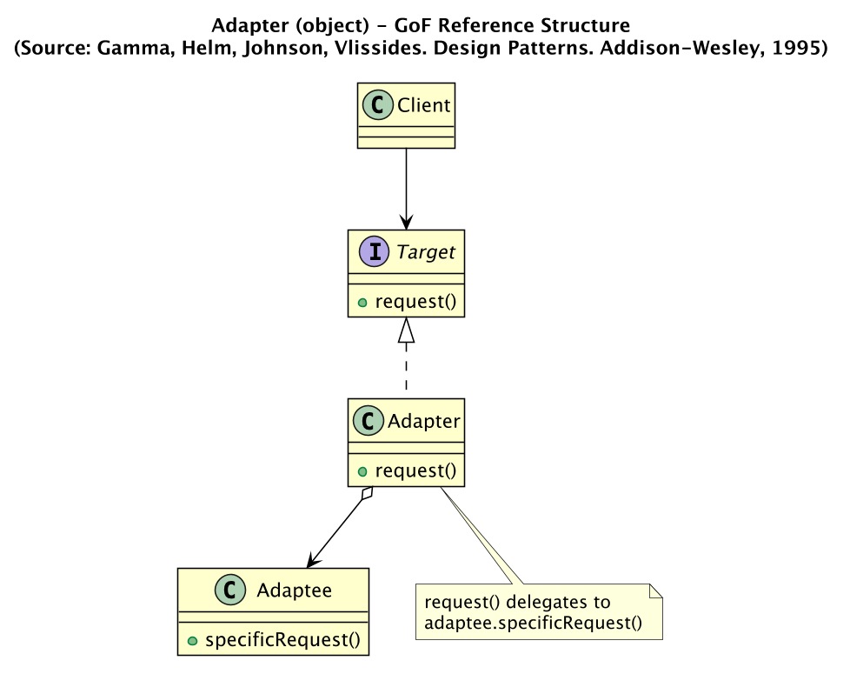 | 
Team: Target = SkypassInterface, Adapter = SkypassAdapter, Adaptee = RemoteSkypassApi; the client uses only the target interface.

16.9 Decorator (structural)

교과서 GoF 레퍼런스 구조 | 우리 팀 구현 (Korean Air)
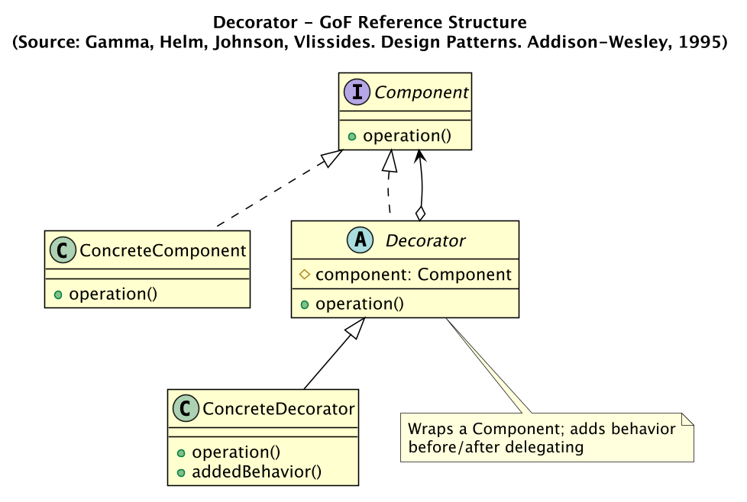 | 
Team: Component = SeatView, ConcreteComponent = SeatViewAdapter; decorators = Window / Aisle / ExtraLegroom / Lounge accumulate surcharge.

Section 17. DP Code Skeleton and Demo Flow (Strengthened)
This appendix gives the highest-priority explanation layer: each GoF role is mapped to our concrete classes, then the exact method/attribute flow and a compact code skeleton are shown. The JavaFX app now includes the same content under the header button "패턴 가이드" so the presenter can explain the code while demonstrating the app.
DP#1 State
Role map: Context=Reservation; State=ReservationState; ConcreteState=8 states; attribute=currentState
Execution flow: UI button -> Reservation delegates to currentState -> state validates -> setState(next)
Demo point: Show STATE badge: PendingPayment -> Confirmed -> Ticketed.
class Reservation {
private ReservationState currentState;
void processPayment(){ currentState.processPayment(this); }
void setState(ReservationState next){ currentState = next; }
}
class PendingPaymentState implements ReservationState {
void processPayment(Reservation r){ r.setState(new ConfirmedState()); }
}
DP#2 Strategy
Role map: Context=RefundHandler; Strategy=RefundPolicy; ConcreteStrategy=Full/Partial/No
Execution flow: Cancel preview -> FareRule selects policy -> RefundHandler calls calculateRefundAmount
Demo point: Open refund preview and explain fare class to policy mapping.
interface RefundPolicy { BigDecimal calculateRefundAmount(BigDecimal paid); }
class FareRule {
RefundPolicy checkRefundPolicy(){
if(!refundable) return new NoRefundPolicy();
if("Y".equals(fareClass)||"B".equals(fareClass)) return new FullRefundPolicy();
return new PartialRefundPolicy();
}
}
DP#3 Observer
Role map: Subject=EventPublisher/TicketPurchasePublisher; Observer=EventListener; Event=TicketIssuedEvent
Execution flow: Issue e-Ticket -> publish(event) -> listeners receive -> bus ticket issued
Demo point: Issue linked bus ticket and show BUS console log.
class TicketPurchasePublisher extends EventPublisher {
void publishTicketIssued(Reservation r, Ticket t, BusCity c){
publish(new TicketIssuedEvent(r,t,c));
}
}
class EventPublisher {
void publish(DomainEvent e){ for(EventListener l:listeners) l.onEvent(e); }
}
DP#4 Composite
Role map: Component=AirportLocation; Composite=AirportCity; Leaf=Airport
Execution flow: City code -> AirportCatalog.resolve -> getAirports expands member airports -> route search
Demo point: Search TYO/NYC/SEL/LON and show airport expansion.
interface AirportLocation { List<Airport> getAirports(); }
class Airport implements AirportLocation {
List<Airport> getAirports(){ return List.of(this); }
}
class AirportCity implements AirportLocation {
private final List<Airport> airports;
List<Airport> getAirports(){ return airports; }
}
DP#5 Singleton
Role map: Singleton=AppConfig; instance=private static volatile; constructor=private
Execution flow: Settings -> AppConfig.getInstance -> mutate value -> notify listeners -> UI re-render
Demo point: Change font/metadata setting and show global consistency.
public final class AppConfig {
private static volatile AppConfig instance;
private AppConfig(){}
public static AppConfig getInstance(){
if(instance==null) synchronized(AppConfig.class){
if(instance==null) instance = new AppConfig();
}
return instance;
}
}
DP#6 Factory Method
Role map: Creator=PaymentProcessorFactory/ItineraryFactory; Product=PaymentMethodProcessor/Itinerary
Execution flow: Combo selection -> enum -> factory creates concrete processor -> processCharge
Demo point: Switch payment method; show connecting/multi-city itinerary creation.
class PaymentProcessorFactory {
static PaymentMethodProcessor forMethod(PaymentMethod m,...){
return switch(m){
case KAKAO_PAY -> new KakaoPayPaymentProcessor(...);
case APPLE_PAY -> new ApplePayPaymentProcessor(...);
case MILEAGE -> new MileagePaymentProcessor(...);
default -> new CreditCardPaymentProcessor(...);
};
}
}
DP#7 Template Method
Role map: AbstractClass=TicketRenderer; templateMethod=final render; primitiveOperation=header/body/footer
Execution flow: Format combo -> choose renderer -> final render fixes order -> subclass fills sections
Demo point: Toggle text/HTML/boarding pass on confirmation screen.
abstract class TicketRenderer {
public final String render(Reservation r, Ticket t){
return header(r,t)+body(r,t)+footer(r,t);
}
protected abstract String header(Reservation r, Ticket t);
protected abstract String body(Reservation r, Ticket t);
protected abstract String footer(Reservation r, Ticket t);
}
DP#8 Adapter
Role map: Target=SkypassInterface; Adapter=SkypassAdapter; Adaptee=RemoteSkypassApi
Execution flow: Payment screen calls target -> adapter invokes remote API -> converts response
Demo point: Log in and show mileage balance/payment through target interface.
interface SkypassInterface {
int getMileageBalance(String memberNo);
Object verifyAndDeduct(String memberNo, int amount);
}
class SkypassAdapter implements SkypassInterface {
private final RemoteSkypassApi remote;
int getMileageBalance(String no){
Map<String,Object> res = remote.getMileage(no);
return (Integer)res.get("balance");
}
}
DP#9 Decorator
Role map: Component=SeatView; ConcreteComponent=SeatViewAdapter; Decorator=AbstractSeatDecorator
Execution flow: Seat selected -> base view -> position decorator -> option decorators -> surcharge accumulated
Demo point: Select A/F or C/D seat and toggle legroom/lounge.
SeatView view = new SeatViewAdapter(seat);
if(col=='A'||col=='F') view = new WindowSeatDecorator(view);
else if(col=='C'||col=='D') view = new AisleSeatDecorator(view);
if(legroomCheck.isSelected()) view = new ExtraLegroomDecorator(view);
if(loungeCheck.isSelected()) view = new LoungeAccessDecorator(view);
ctx.setSeatSurcharge(view.getSurcharge().longValue());

Section 18. Team Roles and Contribution
This section is added to satisfy the final-report requirement that the report include team role distribution and member-level contribution. The exact percentages can be adjusted by the team before final submission if needed.
Member | Primary role | Contribution summary
Kim Jungwook | Domain model and reservation lifecycle | State lifecycle, reservation/payment/refund domain review, demo scenario verification.
Lee Jaeho | UI boundary and presentation flow | Swing-to-JavaFX migration review, demo usability feedback, Pattern Guide / report strengthening, presentation script flow.
Kim Gyeongdong | Control services and integration QA | Search/payment/bus integration checks, pattern mapping validation, Maven/JavaFX execution verification.
Section 19. Red-marked Changes Since Iteration 3
The course notice asks that additions/changes compared with the previous version be marked in red. The following red items summarize the Iteration 4 additions that should be read as changed content from Iteration 3.
• Iteration 4 replaces the Swing Boundary with JavaFX(FXML + CSS + Controller) while preserving Control and Domain behavior.
• Six new GoF patterns are added: Composite, Singleton, Factory Method, Template Method, Adapter, and Decorator.
• All nine patterns from Iterations 1 to 4 are now exercised from the UI, not only described in backend code.
• A Pattern Guide screen is added to the JavaFX app so each DP can be explained through GoF role, team class, method/attribute flow, code skeleton, and demo point.
• Payment screen now exposes multiple payment processors through Factory Method and mileage through Adapter.
• Seat screen now exposes Decorator behavior through seat position, legroom, lounge options, and accumulated surcharge.
• Confirmation screen now exposes Template Method by switching e-ticket formats and Observer by linked bus-ticket issuance.
• The report now includes DP code skeletons and demo flow for DP#1 through DP#9.

