2 Waves

2.7 Soliton Solutions of the KdV Equation

**Question 1:**

$Assume u\left(x,t\right)=f\left(x-ct\right),$ $$where f\left(x^{'}\right)=Asech^{2}\left(φ\right);φ=\frac{x^{'}-x_{0}}{∆}; ∆^{2}=\frac{12δ^{2}}{A};c=\frac{A}{3}.$$

$$\frac{∂u}{∂t}=\frac{∂f}{∂x^{'}}\frac{∂x^{'}}{∂t}=\frac{2Ac}{∆}{sech}^{2}\left(φ\right)\tanh\left(φ\right) \\ \frac{∂u}{∂x}=\frac{∂f}{∂x^{'}}\frac{∂x^{'}}{∂x}=-\frac{2A}{∆}{sech}^{2}\left(φ\right)\tanh\left(φ\right) \\ \frac{∂^{2}u}{∂x^{2}}=-\frac{2A}{∆^{2}}{sech}^{2}\left(φ\right)\left(-2\tanh^{2}\left(φ\right)+{sech}^{2}\left(φ\right)\right) \\ \frac{∂^{3}u}{∂x^{3}}=\frac{8A}{∆^{3}}\tanh\left(φ\right){sech}^{2}\left(φ\right)(-\tanh^{2}\left(φ\right)+2{sech}^{2}{(φ)})$$

Substitute back into the KdV equation $u_{t}+uu_{x}+δ^{2}u_{xxx}$,

$$=\frac{A}{∆}{sech}^{2}\left(φ\right)\tanh\left(φ\right)\left(2c-2A{sech}^{2}\left(φ\right)+\frac{{16δ}^{2}}{∆^{2}}{sech}^{2}\left(φ\right)-\frac{8δ^{2}}{∆^{2}}\tanh^{2}\left(φ\right)\right) \\ =\frac{A}{∆}{sech}^{2}\left(φ\right)\tanh\left(φ\right)\left(2c-6c{sech}^{2}\left(φ\right)+4c{sech}^{2}\left(φ\right)-2c\tanh^{2}\left(φ\right)\right) \\ =\frac{A}{∆}{sech}^{2}\left(φ\right)\tanh\left(φ\right)\left(2c-2c{sech}^{2}\left(φ\right)-2c\tanh^{2}\left(φ\right)\right)=0$$

Therefore, it satisfies the KdV equation.

1. Consider $$\frac{dM}{dt}=\int_{0}^{1}{\frac{∂u}{∂t}\left(x,t\right)dx}=\int_{0}^{1}{\left(-uu_{x}-δ^{2}u_{xxx}\right)dx}={\left[-{\frac{1}{2}u}^{2}-δ^{2}u_{xx}\right]}_{0}^{1}=0$$

As $u and u_{xx}$ are periodic such that $u\left(x+1,t\right)=u\left(x,t\right);u_{xx}\left(x+1,t\right)=u_{xx}\left(x,t\right).$

Similarly

$$\frac{dE}{dt}=\int_{0}^{1}{\frac{∂}{∂t}(\frac{1}{2}u^{2}\left(x,t\right))dx}=\int_{0}^{1}{uu_{t}dx}=\int_{0}^{1}{(-u^{2}u_{x}-δ^{2}uu_{xxx})dx}$$

Integration by parts

$$\int_{0}^{1}{(-u^{2}u_{x}+δ^{2}u_{xx})dx}-δ^{2}{\left[uu_{xx}\right]}_{0}^{1}={\left[-\frac{1}{3}u^{3}+δ^{2}u_{x}-δ^{2}uu_{xx}\right]}_{0}^{1}=0$$

With the same argument as above.

**Question 2:**

*Part (i)*

KdV equation can be discretized as: $$u_{m}^{n+1}=u_{m}^{n-1}-\frac{k}{3h}\left(u_{m+1}^{n}+u_{m}^{n}+u_{m-1}^{n}\right)\left(u_{m+1}^{n}-u_{m-1}^{n}\right)-\frac{kδ^{2}}{h^{3}}(u_{m+2}^{n}-2u_{m+1}^{n}+2u_{m-1}^{n}-u_{m-2}^{n})$$ 
where $x=hm and t=kn with m,n=0, 1, …$

A leapfrog scheme has been employed for each term in the KdV equation.

The Leapfrog Method employs the scheme

$Y_{n+1}=Y_{n-1}+2h\frac{dy}{dx}\left(x_{n},Y_{n}\right) , where h is the step size$

We obtained the KdV discretized form by applying the Leapfrog method to each term in the KdV equations.

1. $u_{m}^{n+1}-u_{m}^{n-1}=2ku_{t}(hm,kn)$ by the Leapfrog Method which has error order $O(k^{3})$
2. $\frac{1}{3}\left(u_{m+1}^{n}+u_{m}^{n}+u_{m-1}^{n}\right)$ is taking the average to approximate $u$ to conserve the energy to second order.
3. $\left(u_{m+1}^{n}-u_{m-1}^{n}\right)=2hu_{x}\left(hm,kn\right)$ by the Leapfrog Method which has error order $O(h^{3})$
4. $\left(u_{m+2}^{n}-2u_{m+1}^{n}+2u_{m-1}^{n}-u_{m-2}^{n}\right)=\left(u_{m+2}^{n}-2u_{m+1}^{n}-u_{m}^{n}+u_{m}^{n}+2u_{m-1}^{n}-u_{m-2}^{n}\right)$ $$=(2hu_{x}\left(h\left(m+1\right),kn\right)-4hu_{x}\left(hm,kn\right)+2hu_{x}(h\left(m-1\right),kn) \\ =\left(2h\right)\left(hu_{xx}\left(hm,kn\right)-hu_{xx}\left(h\left(m-1\right),hn\right)\right) \\ =2h^{3}u_{xxx}\left(hm,kn\right)$$ by the Leapfrog Method and Euler Methods to approximate $u_{xxx}$ which has error order $O(h^{3})$

Therefore, adding each terms up and gives us the error order $O(k^{3}+h^{3})$ and in another word, this scheme is second order in time and second order in space.

*Part(ii)*

Given that for $δ=1 ,$ the scheme is stable if

$$k≤\frac{h^{3}}{4+h^{2}\left|u_{max}\right|}$$

Therefore, for $δ≠1,$ we can obtain a similar expression for the stability condition after rescaling the KdV equation.

KdV equation $u_{t}+uu_{x}+δ^{2}u_{xxx}=0$

Consider $\hat{t}=δt, \hat{x}=δx,\hat{u}=u;$

$$u_{t}=\frac{d\hat{u}}{d\hat{t}}\frac{d\hat{t}}{dt}=δ{\hat{u}}_{\hat{t}}$$

$$u_{x}=\frac{d\hat{u}}{d\hat{x}}\frac{d\hat{x}}{dx}=δ{\hat{u}}_{\hat{x}} \\ u_{xxx}=δ^{3}{\hat{u}}_{\hat{x}\hat{x}\hat{x}}$$

Substitute back into KdV equation: $$u_{t}+uu_{x}+u_{xxx}=0 \\ δ\left({\hat{u}}_{\hat{t}}+\hat{u}{\hat{u}}_{\hat{x}}+δ^{2}{\hat{u}}_{\hat{x}\hat{x}\hat{x}}\right)=0 \\ \left({\hat{u}}_{\hat{t}}+\hat{u}{\hat{u}}_{\hat{x}}+δ^{2}{\hat{u}}_{\hat{x}\hat{x}\hat{x}}\right)=0$$

Therefore, we make a corresponding rescaling to the stability condition and get for $δ≠1$, the scheme is stable if $$δ^{-1}k≤\frac{{δ^{-3}h}^{3}}{4+{δ^{-2}h}^{2}|u_{max}|}$$

For the initial step, I choose to use the Euler Methods.

Let $$φ=\frac{x-x_{0}}{∆}$$

As $u_{t}+uu_{x}+{δ^{2}u}_{xxx}=0$, $u_{t}=-uu_{x}-{δ^{2}u}_{xxx}$. We then use Euler Methods to calculate the $u_{x} and u_{xxx}$ at t=0 with the given initial condition.

$$u_{x}=-\frac{2A}{∆}{sech}^{2}\left(φ\right)\tanh\left(φ\right) \\ u_{xxx}=\frac{8A}{∆^{3}}\tanh\left(φ\right){sech}^{2}\left(φ\right)\left(-\tanh^{2}\left(φ\right)+2{sech}^{2}\left(φ\right)\right)$$ Therefore $$u_{t}=\frac{A}{∆}{sech}^{2}\left(φ\right)\tanh\left(φ\right)\left(2A{sech}^{2}\left(φ\right)-\frac{4A}{3}{sech}^{2}\left(φ\right)+\frac{3A}{2}\tanh^{2}\left(φ\right)\right) at t=0$$

Euler Methods:

$$u_{m}^{1}=u_{m}^{0}+ku_{t} at t=0$$

In addition, according to Ablowitz and Taha (1983), it suggested to carry out the first step with the uncentered scheme:

$$u_{m}^{1}=u_{m}^{0}-\frac{k}{6h}\left(u_{m+1}^{0}+u_{m}^{0}+u_{m-1}^{0}\right)\left(u_{m+1}^{0}-u_{m-1}^{0}\right)-\frac{δ^{2}}{{2h}^{3}}(u_{m+2}^{0}-2u_{m+1}^{0}+2u_{m-1}^{0}-u_{m-2}^{0})$$

Which I have also plotted below which completely overlaps the curve obtained by the approximation starting with Euler Methods.

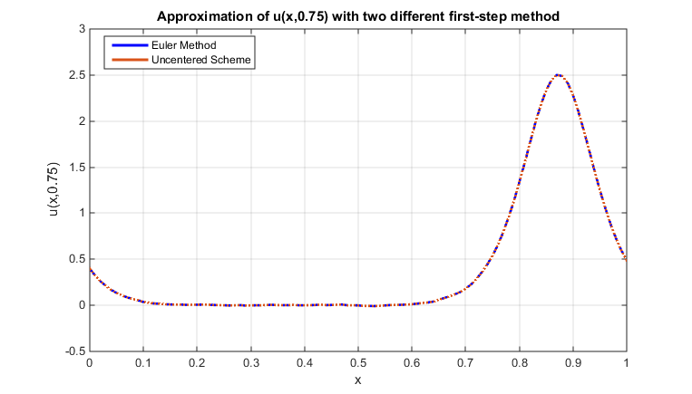

Figure 1: Approximation of u(x,0.75) with different first-step approach

(From now on, I will stick to my approximation beginning with Euler Methods.)

As the program running the approximation is at order $o\left(k^{-1}h^{-1}\right)$ and the approximation is at order $O(k^{3}+h^{3})$, it is important to pick the value of h and k which can balance well the computation time and the accuracy for our approximation.

I have chosen $k={10}^{-5} and h={10}^{-2}$ for the approximation. In order to generate a smooth curve for x at t=0.75 and produce an accurate approximation, I need to pick a relative small value for h which can also provide me a reasonable range of k which can choose from the stability condition constrain. The choice of $h=0.01$ proved to be sufficient regarding to our requirements.

For k, it must satisfy the stability condition:

$$δ^{-1}k≤\frac{{δ^{-3}h}^{3}}{4+{δ^{-2}h}^{2}\left|u_{max}\right|} \\ {0.04}^{-1}k≤\frac{{{0.04}^{-3}0.01}^{3}}{4+{{0.04}^{-2}*0.01}^{2}*2.5} \\ k≤1.5*{10}^{-4}$$

Therefore, I have chosen $k={10}^{-5}$ for the approximation which also gives a reasonable computation time.

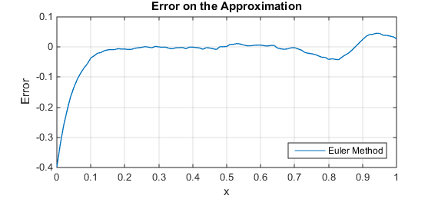

Figure 2: Error on the Approximation with Euler Method as the first step approximation

At t=0.75, we can see the magnitude of error decreases as x increases and the magnitude of the error stays under 0.05 mostly along the x axis. The error is the largest at x=0 which may be explained by the setup of the approximation and the true value. The setup of the approximation expect solitons passing through x=0 to 1 every period, however, I plotted the error graph against one soliton only where its peak at around x=0.88. Therefore, the magnitude of error around x=0 can be ignored because in our scenario, we only target to approximate the movement of one soliton at t=0.75.

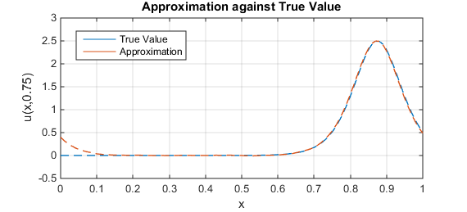

Figure 3: Approximation against the true value

From the graph above, we can see the propagation speed of the numerical solution agrees with the analytical solution as the peak and the shape of the two graphs mostly overlap each other (Both peaks appear very close at x=0.875). Difference of the two curves mainly appear at x=0 which I have made comments and explanation on above. In addition, we can notice the approximation overestimates/underestimates the analytical solutions with a significant size of error before/after the peak. As the value of ${δ^{2}u}_{xxx}$ changes the most and the value of ${δ^{2}u}_{xxx}$ is significantly larger at those range, our approximation picks up more error inevitably. In addition, the larger value of $u_{x}$ also caused us to have a relative error to our approximation at that range.

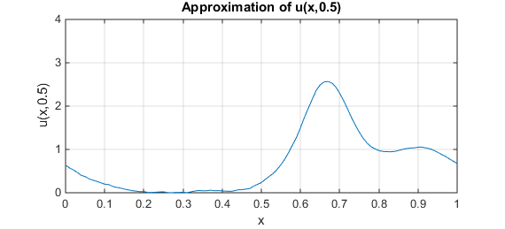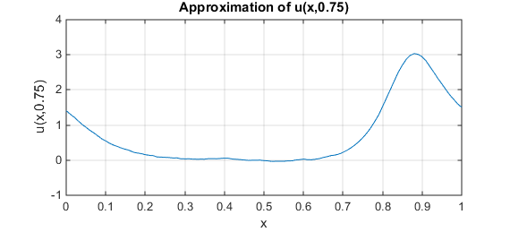**Question 3**: (Denoting the wave on the left be wave (A) and wave on the right be wave (B))

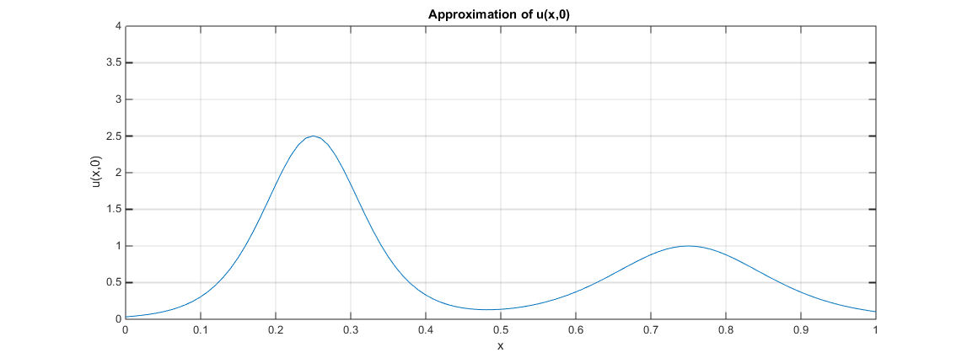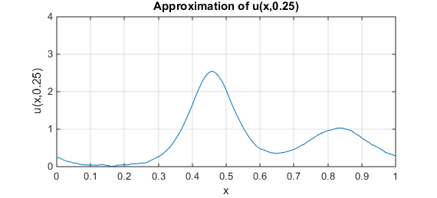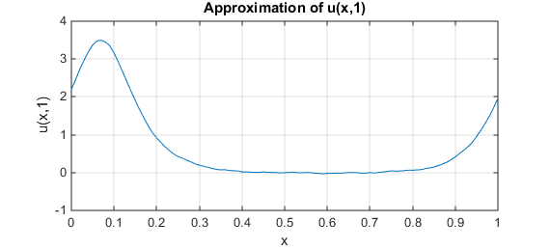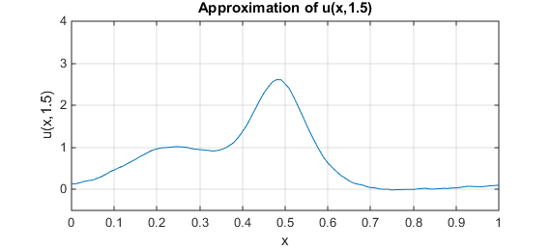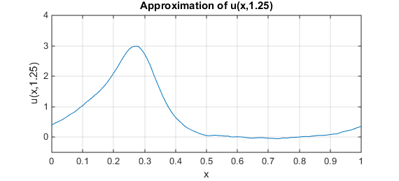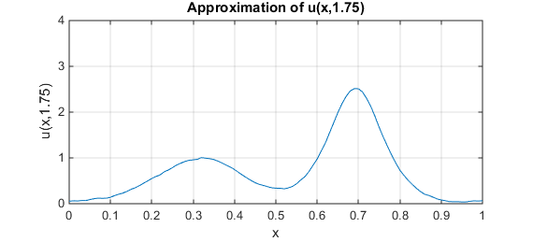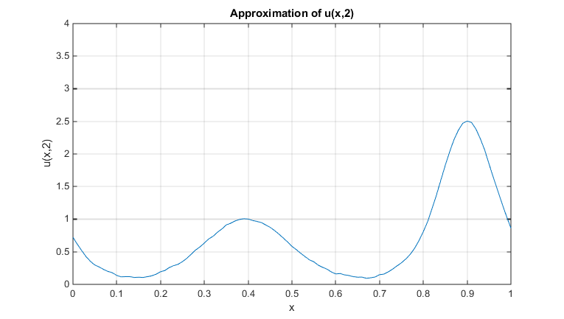

Figure 4: Approximation of u(x,t) at different t

Both waves propagates to the right as simulation starts running. From the graphs captured at different instance of the two solitons, we can see they begin with well apart at t=0 and as time passes, the wave(A) which has a higher magnitude propagates faster and catches up the lower magnitude wave(B). This is because the wave travels quicker if the magnitude of the wave is higher which I have shown below mathematically. When wave (A) cross over wave (B), two waves combine into one with magnitude $2.5+1=3.5$ which we can clearly observe it from the graph at t=1. At t=1.5, we can see the wave starts to separate again and two solitons are restored at t=1.75 clearly. However, at t=2, we can see the wave with higher magnitude has taken over the position of wave (B) which agrees with our previous observation on the difference of the propagation speeds of the two solitons.

We can show mathematically from the analytical solution where the two solitons combine and how fast for each of them travel 1 unit in space.

$$u\left(x,t\right)=f\left(x-ct\right)=A*{sech}^{2}\left(\frac{x-ct-x_{0}}{∆}\right)=A*{sech}^{2}\left(\frac{x-(\frac{A}{3})t-x_{0}}{∆}\right)$$

The peak of the soliton appears when $x-ct-x_{0}=0, →x=\left(\frac{A}{3}\right)t+x_{0}$.  
Equating the two solitons peak’s position, $\left(\frac{2.5}{3}\right)t+0.25=\left(\frac{1}{3}\right)t+0.75, →t=1$  
Wave 1: it takes $\left(\frac{2.5}{3}\right)t=1→t=\frac{6}{5} unit of time$ to travel a unit of x  
Wave 2: it takes $\left(\frac{1}{3}\right)t=1→t=3 units of time$ to travel a unit of x   
Provided that the soliton has wavelength 1 in the unit of x.

From the graphs, we can see no information exchange after the two solitons combine and separate as the propagation speed and magnitude does not change for both of them.

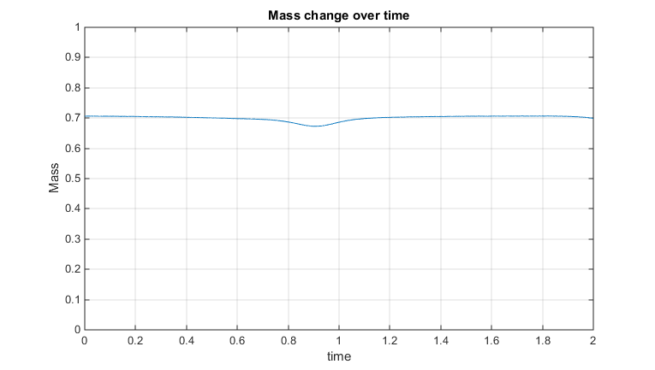

Figure 5: Mass change over time in the approximation

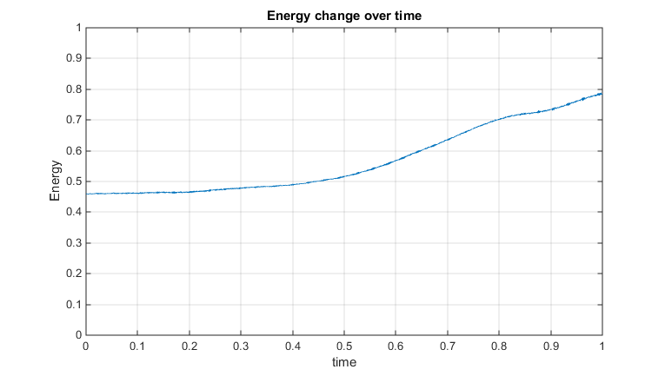

Figure 6: Energy change over time in the approximation

From question 1, we know we are expecting both mass and energy conserves as time passes. From the graph above, we can see the mass is stable at 0.7 mainly from t=0 to t=1 which agrees with our analytical solutions. There is a little slump at t=0.9 and this could be explained by the underestimation of the actual value from our approximation just before the two solitons combine.

However, from the second graph plotting the energy change against time, we can see the energy does not conserve as well as the mass. The energy increases as time passes according to our approximation which is not what we expecting. We can see the energy is stable from t=0 to t=0.3 and then rises up after t=0.3 linearly. This could be explained by the error of the approximation occurs near the peak of the solitons and as two solitons interact and past over, the error stacks up and as we can notice in part 1 of Question 3, u(x,t) is negative at some range of x after t=0.5 in our approximation. As energy proportional to the square of u(x,t), the negative value does not get cancelled out by the overestimation happens near the peaks. Therefore, the errors in the approximation affect the energy of our predicted system a lot compared with the effect on the mass. I believe, even the energy does not conserve perfectly, our approximation is still good because if we have plotted a curve of best fit with the results and averaged out the error of the system, we shall get the value of the mass and energy conserved better.

**Question 4:**

In the case of $δ=0,$ the KdV equation becomes $u_{t}+uu_{x}=0$. We may solve the equation by using Riemann’s Methods of Characteristics directly and obtain an analytical solution. As there is not a dispersive term in the equation and $u_{x}=\frac{u_{t}}{u}$ which means $u_{x}$ would become infinite in finite time, the wave should break or topple at early time. As there is no nonlinear term present in the KdV equation, the wave would disperse in the evolution $u_{t}+u_{xxx}=0$.

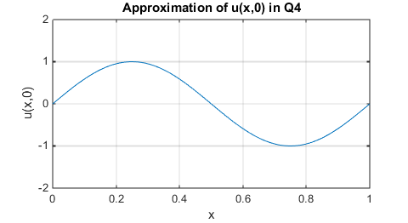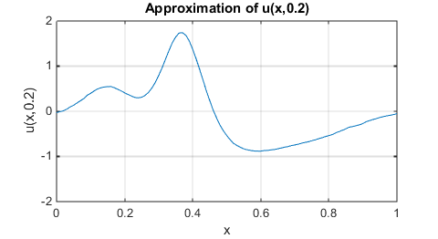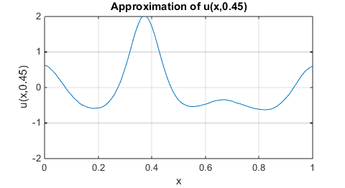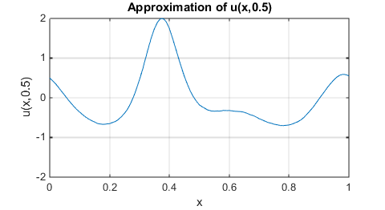

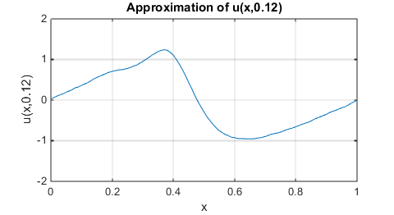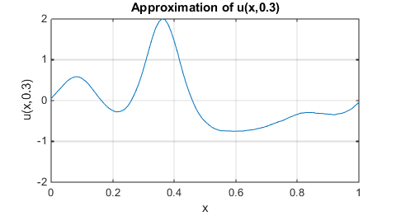

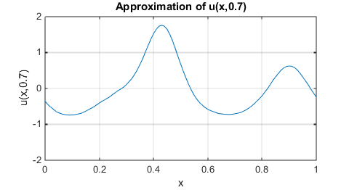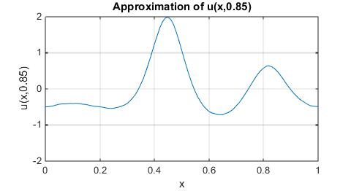

Figure 7: Approximation of u(x,t) at different t

From the graph at early time, we can see the initial wave starts to break and creates a topple effect at t=0.12. This could be explained that the behavior of u(x,t) of $u_{t}+uu_{x}+{\left(0.04\right)}^{2}u_{xxx}=0$ will be similar to the behavior of u(x,t) in $u_{t}+uu_{x}=0$ in part 1 because the magnitude of the $u_{xxx}$ term is insignificant comparing with other two in the equation. Therefore, I expect to see a shock at early time as the magnitude of $u_{xxx}$ is still relatively small $(u^{\left(3\right)}(x,0)≈8π^{3}sin⁡(2πx)).$ As time passes, although the dispersion effect is suppressed by the fact that the magnitude of $u_{xxx}$ is small, our graph can still clearly see the dispersion effect on the kink between t=0.3 to 0.85. We can spot there are total of 3 waves with height at 0.5, -0.3 and 2 in the graphs when t=0.45 and t=0.5. The reason of having three waves with different height is because of the breaking effect due to the relative large magnitude of ${uu}_{x}$. The creation of three waves from the sin wave is from t=0.3 when the breaking effect is dominating over the dispersion effect which cause the wave to break and stacked together. This transformed the sin wave at t=0 into 3 waves with different heights and different wavelengths which do obey the conservation of mass and energy. Therefore, with different value of δ, I expect the style of breaking the waves and the time taken for breaking the waves will be different.

In addition, the nearly-topple effect occurs more apparently in this question comparing with example in question 2 for δ=0.04 because there is half of the initial profile exists below 0 and for points below 0, $uu_{x}<0$ and as this is also the dominant term at early time, the wave exist under the height 0 will travel backwards as time passes which creates a greater “topple”.

After t=0.45, the wave behaves like one of the normal soliton solutions with two other solitons propagating in the same direction. I believe this will also be the equilibria form of the system.

Estimation of time of event

At t=0, the wave starts in the initial wave form (sin wave)  
For t>0, the wave starts (trying to) topples and breaks until the following quantity become significant in the KdV equation:

$$uu_{x}\sim {\left(0.04\right)}^{2}u_{xxx}$$

From then onwards, the wave starts disperse and propagate instead of breaking down into more waves.

*Remark: I have tried to estimate the time of the events by plotting the graphs of the change of energy and mass of the wave. However, as there is not a proper toppling effect, both quantities are conserved from my approximation and I could not deduce the time of each stages.*

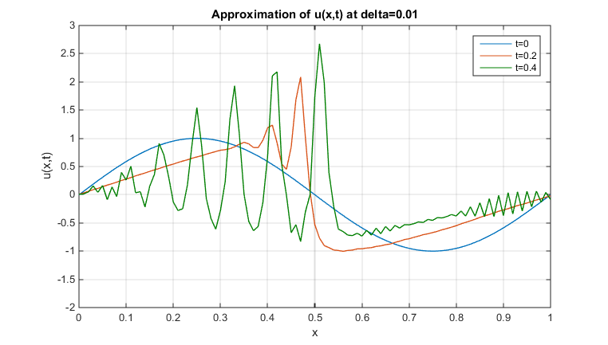

Figure 8: Approximation of u at δ=0.01

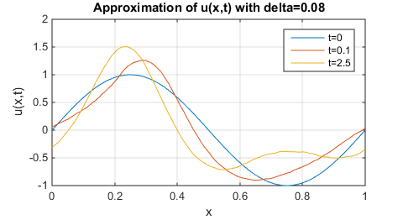

Figure 9: Approximation of u at δ=0.08

Trying with δ=0.08, which means the dispersion effect should be more significant, we can see the wave break into 2 waves as time passes. However, we can see the difference in magnitude of the two waves is not as big as δ=0.04, which we can see the toppling effect is less obvious with δ larger. On the other hand, the time taken transforming from the “breaking” stage to the “dispersion stage” is shorter which could be explained by the time needed for the magnitude of the term ${δ^{2}u}_{xxx}$ become significant is shorter as δ larger.

Trying with δ=0.01, we can obviously see the breaking effect is more significant compared with the two examples I suggested above. We can see the numbers of the waves and the difference in magnitude of the largest and smallest waves are much larger in this example. It behaves similar to the u(x,t) when $u_{t}+uu_{x}=0$. In addition, the time taken for the wave to break is longer than other examples with the reason explained above.

Furthermore, according to Drazin and Johnson, 1989, it suggested that the initial profile will reappear after a very long time and this phenomenon is proved by the topology of the torus.

*Remark: I have tried to run the program forredicting the behavior of u(x,t) when t is large but I realized that for most values of δ, the result will blow up at some point no matter how small h and k we take except δ=0.05 which I believe further investigation is needed on that special case.*

**Reference:**

Drazin, P.G. and Johnson, R.S. (1989). Solitons: An Introduction. pp. 12-16 and 169-187

Ablowitz, M.J. and Taha, T.R. (1983). Analytical and Numerical Aspects of Certain Nonlinear Evolution Equations. III. Numerical, Korteweg-de Vries Equation., pp. 231-234

**Program:**

1.

function [Main]=Q2_Euler(x_0,A,d,t,x,kk,tend)

%This program will output a matrix for which each column represent a fixed time

%frame and each row represent a fixed spots over the time

%x_0 initial point, A: magnitude of wave

%d delta value; t=step of time; x=step of space

%kk time at which it evaluate

%tend be the ending of approximation of t

D=((12*d^2)/A)^0.5;

X=1/x;

T_d=int32((tend)/t);

KK=int32(kk/t)+1;

Main=nan(X+1+4,T_d+1);

%each column represent 0.01 time

%each row represent 0.01 width

%first 2 row and last 2 row repeated and overlapped

POS=zeros(X+1,1);

for i=1:X+1

x_1=x*(i-1);

Main(i+2,1)=A*(sech((x_1-x_0)/D))^2;

POS(i,1)=x_1;

end

%first column done

for j=1:X+1

x_2=x*(j-1);

phi=(x_2-x_0)/D;

S=sech(phi);

T=tanh(phi);

u_t=(A/D)*S^2*T*(2*A*S^2-(4*A*S^2)/3+(3*A/2)*T^2);

Main(j+2,2)=Main(j+2,1)+t*u_t;

end

Main(1,2)=Main(X+2,2);

Main(2,2)=Main(X+3,2);

Main(X+4,2)=Main(3,2);

Main(X+5,2)=Main(4,2);

%Second column done

k=t;

h=x;

for kt=3:T_d+1

for hx=1:X+1

Main(hx+2,kt)=Main(hx+2,kt-2)-(k/(3*h))*(Main(hx+3,kt-1)+Main(hx+2,kt-1)+Main(hx+1,kt-1))*(Main(hx+3,kt-1)-Main(hx+1,kt-1))-((k*d^2)/(x^3))*(Main(hx+4,kt-1)-2*Main(hx+3,kt-1)+2*Main(hx+1,kt-1)-Main(hx,kt-1));

end

Main(1,kt)=Main(X+2,kt);

Main(2,kt)=Main(X+3,kt);

Main(X+4,kt)=Main(3,kt);

Main(X+5,kt)=Main(4,kt);

end

plot(POS(:,1),Main(3:X+3,KK));

end

2.

function [Main]=Q2_Uncen(x_0,A,d,t,x,kk)

%x_0 initial point, A: magnitude of wave

%d delta value; t=step of time; x=step of space

%kk time at which it evaluate

D=((12*d^2)/A)^0.5;

X=1/x;

T_d=int32(1/t);

KK=int32(kk/t)+1;

Main=zeros(X+5,T_d+1);

%each column represent 0.01 time

%each row represent 0.01 width

%first 2 row and last 2 row repeated and overlapped

POS=zeros(X+1,1);

for i=1:X+1

x_1=x*(i-1);

Main(i+2,1)=A*(sech((x_1-x_0)/D))^2;

POS(i,1)=x_1;

end

Main(1,1)=Main(X+2,1);

Main(2,1)=Main(X+3,1);

Main(X+4,1)=Main(3,1);

Main(X+5,1)=Main(4,1);

%first column done

for j=1:X+1

COM_1=-(t/(6*x))*(Main(j+3,1)+Main(j+2,1)+Main(j+1))*(Main(j+3,1)-Main(j+1,1));

COM_2=-((t*d^2)/(2*x^3))*(Main(j+4,1)-2*Main(j+3,1)+2*Main(j+1,1)-Main(j,1));

Main(j+2,2)=Main(j+2,1)+COM_1+COM_2;

end

Main(1,2)=Main(X+2,2);

Main(2,2)=Main(X+3,2);

Main(X+4,2)=Main(3,2);

Main(X+5,2)=Main(4,2);

%Second column done

k=t;

h=x;

for kt=3:T_d+1

for hx=1:X+1

Main(hx+2,kt)=Main(hx+2,kt-2)-(k/(3*h))*(Main(hx+3,kt-1)+Main(hx+2,kt-1)+Main(hx+1,kt-1))*(Main(hx+3,kt-1)-Main(hx+1,kt-1))-((k*d^2)/(h^3))*(Main(hx+4,kt-1)-2*Main(hx+3,kt-1)+2*Main(hx+1,kt-1)-Main(hx,kt-1));

end

Main(1,kt)=Main(X+2,kt);

Main(2,kt)=Main(X+3,kt);

Main(X+4,kt)=Main(3,kt);

Main(X+5,kt)=Main(4,kt);

end

plot(POS(:,1),Main(3:X+3,KK));

end

3.

function [RES]=trapezium_energy(A,h)

T=size(A);

K=T(1,1);

F=0.5*(((A(1,1))^2)+((A(K,1))^2));

for i=2:(K-1)

F=F+(A(i,1))^2;

end

RES=0.5*h*F;

end

4.

function [RES]=trapezium_mass(A,h)

T=size(A);

K=T(1,1);

F=A(1,1)+A(K,1);

for i=2:(K-1)

F=F+2*(A(i,1));

end

RES=0.5*h*F;

end

5.

function [Main]=Q4_Euler(d,t,x,kk,tend)

%Function approximating in Q4 with initial condition sin wave

%x_0 initial point,

%d delta value; t=step of time; x=step of space

%kk time at which it evaluate

%tend be the ending of approximation of t

A=1;

X=1/x;

T_d=int32((tend)/t);

KK=int32(kk/t)+1;

Main=zeros(X+1+4,T_d+1);

%each column represent 0.01 time

%each row represent 0.01 width

%first 2 row and last 2 row repeated and overlapped

POS=zeros(X+1,1);

for i=1:X+1

x_1=x*(i-1);

Main(i+2,1)=sin(2*pi*x_1);

POS(i,1)=x_1;

end

%first column done

for j=1:X+1

x_2=x*(j-1);

u_t=2*pi*cos(2*pi*(x_2));

Main(j+2,2)=Main(j+2,1)+t*u_t;

end

Main(1,2)=Main(X+2,2);

Main(2,2)=Main(X+3,2);

Main(X+4,2)=Main(3,2);

Main(X+5,2)=Main(4,2);

%Second column done

k=t;

h=x;

for kt=3:T_d+1

for hx=1:X+1

Main(hx+2,kt)=Main(hx+2,kt-2)-(k/(3*h))*(Main(hx+3,kt-1)+Main(hx+2,kt-1)+Main(hx+1,kt-1))*(Main(hx+3,kt-1)-Main(hx+1,kt-1))-((k*d^2)/(x^3))*(Main(hx+4,kt-1)-2*Main(hx+3,kt-1)+2*Main(hx+1,kt-1)-Main(hx,kt-1));

end

Main(1,kt)=Main(X+2,kt);

Main(2,kt)=Main(X+3,kt);

Main(X+4,kt)=Main(3,kt);

Main(X+5,kt)=Main(4,kt);

end

plot(POS(:,1),Main(3:X+3,KK));

end