**7. Methods**

**7.5 Pade Approximants**

**Question 1:**

$f_{1}\left(x\right)={\left(1+x\right)}^{\frac{1}{2}}$

$$f_{1}\left(0\right)=1$$

${f^{'}}_{1}\left(0\right)=\frac{1}{2}{\left(1+\left(0\right)\right)}^{-\frac{1}{2}}=\frac{1}{2}$

${f''}_{1}\left(0\right)=-\frac{1}{4}{\left(1+\left(0\right)\right)}^{-\frac{3}{2}}=-\frac{1}{4}$

$$f_{1}^{\left(k\right)}\left(0\right)={\left(-1\right)}^{\left(k\right)}2^{-k}\prod_{n=0}^{k-1}{\left(2n-1\right)} for k≥1$$

Therefore, $$c_{k}=\frac{1}{k!}{{\left(-1\right)}^{k}\left(2^{-1}\right)}^{\left(k\right)}\prod_{n=0}^{k-1}{\left(2n-1\right)} for k≥1$$

and $c_{0}=1$.

1. Radius of convergence: 1; The distance to the nearest singularity/branch point for $f_{1}\left(x\right)$ is 1 at $x=-1$ on a complex plane.

We will require |x| <1 when we use the power series to estimate $f_{1}\left(x\right)$ otherwise the approximation diverges.

$$\sqrt{2}=1.414213562$$

|  |  |  |
| --- | --- | --- |
| $$N$$ | $\sum_{k=0}^{N}{c_{k}}$ | Error |
| 5 | 1.42578125 | -0.011567687 |
| 10 | 1.409931182861328 | 0.0042823795 |
| 20 | 1.412667185988539 | 0.0015463763 |
| 50 | 1.413817654785574 | 0.0003959075 |
| 100 | 1.414073047717716 | 0.0001405146 |
| 150 | 1.414136978762613 | 0.0000765836 |

Table 1: partial sums as N increases

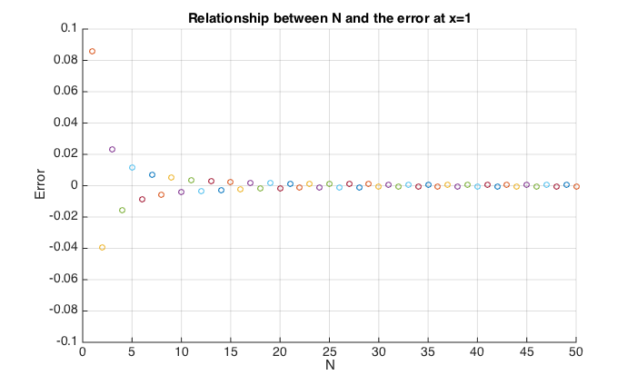

Figure 1: Relationship between N and the error at x=1

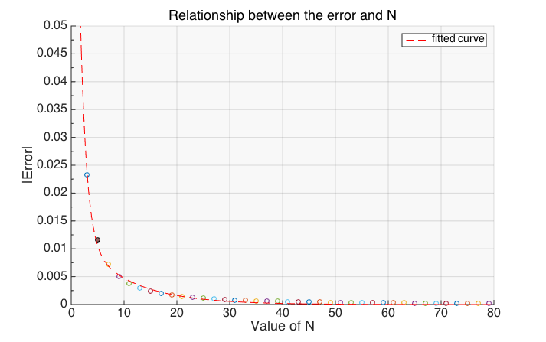 From the graph, the magnitude of the error decreases exponentially as the value of N increases linearly and it also shows a sign changing oscillation on the error as N increases and those results can be explained from the coefficient formula.

Deriving from the formula, we get:

$$c_{k}=\frac{1}{k}\left(-1){(2}^{-1}\right)\left(2\left(k-1\right)-1\right)c_{k-1}=Ac_{k-1} for k≥1$$

1. $\left|A\right|=\left|\frac{2k-3}{2k}\right|<1$; b) $\left|A\right|→1 as k→∞$; c) factor of (-1)

From b) and c), we can deduce that the partial sum should converges as N tends to large because each of the successive terms are (nearly fully) cancelling each other out. Due to the three conditions and as $Error=\sum_{i=N+1}^{∞}{c_{i}}$  
, the error should decreases and shows a sign-changing oscillation as N increases.

|  |  |  |
| --- | --- | --- |
| $$L$$ | $Pade Approximant R_{L,L}$ | Error |
| 3 | 1.414201183431953 | 1.237894114258786e-05 |
| 5 | 1.414213551646055 | 1.072704036708672e-08 |
| 8 | 1.414213562372821 | 2.740030424774886e-13 |
| 10 | 1.414213562373095 | 4.440892098500626e-16 |
| 15 | 1.414213562373095 | -2.22044604925031e-16 |
| 20 | 1.414213562373095 | -2.22044604925031e-16 |
| 25 | 1.414213562373094 | -8.88178419700125e-16 |
| 30 | 1.414213562373095 | -4.44089209850063e-16 |
| 100 | 1.414213562373095 | -2.22044604925031e-16 |

**Question 2:** (assumed L=M unless indicated otherwise)

Table 2: Pade Approximation's Error as L increases at x=1

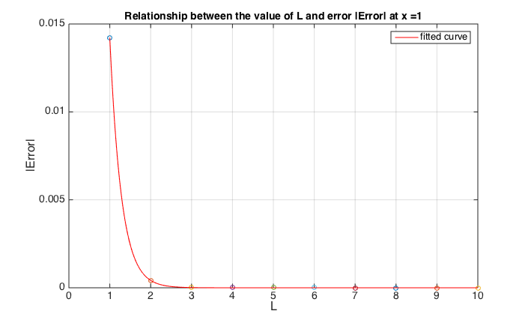

Figure 2: Relationship between L and the magnitude of error at x=1

From the graphs, we can see the error reduce significantly as L increases. By plotting a curve of best fit, we can see there is an exponential decreases as L increases. However, the error did not improve much as before for L greater than 10, we shall investigate more on this and on why the change in magnitude of the error comparing with the power series later in this project.

I cannot choose the error to be arbitrarily small as the error stays stable at ${10}^{-16}$ no matter how large L we choose for the approximation. Therefore, the smallest value to which the error can be reduced is around $2*{10}^{-16}$ and this smallest value determines by the size of L we choose.

|  |  |
| --- | --- |
| Iteration | Error |
| 5 | -4.72854468191580e-06 |
|  | -2.06209292585062e-05 |
|  | -3.74569167361647e-05 |
|  | -3.66843198878325e-05 |
|  | -2.09406993285380e-05 |
|  | -7.02491577216107e-06 |
|  | -1.32511475101285e-06 |
|  | -1.25440866429095e-07 |
|  | -4.58603579370395e-09 |
|  | -2.77399469363511e-11 |

|  |  |
| --- | --- |
| Iteration | Error |
| 1 | -7.74176016782486e-06 |
|  | -3.29839747388397e-05 |
|  | -5.83636007991754e-05 |
|  | -5.54853634540787e-05 |
|  | -3.06133802125115e-05 |
|  | -9.87344024525672e-06 |
|  | -1.77853798783430e-06 |
|  | -1.59387396810016e-07 |
|  | -5.45320171667412e-09 |
|  | -3.03853901893799e-11 |

|  |  |
| --- | --- |
| Iteration | Error |
| 10 | -7.87637958771997e-06 |
|  | -3.36853673490672e-05 |
|  | -5.98672165168747e-05 |
|  | -5.72078541291620e-05 |
|  | -3.17561005812611e-05 |
|  | -1.03169513329921e-05 |
|  | -1.87503877733599e-06 |
|  | -1.69904406812987e-07 |
|  | -5.89513631177618e-09 |
|  | -3.34478689712798e-11 |

After running the iterative improvement, it does not improve the error much after 5 iterations for L=M=10. The methods did not show any significance of improvement on the error as the number of iteration increases.

Comparing the tables from Q1 and Q2, we can clearly see that Pade approximation converges to the actual value quicker than the power series approximation by far. From the samples I generated, the error of Pade approximation is at least less than ${10}^{-5}$ while for power series, we will need up to and include the 150 terms for an approximation having a same accuracy. Therefore, regarding to get the most accurate approximation with limited terms involved, I will suggest the use of Pade approximation over the power series.

If we aim to estimate for $\sqrt{2}$ to specified accuracy, I will suggest the use of power series because it is easier to identify the exact number of terms which we need to include for an estimation to a specified accuracy and we cannot reduce any further error with magnitude smaller than $2*{10}^{-16}$ in Pade approximation as suggested in part 1. With the use of the recurrence formula stated in Q1, we can easily find the smallest N such that $|A^{N}|$ is smaller than the required accuracy.

In addition, Pade approximation works at order o(M(M+L)) which includes solving M simultaneous equations for Q and L+1 calculations for P while power series requires only N calculations for each approximation. It requires more work for Pade approximation than power series although Pade approximation gives us an incomparably more accurate result than using power series up to the nearest $2*{10}^{-16}$.

**Question 3**:

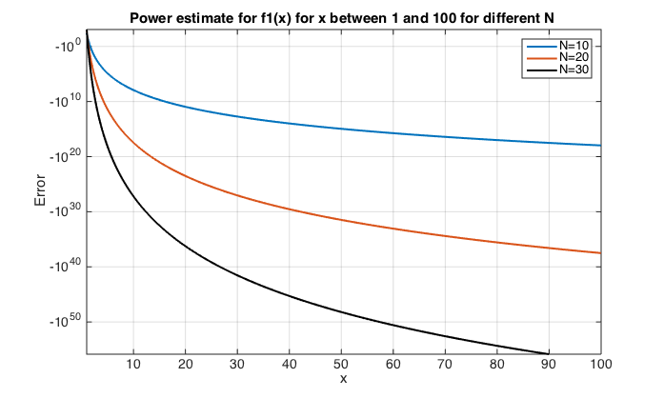

Figure 4: Power Approximation for f_1 for x between 1 and 100 for different N (even) (Semi-Log plot)

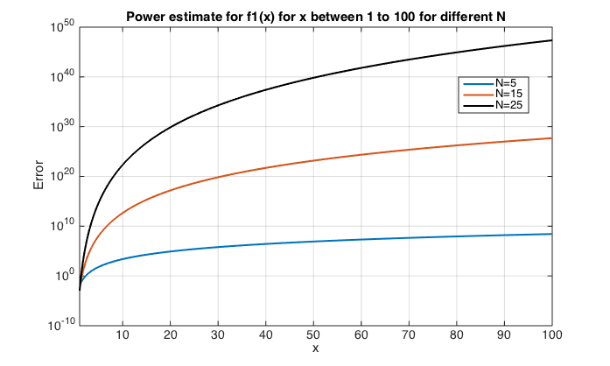

Figure 5: Power Approximation for f_1 for x from 1 to 100 for different N (odd) (Semi-Log plot)

Figure 6: Pade approximation for f_1 with different M as x varies

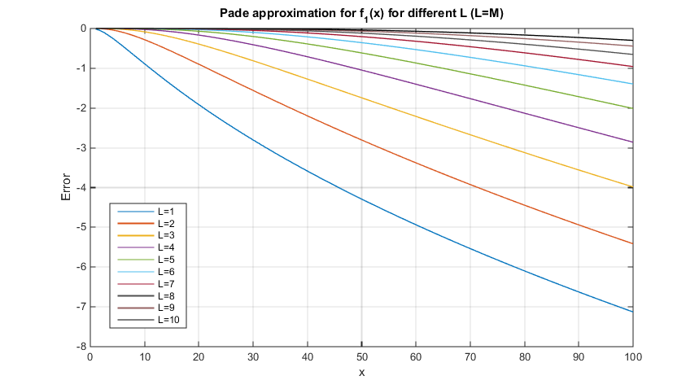

Characteristics obtained from the graphs:

For power series approximation:   
*1a) the magnitude of the error increases exponentially as x increases linearly  
2a) the magnitude of the error increases exponentially as N increases linearly  
3a) a sign-changing oscillation on the error as N increases*

For Pade approximation:

*1b) the magnitude of the error increases linearly for large x   
2b) the magnitude of the error decreases at inverse logarithmical manner as L increases linearly*

*3b) the rate of the magnitude of the error decreases as x increases linearly for L. For small L, the error increases in an exponential manner; as L increases, the error curve tends to a linear style.*

Comparing two graphs, we can see the magnitude of the error in power series is greater than in Pade approximation overall from x=1 to 100. The difference in error from the two approximations diverges in an exponential manner as x increases with the range of error for Pade approximation and power series approximation varies from 0 to -8 and 0 to ${10}^{47}$ respectively. This shows Pade approximation gives higher accuracy than power series approximation.

Observation 1a) and 1b) can be explained by the fact that the rate of error reduces/ increases is affected by the distance between the evaluated point and the radius of convergence. The further we evaluated from the radius of convergence, the quicker the error increases.

There is a significant difference between the number of terms being considered and the magnitude of error within two approximation. For x greater than 1, the error in the Pade approximation decrease as more terms being considered while the error in power series approximation increases in an exponential manner as N increases. This is because the more terms we accepted in power series (which means the expansion is at higher order of x), the greater divergence we get as x being greater than 1 and the coefficient of the expansion does not tend to 0 as quick. The exponential increases can be explained by $$\sum_{i=0}^{N}{a_{i}{\left(x\right)}^{i}}-\sum_{i=0}^{N}{a_{i}{\left(x+ε\right)}^{i}}=o(x^{N-1})$$

(We will discuss about the reason of the rate of convergence of Pade approximation later in this project.)

On the other hand, from the graph, we can see the error of the power series approximation oscillates between positive and negative and N increases. This could be because the coefficient of the power series we used to approximate has a factor of ${\left(-1\right)}^{N}$ and given that the series diverges, the leading term of the polynomial dominates the sign of the series which caused oscillate around the actual result as N changes.

In conclusion, Pade approximation gives a better approximation than power series although both approximation shows some extends of divergence from the actual result from the graph as x increases which is due to the distance from the evaluated point to the radius of convergence increases.

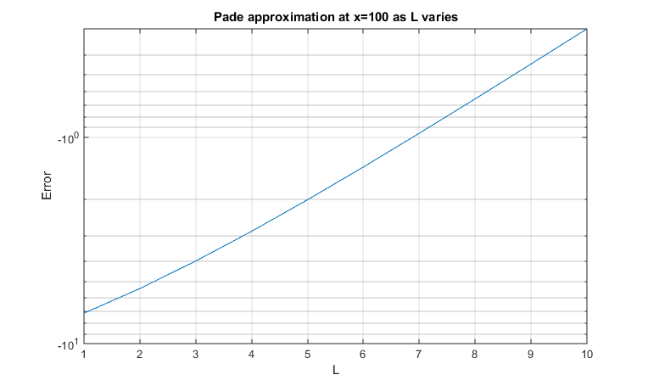

Figure 10: Pade approximation at x=100 as L varies (Semi-Log plot)

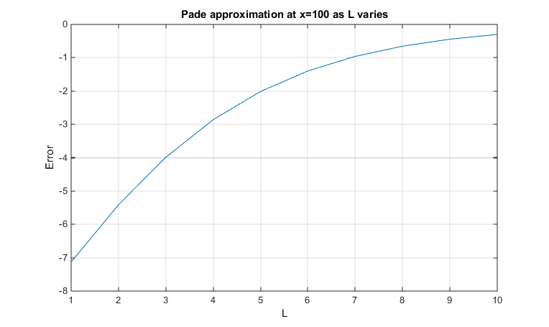

Figure 9: Pade approximation at x=100 as L varies (Linear plot)

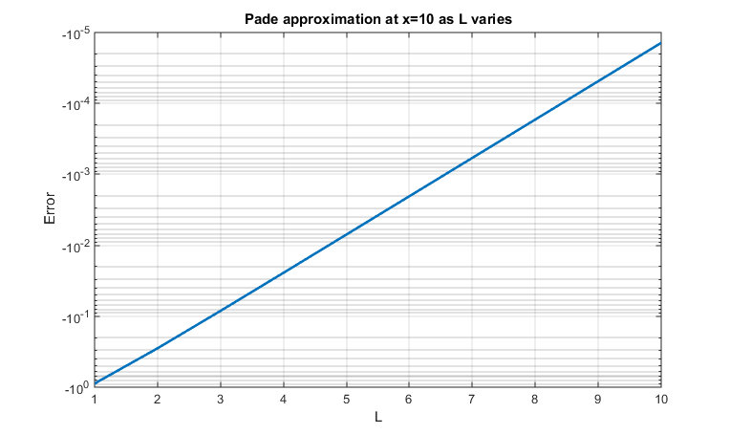

Figure 8: Pade approximation at x=10 as L varies (Semi-Log plot)

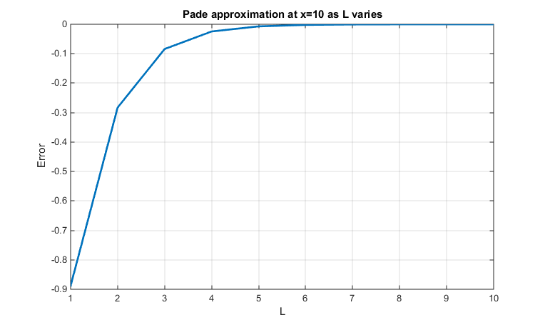

Figure 7: Pade approximation at x=10 as L varies (Linear plot)

Similar to part 1, from the two we can see the magnitude of the error decreases at inverse logarithmical manner as L increases and although the relationship between the size of error and the value of L becomes less strong for large x.

From part 1 (condition 3b), we understand that the value of L needs to be relatively large (e.g. 10) as the error increases in exponential manner for small L and as L increases, the error increases in a logarithmic manner as x increases.

Therefore, to estimate $f_{1}(x)$ for large x with Pade approximation, the value of L needs to be relatively larger in order to achieve a fixed accuracy.

|  |  |  |  |  |  |  |  |
| --- | --- | --- | --- | --- | --- | --- | --- |
| **X** | **Actual Value** | **Pade Approximation (L=M=10)** | | | **Power Series Approximation (N=15)** | | |
| $$f_{2}\left(x\right)$$ | $$f_{2}\left(x\right)$$ | **Error** | **(%)** | $$f_{2}\left(x\right)$$ | **Error** | **(%)** |
| 0.1 | 0.91563334 | 0.915633 | -6.06019E-08 | -6.61858E-06 | 0.91484044 | -0.00079 | -0.0866 |
| 0.2 | 0.85211088 | 0.852111 | 1.79275E-09 | 2.1039E-07 | -31.42068165 | -32.2728 | -3787.39 |
| 0.3 | 0.80118628 | 0.801186 | 1.3659E-08 | 1.70484E-06 | -15385.95186 | -15386.8 | -1920496 |
| 0.4 | 0.75881459 | 0.758815 | 1.32262E-07 | 1.74301E-05 | -1205207.548 | -1205208 | -1.6E+08 |
| 0.5 | 0.72265723 | 0.722658 | 6.24763E-07 | 8.64536E-05 | -35245832.94 | -3.5E+07 | -4.9E+09 |
| 0.6 | 0.69122594 | 0.691228 | 1.98126E-06 | 0.000286629 | -553748521.2 | -5.5E+08 | -8E+10 |
| 0.7 | 0.66351027 | 0.663515 | 4.91558E-06 | 0.000740844 | -5.67E+09 | -5.7E+09 | -8.5E+11 |
| 0.8 | 0.6387911 | 0.638801 | 1.02389E-05 | 0.001602852 | -4.25E+10 | -4.2E+10 | -6.7E+12 |
| 0.9 | 0.61653779 | 0.616557 | 1.88182E-05 | 0.003052243 | -2.51E+11 | -2.5E+11 | -4.1E+13 |
| 1 | 0.59634736 | 0.596379 | 3.15238E-05 | 0.005286148 | -1.23E+12 | -1.2E+12 | -2.1E+14 |
| 2 | 0.46145532 | 0.461960 | 0.000505175 | 0.109474403 | -4.15E+16 | -4.1E+16 | -9E+18 |
| 3 | 0.38560201 | 0.387274 | 0.001671949 | 0.433594569 | -1.84E+19 | -1.8E+19 | -4.8E+21 |
| 4 | 0.33522136 | 0.338565 | 0.003343908 | 0.997522332 | -1.38E+21 | -1.4E+21 | -4.1E+23 |
| 5 | 0.29866975 | 0.303969 | 0.005299605 | 1.774402977 | -3.94E+22 | -3.9E+22 | -1.3E+25 |
| 6 | 0.27063301 | 0.278017 | 0.007384201 | 2.728492272 | -6.08E+23 | -6.1E+23 | -2.2E+26 |
| 7 | 0.24828135 | 0.257783 | 0.009501752 | 3.827009971 | -6.15E+24 | -6.1E+24 | -2.5E+27 |
| 8 | 0.22994778 | 0.241543 | 0.01159563 | 5.042723063 | -4.56E+25 | -4.6E+25 | -2E+28 |
| 9 | 0.2145771 | 0.228211 | 0.013633636 | 6.353723642 | -2.67E+26 | -2.7E+26 | -1.2E+29 |
| 10 | 0.20146425 | 0.217063 | 0.015598475 | 7.7425525 | -1.30E+27 | -1.3E+27 | -6.4E+29 |
| 11 | 0.19011779 | 0.207600 | 0.017481876 | 9.195286529 | -5.43E+27 | -5.4E+27 | -2.9E+30 |
| 12 | 0.18018332 | 0.199464 | 0.019281009 | 10.70077346 | -2.00E+28 | -2E+28 | -1.1E+31 |
| 13 | 0.171398 | 0.192394 | 0.020996304 | 12.25002849 | -6.66E+28 | -6.7E+28 | -3.9E+31 |
| 14 | 0.16356229 | 0.186192 | 0.022630063 | 13.83574571 | -2.02E+29 | -2E+29 | -1.2E+32 |
| 15 | 0.15652164 | 0.180707 | 0.02418564 | 15.45194661 | -5.70E+29 | -5.7E+29 | -3.6E+32 |
| 16 | 0.15015426 | 0.175821 | 0.025666934 | 17.09371014 | -1.50E+30 | -1.5E+30 | -1E+33 |
| 17 | 0.14436271 | 0.171441 | 0.027078074 | 18.75697256 | -3.73E+30 | -3.7E+30 | -2.6E+33 |
| 18 | 0.13906806 | 0.167491 | 0.028423156 | 20.43830595 | -8.79E+30 | -8.8E+30 | -6.3E+33 |
| 19 | 0.13420555 | 0.163912 | 0.029706212 | 22.1348607 | -1.98E+31 | -2E+31 | -1.5E+34 |
| 20 | 0.12972152 | 0.160653 | 0.030931099 | 23.84423137 | -4.27E+31 | -4.3E+31 | -3.3E+34 |

Table 3: Approximation of f_2(x) with the use of Pade approximation and Power series approximation

**Question 4:**

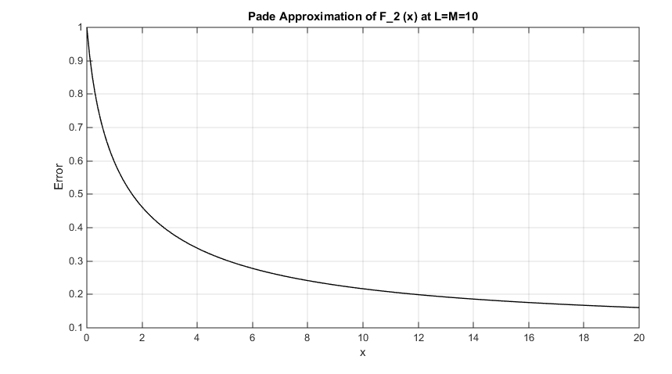

Figure 11: Pade approximation to f_2(x) between x=0.1 to 20 at L=M=10

|  |  |  |  |  |  |
| --- | --- | --- | --- | --- | --- |
| X | Actual | N=3 | N=4 | N=5 | N=6 |
| 0.1 | 0.91563334 | 0.914000 | 0.916400 | 0.91520 | 0.915920 |
| 0.2 | 0.85211088 | 0.832000 | 0.870400 | 0.83200 | 0.878080 |
| 0.3 | 0.80118628 | 0.718000 | 0.912400 | 0.62080 | 1.145680 |

From the table, we can easily identify that the relative error in the truncated power series is, again, incomparably large (varying from ${10}^{9}-{10}^{32}$) comparing with the relative error occurs in Pade approximation for all value of x across 0.1 to 20. Although the error in power series approximation starts off relatively low when x is small, it experiences an exponential increase as x increases and diverges to over ${10}^{31}$. This is because the partial sum of the power series diverges for any non-zero x. The series has a better approximation if we include less term in the series with small x because each extra term we consider, we are adding/subtracting a value of

$k!x^{k}=kx\left(k-1\right)!x^{k-1}=\left(kx-1\right)\left(k-1\right)!x^{k-1}+\left(k-1\right)!x^{k-1}$ to the partial sum, which substantially means cancelling out the last term of the previous partial sum and add back $|\left(kx-1\right)\left(k-1\right)!x^{k-1}|$ to the magnitude of the partial sum. As the partial sum now has the magnitude of $\left|\left(kx-1\right)\left(k-1\right)!x^{k-1}\right|=|\left(kx-1\right)*c_{k-1}|$  
, the partial sums should remain stable and relatively accurate up to the smallest value of $k$ such that $kx>1$. Example as followed:

From the integral expression of $f_{2}(x)$, we can deduce that $f_{2}(x)$ is a decreasing function in x. However, according to the power series, it shows a divergent behaviour as x increases. Therefore, as a basis for calculating $f_{2}(x)$, truncated power series do not give much useful information at all which can also be reflected on the magnitude of error in the table.

Regarding the use of Pade approximation to $f_{2}(x)$, it shows a promising accuracy to the actual value as x increases. A clear trend of $f_{2}(x)$ being a monotonic decreasing function in x is clearly reflected from the table which matches with our observation of the behaviour of $f_{2}(x)$. As x increases, although the relative error increases, it still under a reasonable range at x=20 with around 24%. I believe the relative error will increase as x increases but a clear sign of $f_{2}(x)$ converging to 0 is spotted from the approximation.

Even though the computational order of Pade approximation is higher than the power series approximation, as a basis for calculating $f_{2}(x)$, we should use the Pade approximation over the power series approximation as we can get barely any information from the latter method.

$$f_{1}\left(x\right)=\sqrt{1+x}$$

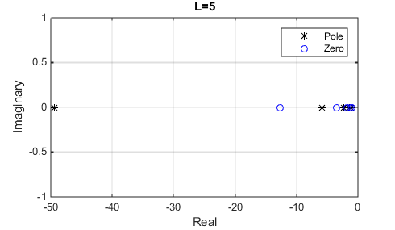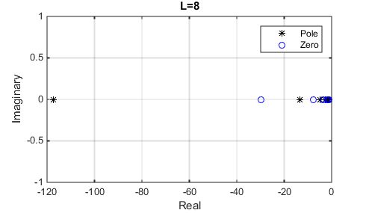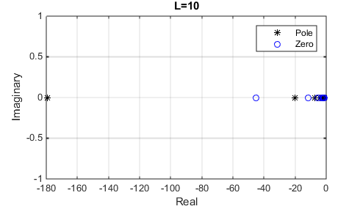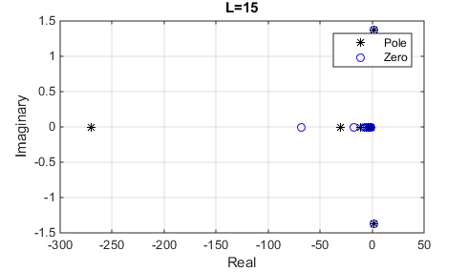

$$f_{3}\left(x\right)=\frac{1}{\sqrt{1+x}}$$

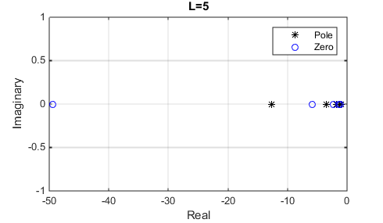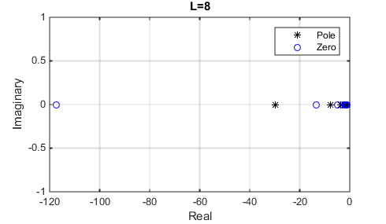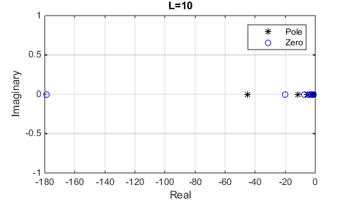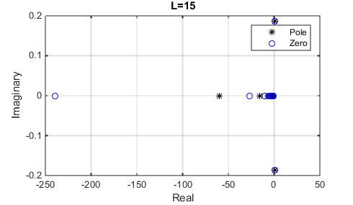

$$f_{4}\left(x\right)=e^{x}$$

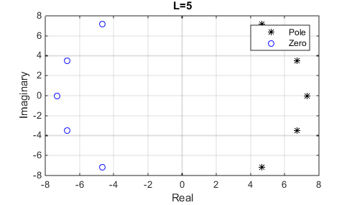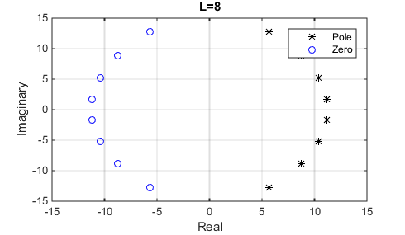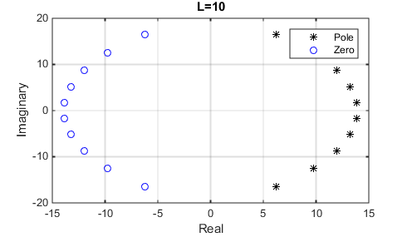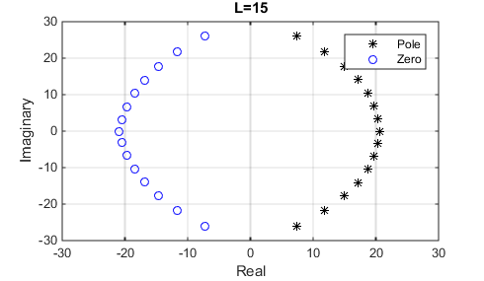

$$f_{5}\left(x\right)=\frac{e^{x}}{1+x}$$

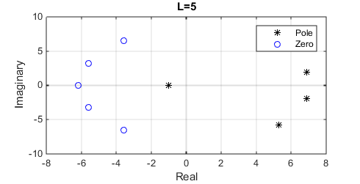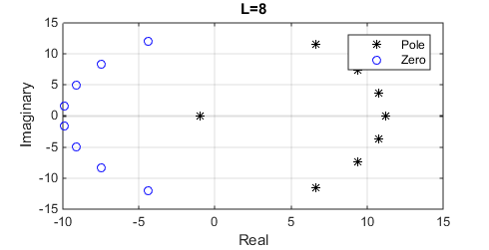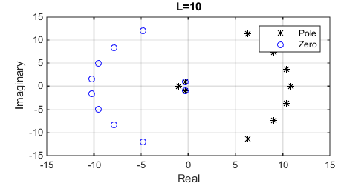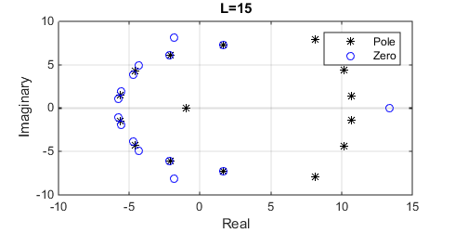

$$f_{6}\left(x\right)={\left(1+x+x^{2}\right)}^{\frac{1}{2}}$$

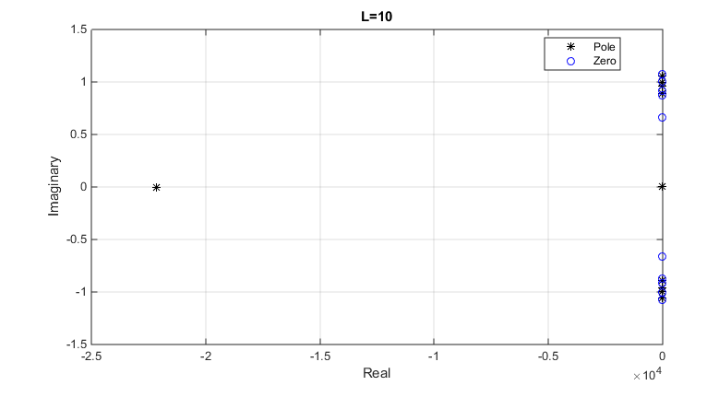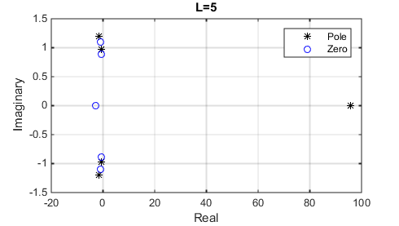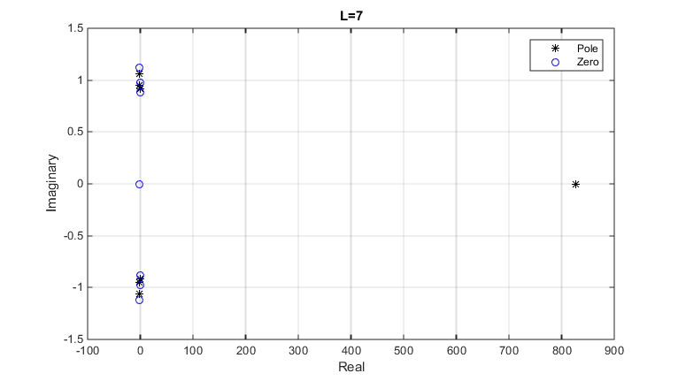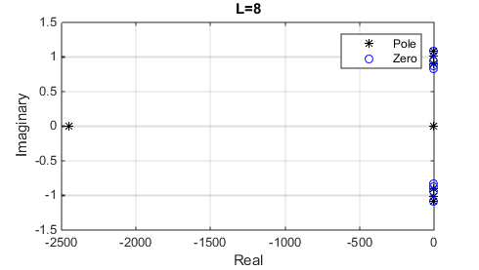

Question 5:

From the graphs for $f_{1}(x)$, we can see the position of the poles and zeros have kept the same pattern of distribution along the negative real axis starting from -1 and reaching out to negative infinity as L increases. The poles and zeros only exist on the left of -1 on the negative real axis for L smaller than 10. As L reaches 10, the poles and zeros start distributing not only on the negative real axis but also over the complex plane. However, we can clearly see that the poles and zeros are always overlapping each other on the complex plane at positions except the negative real axis. This could make those poles cancelled out by the zeros which enable us to ignore those poles when we considering the radius of convergence of the approximation of $f_{1}(x)$.

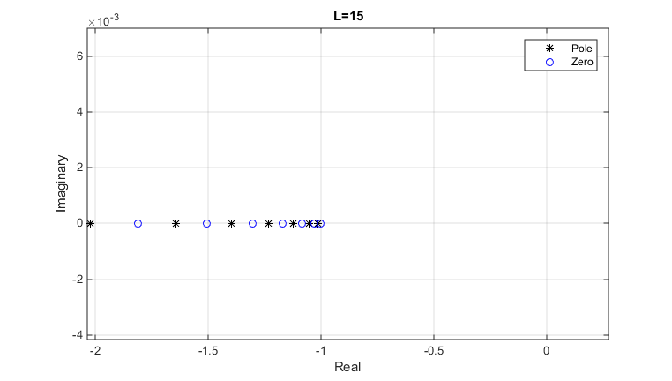

Figure 12: f_1 at L=15 (zoom in)

From the graphs for $f_{3}(x)$, we can spot the four graphs is fundamentally the same as the graphs for $f_{1}(x)$ with the position of the poles and zeros swapped. This is because $f_{3}=\frac{1}{f_{1}}$, therefore the Pade approximation for $f_{3}$ is also the reciprocal of the approximation for $f_{1}$. Similar trend has shown here as in $f_{1}(x)$, the poles and zeros hold in the same pattern on the negative axis starting from the left of -1 and tending to the negative real infinity as L increases. As L becomes large, poles and zeros start distributing around the whole complex plane, however they are always overlapping each other at those position which cancelled out each other from the Pade rational function approximation to $f_{3}$.

For $f_{4}(x)$, we no longer only spot the poles and zeros on the negative real axis anymore. All the poles are distributed evenly in an arc shape on the positive real side on the complex plane while all the zeros distributed on the negative real side on the complex plane similarly in an arc shape. As L increases, the poles and zeros have kept in an arc shape with increasing radius on each side. However, as L becomes large, the arc shape flattens a bit and a semi-oval shape formed for poles and zeros.

In addition, as $f_{4}(x)$ is complete, it does not carry any branch points or poles on the complex plane. Therefore, all the poles on the complex plane are anomalous and any possible branch cuts formed by the zeros of the approximant could not match to any corresponding branch cuts of the approximated function. As L gets to around 50, the positions of the poles and zeros no longer follow the elliptic pattern and, as we can see, two odd poles appear on the real axis and tend to infinity on both sides.

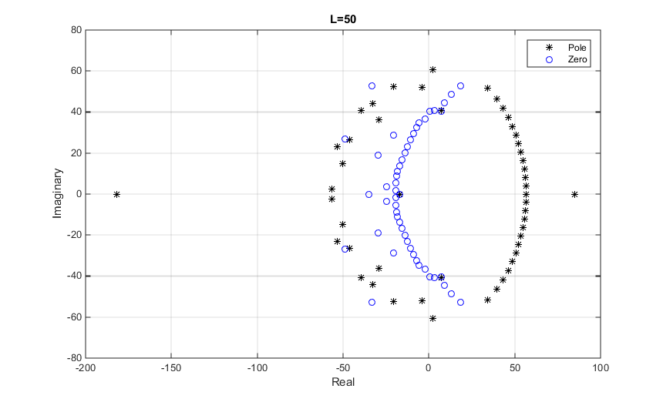

For $f_{5}(x)$, we can see a similar arc shape distribution as $f_{4}(x)$ on the complex plane with a pole at -1 on the negative real axis. However, as L increases, the magnitude of the radius of the arc oscillate between 5 and 10 for both the poles and zeros but not tending to infinity as in $f_{4}(x)$. As L becomes large, the distribution of the poles start invading the left hand side on the complex plane and similarly the zeros getting onto the right hand side as well although the arc shapes with oscillating radius are still kept for both the poles and zeros at large L. When L is large, more poles appear outside the elliptic shape, however, they are all poles at order 0 which has no effect on the radius of convergence of the approximant in this case so we do not need to worry much. I predict, for large L, the distribution of the poles and zeros will be similar to $f_{4}(x)$ with a pole at x=-1 always as it is a simple product of a complete function and a function with a simple pole. Apparently, the pole at x=-1 correspond to the pole of the approximated function. As there is no other branch points or poles in the approximated function which means any poles and zeros appear in the approximant would not match with any branch cuts or poles in the approximated function.

For $f_{6}(x)$, we can see the majority of poles and zeros distributed on the imaginary axis except 2 points. As L increases, the positions of the poles and zeros on the imaginary axis do not change much and stay around $\frac{\sqrt{3}}{2}i and-\frac{\sqrt{3}}{2}i$ on the complex plane. However, for the 2 outstanding points, both of them are on the real axis and with one of them being poles and zeros alternatively as L increases stepwise at the position of -2. For the other outstanding point which is always a pole, it alters its sign with tendency to infinity as L increases.

There are 2 branch points in $f_{6}(x)$ at $x=-\frac{1}{2}±\frac{\sqrt{3}i}{2}$ and a pole at x=∞. We may construct a branch cuts linking these two branch points to the infinity correspondingly and then relate the majority of the poles and zeros to the branch cuts of the approximated function. On the other hand, there is also a pole tending to infinity as L increase which may be correspond to the pole at x=∞.Therefore, the remaining ambiguous point at x=-2 is classified as anomalous.

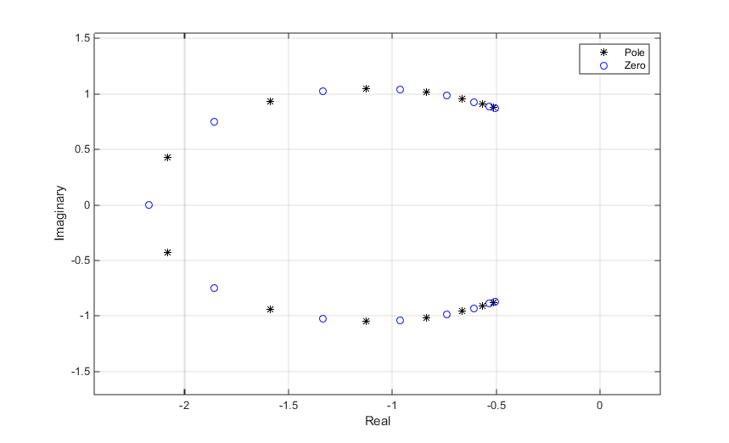

Figure 11: poles and zeros of f_6(x) at L=15

In addition, for L larger than 15, the position of the poles and zeros change completely and it follows another pattern as shown above. We may interpret the above change due to the change of the choice of branch cut. If we join the zeros and poles up, we can spot that it creates a branch cut directly between the two branch points. We will need this result for the second part of this question.

$f_{1}\left(x\right)=\sqrt{1+x}$ $f_{3}\left(x\right)=\frac{1}{\sqrt{1+x}}$

Analytically, we can deduce that there is a branch point at x=-1 and x=∞ in $f_{1}\left(x\right)$ for which we may introduce a branch cut on the real axis from x=-1 to negative infinity. From the graph, we can see majority of the poles and zeros are lying on the branch cut. As L increases, the position of the poles and zeros tends to infinity with increasing spacing between the poles and zeros and however, the total number of poles and zeros does not increase significantly. On the other hand, at L=15, we can see two outstanding poles and zeros lying on the imaginary axis which are classified as anomalous poles and zeros. For L larger than 15, we can see there are more anomalous poles and zeros appearing outside the branch cut on the imaginary axis. However, the poles and zeros are always appear to be overlapping each other which essentially making the poles become removable singularities/ poles at order 0. This eased the effect of those poles and zeros on the approximant’s radius of convergence and also the behaviour of the approximant.

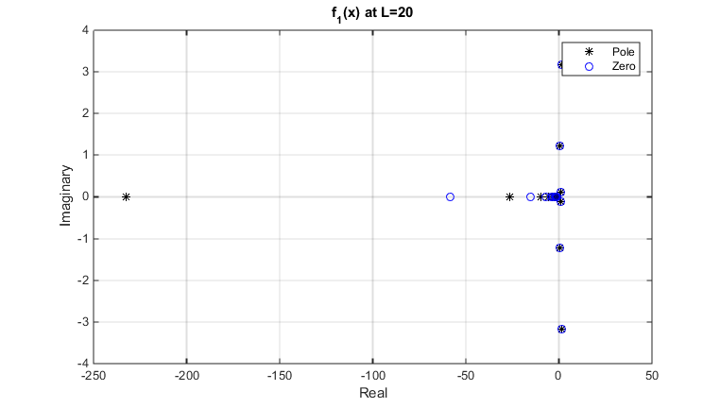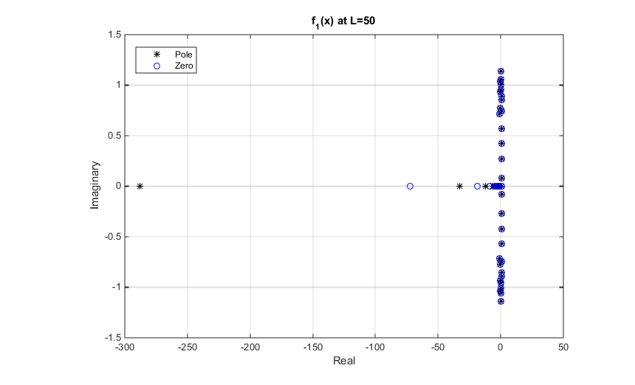

Pade approximation allows us to factor out some of the poles and points on the branch cuts before we do our power series approximation. As there are more overlaps of zeros and poles with the approximated function’s branch cuts and poles, the more terms that we can factor out before obtaining the power series approximation. As we are factoring out the singularities, our radius of convergence increase. In most cases we investigated in this project, for larger L, there are more singularities we are able to factor out which means our approximation will be better as the radius of convergence increases. However, in $f_{1}\left(x\right)=\sqrt{1+x}$, the number of the poles and zeros does not increase when L is greater than 15. This limited our approximation accuracy as no further poles and zeros that we can factor out after L=15. Therefore, in question 2, we can see the magnitude of the error remains stable no matter how large L gets after L=15 at x=1.

In $f_{3}\left(x\right)$, we can see there is a pole at x=-1 and two branch points at x=∞ and x=-1 which is similar to our $f_{1}\left(x\right)$. We can construct the same branch cut here and from the graph, we can see $f_{3}\left(x\right)$ behaves exactly the same except the positions of poles and zeros swapped. We could expect $f_{3}\left(x\right)$ shares the same property of the convergence as $f_{1}\left(x\right)$. However, because the closest singularity to $f_{3}\left(x\right)$ is a pole rather than a branch point in $f_{1}\left(x\right)$, we can factor out the singularity(pole) completely for $f_{3}\left(x\right)$. This pushs the radius of convergence to the nearest branch point which means the Pade approximation for $f_{3}\left(x\right)$ diverges less as the approximation for .

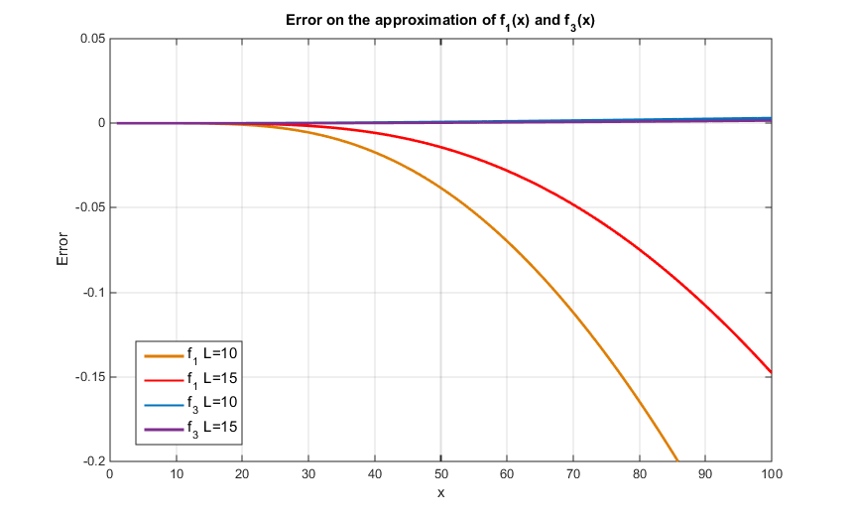

2. Problems encountered when approximating $f_{6}\left(x\right)$?

When I tried to approximate $f_{6}\left(x\right)$ with Pade approximation, as L increases from 6 to 15, the error reduces for the approximation at all x from 1 to 100. However, L greater than 15, the trend changes and the error increases exponentially. This could be because when L becomes greater than 15, the branch cut has suddenly changed which joins the two branch points directly together. This change caused the error diverges as L increases from because all the poles and zeros are no longer on the same branch cuts anymore as before therefore, no factorisation of the poles and zeros can be done by the Pade approximation. Therefore, taking L=15 shall give the most accurate approximation for $f_{6}\left(x\right)$ with the use of Pade Approximation.

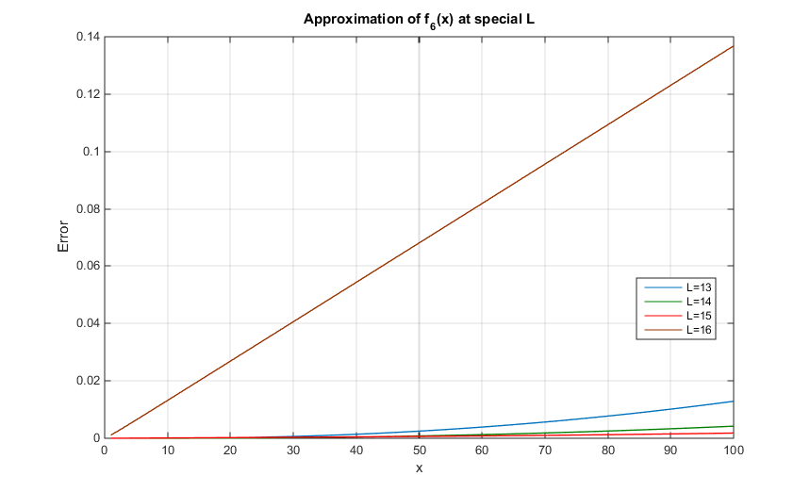

In addition, for L=5, the error diverges at exactly x=95, which is due to the existence of pole at x=95 for the Pade approximation function when L=5. At any poles on the real axis, the corresponding Pade approximation will diverge if we evaluating at that point.

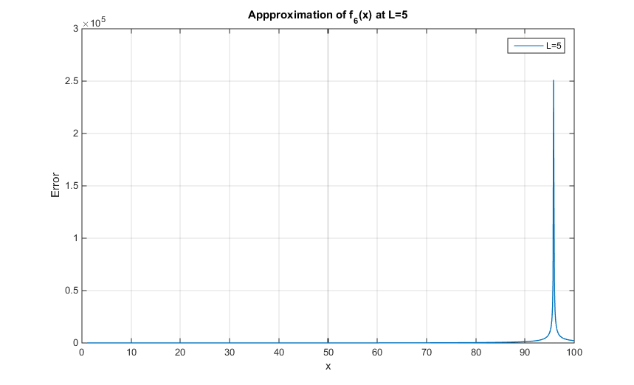

Reference:

Program:

1.

function Q1(Nstart,Nend)

%sketch graph for Q1 error and N

H=zeros(Nend-Nstart+1,2);

for x=Nstart:Nend

A=productinner(x);

B=sum(A);

scatter(x,(B-(2)^0.5));

H(x-Nstart+1,2)=B-(2)^0.5;

H(x-Nstart+1,1)=x;

hold on

end

%plot(fit(H(:,1),H(:,2),'exp2'))

hold off

end

2.

function [H]=Q2padegraphfp(x,Lstart,Lend)

format long

%plotting absolute value of pade

H=zeros(Lend-Lstart+1,2);

for L=Lstart:1:Lend

L

B=padeinner(L,L,x)

scatter(L,((B-(x+1)^0.5)));

H(L-Lstart+1,2)=(B-(x+1)^0.5);

H(L-Lstart+1,1)=L;

hold on

end

hold off

plot(H(:,1),H(:,2));

end

function [R]=padeinner(L,M,x)

%1st Programming task for Proj 7.5

%Solve equations (4) and (5) given the coefficients c_k

%and values of L and M. Also evaluate the resulting Pade approximant

%for set of values x

format long

%remark: c_0 at first place

C=productinner(1000);

C=C';

A_1=zeros(M, M);

C_back=zeros(M,1);

for a=(L+2):(L+M+1),

C_back(a-L-1)=C(1,a);

end

%%%%%%%%%%%%%%%%%%%%%%%%%%

for r=(L+1):(L+M)

min_rm=min(r, M);

for k=1:min_rm,

A_1((r-L),k)=C(1,r-k+1);

end

end

Q=-A_1\C_back;

P=zeros(1,L+1);

P(1,1)=C(1);

for k=1:L

T=0;

min_km=min(k,M);

for s=1:min_km,

T=T+Q(s)*C(k-s+1);

end

P(1,k+1)=C(k+1)+T;

end

P=P';

X_M=zeros(M,1);

for r=1:M,

X_M(r,1)=x^r;

end

X_L=zeros(L+1,1);

for r=0:L,

X_L(r+1,1)=x^r;

end

numer=P'*X_L;

denum=1+Q'*X_M;

R=numer/denum;

end

function [A]=productinner(N)

format long

A=zeros(N+1,1);

A(1,1)=1;

A(2,1)=0.5;

%generating the coefficient of the power series of (1+x)^0.5 in a column

%vector

for k=2:N,

A(k+1,1)=((A(k,1))/2)*(-1)*(2*(k-1)-1)/(k);

end

end

3.

function [Dy]=Q2iterative(L,M,n)

C=productinner(100);

C=C';

T=padeqcoefficientinner(L,M);

for i=1:n

A_1=zeros(M, M);

C_back=zeros(M,1);

for a=(L+2):(L+M+1),

C_back(a-L-1)=C(1,a);

end

%%%%%%%%%%%%%%%%%%%%%%%%%%

for r=(L+1):(L+M)

min_rm=min(r, M);

for k=1:min_rm,

A_1((r-L),k)=C(1,r-k+1);

end

end

Q=-A_1\C_back;

Dy=A_1\(-C_back-A_1*T);

T=T+Dy;

end

end

function [Q]=padeqcoefficientinner(L,M)

%Solve equations (4) and (5) given the coefficients c_k

%and values of L and M. Also evaluate the resulting Pade approximant

%for set of values x

format long

%remark: c_0 at first place

C=productinner(100);

C=C';

A_1=zeros(M, M);

C_back=zeros(M,1);

for a=(L+2):(L+M+1),

C_back(a-L-1)=C(1,a);

end

C_back;

%%%%%%%%%%%%%%%%%%%%%%%%%

for r=(L+1):(L+M)

min_rm=min(r, M);

for k=1:min_rm,

A_1((r-L),k)=C(1,r-k+1);

end

end

A_1;

Q=-A_1\C_back;

P=zeros(1,L+1);

P(1,1)=C(1);

for k=1:L

T=0;

min_km=min(k,M);

for s=1:min_km,

T=T+Q(s)*C(k-s+1);

end

P(1,k+1)=C(k+1)+T;

end

P=P';

end

function [A]=productinner(N)

format long

A=zeros(N+1,1);

A(1,1)=1;

A(2,1)=0.5;

%generating the coefficient of the power series of (1+x)^0.5 in a column

%vector

for k=2:N,

A(k+1,1)=((A(k,1))/2)*(-1)*(2*(k-1)-1)/(k);

end

end

4.

function [Q]=powergraph(xstart,xend,N)

format long

%plotting the error change for power series and actual answer

A=productinner(N);

B=flip(A);

B=B';

syms t

syms y

for x=xstart:0.1:xend,

Q(int16((x-xstart)/0.1+1),1)=x;

I=poly2sym(B,y);

Q(int16((x-xstart)/0.1+1),2)=(subs(I,y,x)-(1+x)^0.5);

end

Q

ezplot((poly2sym(B,t)-(1+t)^0.5),[xstart,xend]);

end

function [A]=productinner(N)

format long

A=zeros(N+1,1);

A(1,1)=1;

A(2,1)=0.5;

%generating the coefficient of the power series of (1+x)^0.5 in a column

%vector

for k=2:N,

A(k+1,1)=((A(k,1))/2)*(-1)*(2*(k-1)-1)/(k);

end

end

5.

function [Q]=Q3padegraph(xstart,xend,M,L)

Q=zeros(10*(xend-xstart)+1,2);

for x=xstart:0.1:xend,

Q(int16((x-xstart)/0.1+1),1)=x;

Q(int16((x-xstart)/0.1+1),2)=(padeinner(L,M,x)-(1+x)^0.5);

end

plot(Q(:,1),Q(:,2));

%plotting error between pade approx and actual curve

end

function [R]=padeinner(L,M,x)

%1st Programming task for Proj 7.5

%Solve equations (4) and (5) given the coefficients c_k

%and values of L and M. Also evaluate the resulting Pade approximant

%for set of values x

format long

%remark: c_0 at first place

C=productinner(1000);

C=C';

A_1=zeros(M, M);

C_back=zeros(M,1);

for a=(L+2):(L+M+1),

C_back(a-L-1)=C(1,a);

end

C_back;

%%%%%%%%%%%%%%%%%%%%%%%%%%

for r=(L+1):(L+M)

min_rm=min(r, M);

for k=1:min_rm,

A_1((r-L),k)=C(1,r-k+1);

end

end

Q=-A_1\C_back;

P=zeros(1,L+1);

P(1,1)=C(1);

for k=1:L

T=0;

min_km=min(k,M);

for s=1:min_km,

T=T+Q(s)*C(k-s+1);

end

P(1,k+1)=C(k+1)+T;

end

P=P';

X_M=zeros(M,1);

for r=1:M,

X_M(r,1)=x^r;

end

X_L=zeros(L+1,1);

for r=0:L,

X_L(r+1,1)=x^r;

end

numer=P'*X_L;

denum=1+Q'*X_M;

R=numer/denum;

end

function [A]=productinner(N)

format long

A=zeros(N+1,1);

A(1,1)=1;

A(2,1)=0.5;

%generating the coefficient of the power series of (1+x)^0.5 in a column

%vector

for k=2:N,

A(k+1,1)=((A(k,1))/2)*(-1)*(2*(k-1)-1)/(k);

end

end

6.

function [Q]=Q4padegraph(xstart,xend,M,L)

Q=zeros(10*(xend-xstart)+1,2);

for x=xstart:0.1:xend,

Q(int16((x-xstart)/0.1+1),1)=x;

Q(int16((x-xstart)/0.1+1),2)=((Q4padeinner(L,M,x)));

end

plot(Q(:,1),Q(:,2));

%plotting error between pade approx and actual curve

end

function [A]=Q4productinner(N)

A=zeros(N+1,1);

for k=0:N,

P=factorial(k);

A(k+1,1)=((-1)^k)*P;

end

end

function [R]=Q4padeinner(L,M,x)

%Q4 Programming task for Proj 7.5

%Solve equations (4) and (5) given the coefficients c_k

%and values of L and M. Also evaluate the resulting Pade approximant

%for set of values x

format long

%remark: c_0 at first place

C=Q4productinner(100);

C=C';

A_1=zeros(M, M);

C_back=zeros(M,1);

for a=(L+2):(L+M+1),

C_back(a-L-1)=C(1,a);

end

%%%%%%%%%%%%%%%%%%%%%%%%%%

for r=(L+1):(L+M)

min_rm=min(r, M);

for k=1:min_rm,

A_1((r-L),k)=C(1,r-k+1);

end

end

Q=-A_1\C_back;

P=zeros(1,L+1);

P(1,1)=C(1);

for k=1:L

T=0;

min_km=min(k,M);

for s=1:min_km,

T=T+Q(s)*C(k-s+1);

end

P(1,k+1)=C(k+1)+T;

end

P=P';

X_M=zeros(M,1);

for r=1:M,

X_M(r,1)=x^r;

end

X_L=zeros(L+1,1);

for r=0:L,

X_L(r+1,1)=x^r;

end

numer=P'*X_L;

denum=1+Q'*X_M;

R=numer/denum;

end

7.

function [Q]=Q4powergraph(xstart,xend,N)

format long

%plotting for power series

A=Q4productinner(N);

B=flip(A);

B=B';

syms t

syms y

for x=xstart:0.1:xend,

Q(int16((x-xstart)/0.1+1),1)=x;

I=poly2sym(B,y);

Q(int16((x-xstart)/0.1+1),2)=(subs(I,y,x));

end

ezplot((poly2sym(B,t)),[xstart,xend]);

end

8.

function [P]=programB(COE)

%COE be the coefficient of the polynomial starting from the highest order

%of the polynomial

P=roots(COE);

end

9.

function [PO,ZE]=Q5f_1(L,M)

%Solve equations (4) and (5) given the coefficients c_k

%and values of L and M. Also evaluate the resulting Pade approximant

%for set of values x

format long

%remark: c_0 at first place

C=productinner(100);

C=C';

A_1=zeros(M, M);

C_back=zeros(M,1);

for a=(L+2):(L+M+1),

C_back(a-L-1)=C(1,a);

end

C_back;

%%%%%%%%%%%%%%%%%%%%%%%%%%

for r=(L+1):(L+M)

min_rm=min(r, M);

for k=1:min_rm,

A_1((r-L),k)=C(1,r-k+1);

end

end

A_1;

Q=-A_1\C_back;

P=zeros(1,L+1);

P(1,1)=C(1);

for k=1:L

T=0;

min_km=min(k,M);

for s=1:min_km,

T=T+Q(s)*C(k-s+1);

end

P(1,k+1)=C(k+1)+T;

end

P=flip(P');

ZE=programB(P);

Q=[1;Q];

Q=flip(Q');

PO=programB(Q);

disp('Poles occur at ');

PO

disp('Zeros occur at ');

ZE

p=plot(real(PO),imag(PO),'g*', real(ZE),imag(ZE),'bo');

p(1).MarkerEdgeColor='k';

p(1).MarkerFaceColor='k';

p(2).MarkerEdgeColor='b';

xlabel('Real') % x-axis label

ylabel('Imaginary') % y-axis label

legend('Pole','Zero')

end

function [A]=productinner(N)

format long

A=zeros(N+1,1);

A(1,1)=1;

A(2,1)=0.5;

%generating the coefficient of the power series of (1+x)^0.5 in a column

%vector

for k=2:N,

A(k+1,1)=((A(k,1))/2)*(-1)*(2*(k-1)-1)/(k);

end

end

10.

function [PO,ZE]=Q5f_3(L,M)

%Solve equations (4) and (5) given the coefficients c_k

%and values of L and M. Also evaluate the resulting Pade approximant

%for set of values x

format long

%remark: c_0 at first place

C=f_3productinner(100);

C=C'

A_1=zeros(M, M);

C_back=zeros(M,1);

for a=(L+2):(L+M+1),

C_back(a-L-1)=C(1,a);

end

C_back;

%%%%%%%%%%%%%%%%%%%%%%%%%%

for r=(L+1):(L+M)

min_rm=min(r, M);

for k=1:min_rm,

A_1((r-L),k)=C(1,r-k+1);

end

end

A_1;

Q=-A_1\C_back;

P=zeros(1,L+1);

P(1,1)=C(1);

for k=1:L

T=0;

min_km=min(k,M);

for s=1:min_km,

T=T+Q(s)*C(k-s+1);

end

P(1,k+1)=C(k+1)+T;

end

P=flip(P');

ZE=programB(P);

Q=[1;Q];

Q=flip(Q');

PO=programB(Q);

disp('Poles occur at ');

PO

disp('Zeros occur at ');

ZE

p=plot(real(PO),imag(PO),'g*', real(ZE),imag(ZE),'bo');

p(1).MarkerEdgeColor='k';

p(1).MarkerFaceColor='k';

p(2).MarkerEdgeColor='b';

xlabel('Real') % x-axis label

ylabel('Imaginary') % y-axis label

legend('Pole','Zero')

end

function [A]=f_3productinner(N)

A=zeros(N+1,1);

A(1,1)=1;

for k=1:N,

A(k+1,1)=A(k,1)*(-1)*(1/k)*(0.5)*(2*(k-1)+1);

end

end

11.

function [PO,ZE]=Q5f_4(L,M)

%Solve equations (4) and (5) given the coefficients c_k

%and values of L and M. Also evaluate the resulting Pade approximant

%for set of values x

format long

%remark: c_0 at first place

C=f_4productinner(100);

C=C'

A_1=zeros(M, M);

C_back=zeros(M,1);

for a=(L+2):(L+M+1),

C_back(a-L-1)=C(1,a);

end

C_back;

%%%%%%%%%%%%%%%%%%%%%%%%%%

for r=(L+1):(L+M)

min_rm=min(r, M);

for k=1:min_rm,

A_1((r-L),k)=C(1,r-k+1);

end

end

A_1;

Q=-A_1\C_back;

P=zeros(1,L+1);

P(1,1)=C(1);

for k=1:L

T=0;

min_km=min(k,M);

for s=1:min_km,

T=T+Q(s)*C(k-s+1);

end

P(1,k+1)=C(k+1)+T;

end

P=flip(P');

ZE=programB(P);

Q=[1;Q];

Q=flip(Q');

PO=programB(Q);

disp('Poles occur at ');

PO

disp('Zeros occur at ');

ZE

p=plot(real(PO),imag(PO),'g*', real(ZE),imag(ZE),'bo');

p(1).MarkerEdgeColor='k';

p(1).MarkerFaceColor='k';

p(2).MarkerEdgeColor='b';

xlabel('Real') % x-axis label

ylabel('Imaginary') % y-axis label

legend('Pole','Zero')

end

function [A]=f_4productinner(N)

A=zeros(N+1,1);

A(1,1)=1;

for k=1:N,

A(k+1,1)=A(k,1)/k;

end

end

12.

function [C]=Q5f_5(L,M)

%Solve equations (4) and (5) given the coefficients c_k

%and values of L and M. Also evaluate the resulting Pade approximant

%for set of values x

format long

%remark: c_0 at first place

C=f_5productinner;

C=C';

A_1=zeros(M, M);

C_back=zeros(M,1);

for a=(L+2):(L+M+1),

C_back(a-L-1)=C(1,a);

end

C_back;

%%%%%%%%%%%%%%%%%%%%%%%%%%

for r=(L+1):(L+M)

min_rm=min(r, M);

for k=1:min_rm,

A_1((r-L),k)=C(1,r-k+1);

end

end

A_1;

Q=-A_1\C_back;

P=zeros(1,L+1);

P(1,1)=C(1);

for k=1:L

T=0;

min_km=min(k,M);

for s=1:min_km,

T=T+Q(s)*C(k-s+1);

end

P(1,k+1)=C(k+1)+T;

end

P=flip(P');

ZE=programB(P);

Q=[1;Q];

Q=flip(Q');

PO=programB(Q);

disp('Poles occur at ');

PO

disp('Zeros occur at ');

ZE

p=plot(real(PO),imag(PO),'g*', real(ZE),imag(ZE),'bo');

p(1).MarkerEdgeColor='k';

p(1).MarkerFaceColor='k';

p(2).MarkerEdgeColor='b';

xlabel('Real') % x-axis label

ylabel('Imaginary') % y-axis label

legend('Pole','Zero')

end

function [C]=f_5productinner

A=zeros(101,1);

B=zeros(101,1);

C=zeros(101,1);

A(1,1)=1;

B(1,1)=1;

for k=1:100,

A(k+1,1)=A(k,1)/k;

B(k+1,1)=-1*B(k,1);

end

for i=1:101,

sum=0;

for j=1:i,

sum=sum+A(j)*B(i-j+1);

end

C(i,1)=sum;

end

end

13.

function []=Q5f_6(L,M)

%Solve equations (4) and (5) given the coefficients c_k

%and values of L and M. Also evaluate the resulting Pade approximant

%for set of values x

format long

%remark: c_0 at first place

C=f_6productinner;

C=C';

A_1=zeros(M, M);

C_back=zeros(M,1);

for a=(L+2):(L+M+1),

C_back(a-L-1)=C(1,a);

end

C_back;

%%%%%%%%%%%%%%%%%%%%%%%%%%

for r=(L+1):(L+M)

min_rm=min(r, M);

for k=1:min_rm,

A_1((r-L),k)=C(1,r-k+1);

end

end

A_1;

Q=-A_1\C_back;

P=zeros(1,L+1);

P(1,1)=C(1);

for k=1:L

T=0;

min_km=min(k,M);

for s=1:min_km,

T=T+Q(s)*C(k-s+1);

end

P(1,k+1)=C(k+1)+T;

end

P=flip(P');

ZE=programB(P);

Q=[1;Q];

Q=flip(Q');

PO=programB(Q);

disp('Poles occur at ');

PO

disp('Zeros occur at ');

ZE

p=plot(real(PO),imag(PO),'g*', real(ZE),imag(ZE),'bo');

p(1).MarkerEdgeColor='k';

p(1).MarkerFaceColor='k';

%p(2).MarkerEdgeColor='b';

xlabel('Real') % x-axis label

ylabel('Imaginary') % y-axis label

legend('Pole','Zero')

end

function [C]=f_6productinner

A=zeros(101,1);

B=zeros(101,1);

C=zeros(101,1);

a_1=complex(-0.5,((3^0.5)/2));

a_2=complex(-0.5,-((3^0.5)/2));

A(1,1)=1;

A(2,1)=-0.5/a_1;

B(1,1)=1;

B(2,1)=-0.5/a_2;

for k=2:100,

A(k+1,1)=((2*k-3)/(2*a_1))*A(k,1)/k;

B(k+1,1)=((2*k-3)/(2*a_2))*B(k,1)/k;

end

for i=1:101,

sum=0;

for j=1:i,

sum=sum+A(j)*B(i-j+1);

end

C(i,1)=sum;

end

end

14.

function [Q]=Q5f_6padegraph(xstart,xend,M,L)

C=f_6productinner';

Q=zeros(10*(xend-xstart)+1,2);

for x=xstart:0.1:xend,

Q(int16((x-xstart)/0.1+1),1)=x;

Q(int16((x-xstart)/0.1+1),2)=(abs(Q5f_6padeinner(L,M,x)-(1+x+x^2)^0.5));

end

plot(Q(:,1),Q(:,2));

%plotting error between pade approx and actual curve

end

function [R]=Q5f_6padeinner(L,M,x)

%1st Programming task for Proj 7.5

%Solve equations (4) and (5) given the coefficients c_k

%and values of L and M. Also evaluate the resulting Pade approximant

%for set of values x

format long

%remark: c_0 at first place

C=f_6productinner;

C=C';

A_1=zeros(M, M);

C_back=zeros(M,1);

for a=(L+2):(L+M+1),

C_back(a-L-1)=C(1,a);

end

C_back;

%%%%%%%%%%%%%%%%%%%%%%%%%%

for r=(L+1):(L+M)

min_rm=min(r, M);

for k=1:min_rm,

A_1((r-L),k)=C(1,r-k+1);

end

end

Q=-A_1\C_back;

P=zeros(1,L+1);

P(1,1)=C(1);

for k=1:L

T=0;

min_km=min(k,M);

for s=1:min_km,

T=T+Q(s)*C(k-s+1);

end

P(1,k+1)=C(k+1)+T;

end

P=P';

X_M=zeros(M,1);

for r=1:M,

X_M(r,1)=x^r;

end

X_M;

X_L=zeros(L+1,1);

for r=0:L,

X_L(r+1,1)=x^r;

end

X_L;

P;

Q;

numer=P'*X_L;

denum=1+Q'*X_M;

R=numer/denum;

end

function [C]=f_6productinner

A=zeros(101,1);

B=zeros(101,1);

C=zeros(101,1);

a_1=complex(-0.5,((3^0.5)/2));

a_2=complex(-0.5,-((3^0.5)/2));

A(1,1)=1;

A(2,1)=-0.5/a_1;

B(1,1)=1;

B(2,1)=-0.5/a_2;

for k=2:100,

A(k+1,1)=((2*k-3)/(2*a_1))*A(k,1)/k;

B(k+1,1)=((2*k-3)/(2*a_2))*B(k,1)/k;

end

for i=1:101,

sum=0;

for j=1:i,

sum=sum+A(j)*B(i-j+1);

end

C(i,1)=sum;

end

end