

BSc (Hons) in Computing
2024.2
Interim Project Report (Mid-Point Progress)
A Privacy-Conscious Blockchain-based Vehicle Ownership and Lifecycle Registry Architecture to Reduce the Fraud of Used Vehicles in Sri Lanka.
Coventry Index No. : 16116030
NIBM Registered Name : S.N.I.W.M.K.V. Illankoon
Supervisor : Mr. Thisara Weerasinghe
Faculty of Engineering, Environment and Computing
School of Computing, Electronics and Mathematics
Coventry University
School of Computing and Engineering
National Institute of Business Management

Declaration
I declare that this interim report and the work presented in it are my own and have been generated by me as the result of my own original research. Where I have consulted the published work of others, this is always clearly attributed. This report is submitted as a progress (mid-point) deliverable for the BSc (Hons) in Computing final year research project and has not been submitted for any other qualification.
Student: S.N.I.W.M.K.V. Illankoon
Coventry Index No.: 16116030
Date: 06th June 2026

Abstract
Sri Lanka's used-vehicle market suffers from persistent fraud, including odometer rollback, concealed accident history, undisclosed insurance claims, and the resale of stolen vehicles. The records needed to detect such fraud are held by separate institutions — the Department of Motor Traffic (DMT), Sri Lanka Police, insurance companies, emission-testing centres, and Customs — and are cross-checked manually, which is slow and easily defeated. Blockchain technology offers tamper-evident, shared record keeping, but a fully transparent ledger exposes owners' personal data, while a fully private ledger lets fraudsters hide behind anonymity.
This project designs, implements, and evaluates a privacy-preserving consortium blockchain registry built on Hyperledger Fabric. Rather than inventing new cryptographic primitives, it adapts established techniques — conditional, authority-revealable pseudonymity (as deployed for general accounts by Concordium and for a national gun registry by Kamara et al., 2021) and a hybrid on-chain/off-chain data model — to the previously unaddressed setting of a national vehicle ownership and lifecycle registry, where the same pseudonym must remain linkable across events for fraud detection to function. Its contributions are: conditional pseudonymity applied to a persistent owner identity, with a policy-coupled, governed multi-party (threshold) identity-reveal protocol — valid only when it cites an existing on-chain fraud flag — for lawful investigations; a rule-based cross-event fraud-detection layer for odometer, accident–insurance, and theft anomalies, together with an analytical minimum-linkability characterisation of which rules fail first as pseudonym linkage is reduced; a hybrid on-chain/off-chain data model aligned with Sri Lanka's Personal Data Protection Act (PDPA, No. 9 of 2022, as amended by Act No. 22 of 2025); and an empirical characterisation of the privacy-versus-detection trade-off — framed as a risk-utility-map instance for a pseudonymous asset-ownership registry — identifying the point at which effective fraud detection would force de-pseudonymisation.
This interim report presents the completed introduction, literature review, research methodology, and system design, including a justified selection of a permissioned (consortium) blockchain over a public blockchain. It also reports the current implementation progress and the evaluation plan to be executed in the next phase. A supervisor-requested capability audit, conducted after the design phase and reported in §4.11 and Appendix C, additionally characterises the boundary of what the designed rules can and cannot detect across forty-eight documented real-world fraud subtypes, and establishes that every non-detection arises from one of four structural causes — two of which are properties of any registry rather than defects of this design, and one of which is a direct consequence of the privacy guarantee itself. That finding motivates the framing proposed for the final thesis in §8.1, in which the pseudonym linkage available to each fraud rule becomes an explicit, machine-enforced parameter and the checks the system cannot decide are declared to the prospective buyer rather than silently omitted.

Acknowledgement
I would like to thank my project supervisor, Mr. Thisara Weerasinghe, for his continued guidance and feedback throughout the analysis and design phases of this project. I also thank the academic staff of the National Institute of Business Management (NIBM) and Coventry University for their support, and my family and peers for their encouragement.

Table of Contents
Right-click and choose "Update Field" to build the Table of Contents.

List of Abbreviations
Abbreviation | Meaning
DMT | Department of Motor Traffic
PDPA | Personal Data Protection Act (No. 9 of 2022)
RBAC | Role-Based Access Control
PII | Personally Identifiable Information
MSP | Membership Service Provider (Hyperledger Fabric)
TPS | Transactions Per Second
DSR | Design Science Research
NIC | National Identity Card
VIN | Vehicle Identification Number
PoW / PoS | Proof of Work / Proof of Stake
BFT | Byzantine Fault Tolerance

Chapter 01: Introduction
Sri Lanka has a history of vehicle fraud in the used-vehicle market, including odometer rollback, hidden accident history, unreported theft history, and forged ownership documents. The existing vehicle registration and ownership-transfer system, which is primarily handled by the Department of Motor Traffic (DMT), is centralised, paper-based, and relies heavily on institutional trust. Blockchain technology offers a strong solution through immutable record keeping and decentralised trust. Transparency would prevent fraud, but it endangers the owner's privacy, and excessive privacy can be used by fraudsters to hide behind anonymity. This research fills the gap by introducing a privacy-preserving consortium blockchain architecture that uses conditional pseudonymous identities for vehicle owners and performs automated fraud detection, modelled on Sri Lanka's institutional context.

Background
DMT records, police reports, insurance claims, emission certificates, and Customs data are isolated, need to be cross-checked manually, and can be easily forged. In March 2025 the Committee on Public Accounts (COPA) documented losses of approximately Rs. 1.2 billion arising from the fraudulent insertion of the engine and chassis numbers of illegally imported vehicles into existing registrations (Parliament of Sri Lanka, 2025). In a separate development in March 2026, COPA approved forwarding a report covering 25 cases of fraud, corruption, and irregularities at the DMT to the Attorney General (The Morning, 2026). The immutability of blockchain is reflected in tamper-proof recorded events, and prior studies in India (Yadav et al., 2023) and Sri Lanka (Malintha et al., 2024) demonstrate the technical feasibility of blockchain vehicle registries but pay limited attention to owner privacy and automated cross-event fraud detection.

The Current Vehicle-Registry System (As-Is)
Sri Lanka's vehicle registry is operated by the Department of Motor Traffic (DMT) under the Motor Traffic Act (Chapter 203), administered by the Commissioner-General of Motor Traffic, who maintains the central register. On first registration the Commissioner-General assigns the distinctive registration number, records the applicant as owner, and issues a paper Certificate of Registration (CR), which is prima facie legal evidence of ownership (Motor Traffic Act, s.9, s.17); for a leased or hire-purchase vehicle the financier is separately recorded as the "absolute owner" (Government of Sri Lanka, 2024). Ownership transfer is paper-driven: the seller completes the prescribed MTA-6 and MTA-8 forms, sends one copy to the Commissioner-General, and hands the remaining copies, the CR and a certified letter of no objection to the buyer, who submits them at the DMT Vehicle Transfer counter, receives a CMT-52 receipt, and must re-register within 14 days (Department of Motor Traffic, n.d.). The DMT's online eServices offers only vehicle-information lookup; first registration and transfer remain in-person and paper-based.

Inter-Agency Data Sharing Today
A central question for this research is whether the DMT, Sri Lanka Police, Sri Lanka Customs, insurers and emission-testing centres share information through a connected database. The evidence shows partial, point-to-point integration rather than a unified registry:
- The Electronic Revenue Licence (eRL / eRL 2.0) system, built by ICTA with the Provincial Departments of Motor Traffic, is the one routine automated cross-organisation check in the lifecycle: when a revenue licence is issued, eRL calls web services that validate the vehicle's insurance certificate against the insurer's system and the emission (VET) certificate against the testing company's system in real time, and it imports new-registration and transfer data from a DMT web service (ICTA, 2019). The system spans all nine provinces and 331 Divisional Secretariats and serves about six million users a year (ICTA, 2023).
- Crucially, this integration does not include Sri Lanka Police or Sri Lanka Customs, and the DMT link is a one-directional data sync into the licensing database, not a shared, bidirectional registry (ICTA, 2019).
- The Customs-to-DMT handoff at first registration is document-driven: the importer physically presents Customs paperwork (the "Customs Link", duty-assessment notice and export certificate) at the DMT counter; no automated feed is published (Department of Motor Traffic, n.d.).
- Ownership transfer, theft reporting, accident records, odometer/mileage history and insurance claims are not held in any shared cross-agency database. Theft is reported to the Police and evidenced by a paper complaint copy; there is no electronic stolen-vehicle check in the transfer flow.
In short, Sri Lanka already proves that real-time multi-party verification is achievable — eRL integrates the DMT, insurers and emission centres — but there is no unified ownership-and-lifecycle view across all five parties, and the most fraud-sensitive events (transfer, theft and odometer history) are still siloed and manually cross-checked. This fragmentation, combined with a forgeable paper CR, is what enables the documented fraud: the Commission to Investigate Allegations of Bribery or Corruption found nearly 400 un-Customs-cleared vehicles fraudulently entered into the DMT database (CIABOC, 2024), and the Committee on Public Accounts documented an Rs. 1.2 billion loss from cloning engine and chassis numbers onto existing registrations (Parliament of Sri Lanka, 2025). Figure 1.1 summarises the current data-sharing landscape.
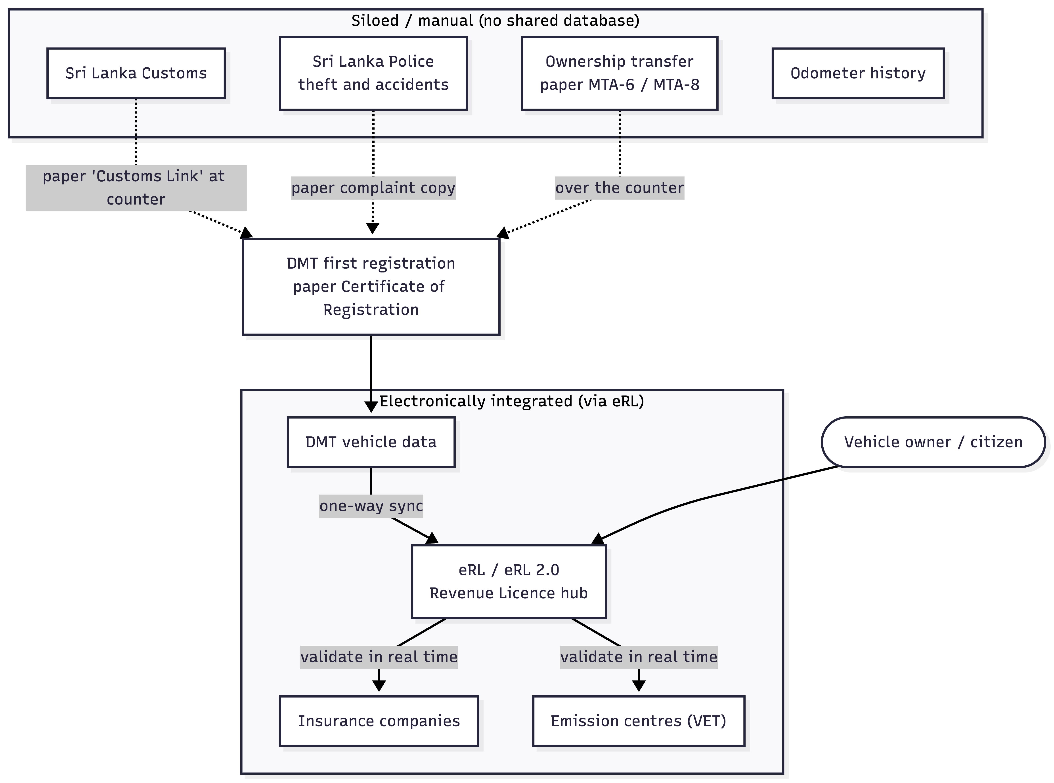
Figure 1.1 — Current ("as-is") vehicle-data landscape in Sri Lanka: the eRL system integrates the DMT, insurers and emission centres at licence issuance, while Customs is document-driven and Police, transfer, theft, accident and odometer records remain siloed.

Research Problem
Although blockchain registries have been shown to be feasible, the core issue remains: the existing systems force a choice between two extremes. Transparent ledgers expose vehicle owners' sensitive data (NIC, addresses), while private ledgers hide fraudsters from accountability. Malintha et al. (2024), the only peer-reviewed Sri Lankan registry, publishes owner identities on a public Ethereum deployment without pseudonymity or PDPA alignment. Yadav et al. (2023) ties accident and insurance records to real-world identities without a conditional reveal mechanism. Souei et al. (2025) detects insurance fraud but ignores privacy and registration. To the best of our knowledge, no existing work brings conditional pseudonymity, rule-based cross-event fraud detection, and PDPA (2022) compliance together for the Sri Lankan vehicle-registration context — and the balance between detecting fraud and preserving owner privacy has not been measured for an ownership registry of this kind.

Aim
To design, implement, and evaluate a blockchain-based privacy-preserving vehicle ownership and lifecycle registry prototype that implements conditional pseudonymity for owner identities and automated fraud detection for the Sri Lankan vehicle ecosystem.

Objectives of the Project
- SO1 — Find the limitations of the currently implemented system in the DMT through stakeholder analysis.
- SO2 — Design a conditional pseudonym model in which on-chain pseudonyms are unlinkable to real identities by default, and identity reveal requires a governed, multi-party (threshold) authorisation held jointly across consortium authorities.
- SO3 — Develop a rule-based detection algorithm for odometer events, accident and insurance mismatches, and theft.
- SO4 — Define a hybrid on-chain/off-chain architecture that keeps personal data off-chain.
- SO5 — Implement smart contracts with role-based access control on Hyperledger Fabric.
- SO6 — Evaluate the privacy, fraud-detection accuracy, and performance of the system.

Research Questions
- RQ1 — What are the privacy and fraud-detection gaps in the current vehicle registration system?
- RQ2 — How does conditional pseudonymity protect an owner's identity while allowing an authorised reveal?
- RQ3 — Which rule-based algorithms can be used to detect cross-event vehicle fraud?
- RQ4 — How can this architecture comply with the PDPA (2022) despite blockchain immutability?

Scope of the Research
This research focuses on the Sri Lankan vehicle-registration scenario within the DMT and includes seven lifecycle events: registration, ownership transfer, accident reporting, insurance claims, mileage reporting, theft reporting, and emission certification. The prototype is implemented on Hyperledger Fabric as a consortium of the DMT, Sri Lanka Police, Customs, insurers, and emission-testing centres. Out of scope are vehicle-to-vehicle communication and cross-border imports beyond Customs declarations. Evaluation is limited to simulated datasets and lab-scale test networks rather than production deployment.

Chapter 02: Literature Review
This literature review explores findings on blockchain-based vehicle registries, privacy and pseudonymity techniques in automotive systems, and fraud detection in the vehicle domain. It places the proposed solution alongside other research, compares them, and identifies the specific gaps that remain unaddressed. A total of three recent studies are reviewed, spanning vehicle registries in India, Sri Lanka, and Tunisia, published between 2023 and 2025.

Findings by Other Researchers
Malintha et al. (2024) proposed the only peer-reviewed Sri Lanka–specific blockchain-based vehicle registry system to date. It supports registering vehicles, issuing certificates, transferring ownership, and viewing ownership history. It is built on a public Ethereum deployment (evaluated on the Rinkeby testnet and a private Ganache/Geth setup, not mainnet), so vehicle details would be publicly viewable and it does not use pseudonymous owner identifiers or off-chain PII storage; it does not address the Personal Data Protection Act of Sri Lanka (2022). Three earlier, non-peer-reviewed Sri Lankan dissertations address closely related problems and are cited here for completeness rather than omitted: Samarakkody (2021), TRUECARE, an Ethereum+IPFS system uniting the RMV/DMT, insurers, leasing, emission testing and service stations against odometer tampering, hidden accidents and stolen vehicles (Malintha et al. themselves cite this work); Tissera (2022), Legit-Ride, a proposed blockchain replacement for the DMT registration workflow; and Wijewardena (2020), a cross-insurer blockchain claims-history platform against vehicle-insurance fraud. None of the three provides owner pseudonymity, a governed identity-reveal mechanism, PDPA alignment, or deterministic cross-event fraud rules.
Yadav et al. (2023) proposed a Hyperledger Fabric–based system for accident reporting and insurance claims in India. It runs as a single Hyperledger Composer network with access-control-list rules and ECC-based signatures rather than Fabric's multi-channel partitioning, does not provide pseudonyms for individual identity protection, and focuses only on accident and insurance events.
Souei et al. (2025) in Tunisia proposed a fraud-detection and vehicle-damage assessment system based on a blockchain, using Ethereum smart contracts and machine learning (Mask R-CNN, XGBoost) for insurance-claim fraud. While innovative in its ML approach, it lacks any focus on privacy, is limited to insurance fraud, and is not integrated with a vehicle registration system.

The Research Gap
The comparative analysis of the reviewed research, read alongside the wider literature on vehicular privacy and blockchain fraud detection — and a subsequent adversarial novelty audit against 107 additional prior works (NOVELTY_AUDIT.md) — shows six areas that remain under-served for a Sri Lankan vehicle ownership registry, each now stated as a positioned differentiation rather than a bare negative. Gap 1 (G1): Persistent owner pseudonymity, gated by a quorum of the actual custodial agencies and coupled to an on-chain fraud flag, is not applied in any located vehicle ownership registry — the reviewed registry systems (Malintha, Yadav) use real owner identities, and the closest mechanism precedents (Concordium's deployed M-of-N anonymity revokers; Kamara et al., 2021, for a national gun-ownership registry; SeDe, Chaudhary & Ivey-Law, 2023; PEReDi, Sarencheh et al., 2022) do not target an ownership-and-lifecycle registry where the pseudonym must also stay linkable for cross-event fraud rules. This is addressed by the Conditional Pseudonym Model. Gap 2 (G2): Conditional identity reveal, although an established primitive in vehicular-network schemes, in Hyperledger Fabric (Idemix; Bogatov et al., 2019), and in the deployed US Security Credential Management System (Brecht et al., 2018), has not been applied to owner identity in a registry that hides identity by default, reveals it only under authorised multi-party conditions, and machine-validates that the request cites an existing on-chain fraud flag before a human quorum signs off — this policy-coupled condition is absent from every located precedent and is addressed by the Multi-Party Reveal Protocol. Gap 3 (G3): Full-lifecycle blockchain registries exist — the Swiss cardossier production consortium and Bragadeesh & Umamakeswari's (2022) six-of-seven-event design — but neither combines full coverage with owner pseudonymity and a deterministic multi-rule detection layer; this is addressed by the seven-event lifecycle schema running over pseudonymous owners. Gap 4 (G4): Deterministic cross-event fraud detection already exists in production, centralised registries — NMVTIS (US, since 2009) and RDW/Car-Pass (Netherlands/Belgium) — but only over fully identified owners in a single-administrator database; no located blockchain registry runs an equivalent rule engine as chaincode over pseudonymised owners, which is addressed by the Fraud-Detection Algorithms. Gap 5 (G5): No located work analyses how blockchain immutability interacts with the erasure and rectification rights of Sri Lanka's PDPA (No. 9 of 2022, as amended by Act No. 22 of 2025) specifically; Baskaran et al. (2023) performed the analogous mapping for Malaysia's PDPA, and the EDPB's Guidelines 02/2025 now prescribe the general off-chain PII / on-chain hash mechanism this thesis adopts — the method is inherited, the Sri Lankan legal mapping is not. Gap 6 (G6): Among peer-reviewed work, only Malintha et al. focus on Sri Lanka; three earlier, non-peer-reviewed dissertations (Samarakkody, 2021; Tissera, 2022; Wijewardena, 2020) address related Sri Lankan vehicle-fraud problems without privacy, governed reveal, or regulatory analysis — this is addressed through the stakeholder and regulatory analysis. The key observation is that, although each individual technique exists somewhere, this specific five-part combination — persistent pseudonym, agency-quorum on-chain-logged reveal, deterministic cross-event rules, a measured privacy-detection trade-off, and Sri Lanka's PDPA — has not been located in one ownership-registry framework.
Comparison (2023+ studies only)
# | Citation | Findings | Gaps Addressed by This Research
1 | Yadav et al. (2023) | Hyperledger Fabric framework for accident reporting and insurance claims in India; uses channels for data partitioning. | G1 pseudonymity, G2 conditional reveal, G3 full lifecycle, G4 cross-event fraud, G5 PDPA, G6 Sri Lankan analysis
2 | Malintha et al. (2024) | Only Sri Lanka–specific blockchain registry; supports registration, certificate issuance, ownership transfer, and history viewing on Ethereum. | G1 pseudonymity, G2 conditional reveal, G3 full lifecycle, G4 cross-event fraud, G5 PDPA
3 | Souei et al. (2025) | Ethereum-based fraud detection with Mask R-CNN and XGBoost for insurance-claim fraud in Tunisia. | G1 pseudonymity, G2 conditional reveal, G3 full lifecycle, G5 PDPA, G6 Sri Lankan analysis

Novelty Against Existing Applications
A supervisor review asked that the novelty of this work be made explicit against existing applications. None of the system's individual capabilities is invented here; each already exists somewhere, so the contribution must be stated honestly as an applied integration rather than a new primitive.
- Centralised vehicle-history services such as CARFAX and AutoCheck (Experian) already provide rich cross-event history and odometer/title-fraud flags, but they are centralised, depend on voluntary reporting, use no blockchain, and provide no owner pseudonymity or consortium governance (CARFAX, n.d.; AutoCheck, n.d.).
- Real-world permissioned blockchain title systems exist: the California DMV digitised 42 million car titles on a permissioned Avalanche network, but the design covers essentially one event — title/ownership transfer — with no published privacy or cross-event fraud-detection layer (Ledger Insights, 2024).
- Multi-event vehicle "passport" / NFT platforms — Arianee, the academic NFT-Vehicle architecture (Lopez-Pimentel et al., 2023), and VehiclePassport (Kaushal, 2025) — cover the lifecycle and some privacy (selective disclosure or zero-knowledge proofs), but run on public chains and target GDPR/EU markets rather than a Sri Lankan DMT consortium under the PDPA. VehiclePassport is the closest single system located: it combines a blockchain vehicle-lifecycle record, zero-knowledge selective disclosure, and odometer-fraud prevention, but it has no registry owner pseudonyms, no agency-quorum reveal, no multi-rule cross-event detection, no measured privacy-versus-detection curve, and no clause-level national-law analysis.
- Production cross-event fraud-checking registries already exist, centralised. NMVTIS, the US national title system, has enforced deterministic theft, insurer-total-loss and odometer checks before title issuance since 2009 (28 CFR Part 25); the Dutch and Belgian registrars (RDW; Car-Pass) apply statutory odometer-monotonicity checks. All operate on fully identified owners in a single-administrator database — the gap is not the existence of cross-event rules, but running them over pseudonymised owners on a shared ledger.
- Full-lifecycle blockchain registries already exist, including the Swiss cardossier production consortium (cantonal road-traffic authority, insurers and manufacturers, on Fabric/Corda) and Bragadeesh & Umamakeswari's (2022) academic design covering six of the seven lifecycle events with fuzzy-logic fraud checks — neither provides owner pseudonymity or a governed reveal mechanism, and neither runs a deterministic, rule-based multi-family fraud engine.
- The closest permissioned, privacy-preserving precedent is Yadav et al. (2023), built on a single Hyperledger Composer network, but it covers only accident and insurance events, has no pseudonymity, and performs a single consensus-level validity check rather than cross-event rules.
- Conditional pseudonymity with authority-controlled, multi-party reveal is an established mechanism family, but not for a vehicle ownership registry: Concordium's deployed identity layer lets an M-of-N quorum of "anonymity revokers" de-anonymise any account under legal process; Kamara et al. (2021) built a near-isomorphic design — quorum-governed access to owner identity — for a national gun ownership registry; SeDe (Chaudhary & Ivey-Law, 2023) and PEReDi (Sarencheh et al., 2022) apply guardian-quorum threshold de-anonymisation in DeFi/CBDC settings; and in the vehicular domain, the deployed US Security Credential Management System (SCMS; Brecht et al., 2018) already requires multi-organisation cooperation to de-anonymise a vehicle while preserving the linkage needed for misbehaviour detection. None of these embeds the mechanism in an authoritative ownership registry where the same pseudonym must also stay linkable across lifecycle events for deterministic fraud rules — that combination, plus a policy-coupled reveal (a reveal is valid only if it cites an existing on-chain fraud flag, which none of the cited schemes require), is this thesis's specific claim on D1.
- VeilAudit (Qiao et al., 2025) combines threshold-gated identity revelation with auditor-linkable pseudonymous history for cross-event financial analytics — the closest located analogue to the reveal-plus-linkability combination this thesis needs — but for financial ledgers, not an asset-ownership registry.
- The only prior Sri Lanka-specific, peer-reviewed registry, Malintha et al. (2024), publishes owner data on a public Ethereum chain — the opposite of conditional pseudonymity — and addresses neither the PDPA nor a multi-agency consortium; three earlier, non-peer-reviewed dissertations (Samarakkody, 2021; Tissera, 2022; Wijewardena, 2020) target related Sri Lankan vehicle-fraud problems without privacy, governed reveal, or regulatory analysis.
How, then, can the work be novel if its parts were invented before? Research novelty does not require inventing a new primitive; it can take the form of a new combination, a new application or context, or new empirical evidence. This work claims the latter three, not invention, and explicitly does not claim: that conditional pseudonymity is new (Concordium, Kamara et al.), that cross-event fraud rules are new (NMVTIS, Car-Pass, RDW), that full-lifecycle coverage is new (cardossier, Bragadeesh & Umamakeswari), that multi-agency governance mirroring real institutions is new (Dubai RTA, 2018), or that a privacy-versus-utility trade-off has never been measured for any system (Tsukada et al., 2022, measured it for vehicular misbehaviour detection; Duncan & Stokes, 2001, formalised the general risk-utility map). Its defensible, narrow novelty is the specific intersection that no located prior work — academic, grey, or production — combines: a persistent per-vehicle owner pseudonym inside an authoritative ownership registry, whose reveal is gated by a quorum of the actual custodial agencies and logged on-chain, where deterministic cross-event fraud rules run over that pseudonymous history, with a measured privacy-versus-detection trade-off, reconciled with Sri Lanka's specific PDPA. Table 2.2 maps existing applications against these dimensions; every comparator located fails at least two of the six columns, including the closest 2025 systems (VehiclePassport, VeilAudit) and the closest deployed mechanism (SCMS). This is an inference from per-system coverage across a documented search of 100+ prior works, not a claim made by any single prior work, and it is stated as such rather than as a universal "no prior work" negative.
Table 2.2 — Capability comparison of existing applications against the proposed system
System | Conditional pseudonymity | Cross-event rule-based fraud detection | Full 7-event lifecycle | Consortium / permissioned | PDPA / regulatory | Sri Lanka
CARFAX / AutoCheck | No | Per-domain flags (centralised) | Partial | No | No | No
California DMV (Avalanche) | No | No | No (title only) | Yes | No | No
Arianee (digital passport) | Partial (selective access) | No | Yes | No (public) | GDPR | No
VehiclePassport (Kaushal, 2025) | Partial (ZK disclosure) | No | Yes | No (public) | GDPR | No
NFT-Vehicle (2023) | No | No | Yes | No (public) | No | No
Yadav et al. (2023) | No (real identities; ACL + ECC, no pseudonyms) | Partial (single consensus check) | No (accident + claim) | Yes (Composer network, not channels) | No | No
Souei et al. (2025) | No | ML, insurance-only | No | No (public) | No | No
Malintha et al. (2024) | No (public data) | No | No (reg/transfer) | No (public) | No | Yes
Chanson et al. (2017; 2019) | Owner-controlled only | No | No (odometer only) | No (public) | No | No
VANET CPPA schemes | Yes | No (V2V messaging) | No | Authority-based | No | No
Samarakkody (2021), TRUECARE | No (public) | No | Partial (5 of 7, no theft rule) | No (public) | No | Yes
Tissera (2022), Legit-Ride | No | No | No (registration only) | No (public) | No | Yes
NMVTIS (US, production since 2009) | No (identified owners) | Yes (theft/total-loss/odometer, centralised) | No (title/history, not full lifecycle) | Yes (agency network, non-blockchain) | No (US regime) | No
cardossier (Switzerland, production) | No | Partial (per-transaction validation, not deterministic multi-rule) | Yes | Yes (Fabric/Corda) | No (Swiss law) | No
Bragadeesh & Umamakeswari (2022), CSSE | No | Partial (per-transaction fuzzy-logic check, not deterministic cross-event) | Yes (6 of 7 events) | No (public) | No | No
Concordium (deployed, M-of-N revokers) | Yes (general accounts, not a registry) | No | No | No (public) | No | No
Dubai RTA (2018, announced) | No | No (unpublished) | Partial (announced only, no evidence of production) | Yes (named agency set) | No | No
Car-Pass (Belgium) / RDW (Netherlands) | No | Yes (odometer-only, centralised) | No | No (single administrator) | No (EU regime) | No
This work (proposed) | Yes (threshold reveal) | Yes (7-event rules) | Yes | Yes (Fabric) | Yes (PDPA) | Yes

Rows below the double line were added following a July 2026 adversarial novelty audit (see NOVELTY_AUDIT.md) that located closer prior art than the studies in §2.1; each is discussed in the Novelty Against Existing Applications section below. No single comparator is affirmative across all six columns.

Chapter Conclusion
The reviewed literature, together with the wider body of work on vehicular privacy and blockchain fraud detection — including a dedicated adversarial audit against 107 additional prior works — shows that conditional pseudonymity, quorum-governed identity reveal, deterministic cross-event fraud detection, full-lifecycle registries, and multi-agency governance are each well established individually: authority-revealable pseudonymity in Hyperledger Fabric (Bogatov et al., 2019), deployed at national scale in Concordium and in the US Security Credential Management System (Brecht et al., 2018); cross-event fraud rules in production at NMVTIS and RDW/Car-Pass; full-lifecycle coverage in the Swiss cardossier consortium and Bragadeesh & Umamakeswari (2022); and a governance structure mirroring the DMT/Police/Customs/insurer set announced by Dubai RTA in 2018. Privacy-preserving vehicle "passport" designs already combine immutable lifecycle records with selective disclosure (Kaushal, 2025), and even a measured privacy-versus-detection curve exists for vehicular misbehaviour detection (Tsukada et al., 2022, instantiating the general risk-utility framework of Duncan & Stokes, 2001). This research claims none of these primitives as new. What remains unaddressed is their specific combination: no located prior work — academic, grey literature, or production system — unifies a persistent per-vehicle owner pseudonym inside an authoritative ownership registry, an agency-quorum reveal that is both policy-coupled to an on-chain fraud flag and logged on-chain, deterministic cross-event fraud rules running over that pseudonymous history, a measured privacy-versus-detection trade-off, and reconciliation with a specific national data-protection act. The contribution of this research is therefore: (i) the applied integration of a persistent owner pseudonym with a policy-coupled, governed multi-party reveal; (ii) a rule-based cross-event fraud-detection layer spanning seven lifecycle events (registration, transfer, accidents, insurance, mileage, theft, and emissions), run over pseudonymous owners; (iii) an explicit, section-level reconciliation with Sri Lanka's PDPA No. 9 of 2022 (as amended by Act No. 22 of 2025); and (iv) an empirical characterisation of the resulting privacy-versus-detection trade-off — framed as a risk-utility-map instance for an asset-ownership registry, together with an analytical minimum-linkability prediction of which fraud rules fail first as linkability is reduced. To the best of our knowledge, this specific five-part combination has not been demonstrated for any ownership registry, and the PDPA mapping and stakeholder set are specific to the Sri Lankan DMT context; the design and the trade-off methodology generalise to other national asset-ownership registries.

Chapter 03: Research Methodology
This research follows the Design Science Research (DSR) paradigm (Hevner et al., 2004; Peffers et al., 2007), in which four artefacts are created: the conditional pseudonym model, the fraud-detection algorithm package, the hybrid on-chain/off-chain architecture, and the proof-of-concept prototype. The process consists of five stages.

Stage 1 — Analysis
A systematic literature review defines the state of the art of blockchain vehicle registries, pseudonymity schemes, and fraud detection. A stakeholder analysis covering the DMT, Sri Lanka Police, insurers, and emission-testing centres determines operational workflows and pain points.

Stage 2 — Design
The conditional pseudonym model is defined in two layers. On-chain, an owner is represented by a salted pseudonym (a one-way commitment) so that, by default, no party reading the ledger can recover the real identity. Reveal is handled separately by a multi-party (threshold) escrow: the pseudonym-to-owner mapping is encrypted off-chain under a key whose shares are split across consortium authorities (e.g., DMT and Police), so that no single party can de-anonymise an owner and a quorum is required to reveal. The model treats the on-chain pseudonym itself as personal data — it is derived from the owner's identity, and the system deliberately links an owner's successive events for fraud detection — and therefore keeps the reveal secrets off-chain and destroyable. Each event type (odometer, accident, insurance, theft) has its own fraud-detection rules, which operate over the linked pseudonymous history without requiring identity reveal. The hybrid architecture stores hashed identifiers and event logs on-chain, separated from personal information held in an off-chain database.

Stage 3 — Implementation
The prototype is developed on Hyperledger Fabric, chosen over public chains because its channel system, built-in RBAC, and private-data collections are natural extensions of the consortium governance among the DMT, Police, insurers, and emission centres (see §4.2 for the full justification). Chaincode is written in Go or JavaScript. Off-chain data is stored in PostgreSQL (structured records), and integrity is ensured by SHA-256 hash anchors stored on-chain. A role-specific view is provided through a Next.js application.

Stage 4 — Evaluation
The artefacts are evaluated in four ways:
- Privacy: linkability attacks are modelled against the pseudonymous identifiers under a defined adversary (an on-chain observer, an honest-but-curious consortium node, and a compromised off-chain store). The metric is the adversary's re-identification advantage and a k-anonymity-style bound on linking an owner's events; every reveal must produce an auditable, multi-party authorisation trail.
- Fraud detection: because the synthetic dataset is generated by the same logic the rules target, results are reported as a correctness check of the rules rather than as real-world detection accuracy. As genuine fraud is a small fraction of events, performance is reported using precision/PPV, recall, F-beta, and area under the precision–recall curve (AUC-PR) at a realistic base rate, together with the expected absolute false-positive volume per million events. Adversarial and held-out cases (e.g., collusive engine/chassis-number forgery) are included to test generalisation beyond scripted fraud.
- Privacy-versus-detection trade-off (headline result): the evaluation quantifies how much linkability must be conceded to reach a given detection performance, and identifies the point at which catching certain frauds would force breaking pseudonymity — the central research finding.
- Performance: the network is load-tested with Hyperledger Caliper under a defined workload (event mix, payload, endorsement policy, organisation/peer/orderer count), reporting p50/p95/p99 latency and sustained throughput; targets of > 100 TPS and sub-3 s latency are treated as feasibility checks, not as contributions.

Stage 5 — Documentation
The final stage produces the complete thesis, the artefact specifications, and the evaluation results.

Chapter 04: System Analysis and Design

System Overview
The proposed system is a consortium blockchain-based vehicle lifecycle registry built on Hyperledger Fabric, connecting the DMT, Sri Lanka Police, insurance companies, emission-testing centres, and Sri Lanka Customs. Each institution operates as an identified, permissioned member of the network. Sensitive personal data is held off-chain by the source institution, while only cryptographic hashes, pseudonyms, and status flags are written on-chain.

4.2 Blockchain Platform Selection: Private vs Public Blockchain
During supervision it was suggested that a public blockchain (such as Ethereum) could be used for this system. This section evaluates that option against a permissioned (private/consortium) blockchain and justifies the platform choice, because the selection has a direct impact on privacy, regulatory compliance, performance, and governance — all of which are central to this project.

4.2.1 Definitions
A public (permissionless) blockchain is open to anyone; any participant can join, read the full ledger, and submit transactions anonymously (e.g., Ethereum, Bitcoin). A private/consortium (permissioned) blockchain restricts participation to known, vetted organisations that are governed by an agreed membership policy (e.g., Hyperledger Fabric). In a consortium model the ledger is jointly operated by several institutions rather than a single owner.

4.2.2 Comparison
Dimension | Public Blockchain (e.g., Ethereum) | Private / Consortium Blockchain (Hyperledger Fabric)
Network access | Open, permissionless — anyone can join | Restricted, permissioned — only vetted members
Participants | Anonymous, unlimited | Identified institutions (DMT, Police, insurers, etc.)
Governance | Fully decentralised, no single authority | Shared among consortium members under agreed rules
Consensus | PoW / PoS — resource-intensive | Pluggable (Raft / BFT) — lightweight
Throughput | Low (~15–30 TPS on Ethereum) | High (1,000+ TPS reported for Fabric)
Finality / latency | Probabilistic, slower confirmation | Deterministic, fast (< 3 s)
Transaction cost | Gas fees — real, volatile cost per write | No gas; only infrastructure cost
Data confidentiality | All data public by default | Channels and private-data collections allow selective disclosure
Handling of PII | Very difficult — everything is visible and permanent | Controllable — PII kept off-chain, only hashes on-chain
Identity & access control | Pseudonymous addresses, no native roles | Built-in MSP and role-based access control
Regulatory / PDPA fit | Poor — immutable public PII conflicts with erasure rights | Good — PII off-chain and access-controlled
Energy consumption | High (especially PoW) | Low
Suitability for a national registry | Low | High

4.2.3 Advantages and Disadvantages
Public blockchain — advantages: openness and censorship resistance; no single point of trust; public verifiability of records; large, mature developer ecosystem.
Public blockchain — disadvantages: no confidentiality (all owner data would be visible); gas fees create ongoing, unpredictable costs at government scale; low throughput unsuitable for national transaction volumes; no native role-based access control; immutable public PII conflicts directly with the PDPA (2022); anonymous addresses can actually shield fraudsters.
Private / consortium blockchain — advantages: data confidentiality through channels and private-data collections; native membership and role-based access control (MSP); high throughput and deterministic finality; no gas fees; governance that mirrors the real institutional structure (DMT, Police, insurers, emission centres); a far better fit for PDPA compliance because PII can be kept off-chain.
Private / consortium blockchain — disadvantages: less decentralised than a public chain; requires a degree of trust and cooperation between consortium members; more complex initial setup and governance agreements; fewer fully independent public verifiers.

4.2.4 Justification of the Selected Platform
For a national vehicle registry that handles sensitive personal data among a known set of government and institutional stakeholders, a permissioned consortium blockchain (Hyperledger Fabric) is the more appropriate choice. The decisive factors are:
- Privacy and PDPA (2022) compliance. A public blockchain would make every owner record permanently and globally visible, which is incompatible with the PDPA's data-protection and erasure principles. Fabric's off-chain storage and private-data collections allow PII to be kept off the ledger while still anchoring integrity on-chain.
- Access control. The system depends on roles — only the Police may log theft, only emission centres may log mileage, and identity reveal requires dual Police + DMT authorisation. Fabric's MSP provides this natively; a public chain does not.
- Performance and cost. A national registry needs high, predictable throughput. Fabric reaches the required > 100 TPS without gas fees, whereas Ethereum's throughput and volatile gas costs are impractical at this scale.
- Governance fit. The stakeholders are already known, identified institutions, which is exactly the consortium model Fabric is designed for; permissionless anonymity is unnecessary and counterproductive here.
It is also worth noting that the core privacy mechanism of this project — conditional pseudonymity with a hybrid on-chain/off-chain split — inherently requires permissioned features (membership identity, private collections), which a public blockchain does not provide. Therefore the consortium model is selected, with the transparency benefits of a public chain preserved instead through pseudonymised, publicly queryable vehicle histories.

4.3 System Architecture (Hybrid On-chain / Off-chain)
The architecture separates data by sensitivity. On-chain it stores cryptographic hashes, owner pseudonyms, numeric values (such as mileage), and status flags (such as theft). Off-chain, at each source institution, it stores the raw documents and personally identifiable information. Integrity between the two layers is guaranteed by SHA-256 hash anchors recorded on-chain.
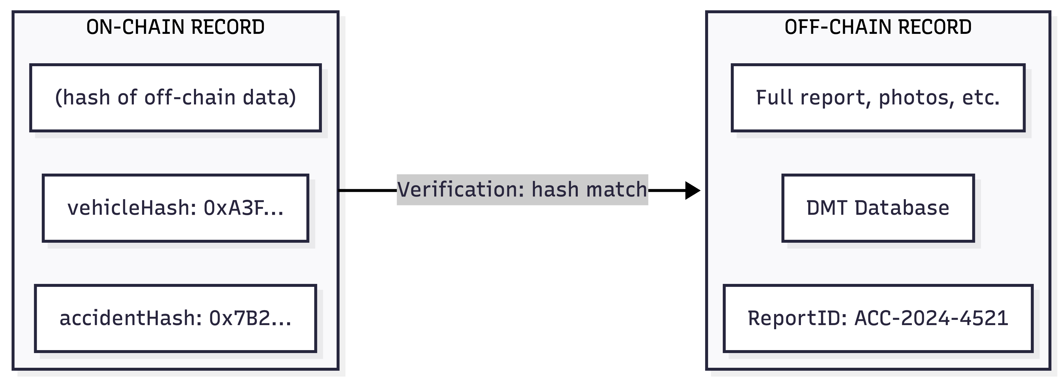
Figure 4.1 — Hybrid on-chain/off-chain record model: on-chain hashes verify the off-chain records held in institutional databases.

4.4 Inputs
Input | Source | Storage
Vehicle registration / chassis (VIN) number | DMT | Hashed on-chain (vehicleHash)
Import permit details | Customs | Hash on-chain, document off-chain
Owner NIC, name, address, contact | DMT | Off-chain (PDPA protected)
Accident reports | Police | Hash on-chain, full report off-chain
Insurance claims | Insurers | Hash on-chain, documents off-chain
Mileage / odometer readings | Emission centres | Stored on-chain (numeric value)
Theft reports (flag / clear) | Police | Stored on-chain (status flag)
Emission test results | Emission centres | Hash on-chain, report off-chain
Ownership transfer requests | DMT | On-chain (pseudonym-to-pseudonym)

4.5 Process Design

Algorithm 1 — Generate Pseudonym
Step | Action
1 | Generate a 256-bit random salt
2 | Compute intermediate hash: SHA-256(ownerNIC + salt)
3 | Compute pseudonym: SHA-256(intermediateHash + registrationTimestamp)
4 | Store the salt securely in the DMT off-chain database, indexed by pseudonym
5 | Encrypt the (pseudonym to ownerNIC) mapping under a consortium threshold key (shares held by DMT and Police) and store the ciphertext off-chain, so that no single authority can decrypt it
6 | Emit on-chain event: PseudonymRegistered(pseudonym, timestamp)

The same owner registering different vehicles receives different pseudonyms (a unique salt each time), so registrations of different vehicles are unlinkable. Within a single vehicle, however, the owner's successive events are deliberately linked under one pseudonym so that the cross-event fraud rules can run; the on-chain pseudonym is therefore treated as personal data, while the real-world identity stays sealed behind the threshold escrow until a multi-party reveal.

Algorithm 2 — Ownership Transfer (with Theft Check)
Step | Action
1 | Receive transfer request (vehicleHash, fromPseudonym, toPseudonym)
2 | Theft check — retrieve the latest theft flag for the vehicle
3 | If flagged STOLEN, block the transfer, emit an alert, and trigger identity reveal
4 | Owner verification — confirm fromPseudonym is the current on-chain owner
5 | Generate a new pseudonym for the buyer and log the transfer on-chain

Algorithm 3 — Conditional Identity Reveal (Multi-Party, Policy-Coupled)
Step | Action
1 | Police submit a reveal request with pseudonym, reason, and Police signature
2 | The contract verifies the Police signature against the registered Police node
3 | Policy check (machine-validated, not merely human-reviewed): the contract queries the FraudDetector contract for an existing, unexpired fraud flag or court-order hash referencing this pseudonym; the request is rejected outright if none exists
4 | The request is forwarded to the DMT for co-authorisation
5 | The DMT officer reviews the legal justification and co-signs
6 | The contract validates the cited legal ground against the enumerated categories (theft investigation / court order / fraud alert)
7 | Each authorising party contributes its key share; the ownerNIC is recovered only when the required quorum (DMT + Police) combines its shares (threshold decryption)
8 | Every reveal attempt (successful or rejected) is logged on-chain permanently, and a human reviewer confirms the outcome before any action is taken against an owner

Because reveal requires reconstructing the escrow key from multiple shares, no single authority can unmask an owner alone, and neither a single compromised authority nor a leaked database can de-anonymise the registry on its own. The immutable audit trail records every attempt. Step 3 is the design's specific differentiator against the closest located precedents: Concordium, Kamara et al. (2021), SeDe, PEReDi and SCMS all gate reveal on a quorum's approval, but none machine-checks the justification itself against a system-generated trigger before that approval is even sought — the reveal condition in those schemes is an off-ledger legal or human artefact that the quorum merely attests to. Coupling the reveal to an on-chain fraud flag means an unjustified request can be rejected by chaincode logic alone, before any human signature is spent, and — as future evaluation work — makes the reveal surface (the fraction of pseudonyms for which a valid reveal condition currently exists) a measurable quantity rather than an unbounded one.
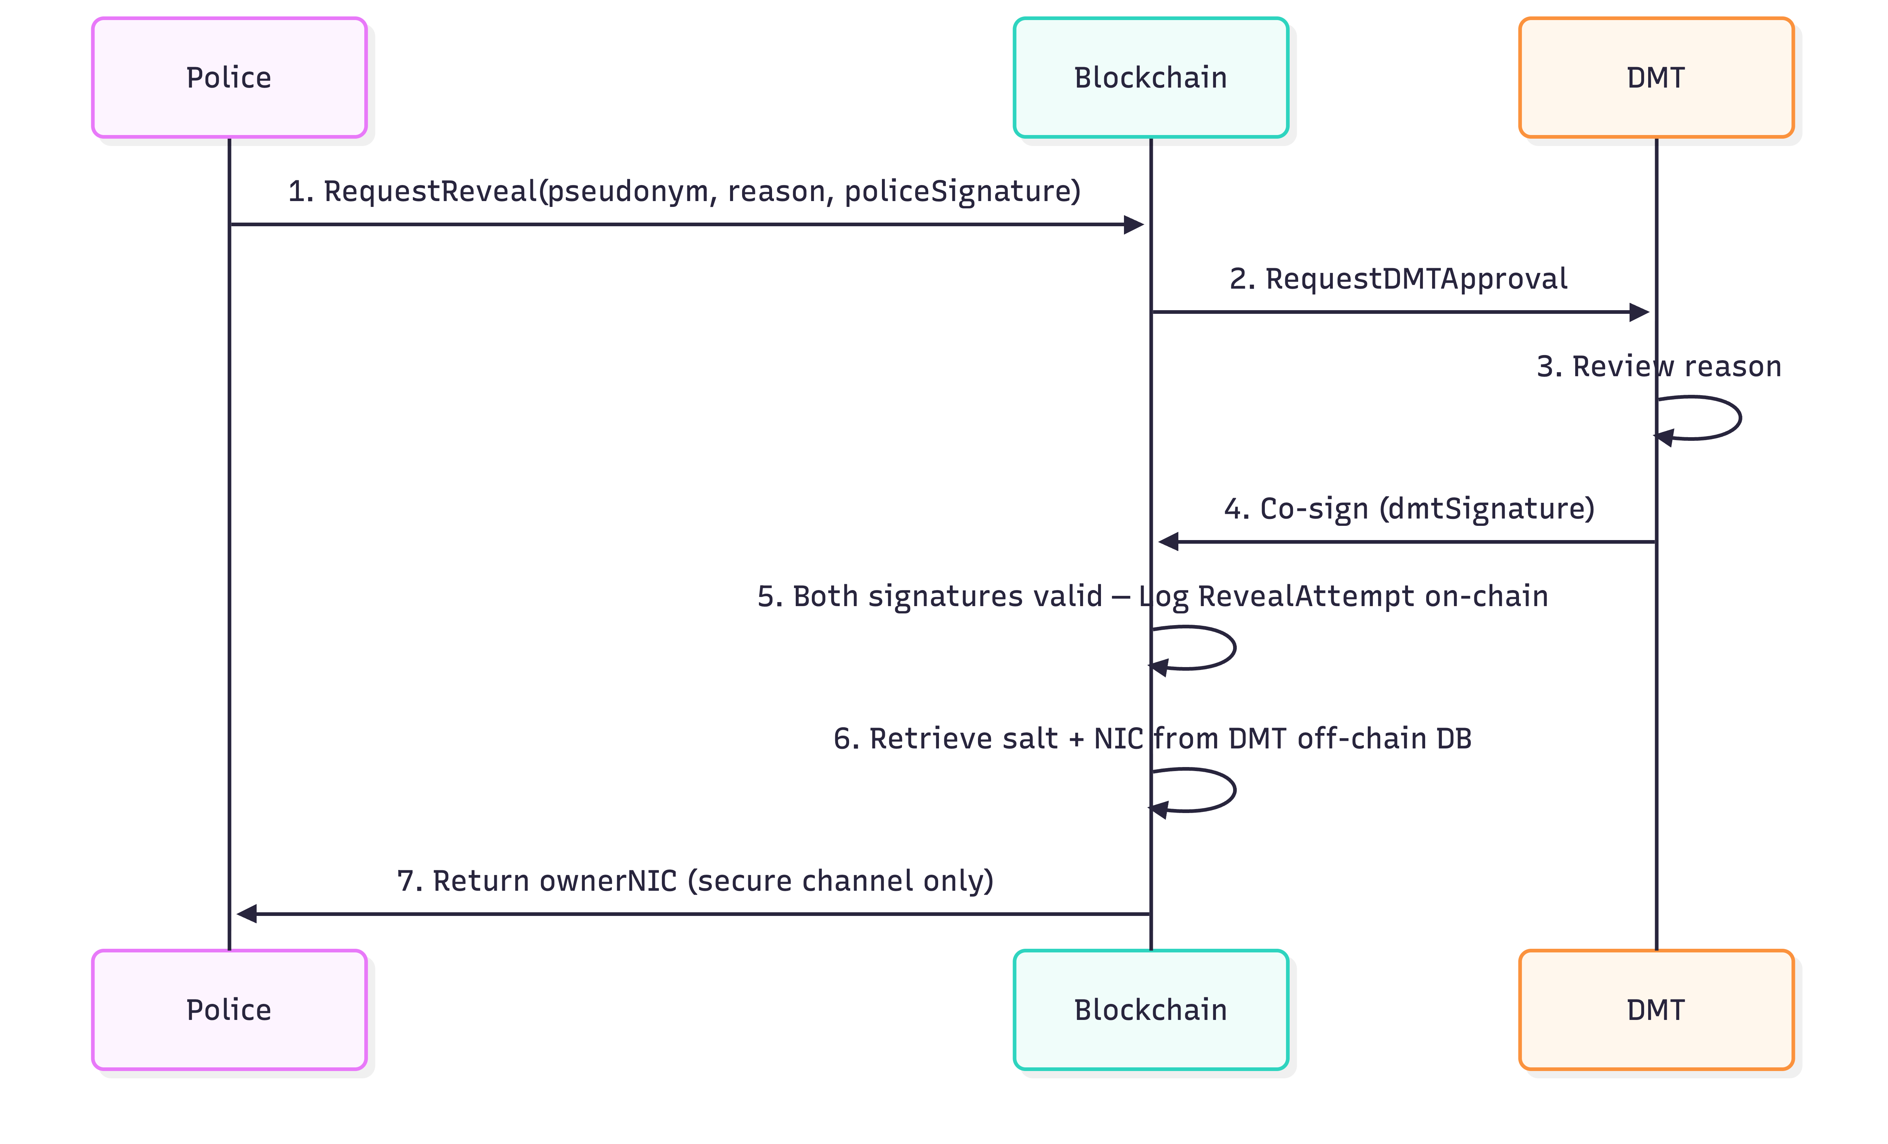
Figure 4.2 — Multi-party conditional identity-reveal flow: a Police request requires DMT co-authorisation, every attempt is logged on-chain, and the owner identity is released only over a secure channel.

Algorithm 4 — Odometer Rollback Detection
Rule | Check | Result
Monotonicity | Is the new mileage less than the last recorded mileage? | FRAUD ALERT — rollback detected
Rate-of-change | Is the daily increase greater than 1,000 km/day? | WARNING — excessive mileage
Stagnation | Is the increase zero over 365+ days? | WARNING — suspiciously stagnant

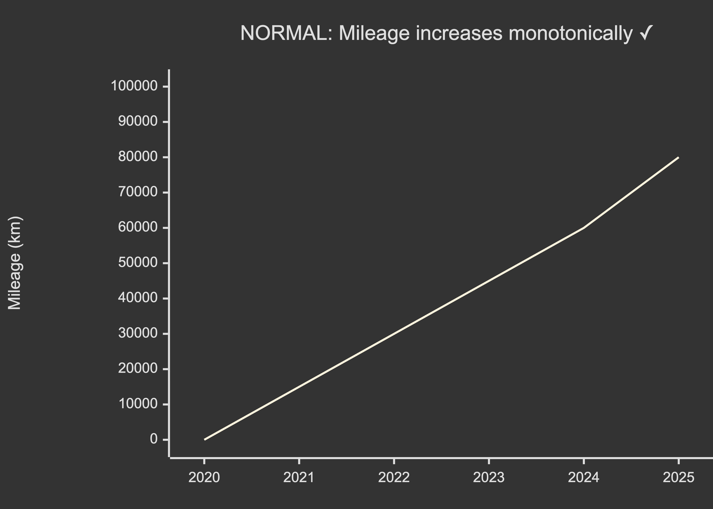
Figure 4.3 — Normal case: mileage increases monotonically and passes the rollback check.
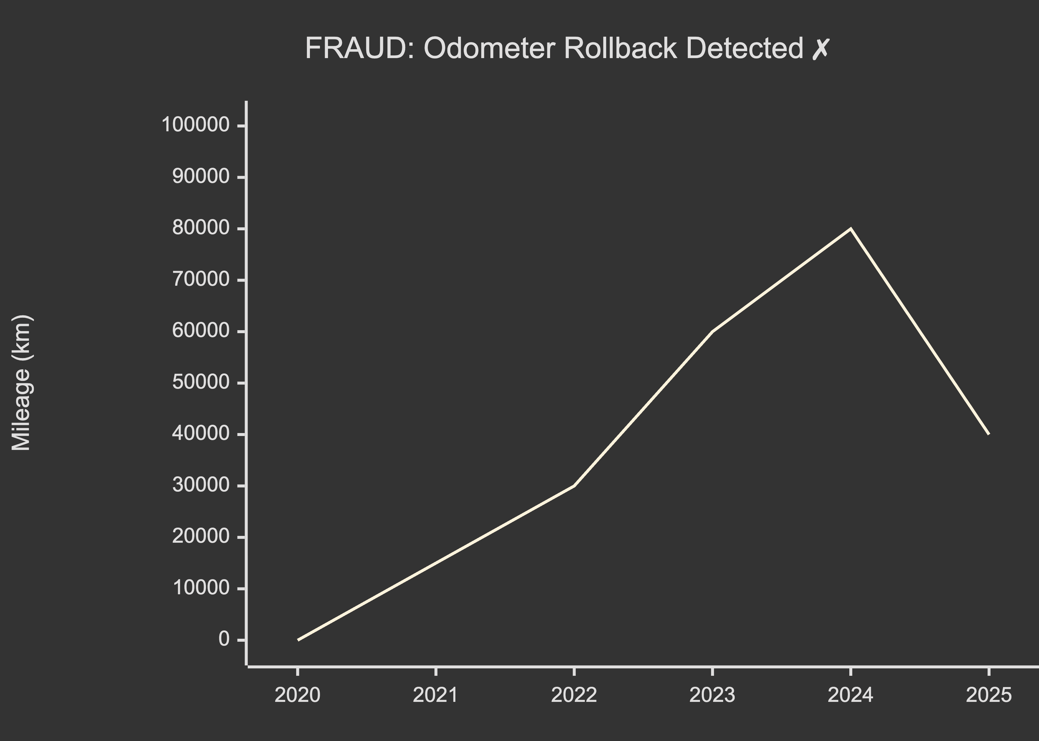
Figure 4.4 — Fraud case: a mileage decrease between readings triggers an odometer-rollback alert.

Algorithm 5 — Accident–Insurance Cross-Reference (Two-Tier Evidence Rule)
Check | Condition | Result
1 | Insurance claim exists with neither a matching Police accident report nor an insurer assessor scene-attestation | FRAUD ALERT — possible insurance fraud
2 | Accident report exists but no insurance claim | INFO FLAG — buyer should be informed
3 | Multiple insurance claims reference the same evidence anchor | FRAUD ALERT — duplicate claims
4 | Claims from different insurers on the same vehicle within an overlapping date window (no shared anchor) | WARNING — possible cross-insurer double-dip

Check 1 was revised during the July 2026 fraud-capability audit (§4.11): the original rule treated a Police accident report as the only valid anchor, but Sri Lankan insurers routinely settle on-the-spot claims — an assessor is dispatched to the scene and no police report is ever filed (police involvement is mandatory only for injury or third-party-dispute cases) — so the unrevised rule would have flagged every legitimate on-the-spot claim as fraud. Under the two-tier rule, a claim must cite either a Police report (independent evidence) or an insurer assessor attestation (self-attested evidence; the assessor's identity, scene timestamp, and a hash of scene photographs are recorded on-chain), and the evidence tier is visible on the vehicle history. Deterministic duplicate-claim detection (Check 3) consequently holds only where both claims share an anchor; the cross-insurer window rule (Check 4) covers assessor-anchored claims at warning rather than alert strength.
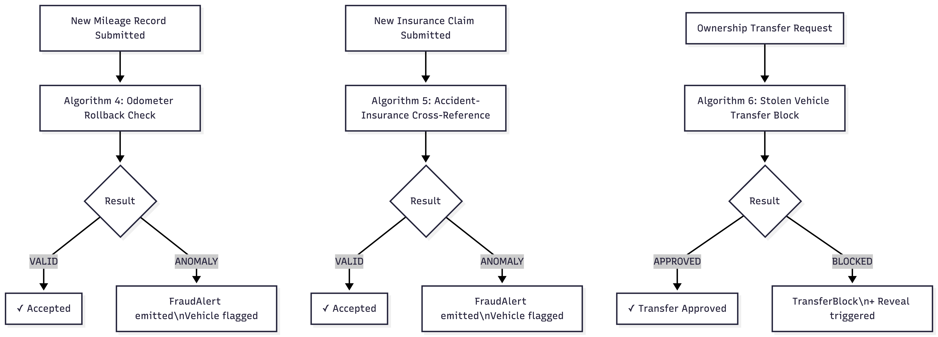
Figure 4.5 — Decision flow of the fraud-detection checks: odometer rollback, accident–insurance cross-reference, and the stolen-vehicle transfer block.

Minimum-Linkability Analysis (Analytical, to be validated empirically in Chapter 6)
The pseudonym model (Algorithm 1) links an owner's events at the per-vehicle level by design. Before that specific granularity is defended empirically, it is possible to derive, purely from each rule's logic, the coarsest pseudonym-linkage tier at which the rule can still be decided — its minimum required linkage. This analysis is not itself claimed as a cryptographic novelty (view-determinacy analysis of this kind is standard in the privacy literature — Nash et al., 2010; Antignac et al., 2017); its contribution here is applying it to this rule set and using the resulting prediction as a falsifiable check against the measured trade-off curve in Chapter 6.
Fraud rule | What the rule must compare | Minimum linkage tier needed | Predicted behaviour as linkage is reduced
Odometer monotonicity / rate / stagnation (Algorithm 4) | Two mileage readings for the same vehicle | Vehicle-level (same-vehicle event chain); owner identity irrelevant | Survives until the vehicle link itself is hidden — the last tier to break
Stolen-vehicle transfer block (Algorithm 2) | The theft flag and the transfer request for the same vehicle, at the same moment | Vehicle-level, time-bound | Survives at per-vehicle and per-event granularity; breaks once even the vehicle link is hidden
Accident–insurance cross-reference (Algorithm 5) | An accident report and a claim for the same vehicle and incident | Vehicle+event-level | Breaks earlier than the odometer rule if events are pseudonymised independently of each other
Straw-owner / serial-fraud pattern (not yet implemented — identified by this analysis) | The same behaviour repeated by the same owner across different vehicles | Owner-level, cross-vehicle | Breaks immediately once each vehicle receives an independent pseudonym — i.e., under this thesis's own design (Algorithm 1)

The last row is the analysis's most consequential finding: the current design (a distinct pseudonym per vehicle, chosen specifically so that different vehicles owned by the same person are not linkable) is deliberately unable to detect a fraud pattern that repeats across a person's vehicles — for example, an owner who clocks the odometer on several cars in turn. This is a genuine limitation, not an oversight, and is reported as such rather than concealed: privacy and this specific detection capability are in direct tension for this rule.
The wider prediction is that the four rule families do not degrade evenly as linkage decreases — each has its own threshold at which it stops being decidable at all, so the expected shape of the empirical curve in Chapter 6 is a step function with breakpoints at these predicted tiers, rather than a smooth decline. Chapter 6 sets out how this prediction is checked against measurement.

4.6 Outputs
Audience | Output
Buyers (public) | Pseudonymised vehicle history, mileage progression, accident count, theft status, claim count, fraud alerts, risk score
Consortium members | Real-time fraud alerts, cross-reference reports, transfer-block notifications, reveal audit trail
Evaluation | Privacy metrics, fraud-detection accuracy, performance benchmarks, PDPA compliance mapping

4.7 Role-Based Access Control
Event Type | Authorised Source
Accident reports | Police only
Insurance claims | Insurers only
Mileage readings | Emission centres only
Theft flags | Police only
Emission tests | Emission centres only
Import records | Customs only
Registration / transfer | DMT only

4.8 Smart Contract (Chaincode) Structure
The chaincode is organised into three smart contracts. The VehicleRegistry contract handles registration, ownership transfer, and the lifecycle events (mileage, accidents, insurance claims, emissions, and theft flags), invoking the fraud-detection rules as events are logged. The IdentityManager contract generates pseudonyms and governs the multi-party conditional reveal. The FraudDetector contract runs the cross-event checks and exposes the fraud alerts and the vehicle risk score.
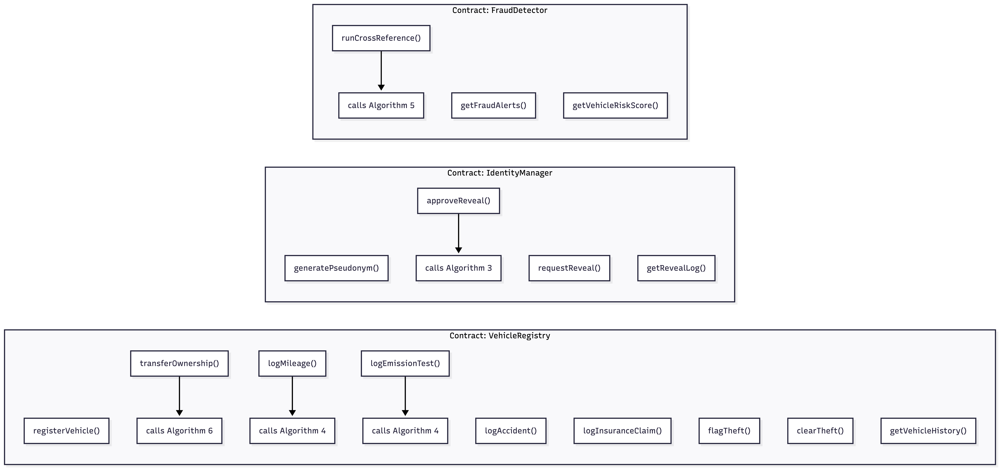
Figure 4.6 — Chaincode decomposition into three smart contracts: VehicleRegistry, IdentityManager, and FraudDetector.

4.9 How the Application Works: Inputs, Process, and Outputs
This section makes the operation of the proposed system concrete by following the inputs, processing and outputs across a vehicle's life, from import into Sri Lanka through resale. The system records seven lifecycle events; each event is an input submitted by the authorised consortium member, is processed by chaincode (pseudonymisation, the hybrid on-chain/off-chain split, and the cross-event fraud rules), and produces outputs (a pseudonymised public history, fraud alerts, and an auditable trail).

4.9.1 The real-world lifecycle and the agency that owns each step
# | Lifecycle step | Owning agency | Key artefact
1 | Import control licence (vehicles are controlled goods) | Imports & Exports Control | Import Control Licence
2 | Customs clearance (CusDec via ASYCUDA; duty assessed and paid) | Sri Lanka Customs | Customs declaration; duty-assessment notice
3 | First registration (chassis/engine verified; number assigned; CR issued) | DMT | Certificate of Registration
4 | Third-party insurance (statutory) | Insurer | Insurance certificate
5 | Vehicle emission test (from the second year) | VET operator (LAUGFS / CleanCo) | VET certificate
6 | Annual revenue licence (requires valid insurance + VET) | Provincial DMT | Revenue licence (eRL)
7 | Ownership transfer | DMT | Re-registered CR
8 | Accident / insurance claim | Insurer (police report) | Claim record
9 | Theft report | Police, then DMT | Police complaint

(Sources: Sri Lanka Customs, n.d.; Department of Motor Traffic, n.d.)

4.9.2 Worked example — a used Japanese import
Consider Mr. K. Perera importing a 2019 Toyota Aqua hybrid, chassis NHP10-1234567, engine 1NZ-FXE-987654, with an import-time odometer reading of 62,400 km. Table 4.9 traces how the proposed system processes the vehicle's life as inputs, processing and outputs.
Table 4.9 — Input to Process to Output for the worked-example vehicle
Lifecycle event | Input (who submits what) | Process (on-chain / off-chain) | Output
First registration | DMT submits chassis/engine, owner NIC, Customs reference | Generate owner pseudonym (salted hash); store NIC-to-pseudonym mapping under threshold escrow off-chain; write vehicleHash + pseudonym on-chain | On-chain registration event; CR issued; owner identity private
Insurance | Insurer submits policy reference for the pseudonymous vehicle | Hash policy reference on-chain; document off-chain | Insurance status flag on the vehicle history
Emission test | Emission centre submits VET result | Numeric value / flag on-chain; report off-chain | Emission status on the history
Mileage (odometer 62,400 km) | Inspection/emission centre submits reading | Algorithm 4 checks monotonicity against prior readings | Reading accepted; mileage progression updated
Ownership transfer (odometer now 78,900 km) | DMT submits transfer request (fromPseudonym to new pseudonym) | Algorithm 2 theft check; ownership verified; new pseudonym minted | Transfer logged; buyer sees full pseudonymised history
Fraud attempt (odometer entered as 61,000 km) | A later reading below 62,400 km | Algorithm 4 detects a decrease | FRAUD ALERT — odometer rollback; event flagged
Theft during a pending transfer | Police flag the vehicle stolen | Algorithm 2 blocks the transfer and triggers a reveal request | Transfer blocked; conditional identity reveal initiated

The outputs a prospective buyer sees are the pseudonymised vehicle history, mileage progression, accident and claim counts, theft status, and any fraud alerts — without exposing the owner's identity. The owner's real identity is released only through the governed multi-party reveal (Algorithm 3). Figure 4.8 shows the input-process-output flow.

4.10 Feasibility Analysis
A supervisor review asked for an assessment of the feasibility of deploying this application. The honest conclusion is that the binding constraints are organisational, legal and fiscal — not technical — and that a proof-of-concept (the scope of this thesis) is clearly feasible, while a national production rollout depends on factors this thesis cannot itself supply.
Technical feasibility — strong. Sri Lanka has approximately 8.53 million registered vehicles, with new registrations peaking near 49,000 per month after the 2025 import-ban lift, plus about six million annual revenue-licence transactions (Daily FT, 2025; Sunday Times, 2026). Even at peak this is only a few sustained transactions per second, far below Hyperledger Fabric's benchmarked throughput of around 3,000 TPS on modest hardware (Hyperledger Foundation, 2023) and up to roughly 20,000 TPS in research configurations (Gorenflo et al., 2019). Throughput and scale are therefore not a risk.
Organisational / governance feasibility — the hardest constraint. Sri Lanka has no precedent for a binding five-party data consortium; documented inter-agency sharing is bilateral (for example, the FIU–DMT memorandum of understanding). A consortium requires each member to cede control over records it currently owns. The mitigating evidence is that the eRL system already runs real-time multi-party integration across the DMT, insurers and emission centres (ICTA, 2019), so the gap is binding governance and adding Police and Customs as write-peers, not basic interoperability. The October 2025 Lanka Government Cloud outage, which simultaneously disabled the eRL, police-clearance and civil-registry services, is both a warning on operational maturity and an argument for a distributed ledger over a single central system (EconomyNext, 2025).
Legal feasibility — a real but unsettled basis. The PDPA No. 9 of 2022 (amended by Act No. 22 of 2025) permits processing necessary for a public-interest task or the exercise of statutory powers, but this is a permission rather than a grant: each agency must already hold statutory authority to share personal data, or cross-agency flows risk being ultra vires; the substantive obligations are not yet in force, awaiting a ministerial commencement order expected in 2026 (DLA Piper, 2025). The system must therefore be designed to be PDPA-ready against a moving target — which the hybrid on-chain-hash / off-chain-PII architecture is well positioned to satisfy.
Economic feasibility. The documented Rs. 1.2 billion fraud loss (Parliament of Sri Lanka, 2025) provides a concrete benefit baseline; comparable government registries have reported large savings (Sweden's land registry was estimated to save about EUR 100 million a year) (Quartz, 2017). A Sri Lanka-specific cost model was not available, so the economic case is comparative rather than costed, and the Rs. 1.2 billion figure is a government-revenue loss rather than a measure of consumer used-vehicle harm.
Precedents — read critically. The most directly analogous design is the Dubai RTA vehicle-lifecycle blockchain announced in 2018 with exactly this stakeholder set, but there is no public evidence it reached production, so it is cited as an announced design analogue only (Arabian Business, 2018). Sweden's land registry is the key cautionary tale — a technical success that stalled because property transfers still required a paper signature, a legal rather than technical failure (Quartz, 2017). Georgia's land-title registry did reach real scale but is a single-agency system, so it validates the ledger concept but not the harder five-party governance model (Exonum, n.d.).
Verdict — proof-of-concept versus production. The thesis-scope proof-of-concept is feasible and defensible: it can be built on a self-hosted Fabric network with simulated organisation peers, synthetic lifecycle data, and a measured privacy-versus-detection trade-off, which sidesteps every institutional, legal and funding blocker (no real personal data, no live agency nodes, no procurement). A production rollout is gated on a multilateral governance charter, per-agency statutory sharing authority, sustained funding under fiscal austerity, and operational maturity, which are recommended as future work rather than claimed as deliverables.
Table 4.10 — Feasibility summary
Dimension | Verdict | Basis
Technical | Feasible (over-provisioned) | Few TPS load vs ~3,000–20,000 TPS Fabric capacity
Organisational | Hardest blocker (N/A for PoC) | No five-party precedent; eRL proves interoperability
Legal | Conditional; design PDPA-ready | PDPA permits but does not grant sharing authority
Economic | Plausible net benefit | Rs. 1.2 bn loss baseline; no local cost model
Proof-of-concept | Clearly feasible | Synthetic data, simulated peers, self-hosted Fabric
Production rollout | Gated (future work) | Governance charter + statutory authority required

4.11 Fraud-Detection Capability Boundary
Following supervisor feedback asking which categories of real-world vehicle fraud the proposed system can and cannot identify — in particular whether it can detect a fraudulently swapped engine — a dedicated fraud-capability analysis was carried out and is maintained as a companion document (FRAUD_CAPABILITY_ANALYSIS.md). Forty-eight fraud subtypes across ten families (odometer fraud, vehicle-identity fraud, stolen-vehicle resale, insurance fraud, document and insider fraud, import/customs fraud, ownership-pattern fraud, leasing/encumbrance fraud, damage-history concealment, and emission-certificate fraud) were assessed against the implemented design, each grounded in at least one real, cited case — including the COPA engine/chassis-number insertion fraud (Parliament of Sri Lanka, 2025) and the CIABOC uncleared-vehicle registrations (CIABOC, 2024). Every verdict was then subjected to an adversarial validation loop (three rounds of independent domain, technical, and consistency review; 86 confirmed corrections applied, 11 challenges refuted).
The validated result is deliberately conservative. Of the 48 subtypes, the implemented rules deterministically detect 2 (odometer rollback below a recorded reading, and official-channel transfer of a theft-flagged vehicle), partially address 23 (detection after the fact, coverage of some variants only, or attribution of the fraudulent write rather than prevention), and cannot address 23. Every "cannot" verdict reduces to one of four structural causes, which are presented as principled boundaries of any pure registry rather than design defects: (i) absence of data — the fraud generates no transaction from any authorised member (the oracle problem; e.g., an undeclared engine swap or an off-record cash repair); (ii) corrupt trusted source — the record is authentic but its content is false (e.g., a bribed emission pass), where the ledger's contribution is a signed, permanent, attributable record; (iii) calibrated fraud within plausible bounds — e.g., an odometer rolled back to just above the last recorded reading, which is arithmetically indistinguishable from honest data and can only be bounded, not detected; and (iv) privacy-by-design linkage limits — cross-vehicle serial fraud is undetectable because per-vehicle pseudonyms are deliberately unlinkable, which is precisely the privacy-versus-detection trade-off this thesis measures.
On the specific supervisor question, a fraudulent engine swap is not detectable by the design as specified: the engine number enters the system once, inside the salted vehicleHash at first registration, and no rule re-reads it — an undeclared swap generates no on-chain event at all. The analysis distinguishes three variants: an undeclared swap (undetectable; the proposed countermeasure is engine re-attestation at physical touchpoints, with coverage honestly bounded by the emission-test exemptions below); a declared swap re-papered with a smuggled or stolen engine (unrecordable as specified, since no engine-amendment transaction exists; addressed by a tiered EngineAmendment design); and the COPA-style insider insertion of smuggled-vehicle identifiers into existing registrations, where the design genuinely improves on the status quo — silent record editing is structurally impossible on an append-only ledger, and the insider is forced into an MSP-signed, permanently attributable transaction — although prevention (rather than attribution) additionally requires a Customs-prerequisite registration rule.

4.11.1 Capability in context: what is caught, what is not, and the comparison that matters
The raw scorecard counts fraud categories, not fraud volume: the 48 subtypes were enumerated adversarially to be exhaustive, and the list deliberately includes frauds no system anywhere catches. The system's coverage is concentrated where the documented losses are. Table 4.11 summarises what the system catches and what each capability replaces in the current process.
Table 4.11 — Principal capabilities against the current Sri Lankan process
Fraud addressed | Mechanism | Current process
Odometer rollback below a recorded reading | Algorithm 4(a), deterministic; history buyer-visible pre-purchase | No mileage history exists at all
Sale of a theft-flagged vehicle via DMT | Algorithm 2 blocks the transfer at commit time | Manual paper police-complaint check
Insider tampering with registrations (the COPA mechanism) | Silent editing structurally impossible; every write MSP-signed and permanently attributable | Mutable DMT database; Rs. 1.2 bn documented loss
Ghost insurance claims | Two-tier Algorithm 5(a): no police report and no assessor attestation raises an alert | Manual, bilateral police-extract verification
Cross-insurer duplicate claims | Algorithm 5(c) on shared anchors; same-vehicle window warning otherwise | Insurers share no claims data
Double-selling on a duplicate CR | Second transfer against the on-chain identity aborts | Paper CR is authoritative; duplicates succeed
Concealed accident / write-off history | Reports, claims and salvage brands permanent and buyer-visible | Concealment is the default

Scored against the same 48 subtypes, the current Sri Lankan process addresses essentially none (the mutable DMT record being itself the documented vulnerability), the US NMVTIS production system addresses three families (theft, total-loss, odometer, over fully identified owners), and Belgium's Car-Pass addresses one (odometer). The proposed design is the broadest scorer on its own adversarially constructed list while being the only one of the four that keeps owner identities pseudonymous — which frames the residual gaps correctly: of the 23 undetectable subtypes, fourteen produce no data any registry could evaluate, six are genuine records with false content, one is calibrated to remain inside plausible bounds, and two are undetectable precisely because of the privacy property whose cost this thesis measures. The value claim is therefore the movement from the status quo — a mileage history, a blocked stolen transfer, an attributable registry, cross-insurer visibility, and unconcealable accident history, each a first for Sri Lanka — delivered under pseudonymity, with the detection cost of that pseudonymity quantified in Chapter 6.

4.11.2 Design refinements carried forward
The audit also surfaced design refinements that are carried into the implementation phase. The most consequential is a deterministic identity index: the per-vehicle salted vehicleHash cannot support uniqueness checks or cross-organisation matching (a fresh salt yields a different hash for the same chassis), so the design adds keyed deterministic commitments — idx_chassis = HMAC(k_c, chassis number) and idx_engine = HMAC(k_c, make + engine serial), with k_c held by the writing members — as the matching key for all duplicate-registration, retired-identity, and Customs-prerequisite rules, at a stated privacy cost (key custodians can dictionary-attack identifiers). Further refinements include the two-tier evidence revision of Algorithm 5 (§4.5); nine candidate rule additions (Customs-or-assembler prerequisite registration, engine re-attestation, tiered engine amendment, duplicate-identity rejection, retired-identity alerts, write-off transfer gating, pre-purchase disclosure via a consortium query portal, an encumbrance flag, and a clearance-to-transfer window alert); a hard-cutoff genesis-migration design for the ~8.5 million pre-system vehicles (legacy records are labelled, closed to post-cutoff insertion, and upgradeable only against Customs archives); and an engine provenance-tier scheme (Customs-verified / donor-linked / declared-only) that avoids any attempt at parts-supply-chain tracking. Three Sri-Lankan workflow realities materially bound the rules and are recorded as evaluation constraints: the emission-test touchpoint exists only from a vehicle's second year and excludes electric, hybrid, LPG, and pre-1976 vehicles; private sales complete on the MTA-6/MTA-8 forms days or weeks before the DMT records the transfer, so buyer protection must operate at pre-purchase query time; and Fabric transaction timestamps are client-set, so before/after fraud logic must rely on block commit order. These constraints will be reflected in the synthetic evaluation dataset and in the false-positive-rate reporting of Chapter 6.

Chapter 05: Implementation (In Progress)
Implementation of the Hyperledger Fabric prototype is underway. The work completed and the work remaining in this phase are summarised below.

Completed so far
- Development environment configured (Fabric test network, peers, orderer, and the chaincode toolchain).
- Membership and organisation structure defined for the consortium members (DMT, Police, insurers, emission centres, Customs).
- Initial chaincode drafted for vehicle registration and pseudonym registration.
- Role-based access control scaffolding using the Membership Service Provider (MSP).
- Off-chain PostgreSQL schema drafted for PII and salt storage.

In progress / remaining
- Ownership-transfer and lifecycle-event chaincode.
- Conditional identity-reveal (dual-signature) protocol.
- Fraud-detection algorithms (odometer, accident–insurance, theft) as chaincode/services.
- Next.js role-specific front-end views.
- Integration of on-chain hash anchoring with the off-chain database.

Chapter 06: Evaluation Plan
Evaluation has not yet started; it will be carried out once the prototype is functional. The planned evaluation, with its targets, is shown below.
Category | Method | Target / Reported measure
Privacy | Simulated linkability / adversary attacks (on-chain observer, honest-but-curious node, compromised off-chain store) | Low re-identification advantage; k-anonymity-style linking bound; auditable multi-party reveal trail
Fraud detection (correctness) | Synthetic dataset (~1,020 labelled cases), reported as a correctness check of the rules | Precision/PPV, recall, F-beta, AUC-PR at a realistic (< 1%) base rate; expected false positives per million events
Privacy-vs-detection trade-off | Vary detection sensitivity against linkability conceded | Trade-off curve and the point at which detection forces de-pseudonymisation (headline finding)
Reveal surface (policy-coupled reveal) | Measure the fraction of pseudonyms for which a valid, machine-checkable reveal condition currently exists (§4.5, Algorithm 3, step 3) | Reveal-surface metric contrasted against the 100% baseline of schemes without a policy-coupled trigger
Performance | Hyperledger Caliper load testing under a defined workload | p50/p95/p99 latency; sustained throughput (feasibility target > 100 TPS, < 3 s)
PDPA compliance | Requirement-by-requirement mapping vs PDPA (2022, as amended by Act No. 22 of 2025), incl. erasure (s.16), rectification (s.15), retention (s.9), and joint-controllership when the mapping key is threshold-split between DMT and Police (see §6.2) | Documented compliance and residual-risk analysis

6.1 Privacy-versus-detection trade-off — detailed method
The headline evaluation holds the fraud-detection rule engine and the synthetic dataset fixed, and sweeps a single variable: the granularity at which the owner's pseudonym links their events. Four settings are tested — (1) one pseudonym per owner across every vehicle and event (least private, most linkable); (2) one pseudonym per vehicle, this thesis's actual design; (3) one pseudonym per event within a vehicle; (4) per-event with the vehicle link itself hidden (most private, least linkable). At each setting, two measurements are taken:
- Detection axis, per rule family, not as one aggregate score. Precision, recall,
and F1 are recorded separately for the odometer, theft-transfer, and accident–insurance rule families (Algorithms 2, 4 and 5) against the labelled synthetic dataset, so that which rule fails first as linkage is reduced is visible, rather than only an overall accuracy figure.
- Privacy axis, under two explicit adversary models. (i) An honest-but-curious
consortium insider with full ledger visibility, and (ii) an external analyst with only a leaked ledger plus public auxiliary data (e.g., vehicle-sale listings that disclose plates or mileage). For each, linkage-attack precision/recall over same-owner event pairs and anonymity-set size per pseudonym are measured.
The resulting curve is checked against the analytical prediction of §4.5 (the minimum-linkability lattice): if the measured breakpoints coincide with the predicted tiers, this supports the step-function characterisation of the trade-off rather than a smooth decline. As a robustness check, the fraud base rate and rule thresholds are varied across a small grid to confirm the breakpoint locations are stable while only the curve heights shift.

6.2 PDPA legal-technical mapping — scope for the final report
The PDPA compliance row above is deepened, for the final thesis, into a section-level mapping of the amended Act (No. 22 of 2025) against the architecture, covering: whether the salted-hash pseudonym constitutes "personal data" under the PDPA definition; the collision between the s.16 right to erasure (which applies only in three enumerated circumstances, not as an absolute right) and the DMT's statutory record-retention duties under the Motor Traffic Act; and — a question not resolved in any located prior work — who bears controller obligations, and whose statutory response clock runs, for a data-subject request when the pseudonym-to-identity mapping key is threshold-split between DMT and Police (cf. Baskaran et al., 2023, for the analogous Malaysian mapping, and EDPB Guidelines 02/2025 for the general consortium-controllership position).

Chapter 07: Project Progress and Management

Progress against objectives
# | Objective | Phase | Status
SO1 | Stakeholder analysis of current DMT system | Analysis | Completed
SO2 | Conditional pseudonym model | Design | Completed
SO3 | Rule-based fraud-detection algorithms | Design | Completed
SO4 | Hybrid on-chain/off-chain architecture | Design | Completed
SO5 | Smart contracts with RBAC on Fabric | Implementation | In progress
SO6 | Privacy / accuracy / performance evaluation | Evaluation | Not started

Progress against plan
Phase | Output | Completion
Proposal | Approved research proposal | 100%
Literature review | Comparative review and confirmed gaps | 100%
Requirement and stakeholder analysis | Stakeholder analysis (SO1) | 100%
System design | Architecture, algorithms, platform selection (SO2–SO4) | 95%
Implementation | Smart contracts on Fabric (SO5) | 25%
Evaluation | Privacy / accuracy / performance (SO6) | 0%
Documentation | Final thesis write-up | 30%

Supervisor engagement
Progress is reviewed regularly with the project supervisor, Mr. Thisara Weerasinghe, and recorded in the Supervisor Log Sheet (see Appendix A). Guidance so far has focused on tightening the research scope, validating the literature gap, evaluating the choice of blockchain platform, and confirming the system design before implementation.

Risks and mitigation
Risk | Mitigation
Learning curve of Hyperledger Fabric chaincode | Building incrementally from official Fabric samples
Generating realistic fraud test data | Designing a synthetic dataset (~1,020 cases) covering normal and fraudulent patterns
Reconciling PDPA with on-chain immutability | Keeping all PII off-chain; only hashes and flags on-chain

Chapter 08: Preliminary Conclusion and Future Work
This interim report has presented the completed introduction, literature review, research methodology, and full system design for a privacy-conscious, blockchain-based vehicle ownership and lifecycle registry for Sri Lanka. A dedicated adversarial novelty audit against 107 prior works (NOVELTY_AUDIT.md) confirmed that no individual mechanism in this design is new — conditional pseudonymity, quorum-governed reveal, deterministic cross-event fraud rules, full-lifecycle coverage, and multi-agency governance are each established elsewhere — but that the specific combination of a persistent, policy-coupled, agency-quorum-revealable owner pseudonym inside an authoritative ownership registry, with deterministic cross-event fraud rules and a measured privacy-versus-detection trade-off, reconciled with Sri Lanka's PDPA, has not been located. The intended contribution is therefore this applied integration, an analytical minimum-linkability characterisation of which fraud rules fail first as pseudonym linkage is reduced, and an empirical measurement of the resulting trade-off. The design phase has produced the conditional pseudonym model with a policy-coupled reveal mechanism, the fraud-detection algorithms, the hybrid on-chain/off-chain architecture, and a justified selection of a permissioned consortium blockchain over a public blockchain. The next phase also carries forward a section-level reconciliation of the design against Sri Lanka's amended PDPA (Act No. 22 of 2025) as a standalone contribution, since it is jurisdictionally the most defensible and least resource-intensive result available.
A supervisor-requested fraud-capability audit (July 2026, FRAUD_CAPABILITY_ANALYSIS.md; summarised in §4.11) subsequently characterised the detection boundary of the designed rules across 48 real-world fraud subtypes, subjected every verdict to an adversarial validation loop, and yielded concrete design refinements — a deterministic identity index, a two-tier evidence revision of Algorithm 5, and nine candidate rule additions — that are carried into the implementation phase alongside the workflow constraints (emission-test coverage gaps, MTA-6/MTA-8 sale timing, client-set transaction timestamps) that the evaluation must respect.

8.1 Proposed Sharpening of the Research Framing for the Final Thesis
The capability boundary reported in §4.11 has a consequence for how the research itself is framed, and this section records the direction proposed for the final thesis. It is presented as a proposal for supervisory approval rather than as a completed change: the aim, research questions, and objectives stated in Chapter 1 remain those of the approved proposal for the purposes of this interim submission.
The observation driving the proposal is that two of the four structural causes of non-detection are not engineering defects. Cause (i), the absence of any submitted record, is a property of every registry irrespective of technology; and cause (iv) is a direct consequence of this design's own privacy decision — per-vehicle pseudonyms make any fraud that repeats across a person's vehicles invisible by construction. The second of these is the more interesting, because it means the detection boundary is not a fixed property of the artefact but a function of the pseudonym linkage the artefact permits.
The proposal is therefore to promote linkage granularity from an implicit design choice to an explicit, versioned, machine-enforced parameter of the registry, and to make the characterisation of the resulting frontier the headline contribution:
- Scoped identifiers. Replace the salted-hash pseudonym of Algorithm 1 with keyed pseudo-random-function identifiers — asset handles for the vehicle and per-vehicle owner pseudonyms — retaining the deterministic identity index of §4.11.2 and removing the per-record salt store, whose compromise would otherwise expose the mapping and whose enumerable input space is analysed as a reported result.
- Linkage profiles. A versioned on-chain configuration defining which linkage scopes are available (owner-scope; per-vehicle; per-event; per-event with the vehicle link hidden; and per-vehicle plus governed escalation). Each fraud rule declares the minimum scope it requires, and the chaincode compares that requirement against the active profile before evaluating. The profile is a consortium governance parameter, not a per-owner preference — were owners able to select their own level, a fraudulent seller would select maximum privacy, and the act of selecting privacy would itself become an adverse signal, so the option would afford no privacy to anyone.
- Declared suppression. Where a rule cannot be decided under the active profile, or where an antecedent event is absent or self-declared only, the chaincode emits a machine-generated notice that is surfaced to the prospective buyer as a checks not performed list, rather than returning a history whose omissions are invisible. The 23 non-detected subtypes of §4.11 thereby become a system output rather than a limitation recorded only in prose.
- Governed owner-scope escalation. Owner-level linkage becomes reachable only through a request that requires a live, evidence-graded fraud flag on the vehicle, an enumerated statutory ground, and the joint action of the DMT and Police, with the number of vehicles disclosed recorded on-chain — so that the privacy cost of recovering owner-level detection is measured rather than asserted.
- Evidence grading and attestor revocation. The two-tier revision of Algorithm 5 generalises to a three-level evidence lattice propagated to every verdict, together with an append-only attestor revocation that degrades, at query time, every past conclusion resting on a source subsequently found to be corrupt — a capability a mutable central database structurally lacks, and one that speaks directly to the COPA and CIABOC findings in which the custodian of the record was the adversary.
Under this framing the headline result becomes the agreement between the minimum-linkability predictions derived analytically in Chapter 4 and the decidability measured empirically across the rule-family-by-profile grid in Chapter 6 — a falsifiable comparison, since prediction and measurement are produced by independent means, and one that cannot be satisfied by construction in the way that reporting detection accuracy over self-generated fraud can. The existing 48-subtype capability matrix (Appendix C), the four-cause taxonomy, the minimum-linkability analysis of §4.5, the stakeholder and PDPA analyses, and the figures of Chapters 1 and 4 are all retained under the proposal; the principal reductions are that five of the nine candidate rule additions (Appendix D) are specified rather than implemented, and that no new cryptographic construction is introduced.
Objectives SO1–SO4 are complete, SO5 (implementation) is in progress, and SO6 (evaluation) will follow. The next phase will complete the Hyperledger Fabric chaincode and the fraud-detection layer, build the synthetic evaluation dataset, and then execute the privacy, accuracy, and performance evaluation against the defined targets. The work remains aligned with the proposed plan, subject to the framing proposal recorded in §8.1.

List of References
Androulaki, E., Barger, A., Bortnikov, V., Cachin, C., Christidis, K., De Caro, A., … Yellick, J. (2018). Hyperledger Fabric: A distributed operating system for permissioned blockchains. Proceedings of the Thirteenth EuroSys Conference, 1–15. https://doi.org/10.1145/3190508.3190538
Antignac, T., Sands, D., & Schneider, G. (2017). Data minimisation: A language-based approach. In S. De Capitani di Vimercati & F. Martinelli (Eds.), ICT Systems Security and Privacy Protection: 32nd IFIP TC 11 International Conference, SEC 2017 (pp. 442–456). Springer. https://doi.org/10.1007/978-3-319-58469-0_30
Arabian Business. (2018, February 1). Dubai's RTA reveals plan for vehicle history blockchain project. https://www.arabianbusiness.com/industries/transport/390983-dubais-rta-reveals-plan-for-vehicle-history-blockchain-project
Arianee. (n.d.). Digital product passport for automobiles. Retrieved June 2026, from https://www.arianee.com/automobile-solutions
AutoCheck. (n.d.). Vehicle history reports and the AutoCheck Score. Experian. Retrieved June 2026, from https://www.autocheck.com/
Baskaran, H., Yussof, S., Abu Bakar, A., & Abdul Rahim, F. (2023). Data sharing using PDPA-compliant blockchain architecture in Malaysia. International Journal of Advanced Computer Science and Applications, 14(5). https://thesai.org/Downloads/Volume14No5/Paper_15-Data_Sharing_using_PDPA_Compliant_Blockchain_Architecture.pdf
Benarous, L., Kadri, B., Bouridane, A., & Benkhelifa, E. (2022). Blockchain-based forgery resilient vehicle registration system. Transactions on Emerging Telecommunications Technologies, 33(10), e4237. https://doi.org/10.1002/ett.4237
Bogatov, D., De Caro, A., Elkhiyaoui, K., & Tackmann, B. (2019). Anonymous transactions with revocation and auditing in Hyperledger Fabric. Cryptology ePrint Archive, Report 2019/1097. https://eprint.iacr.org/2019/1097
Bragadeesh, S. A., & Umamakeswari, A. (2022). Secured vehicle life cycle tracking using blockchain and smart contract. Computer Systems Science and Engineering, 41(1), 1–18. https://doi.org/10.32604/csse.2022.019842
Brecht, B., Therriault, D., Weimerskirch, A., Whyte, W., Kumar, V., Hehn, T., & Goudy, R. (2018). A security credential management system for V2X communications. IEEE Transactions on Intelligent Transportation Systems, 19(12), 3850–3871. https://arxiv.org/abs/1802.05323
Bureau of Justice Assistance, Office of Justice Programs, U.S. Department of Justice. (n.d.). National Motor Vehicle Title Information System (NMVTIS): Overview. Retrieved July 2026, from https://bja.ojp.gov/program/nmvtis/overview
Car-Pass vzw/ASBL. (n.d.). How does Car-Pass work? Retrieved July 2026, from https://www.car-pass.be/en/about-car-pass/how-does-car-pass-work
cardossier (Verein cardossier c/o Adnovum AG). (n.d.). cardossier – ein non-profit Verein [About us]. Retrieved July 2026, from https://www.cardossier.ch/about
CARFAX. (n.d.). How a CARFAX vehicle history report works. Retrieved June 2026, from https://www.carfax.com/
Chanson, M., Bogner, A., Wortmann, F., & Fleisch, E. (2017). Blockchain as a privacy enabler: An odometer fraud prevention system. In Proceedings of the 2017 ACM International Joint Conference on Pervasive and Ubiquitous Computing (UbiComp/ISWC '17 Adjunct) (pp. 13–16). ACM. https://doi.org/10.1145/3123024.3123078
Chanson, M., Bogner, A., Bilgeri, D., Fleisch, E., & Wortmann, F. (2019). Blockchain for the IoT: Privacy-preserving protection of sensor data. Journal of the Association for Information Systems, 20(9), Article 10. https://aisel.aisnet.org/jais/vol20/iss9/10/
Chaudhary, A., & Ivey-Law, H. (2023). SeDe: Balancing blockchain privacy and regulatory compliance by selective de-anonymization. arXiv:2311.08167. https://arxiv.org/abs/2311.08167
CIABOC. (2024). Causing financial loss to the government by fraudulent registration of uncleared vehicles. Commission to Investigate Allegations of Bribery or Corruption. https://ciaboc.gov.lk/media-centre/latest-news/1215
Daily FT. (2025). First five months' vehicle registrations top 73,000. https://www.ft.lk/front-page/First-five-months-vehicle-registrations-top-73-000/44-777928
Damgård, I., Ganesh, C., Khoshakhlagh, H., Orlandi, C., & Siniscalchi, L. (2020). Balancing privacy and accountability in blockchain identity management (Concordium identity layer). Cryptology ePrint Archive, Report 2020/1511. https://eprint.iacr.org/2020/1511
Department of Motor Traffic. (n.d.). Vehicle services: First registration and registration of ownership transfer. Retrieved June 2026, from https://dmt.gov.lk/
DLA Piper. (2025). Data protection laws of the world: Sri Lanka. https://www.dlapiperdataprotection.com/index.html?t=law&c=LK
Duncan, G. T., Keller-McNulty, S. A., & Stokes, S. L. (2001). Disclosure risk vs. data utility: The R-U confidentiality map (Technical Report No. 121). National Institute of Statistical Sciences. https://www.niss.org/sites/default/files/technicalreports/tr121.pdf
EconomyNext. (2025, October). Sri Lanka government's key online services hit by LGC disruption. https://economynext.com/sri-lanka-governments-key-online-services-hit-by-lgc-disruption-icta-243862/
Emara, K. (2017). Safety-aware location privacy in VANET: Evaluation and comparison. IEEE Transactions on Vehicular Technology, 66(12), 10718–10731.
European Data Protection Board. (2025). Guidelines 02/2025 on processing of personal data through blockchain technologies (Version 1.1, adopted 8 April 2025). https://www.edpb.europa.eu/system/files/2025-04/edpb_guidelines_202502_blockchain_en.pdf
Exonum. (n.d.). The Republic of Georgia land-title registry. Retrieved June 2026, from https://exonum.com/story-georgia
Gorenflo, C., Lee, S., Golab, L., & Keshav, S. (2019). FastFabric: Scaling Hyperledger Fabric to 20,000 transactions per second. arXiv. https://arxiv.org/abs/1901.00910
Government of Sri Lanka. (2024). Motor Traffic Act (Chapter 203, consolidated). https://lankalaw.net/wp-content/uploads/2025/03/Motor-Traffic-Consolidated-2024.pdf
Hevner, A. R., March, S. T., Park, J., & Ram, S. (2004). Design science in information systems research. MIS Quarterly, 28(1), 75–105. https://doi.org/10.2307/25148625
Hyperledger Foundation. (2023). Benchmarking Hyperledger Fabric 2.5 performance. https://www.lfdecentralizedtrust.org/blog/2023/02/16/benchmarking-hyperledger-fabric-2-5-performance
ICTA. (2019). Brief of scope: Electronic Revenue Licence system (eRL 2.0). Information and Communication Technology Agency of Sri Lanka. https://www.icta.lk/icta-assets/uploads/2019/06/Brief-of-Scope.pdf
ICTA. (2023). Introducing eRL 2.0: Revolutionizing vehicle revenue licence systems. Information and Communication Technology Agency of Sri Lanka. https://www.icta.lk/media/news/introducing-erl-2-0-revolutionizing-vehicle-revenue-license-systems
Kamara, S., Moataz, T., Park, A., & Qin, L. (2021). A decentralized and encrypted national gun registry. Cryptology ePrint Archive, Report 2021/107. https://eprint.iacr.org/2021/107
Kaushal, P. (2025). VehiclePassport: A GAIA-X-aligned, blockchain-anchored, privacy-preserving, zero-knowledge digital passport for smart vehicles. arXiv. https://arxiv.org/abs/2509.06133
Ledger Insights. (2024). California's DMV digitizes 42M car titles on a permissioned Avalanche chain. https://www.ledgerinsights.com/californias-dmv-digitizes-42m-car-titles-on-permissioned-avalanche-chain/
Lopez-Pimentel, J. C., Morales-Rosales, L. A., Algredo-Badillo, I., & Del-Valle-Soto, C. (2023). NFT-Vehicle: A blockchain-based tokenization architecture to register transactions over a vehicle's life cycle. Mathematics, 11(13), 2801. https://doi.org/10.3390/math11132801
Malintha, C., Diyasena, D., & Madushanka, T. (2024). Blockchain for vehicle registration, transferring and management process in Sri Lanka. Engineering & Technology Quarterly Reviews, 7(1), 56–65. https://doi.org/10.5281/zenodo.12545454
Nash, A., Segoufin, L., & Vianu, V. (2010). Views and queries: Determinacy and rewriting. ACM Transactions on Database Systems, 35(3), Article 21. https://doi.org/10.1145/1806907.1806913
Newswire. (2025, March 24). COPA exposes major vehicle registration fraud at DMT, raps officials. https://www.newswire.lk/2025/03/24/copa-exposes-major-vehicle-registration-fraud-at-dmt-raps-officials/
Parliament of Sri Lanka. (2022). Personal Data Protection Act, No. 9 of 2022. Government of Sri Lanka. https://www.parliament.lk/uploads/acts/gbills/english/6242.pdf
Parliament of Sri Lanka. (2025, March). Committee on Public Accounts reveals multiple losses at the Department of Motor Traffic due to fraudulent vehicle registrations. https://www.parliament.lk/en/news-en/view/4473
Parliament of Sri Lanka. (2025, October). Personal Data Protection (Amendment) Act, No. 22 of 2025. Government of Sri Lanka.
Peffers, K., Tuunanen, T., Rothenberger, M. A., & Chatterjee, S. (2007). A design science research methodology for information systems research. Journal of Management Information Systems, 24(3), 45–77. https://doi.org/10.2753/MIS0742-1222240302
Qiao, M., Dong, H., & Gondal, I. (2025). VeilAudit: Breaking the deadlock between privacy and accountability across blockchains. arXiv:2510.12153. https://arxiv.org/abs/2510.12153
Quartz. (2017). Sweden is turning a blockchain-powered land registry into a reality. https://qz.com/947064/sweden-is-turning-a-blockchain-powered-land-registry-into-a-reality
Samarakkody, D. (2021). Vehicle record/history maintenance through blockchain technology (TRUECARE) [Master of Computer Science dissertation, University of Colombo School of Computing]. https://dl.ucsc.cmb.ac.lk/jspui/handle/123456789/4527
Sarencheh, A., Kiayias, A., & Kohlweiss, M. (2022). PEReDi: Privacy-enhanced, regulated and distributed central bank digital currencies. Cryptology ePrint Archive, Report 2022/974. https://eprint.iacr.org/2022/974
Scientific Reports. (2025). A conditional privacy-preserving authentication scheme for vehicular ad hoc networks. Scientific Reports, 15. https://www.nature.com/articles/s41598-025-89208-5
Souei, W. B. S., Bachir, N. G. A., & Ben Djemaa, R. (2025). A blockchain-based fraud detection and vehicle damage assessment system using machine learning and computer vision. In Proceedings of the 27th International Conference on Enterprise Information Systems (ICEIS 2025) – Volume 1 (pp. 1123–1130). SciTePress. https://doi.org/10.5220/0013500800003929
Sri Lanka Customs. (n.d.). Importing goods. Retrieved June 2026, from https://www.customs.gov.lk/business/importing-goods/
Sunday Times. (2026, January 11). Revenue soars after Sri Lanka lifts vehicle import ban. https://www.sundaytimes.lk/260111/news/revenue-soars-after-sri-lanka-lifts-vehicle-import-ban-627703.html
The Morning. (2026, March 6). COPA approves sending DMT report to Attorney General. https://www.themorning.lk/articles/LIIUyisXNtk4TTBqlTI0
Tissera, T. (2022). Blockchain based vehicle registration system: Improved proposed solution for the existing DMT system (Legit-Ride) [BSc dissertation, Informatics Institute of Technology]. https://dlib.iit.ac.lk/xmlui/handle/123456789/1293
Tsukada, M., Arii, S., Ochiai, H., & Esaki, H. (2022). Misbehavior detection using collective perception under privacy considerations. 2022 IEEE 19th Annual Consumer Communications & Networking Conference (CCNC), 808–814. https://doi.org/10.1109/CCNC49033.2022.9700564
U.S. Department of Justice. (n.d.). 28 CFR Part 25, Subpart B — National Motor Vehicle Title Information System (NMVTIS). Electronic Code of Federal Regulations. Retrieved July 2026, from https://www.ecfr.gov/current/title-28/chapter-I/part-25/subpart-B
van der Heijden, R. W., Dietzel, S., Leinmüller, T., & Kargl, F. (2019). Survey on misbehavior detection in cooperative intelligent transportation systems. IEEE Communications Surveys & Tutorials, 21(1), 779–811. https://arxiv.org/pdf/1610.06810
Wijewardena, T. M. (2020). Collaborative platform for vehicle insurance companies in Sri Lanka to avoid vehicle insurance frauds [BSc dissertation, Informatics Institute of Technology]. https://dlib.iit.ac.lk/xmlui/handle/123456789/1107
Wood, G. (2014). Ethereum: A secure decentralised generalised transaction ledger. Ethereum Project Yellow Paper.
Yadav, A. S., Charles, V., Pandey, D. K., Gupta, S., Gherman, T., & Kushwaha, D. S. (2023). Blockchain-based secure privacy-preserving vehicle accident and insurance registration. Expert Systems with Applications, 230, 120651. https://doi.org/10.1016/j.eswa.2023.120651
Zavolokina, L., Miscione, G., & Schwabe, G. (2020). Buyers of "lemons": How can a blockchain platform address buyers' needs in the market for "lemons"? Electronic Markets, 30(2), 227–239. https://doi.org/10.1007/s12525-019-00380-9
Zheng, Z., Xie, S., Dai, H., Chen, X., & Wang, H. (2017). An overview of blockchain technology: Architecture, consensus, and future trends. 2017 IEEE International Congress on Big Data, 557–564. https://doi.org/10.1109/BigDataCongress.2017.85

Appendices

Appendix A — Supervisor Progress Monitoring Sheet

Supervisor Progress Monitoring Sheet

Appendix B — Supervisor Meeting Evidence

Supervision meeting correspondence (1)
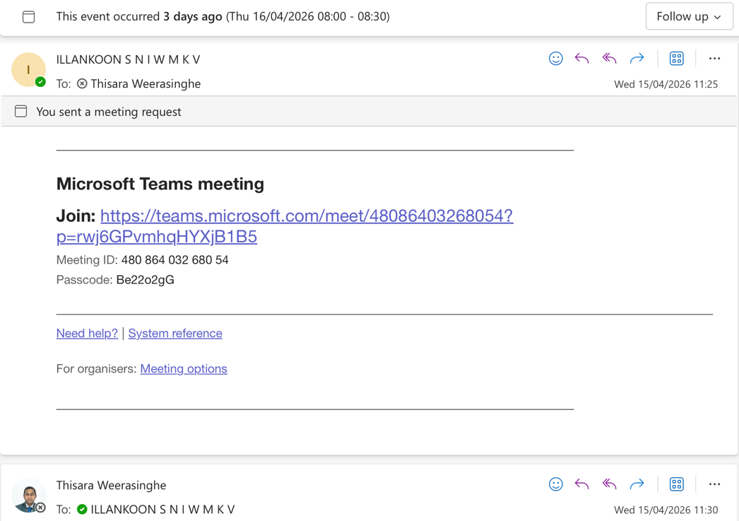
Supervision meeting correspondence (2)

Appendix C — Fraud-Capability Matrix: All 48 Documented Fraud Subtypes
This appendix records, for each of the forty-eight real-world vehicle-fraud subtypes identified in the July 2026 capability audit (§4.11), the verdict reached against the designed system, the mechanism by which the fraud is detected or the precise reason it cannot be, and the recommended handling. Each subtype is grounded in at least one documented real-world case; full case citations, evasion analysis, and cross-system comparison are held in the companion analysis FRAUD_CAPABILITY_ANALYSIS.md. Verdicts were produced by an adversarial validation process of three rounds, in which eighty-six confirmed corrections were applied and eleven challenges refuted.
Verdict key. Detects — an implemented rule fires deterministically on the fraud. Partial — the rule catches some variants only, fires after the transaction has completed, or attributes the fraudulent write rather than preventing it. Cannot — no implemented rule has an input on which to operate.
Distribution. Detects: 2. Partial: 23. Cannot: 23.
Structural causes of non-detection. Every Cannot verdict arises from one of four causes, identified in §4.11: (i) no data is produced, so no rule has an input — fourteen subtypes; (ii) the record is genuine but its content is false, the system's contribution being limited to signed, permanent attribution — six subtypes; (iii) the fraud is calibrated to remain within plausible bounds and is arithmetically indistinguishable from honest data, the registry bounding its magnitude rather than detecting it — one subtype; and (iv) detection would require the cross-vehicle owner linkage that this design deliberately withholds — two subtypes, together with the general cross-vehicle serial pattern.
The twenty-three non-detected subtypes partition exactly, with no remainder, across these four causes, as set out in Table C.1. Causes (i) and (iii) are properties of any registry irrespective of the technology used, and cause (ii) is a limit of any system that accepts attested input from an authorised party; only cause (iv) follows from this design's own privacy decision, and it is the one the research quantifies.
Table C.1 — Structural causes of non-detection
Cause | Subtypes (numbered as in Table C.2) | Count
(i) No data is produced — the fraud generates no submission from any member | 3, 7, 8, 14, 15, 16, 21, 27, 36, 40, 41, 42, 43, 44 | 14
(ii) Genuine record, false content — an authorised member attests a falsehood | 6, 17, 19, 30, 32, 46 | 6
(iii) Calibrated within plausible bounds — indistinguishable from honest data | 2 | 1
(iv) Detection would require the cross-vehicle owner linkage the design withholds | 34, 35 | 2

Table C.2 — Capability against the 48 documented fraud subtypes
# | Fraud subtype | Verdict | Detection mechanism, or reason detection is impossible | Handling
 | Odometer fraud
1 | Classic full rollback before resale | Detects | Algorithm 4(a) monotonicity fires deterministically when the emission centre's next submission falls below the prior on-chain reading, matched through the deterministic identity index idx_chassis; the alert arises at next-reading time, not at tampering time. | Rule already implemented; add the R7 pre-purchase portal query with transfer-time disclosure as backstop, and state explicitly that detection occurs at next reading rather than at tampering.
2 | Calibrated 'gap' rollback above last anchor | Cannot | No rule fires: 4(a) monotonicity is satisfied, 4(b) bounds only implausibly high rates, and 4(c) stagnation demands zero delta. The fraud is calibrated within plausible bounds, arithmetically indistinguishable from genuine low use. | Classify as undetectable in the limitations chapter; extend R7 to disclose reading staleness, add an optional review-only plausibility band, and capture odometers at further member touchpoints.
3 | Pre-first-reading rollback (pre-import) | Cannot | Nothing fires, because the tampered value becomes the on-chain genesis reading and every later submission is monotonically consistent with a lie; no prior anchor is produced, the oracle problem as pure absence of data. | Extend the Customs submission schema to commit an auction-sheet or JEVIC-JOCI genesis odometer, with chaincode rejecting a lower first emission reading, generalising Algorithm 4(a) to a pre-registration anchor.
4 | Mileage-blocker / freeze devices | Partial | Algorithm 4(a) never fires because readings never decrease; only 4(c) stagnation catches a permanent freeze, and merely as a WARNING. Part-time toggling remains calibrated within plausible bounds and undetectable. | Retain 4(c) as a documented weak heuristic, add the plausibility band, and capture a second ECU-internal mileage value where centre equipment permits, applying the divergence check conditionally.
5 | Instrument-cluster replacement | Partial | Algorithm 4(a) fires where a replacement cluster reads below the last anchor, yet calibrated professional swaps collapse into the gap-rollback residual, and legitimate repairs raise false alerts with no schema recording true mileage. | Add an attested odometer-unit-replacement event recording pre- and post-swap readings, so Algorithm 4(a) validates cumulative true mileage; concede that the attestation itself may be purchased.
6 | Corrupt or negligent reading source | Cannot | No rule can fire on an internally consistent corrupt feed: Algorithms 4(a) to 4(c) are all satisfied while false content sits inside a genuine, authorised record; chaincode validates submitter authorisation, never physical truth. | Claim attribution rather than detection; harden through per-centre identities issued by a consortium certificate authority, hardware-bound lane keys, off-chain centre-level anomaly analytics, and device-signed readings as future work.
 | Vehicle identity fraud
7 | Undeclared engine swap (variant a) | Cannot | The engine number enters once inside the salted vehicleHash at first registration and is never re-read by Algorithms 2, 4 or 5; an undeclared swap produces no transaction, hence no data for chaincode. | Adopt R2 engine re-attestation at physical touchpoints, comparing idx_engine via transient data with mismatches routed to a VERIFY queue; failing that, declare the subtype out of scope.
8 | Declared swap, smuggled engine (variant b) | Cannot | No rule fires: the specification contains no engine-amendment transaction, so the amendment executes wholly within DMT's off-chain process and produces no ledger data, while on-chain Customs permit records are cross-referenced by no algorithm. | Implement the R3 EngineAmendment on a stable vehicle key with a separately amendable engine commitment, gated on a Customs or donor record keyed to idx_engine, under tiered provenance.
9 | Insider engine/chassis insertion (variant c) | Partial | Chaincode exposes no function mutating vehicleHash, so the COPA overwrite is structurally impossible and the insider is forced into an attributable, MSP-signed transaction; prevention fails, as no registration prerequisite exists. | Add R1 prerequisite-record registration keyed on idx_chassis with Customs or approved-assembler backing, plus hard-cutoff genesis migration and no single-organisation override; cross-organisation collusion remains attributed only.
10 | Ringing / chassis-VIN cloning and re-VINning | Partial | Collision of clone and donor telemetry on a shared record may trip Algorithm 4(a) or 4(b) incidentally, but exported, scrapped or dormant donors generate no competing events, and Algorithm 2's flag sits on the stolen record. | Adopt the deterministic idx_chassis and idx_engine indexes underpinning R4 uniqueness and R5 RETIRED-identity alerts, add a pass-only event-plausibility clone flag, and require seller ownership-control attestation.
11 | Cut-and-shut composite vehicle | Partial | Algorithm 5(b) exposes a police-reported accident lacking a claim, rendering the surviving identity's crash history unconcealable; the weld lies beyond any registry, and unreported or pre-system donor crashes leave the record clean. | Add the R6 Police or insurer write-off severity flag blocking transfer until a physical re-inspection event is recorded, with a permanent salvage-rebuilt mark reusing Algorithm 2's block-on-flag pattern.
 | Stolen-vehicle resale fraud
12 | Official-channel stolen-vehicle resale | Detects | Algorithm 2 reads the on-chain theft status during ownership transfer and deterministically rejects the transaction while arming identity reveal, provided the endorsement policy requires a counterparty organisation, so no submitter may skip the check. | Retain the rule, add the R9 clearance-to-transfer window REVIEW alert measured by block commit order, and expose a rate-limited boolean theft check through the consortium query portal.
13 | Off-system resale on forged CR | Partial | Algorithm 2 fires only on submitted transfer transactions, so nothing evaluates the sale itself; detection is deferred to the theft flag blocking the buyer's later transfer or to a voluntary pre-purchase portal query. | R7 pre-purchase portal query scoped to theft-flag status and chassis event history, plus the ownership-attestation protocol and a policy rule deeming the paper CR alone insufficient.
14 | Timing-gap resale before theft flagged | Cannot | No data exists at transaction time: Algorithm 2 evaluates the theft flag as committed on-chain, and an unreported or not-yet-flagged theft supplies no rule input, the oracle problem in its purest form. | Retroactive rule making theft-occurrence time T0 mandatory on the Police flag; chaincode scans event history and warns on transfers committed after T0 by block order. Unreported theft: out of scope.
15 | VIN/chassis cloning onto stolen vehicle | Cannot | The clone produces no on-chain transaction, impersonating a genuinely clean record off-chain; no rule is implemented, and the salted vehicleHash cannot enforce uniqueness. Algorithm 4(a) monotonicity fires only incidentally if both vehicles are VET-tested. | R4 uniqueness rejection of any first registration whose idx_chassis or idx_engine already exists, plus a duplicate-activity WARNING on implausibly sourced concurrent events; fully off-rails clones remain physical-inspection territory.
16 | Cross-border theft laundering | Cannot | Outbound: no export event exists in the data model and a national theft flag is unqueryable abroad, an absence of data. Inbound: insiders submit well-formed registrations from authorised keys, so the record is genuine and its content false. | R1 prerequisite-record registration requiring a prior Customs import-permit record matching idx_chassis, forcing a two-organisation conspiracy; INTERPOL SMV gateway as future work; physical export interdiction out of scope.
 | Vehicle insurance fraud
17 | Staged / induced accidents (crash-for-cash) | Cannot | Algorithm 5(a) passes rather than fires: the staged collision yields genuine tier-satisfying evidence, so a genuine record carries false content. Cross-vehicle ring detection is additionally barred by per-vehicle unlinkable pseudonyms. | Out of scope for deterministic chaincode; claim only the shared cross-insurer dataset. Per-vehicle WARNING above N accident reports in twelve months via idx_chassis; cross-owner analytics requires relaxing unlinkability for a regulator role.
18 | Ghost claims / paper accidents | Partial | Redesigned two-tier Algorithm 5(a) raises a FRAUD ALERT on a claim referencing neither an on-chain Police report nor an assessor attestation committed within N days of the FNOL record; the assessor-anchored tier is self-attested. | Adopt the two-tier evidence rule with POLICE-VERIFIED versus INSURER-ASSESSED provenance labels, transaction-ID matching, Fabric v3.x time-window and cross-org endorsement for the freshness WARNING, and a claim-latency bound.
19 | Inflated repair claims / claims build-up | Cannot | Algorithm 5(a) and 5(c) both pass on a genuine single claim, and the claim is stored only as an off-chain document hash: no amount, estimate or parts list exists on-chain for any rule to evaluate. | Out of scope: loss-adjustment and statistical outlier territory, not deterministic chaincode. Claim only forensic value of the immutable estimate hash; garage identity as a claim field is future work.
20 | Duplicate claims across insurers | Partial | Algorithm 5(c) deterministically alerts when two consortium insurers' claims cite the same POLICE-VERIFIED accident record; assessor-anchored duplicates need generalisation to same-vehicle, same-claim-type, overlapping-date matching via idx_chassis, graded only WARNING. | Make claim-type a mandatory on-chain enum, add the idx_chassis date-window WARNING and a Police-side duplicate-report rule, mandate IRCSL-wide membership, and downgrade the matrix row and DETECTS count accordingly.
21 | Fronting (misdeclared main driver) | Cannot | The system stores no policy or underwriting data, only post-hoc claim hashes, so the misrepresented fact never enters the ledger; per-vehicle salted pseudonyms additionally prevent correlating declared policyholder with registered owner. | Declare out of scope: underwriting fraud lies outside the registry's trust boundary. Do not place policyholder or driver identity on-chain, which would breach the privacy model for marginal gain.
22 | Total-loss / salvage write-off laundering | Partial | Accident and claim hashes are immutable, giving NMVTIS-lite wash resistance, and Algorithm 5(b) raises an INFO flag at transfer; but no total-loss status exists on-chain, so severity stays hidden inside the document hash. | R6 SALVAGE brand set on total-loss settlement, exposed to portal queries and surfaced as a blocking transfer warning; ACTIVE-status restoration awaits a DMT rebuilt-vehicle inspection process, and identity re-verification needs idx_chassis/idx_engine recomputation.
 | Document & Insider Registration Fraud
23 | Forged / doctored paper CR | Partial | No algorithm fires, since forgery occurs off-chain; the append-only record becomes the authoritative reference, exposing a contradicting paper CR whenever a buyer or honest clerk queries it. Insider transfers on forged supporting documents still commit, attributably. | Process changes: chain-state check at MTA-6 copy B lodgement printed on the CMT-52 receipt, automatic SMS to the registered owner, and R7 pre-payment portal self-check; QR encodes identifiers only.
24 | Duplicate/replacement-CR scam | Partial | Single on-chain ownership state makes the duplicate paper CR authority-free: the second transfer transaction aborts deterministically because the seller's pseudonym is no longer current owner. Only the second registration is rejected, not the second sale. | Retain the design, add an adversarial test asserting the second competing transfer aborts, promote R7 pre-purchase query and prompt transfer registration, and defer the pawn/lease limb to the R8 encumbrance flag.
25 | Insider fraudulent registrations (CIABOC ~400 vehicles) | Partial | No implemented rule fires; Algorithms 2/4/5 do not touch registration provenance. Strength is forensic: MSP-attributed signature, append-only immutability, and a single deterministic audit query listing registrations with no matching Customs import record. | Add R1 prerequisite-record registration matching a Customs-signed record on idx_chassis/idx_engine; legacy overrides must be dual-human, rate-limited, audit-flagged. Residual: two-organisation collusion.
26 | COPA-style identity insertion into existing registrations | Partial | Chassis identity is immutable: no ChassisAmendment transaction exists, rendering the chassis half inexpressible. The engine half is downgraded by R3 to a signed, attributable DECLARED-ONLY amendment; clone re-registration remains unblocked pending R4. | Implement R4 uniqueness keyed on the deterministic idx_chassis/idx_engine, with R1 closing vacant-number registrations; physical re-stamping is out of scope as a pure oracle problem.
27 | Forged number plates / plate cloning | Cannot | No data produced: no consortium member submits any transaction when a fabricated plate is fitted. The ledger commits chassis and engine identifiers, never plate observations, and pseudonymity deliberately excludes vehicle location. | Declare out of scope; optionally an evaluate-only police query comparing observed idx_chassis/idx_engine, passed as transient data, against DMT's off-chain plate index. A workflow, not a rule.
28 | Fake deregistration / silent record deletion | Partial | Silent deletion or overwrite is structurally dead on an append-only ledger; any reversal is a new attributable event preserving the original. False scrapped or exported status is ungoverned, no algorithm addressing deregistration. | Add R5 terminal RETIRED state on idx_chassis/idx_engine, alerting on later events and rejecting re-registration via R4; destruction requires a second organisation's prerequisite corroborating record.
 | Vehicle import/customs fraud
29 | Registration of never-Customs-cleared vehicles | Partial | As specified no rule fires, leaving attribution, immutability and cheap audit of registrations lacking Customs records. R1 would reject deterministically by matching a Customs-MSP-signed record at the deterministic identity index. | Adopt R1, refined so each Customs import record is consumable once and matching runs on idx_chassis/idx_engine; concede cross-agency collusion and override paths honestly.
30 | Under-invoicing / undervaluation to evade duty | Cannot | False content in a genuine record: the deflated value resides inside an authentic Customs declaration of which only the hash is committed, and no deterministic rule can compare declared price with market value absent a valuation oracle. | Acknowledge as out of scope, valuation being a Customs-side control. Claim only that the declared figure becomes tamper-evident and attributable, assisting prosecution rather than prevention.
31 | Misdeclared year-of-manufacture / engine capacity | Partial | Registry-time backdating is defeated by R1 together with the section 6.1 hard legacy cutoff and immutable commit ordering, not by timestamps. Import-time misdeclaration and parts-splitting yield genuine declarations carrying false attributes. | Add a model-level type-approval kW/cc deviation check at import recording plus R2 engine-number attestation; VET exemptions void electric coverage, so import-time prevention stays out of scope.
32 | Concessionary/duty-free permit abuse | Cannot | Every record is genuine and the abuse operates around the statutory non-transfer condition; identifying serial permit brokers demands cross-vehicle owner correlation destroyed by per-vehicle unlinkable pseudonyms, the privacy-by-design linkage limit. | Add an on-chain concessionary flag and restriction-end date blocking early transfer, digitising existing law; pre-import permit resale and straw brokerage remain explicitly out of scope.
33 | Smuggled-vehicle re-papering | Partial | Chassis amendment is not an expressible operation, so the chassis insertion and vacant or diplomatic number reissue die, conditional on ledger authority; R3's DECLARED-ONLY tier leaves engine insertion open though signed and tier-labelled. | Implement the planned cloning heuristic as chaincode, using implausible concurrent activity and Algorithm 4 monotonicity breaks, and state ledger-authoritative deployment as an explicit precondition.
 | Ownership-pattern fraud
34 | Straw ownership | Cannot | Privacy-by-design linkage limit: each registration is individually legitimate, and the only anti-straw signal requires cross-vehicle owner linkage erased by per-vehicle salted pseudonyms; reveal presupposes a fraud flag the straw vehicle never generates. | Add a DMT-only private data collection counting HMAC-hashed NIC holdings with FIU escalation, plus quorum-gated escrowed reveal; one-straw-per-vehicle laundering remains an AML matter.
35 | Curbstoning | Cannot | Privacy-by-design linkage limit: the natural threshold rule counting one party's transfers annually is a cross-vehicle owner query unrunnable under per-vehicle pseudonyms, while the non-registering variant produces no transaction whatsoever. | Add a DMT-only private-collection transfer counter per hashed NIC against a statutory threshold, plus vehicle-churn disclosure via the portal; effective only after transfer-process reform.
36 | Title jumping / open-paper sales | Cannot | No data produced: the intermediate sale is never submitted, so the eventual previous-owner-to-final-buyer record is well formed and the skipped hop leaves no on-chain artefact for any rule to reference. | Procedural remedy: both-party NIC-authenticated transfer within a statutory window. The chain contributes immutable commit ordering that precludes retroactive insertion, not detection.
37 | Serial odometer fraudsters | Partial | Algorithm 4(a) monotonicity fires deterministically per vehicle for the VET-liable ICE fleet, and history is immutable; cross-vehicle actor linkage is precluded by per-owner pseudonym unlinkability, and the VET-exempt hybrid, EV and first-year fleet yields no reading source at all. | R7 pre-purchase query plus escrowed quorum-gated NIC reveal after an Algorithm 4 alert; Customs export-certificate genesis floor; eRL-conditioned annual inspection for VET-exempt classes as process reform.
38 | Serial staged-accident claim rings | Partial | Algorithm 5(a) flags claims citing neither evidence tier and 5(c) flags duplicates deterministically only within a shared evidence anchor; staged yet genuinely police-reported single claims, and cross-vehicle ring correlation, remain outside any rule. | Add a per-vehicle claim-frequency WARNING rule; position insurers' off-chain analytics as the ring consumer with the chain supplying commit ordering; ring attribution needs quorum-gated linkage post-flag.
39 | Insider registration via straw registrants | Partial | R1 prerequisite-record matching on the deterministic idx_chassis against a Customs-MSP-signed import record, unwritable by DMT identities, plus immutable commit ordering defeating backdating; the nominee beneficial-ownership layer stays unlinkable and the rule remains unimplemented. | Implement R1 two-path prerequisite registration and R4 uniqueness on idx_chassis/idx_engine; bound client-declared timestamps to endorsing-peer clock skew; gate legacy overrides by dual-human approval.
 | Leasing/finance encumbrance fraud
40 | Sale of leased vehicle without settlement | Cannot | No encumbrance datum reaches the ledger, since the data model omits DMT's statutory absolute-owner endorsement; a transfer of an unsettled leased vehicle is therefore indistinguishable from a clean sale and Algorithm 2's theft check passes. | R8 encumbrance flag: DMT mirrors its existing absolute-owner endorsement on-chain with transfer block-on-flag, exposed as a boolean via the R7 pre-purchase portal; lessor membership as upgrade.
41 | Encumbrance laundering via duplicate CR | Cannot | Duplicate-CR issuance is an entirely off-chain paper process generating no ledger event, and DMT is an authorised writer, so a corruptly cleaned title is a genuine record whose content is false. | R8 Step 2: admit CBSL-licensed lessors or a CBSL gateway with setEncumbrance/releaseEncumbrance scope so release requires the encumbering member's key; hash duplicate-CR issuance events on-chain.
42 | 'Open papers' sale of encumbered vehicle | Cannot | No transfer transaction is ever submitted, so no chaincode executes and no data is produced; prolonged unchanged pseudonymous ownership is the honest case as well, making this an oracle-boundary limit rather than a rule gap. | Out of scope for detection; mitigated by the R8 encumbrance boolean in the R7 pre-purchase query, a DMT OTP ownership-attestation service, and CGMT transfer-fee process reform.
 | Accident/damage-history concealment via off-record repairs
43 | Off-record cash repair of crash damage | Cannot | Neither a claim nor a police report is produced, so Algorithm 5(a) and 5(b) have no artefact to cross-reference and the history is byte-identical to an undamaged vehicle; the evasion is non-reporting itself. | Out of scope; the interface must state 'no reported accidents'; add a mandatory pre-transfer inspection record hashed on-chain and surfaced through the R7 portal. VET-lane damage enum withdrawn.
44 | Flood/water-damage laundering | Cannot | The third-party-only majority produces no artefact, while a comprehensively insured flood claim backed by an assessor attestation satisfies the two-tier evidence rule and passes 5(a) cleanly because the schema encodes no claimType or total-loss semantics. | Unified 5(a) claimType field; R6b permanent floodDamaged brand gated on TOTAL_LOSS with quorum-gated correction; DMT address-based flood-exposure INFO flag; pre-transfer flood-indicator inspection.
45 | Total-loss buy-back and salvage rebuild | Partial | The claim hash yields an Algorithm 5 INFO trail that some insured event occurred, but severity resides in the off-chain document reachable only by hash, so no rule distinguishes a windscreen claim from a write-off. | R6 write-off severity flag: mandatory settlementType and claimType enums on the insurer transaction, TOTAL_LOSS setting a permanent writtenOff brand blocking transfer pending rebuilt-inspection acknowledgment.
 | Emission-test certificate fraud
46 | Bribed pass (VET certificate to failing vehicle) | Cannot | The emission centre is an authorised writer submitting only a signed result hash and a genuine odometer reading, so a corruptly issued pass is an authentic record with false content, on-chain indistinguishable from an honest pass. | Out of scope for chaincode; hardening by device-signed numeric analyser readings, a limit-comparison rule keyed on DMT-attested fuel, class and vintage, and Police roadside re-test cross-referencing.
47 | Ghost test / clean piping | Partial | Algorithm 4 supplies an incidental presence check: 4(c) raises a stagnation WARNING on a recycled reading, 4(a) a FRAUD ALERT below the last value, 4(b) on absurd jumps; a plausibly interpolated reading defeats all three. | Require a device-signed ANPR lane capture whose analyser session identifier chaincode equality-checks against the test submission, plus randomized cross-centre re-tests writing alerts against the issuing centre.
48 | Counterfeit paper VET certificate | Partial | Absence of a matching operator-MSP-signed certificate hash in the vehicle's history is deterministically detectable and unforgeable, but the licence-issuance lookup is unimplemented and the issuing authority is not a consortium participant, so no check executes. | Admit the eRL system and divisional secretariats as query-only consortium consumers, make on-chain hash presence a licence-issuance precondition, and print the transaction identifier for portal-anchored verification.

Appendix D — Candidate Rule Additions (R1–R9)
The capability audit produced nine candidate rule additions, each reusing an existing chaincode pattern rather than introducing new architecture. Their status under the framing proposed in §8.1 is given in the final column: implement denotes inclusion in the prototype, and specify denotes a designed but unbuilt contribution, reported analytically.
# | Rule | Mechanism | Fraud addressed | Status
R1 | Prerequisite-record registration | First registration is rejected unless the deterministic chassis index matches either a Customs-submitted import record or a build attestation from a registered local assembler; the two-path form is required because locally assembled vehicles clear Customs as parts, never per chassis | Insider registration of un-Customs-cleared vehicles (CIABOC); re-VINning; smuggled-vehicle re-papering | Implement
R2 | Engine re-attestation at physical touchpoints | The emission centre submits the engine number physically observed; chaincode compares the make-scoped engine index against the registered value and routes a mismatch to a review queue rather than raising an immediate alert | Undeclared engine swap, for vehicles that are liable to emission testing | Specify (implement if schedule permits)
R3 | Engine amendment with tiered provenance | An engine change becomes an on-chain transaction admitted only against a Customs-verified import record or a donor-linked release from a retired vehicle; bulk reconditioned engines are admitted but permanently labelled as declared-only | Declared engine swap re-papered with a smuggled or stolen engine | Specify
R4 | Duplicate-identity rejection | Registration or amendment is rejected where the deterministic chassis or engine index already exists on a non-retired vehicle; an index belonging to a retired vehicle raises a resurrection alert | COPA-style identity insertion; naive cloning and double registration | Implement
R5 | Retired-identity terminal state | Scrapping or export writes a terminal status; any subsequent event on that identity raises an automatic alert. The export path is evidenced by Customs; the scrapping path currently has no reporting oracle in Sri Lanka | Ringing using exported or scrapped donor identities | Specify
R6 | Write-off transfer gate | A police or insurer write-off flag blocks ownership transfer until a physical re-inspection record exists, and marks the vehicle permanently as salvage-rebuilt | Cut-and-shut; total-loss and flood-damage laundering, for the insured and claim-filed subset | Implement
R7 | Pre-purchase disclosure | The consortium query portal returns the latest odometer reading, open alerts, evidence tiers and the checks-not-performed list before payment; the transfer chaincode repeats the disclosure at lodgement as a recorded backstop | Converts after-the-fact odometer and history detection into pre-purchase disclosure, which is the only point at which a Sri Lankan private sale can still be prevented | Implement
R8 | Encumbrance flag | A financier-signed settlement release, recorded on-chain, is required before the transfer of a vehicle carrying an absolute-owner endorsement | Sale of a leased or hire-purchase vehicle without settlement | Specify (requires financiers as consortium members)
R9 | Clearance-to-transfer alert | A transfer committed shortly after a theft-flag clearance on the same vehicle, measured by block commit order rather than the client-set transaction timestamp, raises a review alert with the clearance event attached | Corrupt clearance followed by immediate resale | Specify

