Tom Ginader - 20080456

MSCS 630

Due: 1/25/17

Homework 0

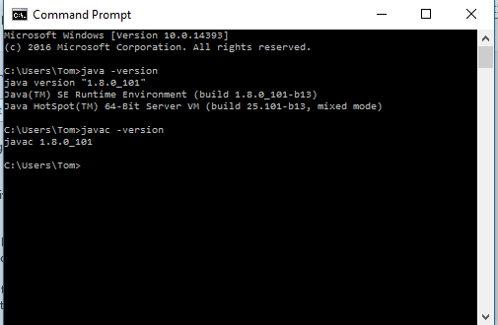

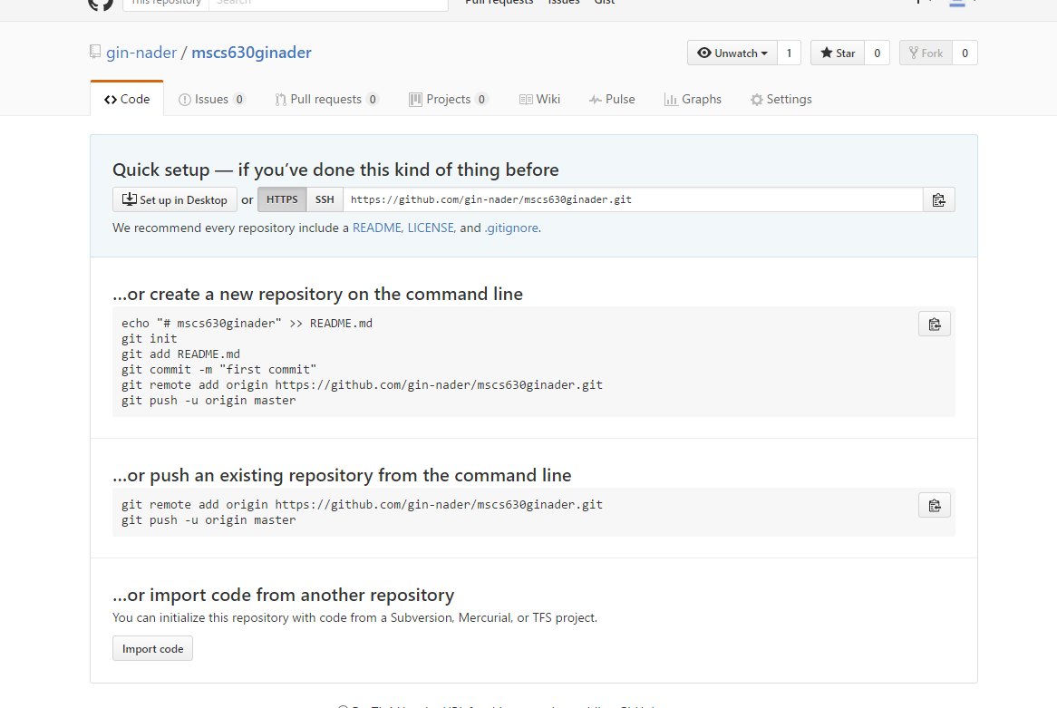

<https://github.com/gin-nader/mscs630ginader.git>

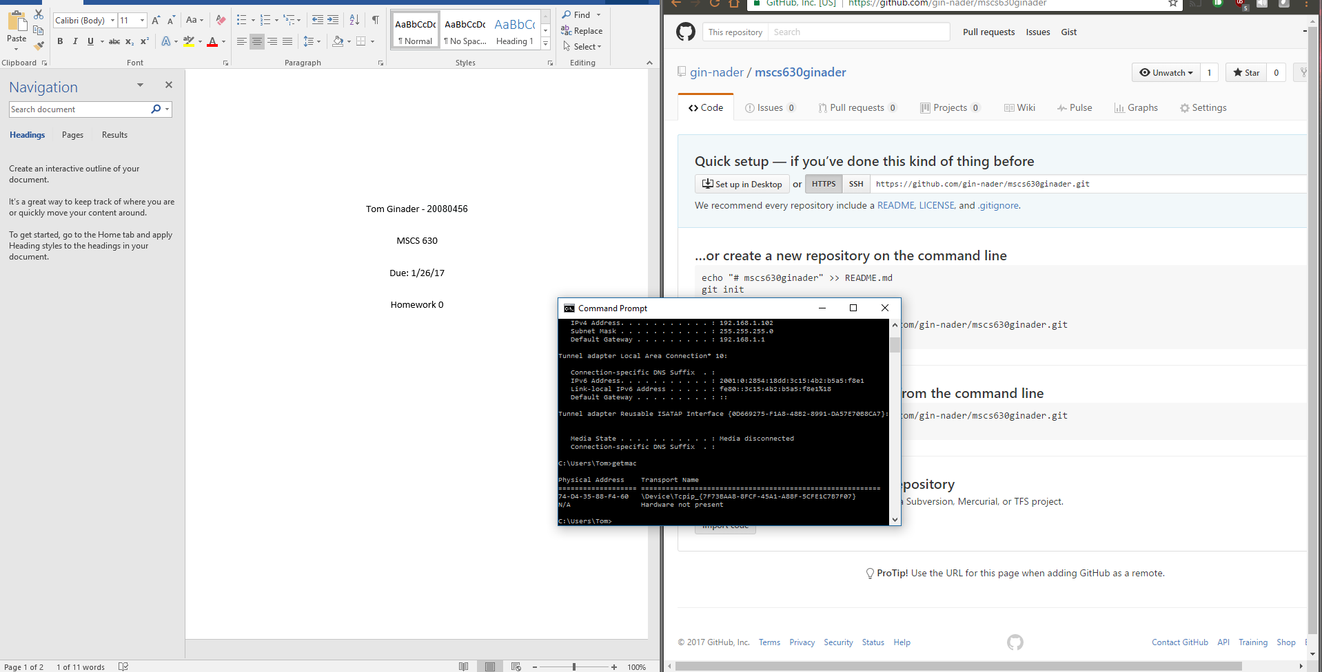

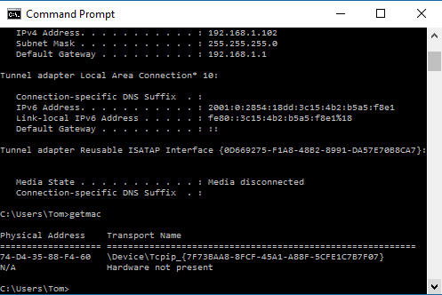

I understand that a MAC address can be spoofed, and that it is not the best way to uniquely identify a computer. But, I believe for the purpose of this assignment, that it should suffice. Or, maybe my IPv6 address will do?