Website Administrator

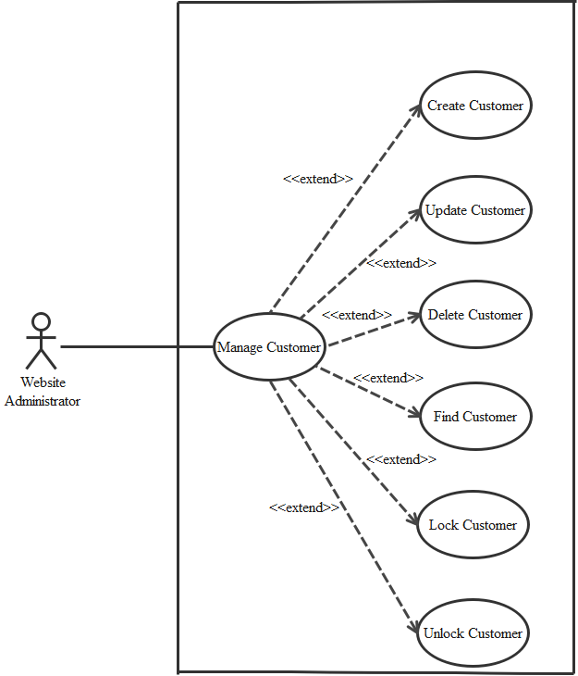

1. Create Customer

|  |  |  |
| --- | --- | --- |
| **Author** |  | |
| **Use case name** | Create Customer | |
| **Actor** | Admin | |
| **Description** | When admin wants to create customer | |
| **Requirements** | Actor provides customer information | |
| **Pre-conditions** | Actor is logged in admin | |
| **Post-conditions** | Success: new Customer is added into the database | |
| Fail: refill information | |
| **Basic flow** | Actor’s action | System’s responses: |
| 1. Actor chooses Customer Tab on menu.  3. Actor clicks ‘Add New Customer’ button.  5. Actor inputs information to create Customer. | 2. System redirects to ‘Customer’ page and  display a list of existing Customers.  4. System displays a form with the following fields.  ID  Fullname  Usename  Password  Adress  Phone  Email  Registered_at  Birthday  Gender  Ative  Random_key  Login_number  Expired_at  Image  6. System validates inputs.  7. System adds book into database.  8. System displays confirmation message or  error message. |

1. Update Customer

|  |  |  |
| --- | --- | --- |
| Author |  | |
| Use Case Name | Update Customer | |
| Actors | Admin | |
| Description | When admin wants to Update customer | |
| Requirements | Actor provides customer information | |
| Pre-conditions | Actor is logged in admin | |
| Post-condition | Success: Customer is update into the database | |
| Fail: refill information | |
| Basic flow | Actor’s action | System’s responses: |
| 1. Actor chooses Customer Tab on menu.  3. Actor clicks on ‘View Details’ on a Customer  5. Actor chooses the criteria they want to  update and input information. | 2. System redirects to ‘Custumer’ page and  display a list of existing Customers.  ID  Fullname  Usename  Password  Adress  Phone  Email  Registered_at  Birthday  Gender  Ative  Random_key  Login_number  Expired_at  Image  6. System validates inputs.  7. System adds book into database.  8. System displays confirmation message or  error message.  9. System redirects to customer’s detail page. |

1. Delete Customer

|  |  |  |
| --- | --- | --- |
| Author |  | |
| Use Case Name | Delete Customer | |
| Actors | Admin | |
| Description | When admin wants to delete customer | |
| Requirements | Actor provides customer information | |
| Pre-conditions | Actor is logged in admin | |
| Post-condition | Success: Customer is delete from the database | |
| Fail: Customer is not deleted from the database | |
| Basic flow | Actor’s action | System’s responses: |
| 1. Actor chooses Customer Tab on menu.  3. Actor clicks ‘Delete’ button. | 2. System redirects to ‘Customer’ page and  display a list of existing Customers.  7. System delete customer in the database.  8. System displays confirmation message or  error message. |

1. Find Customer

|  |  |  |
| --- | --- | --- |
| Author |  | |
| Use Case Name | Find Customer | |
| Actors | Admin | |
| Description | When admin wants to find customer by ID | |
| Requirements | Actor provides find iD | |
| Pre-conditions | Actor is logged in admin | |
| Post-condition | Success: Show customer that matches ID | |
| Fail: No customer to shown | |
| Basic flow | Actor’s action | System’s responses: |
| 1 Actor inputs find ID.  3. Actor clicks customer’s title in list or view  Every customer that matches find ID. | 2. System show list of customer that match the ID. |

1. Lock Customer

|  |  |  |
| --- | --- | --- |
| Author |  | |
| Use Case Name | Lock Customer | |
| Actors | Admin | |
| Description | When admin wants to lock a customer | |
| Requirements | Actor provides Customer’s information | |
| Pre-conditions | Actor is logged in admin | |
| Post-condition | Success: set customer’s status into “Lock” and updated in database | |
| Fail: No changes are made | |
| **Basic flow** | Actor’s action | System’s responses: |
| 1. Actor chooses Customer row on User list and  click “enabled” button | 2. System updates Customer’s status in database.  3. System displays confirmation message or  error message. |

1. Unlock Customer

|  |  |  |
| --- | --- | --- |
| Author |  | |
| Use Case Name | Unlock Customer | |
| Actors | Admin | |
| Description | When admin wants to unlock a customer | |
| Requirements | Actor provides Customer’s information | |
| Pre-conditions | Actor is logged in admin | |
| Post-condition | Success: set customer’s status into “UnLock” and updated in database | |
| Fail: No changes are made | |
| **Basic flow** | Actor’s action | System’s responses: |
| 1. Actor chooses Customer row on User list and  click “enabled” button | 2. System updates Customer’s status in database.  3. System displays confirmation message or  error message. |