NEW

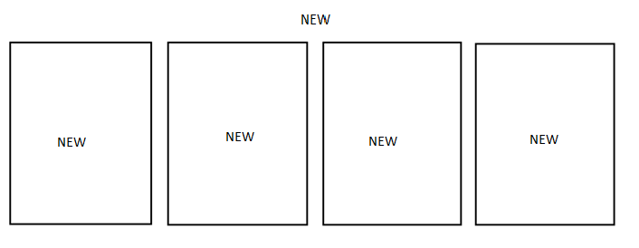

**Shop System**

**Shop System**

**TEXT**

Purchase history

Ádsd

Continues

Code oders:

**Look up oder infomation**

|  |  |  |  |  |  |
| --- | --- | --- | --- | --- | --- |
| NO | NAME | type | vadilasion | event | Desrciption |
| 1 | Look up oder infomation | NULL | Not null must be code oder |  | Code oders |

Store rules

Store rules

Text