AVHRR NDVI metrics Algorithm running in windows such as windows 7

1. Preparation:

a. copy avhrr_ndvi and its sub-directories and all files in the dir_your_choice

in my case, dir_your_choice=C:\Users\jiang\Documents\work\nps

In order to program the runs in IDL+ENVI development environment, you have to setup

an environment variable:IDL_STARTUP, and edit the startup_nps file.

b. set system environmental variable IDL_STARTUP

start->control panel->system->Advanced system settings->Environment Variables:

new a variable:IDL_STARTUP, make its value equal to $dir_where_your_start_nps_is.

In my case, I set the value as

C:\Users\jiang\Documents\work\nps\avhrr_ndvi\startup_nps

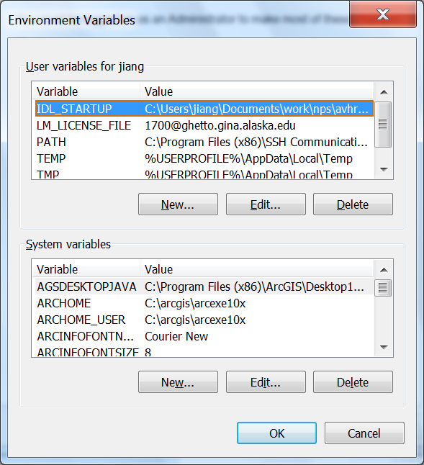

c. edit the startup_nps file

The startup_nps file looks like:

#########################################################

ENVI, /RESTORE_BASE_SAVE_FILES

PREF_SET, 'IDL_PATH', '<IDL_DEFAULT>;+dir_where_avhrr_ndvi_is', /COMMIT  
#########################################################

replace “dir_where_avhrr_ndvi_is” to your directory where the avhrr_ndvi is. In my case, “C:\Users\jiang\Documents\work\nps\avhrr_ndvi”

Please keep the “+” right before the “dir_where_avhrr_ndvi_is”

2. run avhrr_calulate_ndvi_metrics_tile program

double click IDL to start the IDLDE

in the idl command line, run following commands:

restore,'dir_your_choice/avhrr_ndvi/sav/avhrr_calculate_ndvi_metrics_tile.sav'

filen='dir_your_choice/avhrr_ndvi/data/ak_nd_1982'

filen_sm='dir_your_choice/avhrr_ndvi/data/ak_nd_1982sm'

avhrr_calculate_ndvi_metrics_tile, filen,filen_sm

3. compile sav file by yourself in case the sav file provided does not work

The sav file I provided is based on IDL708 (ENVI 4.6), perhaps it is compatible

with your IDL+ENVI environment. I this case, you need compile the sav file.

After you follow item 1 to set the environment, do follows to build the sav file.  
  
a. start the IDL  
  
b. File->switch workspace  to: L:\GINA_metrics\avhrr_ndvi, then open the workspace.

the workspace "avhrr-ndvi-metrics" will show on the project explorer   
  
c. project->open the project->build All, you get the *.sav file in the

L:\GINA_metrics\avhrr_ndvi\avhrr-ndvi-metrics  
  
d. copy the new *.sav file into the L:\GINA_metrics\avhrr_ndvi\sav.   
  
now that you get the *.sav file. You can run the *.sav file following the previous

guidance.

4. Algorithm explaination

detail algorthm explaination is referred to "ndvi_metrics_algorithm_doc_201201.docx"