Snow Metrics

- The MODIS Aqua and Terra Snow Cover Daily L3 Global 500m Grid (MYD10A1 and MOD10A1, respectively) are used to calculate snow metrics.

- Calculation of snow metrics is divided into two stages: data processing to reduce cloud pixels and deriving snow metrics. Following are the steps:

a). spatial filting cloud pixels for both aqua and terra data

when a pixel is classified as cloud pixel, check its adjunct 4 pixels. If 3 of 4 are snow pixels, then re-classify the cloud pixel as a snow pixel; If 3 of 4 are no-snow pixels, then re-classify the cloud pixel as a no-snow pixel.

b). stack one snow year (year of 8/1 to next year of 7/31) of daily aqua and terra data, respectively.

After above steps, goes through each pixel to do following steps, finally to calcualte the snow metrics.

c). combine aqua and terra time-serieses of the pixel to reduce the cloud pixel.
At given position (index) of the time-series, if either is no-cloud, keeps the no-cloud in the result combined time-series.

d). temporal filting to reduce the cloud pixel.
Check each cloud pixel in the time-series, if right before and after adjacent pixels are snow pixels, re-classify the pixel as snow pixel; if both right before and after adjacent pixels are no-snow pixels, re-classify the pixel as a no-snow pixel.

e). reducing cloud pixels according to the snow cycle.

First, divide the time-series into three segements: Seg.1, the first point to the first-consecutive snow point; Seg. 2, the first-consecutive point to the last-consecutive point, and Seg. 3, the last-consecutive point to the last point. Reduce the cloud pixels of the three segements by using different methods.

Seg.1: backforward processing, if ith point is no-snow, and i-1th is cloud, then reclassify the i-1 th as no-snow pixel; forward processing, if i th point is snow, and the i+1 th is cloud, then re-classify the i+1 th as snow pixel.

Seg2: backward processing: if i th point is snow, and i-1 th is cloud, re-classify i-1 th into snow, forward processing: if i th point is snow, and i+1 th is cloud, re-classify i+1 th point as snow point.

Seg3: backward processing: if i th is snow, and i-1 th is cloud, re-classify i-1 th as snow. Forward processing: if i th point is no-snow and i+1 th point is cloud, re-classify i+1 th as no-snow.

f). calculate the metrics

find the first snow point and last snow point (easy)

find the first consecutive snow point and the last consecutive snow point by the definition that snow cover must last from two or more weeks in late January to mid-February for a cell to be considered to have a consecutive snow season. There are many night points between first and last consecutive snow points, we assume there are snow points.

Aqua and Terra daily data
Spatial filting cloud pixels of Aqua and Terra
Combine aqua and terra time series
Finish the loop?
Stack Aqua and Terra, respectively
Temporal filting to reduce cloud pixels
Reduce cloud pixels according to snow cycle
Calcualte snow metrics
Snow metrics and snow cover

Fig.1 Flowchart of snow metrics algorithm

Results: snow metrics data and snow cover data files

The format of the snow metrics file: 10 bands ENVI image file. The band names are:

0-first_day, first day of snow occurs
1-last_day, last day of snow occurs
2-fss_range, last_day-first_day
3-css_first_day, first day of continous snow season
4-css_last_day, last day of the continous snow season
5-css_day_range, days of continious snow season
6-snow_days, number of days which are snow-covered
7-no_snow_days, number of days which are snow-free
8-reserved, not used
9-mflag,flag indicating the snow_metrics is valid (1), not-valid (0), or no data(-1)

The foramt of the snow cover file: 165 bands of envi image file. Each band corresponds a day.
The data in a pixel of a day is one of classification flags.

0—missing data
1--- no decision
11--- night
25—no snow-covered
37--- lake
39--- ocean
50--- cloud
100--- lake ice
200--- snow
254--- detector
255--- fill

Snow Metrics in Snow Year 2009 (2009/08/01- 2010/07/31)

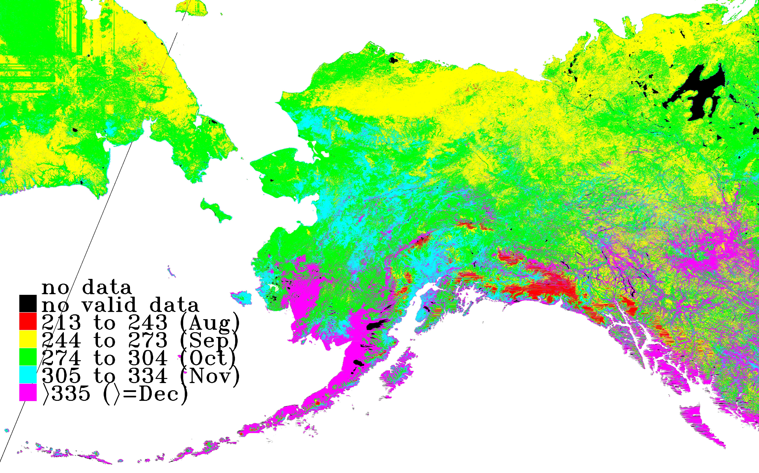

Fig. 2 First day of consecutive snow season

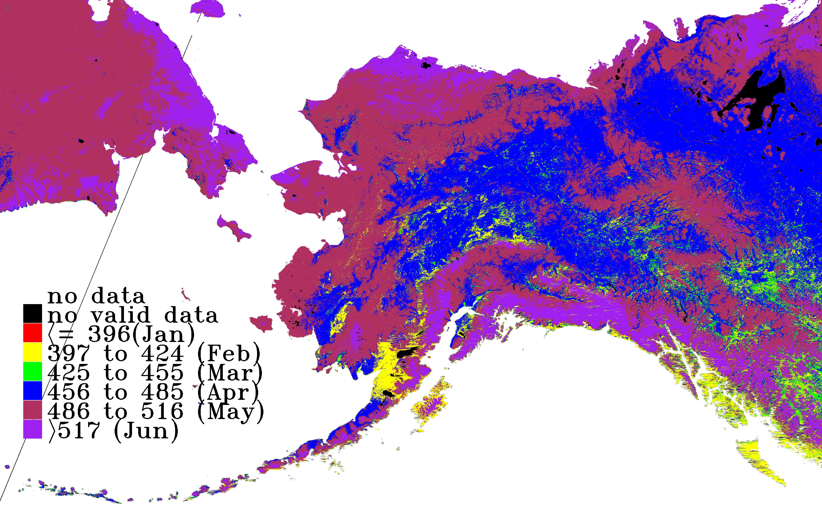

Fig. 3 Last day of consecutive snow season

Fig.4 Day range of consecutive snow season

Problems:

1. using albedo to determine old/new snow is not reliable. I found some snow pixels in consecutive snow period are with very low albedo values, while some pixels before the consecutive snow period are with very high albedo values.

2. The reason that no metrics data in the Brooks Range is the results of fill values (255) in the area.

