MODIS-derived Snow Metrics Algorithm

Version 1.0

Jiang Zhu¹, Chuck Lindsay²
1. Geographic Information Network of Alaska, UAF
2. National Park Service, Anchorage

Mar., 26, 2013

Introduction

The National Park Service and Geographic Information Network of Alaska (GINA) are developing an algorithm to derive snow cover climatology for Alaska using the Moderate Resolution Imaging Spectroradiometer (MODIS) snow cover daily product. The algorithm is two-fold and involves both data processing and the derivation of snow cover metrics. Terra MODIS snow cover daily 500m grid data (MOD10A1) are processed to reduce cloud obscuration through iterations of cloud reduction methods that include spatial, temporal, and snow cycle filtering. MRT tool is used to mosaic daily tile files and re-sample the data. A total of 12 metrics (e.g. date of first snow, date of persistent snow cover) for each pixel are calculated. IDL with ENVI subroutines were used to develop the algorithm.

Input dataset

The MODIS Terra Snow Cover Daily L3 Global 500m Grid data (MOD10A1) from the National Snow and Ice Data center (NSIDC) are used to calculate the snow metrics for a snow year. A snow year is defined as August 1 of the previous year to July 31 of the year in which it ends. For example, 2010 snow year is from August 1 of 2009 to July 31 of 2010.

MOD10A1 data contains snow cover, snow albedo, fractional snow cover, and Quality Assessment (QA) data in compressed Hierarchical Data Format-Earth Observing System (HDF-EOS) format along with corresponding metadata. MOD10A1 consists of 1200 km by 1200 km tiles of 500 m resolution data gridded in a sinusoidal map projection. The MODIS snow cover data is based on a snow mapping algorithm that employs a Normalized Difference Snow Index (NDSI) and other criteria tests. (See http://nsidc.org/data/mod10a1v5.html).

For our purposes, we download 26 daily tile files covering all of the Alaska region (Figure 1).

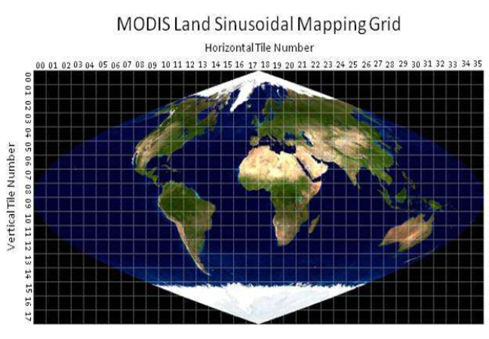

Figure 1. 26 tiles files are downloaded from NSIDC.

The 26 tiles are h06v03, h07v03, h08v03, h09v02, h09v03, h10v02, h10v03, h11v02, h11v03, h12v01, h12v02, h13v01, h13v02, h14v01, h20v01, h21v01, h22v01, h23v01, h23v02, h24v02, h25v02, h26v02, h26v03, h27v03, h28v03, h29v03.

Each tile file includes four scientific fields such as snow_cover, fractional_snow_cover, Snow_albedo, and snow_cover_spatial_quality to indicate the attributes of the pixels in the tile. The the snow_cover, snow_fraction, snow_albedo, and snow_spatial_QA fields are defined in Tables 1 to 4, respectively.

Table 1. Local attributes for the Snow_Cover field of tile data
Value | Description
0=missing data | data missing
1=no decision | no decision
11=night | Darkness, terminator, or polar night
25=no snow | Snow-free land
37=lake | Lake or inland water
39=ocean | Open water
50=cloud | Cloud obscured
100=lake ice | Snow-covered lake ice
200=snow | Snow-covered land
254=detector saturated | Detector saturated
255=fill | Fill

Table 2. Attributes for Fractional_Snow_Cover Field of tile data

Value | Description
0-100=fractional snow | In percent
200=missing data | Missing data
211=night | Darkness, terminator, or polar night
225=land | Snow-free land
237=lake | Lake or inland water
239=ocean | Open water
250=cloud | Cloud obscured
254=detector saturated | Detector saturated
255=fill | Fill

Table 3. Attributes for the snow-albedo field of tile data

Value | Description
0-100=snow albedo | In percent
101=no decision | no decision
111=night | Darkness, terminator, or polar night
125=no snow | Snow-free land
137=lake | Lake or inland water
139=ocean | Open water
150=cloud | Cloud obscured
250=missing | Missing data
251=self-shadowing | Self-shadowing
252=landmask mismatch | Landmask mismatch
253=BRDF_failure | Bidirectional reflectance distribution function failure
254=non-production-mask | Non-production-mask

Table 4. Attributes for the Snow_Spatial_QA field

Value | Description
0 | Good quality
1 | Other quality
252 | Antarctic mask
253 | Land mask
254 | Ocean mask
255 | Fill

Daily tile files are mosaicked and re-projected using the MRT tool into the Alaska Albers Projection (NAD83), and converted into four single band GeoTIFF files. For example, the four TIFF files for 2009/02/28 are: 2009-059.Snow_Albedo_Daily_Tile.tif, 2009_059.Fractional_Snow_Cover.tif, 2009_059.Snow_Cover_Daily_Tile.tif, and 2009_059.Snow_Spatial_QA.tif.

Snow metrics algorithm

Calculation of snow metrics for a snow year (Aug 1 to July 31) is divided into two stages: processing data to reduce cloud pixels and deriving the snow metrics. Figure 2 shows the scheme of the algorithm. Data processing includes spatial, temporal, snow-cycle filtering methods to reduce the cloudy days. Snow metrics processing produces snow metrics. Finally, the algorithm outputs the snow metrics as well as the modified snow cover.

Daily data are composed of four TIFF format files. The value of a pixel in the cover file is defined in Table 1.

One year of snow_cover, snow_fract, snow_quali and snow_albed files
a), spatial filtering cloud pixels and stack one year of snow_cover, snow_fract, snow_quali and snow_albed
b), temporal filtering cloud pixel of time series i
c), reducing cloud points according to snow cycle
d), check glacier pixel
e), calculate snow metrics
All pixels are processed?
Cloud-reduced cover, smoothed-fraction, and snow metrics data
For I =1 to number of pixels do items b to e process

Figure 2. Flowchart for data processing and metrics calculation.
a) Spatial filtering cloud pixels and stacking one-snow-year data

Each day of cover file is processed with the spatial filtering cloud pixels algorithm. Check each cloud pixel, if ¾ of its orthogonal neighbor pixels are snow, then re-classify the cloud pixel as snow pixel; if ¾ of them are no-snow, re-classify the cloud pixel as no-snow pixel.

All daily files that are available for the snow year (Aug 1 to Jul 31) are stacked, resulting in four stacked files - one for each of the scientific data sets (cover, albedo, quality, and fraction).
For example, 2009 snow year has four stacked files, which are: 2009_snow_cover, 2009_frac, 2009_albed, and 2009_quali.

Within a snow year, there are few days of missing data. We do not interpolate the missing days when deriving snow metrics. For example, 2009 snow year has 351 days. Days from 2009-275 to 2009-287 are missing. Appendix A lists days with data for the 2009 snow year. Note that data of a snow year are processed from August 1 of the first year to July 31 of next year, but that the metrics days are reported as day of year, starting with Jan 1 of the first year. That is, we report the first and last snow cover days, and the first and last days for the longest consecutive snow cover period in terms of the number of days from Jan 1 of first year to July 31 of the following year. So, the range of the metrics days is from 213 to 577 (578 in leap year).

b). Temporal filtering to reduce the cloud pixels

Each pixel is described by its cover, fraction, quality, and albedo vectors. A temporal filter is applied for each pixel using the following steps. For example, Figure 3 presents the raw data for the cover time series at pixel (sample 3249 and line 3435) for snow-year 2009. Please notice that the total days for available satellite data for this snow-year (from August 1 to next year July 31) are 351 days.
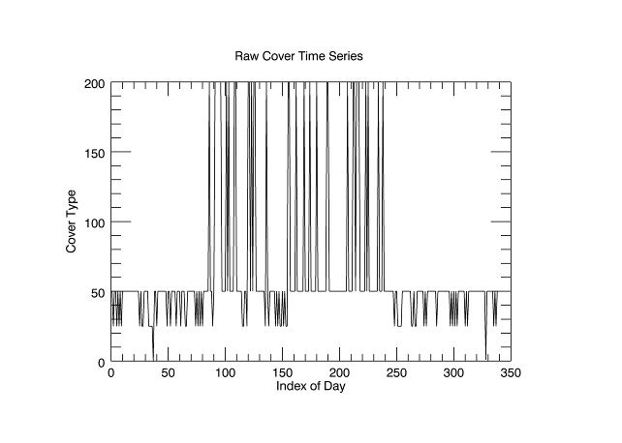Figure 3. Raw cover time series at pixel (sample 3249 and line 3435).Value 200 is snow, 50 is cloud, 25 is no-snow, and 0 is no-data.

The temporal filtering method includes following steps. First, we determine what the pixel is (ocean, land, or lake/inland water) by counting the number of the types information in the cover time-series produced in step b. If more than 10 points in the cover time-series are ocean, the pixel is classified as ocean, if more than 10 points are lake/inland water the pixel is classified as lake/inland water, otherwise it is classified as land. Second, we check the snow flag in the cover time-series to determine if the pixel is snow covered or not. Then, we check each cloud day in the cover time-series produced in step b. If one day before and after the cloud day are snow, the cloud day is reclassified as snow day; if one day before and after the cloud day are no-snow, the cloud day is reclassified as a no-snow day.

Figure 4 shows the temporal filtered time series for the same time series that was shown in Figure 3.
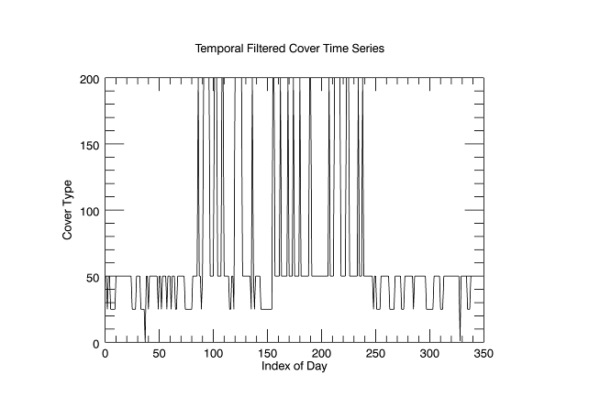
Figure 4. Temporal filtered time series.

c). Snow cycle filtering

We define a snow year (or cycle) as having three segments: snow accumulation, snow cover, and snow melt. During the snow accumulation segment, cloud days that occur before a no-snow day can be assumed to be no-snow days. During the snow cover segment, cloud days that are bound by snow days are assumed to represent snow days. Cloud days that occur after a no-snow day in the snow melt segment are assumed to be no-snow days. Therefore, we apply different cloud re-classifying methods to each of the different segments of the snow year. We first use a method to estimate the snow cycle of the cover time-series and then apply different cloud filtering methods to each segment of the time series.
- Segment1 is defined as the first day of snow calendar year (August 1st) to the estimated start of consecutive snow season (SOCSS) day ;
- Segment 2 is defined as the estimated SOCSS day to the estimated end of consecutive snow season(EOCSS) day, and
- Segment 3 is defined as the estimated EOCSS day to the last day of the snow calendar year (July 31st).

In order to estimate the SOCSS day, candidate SOCSS days and their related location indexes in the time series are found by identifying snow pixel points whose fractions are equal to or greater than 50% and whose albedos are equal to or greater than 30%.

The estimated SOCSS day is evaluated by forward checking candidate SOCSS days - starting from the first candidate SOCSS day with the smallest location index in the time series. If the estimated SOCSS day and following days meet the consecutive snow period requirements (the following days must not be classified as no-snow/lake/ocean and the number of these kinds of days (num_threshold) must be greater than 14 days) then this is the estimated SOCSS day. Otherwise, we continue to evaluate the next SOCSS day in the remaining candidate SOCSS days until we find a SOCSS day that meets the requirement for the consecutive snow season.

If none of the candidate SOCSS days meet the requirement, then Dec 31st of the first year is picked as the estimated SOCSS day.

For example, consider a cover time series (Table 5) with fractional snow cover of all snow days greater than 50% and albedo values of all snow days greater than 30%. In this table, we present that s—snow, n—no snow, f—fill, c—cloud, t—night, l—lake, o—ocean, m—missing data.

Table 5. Example for estimating the first day of consecutive snow season.

0 | 1 | 2 | 3 | 4 | 5 | 6 | 7 | 8 | 9 | 10 | 11 | 12 | 13 | 14 | 15 | 16 | 17 | 18 | 19 | 20 | 21 | 22 | 23 | 24 | 25 | 26 | 27 | 28
n | n | f | S | c | n | s | s | s | t | t | t | t | c | c | f | t | s | s | c | c | c | f | c | s | n | n | n | n
 |  |  |  |  |  | x

By using above method, we determine that day 6 is the first day of the consecutive snow season because the day 6 is the first of more than 14 consecutive days that are not classified as no-snow/lake/ocean days (in Table 5 it is actually the first of 19 consecutive days).

A similar method is used to determine the EOCSS day, except backward checking is used to determine the EOCSS day from the candidate EOCSS days.

After determining the SOCSS day and the EOCSS day, the time series is divided into three segments:
Segment 1: first day (first_idx) to SOCSS day - 1
Segment 2: SOCSS day to EOCSS day
Segment 3: OCSS day + 1 to the last day (last_idx)

These segments are then filtered to reduce cloud days using the following steps. During filtering, we treat the missing, night, or fill days as cloud days. So, it appears that there are only three kinds of days in the cover time series: snow, no-snow, and cloud days.

Backward filtering segment 3

Beginning with the last day, if day i is a snow day and the preceding consecutive days (i-1,i-2,..., i-n) are cloud days, then we re-classify the preceding consecutive days ( i-1,i-2,..., i-n) as snow days. Table 6 illustrates how the hypothetical time series are processed by the backward process for segment 3. The second row represents a hypothetical segment 3 (end of season), and the third row is the result produced by backward filtering of segment 3. The letters used are the same as those in Table 5 and changes are shown in red.

Table 6. Segment 3 and the result of backward filtering.

0 | 1 | 2 | 3 | 4 | 5 | 6 | 7 | 8 | 9 | 10 | 11 | 12 | 13 | 14 | 15 | 16 | 17 | 18 | 19 | 20 | 21 | 22 | 23 | 24 | 25 | 26 | 27 | 28
n | n | n | n | s | c | n | c | c | c | f | f | f | c | c | c | n | s | c | c | s | s | c | c | f | s | t | t | c
n | n | n | n | s | c | n | c | c | c | f | f | f | c | c | c | n | s | s | s | s | s | s | s | s | s | t | t | c

The result of backward filtering segment 3 for the time series shown in Figure 4 is presented in Figure 5. Because backward filtering did not change anything in this case, the plot shown in Figure 5 is identical to that in Figure 4.

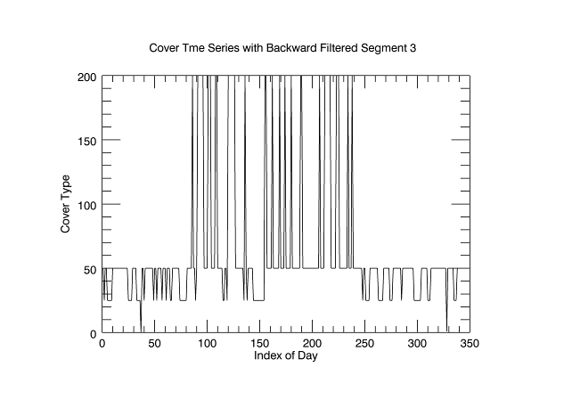
Figure 5. Backward filtering of segment 3.

Backward filtering segment 2

Beginning with the last day of segment 2, if day i is snow and the preceding consecutive days (i-1,i-2,...,i-n) are cloud, then we reclassify the preceding consecutive days ( i-1,i-2,...,i-n) as snow. Figure 6 shows the result of backward filtering segment 2 for the same time series that is presented in Figure 5.
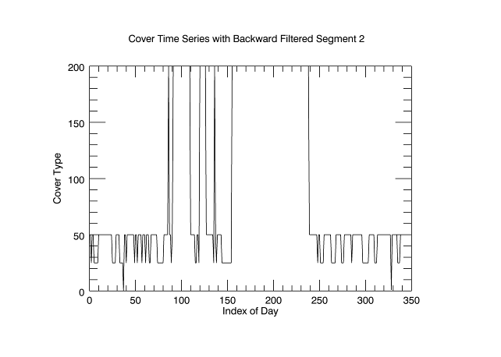

Figure 6. Backward filtering segment 2.

Backward filtering segment 1

Beginning with the last day of segment 1, if day i is no-snow and the preceding days (i-1, i-2,.., i-n) are cloud, then we reclassify the preceding consecutive days ( i-1,i-2,...,i-n) as no-snow days. Figure 7 presents the results of backward filtering segment 1.

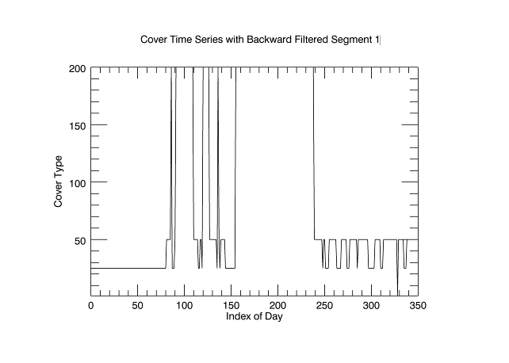

Figure 7. Backward filtering segment 1.

Forward filtering segment 1

Beginning with the first day of segment 1, if day i is snow and the following consecutive days ( i+1,i+2,...,i+n) are cloud, then we reclassify the following consecutive days (i+1, i+2,..., i+n) as snow. An example is shown in Table 7. The second row represents a hypothetical segment 1 time-series. The third row is the result of forward filtering of the second row. The reclassification of clouds is indicated by red-colored characters. The result of forward filtering segment 1 is shown in Figure 8. Because forward filtering did not change anything in this case, the plot shown in Figure 8 is identical to that in Figure 7.

Table 7. Example of forward filtering segment 1.

0 | 1 | 2 | 3 | 4 | 5 | 6 | 7 | 8 | 9 | 10 | 11 | 12 | 13 | 14 | 15 | 16 | 17 | 18 | 19 | 20 | 21 | 22 | 23 | 24 | 25 | 26 | 27 | 28
n | n | n | n | s | c | n | c | c | c | f | f | f | c | c | c | n | s | c | c | s | s | c | c | f | s | t | t | c
n | n | n | n | s | s | n | c | c | c | f | f | f | c | c | c | n | s | s | s | s | s | s | s | f | s | t | t | c

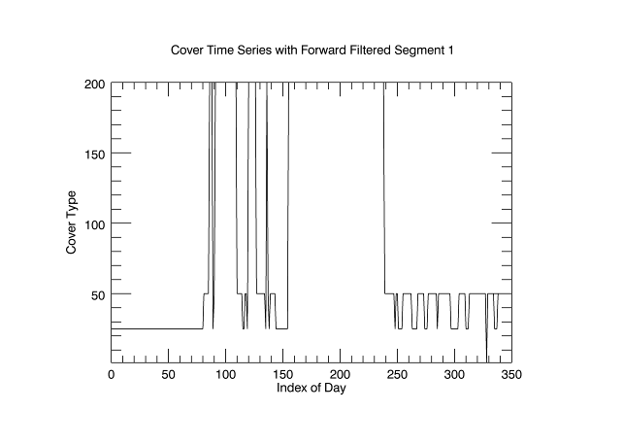

Figure 8. Forward filtering segment 1.

Forward filtering the Segment 2

Beginning with the first day of segment 2, if day i is snow and the following consecutive days (i+1,i+2,..., i+n) are cloud, then we reclassify the following consecutive days (i+1,i+2,..., i+n) as snow. Figure 9 displays the result of forward filtering segment 2. In this case, forward filtering did not change anything so the plot shown in Figure 9 is identical to that in Figure 8.
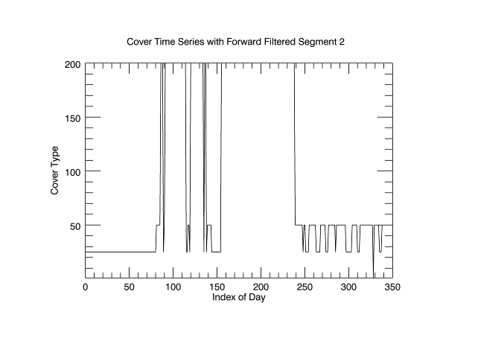

Figure 9. Forward filtering segment 2.

Forward filtering segment 3

Beginning with the first day of segment 3, if day i is no-snow and the following consecutive days (i+1,i+2,...,i+n) are cloud, then we re-classify the following consecutive days (i+1,i+2,...,i+n) as no-snow. Figure 10 illustrates the result of forward filtering segment 3.

After cloud filtering the snow cycle there are still some cloud days left in the time series. There is no reasonable way to get rid of these remaining cloud days in the time series because they primarily occur in the transition period between segment 1and segment 2 and/or segment 2 and segment 3.
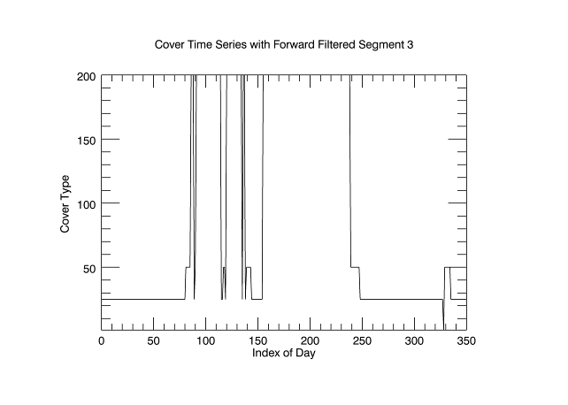

Figure 10. Forward filtering segment 3.

d) Check and re-classify the glacier pixels

The final step for snow cycle filtering is determining if the time series represents a glacier pixel. If the time series does not have any no-snow, lake, or ocean classifications, we consider the time series to represent a glacier pixel. For the time series of a glacier pixel, we reclassify all days the as snow days. The time-series shown in Figures 2 - 10 is not for a glacier pixel, so the results of filtering this time series are not shown.

e) Calculation of snow metrics

After finishing the spatial, temporal, and snow-cycle filtering, the time-series is ready for calculating snow metrics (Figure 1, Step e).

Finding the first snow day (FSD) and the last snow day (LSD):

Obtain the index for the first snow day and index for the last snow day in the cover time-series (refers to the first column in Appendix A). We do not consider the cloudy days before the first snow day and after the last snow day as possible snow days. That means that FSD and LSD days are the same as MODIS snow_cover_field. Then locate these indices in the band name array (refers to the second column in Appendix A) to obtain the first_snow day (FSD) and the last_snow day (LSD), and calculate the day range between the first and last snow day. For example, for the time series shown in the Figure 10, we determine that the first snow cover day index = 86, and the last snow cover index =238. By locating the indices in the band name array, we get that first_snow_day=312, last_snow_cover day=464. The range from the first and last snow cover day is 153 days.

Finding the first day of the consecutive snow season (FCSS) and the last day of the consecutive snow season (LCSS):

Within the range of FSD and LSD, we identify the “first day for looking (FLD) for continuous snow season (CSS) segments”, which is the first snow day with fraction equal to or greater than 50% and with albedo equal to or more than 30% and the “last day for looking (LLD) for CSS segments”, which is the last snow day (with the same fraction/albedo qualifications). Then, we start to look for CSS segments within the range of FLD - LLD. The CSS is defined as having 14 or more consecutive days that must be “snow” or “cloud”, and no more than 2 consecutive days of no-snow days. The CSS segments may include a number of cloudy days in the beginning or/and at the end of a segment. So, the first day of the CSS segment (FCD) and the last day of the CSS segment (LCD) may need to be adjusted. If the FCD is a cloud day, then we look forwards for the first snow day of the CSS segment and pick the middle day as the FCD. In a similar way, if the LCD is a cloud day, then we look backwards for the last snow day of the CSS segment, and pick the middle day as the LCD (Figure 11). Figure 12 also gives an example of how the FCD and LCD are determined.

s n c c c s s s s s c c s s s s c s s s s s c s s s s s c c c n n c c s c c s
1 2 3 4 5 6 7 8 9 0 1 2 3 4 5 6 7 8 9 0 1 2 3 4 5 6 7 8 9 0 1 2 3 4 5 6 7 8 9
The Day 1 is the both FSD and the FLD, and the day39 is the LSD and the day 36 is the LLD. Because day 39 has snow fraction of 38% which is less than 50%, and day 36 has snow fraction of 87% and albedo 56%, day 36 is LLD.
The continuous snow season segment is initially identified as to be from the day 3 to the day 31. Because the first snow day of the continuous snow season (FCD) is the day 6, we adjust the first day of the CSS segment to the day 4. The last day of the CSS segment is the day 31, and the last snow day of the CSS segment do is the day 28, we change the last day of the un-broken segment (LCD) to the day 30.
Figure 11. Determination of CSS segment by adjusting cloudy days

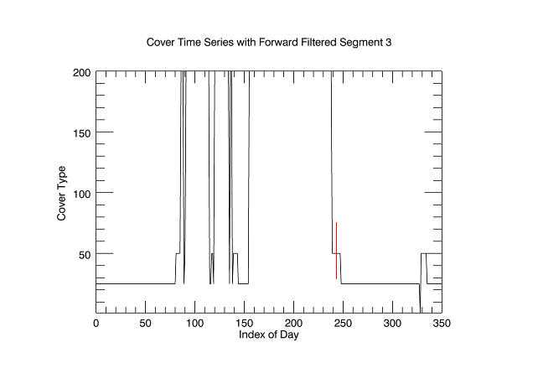
Figure 12. Extending the length of the continuous snow season segment to the middle day of cloud days. The vertical red line shows the modified date selected as the last day of the CSS segment.
After determining if there are one or more CSS segments, we count the number of CSS segments, and pick up the longest CSS segment to get the first day of the longest CSS, the last day of longest CSS, and other metrics. For the time series shown in Figure 11, the longest CSS segment is from index 155 (day of first year 381 or Jan. 16, 2010) to index 238 (day of second year 464 or Apr. 9, 2010). The FCSS day is Jan. 16, 2010, and the LCSS day is Apr. 9, 2010.

Results

The outputs of the algorithm include snow-metrics, snow-fraction, and snow-cover data files.

- Snow-metrics data file defines 12 snow metrics as following:

01-first_snow_day, first day of the full snow season (FSS start day)
02-last_snow_day, last day of the full snow season (FSS end day)
03-fss_range, last_snow_day-first_snow_day +1
04-longest_css_first_day, first day of the longest CSS segment (CSS start day)
05-longest_css_last_day, last day of the longest CSS segment (CSS end day)
06-longest_css_day_range, longest_css_last_day-longest_css_first_day +1
07-snow_days, the number of snow days
08-no_snow_days, the number of no snow days
09-css_segment_num, the number of CSS segments
10-mflag, pixel type (ocean, land, or lake/inland water) and type of snow (no snow, broken snow, or continuous snow)
11-cloud_days, number of cloud days
12-tot_css_days, total number of all days within CSS segments

Note:
Days reported as metrics are counted as day of year beginning on Jan.1 of the year that precedes the name of the snow year. For example, the days reported in the snow metrics of the snow-year of 2010 are counted from Jan.1, 2009.
The mflag values and their descriptions are defined in Table 5.

Table 5. Values and their description for mflag

 | Ocean (1) | Land (2) | Lake (3)
No-snow (10) | 11 | 12 | 13
Broken-snow (20) | 21 | 22 | 23
Css-snow (30) | 31 | 32 | 33

- The snow-cover file includes after cloud filtering snow cover data. It is a multi-band ENVI image file. Each band corresponds to a day in a snow-year. The value for a day in a pixel is one of classification flags defined previously.

- The snow-fraction data file recorded cloud fraction of the smoothed time series. It is a multi-band ENVI image file. Each band corresponds to a day in a snow-year, and the value for a day in a pixel fraction of snow cover from 0 to 100.

Reference

- http://nsidc.org/data/docs/daac/modis_v5/mod10a1_modis_terra_snow_daily_global_500m_grid.gd.html

- Bradley Reed, Michael Budde, Page Spencer and Amy Miller, 2006. Satellite-Derived Measures of Landscape Processes DRAFT Monitoring Protocol for the Southwest Alaska Network.

- Keshav Prasad Paudel and Peter Andersen, 2011. Monitoring snow cover variability in an agropastoral area in the Trans Himalayan region of Nepal using MODIS data with improved cloud removal methodology, Remote Sensing of Environment, 115, 1234-1246.

- Dorothy Hall, George Riggs and Vincent Salomonson, 2006 (updated daily). MODIS/Terra Snow Cover Daily L3 Global 500m Grid V005, [1 August 2009 to 31 July, 2010]. Boulder, Colorado USA: National Snow and Ice Data Center. Digital media.

Appendix A. Days of 2009 snow year

Index year-days of the year days from the Jan. 1 of 2009
0 2009-213 213
1 2009-214 214
2 2009-215 215
3 2009-216 216
4 2009-217 217
5 2009-218 218
6 2009-219 219
7 2009-220 220
8 2009-221 221
9 2009-222 222
10 2009-223 223
11 2009-224 224
12 2009-225 225
13 2009-226 226
14 2009-227 227
15 2009-228 228
16 2009-229 229
17 2009-230 230
18 2009-231 231
19 2009-232 232
20 2009-233 233
21 2009-234 234
22 2009-235 235
23 2009-236 236
24 2009-237 237
25 2009-238 238
26 2009-239 239
27 2009-240 240
28 2009-241 241
29 2009-242 242
30 2009-243 243
31 2009-244 244
32 2009-245 245
33 2009-246 246
34 2009-247 247
35 2009-248 248
36 2009-249 249
37 2009-250 250
38 2009-251 251
39 2009-252 252
40 2009-253 253
41 2009-254 254
42 2009-255 255
43 2009-256 256
44 2009-257 257
45 2009-258 258

46 2009-259 259
47 2009-260 260
48 2009-261 261
49 2009-262 262
50 2009-263 263
51 2009-264 264
52 2009-265 265
53 2009-266 266
54 2009-267 267
55 2009-268 268
56 2009-269 269
57 2009-270 270
58 2009-271 271
59 2009-272 272
60 2009-273 273
61 2009-274 274
62 2009-288 288
63 2009-289 289
64 2009-290 290
65 2009-291 291
66 2009-292 292
67 2009-293 293
68 2009-294 294
69 2009-295 295
70 2009-296 296
71 2009-297 297
72 2009-298 298
73 2009-299 299
74 2009-300 300
75 2009-301 301
76 2009-302 302
77 2009-303 303
78 2009-304 304
79 2009-305 305
80 2009-306 306
81 2009-307 307
82 2009-308 308
83 2009-309 309
84 2009-310 310
85 2009-311 311
86 2009-312 312
87 2009-313 313
88 2009-314 314
89 2009-315 315
90 2009-316 316
91 2009-317 317
92 2009-318 318
93 2009-319 319
94 2009-320 320
95 2009-321 321
96 2009-322 322
97 2009-323 323
98 2009-324 324
99 2009-325 325
100 2009-326 326
101 2009-327 327
102 2009-328 328
103 2009-329 329
104 2009-330 330
105 2009-331 331
106 2009-332 332
107 2009-333 333
108 2009-334 334
109 2009-335 335
110 2009-336 336
111 2009-337 337
112 2009-338 338
113 2009-339 339
114 2009-340 340
115 2009-341 341
116 2009-342 342
117 2009-343 343
118 2009-344 344
119 2009-345 345
120 2009-346 346
121 2009-347 347
122 2009-348 348
123 2009-349 349
124 2009-350 350
125 2009-351 351
126 2009-352 352
127 2009-353 353
128 2009-354 354
129 2009-355 355
130 2009-356 356
131 2009-357 357
132 2009-358 358
133 2009-359 359
134 2009-360 360
135 2009-361 361
136 2009-362 362
137 2009-363 363
138 2009-364 364
139 2009-365 365
140 2010-001 366
141 2010-002 367
142 2010-003 368
143 2010-004 369
144 2010-005 370
145 2010-006 371
146 2010-007 372
147 2010-008 373
148 2010-009 374
149 2010-010 375
150 2010-011 376
151 2010-012 377
152 2010-013 378
153 2010-014 379
154 2010-015 380
155 2010-016 381
156 2010-017 382
157 2010-018 383
158 2010-019 384
159 2010-020 385
160 2010-021 386
161 2010-022 387
162 2010-023 388
163 2010-024 389
164 2010-025 390
165 2010-026 391
166 2010-027 392
167 2010-028 393
168 2010-029 394
169 2010-030 395
170 2010-031 396
171 2010-032 397
172 2010-033 398
173 2010-034 399
174 2010-035 400
175 2010-036 401
176 2010-037 402
177 2010-038 403
178 2010-039 404
179 2010-040 405
180 2010-041 406
181 2010-042 407
182 2010-043 408
183 2010-044 409
184 2010-045 410
185 2010-046 411
186 2010-047 412
187 2010-048 413
188 2010-049 414
189 2010-050 415
190 2010-051 416
191 2010-052 417
192 2010-053 418
193 2010-054 419
194 2010-055 420
195 2010-056 421
196 2010-057 422
197 2010-058 423
198 2010-059 424
199 2010-060 425
200 2010-061 426
201 2010-062 427
202 2010-063 428
203 2010-064 429
204 2010-065 430
205 2010-066 431
206 2010-067 432
207 2010-068 433
208 2010-069 434
209 2010-070 435
210 2010-071 436
211 2010-072 437
212 2010-073 438
213 2010-074 439
214 2010-075 440
215 2010-076 441
216 2010-077 442
217 2010-078 443
218 2010-079 444
219 2010-080 445
220 2010-081 446
221 2010-082 447
222 2010-083 448
223 2010-084 449
224 2010-085 450
225 2010-086 451
226 2010-087 452
227 2010-088 453
228 2010-089 454
229 2010-090 455
230 2010-091 456
231 2010-092 457
232 2010-093 458
233 2010-094 459
234 2010-095 460
235 2010-096 461
236 2010-097 462
237 2010-098 463
238 2010-099 464
239 2010-100 465
240 2010-101 466
241 2010-102 467
242 2010-103 468
243 2010-104 469
244 2010-105 470
245 2010-106 471
246 2010-107 472
247 2010-108 473
248 2010-109 474
249 2010-110 475
250 2010-111 476
251 2010-112 477
252 2010-113 478
253 2010-114 479
254 2010-115 480
255 2010-116 481
256 2010-117 482
257 2010-118 483
258 2010-119 484
259 2010-120 485
260 2010-121 486
261 2010-122 487
262 2010-123 488
263 2010-124 489
264 2010-125 490
265 2010-126 491
266 2010-127 492
267 2010-128 493
268 2010-129 494
269 2010-130 495
270 2010-131 496
271 2010-132 497
272 2010-133 498
273 2010-134 499
274 2010-135 500
275 2010-136 501
276 2010-137 502
277 2010-138 503
278 2010-139 504
279 2010-140 505
280 2010-141 506
281 2010-142 507
282 2010-143 508
283 2010-144 509
284 2010-145 510
285 2010-146 511
286 2010-147 512
287 2010-148 513
288 2010-149 514
289 2010-150 515
290 2010-151 516
291 2010-152 517
292 2010-153 518
293 2010-154 519
294 2010-155 520
295 2010-156 521
296 2010-157 522
297 2010-158 523
298 2010-159 524
299 2010-160 525
300 2010-161 526
301 2010-162 527
302 2010-163 528
303 2010-164 529
304 2010-165 530
305 2010-166 531
306 2010-167 532
307 2010-168 533
308 2010-169 534
309 2010-170 535
310 2010-171 536
311 2010-172 537
312 2010-173 538
313 2010-174 539
314 2010-175 540
315 2010-176 541
316 2010-177 542
317 2010-178 543
318 2010-179 544
319 2010-180 545
320 2010-181 546
321 2010-183 548
322 2010-184 549
323 2010-185 550
324 2010-186 551
325 2010-187 552
326 2010-188 553
327 2010-189 554
328 2010-190 555
329 2010-191 556
330 2010-192 557
331 2010-193 558
332 2010-194 559
333 2010-195 560
334 2010-196 561
335 2010-197 562
336 2010-198 563
337 2010-199 564
338 2010-200 565
339 2010-201 566
340 2010-202 567
341 2010-203 568
342 2010-204 569
343 2010-205 570
344 2010-206 571
345 2010-207 572
346 2010-208 573
347 2010-209 574
348 2010-210 575
349 2010-211 576
350 2010-212 577

