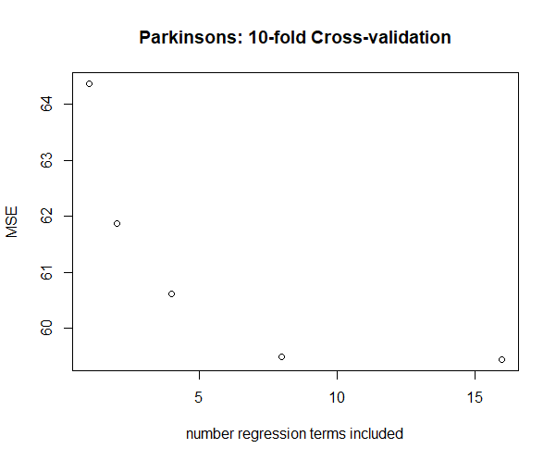

This figure shows that, as more regression terms/variables are included in models for cross-validation, the mean squared error decreases. This is because as more significant variables are added to the model, the error decreases and the accuracy of the model increases.