To run the project:

* Open a Terminal from the quick-launch bar at the bottom of the screen and navigate to the right location (Copy & Paste cd /opt/eclipse-ws/testingproject/bsk and hit Enter). Please *do not use the Eclipse JUnit Runner*.
* Open a second Terminal and launch Eclipse with the command eclipse &
* If the project is not imported, import the project into Eclipse (Right click in the Project Explorer, select Import -> Maven -> Existing Maven Projects -> browse to the location from above)
* Insert whatever breakpoints you feel like. If you just want to run the tests, and not debug them, leave out breakpoints, but follow the rest of these steps.
* **If you do not want to use Eclipse, run the provided runner_noide.sh script instead, and do your development from a text editor such as nano or vim. You may skip the rest of these instructions**.
* Run the provided runner.sh script (./runner.sh from a terminal open to the right location)
* In Eclipse, open Debug Perspective (Window -> Perspective -> Open Perspective -> Debug)
* Click the arrow to the right of the Debug button, then Debug Configurations
* Select "Remote Java Applications", then click "New Launch Configuration"; set "Port" to 5005, and check "Allow termination of remote VM". Your window should look like the following:

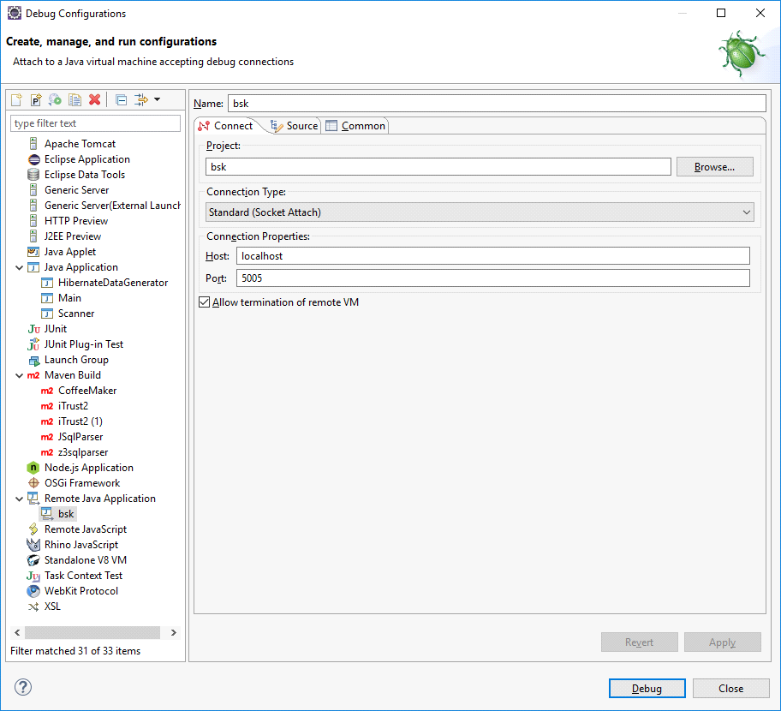

* Click Apply -> Debug
* You should now have access to the Eclipse debugger and all results will be saved

Now that the debug configuration is setup, in the future to run things, you can just hit the up arrow and then "Enter" key from your terminal to rerun the script, and click on the "Debug" button in Eclipse to reuse the configuration created previously.

Information about what tests passed and what failed will be printed to your console.

To run a subset of the tests, runner.sh accepts optional arguments as follows:

* ./runner.sh will run everything
* ./runner.sh US04 will run everything in the class US04
* ./runner.sh US04#testGetFrame will run just the testGetFrame method from the US04 class