D3. Project development: descriptive analysis

#7TotaldescriptivaClean5.Rmd #install.packages(“rmarkdown”) #library(“rmarkdown”)

## Introduction

This document provides the initial univariate descriptive statistics of the raw variables in the hotel booking dataset.

#loading libraries install.packages(“ggplot2”) library(ggplot2) install.packages(“dplyr”) library(dplyr)

#WARNING: data must have been properly declared before (factors, dates…)

#Set the folder where the word file is going to be generated

#without including the R instruction in the final document

## [1] "data.frame"

#Get dimensions of the dataset

## [1] 5000 36

## [1] 5000

## [1] 36

#Check the variables

## [1] "hotel" "is_canceled"   
## [3] "lead_time" "arrival_date_year"   
## [5] "arrival_date_month" "arrival_date_week_number"   
## [7] "arrival_date_day_of_month" "stays_in_weekend_nights"   
## [9] "stays_in_week_nights" "adults"   
## [11] "children" "babies"   
## [13] "meal" "country"   
## [15] "market_segment" "distribution_channel"   
## [17] "is_repeated_guest" "previous_cancellations"   
## [19] "previous_bookings_not_canceled" "reserved_room_type"   
## [21] "assigned_room_type" "booking_changes"   
## [23] "deposit_type" "agent"   
## [25] "company" "days_in_waiting_list"   
## [27] "customer_type" "adr"   
## [29] "required_car_parking_spaces" "total_of_special_requests"   
## [31] "reservation_status" "reservation_status_date"   
## [33] "name" "email"   
## [35] "phone.number" "credit_card"

## 'data.frame': 5000 obs. of 36 variables:  
## $ hotel : chr "Resort Hotel" "City Hotel" "City Hotel" "City Hotel" ...  
## $ is_canceled : int 0 1 1 0 1 0 0 0 1 0 ...  
## $ lead_time : int 37 121 50 76 73 26 394 14 47 8 ...  
## $ arrival_date_year : int 2015 2017 2015 2016 2017 2017 2017 2015 2015 2015 ...  
## $ arrival_date_month : chr "August" "August" "August" "May" ...  
## $ arrival_date_week_number : int 35 32 35 21 17 34 20 39 44 37 ...  
## $ arrival_date_day_of_month : int 23 10 25 17 23 21 16 26 25 9 ...  
## $ stays_in_weekend_nights : int 2 2 0 0 2 1 0 2 2 0 ...  
## $ stays_in_week_nights : int 3 5 4 2 2 5 4 1 4 4 ...  
## $ adults : int 2 2 2 1 1 2 2 1 2 2 ...  
## $ children : int 1 0 0 0 0 0 0 0 1 0 ...  
## $ babies : int 0 0 0 0 0 0 0 0 0 0 ...  
## $ meal : chr "BB" "BB" "BB" "BB" ...  
## $ country : chr "PRT" "BEL" "PRT" "GBR" ...  
## $ market_segment : chr "Online TA" "Direct" "Groups" "Corporate" ...  
## $ distribution_channel : chr "TA/TO" "Direct" "TA/TO" "TA/TO" ...  
## $ is_repeated_guest : int 0 0 0 0 0 0 0 0 0 0 ...  
## $ previous_cancellations : int 0 0 0 0 0 0 0 0 0 0 ...  
## $ previous_bookings_not_canceled: int 0 0 0 0 0 0 0 0 0 0 ...  
## $ reserved_room_type : chr "A" "A" "A" "A" ...  
## $ assigned_room_type : chr "D" "A" "A" "A" ...  
## $ booking_changes : int 0 0 0 0 0 0 4 0 0 0 ...  
## $ deposit_type : chr "No Deposit" "No Deposit" "No Deposit" "No Deposit" ...  
## $ agent : int 241 14 1 NA 7 240 229 9 66 27 ...  
## $ company : int NA NA NA 218 NA NA NA NA NA NA ...  
## $ days_in_waiting_list : int 0 0 0 12 0 0 0 0 0 0 ...  
## $ customer_type : chr "Transient" "Transient" "Transient-Party" "Transient-Party" ...  
## $ adr : num 143 112 62 130 117 ...  
## $ required_car_parking_spaces : int 0 0 0 0 0 0 0 0 0 0 ...  
## $ total_of_special_requests : int 3 0 0 0 0 1 1 0 2 0 ...  
## $ reservation_status : chr "Check-Out" "Canceled" "Canceled" "Check-Out" ...  
## $ reservation_status_date : chr "2015-08-28" "2017-04-18" "2015-08-06" "2016-05-19" ...  
## $ name : chr "Melinda Marshall" "Jennifer Vasquez" "Brenda Green" "Angel Perez" ...  
## $ email : chr "Melinda.M@zoho.com" "Jennifer_V@gmail.com" "Brenda.Green@yandex.com" "APerez@verizon.com" ...  
## $ phone.number : chr "382-323-6516" "651-117-0165" "494-110-3051" "301-328-9144" ...  
## $ credit_card : chr "************2846" "************5640" "************6389" "************7175" ...

## hotel is_canceled lead_time arrival_date_year arrival_date_month  
## 1 Resort Hotel 0 37 2015 August  
## 2 City Hotel 1 121 2017 August  
## 3 City Hotel 1 50 2015 August  
## 4 City Hotel 0 76 2016 May  
## 5 City Hotel 1 73 2017 April  
## 6 Resort Hotel 0 26 2017 August  
## arrival_date_week_number arrival_date_day_of_month stays_in_weekend_nights  
## 1 35 23 2  
## 2 32 10 2  
## 3 35 25 0  
## 4 21 17 0  
## 5 17 23 2  
## 6 34 21 1  
## stays_in_week_nights adults children babies meal country market_segment  
## 1 3 2 1 0 BB PRT Online TA  
## 2 5 2 0 0 BB BEL Direct  
## 3 4 2 0 0 BB PRT Groups  
## 4 2 1 0 0 BB GBR Corporate  
## 5 2 1 0 0 BB PRT Online TA  
## 6 5 2 0 0 BB IRL Online TA  
## distribution_channel is_repeated_guest previous_cancellations  
## 1 TA/TO 0 0  
## 2 Direct 0 0  
## 3 TA/TO 0 0  
## 4 TA/TO 0 0  
## 5 TA/TO 0 0  
## 6 TA/TO 0 0  
## previous_bookings_not_canceled reserved_room_type assigned_room_type  
## 1 0 A D  
## 2 0 A A  
## 3 0 A A  
## 4 0 A A  
## 5 0 A A  
## 6 0 A A  
## booking_changes deposit_type agent company days_in_waiting_list  
## 1 0 No Deposit 241 NA 0  
## 2 0 No Deposit 14 NA 0  
## 3 0 No Deposit 1 NA 0  
## 4 0 No Deposit NA 218 12  
## 5 0 No Deposit 7 NA 0  
## 6 0 No Deposit 240 NA 0  
## customer_type adr required_car_parking_spaces total_of_special_requests  
## 1 Transient 143.34 0 3  
## 2 Transient 112.50 0 0  
## 3 Transient-Party 62.00 0 0  
## 4 Transient-Party 130.00 0 0  
## 5 Transient 117.00 0 0  
## 6 Transient 230.00 0 1  
## reservation_status reservation_status_date name  
## 1 Check-Out 2015-08-28 Melinda Marshall  
## 2 Canceled 2017-04-18 Jennifer Vasquez  
## 3 Canceled 2015-08-06 Brenda Green  
## 4 Check-Out 2016-05-19 Angel Perez  
## 5 Canceled 2017-02-09 Ryan Wallace  
## 6 Check-Out 2017-08-27 Brittany Leach  
## email phone.number credit_card  
## 1 Melinda.M@zoho.com 382-323-6516 ************2846  
## 2 Jennifer_V@gmail.com 651-117-0165 ************5640  
## 3 Brenda.Green@yandex.com 494-110-3051 ************6389  
## 4 APerez@verizon.com 301-328-9144 ************7175  
## 5 Wallace_Ryan@yandex.com 455-364-9935 ************1286  
## 6 BrittanyLeach@att.com 777-364-2874 ************8272

## hotel is_canceled lead_time arrival_date_year  
## Length:5000 Min. :0.0000 Min. : 0.0 Min. :2015   
## Class :character 1st Qu.:0.0000 1st Qu.: 18.0 1st Qu.:2016   
## Mode :character Median :0.0000 Median : 69.0 Median :2016   
## Mean :0.3564 Mean :105.3 Mean :2016   
## 3rd Qu.:1.0000 3rd Qu.:160.0 3rd Qu.:2017   
## Max. :1.0000 Max. :629.0 Max. :2017   
##   
## arrival_date_month arrival_date_week_number arrival_date_day_of_month  
## Length:5000 Min. : 1.00 Min. : 1.00   
## Class :character 1st Qu.:16.00 1st Qu.: 8.00   
## Mode :character Median :27.00 Median :16.00   
## Mean :27.03 Mean :15.75   
## 3rd Qu.:38.00 3rd Qu.:23.00   
## Max. :53.00 Max. :31.00   
##   
## stays_in_weekend_nights stays_in_week_nights adults children   
## Min. :0.0000 Min. : 0.000 Min. :0.000 Min. :0.0000   
## 1st Qu.:0.0000 1st Qu.: 1.000 1st Qu.:2.000 1st Qu.:0.0000   
## Median :1.0000 Median : 2.000 Median :2.000 Median :0.0000   
## Mean :0.9478 Mean : 2.522 Mean :1.862 Mean :0.1024   
## 3rd Qu.:2.0000 3rd Qu.: 3.000 3rd Qu.:2.000 3rd Qu.:0.0000   
## Max. :8.0000 Max. :20.000 Max. :4.000 Max. :3.0000   
##   
## babies meal country market_segment   
## Min. :0.0000 Length:5000 Length:5000 Length:5000   
## 1st Qu.:0.0000 Class :character Class :character Class :character   
## Median :0.0000 Mode :character Mode :character Mode :character   
## Mean :0.0076   
## 3rd Qu.:0.0000   
## Max. :1.0000   
##   
## distribution_channel is_repeated_guest previous_cancellations  
## Length:5000 Min. :0.0000 Min. : 0.0000   
## Class :character 1st Qu.:0.0000 1st Qu.: 0.0000   
## Mode :character Median :0.0000 Median : 0.0000   
## Mean :0.0306 Mean : 0.0732   
## 3rd Qu.:0.0000 3rd Qu.: 0.0000   
## Max. :1.0000 Max. :26.0000   
##   
## previous_bookings_not_canceled reserved_room_type assigned_room_type  
## Min. : 0.0000 Length:5000 Length:5000   
## 1st Qu.: 0.0000 Class :character Class :character   
## Median : 0.0000 Mode :character Mode :character   
## Mean : 0.1268   
## 3rd Qu.: 0.0000   
## Max. :60.0000   
##   
## booking_changes deposit_type agent company   
## Min. : 0.0000 Length:5000 Min. : 1.00 Min. : 8.0   
## 1st Qu.: 0.0000 Class :character 1st Qu.: 9.00 1st Qu.: 67.0   
## Median : 0.0000 Mode :character Median : 14.00 Median :208.0   
## Mean : 0.2156 Mean : 87.69 Mean :195.6   
## 3rd Qu.: 0.0000 3rd Qu.:229.00 3rd Qu.:278.0   
## Max. :15.0000 Max. :531.00 Max. :531.0   
## NA's :678 NA's :4710   
## days_in_waiting_list customer_type adr   
## Min. : 0.00 Length:5000 Min. : 0.0   
## 1st Qu.: 0.00 Class :character 1st Qu.: 71.0   
## Median : 0.00 Mode :character Median : 96.0   
## Mean : 2.71 Mean :103.3   
## 3rd Qu.: 0.00 3rd Qu.:127.3   
## Max. :391.00 Max. :508.0   
##   
## required_car_parking_spaces total_of_special_requests reservation_status  
## Min. :0.0000 Min. :0.000 Length:5000   
## 1st Qu.:0.0000 1st Qu.:0.000 Class :character   
## Median :0.0000 Median :0.000 Mode :character   
## Mean :0.0692 Mean :0.593   
## 3rd Qu.:0.0000 3rd Qu.:1.000   
## Max. :8.0000 Max. :5.000   
##   
## reservation_status_date name email   
## Length:5000 Length:5000 Length:5000   
## Class :character Class :character Class :character   
## Mode :character Mode :character Mode :character   
##   
##   
##   
##   
## phone.number credit_card   
## Length:5000 Length:5000   
## Class :character Class :character   
## Mode :character Mode :character   
##   
##   
##   
##

#Decide if you need to declare some more factor or date

##   
## Adjuntando el paquete: 'dplyr'

## The following objects are masked from 'package:stats':  
##   
## filter, lag

## The following objects are masked from 'package:base':  
##   
## intersect, setdiff, setequal, union

## 'data.frame': 5000 obs. of 33 variables:  
## $ hotel : Factor w/ 2 levels "City Hotel","Resort Hotel": 2 1 1 1 1 2 1 1 1 1 ...  
## $ is_canceled : Factor w/ 2 levels "0","1": 1 2 2 1 2 1 1 1 2 1 ...  
## $ lead_time : int 37 121 50 76 73 26 394 14 47 8 ...  
## $ arrival_date_year : Factor w/ 3 levels "2015","2016",..: 1 3 1 2 3 3 3 1 1 1 ...  
## $ arrival_date_month : Factor w/ 12 levels "1","2","3","4",..: 8 8 8 5 4 8 5 9 10 9 ...  
## ..- attr(*, "names")= chr [1:5000] "August" "August" "August" "May" ...  
## $ arrival_date_week_number : int 35 32 35 21 17 34 20 39 44 37 ...  
## $ arrival_date_day_of_month : Factor w/ 31 levels "1","2","3","4",..: 23 10 25 17 23 21 16 26 25 9 ...  
## $ stays_in_weekend_nights : int 2 2 0 0 2 1 0 2 2 0 ...  
## $ stays_in_week_nights : int 3 5 4 2 2 5 4 1 4 4 ...  
## $ adults : int 2 2 2 1 1 2 2 1 2 2 ...  
## $ children : int 1 0 0 0 0 0 0 0 1 0 ...  
## $ babies : int 0 0 0 0 0 0 0 0 0 0 ...  
## $ meal : Factor w/ 5 levels "BB","FB","HB",..: 1 1 1 1 1 1 1 4 3 1 ...  
## $ country : Factor w/ 89 levels "","AGO","ARE",..: 71 7 71 32 71 40 5 6 71 22 ...  
## $ market_segment : Factor w/ 7 levels "Aviation","Complementary",..: 7 4 5 3 7 7 6 7 6 6 ...  
## $ distribution_channel : Factor w/ 4 levels "Corporate","Direct",..: 4 2 4 4 4 4 4 4 4 4 ...  
## $ is_repeated_guest : Factor w/ 2 levels "0","1": 1 1 1 1 1 1 1 1 1 1 ...  
## $ previous_cancellations : int 0 0 0 0 0 0 0 0 0 0 ...  
## $ previous_bookings_not_canceled: int 0 0 0 0 0 0 0 0 0 0 ...  
## $ reserved_room_type : Factor w/ 9 levels "A","B","C","D",..: 1 1 1 1 1 1 1 1 1 1 ...  
## $ assigned_room_type : Factor w/ 11 levels "A","B","C","D",..: 4 1 1 1 1 1 1 4 1 1 ...  
## $ booking_changes : int 0 0 0 0 0 0 4 0 0 0 ...  
## $ deposit_type : Factor w/ 3 levels "No Deposit","Non Refund",..: 1 1 1 1 1 1 1 1 1 1 ...  
## $ agent : int 241 14 1 NA 7 240 229 9 66 27 ...  
## $ company : Factor w/ 100 levels "8","9","12","20",..: NA NA NA 45 NA NA NA NA NA NA ...  
## $ days_in_waiting_list : int 0 0 0 12 0 0 0 0 0 0 ...  
## $ customer_type : Factor w/ 4 levels "Contract","Group",..: 3 3 4 4 3 3 4 3 4 3 ...  
## $ adr : num 143 112 62 130 117 ...  
## $ required_car_parking_spaces : int 0 0 0 0 0 0 0 0 0 0 ...  
## $ total_of_special_requests : int 3 0 0 0 0 1 1 0 2 0 ...  
## $ reservation_status : Factor w/ 3 levels "Canceled","Check-Out",..: 2 1 1 2 1 2 2 2 1 2 ...  
## $ reservation_status_date : chr "2015-08-28" "2017-04-18" "2015-08-06" "2016-05-19" ...  
## $ arrival_date : Date, format: "2015-08-23" "2017-08-10" ...

#Calculation of mean, median and standard deviation

## lead_time_mean arrival_date_week_number_mean stays_in_weekend_nights_mean  
## 1 105.29 27.0298 0.9478  
## stays_in_week_nights_mean adults_mean children_mean babies_mean  
## 1 2.5218 1.8624 0.1024 0.0076  
## previous_cancellations_mean previous_bookings_not_canceled_mean  
## 1 0.0732 0.1268  
## booking_changes_mean agent_mean days_in_waiting_list_mean adr_mean  
## 1 0.2156 87.69366 2.7102 103.3156  
## required_car_parking_spaces_mean total_of_special_requests_mean  
## 1 0.0692 0.593  
## lead_time_median arrival_date_week_number_median  
## 1 69 27  
## stays_in_weekend_nights_median stays_in_week_nights_median adults_median  
## 1 1 2 2  
## children_median babies_median previous_cancellations_median  
## 1 0 0 0  
## previous_bookings_not_canceled_median booking_changes_median agent_median  
## 1 0 0 14  
## days_in_waiting_list_median adr_median required_car_parking_spaces_median  
## 1 0 96 0  
## total_of_special_requests_median lead_time_sd arrival_date_week_number_sd  
## 1 0 109.1437 13.53047  
## stays_in_weekend_nights_sd stays_in_week_nights_sd adults_sd children_sd  
## 1 0.9966312 1.876654 0.4836456 0.397927  
## babies_sd previous_cancellations_sd previous_bookings_not_canceled_sd  
## 1 0.08685476 0.7688693 1.471175  
## booking_changes_sd agent_sd days_in_waiting_list_sd adr_sd  
## 1 0.6477658 111.111 19.2902 48.83188  
## required_car_parking_spaces_sd total_of_special_requests_sd lead_time_var  
## 1 0.2757292 0.8128242 11912.35  
## arrival_date_week_number_var stays_in_weekend_nights_var  
## 1 183.0735 0.9932738  
## stays_in_week_nights_var adults_var children_var babies_var  
## 1 3.521829 0.233913 0.1583459 0.007543749  
## previous_cancellations_var previous_bookings_not_canceled_var  
## 1 0.59116 2.164355  
## booking_changes_var agent_var days_in_waiting_list_var adr_var  
## 1 0.4196006 12345.66 372.1118 2384.552  
## required_car_parking_spaces_var total_of_special_requests_var  
## 1 0.07602657 0.6606831

#Given scheme for descriptive analyis

#Basic descriptive analysis for numerical variables #(decide the maximum number of colors you can need in a graph based on your metadata file)

## [1] "variable 1 : hotel"

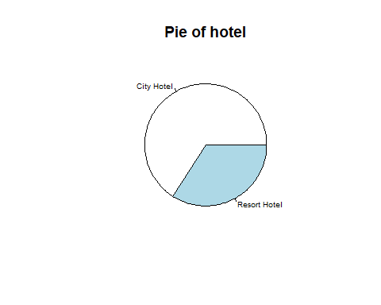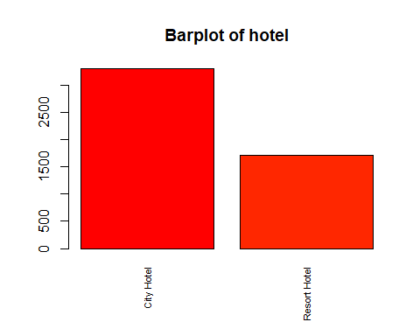

## [1] "Number of modalities: 2"  
## [1] "Frequency table"  
##   
## City Hotel Resort Hotel   
## 3297   
## [1] "Relative frequency table (proportions)"  
##   
## City Hotel Resort Hotel   
## 0.6594 0.3406   
## [1] "Frequency table sorted"  
##   
## City Hotel Resort Hotel   
## 3297 1703   
## [1] "Relative frequency table (proportions) sorted"  
##   
## City Hotel Resort Hotel   
## 0.6594 0.3406   
## [1] "variable 2 : is_canceled"

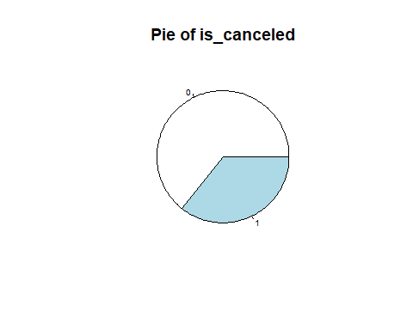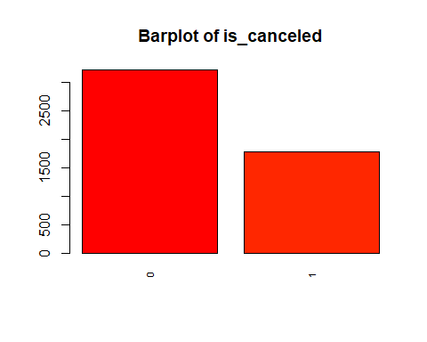

## [1] "Number of modalities: 2"  
## [1] "Frequency table"  
##   
## 0 1   
## 3218 1782   
## [1] "Relative frequency table (proportions)"  
##   
## 0 1   
## 0.6436 0.3564   
## [1] "Frequency table sorted"  
##   
## 0 1   
## 3218 1782   
## [1] "Relative frequency table (proportions) sorted"  
##   
## 0 1   
## 0.6436 0.3564   
## [1] "variable 3 : lead_time"

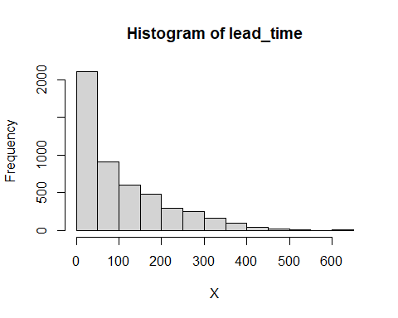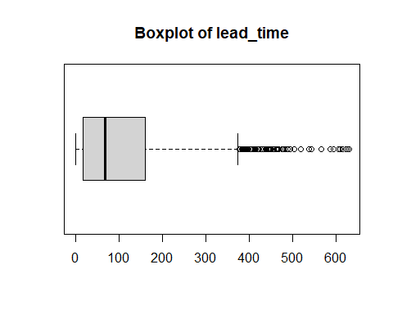

## [1] "Extended Summary Statistics"  
## Min. 1st Qu. Median Mean 3rd Qu. Max.   
## 0.0 18.0 69.0 105.3 160.0 629.0   
## [1] "sd: 3695966711"  
## [1] "vc: 1.03660077848524"  
## [1] "variable 4 : arrival_date_year"

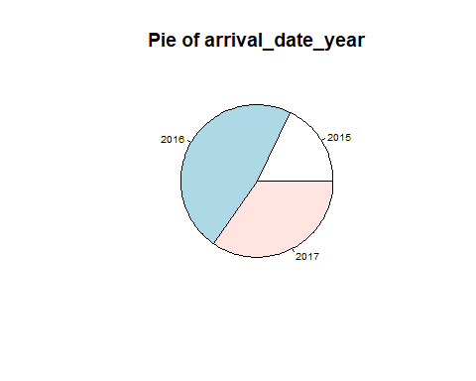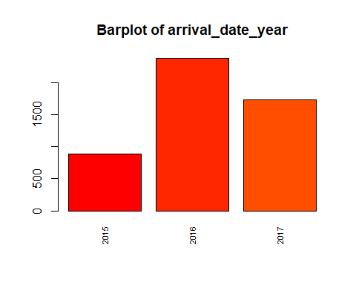

## [1] "Number of modalities: 3"  
## [1] "Frequency table"  
##   
## 2015 2016 2017   
## 889 2377 1734   
## [1] "Relative frequency table (proportions)"  
##   
## 2015 2016 2017   
## 0.1778 0.4754 0.3468   
## [1] "Frequency table sorted"  
##   
## 2016 2017 2015   
## 2377 1734 889   
## [1] "Relative frequency table (proportions) sorted"  
##   
## 2016 2017 2015   
## 0.4754 0.3468 0.1778   
## [1] "variable 5 : arrival_date_month"

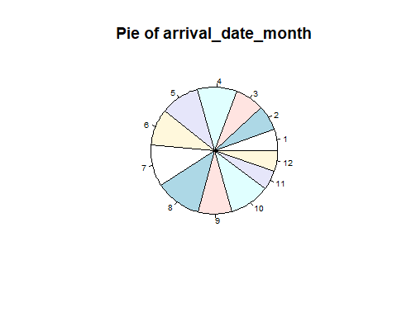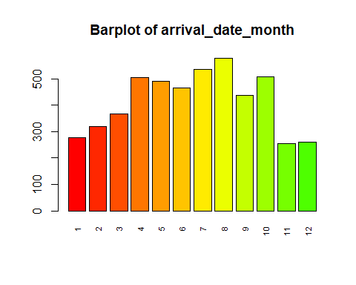

## [1] "Number of modalities: 12"  
## [1] "Frequency table"  
##   
## 1 2 3 4 5 6 7 8 9 10 11 12   
## 276 320 367 505 491 465 537 578 439 507 254 261   
## [1] "Relative frequency table (proportions)"  
##   
## 1 2 3 4 5 6 7 8 9 10 11   
## 0.0552 0.0640 0.0734 0.1010 0.0982 0.0930 0.1074 0.1156 0.0878 0.1014 0.0508   
## 12   
## 0.0522   
## [1] "Frequency table sorted"  
##   
## 8 7 10 4 5 6 9 3 2 1 12 11   
## 578 537 507 505 491 465 439 367 320 276 261 254   
## [1] "Relative frequency table (proportions) sorted"  
##   
## 8 7 10 4 5 6 9 3 2 1 12   
## 0.1156 0.1074 0.1014 0.1010 0.0982 0.0930 0.0878 0.0734 0.0640 0.0552 0.0522   
## 11   
## 0.0508   
## [1] "variable 6 : arrival_date_week_number"

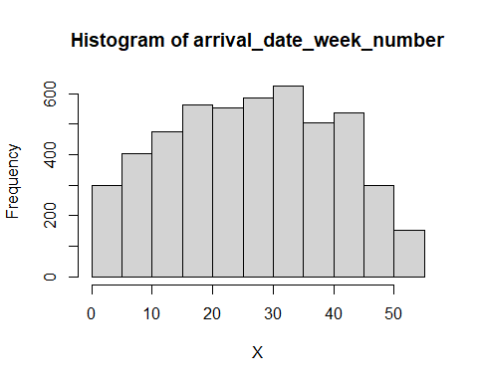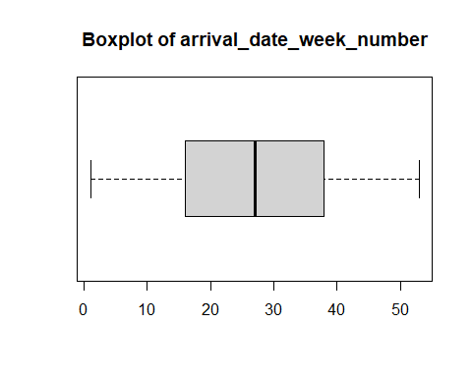

## [1] "Extended Summary Statistics"  
## Min. 1st Qu. Median Mean 3rd Qu. Max.   
## 1.00 16.00 27.00 27.03 38.00 53.00   
## [1] "sd: 13.5304666092982"  
## [1] "vc: 0.500575905456133"  
## [1] "variable 7 : arrival_date_day_of_month"

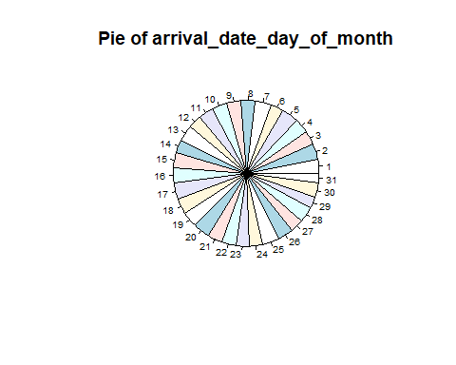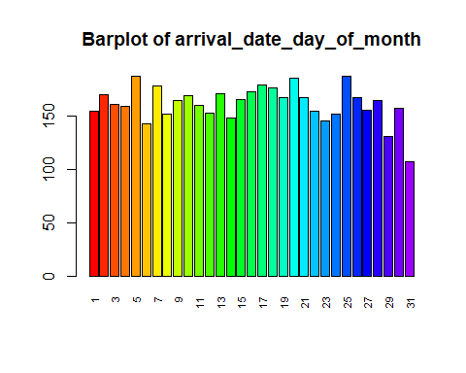

## [1] "Number of modalities: 31"  
## [1] "Frequency table"  
##   
## 1 2 3 4 5 6 7 8 9 10 11 12 13 14 15 16 17 18 19 20   
## 154 170 161 159 187 143 178 152 164 169 160 153 171 148 165 173 179 176 167 185   
## 21 22 23 24 25 26 27 28 29 30 31   
## 167 154 145 152 187 167 155 164 131 157 107   
## [1] "Relative frequency table (proportions)"  
##   
## 1 2 3 4 5 6 7 8 9 10 11   
## 0.0308 0.0340 0.0322 0.0318 0.0374 0.0286 0.0356 0.0304 0.0328 0.0338 0.0320   
## 12 13 14 15 16 17 18 19 20 21 22   
## 0.0306 0.0342 0.0296 0.0330 0.0346 0.0358 0.0352 0.0334 0.0370 0.0334 0.0308   
## 23 24 25 26 27 28 29 30 31   
## 0.0290 0.0304 0.0374 0.0334 0.0310 0.0328 0.0262 0.0314 0.0214   
## [1] "Frequency table sorted"  
##   
## 5 25 20 17 7 18 16 13 2 10 19 21 26 15 9 28 3 11 4 30   
## 187 187 185 179 178 176 173 171 170 169 167 167 167 165 164 164 161 160 159 157   
## 27 1 22 12 8 24 14 23 6 29 31   
## 155 154 154 153 152 152 148 145 143 131 107   
## [1] "Relative frequency table (proportions) sorted"  
##   
## 5 25 20 17 7 18 16 13 2 10 19   
## 0.0374 0.0374 0.0370 0.0358 0.0356 0.0352 0.0346 0.0342 0.0340 0.0338 0.0334   
## 21 26 15 9 28 3 11 4 30 27 1   
## 0.0334 0.0334 0.0330 0.0328 0.0328 0.0322 0.0320 0.0318 0.0314 0.0310 0.0308   
## 22 12 8 24 14 23 6 29 31   
## 0.0308 0.0306 0.0304 0.0304 0.0296 0.0290 0.0286 0.0262 0.0214   
## [1] "variable 8 : stays_in_weekend_nights"

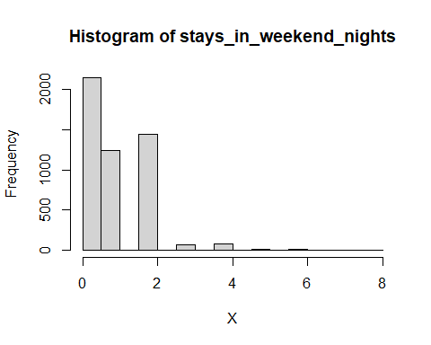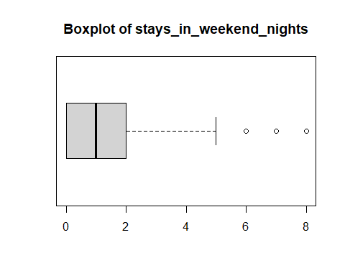

## [1] "Extended Summary Statistics"  
## Min. 1st Qu. Median Mean 3rd Qu. Max.   
## 0.0000 0.0000 1.0000 0.9478 2.0000 8.0000   
## [1] "sd: 0.996631233086217"  
## [1] "vc: 1.05152060886919"  
## [1] "variable 9 : stays_in_week_nights"

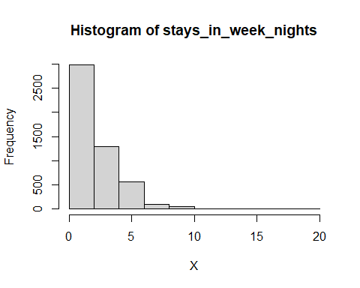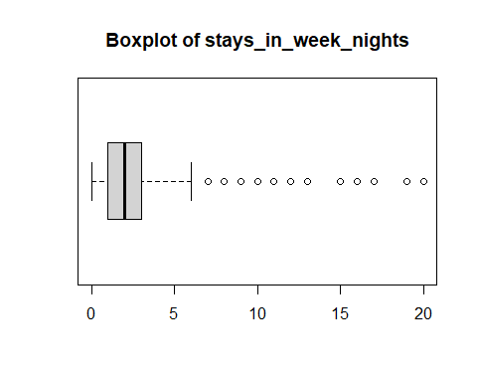

## [1] "Extended Summary Statistics"  
## Min. 1st Qu. Median Mean 3rd Qu. Max.   
## 0.000 1.000 2.000 2.522 3.000 20.000   
## [1] "sd: 1.87665370428994"  
## [1] "vc: 0.744172299266374"  
## [1] "variable 10 : adults"

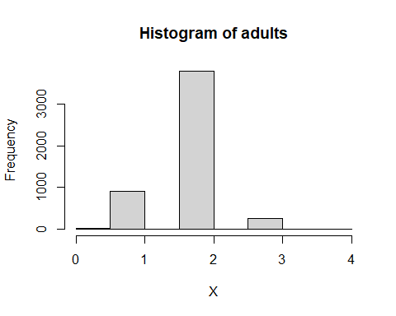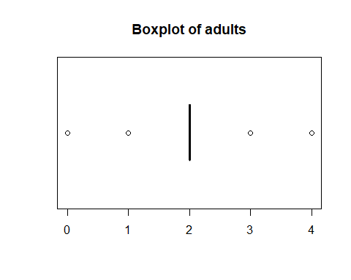

## [1] "Extended Summary Statistics"  
## Min. 1st Qu. Median Mean 3rd Qu. Max.   
## 0.000 2.000 2.000 1.862 2.000 4.000   
## [1] "sd: 0.483645554724243"  
## [1] "vc: 0.259689408679254"  
## [1] "variable 11 : children"

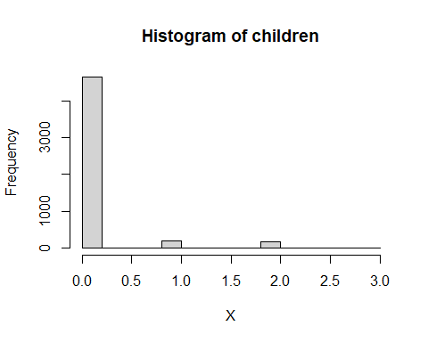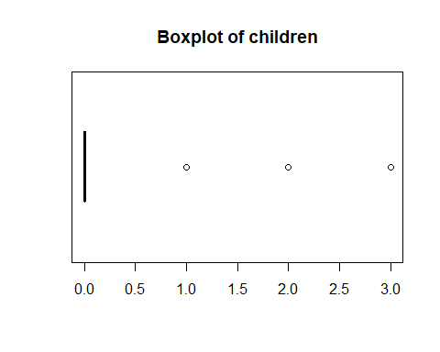

## [1] "Extended Summary Statistics"  
## Min. 1st Qu. Median Mean 3rd Qu. Max.   
## 0.0000 0.0000 0.0000 0.1024 0.0000 3.0000   
## [1] "sd: 0.397927014893229"  
## [1] "vc: 3.88600600481669"  
## [1] "variable 12 : babies"

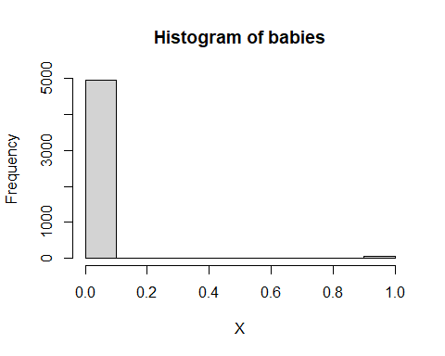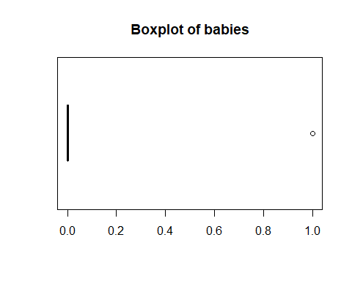

## [1] "Extended Summary Statistics"  
## Min. 1st Qu. Median Mean 3rd Qu. Max.   
## 0.0000 0.0000 0.0000 0.0076 0.0000 1.0000   
## [1] "sd: 0.0868547566328405"  
## [1] "vc: 11.4282574516895"  
## [1] "variable 13 : meal"

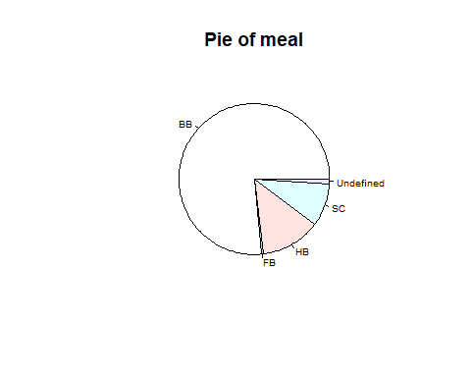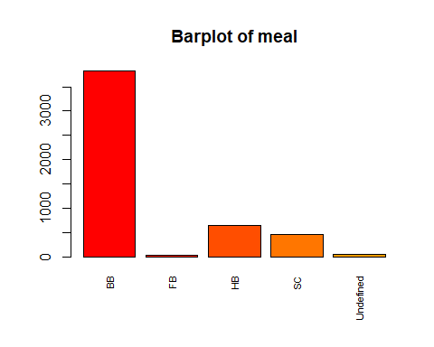

## [1] "Number of modalities: 5"  
## [1] "Frequency table"  
##   
## BB FB HB SC Undefined   
## 3822 28 637 464 49   
## [1] "Relative frequency table (proportions)"  
##   
## BB FB HB SC Undefined   
## 0.7644 0.0056 0.1274 0.0928 0.0098   
## [1] "Frequency table sorted"  
##   
## BB HB SC Undefined FB   
## 3822 637 464 49 28   
## [1] "Relative frequency table (proportions) sorted"  
##   
## BB HB SC Undefined FB   
## 0.7644 0.1274 0.0928 0.0098 0.0056   
## [1] "variable 14 : country"

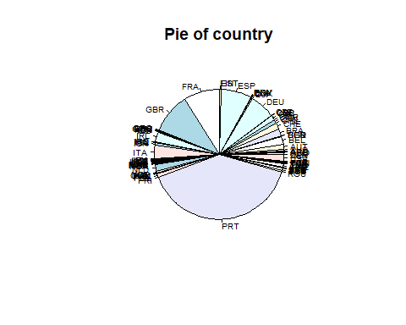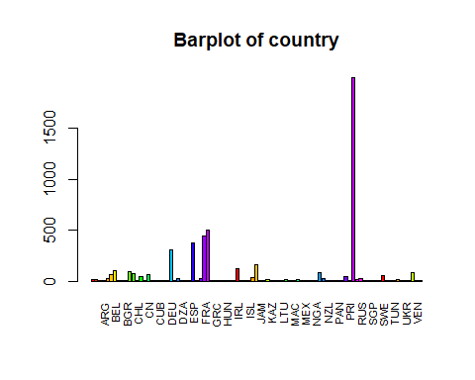x

## [1] "Number of modalities: 89"  
## [1] "Frequency table"  
##   
## AGO ARE ARG AUS AUT BEL BEN BGD BGR BRA CHE CHL CHN CMR CN   
## 17 15 3 9 20 60 100 1 1 2 95 77 4 41 1 59   
## COL CRI CUB CYP CZE DEU DJI DNK DZA ECU EGY ESP EST FIN FRA GBR   
## 1 1 1 1 6 303 1 21 5 2 1 375 3 24 445 500   
## GEO GRC GTM HRV HUN IDN IND IRL IRN IRQ ISL ISR ITA JAM JEY JPN   
## 3 7 1 2 7 1 6 125 4 3 2 33 164 1 1 12   
## KAZ KOR LCA LTU LUX LVA MAC MAR MDV MEX MOZ NAM NGA NLD NOR NZL   
## 1 8 1 6 16 2 1 11 1 2 2 1 2 85 25 2   
## OMN PAK PAN PHL POL PRI PRT ROU RUS SAU SEN SGP SRB SVK SWE TGO   
## 2 1 1 1 48 1 1995 19 26 2 2 1 6 1 49 1   
## THA TUN TUR TWN UKR URY USA VEN ZAF   
## 5 2 13 3 4 2 79 1 2   
## [1] "Relative frequency table (proportions)"  
##   
## AGO ARE ARG AUS AUT BEL BEN BGD BGR BRA   
## 0.0034 0.0030 0.0006 0.0018 0.0040 0.0120 0.0200 0.0002 0.0002 0.0004 0.0190   
## CHE CHL CHN CMR CN COL CRI CUB CYP CZE DEU   
## 0.0154 0.0008 0.0082 0.0002 0.0118 0.0002 0.0002 0.0002 0.0002 0.0012 0.0606   
## DJI DNK DZA ECU EGY ESP EST FIN FRA GBR GEO   
## 0.0002 0.0042 0.0010 0.0004 0.0002 0.0750 0.0006 0.0048 0.0890 0.1000 0.0006   
## GRC GTM HRV HUN IDN IND IRL IRN IRQ ISL ISR   
## 0.0014 0.0002 0.0004 0.0014 0.0002 0.0012 0.0250 0.0008 0.0006 0.0004 0.0066   
## ITA JAM JEY JPN KAZ KOR LCA LTU LUX LVA MAC   
## 0.0328 0.0002 0.0002 0.0024 0.0002 0.0016 0.0002 0.0012 0.0032 0.0004 0.0002   
## MAR MDV MEX MOZ NAM NGA NLD NOR NZL OMN PAK   
## 0.0022 0.0002 0.0004 0.0004 0.0002 0.0004 0.0170 0.0050 0.0004 0.0004 0.0002   
## PAN PHL POL PRI PRT ROU RUS SAU SEN SGP SRB   
## 0.0002 0.0002 0.0096 0.0002 0.3990 0.0038 0.0052 0.0004 0.0004 0.0002 0.0012   
## SVK SWE TGO THA TUN TUR TWN UKR URY USA VEN   
## 0.0002 0.0098 0.0002 0.0010 0.0004 0.0026 0.0006 0.0008 0.0004 0.0158 0.0002   
## ZAF   
## 0.0004   
## [1] "Frequency table sorted"  
##   
## PRT GBR FRA ESP DEU ITA IRL BEL BRA NLD USA CHE AUT CN SWE POL   
## 1995 500 445 375 303 164 125 100 95 85 79 77 60 59 49 48   
## CHN ISR RUS NOR FIN DNK AUS ROU LUX AGO TUR JPN MAR ARG KOR   
## 41 33 26 25 24 21 20 19 17 16 15 13 12 11 9 8   
## GRC HUN CZE IND LTU SRB DZA THA CHL IRN UKR ARE EST GEO IRQ TWN   
## 7 7 6 6 6 6 5 5 4 4 4 3 3 3 3 3   
## BGR ECU HRV ISL LVA MEX MOZ NGA NZL OMN SAU SEN TUN URY ZAF BEN   
## 2 2 2 2 2 2 2 2 2 2 2 2 2 2 2 1   
## BGD CMR COL CRI CUB CYP DJI EGY GTM IDN JAM JEY KAZ LCA MAC MDV   
## 1 1 1 1 1 1 1 1 1 1 1 1 1 1 1 1   
## NAM PAK PAN PHL PRI SGP SVK TGO VEN   
## 1 1 1 1 1 1 1 1 1   
## [1] "Relative frequency table (proportions) sorted"  
##   
## PRT GBR FRA ESP DEU ITA IRL BEL BRA NLD USA   
## 0.3990 0.1000 0.0890 0.0750 0.0606 0.0328 0.0250 0.0200 0.0190 0.0170 0.0158   
## CHE AUT CN SWE POL CHN ISR RUS NOR FIN DNK   
## 0.0154 0.0120 0.0118 0.0098 0.0096 0.0082 0.0066 0.0052 0.0050 0.0048 0.0042   
## AUS ROU LUX AGO TUR JPN MAR ARG KOR GRC   
## 0.0040 0.0038 0.0034 0.0032 0.0030 0.0026 0.0024 0.0022 0.0018 0.0016 0.0014   
## HUN CZE IND LTU SRB DZA THA CHL IRN UKR ARE   
## 0.0014 0.0012 0.0012 0.0012 0.0012 0.0010 0.0010 0.0008 0.0008 0.0008 0.0006   
## EST GEO IRQ TWN BGR ECU HRV ISL LVA MEX MOZ   
## 0.0006 0.0006 0.0006 0.0006 0.0004 0.0004 0.0004 0.0004 0.0004 0.0004 0.0004   
## NGA NZL OMN SAU SEN TUN URY ZAF BEN BGD CMR   
## 0.0004 0.0004 0.0004 0.0004 0.0004 0.0004 0.0004 0.0004 0.0002 0.0002 0.0002   
## COL CRI CUB CYP DJI EGY GTM IDN JAM JEY KAZ   
## 0.0002 0.0002 0.0002 0.0002 0.0002 0.0002 0.0002 0.0002 0.0002 0.0002 0.0002   
## LCA MAC MDV NAM PAK PAN PHL PRI SGP SVK TGO   
## 0.0002 0.0002 0.0002 0.0002 0.0002 0.0002 0.0002 0.0002 0.0002 0.0002 0.0002   
## VEN   
## 0.0002   
## [1] "variable 15 : market_segment"

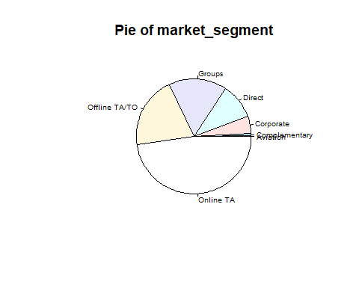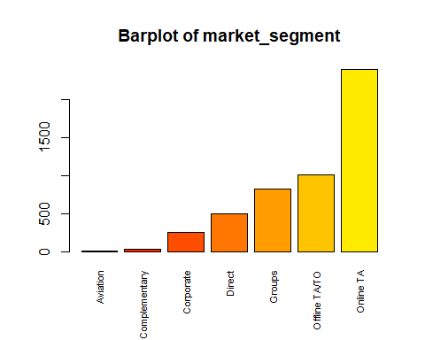

## [1] "Number of modalities: 7"  
## [1] "Frequency table"  
##   
## Aviation Complementary Corporate Direct Groups   
## 7 29 249 500 819   
## Offline TA/TO Online TA   
## 1008 2388   
## [1] "Relative frequency table (proportions)"  
##   
## Aviation Complementary Corporate Direct Groups   
## 0.0014 0.0058 0.0498 0.1000 0.1638   
## Offline TA/TO Online TA   
## 0.2016 0.4776   
## [1] "Frequency table sorted"  
##   
## Online TA Offline TA/TO Groups Direct Corporate   
## 2388 1008 819 500 249   
## Complementary Aviation   
## 29 7   
## [1] "Relative frequency table (proportions) sorted"  
##   
## Online TA Offline TA/TO Groups Direct Corporate   
## 0.4776 0.2016 0.1638 0.1000 0.0498   
## Complementary Aviation   
## 0.0058 0.0014   
## [1] "variable 16 : distribution_channel"

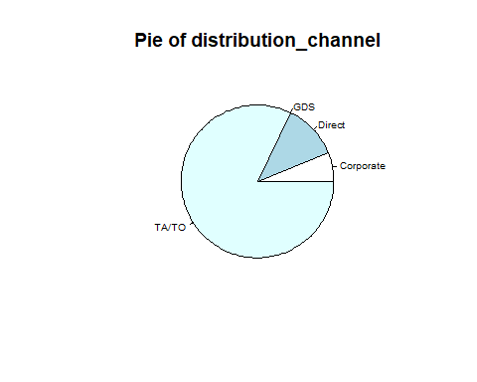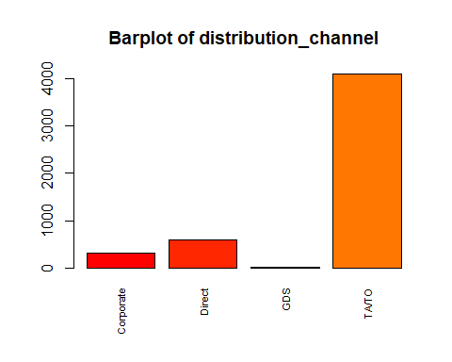

## [1] "Number of modalities: 4"  
## [1] "Frequency table"  
##   
## Corporate Direct GDS TA/TO   
## 303 589 4 4104   
## [1] "Relative frequency table (proportions)"  
##   
## Corporate Direct GDS TA/TO   
## 0.0606 0.1178 0.0008 0.8208   
## [1] "Frequency table sorted"  
##   
## TA/TO Direct Corporate GDS   
## 4104 589 303 4   
## [1] "Relative frequency table (proportions) sorted"  
##   
## TA/TO Direct Corporate GDS   
## 0.8208 0.1178 0.0606 0.0008   
## [1] "variable 17 : is_repeated_guest"

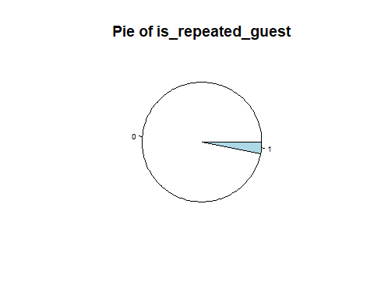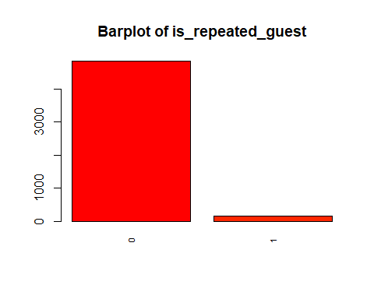

## [1] "Number of modalities: 2"  
## [1] "Frequency table"  
##   
## 0 1   
## 4847 153   
## [1] "Relative frequency table (proportions)"  
##   
## 0 1   
## 0.9694 0.0306   
## [1] "Frequency table sorted"  
##   
## 0 1   
## 4847 153   
## [1] "Relative frequency table (proportions) sorted"  
##   
## 0 1   
## 0.9694 0.0306   
## [1] "variable 18 : previous_cancellations"

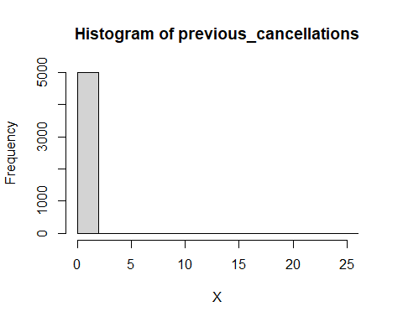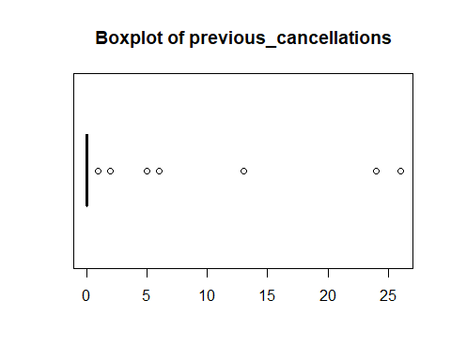

## [1] "Extended Summary Statistics"  
## Min. 1st Qu. Median Mean 3rd Qu. Max.   
## 0.0000 0.0000 0.0000 0.0732 0.0000 26.0000   
## [1] "sd: 0.768869294482749"  
## [1] "vc: 10.5036788863763"  
## [1] "variable 19 : previous_bookings_not_canceled"

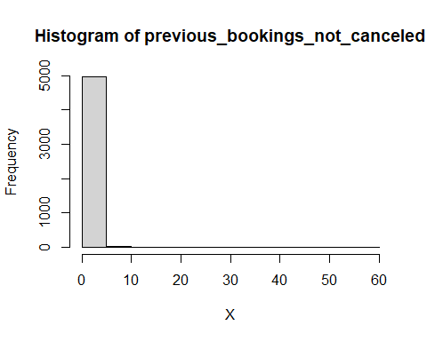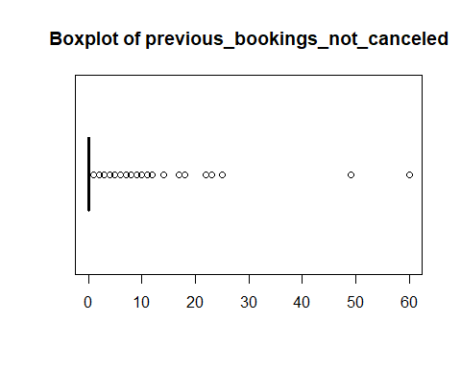

## [1] "Extended Summary Statistics"  
## Min. 1st Qu. Median Mean 3rd Qu. Max.   
## 0.0000 0.0000 0.0000 0.1268 0.0000 60.0000   
## [1] "sd: 1.47117457527181"  
## [1] "vc: 11.6023231488313"  
## [1] "variable 20 : reserved_room_type"

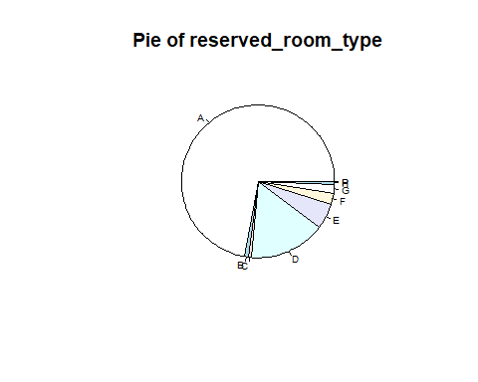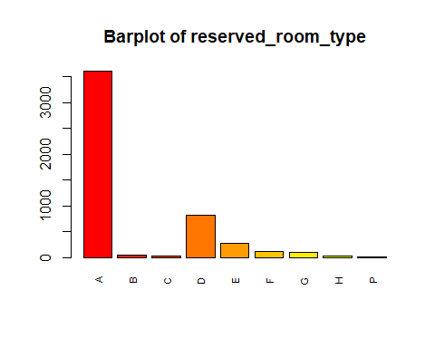

## [1] "Number of modalities: 9"  
## [1] "Frequency table"  
##   
## A B C D E F G H P   
## 3603 42 34 811 269 117 95 28 1   
## [1] "Relative frequency table (proportions)"  
##   
## A B C D E F G H P   
## 0.7206 0.0084 0.0068 0.1622 0.0538 0.0234 0.0190 0.0056 0.0002   
## [1] "Frequency table sorted"  
##   
## A D E F G B C H P   
## 3603 811 269 117 95 42 34 28 1   
## [1] "Relative frequency table (proportions) sorted"  
##   
## A D E F G B C H P   
## 0.7206 0.1622 0.0538 0.0234 0.0190 0.0084 0.0068 0.0056 0.0002   
## [1] "variable 21 : assigned_room_type"

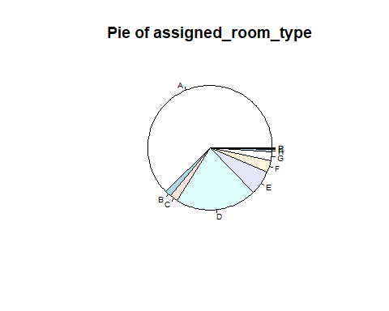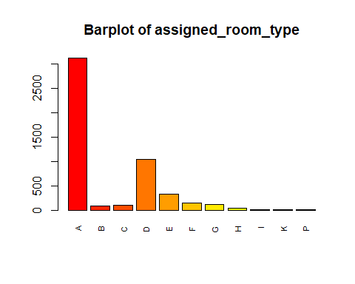

## [1] "Number of modalities: 11"  
## [1] "Frequency table"  
##   
## A B C D E F G H I K P   
## 3123 83 101 1049 327 146 115 31 11 13 1   
## [1] "Relative frequency table (proportions)"  
##   
## A B C D E F G H I K P   
## 0.6246 0.0166 0.0202 0.2098 0.0654 0.0292 0.0230 0.0062 0.0022 0.0026 0.0002   
## [1] "Frequency table sorted"  
##   
## A D E F G C B H K I P   
## 3123 1049 327 146 115 101 83 31 13 11 1   
## [1] "Relative frequency table (proportions) sorted"  
##   
## A D E F G C B H K I P   
## 0.6246 0.2098 0.0654 0.0292 0.0230 0.0202 0.0166 0.0062 0.0026 0.0022 0.0002   
## [1] "variable 22 : booking_changes"

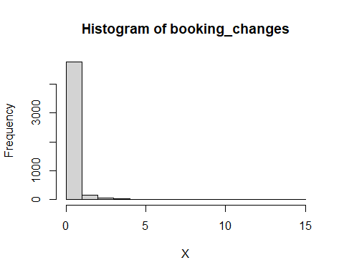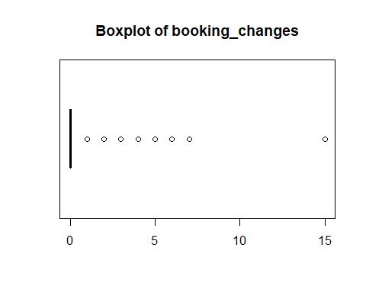

## [1] "Extended Summary Statistics"  
## Min. 1st Qu. Median Mean 3rd Qu. Max.   
## 0.0000 0.0000 0.0000 0.2156 0.0000 15.0000   
## [1] "sd: 0.647765821969655"  
## [1] "vc: 3.0044796937368"  
## [1] "variable 23 : deposit_type"

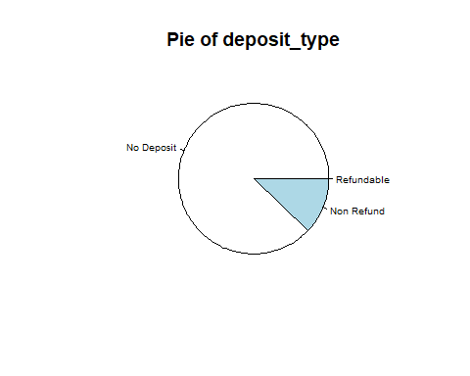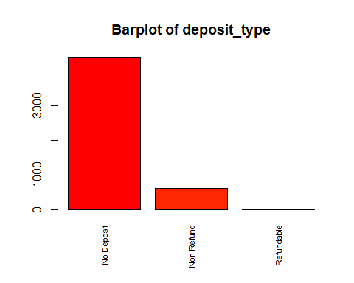

## [1] "Number of modalities: 3"  
## [1] "Frequency table"  
##   
## No Deposit Non Refund Refundable   
## 4386 608 6   
## [1] "Relative frequency table (proportions)"  
##   
## No Deposit Non Refund Refundable   
## 0.8772 0.1216 0.0012   
## [1] "Frequency table sorted"  
##   
## No Deposit Non Refund Refundable   
## 4386 608 6   
## [1] "Relative frequency table (proportions) sorted"  
##   
## No Deposit Non Refund Refundable   
## 0.8772 0.1216 0.0012   
## [1] "variable 24 : agent"

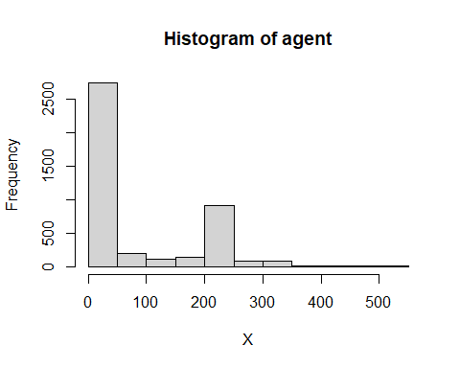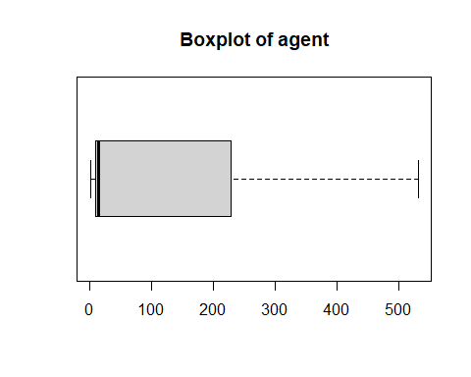

## [1] "Extended Summary Statistics"  
## Min. 1st Qu. Median Mean 3rd Qu. Max. NA's   
## 1.00 9.00 14.00 87.69 229.00 531.00 678   
## [1] "sd: 111.111035497284"  
## [1] "vc: 1.26703612397302"  
## [1] "variable 25 : company"

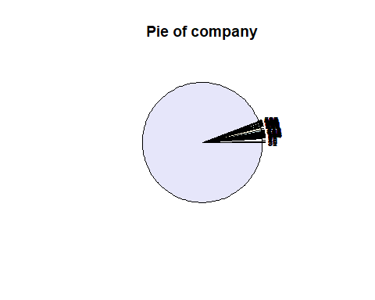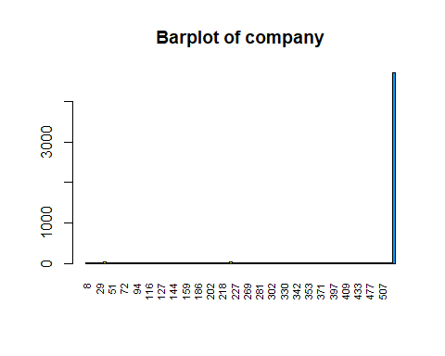

## [1] "Number of modalities: 101"  
## [1] "Frequency table"  
##   
## 8 9 12 20 29 34 40 45 51 62 67 68 72 78 91 93   
## 1 1 1 2 1 1 46 11 1 4 12 1 3 2 3 1   
## 94 101 106 113 116 118 122 126 127 130 135 143 144 150 153 154   
## 6 1 1 1 1 1 1 1 1 1 4 1 1 1 5 5   
## 159 169 174 180 186 193 195 197 202 204 212 216 218 219 221 223   
## 1 2 7 1 1 1 2 2 2 3 1 2 2 11 2 40   
## 227 233 238 242 269 270 272 280 281 286 291 292 302 307 308 323   
## 2 6 1 2 1 1 1 2 3 3 1 2 1 1 1 2   
## 330 331 333 337 342 343 346 348 353 355 365 367 371 385 390 394   
## 1 2 2 1 3 1 1 2 1 2 2 2 1 1 3 1   
## 397 400 405 408 409 419 424 428 433 436 459 465 477 485 489 498   
## 1 1 7 1 1 1 2 2 1 1 1 1 1 1 1 2   
## 507 521 525 531 <NA>   
## 1 1 3 1 4710   
## [1] "Relative frequency table (proportions)"  
##   
## 8 9 12 20 29 34 40 45 51 62 67   
## 0.0002 0.0002 0.0002 0.0004 0.0002 0.0002 0.0092 0.0022 0.0002 0.0008 0.0024   
## 68 72 78 91 93 94 101 106 113 116 118   
## 0.0002 0.0006 0.0004 0.0006 0.0002 0.0012 0.0002 0.0002 0.0002 0.0002 0.0002   
## 122 126 127 130 135 143 144 150 153 154 159   
## 0.0002 0.0002 0.0002 0.0002 0.0008 0.0002 0.0002 0.0002 0.0010 0.0010 0.0002   
## 169 174 180 186 193 195 197 202 204 212 216   
## 0.0004 0.0014 0.0002 0.0002 0.0002 0.0004 0.0004 0.0004 0.0006 0.0002 0.0004   
## 218 219 221 223 227 233 238 242 269 270 272   
## 0.0004 0.0022 0.0004 0.0080 0.0004 0.0012 0.0002 0.0004 0.0002 0.0002 0.0002   
## 280 281 286 291 292 302 307 308 323 330 331   
## 0.0004 0.0006 0.0006 0.0002 0.0004 0.0002 0.0002 0.0002 0.0004 0.0002 0.0004   
## 333 337 342 343 346 348 353 355 365 367 371   
## 0.0004 0.0002 0.0006 0.0002 0.0002 0.0004 0.0002 0.0004 0.0004 0.0004 0.0002   
## 385 390 394 397 400 405 408 409 419 424 428   
## 0.0002 0.0006 0.0002 0.0002 0.0002 0.0014 0.0002 0.0002 0.0002 0.0004 0.0004   
## 433 436 459 465 477 485 489 498 507 521 525   
## 0.0002 0.0002 0.0002 0.0002 0.0002 0.0002 0.0002 0.0004 0.0002 0.0002 0.0006   
## 531 <NA>   
## 0.0002 0.9420   
## [1] "Frequency table sorted"  
##   
## <NA> 40 223 67 45 219 174 405 94 233 153 154 62 135 72 91   
## 4710 46 40 12 11 11 7 7 6 6 5 5 4 4 3 3   
## 204 281 286 342 390 525 20 78 169 195 197 202 216 218 221 227   
## 3 3 3 3 3 3 2 2 2 2 2 2 2 2 2 2   
## 242 280 292 323 331 333 348 355 365 367 424 428 498 8 9 12   
## 2 2 2 2 2 2 2 2 2 2 2 2 2 1 1 1   
## 29 34 51 68 93 101 106 113 116 118 122 126 127 130 143 144   
## 1 1 1 1 1 1 1 1 1 1 1 1 1 1 1 1   
## 150 159 180 186 193 212 238 269 270 272 291 302 307 308 330 337   
## 1 1 1 1 1 1 1 1 1 1 1 1 1 1 1 1   
## 343 346 353 371 385 394 397 400 408 409 419 433 436 459 465 477   
## 1 1 1 1 1 1 1 1 1 1 1 1 1 1 1 1   
## 485 489 507 521 531   
## 1 1 1 1 1   
## [1] "Relative frequency table (proportions) sorted"  
##   
## <NA> 40 223 67 45 219 174 405 94 233 153   
## 0.9420 0.0092 0.0080 0.0024 0.0022 0.0022 0.0014 0.0014 0.0012 0.0012 0.0010   
## 154 62 135 72 91 204 281 286 342 390 525   
## 0.0010 0.0008 0.0008 0.0006 0.0006 0.0006 0.0006 0.0006 0.0006 0.0006 0.0006   
## 20 78 169 195 197 202 216 218 221 227 242   
## 0.0004 0.0004 0.0004 0.0004 0.0004 0.0004 0.0004 0.0004 0.0004 0.0004 0.0004   
## 280 292 323 331 333 348 355 365 367 424 428   
## 0.0004 0.0004 0.0004 0.0004 0.0004 0.0004 0.0004 0.0004 0.0004 0.0004 0.0004   
## 498 8 9 12 29 34 51 68 93 101 106   
## 0.0004 0.0002 0.0002 0.0002 0.0002 0.0002 0.0002 0.0002 0.0002 0.0002 0.0002   
## 113 116 118 122 126 127 130 143 144 150 159   
## 0.0002 0.0002 0.0002 0.0002 0.0002 0.0002 0.0002 0.0002 0.0002 0.0002 0.0002   
## 180 186 193 212 238 269 270 272 291 302 307   
## 0.0002 0.0002 0.0002 0.0002 0.0002 0.0002 0.0002 0.0002 0.0002 0.0002 0.0002   
## 308 330 337 343 346 353 371 385 394 397 400   
## 0.0002 0.0002 0.0002 0.0002 0.0002 0.0002 0.0002 0.0002 0.0002 0.0002 0.0002   
## 408 409 419 433 436 459 465 477 485 489 507   
## 0.0002 0.0002 0.0002 0.0002 0.0002 0.0002 0.0002 0.0002 0.0002 0.0002 0.0002   
## 521 531   
## 0.0002 0.0002   
## [1] "variable 26 : days_in_waiting_list"

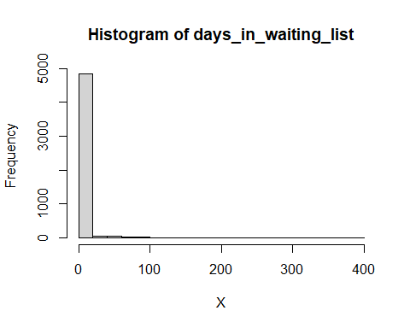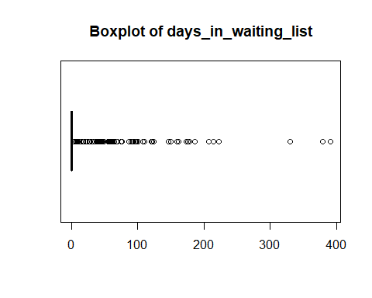

## [1] "Extended Summary Statistics"  
## Min. 1st Qu. Median Mean 3rd Qu. Max.   
## 0.00 0.00 0.00 2.71 0.00 391.00   
## [1] "sd: 19.290200577694"  
## [1] "vc: 7.11762990838093"  
## [1] "variable 27 : customer_type"

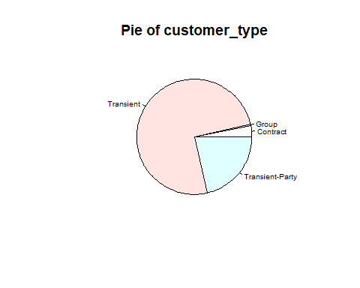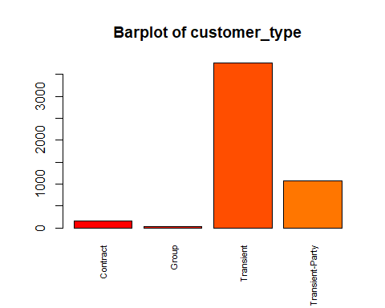

## [1] "Number of modalities: 4"  
## [1] "Frequency table"  
##   
## Contract Group Transient Transient-Party   
## 153 22 3755 1070   
## [1] "Relative frequency table (proportions)"  
##   
## Contract Group Transient Transient-Party   
## 0.0306 0.0044 0.7510 0.2140   
## [1] "Frequency table sorted"  
##   
## Transient Transient-Party Contract Group   
## 3755 1070 153 22   
## [1] "Relative frequency table (proportions) sorted"  
##   
## Transient Transient-Party Contract Group   
## 0.7510 0.2140 0.0306 0.0044   
## [1] "variable 28 : adr"

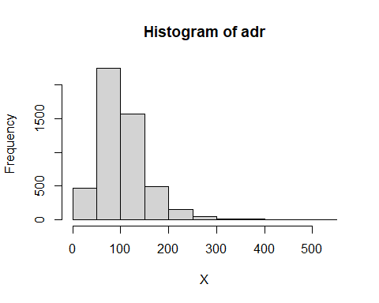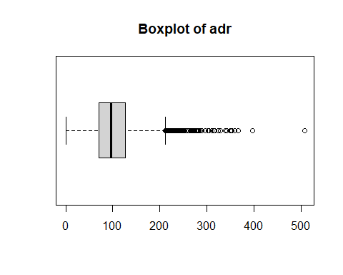

## [1] "Extended Summary Statistics"  
## Min. 1st Qu. Median Mean 3rd Qu. Max.   
## 0.0 71.0 96.0 103.3 127.3 508.0   
## [1] "sd: 48.8318755719865"  
## [1] "vc: 0.472647741724787"  
## [1] "variable 29 : required_car_parking_spaces"

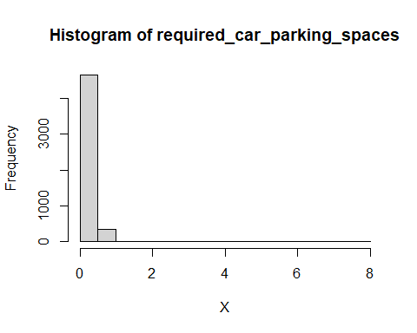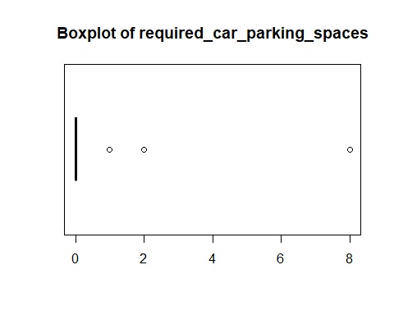

## [1] "Extended Summary Statistics"  
## Min. 1st Qu. Median Mean 3rd Qu. Max.   
## 0.0000 0.0000 0.0000 0.0692 0.0000 8.0000   
## [1] "sd: 0.275729152091437"  
## [1] "vc: 3.98452531924041"  
## [1] "variable 30 : total_of_special_requests"

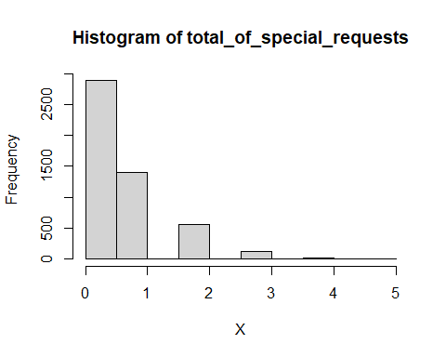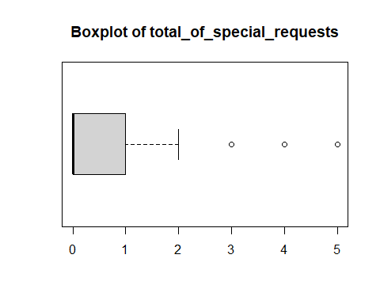

## [1] "Extended Summary Statistics"  
## Min. 1st Qu. Median Mean 3rd Qu. Max.   
## 0.000 0.000 0.000 0.593 1.000 5.000   
## [1] "sd: 0.812824173254785"  
## [1] "vc: 1.37069843719188"  
## [1] "variable 31 : reservation_status"

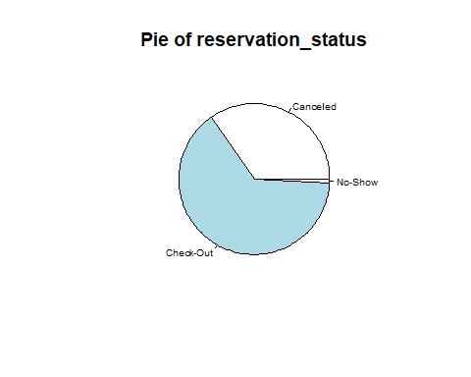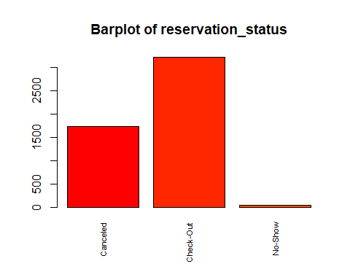

## [1] "Number of modalities: 3"  
## [1] "Frequency table"  
##   
## Canceled Check-Out No-Show   
## 1735 3218 47   
## [1] "Relative frequency table (proportions)"  
##   
## Canceled Check-Out No-Show   
## 0.3470 0.6436 0.0094   
## [1] "Frequency table sorted"  
##   
## Check-Out Canceled No-Show   
## 3218 1735 47   
## [1] "Relative frequency table (proportions) sorted"  
##   
## Check-Out Canceled No-Show   
## 0.6436 0.3470 0.0094   
## [1] "variable 32 : reservation_status_date"

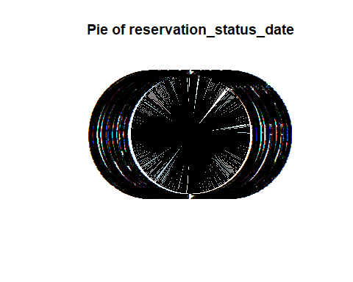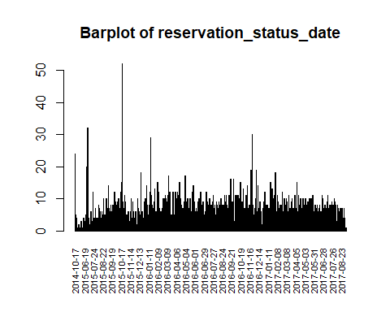

## [1] "Number of modalities: 828"  
## [1] "Frequency table"  
##   
## 2014-10-17 2015-01-01 2015-01-21 2015-01-22 2015-01-30 2015-02-20 2015-03-03   
## 5 24 5 1 4 1 1   
## 2015-04-04 2015-04-14 2015-04-16 2015-04-20 2015-04-25 2015-04-28 2015-04-29   
## 1 1 1 1 1 2 2   
## 2015-05-01 2015-05-04 2015-05-12 2015-05-13 2015-05-14 2015-05-23 2015-05-25   
## 1 1 1 1 1 3 1   
## 2015-05-28 2015-06-08 2015-06-09 2015-06-13 2015-06-15 2015-06-16 2015-06-17   
## 2 1 1 1 4 1 4   
## 2015-06-19 2015-06-23 2015-06-25 2015-06-26 2015-06-27 2015-06-29 2015-06-30   
## 1 3 2 3 1 5 1   
## 2015-07-01 2015-07-02 2015-07-03 2015-07-05 2015-07-06 2015-07-07 2015-07-08   
## 2 20 4 2 32 1 5   
## 2015-07-09 2015-07-10 2015-07-11 2015-07-12 2015-07-14 2015-07-15 2015-07-16   
## 2 4 2 1 1 3 3   
## 2015-07-17 2015-07-18 2015-07-19 2015-07-20 2015-07-21 2015-07-22 2015-07-23   
## 6 2 2 3 3 2 12   
## 2015-07-24 2015-07-25 2015-07-26 2015-07-27 2015-07-28 2015-07-29 2015-07-30   
## 3 4 3 3 1 4 3   
## 2015-07-31 2015-08-01 2015-08-02 2015-08-03 2015-08-04 2015-08-06 2015-08-07   
## 7 3 1 4 4 4 2   
## 2015-08-08 2015-08-09 2015-08-10 2015-08-11 2015-08-12 2015-08-13 2015-08-14   
## 4 2 7 8 7 2 6   
## 2015-08-15 2015-08-16 2015-08-17 2015-08-18 2015-08-19 2015-08-20 2015-08-21   
## 3 3 4 3 2 2 6   
## 2015-08-22 2015-08-23 2015-08-24 2015-08-25 2015-08-26 2015-08-27 2015-08-28   
## 5 4 5 10 3 5 5   
## 2015-08-29 2015-08-30 2015-08-31 2015-09-01 2015-09-02 2015-09-03 2015-09-04   
## 5 2 3 2 10 10 2   
## 2015-09-05 2015-09-06 2015-09-07 2015-09-08 2015-09-09 2015-09-10 2015-09-11   
## 8 5 4 7 14 7 6   
## 2015-09-12 2015-09-13 2015-09-14 2015-09-15 2015-09-16 2015-09-17 2015-09-18   
## 3 6 3 2 5 8 5   
## 2015-09-19 2015-09-20 2015-09-21 2015-09-22 2015-09-23 2015-09-24 2015-09-25   
## 6 2 8 4 8 5 5   
## 2015-09-26 2015-09-27 2015-09-28 2015-09-29 2015-09-30 2015-10-01 2015-10-02   
## 7 2 12 6 6 9 5   
## 2015-10-03 2015-10-04 2015-10-05 2015-10-06 2015-10-07 2015-10-08 2015-10-09   
## 6 6 8 7 7 9 6   
## 2015-10-10 2015-10-11 2015-10-12 2015-10-13 2015-10-14 2015-10-15 2015-10-16   
## 10 4 6 7 3 7 12   
## 2015-10-17 2015-10-18 2015-10-19 2015-10-20 2015-10-21 2015-10-22 2015-10-23   
## 6 8 15 7 52 3 9   
## 2015-10-24 2015-10-25 2015-10-26 2015-10-27 2015-10-28 2015-10-29 2015-10-30   
## 6 3 4 7 11 3 1   
## 2015-10-31 2015-11-01 2015-11-02 2015-11-03 2015-11-04 2015-11-05 2015-11-06   
## 9 4 4 3 5 3 3   
## 2015-11-07 2015-11-08 2015-11-09 2015-11-10 2015-11-11 2015-11-12 2015-11-13   
## 2 3 6 1 2 2 2   
## 2015-11-14 2015-11-15 2015-11-16 2015-11-17 2015-11-18 2015-11-19 2015-11-20   
## 3 6 6 10 1 3 4   
## 2015-11-21 2015-11-22 2015-11-23 2015-11-24 2015-11-25 2015-11-26 2015-11-27   
## 4 9 3 6 1 2 4   
## 2015-11-28 2015-11-29 2015-11-30 2015-12-01 2015-12-02 2015-12-03 2015-12-04   
## 3 2 6 1 6 3 1   
## 2015-12-06 2015-12-07 2015-12-08 2015-12-09 2015-12-10 2015-12-11 2015-12-12   
## 1 2 10 5 7 2 4   
## 2015-12-13 2015-12-14 2015-12-15 2015-12-16 2015-12-17 2015-12-18 2015-12-19   
## 2 6 5 1 5 18 1   
## 2015-12-20 2015-12-21 2015-12-22 2015-12-23 2015-12-25 2015-12-26 2015-12-27   
## 1 3 6 5 3 4 3   
## 2015-12-28 2015-12-29 2015-12-30 2015-12-31 2016-01-01 2016-01-02 2016-01-03   
## 3 9 3 3 3 10 6   
## 2016-01-04 2016-01-05 2016-01-06 2016-01-07 2016-01-08 2016-01-09 2016-01-10   
## 4 10 14 6 8 5 4   
## 2016-01-11 2016-01-12 2016-01-13 2016-01-14 2016-01-15 2016-01-16 2016-01-17   
## 4 2 8 1 2 12 2   
## 2016-01-18 2016-01-19 2016-01-20 2016-01-21 2016-01-22 2016-01-23 2016-01-24   
## 29 6 6 11 8 1 6   
## 2016-01-25 2016-01-26 2016-01-27 2016-01-28 2016-01-29 2016-01-31 2016-02-01   
## 4 7 3 9 6 3 13   
## 2016-02-02 2016-02-03 2016-02-04 2016-02-05 2016-02-06 2016-02-07 2016-02-08   
## 2 5 6 3 2 6 1   
## 2016-02-09 2016-02-10 2016-02-11 2016-02-12 2016-02-13 2016-02-14 2016-02-15   
## 15 9 8 12 3 7 3   
## 2016-02-16 2016-02-17 2016-02-18 2016-02-19 2016-02-20 2016-02-21 2016-02-22   
## 4 3 2 6 3 4 7   
## 2016-02-23 2016-02-24 2016-02-25 2016-02-27 2016-02-28 2016-02-29 2016-03-01   
## 6 3 10 6 9 10 5   
## 2016-03-02 2016-03-03 2016-03-04 2016-03-05 2016-03-06 2016-03-07 2016-03-08   
## 5 10 11 6 10 8 5   
## 2016-03-09 2016-03-10 2016-03-11 2016-03-12 2016-03-13 2016-03-14 2016-03-15   
## 4 5 9 5 11 17 14   
## 2016-03-16 2016-03-17 2016-03-18 2016-03-19 2016-03-20 2016-03-21 2016-03-22   
## 6 5 12 6 11 4 3   
## 2016-03-23 2016-03-24 2016-03-25 2016-03-26 2016-03-27 2016-03-28 2016-03-29   
## 5 2 5 5 5 12 8   
## 2016-03-30 2016-03-31 2016-04-01 2016-04-02 2016-04-03 2016-04-04 2016-04-05   
## 5 5 3 2 7 12 3   
## 2016-04-06 2016-04-07 2016-04-08 2016-04-09 2016-04-10 2016-04-11 2016-04-12   
## 12 10 8 3 9 12 4   
## 2016-04-13 2016-04-14 2016-04-15 2016-04-16 2016-04-17 2016-04-18 2016-04-19   
## 11 3 11 4 15 10 10   
## 2016-04-20 2016-04-21 2016-04-22 2016-04-23 2016-04-24 2016-04-25 2016-04-26   
## 5 4 8 5 4 5 4   
## 2016-04-27 2016-04-28 2016-04-29 2016-04-30 2016-05-01 2016-05-02 2016-05-03   
## 7 4 7 6 6 9 7   
## 2016-05-04 2016-05-05 2016-05-06 2016-05-07 2016-05-08 2016-05-09 2016-05-10   
## 17 7 8 3 9 7 8   
## 2016-05-11 2016-05-12 2016-05-13 2016-05-14 2016-05-15 2016-05-16 2016-05-17   
## 6 10 2 2 7 4 6   
## 2016-05-18 2016-05-19 2016-05-20 2016-05-21 2016-05-22 2016-05-23 2016-05-24   
## 4 10 5 8 3 6 6   
## 2016-05-25 2016-05-26 2016-05-27 2016-05-28 2016-05-29 2016-05-30 2016-05-31   
## 4 12 8 2 14 7 3   
## 2016-06-01 2016-06-02 2016-06-03 2016-06-04 2016-06-05 2016-06-06 2016-06-07   
## 2 9 6 5 6 6 7   
## 2016-06-08 2016-06-09 2016-06-10 2016-06-11 2016-06-12 2016-06-13 2016-06-14   
## 6 3 4 5 9 6 7   
## 2016-06-15 2016-06-16 2016-06-17 2016-06-18 2016-06-19 2016-06-20 2016-06-21   
## 10 4 8 4 6 12 6   
## 2016-06-22 2016-06-23 2016-06-24 2016-06-25 2016-06-26 2016-06-27 2016-06-28   
## 6 7 8 3 8 8 9   
## 2016-06-29 2016-06-30 2016-07-01 2016-07-02 2016-07-03 2016-07-04 2016-07-05   
## 4 4 5 5 5 2 6   
## 2016-07-06 2016-07-07 2016-07-08 2016-07-09 2016-07-10 2016-07-11 2016-07-12   
## 6 6 12 8 3 9 3   
## 2016-07-13 2016-07-14 2016-07-15 2016-07-16 2016-07-17 2016-07-18 2016-07-19   
## 8 8 7 10 2 10 4   
## 2016-07-20 2016-07-21 2016-07-22 2016-07-23 2016-07-24 2016-07-25 2016-07-26   
## 5 7 8 7 8 8 7   
## 2016-07-27 2016-07-28 2016-07-29 2016-07-30 2016-07-31 2016-08-01 2016-08-02   
## 9 10 11 7 3 7 1   
## 2016-08-03 2016-08-04 2016-08-05 2016-08-06 2016-08-07 2016-08-08 2016-08-09   
## 8 5 3 3 7 9 8   
## 2016-08-10 2016-08-11 2016-08-12 2016-08-13 2016-08-14 2016-08-15 2016-08-16   
## 7 4 5 7 2 9 4   
## 2016-08-17 2016-08-18 2016-08-19 2016-08-20 2016-08-21 2016-08-22 2016-08-23   
## 4 6 8 9 10 7 8   
## 2016-08-24 2016-08-25 2016-08-26 2016-08-27 2016-08-28 2016-08-29 2016-08-30   
## 8 4 4 6 8 8 6   
## 2016-08-31 2016-09-01 2016-09-02 2016-09-03 2016-09-04 2016-09-05 2016-09-06   
## 5 6 11 2 9 9 11   
## 2016-09-07 2016-09-08 2016-09-09 2016-09-10 2016-09-11 2016-09-12 2016-09-13   
## 5 8 3 3 7 7 4   
## 2016-09-14 2016-09-15 2016-09-16 2016-09-17 2016-09-18 2016-09-19 2016-09-20   
## 7 11 6 2 4 7 16   
## 2016-09-21 2016-09-22 2016-09-23 2016-09-24 2016-09-25 2016-09-26 2016-09-27   
## 5 5 5 2 9 8 4   
## 2016-09-28 2016-09-29 2016-09-30 2016-10-01 2016-10-02 2016-10-03 2016-10-04   
## 11 16 3 2 3 9 8   
## 2016-10-05 2016-10-06 2016-10-07 2016-10-08 2016-10-09 2016-10-10 2016-10-11   
## 11 10 9 5 10 11 7   
## 2016-10-12 2016-10-13 2016-10-14 2016-10-15 2016-10-16 2016-10-17 2016-10-18   
## 8 8 11 2 10 8 5   
## 2016-10-19 2016-10-20 2016-10-21 2016-10-22 2016-10-23 2016-10-24 2016-10-25   
## 3 15 12 6 4 7 9   
## 2016-10-26 2016-10-27 2016-10-28 2016-10-29 2016-10-30 2016-10-31 2016-11-01   
## 5 8 13 5 3 5 7   
## 2016-11-02 2016-11-03 2016-11-04 2016-11-05 2016-11-06 2016-11-07 2016-11-08   
## 7 4 10 6 11 4 1   
## 2016-11-09 2016-11-10 2016-11-11 2016-11-12 2016-11-13 2016-11-14 2016-11-15   
## 14 6 2 7 7 8 4   
## 2016-11-16 2016-11-17 2016-11-18 2016-11-19 2016-11-20 2016-11-21 2016-11-22   
## 8 7 3 10 2 19 4   
## 2016-11-23 2016-11-24 2016-11-25 2016-11-26 2016-11-27 2016-11-28 2016-11-29   
## 6 8 30 1 8 3 5   
## 2016-11-30 2016-12-01 2016-12-02 2016-12-03 2016-12-04 2016-12-05 2016-12-06   
## 5 3 7 1 10 2 7   
## 2016-12-07 2016-12-08 2016-12-09 2016-12-10 2016-12-11 2016-12-12 2016-12-13   
## 19 6 6 2 6 14 7   
## 2016-12-14 2016-12-15 2016-12-16 2016-12-17 2016-12-18 2016-12-19 2016-12-20   
## 7 6 5 2 9 4 5   
## 2016-12-21 2016-12-22 2016-12-23 2016-12-24 2016-12-25 2016-12-26 2016-12-27   
## 6 3 2 2 2 5 7   
## 2016-12-28 2016-12-29 2016-12-30 2016-12-31 2017-01-01 2017-01-02 2017-01-03   
## 5 9 3 5 7 12 8   
## 2017-01-04 2017-01-05 2017-01-06 2017-01-07 2017-01-08 2017-01-09 2017-01-10   
## 3 6 8 1 8 8 7   
## 2017-01-11 2017-01-12 2017-01-13 2017-01-14 2017-01-15 2017-01-16 2017-01-17   
## 7 7 6 3 2 6 7   
## 2017-01-18 2017-01-19 2017-01-20 2017-01-21 2017-01-22 2017-01-23 2017-01-24   
## 11 15 7 5 6 3 13   
## 2017-01-25 2017-01-26 2017-01-27 2017-01-28 2017-01-29 2017-01-30 2017-01-31   
## 9 7 8 4 10 11 5   
## 2017-02-01 2017-02-02 2017-02-03 2017-02-04 2017-02-05 2017-02-06 2017-02-07   
## 5 13 18 3 6 6 2   
## 2017-02-08 2017-02-09 2017-02-10 2017-02-11 2017-02-12 2017-02-13 2017-02-14   
## 4 6 11 5 9 7 4   
## 2017-02-15 2017-02-16 2017-02-17 2017-02-18 2017-02-19 2017-02-20 2017-02-21   
## 6 8 8 5 8 8 8   
## 2017-02-22 2017-02-23 2017-02-24 2017-02-25 2017-02-26 2017-02-27 2017-02-28   
## 5 5 12 5 4 4 6   
## 2017-03-01 2017-03-02 2017-03-03 2017-03-04 2017-03-05 2017-03-06 2017-03-07   
## 6 10 3 8 7 5 8   
## 2017-03-08 2017-03-09 2017-03-10 2017-03-11 2017-03-12 2017-03-13 2017-03-14   
## 7 10 9 7 6 5 2   
## 2017-03-15 2017-03-16 2017-03-17 2017-03-18 2017-03-19 2017-03-20 2017-03-21   
## 4 11 5 2 3 7 3   
## 2017-03-22 2017-03-23 2017-03-24 2017-03-25 2017-03-26 2017-03-27 2017-03-28   
## 3 9 7 3 10 6 4   
## 2017-03-29 2017-03-30 2017-03-31 2017-04-01 2017-04-02 2017-04-03 2017-04-04   
## 7 2 7 5 6 11 9   
## 2017-04-05 2017-04-06 2017-04-07 2017-04-08 2017-04-09 2017-04-10 2017-04-11   
## 11 2 7 5 15 6 5   
## 2017-04-12 2017-04-13 2017-04-14 2017-04-15 2017-04-16 2017-04-17 2017-04-18   
## 4 6 11 11 8 5 4   
## 2017-04-19 2017-04-20 2017-04-21 2017-04-22 2017-04-23 2017-04-24 2017-04-25   
## 4 7 10 3 6 5 7   
## 2017-04-26 2017-04-27 2017-04-28 2017-04-29 2017-04-30 2017-05-01 2017-05-02   
## 6 7 10 9 5 8 8   
## 2017-05-03 2017-05-04 2017-05-05 2017-05-06 2017-05-07 2017-05-08 2017-05-09   
## 4 3 10 8 10 7 8   
## 2017-05-10 2017-05-11 2017-05-12 2017-05-13 2017-05-14 2017-05-15 2017-05-16   
## 6 6 6 9 4 9 4   
## 2017-05-17 2017-05-18 2017-05-19 2017-05-20 2017-05-21 2017-05-22 2017-05-23   
## 9 10 8 7 8 10 10   
## 2017-05-24 2017-05-25 2017-05-26 2017-05-27 2017-05-28 2017-05-29 2017-05-30   
## 7 10 1 4 11 11 3   
## 2017-05-31 2017-06-01 2017-06-02 2017-06-03 2017-06-04 2017-06-05 2017-06-06   
## 5 6 5 5 8 8 5   
## 2017-06-07 2017-06-08 2017-06-09 2017-06-10 2017-06-11 2017-06-12 2017-06-13   
## 5 6 7 4 8 3 6   
## 2017-06-14 2017-06-15 2017-06-16 2017-06-17 2017-06-18 2017-06-19 2017-06-20   
## 6 7 2 2 8 2 4   
## 2017-06-21 2017-06-22 2017-06-23 2017-06-24 2017-06-25 2017-06-26 2017-06-27   
## 2 6 3 6 11 4 10   
## 2017-06-28 2017-06-29 2017-06-30 2017-07-01 2017-07-02 2017-07-03 2017-07-04   
## 10 1 7 6 6 4 8   
## 2017-07-05 2017-07-06 2017-07-07 2017-07-08 2017-07-09 2017-07-10 2017-07-11   
## 4 6 3 2 7 6 9   
## 2017-07-12 2017-07-13 2017-07-14 2017-07-15 2017-07-16 2017-07-17 2017-07-18   
## 7 11 6 7 4 3 4   
## 2017-07-19 2017-07-20 2017-07-21 2017-07-22 2017-07-23 2017-07-24 2017-07-25   
## 8 6 5 8 3 5 7   
## 2017-07-26 2017-07-27 2017-07-28 2017-07-29 2017-07-30 2017-07-31 2017-08-01   
## 9 6 4 8 5 5 1   
## 2017-08-02 2017-08-03 2017-08-04 2017-08-05 2017-08-06 2017-08-07 2017-08-08   
## 10 9 6 6 7 8 3   
## 2017-08-09 2017-08-10 2017-08-11 2017-08-12 2017-08-13 2017-08-14 2017-08-15   
## 3 3 8 4 7 3 5   
## 2017-08-16 2017-08-17 2017-08-18 2017-08-19 2017-08-20 2017-08-21 2017-08-22   
## 3 4 6 5 7 1 2   
## 2017-08-23 2017-08-24 2017-08-25 2017-08-26 2017-08-27 2017-08-28 2017-08-29   
## 4 5 7 6 4 3 4   
## 2017-08-30 2017-08-31 2017-09-01 2017-09-02 2017-09-03 2017-09-04 2017-09-06   
## 2 5 7 2 4 1 1   
## 2017-09-08 2017-09-09   
## 1 1   
## [1] "Relative frequency table (proportions)"  
##   
## 2014-10-17 2015-01-01 2015-01-21 2015-01-22 2015-01-30 2015-02-20 2015-03-03   
## 0.0010 0.0048 0.0010 0.0002 0.0008 0.0002 0.0002   
## 2015-04-04 2015-04-14 2015-04-16 2015-04-20 2015-04-25 2015-04-28 2015-04-29   
## 0.0002 0.0002 0.0002 0.0002 0.0002 0.0004 0.0004   
## 2015-05-01 2015-05-04 2015-05-12 2015-05-13 2015-05-14 2015-05-23 2015-05-25   
## 0.0002 0.0002 0.0002 0.0002 0.0002 0.0006 0.0002   
## 2015-05-28 2015-06-08 2015-06-09 2015-06-13 2015-06-15 2015-06-16 2015-06-17   
## 0.0004 0.0002 0.0002 0.0002 0.0008 0.0002 0.0008   
## 2015-06-19 2015-06-23 2015-06-25 2015-06-26 2015-06-27 2015-06-29 2015-06-30   
## 0.0002 0.0006 0.0004 0.0006 0.0002 0.0010 0.0002   
## 2015-07-01 2015-07-02 2015-07-03 2015-07-05 2015-07-06 2015-07-07 2015-07-08   
## 0.0004 0.0040 0.0008 0.0004 0.0064 0.0002 0.0010   
## 2015-07-09 2015-07-10 2015-07-11 2015-07-12 2015-07-14 2015-07-15 2015-07-16   
## 0.0004 0.0008 0.0004 0.0002 0.0002 0.0006 0.0006   
## 2015-07-17 2015-07-18 2015-07-19 2015-07-20 2015-07-21 2015-07-22 2015-07-23   
## 0.0012 0.0004 0.0004 0.0006 0.0006 0.0004 0.0024   
## 2015-07-24 2015-07-25 2015-07-26 2015-07-27 2015-07-28 2015-07-29 2015-07-30   
## 0.0006 0.0008 0.0006 0.0006 0.0002 0.0008 0.0006   
## 2015-07-31 2015-08-01 2015-08-02 2015-08-03 2015-08-04 2015-08-06 2015-08-07   
## 0.0014 0.0006 0.0002 0.0008 0.0008 0.0008 0.0004   
## 2015-08-08 2015-08-09 2015-08-10 2015-08-11 2015-08-12 2015-08-13 2015-08-14   
## 0.0008 0.0004 0.0014 0.0016 0.0014 0.0004 0.0012   
## 2015-08-15 2015-08-16 2015-08-17 2015-08-18 2015-08-19 2015-08-20 2015-08-21   
## 0.0006 0.0006 0.0008 0.0006 0.0004 0.0004 0.0012   
## 2015-08-22 2015-08-23 2015-08-24 2015-08-25 2015-08-26 2015-08-27 2015-08-28   
## 0.0010 0.0008 0.0010 0.0020 0.0006 0.0010 0.0010   
## 2015-08-29 2015-08-30 2015-08-31 2015-09-01 2015-09-02 2015-09-03 2015-09-04   
## 0.0010 0.0004 0.0006 0.0004 0.0020 0.0020 0.0004   
## 2015-09-05 2015-09-06 2015-09-07 2015-09-08 2015-09-09 2015-09-10 2015-09-11   
## 0.0016 0.0010 0.0008 0.0014 0.0028 0.0014 0.0012   
## 2015-09-12 2015-09-13 2015-09-14 2015-09-15 2015-09-16 2015-09-17 2015-09-18   
## 0.0006 0.0012 0.0006 0.0004 0.0010 0.0016 0.0010   
## 2015-09-19 2015-09-20 2015-09-21 2015-09-22 2015-09-23 2015-09-24 2015-09-25   
## 0.0012 0.0004 0.0016 0.0008 0.0016 0.0010 0.0010   
## 2015-09-26 2015-09-27 2015-09-28 2015-09-29 2015-09-30 2015-10-01 2015-10-02   
## 0.0014 0.0004 0.0024 0.0012 0.0012 0.0018 0.0010   
## 2015-10-03 2015-10-04 2015-10-05 2015-10-06 2015-10-07 2015-10-08 2015-10-09   
## 0.0012 0.0012 0.0016 0.0014 0.0014 0.0018 0.0012   
## 2015-10-10 2015-10-11 2015-10-12 2015-10-13 2015-10-14 2015-10-15 2015-10-16   
## 0.0020 0.0008 0.0012 0.0014 0.0006 0.0014 0.0024   
## 2015-10-17 2015-10-18 2015-10-19 2015-10-20 2015-10-21 2015-10-22 2015-10-23   
## 0.0012 0.0016 0.0030 0.0014 0.0104 0.0006 0.0018   
## 2015-10-24 2015-10-25 2015-10-26 2015-10-27 2015-10-28 2015-10-29 2015-10-30   
## 0.0012 0.0006 0.0008 0.0014 0.0022 0.0006 0.0002   
## 2015-10-31 2015-11-01 2015-11-02 2015-11-03 2015-11-04 2015-11-05 2015-11-06   
## 0.0018 0.0008 0.0008 0.0006 0.0010 0.0006 0.0006   
## 2015-11-07 2015-11-08 2015-11-09 2015-11-10 2015-11-11 2015-11-12 2015-11-13   
## 0.0004 0.0006 0.0012 0.0002 0.0004 0.0004 0.0004   
## 2015-11-14 2015-11-15 2015-11-16 2015-11-17 2015-11-18 2015-11-19 2015-11-20   
## 0.0006 0.0012 0.0012 0.0020 0.0002 0.0006 0.0008   
## 2015-11-21 2015-11-22 2015-11-23 2015-11-24 2015-11-25 2015-11-26 2015-11-27   
## 0.0008 0.0018 0.0006 0.0012 0.0002 0.0004 0.0008   
## 2015-11-28 2015-11-29 2015-11-30 2015-12-01 2015-12-02 2015-12-03 2015-12-04   
## 0.0006 0.0004 0.0012 0.0002 0.0012 0.0006 0.0002   
## 2015-12-06 2015-12-07 2015-12-08 2015-12-09 2015-12-10 2015-12-11 2015-12-12   
## 0.0002 0.0004 0.0020 0.0010 0.0014 0.0004 0.0008   
## 2015-12-13 2015-12-14 2015-12-15 2015-12-16 2015-12-17 2015-12-18 2015-12-19   
## 0.0004 0.0012 0.0010 0.0002 0.0010 0.0036 0.0002   
## 2015-12-20 2015-12-21 2015-12-22 2015-12-23 2015-12-25 2015-12-26 2015-12-27   
## 0.0002 0.0006 0.0012 0.0010 0.0006 0.0008 0.0006   
## 2015-12-28 2015-12-29 2015-12-30 2015-12-31 2016-01-01 2016-01-02 2016-01-03   
## 0.0006 0.0018 0.0006 0.0006 0.0006 0.0020 0.0012   
## 2016-01-04 2016-01-05 2016-01-06 2016-01-07 2016-01-08 2016-01-09 2016-01-10   
## 0.0008 0.0020 0.0028 0.0012 0.0016 0.0010 0.0008   
## 2016-01-11 2016-01-12 2016-01-13 2016-01-14 2016-01-15 2016-01-16 2016-01-17   
## 0.0008 0.0004 0.0016 0.0002 0.0004 0.0024 0.0004   
## 2016-01-18 2016-01-19 2016-01-20 2016-01-21 2016-01-22 2016-01-23 2016-01-24   
## 0.0058 0.0012 0.0012 0.0022 0.0016 0.0002 0.0012   
## 2016-01-25 2016-01-26 2016-01-27 2016-01-28 2016-01-29 2016-01-31 2016-02-01   
## 0.0008 0.0014 0.0006 0.0018 0.0012 0.0006 0.0026   
## 2016-02-02 2016-02-03 2016-02-04 2016-02-05 2016-02-06 2016-02-07 2016-02-08   
## 0.0004 0.0010 0.0012 0.0006 0.0004 0.0012 0.0002   
## 2016-02-09 2016-02-10 2016-02-11 2016-02-12 2016-02-13 2016-02-14 2016-02-15   
## 0.0030 0.0018 0.0016 0.0024 0.0006 0.0014 0.0006   
## 2016-02-16 2016-02-17 2016-02-18 2016-02-19 2016-02-20 2016-02-21 2016-02-22   
## 0.0008 0.0006 0.0004 0.0012 0.0006 0.0008 0.0014   
## 2016-02-23 2016-02-24 2016-02-25 2016-02-27 2016-02-28 2016-02-29 2016-03-01   
## 0.0012 0.0006 0.0020 0.0012 0.0018 0.0020 0.0010   
## 2016-03-02 2016-03-03 2016-03-04 2016-03-05 2016-03-06 2016-03-07 2016-03-08   
## 0.0010 0.0020 0.0022 0.0012 0.0020 0.0016 0.0010   
## 2016-03-09 2016-03-10 2016-03-11 2016-03-12 2016-03-13 2016-03-14 2016-03-15   
## 0.0008 0.0010 0.0018 0.0010 0.0022 0.0034 0.0028   
## 2016-03-16 2016-03-17 2016-03-18 2016-03-19 2016-03-20 2016-03-21 2016-03-22   
## 0.0012 0.0010 0.0024 0.0012 0.0022 0.0008 0.0006   
## 2016-03-23 2016-03-24 2016-03-25 2016-03-26 2016-03-27 2016-03-28 2016-03-29   
## 0.0010 0.0004 0.0010 0.0010 0.0010 0.0024 0.0016   
## 2016-03-30 2016-03-31 2016-04-01 2016-04-02 2016-04-03 2016-04-04 2016-04-05   
## 0.0010 0.0010 0.0006 0.0004 0.0014 0.0024 0.0006   
## 2016-04-06 2016-04-07 2016-04-08 2016-04-09 2016-04-10 2016-04-11 2016-04-12   
## 0.0024 0.0020 0.0016 0.0006 0.0018 0.0024 0.0008   
## 2016-04-13 2016-04-14 2016-04-15 2016-04-16 2016-04-17 2016-04-18 2016-04-19   
## 0.0022 0.0006 0.0022 0.0008 0.0030 0.0020 0.0020   
## 2016-04-20 2016-04-21 2016-04-22 2016-04-23 2016-04-24 2016-04-25 2016-04-26   
## 0.0010 0.0008 0.0016 0.0010 0.0008 0.0010 0.0008   
## 2016-04-27 2016-04-28 2016-04-29 2016-04-30 2016-05-01 2016-05-02 2016-05-03   
## 0.0014 0.0008 0.0014 0.0012 0.0012 0.0018 0.0014   
## 2016-05-04 2016-05-05 2016-05-06 2016-05-07 2016-05-08 2016-05-09 2016-05-10   
## 0.0034 0.0014 0.0016 0.0006 0.0018 0.0014 0.0016   
## 2016-05-11 2016-05-12 2016-05-13 2016-05-14 2016-05-15 2016-05-16 2016-05-17   
## 0.0012 0.0020 0.0004 0.0004 0.0014 0.0008 0.0012   
## 2016-05-18 2016-05-19 2016-05-20 2016-05-21 2016-05-22 2016-05-23 2016-05-24   
## 0.0008 0.0020 0.0010 0.0016 0.0006 0.0012 0.0012   
## 2016-05-25 2016-05-26 2016-05-27 2016-05-28 2016-05-29 2016-05-30 2016-05-31   
## 0.0008 0.0024 0.0016 0.0004 0.0028 0.0014 0.0006   
## 2016-06-01 2016-06-02 2016-06-03 2016-06-04 2016-06-05 2016-06-06 2016-06-07   
## 0.0004 0.0018 0.0012 0.0010 0.0012 0.0012 0.0014   
## 2016-06-08 2016-06-09 2016-06-10 2016-06-11 2016-06-12 2016-06-13 2016-06-14   
## 0.0012 0.0006 0.0008 0.0010 0.0018 0.0012 0.0014   
## 2016-06-15 2016-06-16 2016-06-17 2016-06-18 2016-06-19 2016-06-20 2016-06-21   
## 0.0020 0.0008 0.0016 0.0008 0.0012 0.0024 0.0012   
## 2016-06-22 2016-06-23 2016-06-24 2016-06-25 2016-06-26 2016-06-27 2016-06-28   
## 0.0012 0.0014 0.0016 0.0006 0.0016 0.0016 0.0018   
## 2016-06-29 2016-06-30 2016-07-01 2016-07-02 2016-07-03 2016-07-04 2016-07-05   
## 0.0008 0.0008 0.0010 0.0010 0.0010 0.0004 0.0012   
## 2016-07-06 2016-07-07 2016-07-08 2016-07-09 2016-07-10 2016-07-11 2016-07-12   
## 0.0012 0.0012 0.0024 0.0016 0.0006 0.0018 0.0006   
## 2016-07-13 2016-07-14 2016-07-15 2016-07-16 2016-07-17 2016-07-18 2016-07-19   
## 0.0016 0.0016 0.0014 0.0020 0.0004 0.0020 0.0008   
## 2016-07-20 2016-07-21 2016-07-22 2016-07-23 2016-07-24 2016-07-25 2016-07-26   
## 0.0010 0.0014 0.0016 0.0014 0.0016 0.0016 0.0014   
## 2016-07-27 2016-07-28 2016-07-29 2016-07-30 2016-07-31 2016-08-01 2016-08-02   
## 0.0018 0.0020 0.0022 0.0014 0.0006 0.0014 0.0002   
## 2016-08-03 2016-08-04 2016-08-05 2016-08-06 2016-08-07 2016-08-08 2016-08-09   
## 0.0016 0.0010 0.0006 0.0006 0.0014 0.0018 0.0016   
## 2016-08-10 2016-08-11 2016-08-12 2016-08-13 2016-08-14 2016-08-15 2016-08-16   
## 0.0014 0.0008 0.0010 0.0014 0.0004 0.0018 0.0008   
## 2016-08-17 2016-08-18 2016-08-19 2016-08-20 2016-08-21 2016-08-22 2016-08-23   
## 0.0008 0.0012 0.0016 0.0018 0.0020 0.0014 0.0016   
## 2016-08-24 2016-08-25 2016-08-26 2016-08-27 2016-08-28 2016-08-29 2016-08-30   
## 0.0016 0.0008 0.0008 0.0012 0.0016 0.0016 0.0012   
## 2016-08-31 2016-09-01 2016-09-02 2016-09-03 2016-09-04 2016-09-05 2016-09-06   
## 0.0010 0.0012 0.0022 0.0004 0.0018 0.0018 0.0022   
## 2016-09-07 2016-09-08 2016-09-09 2016-09-10 2016-09-11 2016-09-12 2016-09-13   
## 0.0010 0.0016 0.0006 0.0006 0.0014 0.0014 0.0008   
## 2016-09-14 2016-09-15 2016-09-16 2016-09-17 2016-09-18 2016-09-19 2016-09-20   
## 0.0014 0.0022 0.0012 0.0004 0.0008 0.0014 0.0032   
## 2016-09-21 2016-09-22 2016-09-23 2016-09-24 2016-09-25 2016-09-26 2016-09-27   
## 0.0010 0.0010 0.0010 0.0004 0.0018 0.0016 0.0008   
## 2016-09-28 2016-09-29 2016-09-30 2016-10-01 2016-10-02 2016-10-03 2016-10-04   
## 0.0022 0.0032 0.0006 0.0004 0.0006 0.0018 0.0016   
## 2016-10-05 2016-10-06 2016-10-07 2016-10-08 2016-10-09 2016-10-10 2016-10-11   
## 0.0022 0.0020 0.0018 0.0010 0.0020 0.0022 0.0014   
## 2016-10-12 2016-10-13 2016-10-14 2016-10-15 2016-10-16 2016-10-17 2016-10-18   
## 0.0016 0.0016 0.0022 0.0004 0.0020 0.0016 0.0010   
## 2016-10-19 2016-10-20 2016-10-21 2016-10-22 2016-10-23 2016-10-24 2016-10-25   
## 0.0006 0.0030 0.0024 0.0012 0.0008 0.0014 0.0018   
## 2016-10-26 2016-10-27 2016-10-28 2016-10-29 2016-10-30 2016-10-31 2016-11-01   
## 0.0010 0.0016 0.0026 0.0010 0.0006 0.0010 0.0014   
## 2016-11-02 2016-11-03 2016-11-04 2016-11-05 2016-11-06 2016-11-07 2016-11-08   
## 0.0014 0.0008 0.0020 0.0012 0.0022 0.0008 0.0002   
## 2016-11-09 2016-11-10 2016-11-11 2016-11-12 2016-11-13 2016-11-14 2016-11-15   
## 0.0028 0.0012 0.0004 0.0014 0.0014 0.0016 0.0008   
## 2016-11-16 2016-11-17 2016-11-18 2016-11-19 2016-11-20 2016-11-21 2016-11-22   
## 0.0016 0.0014 0.0006 0.0020 0.0004 0.0038 0.0008   
## 2016-11-23 2016-11-24 2016-11-25 2016-11-26 2016-11-27 2016-11-28 2016-11-29   
## 0.0012 0.0016 0.0060 0.0002 0.0016 0.0006 0.0010   
## 2016-11-30 2016-12-01 2016-12-02 2016-12-03 2016-12-04 2016-12-05 2016-12-06   
## 0.0010 0.0006 0.0014 0.0002 0.0020 0.0004 0.0014   
## 2016-12-07 2016-12-08 2016-12-09 2016-12-10 2016-12-11 2016-12-12 2016-12-13   
## 0.0038 0.0012 0.0012 0.0004 0.0012 0.0028 0.0014   
## 2016-12-14 2016-12-15 2016-12-16 2016-12-17 2016-12-18 2016-12-19 2016-12-20   
## 0.0014 0.0012 0.0010 0.0004 0.0018 0.0008 0.0010   
## 2016-12-21 2016-12-22 2016-12-23 2016-12-24 2016-12-25 2016-12-26 2016-12-27   
## 0.0012 0.0006 0.0004 0.0004 0.0004 0.0010 0.0014   
## 2016-12-28 2016-12-29 2016-12-30 2016-12-31 2017-01-01 2017-01-02 2017-01-03   
## 0.0010 0.0018 0.0006 0.0010 0.0014 0.0024 0.0016   
## 2017-01-04 2017-01-05 2017-01-06 2017-01-07 2017-01-08 2017-01-09 2017-01-10   
## 0.0006 0.0012 0.0016 0.0002 0.0016 0.0016 0.0014   
## 2017-01-11 2017-01-12 2017-01-13 2017-01-14 2017-01-15 2017-01-16 2017-01-17   
## 0.0014 0.0014 0.0012 0.0006 0.0004 0.0012 0.0014   
## 2017-01-18 2017-01-19 2017-01-20 2017-01-21 2017-01-22 2017-01-23 2017-01-24   
## 0.0022 0.0030 0.0014 0.0010 0.0012 0.0006 0.0026   
## 2017-01-25 2017-01-26 2017-01-27 2017-01-28 2017-01-29 2017-01-30 2017-01-31   
## 0.0018 0.0014 0.0016 0.0008 0.0020 0.0022 0.0010   
## 2017-02-01 2017-02-02 2017-02-03 2017-02-04 2017-02-05 2017-02-06 2017-02-07   
## 0.0010 0.0026 0.0036 0.0006 0.0012 0.0012 0.0004   
## 2017-02-08 2017-02-09 2017-02-10 2017-02-11 2017-02-12 2017-02-13 2017-02-14   
## 0.0008 0.0012 0.0022 0.0010 0.0018 0.0014 0.0008   
## 2017-02-15 2017-02-16 2017-02-17 2017-02-18 2017-02-19 2017-02-20 2017-02-21   
## 0.0012 0.0016 0.0016 0.0010 0.0016 0.0016 0.0016   
## 2017-02-22 2017-02-23 2017-02-24 2017-02-25 2017-02-26 2017-02-27 2017-02-28   
## 0.0010 0.0010 0.0024 0.0010 0.0008 0.0008 0.0012   
## 2017-03-01 2017-03-02 2017-03-03 2017-03-04 2017-03-05 2017-03-06 2017-03-07   
## 0.0012 0.0020 0.0006 0.0016 0.0014 0.0010 0.0016   
## 2017-03-08 2017-03-09 2017-03-10 2017-03-11 2017-03-12 2017-03-13 2017-03-14   
## 0.0014 0.0020 0.0018 0.0014 0.0012 0.0010 0.0004   
## 2017-03-15 2017-03-16 2017-03-17 2017-03-18 2017-03-19 2017-03-20 2017-03-21   
## 0.0008 0.0022 0.0010 0.0004 0.0006 0.0014 0.0006   
## 2017-03-22 2017-03-23 2017-03-24 2017-03-25 2017-03-26 2017-03-27 2017-03-28   
## 0.0006 0.0018 0.0014 0.0006 0.0020 0.0012 0.0008   
## 2017-03-29 2017-03-30 2017-03-31 2017-04-01 2017-04-02 2017-04-03 2017-04-04   
## 0.0014 0.0004 0.0014 0.0010 0.0012 0.0022 0.0018   
## 2017-04-05 2017-04-06 2017-04-07 2017-04-08 2017-04-09 2017-04-10 2017-04-11   
## 0.0022 0.0004 0.0014 0.0010 0.0030 0.0012 0.0010   
## 2017-04-12 2017-04-13 2017-04-14 2017-04-15 2017-04-16 2017-04-17 2017-04-18   
## 0.0008 0.0012 0.0022 0.0022 0.0016 0.0010 0.0008   
## 2017-04-19 2017-04-20 2017-04-21 2017-04-22 2017-04-23 2017-04-24 2017-04-25   
## 0.0008 0.0014 0.0020 0.0006 0.0012 0.0010 0.0014   
## 2017-04-26 2017-04-27 2017-04-28 2017-04-29 2017-04-30 2017-05-01 2017-05-02   
## 0.0012 0.0014 0.0020 0.0018 0.0010 0.0016 0.0016   
## 2017-05-03 2017-05-04 2017-05-05 2017-05-06 2017-05-07 2017-05-08 2017-05-09   
## 0.0008 0.0006 0.0020 0.0016 0.0020 0.0014 0.0016   
## 2017-05-10 2017-05-11 2017-05-12 2017-05-13 2017-05-14 2017-05-15 2017-05-16   
## 0.0012 0.0012 0.0012 0.0018 0.0008 0.0018 0.0008   
## 2017-05-17 2017-05-18 2017-05-19 2017-05-20 2017-05-21 2017-05-22 2017-05-23   
## 0.0018 0.0020 0.0016 0.0014 0.0016 0.0020 0.0020   
## 2017-05-24 2017-05-25 2017-05-26 2017-05-27 2017-05-28 2017-05-29 2017-05-30   
## 0.0014 0.0020 0.0002 0.0008 0.0022 0.0022 0.0006   
## 2017-05-31 2017-06-01 2017-06-02 2017-06-03 2017-06-04 2017-06-05 2017-06-06   
## 0.0010 0.0012 0.0010 0.0010 0.0016 0.0016 0.0010   
## 2017-06-07 2017-06-08 2017-06-09 2017-06-10 2017-06-11 2017-06-12 2017-06-13   
## 0.0010 0.0012 0.0014 0.0008 0.0016 0.0006 0.0012   
## 2017-06-14 2017-06-15 2017-06-16 2017-06-17 2017-06-18 2017-06-19 2017-06-20   
## 0.0012 0.0014 0.0004 0.0004 0.0016 0.0004 0.0008   
## 2017-06-21 2017-06-22 2017-06-23 2017-06-24 2017-06-25 2017-06-26 2017-06-27   
## 0.0004 0.0012 0.0006 0.0012 0.0022 0.0008 0.0020   
## 2017-06-28 2017-06-29 2017-06-30 2017-07-01 2017-07-02 2017-07-03 2017-07-04   
## 0.0020 0.0002 0.0014 0.0012 0.0012 0.0008 0.0016   
## 2017-07-05 2017-07-06 2017-07-07 2017-07-08 2017-07-09 2017-07-10 2017-07-11   
## 0.0008 0.0012 0.0006 0.0004 0.0014 0.0012 0.0018   
## 2017-07-12 2017-07-13 2017-07-14 2017-07-15 2017-07-16 2017-07-17 2017-07-18   
## 0.0014 0.0022 0.0012 0.0014 0.0008 0.0006 0.0008   
## 2017-07-19 2017-07-20 2017-07-21 2017-07-22 2017-07-23 2017-07-24 2017-07-25   
## 0.0016 0.0012 0.0010 0.0016 0.0006 0.0010 0.0014   
## 2017-07-26 2017-07-27 2017-07-28 2017-07-29 2017-07-30 2017-07-31 2017-08-01   
## 0.0018 0.0012 0.0008 0.0016 0.0010 0.0010 0.0002   
## 2017-08-02 2017-08-03 2017-08-04 2017-08-05 2017-08-06 2017-08-07 2017-08-08   
## 0.0020 0.0018 0.0012 0.0012 0.0014 0.0016 0.0006   
## 2017-08-09 2017-08-10 2017-08-11 2017-08-12 2017-08-13 2017-08-14 2017-08-15   
## 0.0006 0.0006 0.0016 0.0008 0.0014 0.0006 0.0010   
## 2017-08-16 2017-08-17 2017-08-18 2017-08-19 2017-08-20 2017-08-21 2017-08-22   
## 0.0006 0.0008 0.0012 0.0010 0.0014 0.0002 0.0004   
## 2017-08-23 2017-08-24 2017-08-25 2017-08-26 2017-08-27 2017-08-28 2017-08-29   
## 0.0008 0.0010 0.0014 0.0012 0.0008 0.0006 0.0008   
## 2017-08-30 2017-08-31 2017-09-01 2017-09-02 2017-09-03 2017-09-04 2017-09-06   
## 0.0004 0.0010 0.0014 0.0004 0.0008 0.0002 0.0002   
## 2017-09-08 2017-09-09   
## 0.0002 0.0002   
## [1] "Frequency table sorted"  
##   
## 2015-10-21 2015-07-06 2016-11-25 2016-01-18 2015-01-01 2015-07-02 2016-11-21   
## 52 32 30 29 24 20 19   
## 2016-12-07 2015-12-18 2017-02-03 2016-03-14 2016-05-04 2016-09-20 2016-09-29   
## 19 18 18 17 17 16 16   
## 2015-10-19 2016-02-09 2016-04-17 2016-10-20 2017-01-19 2017-04-09 2015-09-09   
## 15 15 15 15 15 15 14   
## 2016-01-06 2016-03-15 2016-05-29 2016-11-09 2016-12-12 2016-02-01 2016-10-28   
## 14 14 14 14 14 13 13   
## 2017-01-24 2017-02-02 2015-07-23 2015-09-28 2015-10-16 2016-01-16 2016-02-12   
## 13 13 12 12 12 12 12   
## 2016-03-18 2016-03-28 2016-04-04 2016-04-06 2016-04-11 2016-05-26 2016-06-20   
## 12 12 12 12 12 12 12   
## 2016-07-08 2016-10-21 2017-01-02 2017-02-24 2015-10-28 2016-01-21 2016-03-04   
## 12 12 12 12 11 11 11   
## 2016-03-13 2016-03-20 2016-04-13 2016-04-15 2016-07-29 2016-09-02 2016-09-06   
## 11 11 11 11 11 11 11   
## 2016-09-15 2016-09-28 2016-10-05 2016-10-10 2016-10-14 2016-11-06 2017-01-18   
## 11 11 11 11 11 11 11   
## 2017-01-30 2017-02-10 2017-03-16 2017-04-03 2017-04-05 2017-04-14 2017-04-15   
## 11 11 11 11 11 11 11   
## 2017-05-28 2017-05-29 2017-06-25 2017-07-13 2015-08-25 2015-09-02 2015-09-03   
## 11 11 11 11 10 10 10   
## 2015-10-10 2015-11-17 2015-12-08 2016-01-02 2016-01-05 2016-02-25 2016-02-29   
## 10 10 10 10 10 10 10   
## 2016-03-03 2016-03-06 2016-04-07 2016-04-18 2016-04-19 2016-05-12 2016-05-19   
## 10 10 10 10 10 10 10   
## 2016-06-15 2016-07-16 2016-07-18 2016-07-28 2016-08-21 2016-10-06 2016-10-09   
## 10 10 10 10 10 10 10   
## 2016-10-16 2016-11-04 2016-11-19 2016-12-04 2017-01-29 2017-03-02 2017-03-09   
## 10 10 10 10 10 10 10   
## 2017-03-26 2017-04-21 2017-04-28 2017-05-05 2017-05-07 2017-05-18 2017-05-22   
## 10 10 10 10 10 10 10   
## 2017-05-23 2017-05-25 2017-06-27 2017-06-28 2017-08-02 2015-10-01 2015-10-08   
## 10 10 10 10 10 9 9   
## 2015-10-23 2015-10-31 2015-11-22 2015-12-29 2016-01-28 2016-02-10 2016-02-28   
## 9 9 9 9 9 9 9   
## 2016-03-11 2016-04-10 2016-05-02 2016-05-08 2016-06-02 2016-06-12 2016-06-28   
## 9 9 9 9 9 9 9   
## 2016-07-11 2016-07-27 2016-08-08 2016-08-15 2016-08-20 2016-09-04 2016-09-05   
## 9 9 9 9 9 9 9   
## 2016-09-25 2016-10-03 2016-10-07 2016-10-25 2016-12-18 2016-12-29 2017-01-25   
## 9 9 9 9 9 9 9   
## 2017-02-12 2017-03-10 2017-03-23 2017-04-04 2017-04-29 2017-05-13 2017-05-15   
## 9 9 9 9 9 9 9   
## 2017-05-17 2017-07-11 2017-07-26 2017-08-03 2015-08-11 2015-09-05 2015-09-17   
## 9 9 9 9 8 8 8   
## 2015-09-21 2015-09-23 2015-10-05 2015-10-18 2016-01-08 2016-01-13 2016-01-22   
## 8 8 8 8 8 8 8   
## 2016-02-11 2016-03-07 2016-03-29 2016-04-08 2016-04-22 2016-05-06 2016-05-10   
## 8 8 8 8 8 8 8   
## 2016-05-21 2016-05-27 2016-06-17 2016-06-24 2016-06-26 2016-06-27 2016-07-09   
## 8 8 8 8 8 8 8   
## 2016-07-13 2016-07-14 2016-07-22 2016-07-24 2016-07-25 2016-08-03 2016-08-09   
## 8 8 8 8 8 8 8   
## 2016-08-19 2016-08-23 2016-08-24 2016-08-28 2016-08-29 2016-09-08 2016-09-26   
## 8 8 8 8 8 8 8   
## 2016-10-04 2016-10-12 2016-10-13 2016-10-17 2016-10-27 2016-11-14 2016-11-16   
## 8 8 8 8 8 8 8   
## 2016-11-24 2016-11-27 2017-01-03 2017-01-06 2017-01-08 2017-01-09 2017-01-27   
## 8 8 8 8 8 8 8   
## 2017-02-16 2017-02-17 2017-02-19 2017-02-20 2017-02-21 2017-03-04 2017-03-07   
## 8 8 8 8 8 8 8   
## 2017-04-16 2017-05-01 2017-05-02 2017-05-06 2017-05-09 2017-05-19 2017-05-21   
## 8 8 8 8 8 8 8   
## 2017-06-04 2017-06-05 2017-06-11 2017-06-18 2017-07-04 2017-07-19 2017-07-22   
## 8 8 8 8 8 8 8   
## 2017-07-29 2017-08-07 2017-08-11 2015-07-31 2015-08-10 2015-08-12 2015-09-08   
## 8 8 8 7 7 7 7   
## 2015-09-10 2015-09-26 2015-10-06 2015-10-07 2015-10-13 2015-10-15 2015-10-20   
## 7 7 7 7 7 7 7   
## 2015-10-27 2015-12-10 2016-01-26 2016-02-14 2016-02-22 2016-04-03 2016-04-27   
## 7 7 7 7 7 7 7   
## 2016-04-29 2016-05-03 2016-05-05 2016-05-09 2016-05-15 2016-05-30 2016-06-07   
## 7 7 7 7 7 7 7   
## 2016-06-14 2016-06-23 2016-07-15 2016-07-21 2016-07-23 2016-07-26 2016-07-30   
## 7 7 7 7 7 7 7   
## 2016-08-01 2016-08-07 2016-08-10 2016-08-13 2016-08-22 2016-09-11 2016-09-12   
## 7 7 7 7 7 7 7   
## 2016-09-14 2016-09-19 2016-10-11 2016-10-24 2016-11-01 2016-11-02 2016-11-12   
## 7 7 7 7 7 7 7   
## 2016-11-13 2016-11-17 2016-12-02 2016-12-06 2016-12-13 2016-12-14 2016-12-27   
## 7 7 7 7 7 7 7   
## 2017-01-01 2017-01-10 2017-01-11 2017-01-12 2017-01-17 2017-01-20 2017-01-26   
## 7 7 7 7 7 7 7   
## 2017-02-13 2017-03-05 2017-03-08 2017-03-11 2017-03-20 2017-03-24 2017-03-29   
## 7 7 7 7 7 7 7   
## 2017-03-31 2017-04-07 2017-04-20 2017-04-25 2017-04-27 2017-05-08 2017-05-20   
## 7 7 7 7 7 7 7   
## 2017-05-24 2017-06-09 2017-06-15 2017-06-30 2017-07-09 2017-07-12 2017-07-15   
## 7 7 7 7 7 7 7   
## 2017-07-25 2017-08-06 2017-08-13 2017-08-20 2017-08-25 2017-09-01 2015-07-17   
## 7 7 7 7 7 7 6   
## 2015-08-14 2015-08-21 2015-09-11 2015-09-13 2015-09-19 2015-09-29 2015-09-30   
## 6 6 6 6 6 6 6   
## 2015-10-03 2015-10-04 2015-10-09 2015-10-12 2015-10-17 2015-10-24 2015-11-09   
## 6 6 6 6 6 6 6   
## 2015-11-15 2015-11-16 2015-11-24 2015-11-30 2015-12-02 2015-12-14 2015-12-22   
## 6 6 6 6 6 6 6   
## 2016-01-03 2016-01-07 2016-01-19 2016-01-20 2016-01-24 2016-01-29 2016-02-04   
## 6 6 6 6 6 6 6   
## 2016-02-07 2016-02-19 2016-02-23 2016-02-27 2016-03-05 2016-03-16 2016-03-19   
## 6 6 6 6 6 6 6   
## 2016-04-30 2016-05-01 2016-05-11 2016-05-17 2016-05-23 2016-05-24 2016-06-03   
## 6 6 6 6 6 6 6   
## 2016-06-05 2016-06-06 2016-06-08 2016-06-13 2016-06-19 2016-06-21 2016-06-22   
## 6 6 6 6 6 6 6   
## 2016-07-05 2016-07-06 2016-07-07 2016-08-18 2016-08-27 2016-08-30 2016-09-01   
## 6 6 6 6 6 6 6   
## 2016-09-16 2016-10-22 2016-11-05 2016-11-10 2016-11-23 2016-12-08 2016-12-09   
## 6 6 6 6 6 6 6   
## 2016-12-11 2016-12-15 2016-12-21 2017-01-05 2017-01-13 2017-01-16 2017-01-22   
## 6 6 6 6 6 6 6   
## 2017-02-05 2017-02-06 2017-02-09 2017-02-15 2017-02-28 2017-03-01 2017-03-12   
## 6 6 6 6 6 6 6   
## 2017-03-27 2017-04-02 2017-04-10 2017-04-13 2017-04-23 2017-04-26 2017-05-10   
## 6 6 6 6 6 6 6   
## 2017-05-11 2017-05-12 2017-06-01 2017-06-08 2017-06-13 2017-06-14 2017-06-22   
## 6 6 6 6 6 6 6   
## 2017-06-24 2017-07-01 2017-07-02 2017-07-06 2017-07-10 2017-07-14 2017-07-20   
## 6 6 6 6 6 6 6   
## 2017-07-27 2017-08-04 2017-08-05 2017-08-18 2017-08-26 2014-10-17 2015-01-21   
## 6 6 6 6 6 5 5   
## 2015-06-29 2015-07-08 2015-08-22 2015-08-24 2015-08-27 2015-08-28 2015-08-29   
## 5 5 5 5 5 5 5   
## 2015-09-06 2015-09-16 2015-09-18 2015-09-24 2015-09-25 2015-10-02 2015-11-04   
## 5 5 5 5 5 5 5   
## 2015-12-09 2015-12-15 2015-12-17 2015-12-23 2016-01-09 2016-02-03 2016-03-01   
## 5 5 5 5 5 5 5   
## 2016-03-02 2016-03-08 2016-03-10 2016-03-12 2016-03-17 2016-03-23 2016-03-25   
## 5 5 5 5 5 5 5   
## 2016-03-26 2016-03-27 2016-03-30 2016-03-31 2016-04-20 2016-04-23 2016-04-25   
## 5 5 5 5 5 5 5   
## 2016-05-20 2016-06-04 2016-06-11 2016-07-01 2016-07-02 2016-07-03 2016-07-20   
## 5 5 5 5 5 5 5   
## 2016-08-04 2016-08-12 2016-08-31 2016-09-07 2016-09-21 2016-09-22 2016-09-23   
## 5 5 5 5 5 5 5   
## 2016-10-08 2016-10-18 2016-10-26 2016-10-29 2016-10-31 2016-11-29 2016-11-30   
## 5 5 5 5 5 5 5   
## 2016-12-16 2016-12-20 2016-12-26 2016-12-28 2016-12-31 2017-01-21 2017-01-31   
## 5 5 5 5 5 5 5   
## 2017-02-01 2017-02-11 2017-02-18 2017-02-22 2017-02-23 2017-02-25 2017-03-06   
## 5 5 5 5 5 5 5   
## 2017-03-13 2017-03-17 2017-04-01 2017-04-08 2017-04-11 2017-04-17 2017-04-24   
## 5 5 5 5 5 5 5   
## 2017-04-30 2017-05-31 2017-06-02 2017-06-03 2017-06-06 2017-06-07 2017-07-21   
## 5 5 5 5 5 5 5   
## 2017-07-24 2017-07-30 2017-07-31 2017-08-15 2017-08-19 2017-08-24 2017-08-31   
## 5 5 5 5 5 5 5   
## 2015-01-30 2015-06-15 2015-06-17 2015-07-03 2015-07-10 2015-07-25 2015-07-29   
## 4 4 4 4 4 4 4   
## 2015-08-03 2015-08-04 2015-08-06 2015-08-08 2015-08-17 2015-08-23 2015-09-07   
## 4 4 4 4 4 4 4   
## 2015-09-22 2015-10-11 2015-10-26 2015-11-01 2015-11-02 2015-11-20 2015-11-21   
## 4 4 4 4 4 4 4   
## 2015-11-27 2015-12-12 2015-12-26 2016-01-04 2016-01-10 2016-01-11 2016-01-25   
## 4 4 4 4 4 4 4   
## 2016-02-16 2016-02-21 2016-03-09 2016-03-21 2016-04-12 2016-04-16 2016-04-21   
## 4 4 4 4 4 4 4   
## 2016-04-24 2016-04-26 2016-04-28 2016-05-16 2016-05-18 2016-05-25 2016-06-10   
## 4 4 4 4 4 4 4   
## 2016-06-16 2016-06-18 2016-06-29 2016-06-30 2016-07-19 2016-08-11 2016-08-16   
## 4 4 4 4 4 4 4   
## 2016-08-17 2016-08-25 2016-08-26 2016-09-13 2016-09-18 2016-09-27 2016-10-23   
## 4 4 4 4 4 4 4   
## 2016-11-03 2016-11-07 2016-11-15 2016-11-22 2016-12-19 2017-01-28 2017-02-08   
## 4 4 4 4 4 4 4   
## 2017-02-14 2017-02-26 2017-02-27 2017-03-15 2017-03-28 2017-04-12 2017-04-18   
## 4 4 4 4 4 4 4   
## 2017-04-19 2017-05-03 2017-05-14 2017-05-16 2017-05-27 2017-06-10 2017-06-20   
## 4 4 4 4 4 4 4   
## 2017-06-26 2017-07-03 2017-07-05 2017-07-16 2017-07-18 2017-07-28 2017-08-12   
## 4 4 4 4 4 4 4   
## 2017-08-17 2017-08-23 2017-08-27 2017-08-29 2017-09-03 2015-05-23 2015-06-23   
## 4 4 4 4 4 3 3   
## 2015-06-26 2015-07-15 2015-07-16 2015-07-20 2015-07-21 2015-07-24 2015-07-26   
## 3 3 3 3 3 3 3   
## 2015-07-27 2015-07-30 2015-08-01 2015-08-15 2015-08-16 2015-08-18 2015-08-26   
## 3 3 3 3 3 3 3   
## 2015-08-31 2015-09-12 2015-09-14 2015-10-14 2015-10-22 2015-10-25 2015-10-29   
## 3 3 3 3 3 3 3   
## 2015-11-03 2015-11-05 2015-11-06 2015-11-08 2015-11-14 2015-11-19 2015-11-23   
## 3 3 3 3 3 3 3   
## 2015-11-28 2015-12-03 2015-12-21 2015-12-25 2015-12-27 2015-12-28 2015-12-30   
## 3 3 3 3 3 3 3   
## 2015-12-31 2016-01-01 2016-01-27 2016-01-31 2016-02-05 2016-02-13 2016-02-15   
## 3 3 3 3 3 3 3   
## 2016-02-17 2016-02-20 2016-02-24 2016-03-22 2016-04-01 2016-04-05 2016-04-09   
## 3 3 3 3 3 3 3   
## 2016-04-14 2016-05-07 2016-05-22 2016-05-31 2016-06-09 2016-06-25 2016-07-10   
## 3 3 3 3 3 3 3   
## 2016-07-12 2016-07-31 2016-08-05 2016-08-06 2016-09-09 2016-09-10 2016-09-30   
## 3 3 3 3 3 3 3   
## 2016-10-02 2016-10-19 2016-10-30 2016-11-18 2016-11-28 2016-12-01 2016-12-22   
## 3 3 3 3 3 3 3   
## 2016-12-30 2017-01-04 2017-01-14 2017-01-23 2017-02-04 2017-03-03 2017-03-19   
## 3 3 3 3 3 3 3   
## 2017-03-21 2017-03-22 2017-03-25 2017-04-22 2017-05-04 2017-05-30 2017-06-12   
## 3 3 3 3 3 3 3   
## 2017-06-23 2017-07-07 2017-07-17 2017-07-23 2017-08-08 2017-08-09 2017-08-10   
## 3 3 3 3 3 3 3   
## 2017-08-14 2017-08-16 2017-08-28 2015-04-28 2015-04-29 2015-05-28 2015-06-25   
## 3 3 3 2 2 2 2   
## 2015-07-01 2015-07-05 2015-07-09 2015-07-11 2015-07-18 2015-07-19 2015-07-22   
## 2 2 2 2 2 2 2   
## 2015-08-07 2015-08-09 2015-08-13 2015-08-19 2015-08-20 2015-08-30 2015-09-01   
## 2 2 2 2 2 2 2   
## 2015-09-04 2015-09-15 2015-09-20 2015-09-27 2015-11-07 2015-11-11 2015-11-12   
## 2 2 2 2 2 2 2   
## 2015-11-13 2015-11-26 2015-11-29 2015-12-07 2015-12-11 2015-12-13 2016-01-12   
## 2 2 2 2 2 2 2   
## 2016-01-15 2016-01-17 2016-02-02 2016-02-06 2016-02-18 2016-03-24 2016-04-02   
## 2 2 2 2 2 2 2   
## 2016-05-13 2016-05-14 2016-05-28 2016-06-01 2016-07-04 2016-07-17 2016-08-14   
## 2 2 2 2 2 2 2   
## 2016-09-03 2016-09-17 2016-09-24 2016-10-01 2016-10-15 2016-11-11 2016-11-20   
## 2 2 2 2 2 2 2   
## 2016-12-05 2016-12-10 2016-12-17 2016-12-23 2016-12-24 2016-12-25 2017-01-15   
## 2 2 2 2 2 2 2   
## 2017-02-07 2017-03-14 2017-03-18 2017-03-30 2017-04-06 2017-06-16 2017-06-17   
## 2 2 2 2 2 2 2   
## 2017-06-19 2017-06-21 2017-07-08 2017-08-22 2017-08-30 2017-09-02 2015-01-22   
## 2 2 2 2 2 2 1   
## 2015-02-20 2015-03-03 2015-04-04 2015-04-14 2015-04-16 2015-04-20 2015-04-25   
## 1 1 1 1 1 1 1   
## 2015-05-01 2015-05-04 2015-05-12 2015-05-13 2015-05-14 2015-05-25 2015-06-08   
## 1 1 1 1 1 1 1   
## 2015-06-09 2015-06-13 2015-06-16 2015-06-19 2015-06-27 2015-06-30 2015-07-07   
## 1 1 1 1 1 1 1   
## 2015-07-12 2015-07-14 2015-07-28 2015-08-02 2015-10-30 2015-11-10 2015-11-18   
## 1 1 1 1 1 1 1   
## 2015-11-25 2015-12-01 2015-12-04 2015-12-06 2015-12-16 2015-12-19 2015-12-20   
## 1 1 1 1 1 1 1   
## 2016-01-14 2016-01-23 2016-02-08 2016-08-02 2016-11-08 2016-11-26 2016-12-03   
## 1 1 1 1 1 1 1   
## 2017-01-07 2017-05-26 2017-06-29 2017-08-01 2017-08-21 2017-09-04 2017-09-06   
## 1 1 1 1 1 1 1   
## 2017-09-08 2017-09-09   
## 1 1   
## [1] "Relative frequency table (proportions) sorted"  
##   
## 2015-10-21 2015-07-06 2016-11-25 2016-01-18 2015-01-01 2015-07-02 2016-11-21   
## 0.0104 0.0064 0.0060 0.0058 0.0048 0.0040 0.0038   
## 2016-12-07 2015-12-18 2017-02-03 2016-03-14 2016-05-04 2016-09-20 2016-09-29   
## 0.0038 0.0036 0.0036 0.0034 0.0034 0.0032 0.0032   
## 2015-10-19 2016-02-09 2016-04-17 2016-10-20 2017-01-19 2017-04-09 2015-09-09   
## 0.0030 0.0030 0.0030 0.0030 0.0030 0.0030 0.0028   
## 2016-01-06 2016-03-15 2016-05-29 2016-11-09 2016-12-12 2016-02-01 2016-10-28   
## 0.0028 0.0028 0.0028 0.0028 0.0028 0.0026 0.0026   
## 2017-01-24 2017-02-02 2015-07-23 2015-09-28 2015-10-16 2016-01-16 2016-02-12   
## 0.0026 0.0026 0.0024 0.0024 0.0024 0.0024 0.0024   
## 2016-03-18 2016-03-28 2016-04-04 2016-04-06 2016-04-11 2016-05-26 2016-06-20   
## 0.0024 0.0024 0.0024 0.0024 0.0024 0.0024 0.0024   
## 2016-07-08 2016-10-21 2017-01-02 2017-02-24 2015-10-28 2016-01-21 2016-03-04   
## 0.0024 0.0024 0.0024 0.0024 0.0022 0.0022 0.0022   
## 2016-03-13 2016-03-20 2016-04-13 2016-04-15 2016-07-29 2016-09-02 2016-09-06   
## 0.0022 0.0022 0.0022 0.0022 0.0022 0.0022 0.0022   
## 2016-09-15 2016-09-28 2016-10-05 2016-10-10 2016-10-14 2016-11-06 2017-01-18   
## 0.0022 0.0022 0.0022 0.0022 0.0022 0.0022 0.0022   
## 2017-01-30 2017-02-10 2017-03-16 2017-04-03 2017-04-05 2017-04-14 2017-04-15   
## 0.0022 0.0022 0.0022 0.0022 0.0022 0.0022 0.0022   
## 2017-05-28 2017-05-29 2017-06-25 2017-07-13 2015-08-25 2015-09-02 2015-09-03   
## 0.0022 0.0022 0.0022 0.0022 0.0020 0.0020 0.0020   
## 2015-10-10 2015-11-17 2015-12-08 2016-01-02 2016-01-05 2016-02-25 2016-02-29   
## 0.0020 0.0020 0.0020 0.0020 0.0020 0.0020 0.0020   
## 2016-03-03 2016-03-06 2016-04-07 2016-04-18 2016-04-19 2016-05-12 2016-05-19   
## 0.0020 0.0020 0.0020 0.0020 0.0020 0.0020 0.0020   
## 2016-06-15 2016-07-16 2016-07-18 2016-07-28 2016-08-21 2016-10-06 2016-10-09   
## 0.0020 0.0020 0.0020 0.0020 0.0020 0.0020 0.0020   
## 2016-10-16 2016-11-04 2016-11-19 2016-12-04 2017-01-29 2017-03-02 2017-03-09   
## 0.0020 0.0020 0.0020 0.0020 0.0020 0.0020 0.0020   
## 2017-03-26 2017-04-21 2017-04-28 2017-05-05 2017-05-07 2017-05-18 2017-05-22   
## 0.0020 0.0020 0.0020 0.0020 0.0020 0.0020 0.0020   
## 2017-05-23 2017-05-25 2017-06-27 2017-06-28 2017-08-02 2015-10-01 2015-10-08   
## 0.0020 0.0020 0.0020 0.0020 0.0020 0.0018 0.0018   
## 2015-10-23 2015-10-31 2015-11-22 2015-12-29 2016-01-28 2016-02-10 2016-02-28   
## 0.0018 0.0018 0.0018 0.0018 0.0018 0.0018 0.0018   
## 2016-03-11 2016-04-10 2016-05-02 2016-05-08 2016-06-02 2016-06-12 2016-06-28   
## 0.0018 0.0018 0.0018 0.0018 0.0018 0.0018 0.0018   
## 2016-07-11 2016-07-27 2016-08-08 2016-08-15 2016-08-20 2016-09-04 2016-09-05   
## 0.0018 0.0018 0.0018 0.0018 0.0018 0.0018 0.0018   
## 2016-09-25 2016-10-03 2016-10-07 2016-10-25 2016-12-18 2016-12-29 2017-01-25   
## 0.0018 0.0018 0.0018 0.0018 0.0018 0.0018 0.0018   
## 2017-02-12 2017-03-10 2017-03-23 2017-04-04 2017-04-29 2017-05-13 2017-05-15   
## 0.0018 0.0018 0.0018 0.0018 0.0018 0.0018 0.0018   
## 2017-05-17 2017-07-11 2017-07-26 2017-08-03 2015-08-11 2015-09-05 2015-09-17   
## 0.0018 0.0018 0.0018 0.0018 0.0016 0.0016 0.0016   
## 2015-09-21 2015-09-23 2015-10-05 2015-10-18 2016-01-08 2016-01-13 2016-01-22   
## 0.0016 0.0016 0.0016 0.0016 0.0016 0.0016 0.0016   
## 2016-02-11 2016-03-07 2016-03-29 2016-04-08 2016-04-22 2016-05-06 2016-05-10   
## 0.0016 0.0016 0.0016 0.0016 0.0016 0.0016 0.0016   
## 2016-05-21 2016-05-27 2016-06-17 2016-06-24 2016-06-26 2016-06-27 2016-07-09   
## 0.0016 0.0016 0.0016 0.0016 0.0016 0.0016 0.0016   
## 2016-07-13 2016-07-14 2016-07-22 2016-07-24 2016-07-25 2016-08-03 2016-08-09   
## 0.0016 0.0016 0.0016 0.0016 0.0016 0.0016 0.0016   
## 2016-08-19 2016-08-23 2016-08-24 2016-08-28 2016-08-29 2016-09-08 2016-09-26   
## 0.0016 0.0016 0.0016 0.0016 0.0016 0.0016 0.0016   
## 2016-10-04 2016-10-12 2016-10-13 2016-10-17 2016-10-27 2016-11-14 2016-11-16   
## 0.0016 0.0016 0.0016 0.0016 0.0016 0.0016 0.0016   
## 2016-11-24 2016-11-27 2017-01-03 2017-01-06 2017-01-08 2017-01-09 2017-01-27   
## 0.0016 0.0016 0.0016 0.0016 0.0016 0.0016 0.0016   
## 2017-02-16 2017-02-17 2017-02-19 2017-02-20 2017-02-21 2017-03-04 2017-03-07   
## 0.0016 0.0016 0.0016 0.0016 0.0016 0.0016 0.0016   
## 2017-04-16 2017-05-01 2017-05-02 2017-05-06 2017-05-09 2017-05-19 2017-05-21   
## 0.0016 0.0016 0.0016 0.0016 0.0016 0.0016 0.0016   
## 2017-06-04 2017-06-05 2017-06-11 2017-06-18 2017-07-04 2017-07-19 2017-07-22   
## 0.0016 0.0016 0.0016 0.0016 0.0016 0.0016 0.0016   
## 2017-07-29 2017-08-07 2017-08-11 2015-07-31 2015-08-10 2015-08-12 2015-09-08   
## 0.0016 0.0016 0.0016 0.0014 0.0014 0.0014 0.0014   
## 2015-09-10 2015-09-26 2015-10-06 2015-10-07 2015-10-13 2015-10-15 2015-10-20   
## 0.0014 0.0014 0.0014 0.0014 0.0014 0.0014 0.0014   
## 2015-10-27 2015-12-10 2016-01-26 2016-02-14 2016-02-22 2016-04-03 2016-04-27   
## 0.0014 0.0014 0.0014 0.0014 0.0014 0.0014 0.0014   
## 2016-04-29 2016-05-03 2016-05-05 2016-05-09 2016-05-15 2016-05-30 2016-06-07   
## 0.0014 0.0014 0.0014 0.0014 0.0014 0.0014 0.0014   
## 2016-06-14 2016-06-23 2016-07-15 2016-07-21 2016-07-23 2016-07-26 2016-07-30   
## 0.0014 0.0014 0.0014 0.0014 0.0014 0.0014 0.0014   
## 2016-08-01 2016-08-07 2016-08-10 2016-08-13 2016-08-22 2016-09-11 2016-09-12   
## 0.0014 0.0014 0.0014 0.0014 0.0014 0.0014 0.0014   
## 2016-09-14 2016-09-19 2016-10-11 2016-10-24 2016-11-01 2016-11-02 2016-11-12   
## 0.0014 0.0014 0.0014 0.0014 0.0014 0.0014 0.0014   
## 2016-11-13 2016-11-17 2016-12-02 2016-12-06 2016-12-13 2016-12-14 2016-12-27   
## 0.0014 0.0014 0.0014 0.0014 0.0014 0.0014 0.0014   
## 2017-01-01 2017-01-10 2017-01-11 2017-01-12 2017-01-17 2017-01-20 2017-01-26   
## 0.0014 0.0014 0.0014 0.0014 0.0014 0.0014 0.0014   
## 2017-02-13 2017-03-05 2017-03-08 2017-03-11 2017-03-20 2017-03-24 2017-03-29   
## 0.0014 0.0014 0.0014 0.0014 0.0014 0.0014 0.0014   
## 2017-03-31 2017-04-07 2017-04-20 2017-04-25 2017-04-27 2017-05-08 2017-05-20   
## 0.0014 0.0014 0.0014 0.0014 0.0014 0.0014 0.0014   
## 2017-05-24 2017-06-09 2017-06-15 2017-06-30 2017-07-09 2017-07-12 2017-07-15   
## 0.0014 0.0014 0.0014 0.0014 0.0014 0.0014 0.0014   
## 2017-07-25 2017-08-06 2017-08-13 2017-08-20 2017-08-25 2017-09-01 2015-07-17   
## 0.0014 0.0014 0.0014 0.0014 0.0014 0.0014 0.0012   
## 2015-08-14 2015-08-21 2015-09-11 2015-09-13 2015-09-19 2015-09-29 2015-09-30   
## 0.0012 0.0012 0.0012 0.0012 0.0012 0.0012 0.0012   
## 2015-10-03 2015-10-04 2015-10-09 2015-10-12 2015-10-17 2015-10-24 2015-11-09   
## 0.0012 0.0012 0.0012 0.0012 0.0012 0.0012 0.0012   
## 2015-11-15 2015-11-16 2015-11-24 2015-11-30 2015-12-02 2015-12-14 2015-12-22   
## 0.0012 0.0012 0.0012 0.0012 0.0012 0.0012 0.0012   
## 2016-01-03 2016-01-07 2016-01-19 2016-01-20 2016-01-24 2016-01-29 2016-02-04   
## 0.0012 0.0012 0.0012 0.0012 0.0012 0.0012 0.0012   
## 2016-02-07 2016-02-19 2016-02-23 2016-02-27 2016-03-05 2016-03-16 2016-03-19   
## 0.0012 0.0012 0.0012 0.0012 0.0012 0.0012 0.0012   
## 2016-04-30 2016-05-01 2016-05-11 2016-05-17 2016-05-23 2016-05-24 2016-06-03   
## 0.0012 0.0012 0.0012 0.0012 0.0012 0.0012 0.0012   
## 2016-06-05 2016-06-06 2016-06-08 2016-06-13 2016-06-19 2016-06-21 2016-06-22   
## 0.0012 0.0012 0.0012 0.0012 0.0012 0.0012 0.0012   
## 2016-07-05 2016-07-06 2016-07-07 2016-08-18 2016-08-27 2016-08-30 2016-09-01   
## 0.0012 0.0012 0.0012 0.0012 0.0012 0.0012 0.0012   
## 2016-09-16 2016-10-22 2016-11-05 2016-11-10 2016-11-23 2016-12-08 2016-12-09   
## 0.0012 0.0012 0.0012 0.0012 0.0012 0.0012 0.0012   
## 2016-12-11 2016-12-15 2016-12-21 2017-01-05 2017-01-13 2017-01-16 2017-01-22   
## 0.0012 0.0012 0.0012 0.0012 0.0012 0.0012 0.0012   
## 2017-02-05 2017-02-06 2017-02-09 2017-02-15 2017-02-28 2017-03-01 2017-03-12   
## 0.0012 0.0012 0.0012 0.0012 0.0012 0.0012 0.0012   
## 2017-03-27 2017-04-02 2017-04-10 2017-04-13 2017-04-23 2017-04-26 2017-05-10   
## 0.0012 0.0012 0.0012 0.0012 0.0012 0.0012 0.0012   
## 2017-05-11 2017-05-12 2017-06-01 2017-06-08 2017-06-13 2017-06-14 2017-06-22   
## 0.0012 0.0012 0.0012 0.0012 0.0012 0.0012 0.0012   
## 2017-06-24 2017-07-01 2017-07-02 2017-07-06 2017-07-10 2017-07-14 2017-07-20   
## 0.0012 0.0012 0.0012 0.0012 0.0012 0.0012 0.0012   
## 2017-07-27 2017-08-04 2017-08-05 2017-08-18 2017-08-26 2014-10-17 2015-01-21   
## 0.0012 0.0012 0.0012 0.0012 0.0012 0.0010 0.0010   
## 2015-06-29 2015-07-08 2015-08-22 2015-08-24 2015-08-27 2015-08-28 2015-08-29   
## 0.0010 0.0010 0.0010 0.0010 0.0010 0.0010 0.0010   
## 2015-09-06 2015-09-16 2015-09-18 2015-09-24 2015-09-25 2015-10-02 2015-11-04   
## 0.0010 0.0010 0.0010 0.0010 0.0010 0.0010 0.0010   
## 2015-12-09 2015-12-15 2015-12-17 2015-12-23 2016-01-09 2016-02-03 2016-03-01   
## 0.0010 0.0010 0.0010 0.0010 0.0010 0.0010 0.0010   
## 2016-03-02 2016-03-08 2016-03-10 2016-03-12 2016-03-17 2016-03-23 2016-03-25   
## 0.0010 0.0010 0.0010 0.0010 0.0010 0.0010 0.0010   
## 2016-03-26 2016-03-27 2016-03-30 2016-03-31 2016-04-20 2016-04-23 2016-04-25   
## 0.0010 0.0010 0.0010 0.0010 0.0010 0.0010 0.0010   
## 2016-05-20 2016-06-04 2016-06-11 2016-07-01 2016-07-02 2016-07-03 2016-07-20   
## 0.0010 0.0010 0.0010 0.0010 0.0010 0.0010 0.0010   
## 2016-08-04 2016-08-12 2016-08-31 2016-09-07 2016-09-21 2016-09-22 2016-09-23   
## 0.0010 0.0010 0.0010 0.0010 0.0010 0.0010 0.0010   
## 2016-10-08 2016-10-18 2016-10-26 2016-10-29 2016-10-31 2016-11-29 2016-11-30   
## 0.0010 0.0010 0.0010 0.0010 0.0010 0.0010 0.0010   
## 2016-12-16 2016-12-20 2016-12-26 2016-12-28 2016-12-31 2017-01-21 2017-01-31   
## 0.0010 0.0010 0.0010 0.0010 0.0010 0.0010 0.0010   
## 2017-02-01 2017-02-11 2017-02-18 2017-02-22 2017-02-23 2017-02-25 2017-03-06   
## 0.0010 0.0010 0.0010 0.0010 0.0010 0.0010 0.0010   
## 2017-03-13 2017-03-17 2017-04-01 2017-04-08 2017-04-11 2017-04-17 2017-04-24   
## 0.0010 0.0010 0.0010 0.0010 0.0010 0.0010 0.0010   
## 2017-04-30 2017-05-31 2017-06-02 2017-06-03 2017-06-06 2017-06-07 2017-07-21   
## 0.0010 0.0010 0.0010 0.0010 0.0010 0.0010 0.0010   
## 2017-07-24 2017-07-30 2017-07-31 2017-08-15 2017-08-19 2017-08-24 2017-08-31   
## 0.0010 0.0010 0.0010 0.0010 0.0010 0.0010 0.0010   
## 2015-01-30 2015-06-15 2015-06-17 2015-07-03 2015-07-10 2015-07-25 2015-07-29   
## 0.0008 0.0008 0.0008 0.0008 0.0008 0.0008 0.0008   
## 2015-08-03 2015-08-04 2015-08-06 2015-08-08 2015-08-17 2015-08-23 2015-09-07   
## 0.0008 0.0008 0.0008 0.0008 0.0008 0.0008 0.0008   
## 2015-09-22 2015-10-11 2015-10-26 2015-11-01 2015-11-02 2015-11-20 2015-11-21   
## 0.0008 0.0008 0.0008 0.0008 0.0008 0.0008 0.0008   
## 2015-11-27 2015-12-12 2015-12-26 2016-01-04 2016-01-10 2016-01-11 2016-01-25   
## 0.0008 0.0008 0.0008 0.0008 0.0008 0.0008 0.0008   
## 2016-02-16 2016-02-21 2016-03-09 2016-03-21 2016-04-12 2016-04-16 2016-04-21   
## 0.0008 0.0008 0.0008 0.0008 0.0008 0.0008 0.0008   
## 2016-04-24 2016-04-26 2016-04-28 2016-05-16 2016-05-18 2016-05-25 2016-06-10   
## 0.0008 0.0008 0.0008 0.0008 0.0008 0.0008 0.0008   
## 2016-06-16 2016-06-18 2016-06-29 2016-06-30 2016-07-19 2016-08-11 2016-08-16   
## 0.0008 0.0008 0.0008 0.0008 0.0008 0.0008 0.0008   
## 2016-08-17 2016-08-25 2016-08-26 2016-09-13 2016-09-18 2016-09-27 2016-10-23   
## 0.0008 0.0008 0.0008 0.0008 0.0008 0.0008 0.0008   
## 2016-11-03 2016-11-07 2016-11-15 2016-11-22 2016-12-19 2017-01-28 2017-02-08   
## 0.0008 0.0008 0.0008 0.0008 0.0008 0.0008 0.0008   
## 2017-02-14 2017-02-26 2017-02-27 2017-03-15 2017-03-28 2017-04-12 2017-04-18   
## 0.0008 0.0008 0.0008 0.0008 0.0008 0.0008 0.0008   
## 2017-04-19 2017-05-03 2017-05-14 2017-05-16 2017-05-27 2017-06-10 2017-06-20   
## 0.0008 0.0008 0.0008 0.0008 0.0008 0.0008 0.0008   
## 2017-06-26 2017-07-03 2017-07-05 2017-07-16 2017-07-18 2017-07-28 2017-08-12   
## 0.0008 0.0008 0.0008 0.0008 0.0008 0.0008 0.0008   
## 2017-08-17 2017-08-23 2017-08-27 2017-08-29 2017-09-03 2015-05-23 2015-06-23   
## 0.0008 0.0008 0.0008 0.0008 0.0008 0.0006 0.0006   
## 2015-06-26 2015-07-15 2015-07-16 2015-07-20 2015-07-21 2015-07-24 2015-07-26   
## 0.0006 0.0006 0.0006 0.0006 0.0006 0.0006 0.0006   
## 2015-07-27 2015-07-30 2015-08-01 2015-08-15 2015-08-16 2015-08-18 2015-08-26   
## 0.0006 0.0006 0.0006 0.0006 0.0006 0.0006 0.0006   
## 2015-08-31 2015-09-12 2015-09-14 2015-10-14 2015-10-22 2015-10-25 2015-10-29   
## 0.0006 0.0006 0.0006 0.0006 0.0006 0.0006 0.0006   
## 2015-11-03 2015-11-05 2015-11-06 2015-11-08 2015-11-14 2015-11-19 2015-11-23   
## 0.0006 0.0006 0.0006 0.0006 0.0006 0.0006 0.0006   
## 2015-11-28 2015-12-03 2015-12-21 2015-12-25 2015-12-27 2015-12-28 2015-12-30   
## 0.0006 0.0006 0.0006 0.0006 0.0006 0.0006 0.0006   
## 2015-12-31 2016-01-01 2016-01-27 2016-01-31 2016-02-05 2016-02-13 2016-02-15   
## 0.0006 0.0006 0.0006 0.0006 0.0006 0.0006 0.0006   
## 2016-02-17 2016-02-20 2016-02-24 2016-03-22 2016-04-01 2016-04-05 2016-04-09   
## 0.0006 0.0006 0.0006 0.0006 0.0006 0.0006 0.0006   
## 2016-04-14 2016-05-07 2016-05-22 2016-05-31 2016-06-09 2016-06-25 2016-07-10   
## 0.0006 0.0006 0.0006 0.0006 0.0006 0.0006 0.0006   
## 2016-07-12 2016-07-31 2016-08-05 2016-08-06 2016-09-09 2016-09-10 2016-09-30   
## 0.0006 0.0006 0.0006 0.0006 0.0006 0.0006 0.0006   
## 2016-10-02 2016-10-19 2016-10-30 2016-11-18 2016-11-28 2016-12-01 2016-12-22   
## 0.0006 0.0006 0.0006 0.0006 0.0006 0.0006 0.0006   
## 2016-12-30 2017-01-04 2017-01-14 2017-01-23 2017-02-04 2017-03-03 2017-03-19   
## 0.0006 0.0006 0.0006 0.0006 0.0006 0.0006 0.0006   
## 2017-03-21 2017-03-22 2017-03-25 2017-04-22 2017-05-04 2017-05-30 2017-06-12   
## 0.0006 0.0006 0.0006 0.0006 0.0006 0.0006 0.0006   
## 2017-06-23 2017-07-07 2017-07-17 2017-07-23 2017-08-08 2017-08-09 2017-08-10   
## 0.0006 0.0006 0.0006 0.0006 0.0006 0.0006 0.0006   
## 2017-08-14 2017-08-16 2017-08-28 2015-04-28 2015-04-29 2015-05-28 2015-06-25   
## 0.0006 0.0006 0.0006 0.0004 0.0004 0.0004 0.0004   
## 2015-07-01 2015-07-05 2015-07-09 2015-07-11 2015-07-18 2015-07-19 2015-07-22   
## 0.0004 0.0004 0.0004 0.0004 0.0004 0.0004 0.0004   
## 2015-08-07 2015-08-09 2015-08-13 2015-08-19 2015-08-20 2015-08-30 2015-09-01   
## 0.0004 0.0004 0.0004 0.0004 0.0004 0.0004 0.0004   
## 2015-09-04 2015-09-15 2015-09-20 2015-09-27 2015-11-07 2015-11-11 2015-11-12   
## 0.0004 0.0004 0.0004 0.0004 0.0004 0.0004 0.0004   
## 2015-11-13 2015-11-26 2015-11-29 2015-12-07 2015-12-11 2015-12-13 2016-01-12   
## 0.0004 0.0004 0.0004 0.0004 0.0004 0.0004 0.0004   
## 2016-01-15 2016-01-17 2016-02-02 2016-02-06 2016-02-18 2016-03-24 2016-04-02   
## 0.0004 0.0004 0.0004 0.0004 0.0004 0.0004 0.0004   
## 2016-05-13 2016-05-14 2016-05-28 2016-06-01 2016-07-04 2016-07-17 2016-08-14   
## 0.0004 0.0004 0.0004 0.0004 0.0004 0.0004 0.0004   
## 2016-09-03 2016-09-17 2016-09-24 2016-10-01 2016-10-15 2016-11-11 2016-11-20   
## 0.0004 0.0004 0.0004 0.0004 0.0004 0.0004 0.0004   
## 2016-12-05 2016-12-10 2016-12-17 2016-12-23 2016-12-24 2016-12-25 2017-01-15   
## 0.0004 0.0004 0.0004 0.0004 0.0004 0.0004 0.0004   
## 2017-02-07 2017-03-14 2017-03-18 2017-03-30 2017-04-06 2017-06-16 2017-06-17   
## 0.0004 0.0004 0.0004 0.0004 0.0004 0.0004 0.0004   
## 2017-06-19 2017-06-21 2017-07-08 2017-08-22 2017-08-30 2017-09-02 2015-01-22   
## 0.0004 0.0004 0.0004 0.0004 0.0004 0.0004 0.0002   
## 2015-02-20 2015-03-03 2015-04-04 2015-04-14 2015-04-16 2015-04-20 2015-04-25   
## 0.0002 0.0002 0.0002 0.0002 0.0002 0.0002 0.0002   
## 2015-05-01 2015-05-04 2015-05-12 2015-05-13 2015-05-14 2015-05-25 2015-06-08   
## 0.0002 0.0002 0.0002 0.0002 0.0002 0.0002 0.0002   
## 2015-06-09 2015-06-13 2015-06-16 2015-06-19 2015-06-27 2015-06-30 2015-07-07   
## 0.0002 0.0002 0.0002 0.0002 0.0002 0.0002 0.0002   
## 2015-07-12 2015-07-14 2015-07-28 2015-08-02 2015-10-30 2015-11-10 2015-11-18   
## 0.0002 0.0002 0.0002 0.0002 0.0002 0.0002 0.0002   
## 2015-11-25 2015-12-01 2015-12-04 2015-12-06 2015-12-16 2015-12-19 2015-12-20   
## 0.0002 0.0002 0.0002 0.0002 0.0002 0.0002 0.0002   
## 2016-01-14 2016-01-23 2016-02-08 2016-08-02 2016-11-08 2016-11-26 2016-12-03   
## 0.0002 0.0002 0.0002 0.0002 0.0002 0.0002 0.0002   
## 2017-01-07 2017-05-26 2017-06-29 2017-08-01 2017-08-21 2017-09-04 2017-09-06   
## 0.0002 0.0002 0.0002 0.0002 0.0002 0.0002 0.0002   
## 2017-09-08 2017-09-09   
## 0.0002 0.0002   
## [1] "variable 33 : arrival_date"  
## Min. 1st Qu. Median Mean 3rd Qu. Max.   
## "2015-07-01" "2016-03-19" "2016-09-11" "2016-09-01" "2017-03-25" "2017-08-31"   
## [1] 222.6313

