Mixing or Moving? Segregation, Gentrification and the Renewal of the Waterloo Estate
Contents
1. Introduction
2. The global city: why Waterloo is drawn into the dispute
3. Housing: the strategy, and the conflict between home and real estate
4. Segregation: testing the remedy against the chain
5. Gentrification: price, cost and promise
6. Conclusion and discussion
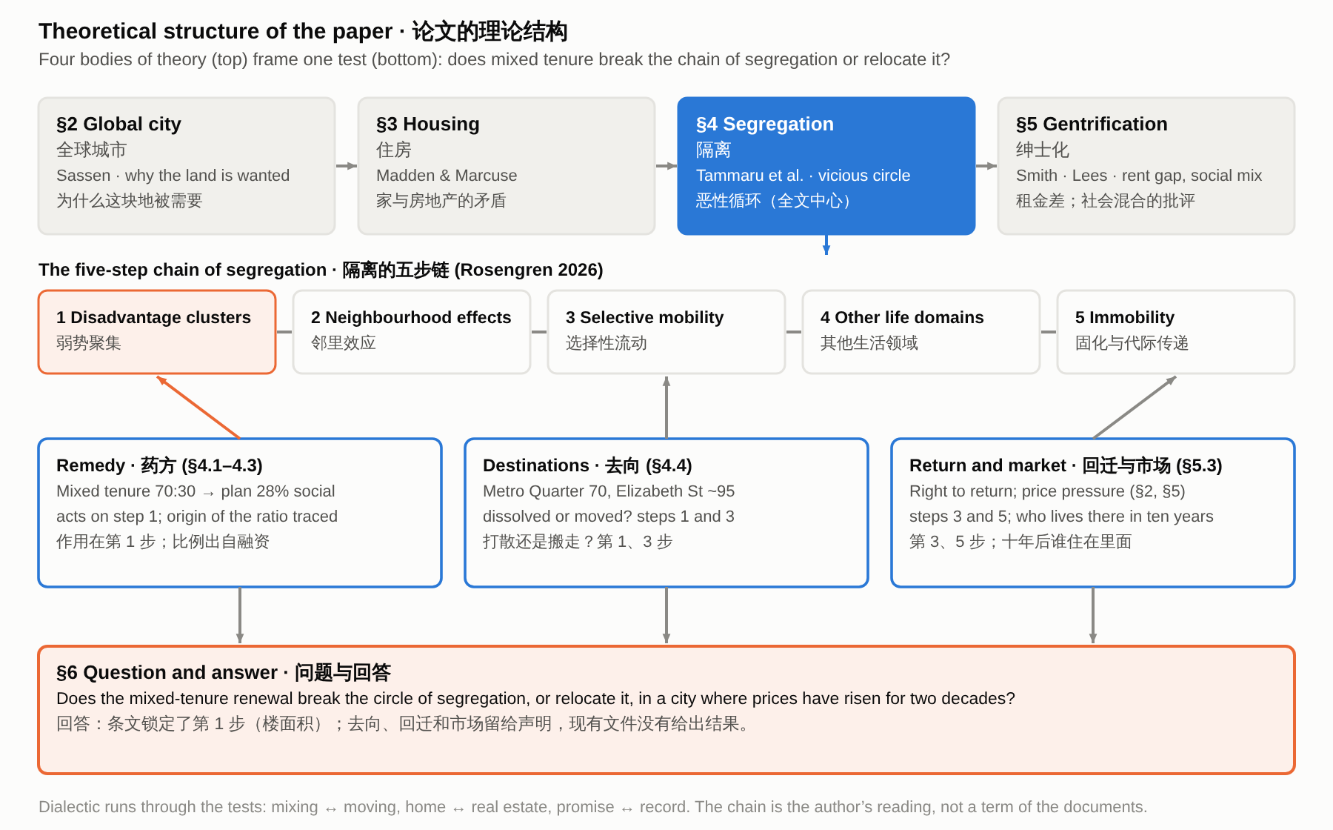
Figure 0. Theoretical structure: four bodies of theory frame one test of the chain of segregation.
1. Introduction
[1.1] Mixing tenures is a standard remedy for the concentration of disadvantage in public housing estates. The NSW Government justified renewing its estates with a diagnosis, that disadvantage clusters in estates and is “passed on through multiple generations” (NSW Government 2016, PDF p. 24), and with a remedy, a 70:30 split between private and social dwellings “to enable more integrated communities” (NSW Government 2016, PDF p. 9). This paper asks whether the renewal of the Waterloo estate in Sydney breaks that circle of segregation or only moves it, and argues that the answer depends on what the planning rules actually guarantee: they fix how much floor space goes to social housing, but the right of return appears only as a statement of intent.
结构｜作用：题目与论点：诊断、药方、问题和答案 辩证：打破循环 ↔ 搬到别处 实在：Future Directions pp. 24、9
[1.2] Waterloo, with about 2,000 dwellings on 18 hectares, is among Sydney's largest inner-city public housing estates (Chatterjee et al. 2018), and its renewal has been described as the largest estate renewal proposed in Australia to date (Zanardo et al. 2024, 1208). The plan has changed several times since the state government announced it in 2015. The planning route, which decides what the rules can fix, moved from a state-led process to a council-led one in 2019 (Turner Studio & Turf 2020, PDF p. 6) and back to the state in 2021 (NSW Department of Planning and Environment 2022, PDF p. 11), and in 2023 the target for social and affordable housing across the estate was raised from 34 to 50 per cent (NSW Government 2023).
结构｜作用：交代案例与时间线 辩证：规模与历史 ↔ 目标反复改变 实在：约 2,000 套、18 公顷；2015 年起路径与比例的变化
[1.3] The renewal takes place in an expensive and unequal market. Sydney’s council, arguing for more affordable housing at Green Square Town Centre, describes it: “Gentrification of inner city neighbourhoods has exacerbated relative inequality among those who can and cannot afford housing,” and there is “a growing disconnect between affluent households able to afford private market housing and highly socio-economically disadvantaged households living in inner city public housing estates” (City of Sydney n.d.). In that market the median price of attached dwellings more than doubled between 2006 and 2026 (Australian Bureau of Statistics 2026), and the sale of private dwellings funds the renewal (Zanardo et al. 2024, 1208).
结构｜作用：市场背景 辩证：市场的论证 ↔ 公屋区的现状 实在：City of Sydney 对市场的描述；ABS 价格；Zanardo 1208
[1.4] Existing work on Waterloo concerns reputation and displacement. Zanardo et al. (2024, 1236) and Sisson (2024) describe a reputational gap, a term Yrjänä (2026) attributes to Kallin, in which the present of a place is devalued and its imagined potential is set against it, and Wynne and Rogers (2021) show how residents experience the threat of displacement before any demolition. Officials and residents describe the estate differently: Hazzard called it “terrible” and Jackson “not fit for purpose” (Zanardo et al. 2024, 1208–1209), while the housing activist Karyn Brown answered, “It is very functional” (Bowring 2026). This paper takes reputation as background and reads the plan against the five steps of the vicious circle of segregation.
结构｜作用：已有研究与本文的位置 辩证：现在被贬低 ↔ 未来被理想化；官员 ↔ 居民 实在：Zanardo、Sisson、Yrjänä、Wynne and Rogers、Bowring 2026
[1.5] The paper is a document analysis. Its materials are the planning documents for Waterloo South (the plan finalisation report, the final planning proposal and the Design Guide, all from 2022) and for the concept application of 2025–26 (the proponent’s scoping report, the issued assessment requirements, the exhibition notice and appendices A–E of the impact statement), government statements and media releases from 2015 to 2026, news reports, and published studies of Waterloo and of other Sydney estates. I sorted each protection for tenants by where it appears: in a binding planning control, in the Design Guide, in a statement inside the planning record, or only in an announcement.
结构｜作用：材料与方法 辩证：文件的层次：条文 ↔ 设计指南 ↔ 声明 ↔ 公告 实在：2022 年三份规划文件；2015–2026 年声明与新闻
[1.6] This paper reads the plan’s tenure mix, the destinations of relocated tenants and the promise of return against the five steps of the vicious circle of segregation (Rosengren 2026; Tammaru et al. 2021), and asks which of them the planning rules guarantee and which are only promised in announcements. The sections take four bodies of urban theory in turn: the global city, housing, segregation and gentrification.
结构｜作用：路线 辩证：条文锁定 ↔ 声明 实在：五步链；四个课程单元
2. The global city: why Waterloo is drawn into the dispute
[2.1] The strategy that frames Sydney as a global city does not name Waterloo. The state’s 2014 metropolitan strategy defines a Global Economic Corridor that “generates over 41 per cent of the NSW Gross State Product” and lists Green Square among its strategic centres, in line with the global-city idea that a city’s competitiveness rests on central land, infrastructure and the services of a global economy (Sassen 1991; NSW Planning and Environment 2014, 44). Waterloo’s tenants nevertheless live inside this ambition, as Wynne (2018) shows. So the question for the renewal is what happens to the people already living on the land.
结构｜作用：给案例定位：这块地为什么被需要 辩证：城市的雄心 ↔ 已经住在这里的人 实在：2014 年大都市战略；Wynne 2018
[2.2] The renewal is paid for by selling new private flats, so the price those flats can fetch matters, and that price has risen strongly. The median transfer price of attached dwellings in Sydney rose from $390,000 in June 2006 to $840,000 in June 2026, and that of houses from $495,000 to $1,487,600 (Australian Bureau of Statistics 2026; Figure 1). The rise has paused: Sydney values fell 9.4 per cent in the year to October 2026 but remain 34.5 per cent above their level ten years earlier (Cotality 2026). These figures show the pressure on the plan, not what happens to tenants, and they are for the whole city and the postcode. I found no price or rent figures for the Waterloo site itself.
结构｜作用：给雄心以分量：价格 辩证：上涨 ↔ 2026 年回调与局部租金没涨 实在：ABS、Cotality、DCJ、普查租金
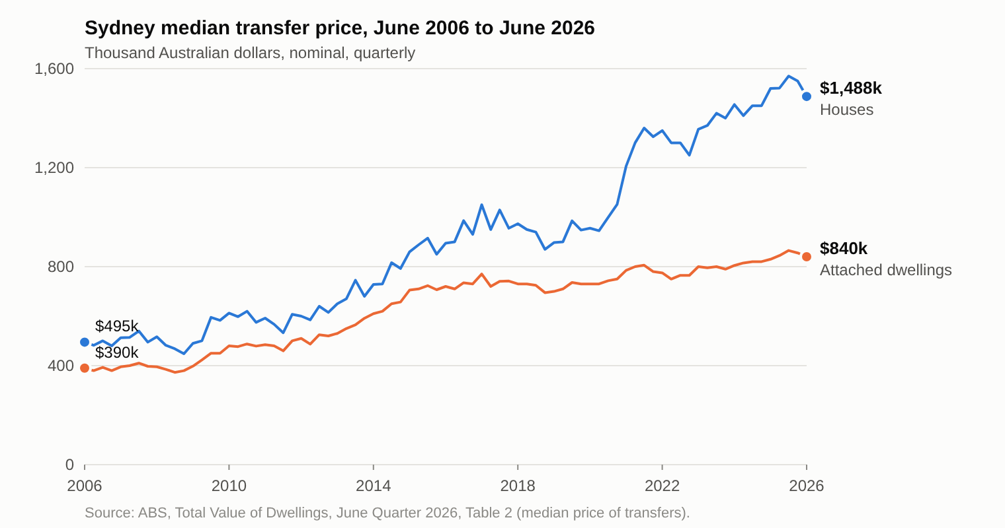
Figure 1. Sydney’s median transfer prices have risen strongly since 2006, though they fell in 2026 (see text).
[2.3] What brought the pressure to Waterloo was a metro station. The urban design study for Waterloo South calls the station “the catalyst for the renewal” (Turner Studio & Turf 2020, Part 1, PDF p. 6), and the planning proposal argues that keeping the site as it is would ignore “the potential catalytic effects of the new Metro station” (NSW Land and Housing Corporation [LAHC] 2020, 92). So the pressure arrived through a transport investment and not through the global-city strategy. The reason given for replacing the housing is a different one. Future Directions, a statewide strategy, says that “many estates experience high levels of crime, unemployment, domestic violence, tenancy management problems, poor educational outcomes and associated child protection issues” (NSW Government 2016, PDF p. 24). This describes estates in general, not Waterloo, and section 4 tests it.
结构｜作用：触发点与官方诊断，转向第 4 节 辩证：催化剂（土地）↔ 诊断（房子） 实在：规划建议书、城市设计研究、Future Directions
3. Housing: the strategy, and the conflict between home and real estate
[3.1] From the start the plan has treated Waterloo both as people’s homes and as a way to pay for new housing. In December 2015 the state announced that the estate would be demolished and rebuilt with about 30 per cent social and 70 per cent private housing, the sale of the private dwellings funding the project (Zanardo et al. 2024, 1208), in line with a statewide target of 70:30 (NSW Government 2016, PDF p. 9). Who decides has also changed: in November 2019 the planning route moved from the state to the council (Turner Studio & Turf 2020, Part 1, PDF p. 6), and in March 2021 the state took the planning authority back (NSW Department of Planning and Environment 2022, PDF p. 11). The planning proposal says the existing properties are “at the end of their economic life” (LAHC 2020, 23), yet the same study gives their average age as 44 years against a benchmark life of 60 (Turner Studio & Turf 2020, Part 1, PDF p. 6). Madden and Marcuse (2016) call this tension a conflict between home and real estate: housing as lived, social space against housing as an instrument for profit-making.
结构｜作用：给出住房单元的对立，写 2015–2021 年的策略 辩证：家 ↔ 房地产 实在：2015 年宣布约 30:70；2019、2021 年路径变化；44 年对 60 年
[3.2] The promises to tenants grew after 2023, but the planning rules were written before them (Figure 2). The plan approved in 2022 provides 3,012 dwellings, of which 847 are social housing, and its planning controls date from November 2022 (NSW Department of Planning and Environment 2022, PDF p. 37). After a change of government in March 2023, the share of social and affordable housing across the estate was raised from 34 to 50 per cent, tenants were promised the right to return, and relocation was to proceed in small stages (NSW Government 2023). In 2024 the government promised at least six months’ notice and dedicated support, and repeated that all residents would be given the right to return (NSW Government 2024). By 2026 a new concept application proposed about 3,300 homes, at least half of them social or affordable (Scully 2026), and fencing began around the first block of about 150 homes, due for demolition by the end of June (Bowring 2026). So the promises moved ahead of the rules. The floor-area part has since reached the planning documents: the proponent’s 2025 scoping report describes 50 per cent of residential floor area as committed to social and affordable housing (Beam Planning 2025, PDF pp. 4, 20), and the 2026 concept application proposes at least 30 per cent of residential floor area as social housing and no more than 50 per cent as market housing (NSW Department of Planning, Housing and Infrastructure 2026). None of the three documents I read for this stage mentions a right of return.
结构｜作用：写策略怎样变：2022–2026 辩证：条件在变 ↔ 负面描述连续 实在：847/3,012；34%→50%；Hazzard 与 Jackson 的话
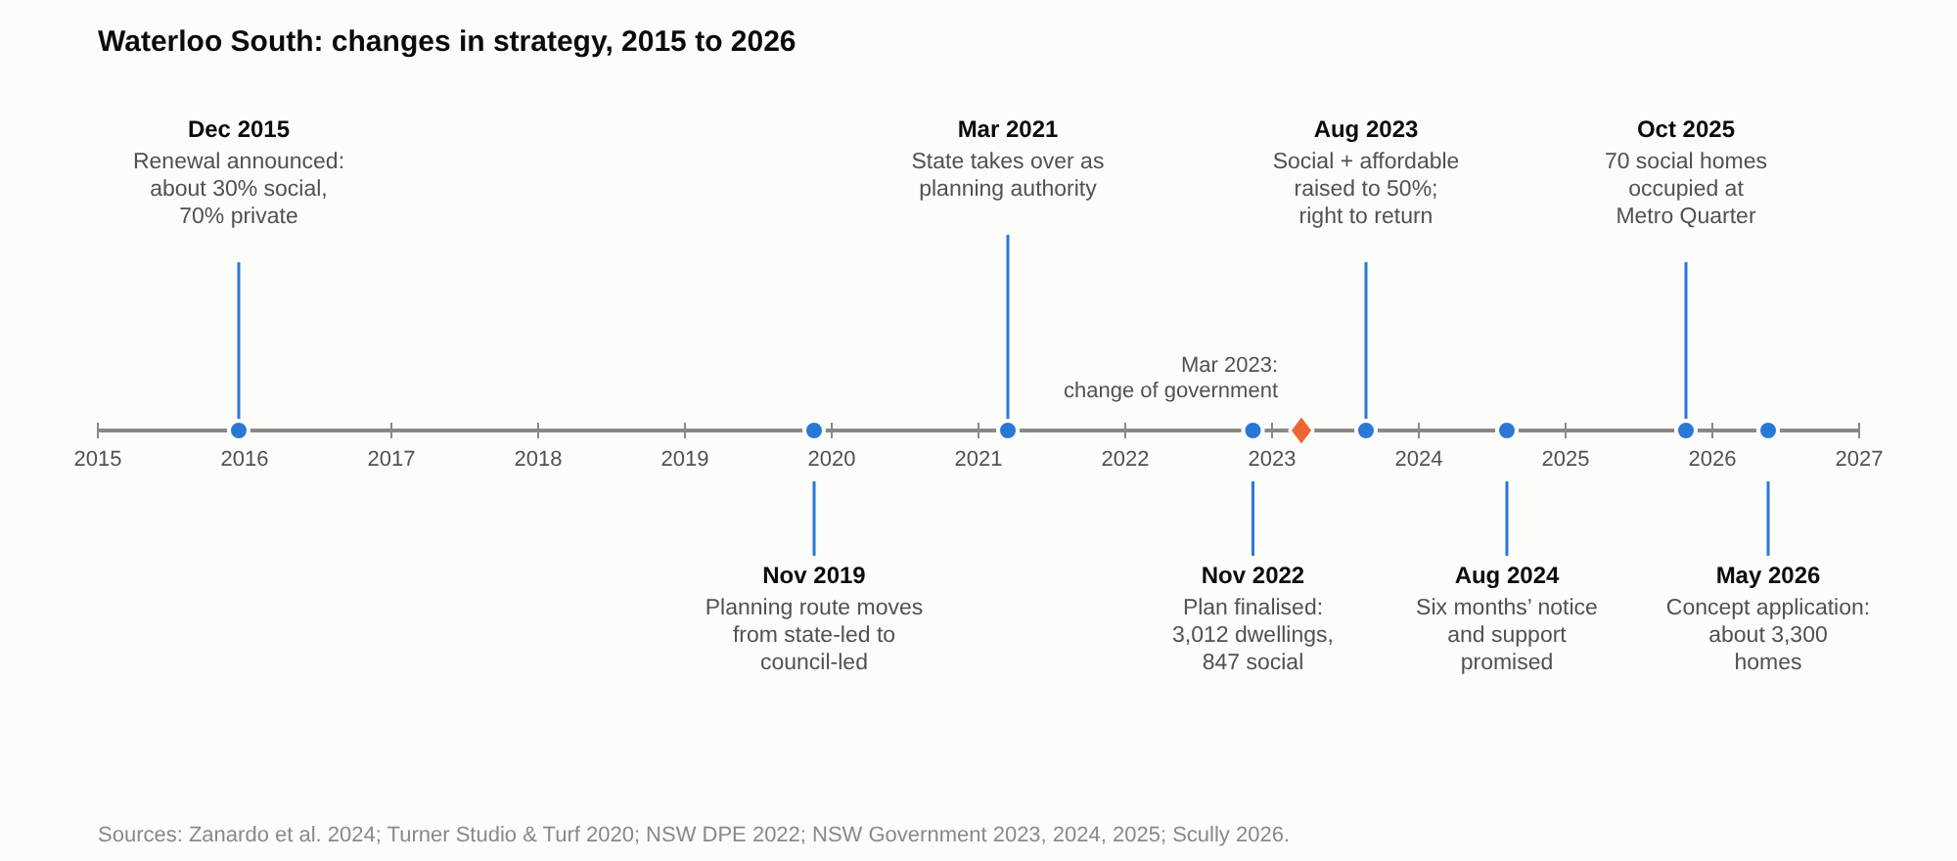
Figure 2. The strategy for Waterloo South changed several times between 2015 and 2026.
[3.3] The strategy can be sorted into measures that protect the money and measures that protect the tenants’ homes. On the money side, the planning proposal says that the existing planning rules “would not be capable of supporting a feasible redevelopment of the entire site given the costs of demolition and construction” (LAHC 2020, 92), an early proposal offered extra floor space only if 30 per cent of residential floor area were social housing and 20 per cent affordable (NSW Land and Housing Corporation 2021, Attachment A), and the sale of private dwellings carries the cost. On the tenants’ side are the right to return, more social homes in Waterloo South than there are now (Homes NSW 2026) and a promise that Aboriginal people will get at least 15 per cent of the new social and affordable homes (NSW Government 2023). No official document describes the funding in these terms; the sorting is mine. Sections 4.5 and 4.6 ask which side the binding rules protect.
结构｜作用：用对立读这套策略 辩证：商品一边 ↔ 使用一边 实在：可行性成本、早期容积奖励；回迁权、更多社会住房
4. Segregation: testing the remedy against the chain
[4.1] The state’s case for renewal rests on an argument that segregation research also makes: disadvantage that clusters in one place reproduces itself. Tammaru et al. (2021) describe vicious circles of segregation as the product of connected social and spatial inequalities in different life domains: advantage breeds advantage and disadvantage breeds disadvantage. Five steps can be distinguished (Figure 3): disadvantage clusters spatially, neighbourhood effects follow, poor perceptions shape who moves, segregation spreads to other domains such as schools and work, and it becomes immobility across the life course and across generations (Rosengren 2026). Future Directions follows the same chain. It finds disadvantage concentrated in estates, says that its effects “can be passed on through multiple generations, reinforcing the cycle of disadvantage” (NSW Government 2016, PDF p. 24), and proposes mixed tenure, with a 70:30 split between private and social dwellings “to enable more integrated communities” (PDF p. 9). The rest of this section tests that remedy step by step.
结构｜作用：全文中心：链条与官方理由 辩证：诊断（代代相传）↔ 药方（混合租住） 实在：Tammaru 等、Rosengren；Future Directions 第 9、24 页
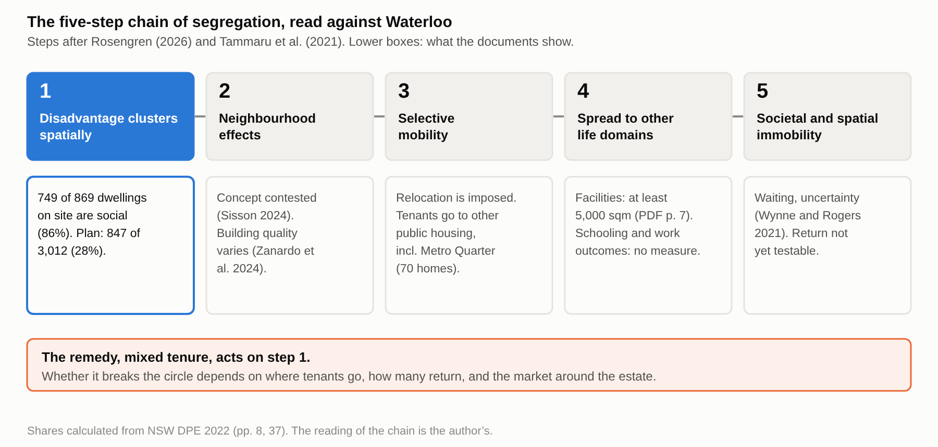
Figure 3. The five-step chain of segregation, read against Waterloo: mixed tenure acts on step 1.
[4.2] On step 1 the plan works: social housing falls from 86 per cent of the site’s dwellings to 28 per cent. Waterloo South now has 749 social and 120 private dwellings, and the approved plan has 847 social dwellings among 3,012 (NSW Department of Planning and Environment 2022, PDF pp. 8, 37; shares calculated from these figures; Figure 4). This is dilution by social mixing, which makes concentrated disadvantage less visible. The same plan can also be described as growth, 847 social dwellings against 749, so a document can call it dilution or growth depending on whether it counts share or number. The precedent that the urban design study uses for density has far less social housing: Green Square Town Centre is tabulated with 104 social and affordable dwellings among 3,308, about 3 per cent (Turner Studio & Turf 2020, App. 6, 463–464). Either way, step 1 is the part of the remedy that the planning rules fix (section 4.5).
结构｜作用：检验第 1 步 辩证：聚集 ↔ 稀释 实在：社会住房 86%→28%；Green Square Town Centre 约 3%
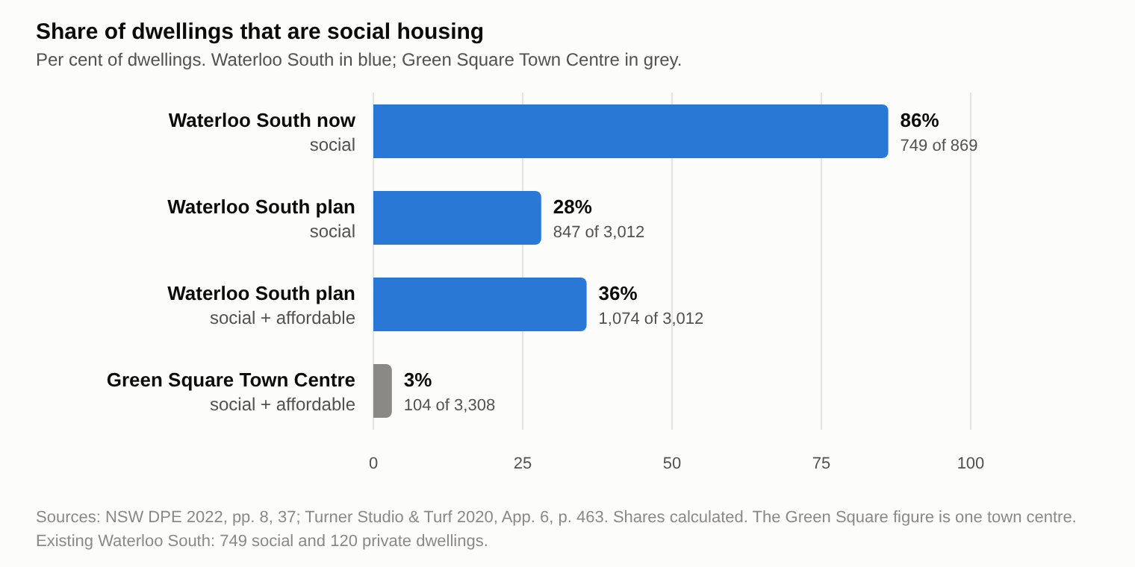
Figure 4. The share of social housing at Waterloo South falls from about 86 to about 28 per cent in the plan; Green Square Town Centre is shown for comparison.
[4.3] The 70:30 remedy was not designed from evidence about what mixing achieves. Khor et al. (2023, 77), citing Darcy and Rogers (2019), trace the ratio to Bonnyrigg, a suburban estate, where social-mixing outcomes “was not a determinant of decision-making”, and Shrestha, Ruming and Rogers (2025) find that Sydney’s estate-renewal models have moved “from periphery, through middle ring, towards core”. So a remedy first used on suburban estates has now reached the inner city. I found no counts of returning tenants and no measures of neighbourhood effects for these estates. My inference, which these authors do not state, is that the ratio was set by what financing required, a case of the financialisation of housing (Aalbers 2016), and so the rules enforce a quantity of tenure and not an outcome.
结构｜作用：药方从哪里来 辩证：药方的出处 ↔ 效果证据 实在：AHURI 412；Shrestha 等；Sisson and Ruming
[4.4] Where displaced tenants go decides whether the cluster is dissolved or only moved. Current tenants have moved into other public housing, at least 70 of them into the new homes beside the Waterloo metro station (Bowring 2026). The government names two local destinations, the 70 social homes at the Metro Quarter and about 95 more at Elizabeth Street, Redfern (Homes NSW 2026), and in 2023 it presented Elizabeth Street as a way to rehouse Waterloo South tenants locally (NSW Government 2023; Figure 5). No document gives the number of tenants at each Waterloo destination. What can be said is that the plan dilutes social housing on the site while also placing social housing nearby.
结构｜作用：检验第 1、3 步：去向 辩证：打散 ↔ 搬走 实在：Metro Quarter 70 套、Elizabeth St 约 95 套；Bonnyrigg 小样本
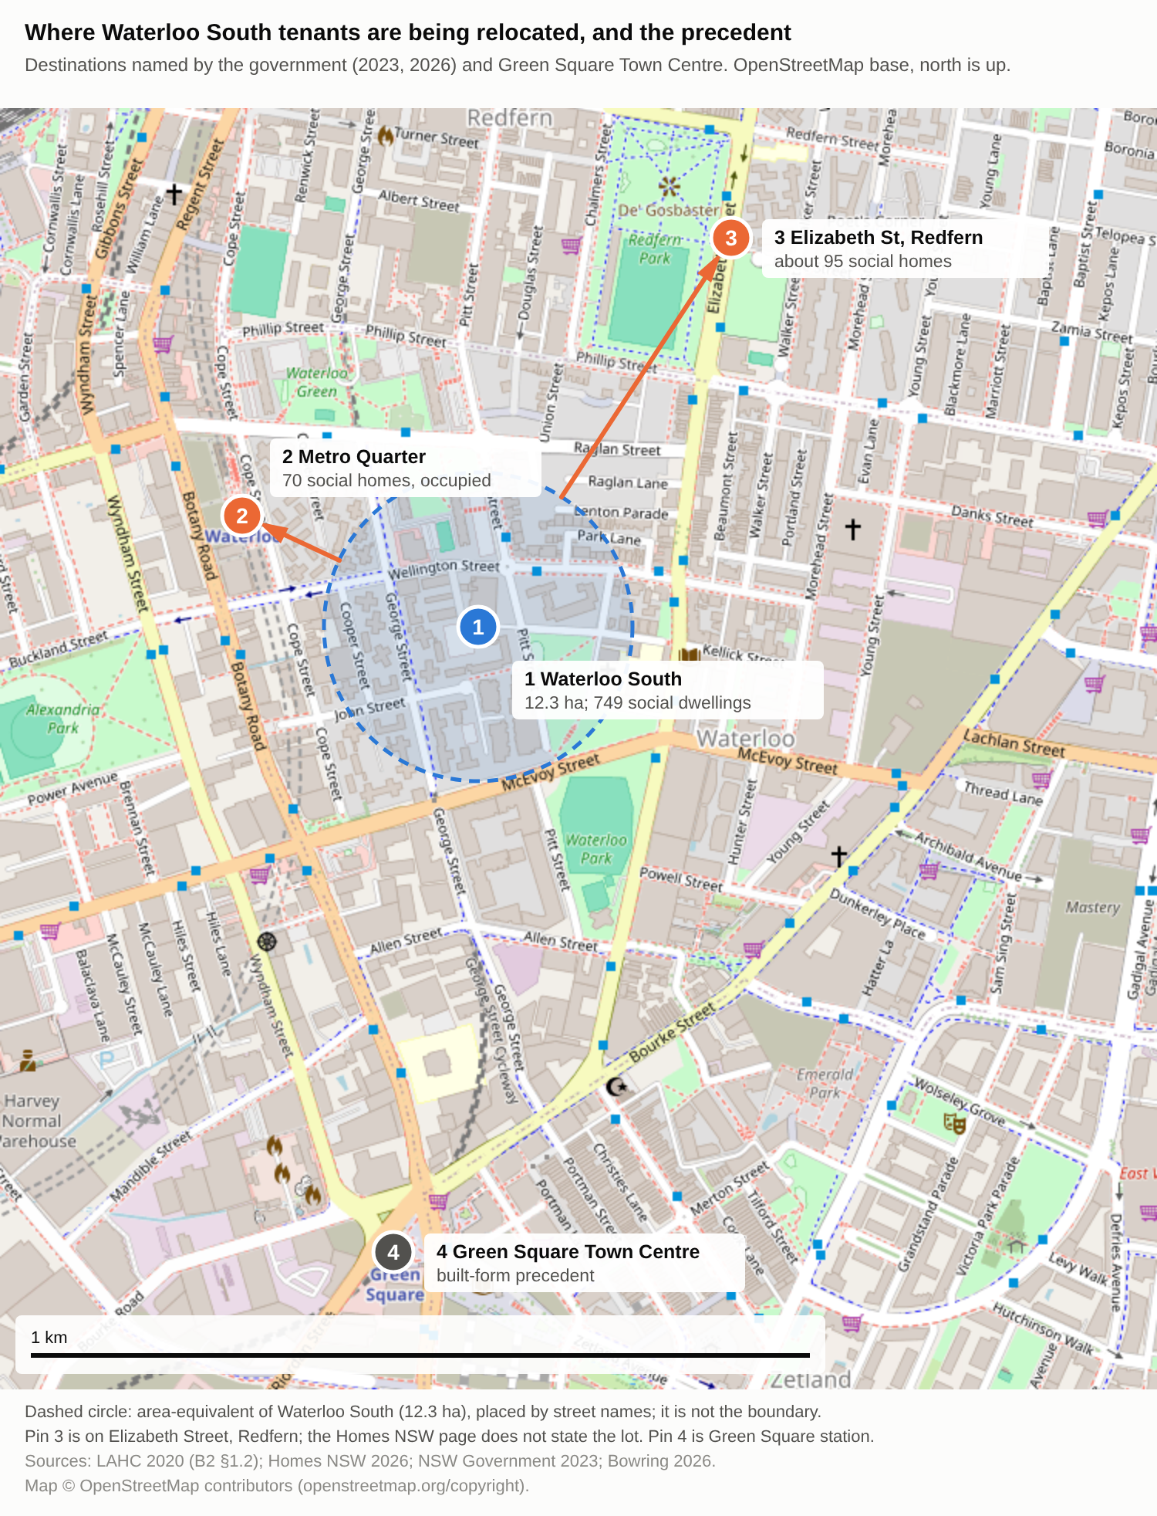
Figure 5. Where Waterloo South tenants are being relocated: the Metro Quarter and Elizabeth Street, Redfern are the destinations named by the government; Green Square Town Centre is the precedent.
[4.5] The planning rules guarantee how much social housing is built, but not who lives in it and not whether tenants can come back. The site-specific controls that the plan finalisation report lists for Waterloo South require no less than 26.5 per cent of residential floor area as social housing, no less than 7.0 per cent as affordable housing, and at least 5,000 square metres for community, health and childcare facilities (NSW Department of Planning and Environment 2022, PDF p. 7). These are minimum amounts of floor area. If a person’s relation to housing shapes their class position, as housing class theory holds (Ruonavaara 2025), such minimums fix which kinds of housing the new buildings contain, not which households hold them. The Design Guide, where the tenure and Aboriginal housing provisions sit, is only to be considered in development applications “but not to elevate the guidance within the design guide to development standards” (PDF p. 7). Its principle that social and affordable housing be provided “so that a socially diverse residential population, representative of all income groups, is created” (Hassell 2022b, PDF p. 22) comes closest to the people the housing is for, and it does not mention return. So the rules say how much social housing there will be, and say nothing about who will live in it or whether tenants can come back.
结构｜作用：规则保证了什么 辩证：保证（楼面积下限）↔ 没保证（谁来住） 实在：DPE 2022, PDF p. 7；设计指南 PDF p. 22
[4.6] Return and relocation appear only as statements. The final planning proposal records that the Land and Housing Corporation “has noted” that current residents have a right of return (Hassell 2022a, PDF p. 59), and in assessing the rezoning the department accepted a response stating that “appropriate relocation strategies will be developed” (NSW Department of Planning and Environment 2022, PDF p. 14). The report adds that state significant developments must include a social impact assessment (PDF p. 31), which is done when applying, and neither document requires anyone to track what happens to tenants after they move. These controls are also changing. The 2025 evaluation panel report describes a proposal to amend the Sydney local plan by “increasing building heights, redistributing floor space, and introducing flexibility to the application of the design guide” (NSW Department of Planning, Housing and Infrastructure 2025a, 1), and the exhibition notice of May 2026 lists amendments to the local plan alongside a concept plan with a minimum of 30 per cent of residential floor area as social housing (NSW Department of Planning, Housing and Infrastructure 2026). The requirements issued for the concept application in October 2025 ask for a Social Impact Assessment and a Preliminary Social Impact Management Plan “to identify and mitigate impacts from the development on local communities” (NSW Department of Planning, Housing and Infrastructure 2025b, PDF p. 9), without naming relocation or return. The proponent’s scoping report says that faster design review will “support tenant relocations directly into new homes” (Beam Planning 2025, PDF p. 27), a statement and not a mechanism. The impact statement lodged for that application in April 2026 adds measures of the same kind. Its mitigation measures, listed for later detailed applications, say that “current social housing residents are to be supported during relocations” (Beam Planning 2026, App. C, PDF p. 11), and its consultation table records “relocation certainty” among community concerns (App. D, PDF p. 1). Neither says return, and neither sets a count or a follow-up. I did not read the body of the impact statement, the social impact assessment (its Appendix EE) or the gazetted rules. In terms of the five steps, the rules reach step 1 and, through the facilities, the services side of step 4. Steps 3 and 5, which concern where people go and what happens to them, depend on promises outside the rules (Table 1).
结构｜作用：回迁和搬迁只是声明 辩证：规则 ↔ 声明 实在：Hassell 2022a, PDF p. 59；DPE 2022, PDF pp. 14, 31；2025 评估小组报告
Table 1. The measures protecting Waterloo South tenants and housing, sorted by where they sit in the planning documents read (2022 versions, with the 2025–26 additions).
Measure | Where it sits | Source
Social housing: no less than 26.5% of residential floor area | Binding site-specific control | DPE 2022, PDF p. 7
Affordable housing: no less than 7.0% of residential floor area | Binding site-specific control | DPE 2022, PDF p. 7
Community, health and childcare facilities: no less than 5,000 sqm | Binding site-specific control | DPE 2022, PDF p. 7
Affordable housing in perpetuity; a socially diverse population; Aboriginal housing provisions | Design Guide (to be considered, not a development standard) | Hassell 2022b, PDF p. 22; DPE 2022, PDF p. 7
Right of return | Statement in the planning record (“has noted”), and announcements | Hassell 2022a, PDF p. 59; NSW Government 2023, 2024
Relocation strategy | Statement (“will be developed”) | DPE 2022, PDF p. 14
Six months’ notice; staged relocation | Announcement only, outside the planning documents read | NSW Government 2023, 2024
Floor-area shares in the 2026 concept: social at least 30%, market at most 50%, the rest affordable | Proposed in the concept application (on exhibition May–June 2026) | DPHI 2026
Social Impact Assessment and Preliminary Social Impact Management Plan | Requirement for the concept application (assessment requirements, October 2025) | DPHI 2025b, PDF p. 9
Support for current social housing residents during relocation | Statement in the application: a mitigation measure for later applications (impact statement, April 2026); no return, count or follow-up | Beam Planning 2026, App. C, PDF p. 11

[4.7] Steps 2 to 5 are where the evidence is thinnest. Sisson (2024) notes that the concept of neighbourhood effects behind “concentrated disadvantage” “controversially” places the cause in the estate. Hirvonen and Lilius (2019), in a Finnish survey, find only small differences in neighbour ties between house types and a need to develop social ties “also in rental houses”, which suggests that contact across tenures has to be built and does not follow from proximity; the survey is Finnish and does not address mixed tenure. Uncertainty already acts on steps three and five. Wynne and Rogers (2021) argue that the threat of eviction “has already done significant damage to their relationship to place” before any move, and a resident, Julie, said that she heard of the demolition work when she woke to find fences going up, and that her relocation had been delayed (Bowring 2026). Read through the chain, residents neither choose nor time their moves, and the wait is part of the circle. This is my reading; no document measures residents’ mobility or opportunities.
结构｜作用：检验第 2–5 步 辩证：已知（等待）↔ 未知（接触、服务、学校、就业的结果） 实在：Sisson、Hirvonen and Lilius、Wynne and Rogers、Bowring 2026
5. Gentrification: price, cost and promise
[5.1] Tenants can lose their homes in two ways, and the promise of return covers only one of them. Gentrification research asks who gains when land is reinvested in and who bears the cost. Smith’s rent gap is the disparity between potential ground rent and the rent capitalised under the present use (Smith 1979), and Stein describes gentrification as “planned by the state, produced by the developers and consumed by the condo crowd” (Stein 2019, 41). Sydney’s council, arguing for more affordable housing at Green Square, says that gentrification “has exacerbated relative inequality among those who can and cannot afford housing” and that the market is becoming “virtually inaccessible to those on very low to moderate incomes” (City of Sydney n.d.). One way is through the market around an estate: Atkinson et al. (2011, 10) found for Sydney and Melbourne that displacement from gentrified neighbourhoods ran at about one and a half times the out-movement of similar households elsewhere, and that the most vulnerable displaced households were private renters, in data from the 2000s. The other way is direct: the estate’s own tenants are moved by their landlord, and the promise of return addresses only this second way. None of the documents I read addresses the first.
结构｜作用：定位绅士化单元：谁获益、谁承担 辩证：获益（租金差）↔ 代价（置换） 实在：Smith、Stein、Zanardo、Sisson；City of Sydney；Atkinson 等 2011
[5.2] Mixing is the policy that this remedy shares with “positive gentrification”, and the evidence for it is weak. Lees (2008) finds a “poor evidence base” for that policy, which is promoted in the belief that it will reduce segregation. Yrjänä (2026) shows in Helsinki how an anti-segregation policy can serve state-led gentrification, with a subsidy gap in which the state pays the difference to de-risk private investment. Hochstenbach (2017) finds for Amsterdam that the instruments of social mixing moved from the renewal of declining post-war neighbourhoods to high-demand neighbourhoods where housing policy pushes gentrification, the direction that Shrestha, Ruming and Rogers (2025) trace in Sydney. Davidson (2018, 249), reading new-build gentrification as large-scale capital working with state power, adds that the state “has been required to provide justifications for its actions”; for Waterloo the justification offered is the statewide diagnosis of section 4. Waterloo’s documents use the language of mixing, and Homes NSW states that “part of the success of mixed housing communities is that social and private housing are indistinguishable” (Homes NSW 2026). In the 2022 planning proposal, residential floor area on Land and Housing Corporation sites was split 26.5 per cent social, 7.0 per cent affordable and 66.5 per cent market (Hassell 2022a, PDF p. 19). The 2026 concept application proposes at least 30 per cent social housing and no more than 50 per cent market housing, with the balance affordable (NSW Department of Planning, Housing and Infrastructure 2026). Because the sale of private dwellings funds the project (section 3), I take the market share to be the part that pays for the rest, and that share has fallen from two thirds to at most a half as the policy changed. Whether this dilutes the cluster or prepares the area for richer residents, the documents do not show.
结构｜作用：社会混合的批评 辩证：混合的话语 ↔ 绅士化的话语 实在：Lees、Yrjänä、Hochstenbach；Homes NSW 的 “indistinguishable”；Green Square 约 3%
[5.3] On paper tenants are better protected than in 2015, but most of the protections are promises and not rules. They include the right to return, six months’ notice, staged relocation, more social homes and a share for Aboriginal households (NSW Government 2023, 2024; Homes NSW 2026). Of these, the right to return, notice and staging are not among the site-specific controls listed in the plan finalisation report (NSW Department of Planning and Environment 2022, PDF p. 7). The reported gaps are also clear. The plan replaces 749 social dwellings with 847, an increase of 98 (NSW Department of Planning and Environment 2022, PDF pp. 8, 37; difference calculated), and under the previous government’s plan for the whole estate Sisson and Ruming (2025, 1839) calculated a net gain of 148, an uplift of 7 per cent. The minister could not say what part of the 20 per cent affordable share would be permanent (Bowring 2026). The applicant’s 2026 assessment of the Design Guide says that at least 7 per cent of residential floor area will be affordable housing held in perpetuity by a community housing provider and any further affordable housing for a minimum of 25 years, and expects these requirements to be imposed as conditions of consent on later applications (Beam Planning 2026, App. E, PDF p. 6). Activists said that at least ten people were still living on the site while the minister said that the remaining people were not tenants (Bowring 2026). No figures are published on how many tenants return or how soon. The question is therefore not whether the new buildings will exist but who will live in them and near them in ten years’ time. The documents promise return and do not show it.
结构｜作用：保护与缺口 辩证：承诺 ↔ 记录；声明 ↔ 条文 实在：回迁等不在专用控制里；749→847（+98）；整个住宅区 +148、7%
6. Conclusion and discussion
[6.1] The renewal mixes the site, and the planning rules guarantee only the mixing. Social housing falls from 86 to 28 per cent of the dwellings on the site, and the rules fix minimum floor areas for it, so step 1 of the chain is addressed. Whether the circle is broken or only moved depends on what the rules leave out: where the displaced tenants live, how many return, and what the market around the estate does. The evidence here shows some tenants placed in other social housing nearby and return promised to the rest, in a market where gentrification has widened the gap between households in private housing and in public housing estates (City of Sydney n.d.). The reputational gap that Zanardo et al. (2024) and Sisson (2024) describe may explain why the remedy is accepted. That is my suggestion, and it is the least tested part of the argument. On what the documents show, I cannot say that the circle is broken, and I cannot say that it is only moved: nothing in the planning documents I read would show which.
结构｜作用：回答论文问题 辩证：打破 ↔ 搬走：取决于条文沉默的地方 实在：前面各节的汇总；Shrestha 等
[6.2] This paper adds three small things to existing work on Waterloo. First, it reads the renewal through the chain of segregation. The studies of Waterloo that I used (Zanardo et al. 2024; Sisson 2024; Wynne and Rogers 2021; Sisson and Ruming 2025) deal with reputation, land value, displacement and housing supply, and none of them uses the vocabulary of segregation. Second, it sorts each protection for tenants by where it sits in the planning documents (Table 1) and finds that the rules guarantee floor area while return and relocation are statements. Third, it separates two things that are often run together: a plan can be described as dilution or as growth depending on whether it counts share or number, and tenants can lose their homes through the market around an estate or directly through their landlord, and only the second is covered by the promise of return. These are findings about documents. They do not test what happens to tenants.
结构｜作用：说明限度 辩证：已有 ↔ 缺失 实在：无访谈；去向无人数；价格转向；链条是读法
[6.3] The case supports some frameworks and limits others. It is consistent with the view of Stein and Davidson that the state plans and justifies large-scale redevelopment (Davidson 2018, 249), and it extends the global-city account by showing that the pressure reached Waterloo through a metro station and not through the strategy that frames the corridor. It limits two accounts. In Yrjänä’s (2026) Helsinki the state pays a subsidy gap to de-risk private investment, while in the Waterloo documents I read the money runs the other way, with private sales paying for social homes. And accounts of home against real estate (Madden and Marcuse 2016), or of mixing against segregation, treat the two sides as opposed, while Waterloo’s policy has kept changing: the share of social and affordable housing rose from 34 to 50 per cent in 2023 (NSW Government 2023), the right to return was added, and a 2025 proposal would loosen how the Design Guide applies (NSW Department of Planning, Housing and Infrastructure 2025a, 1). A single case and a set of documents can show such mechanisms. They cannot test the theories.
结构｜作用：讨论：案例对各框架的意义 辩证：赞同／拓展 ↔ 限定 实在：Davidson 2018, 249；Yrjänä 2026；NSW Government 2023；2025 评估小组报告
Table 2. What the Waterloo case does to each framework used in the paper.
Framework | Verdict | What the case shows | Evidence
Global-city frame (Sassen 1991) | Extended | Pressure reached the site through a metro station, not through the corridor strategy | NSW Planning and Environment 2014, 44; Turner Studio & Turf 2020, Part 1, PDF p. 6
Home against real estate (Madden and Marcuse 2016) | Consistent, with a limit | One plan carries both; the ratio was renegotiated, so the sides are not simply opposed | NSW Government 2023; DPE 2022, PDF pp. 7, 30
Chain of segregation (Tammaru et al. 2021; Rosengren 2026) | Consistent, extended | The state uses the chain; moves are administered and local; the remedy came from suburban estates | NSW Government 2016, PDF p. 24; Homes NSW 2026; Khor et al. 2023, 77
State-led gentrification (Stein 2019; Davidson 2018) | Consistent | The state plans and has to justify; the justification is a statewide diagnosis | Davidson 2018, 249; NSW Government 2016, PDF p. 24
Positive gentrification (Lees 2008) | Partly consistent | Mixing is promoted without outcome evidence; social dwellings still rise from 749 to 847 | Lees 2008; DPE 2022, PDF pp. 8, 37
Subsidy gap (Yrjänä 2026) | Limited | Private sales pay for social homes, the reverse of the Helsinki flow | Zanardo et al. 2024, 1208; Yrjänä 2026
Displacement (Atkinson et al. 2011) | Extended | Two channels: the market around the estate, and direct relocation by the landlord | Atkinson et al. 2011, 10; Hassell 2022a, PDF p. 59

[6.4] This argument has limits. It rests on documents and published studies, not on interviews, so residents’ experience comes through other researchers and single news reports. The body of the environmental impact statement, the social impact assessment, the gazetted rules and the Homes NSW relocation policy I did not read (of the impact statement I read appendices A to E), so “not among the rules” means only that a measure is not in the documents I read, and the finding may change if the exhibited documents write return into the rules. Two sources, Shrestha, Ruming and Rogers (2025) and Hochstenbach (2017), I read as abstracts. Destinations are named but not counted, and I found no counts of returning tenants and no measures of neighbourhood effects. The price series is for the whole city and turned in 2026, so the claim concerns two decades of rise, not the present. The five-step chain is my way of reading the case, and the documents do not use it. No official document explains the land-value funding model. The conclusion therefore holds for the 2022 documents and the 2025–26 summaries I read, and it may change when the exhibited proposal is read in full.
结构｜作用：说明局限 辩证：已有 ↔ 缺失 实在：无访谈；只读 2022 年文件；去向无人数；部分文献只读摘要
[6.5] Planning could do for people what it already does for floor space. The rules fix floor space by tenure; they could also require reporting on how many tenants return, when, and to the same place or only the same area, and where those who do not return live. The share of social housing should be published beside the number of social homes, because the number rises while the share falls. The permanence of the affordable homes beyond the first 7 per cent, which the applicant says will be held in perpetuity, should be confirmed. Where the existing buildings can be renovated, retention should be considered (Zanardo et al. 2024). None of this assumes bad faith. It asks that the cost of the remedy to the people it is meant to help be counted.
结构｜作用：提出可检查的建议 辩证：楼面积 ↔ 人：把对楼面积做的事也对人做 实在：回迁、去向、占比、永久性、翻新
References
Aalbers, M. B. 2016. The Financialization of Housing: A Political Economy Approach. Routledge.
Atkinson, R., M. Wulff, M. Reynolds, and A. Spinney. 2011. Gentrification and Displacement: The Household Impacts of Neighbourhood Change. AHURI Final Report No. 160. Australian Housing and Urban Research Institute.
Australian Bureau of Statistics. 2026. "Total Value of Dwellings, June Quarter 2026." Released September 8, 2026. https://www.abs.gov.au/statistics/economy/price-indexes-and-inflation/total-value-dwellings/latest-release.
Beam Planning. 2025. Scoping Proposal: Rezoning and Concept SSDA, Waterloo Estate (South). Prepared for Stockland and Homes NSW. August 20, 2025.
Beam Planning. 2026. Environmental Impact Statement, Waterloo Estate (South) Concept SSDA, SSD-93222706: Appendices A–E (SEARs Compliance Table, Statutory Compliance Table, Mitigation Measures, Community Consultation Table, Design Guide Assessment). April 2026.
Bowring, D. 2026. "Housing Minister Says Waterloo Community ‘Not Functional’ as Demolition Looms for Public Housing Estate." ABC News, May 25, 2026. https://www.abc.net.au/news/2026-05-25/waterloo-public-housing-estate-fenced-off-ahead-of-demolition/106718016.
Chatterjee, P., A. Sisson, J. Condie, and L. Wynne. 2018. "We Still Live Here: Public Housing Tenants Fight for Their Place in the City." The Conversation, November 19, 2018. https://theconversation.com/we-still-live-here-public-housing-tenants-fight-for-their-place-in-the-city-107188.
City of Sydney. n.d. "Planning Proposal: Affordable Housing Review – Green Square Town Centre (Post Exhibition), Attachment B." Accessed November 2026. https://meetings.cityofsydney.nsw.gov.au/documents/s44648/.
Cotality. 2026. Cotality Home Value Index, November 2026. https://discover.cotality.com/hubfs/COTALITY%20HVI%20NOV%202026%20FINAL.pdf.
Davidson, M. 2018. "New-Build Gentrification." In Handbook of Gentrification Studies, edited by L. Lees with M. Phillips, chap. 15, beginning p. 247. Edward Elgar.
Hassell. 2022a. Planning Proposal: Waterloo Estate (South). Final version, Attachment A to NSW Department of Planning and Environment (2022).
Hassell. 2022b. Waterloo Estate (South): Design Guide 2022. November 2022. Attachment B, City of Sydney Council meeting papers. https://meetings.cityofsydney.nsw.gov.au/documents/s70608/.
Hirvonen, J., and J. Lilius. 2019. "Do Neighbour Relationships Still Matter?" Journal of Housing and the Built Environment. https://doi.org/10.1007/s10901-019-09656-0.
Hochstenbach, C. 2017. "State-Led Gentrification and the Changing Geography of Market-Oriented Housing Policies." Housing, Theory and Society 34 (4): 399–419. https://doi.org/10.1080/14036096.2016.1271825.
Homes NSW. 2026. "Waterloo Renewal Project." Last modified October 21, 2026. https://www.nsw.gov.au/homes-nsw/waterloo.
Khor, L.-A., L. Taylor, S. Glackin, S. Rowley, S. Siebel, D. Tinios, and R. Azizi. 2023. From Mixed Tenure Development to Mixed Tenure Neighbourhoods. AHURI Final Report No. 412. Australian Housing and Urban Research Institute. https://doi.org/10.18408/ahuri5229701.
Lees, L. 2008. "Gentrification and Social Mixing: Towards an Inclusive Urban Renaissance?" Urban Studies 45 (12): 2449–2470.
Madden, D., and P. Marcuse. 2016. In Defense of Housing. Verso.
NSW Department of Planning and Environment. 2022. Plan Finalisation Report: Waterloo Estate (South), PP-2021-3265. https://shared-drupal-s3fs.s3.ap-southeast-2.amazonaws.com/master-test/fapub_pdf/Keelie+Drupal+Documents/Plan+Finalisation+Report.pdf.
NSW Department of Planning, Housing and Infrastructure. 2025a. Evaluation Panel Outcome Report: Waterloo Estate (South). Panel meeting June 10, 2025. https://shared-drupal-s3fs.s3.ap-southeast-2.amazonaws.com/master-test/fapub_pdf/PPR/Waterloo+Estate+(South)+Evaluation+Panel+Outcome+Report.pdf.
NSW Department of Planning, Housing and Infrastructure. 2025b. Waterloo Estate (South) Concept, SSD-93222706: Secretary’s Environmental Assessment Requirements and Rezoning Study Requirements. Issued October 8, 2025.
NSW Department of Planning, Housing and Infrastructure. 2026. “Exhibition of State Significant Development Application and State Assessed Rezoning Proposal: Waterloo Estate (South) Concept, SSD-93222706.” Public notice, May 6, 2026.
NSW Government. 2016. Future Directions for Social Housing in NSW. NSW Family and Community Services.
NSW Government. 2023. "Waterloo South Social and Affordable Housing Boosted to 50%." Media release, August 21, 2023. https://www.nsw.gov.au/media-releases/waterloo-affordable-housing-boost.
NSW Government. 2024. "Next Step Complete for Australia’s Largest Social Housing Build." Media release, August 9, 2024. https://nsw.gov.au/media-releases/next-step-complete-for-australias-largest-social-housing-build.
NSW Land and Housing Corporation. 2020. Waterloo South Planning Proposal Report. Attachment B2. https://meetings.cityofsydney.nsw.gov.au/documents/s49951/.
NSW Land and Housing Corporation. 2021. Planning Proposal: Waterloo Estate (South) – Sydney Local Environmental Plan 2012 Amendment. Attachment A. https://meetings.cityofsydney.nsw.gov.au/documents/s49854/.
NSW Planning and Environment. 2014. A Plan for Growing Sydney: A Strong Global City, a Great Place to Live. NSW Government.
NSW Planning Portal. n.d. "Waterloo Estate (South): Post-Exhibition." Accessed November 10, 2026. https://www.planningportal.nsw.gov.au/ppr/post-exhibition/waterloo-estate-south.
Rosengren, K. 2026. "Segregation in a Retrenching Housing Regime." Lecture, Aalto University, January 27, 2026.
Ruonavaara, H. 2025. "An Idea That Refuses to Die: Rise, Fall and Resurgence of “Housing Class.”" Housing Studies 40 (11): 2507–2527. https://doi.org/10.1080/02673037.2024.2409320.
Sassen, S. 1991. The Global City: New York, London, Tokyo. Princeton University Press.
Scully, P. 2026. "First Look at New Waterloo South as Renewal Enters Next Stage." Media release, May 7, 2026. https://paulscullymp.com.au/news/media-releases/first-look-at-new-waterloo-south-as-renewal-enters-next-stage/.
Shrestha, P., K. Ruming, and D. Rogers. 2025. "Dispersing the Public Housing 'Estate': Evolution of Public Housing Estate Renewal Projects in Sydney, NSW." International Journal of Housing Policy. Advance online publication, December 29, 2025. https://doi.org/10.1080/19491247.2025.2599101.
Sisson, A. 2024. "Public Housing and Territorial Stigma: Towards a Symbolic and Political Economy." Housing Studies 39 (5): 1199–1218. https://doi.org/10.1080/02673037.2022.2108383.
Sisson, A., and K. Ruming. 2025. "Calculating the System-Wide Supply Impacts of Social Housing Estate Renewal: New Measures and Methods." Housing Studies 40 (8): 1821–1845. https://doi.org/10.1080/02673037.2024.2378852.
Smith, N. 1979. "Toward a Theory of Gentrification: A Back to the City Movement by Capital, Not People." Journal of the American Planning Association 45 (4): 538–548.
Stein, S. 2019. Capital City: Gentrification and the Real Estate State. Verso.
Tammaru, T., D. Knapp, S. Silm, M. van Ham, and F. Witlox. 2021. "Spatial Underpinnings of Social Inequalities: A Vicious Circles of Segregation Approach." Social Inclusion 9 (2): 65–76. https://doi.org/10.17645/si.v9i2.4345.
Turner Studio & Turf. 2020. Waterloo Estate – Waterloo South: Urban Design & Public Domain Study. Part 1 and Appendix 6 case studies; planning proposal Attachment 5. City of Sydney meeting papers, Attachments B7a and B7i.
Wynne, L. 2018. "Trying to Stay Local in Sydney’s ‘Global Arc’: Social Housing Tenant Perspectives." Paper presented at the 8th State of Australian Cities National Conference, 1–11. https://opus.lib.uts.edu.au/handle/10453/133423.
Wynne, L., and D. Rogers. 2021. "Emplaced Displacement and Public Housing Redevelopment: From Physical Displacement to Social, Cultural, and Economic Replacement." Housing Policy Debate 31 (3–5): 395–410. https://doi.org/10.1080/10511482.2020.1772337.
Yrjänä, H. 2026. "By Any Means Necessary: The Anti-Segregation Efforts and State-Led Gentrification in Helsinki." Cities 170: 106718. https://doi.org/10.1016/j.cities.2025.106718.
Zanardo, M., A. Sisson, C. Logan, and R. McLaughlan. 2024. "Wilful Ignorance at Waterloo: Public Housing Quality and Political Stigma in Sydney’s Largest Estate Renewal." Planning Perspectives 39 (6): 1207–1239. https://doi.org/10.1080/02665433.2024.2337268.

辩证与实在对照（工作稿，不属于正文）
辩证的张力 | 出现在 | 怎样处理
A 家 ↔ 房地产（Home ↔ real estate）：住房作为生活空间，与住房作为盈利工具之间的冲突（Madden and Marcuse 2016）。 | ¶3.1, 3.3, 5.1 | 3.3 为两边各列证据（可行性成本、早期容积奖励 ↔ 回迁权、更多社会住房），5.1 用租金差说明谁获益。作为并列的张力保留，不宣布哪一边赢。
B 混合 ↔ 搬走（Mixing ↔ moving）：同一个措施，在一个场地上稀释聚集，在另一些场地上可能只是把聚集放到别处。这是核心问题。 | ¶4.2, 4.3, 4.4, 6.1 | 4.2 给稀释的数字（86%→28%），4.4 给去向的名称，4.3 说明 Bonnyrigg 的去向不能照搬；6.1 的回答取决于去向、回迁和市场这三件文件没回答的事。
C 诊断 ↔ 证据（Diagnosis ↔ evidence）：官方把住宅区的弱势读成代代相传的循环，药方是混合租住；但药方的比例出自融资条件，邻里效应也有争议。 | ¶2.3, 4.1, 4.3, 4.7 | 2.3、4.1 摆出诊断；4.3 追溯 70:30 的出处；4.5 引 Sisson 与 Zanardo 说明证据并不确定。
D 承诺 ↔ 记录（Promise ↔ record）：2023 年以来保护增多（回迁权、通知期），但回迁人数、永久性和时间没有公布。 | ¶3.2, 5.3, 6.2, 6.3 | 3.2、5.3 分别写承诺与缺口；6.3 把缺口变成可以对照文件检查的建议。
E 想象的未来 ↔ 居民的经验（Imagined future ↔ lived experience）：现在被贬低、未来被理想化（声誉差距），而居民经历的是在地失所与等待。 | ¶1.3, 1.4, 3.2, 4.7, 6.1 | 作为支线：1.3–1.4 引出，3.2 显示负面描述跨两届政府连续，4.5 写居民的等待，6.1 承认这是检验得最少的部分。
F 锁定 ↔ 声明（Secured ↔ announced）：规划条文用楼面积下限锁定了混合租住，回迁、通知和搬迁却只以声明出现。这是本文自己的角度。 | ¶4.5–4.6, 5.3, 6.1, 6.3 | 4.5 逐条分层：专用控制、设计指南、声明；5.3 说明保护不在控制里；6.3 建议把对楼面积做的事也对人做。

实在的项目 | 内容 | 出处 | 位置
价格压力 | 悉尼附属住宅中位转手价 $390,000 → $840,000（2006→2026） | ABS 2026 | ¶2.2
规划控制 | 社会住房 ≥26.5%、可负担 ≥7.0% 的住宅建筑面积；社区/健康/托育 ≥5,000 平方米 | DPE 2022, PDF p. 7 | ¶4.5
回迁与搬迁的位置 | LAHC “has noted” 回迁权；“appropriate relocation strategies will be developed” | Hassell 2022a, PDF p. 59；DPE 2022, PDF p. 14 | ¶4.6
占比 | 社会住房 86% → 28%（749/869 → 847/3,012） | DPE 2022, PDF pp. 8, 37；占比由计算得出 | ¶4.2
先例 | Green Square Town Centre 104/3,308，约 3% | Turner Studio & Turf 2020, App. 6, 463 | ¶4.2, 5.2
药方的出处 | 70:30 追溯到 Bonnyrigg；Bonnyrigg 833 套 / 2,330 套 | Khor 等 2023, 77；Benedict 等 2022 | ¶4.3
净增 | 749→847（+98）；前政府计划整个住宅区 +148、7% | DPE 2022；Sisson and Ruming 2025, 1839 | ¶5.3
去向 | Metro Quarter 70 套 + Elizabeth St 约 95 套；各去向人数未公布 | Homes NSW 2026 | ¶4.4
官方诊断 | 弱势“可代代相传” | NSW Government 2016, PDF p. 24 | ¶2.3, 4.1
保护 | 回迁权、六个月通知、分阶段搬迁 | NSW Government 2023, 2024 | ¶3.2, 5.3

