Mixing or Moving? Segregation, Gentrification and the Renewal of the Waterloo Estate
1. Introduction
[1.1] Public housing is often discussed as if its quality were a plain fact, yet the way it is understood changes with the plans made for it. Zanardo et al. (2024, 1207) open their study of the Waterloo estate in Sydney with a claim: "The history of public housing in Australia is being rewritten by redevelopment." In a district planned as part of a global city, the imagined future of a place and the planning treatment given to it are closely tied, because a plan needs a past to replace and a future to deliver.
[1.2] Waterloo, with about 2,000 dwellings on 18 hectares, is among Sydney's largest inner-city public housing estates (Chatterjee et al. 2018), and its renewal has been described as the largest estate renewal proposed in Australia to date (Zanardo et al. 2024, 1208). The plan has changed several times since the state government announced it in 2015. The planning route moved from a state-led process to a council-led one in 2019 (Turner Studio & Turf 2020, PDF p. 6) and back to the state in 2021 (NSW Department of Planning and Environment 2022, PDF p. 11), and in 2023 the target for social and affordable housing across the estate was raised from 34 to 50 per cent (NSW Government 2023).
[1.3] Its reputation has also kept changing, and it has been contested between the government and its residents. Zanardo et al. (2024, 1208–1209) record officials calling the estate "terrible" (Hazzard), "not fit for purpose" (Jackson) and "well past the renewal date" (Hoenig). The housing minister, Rose Jackson, has since said that "old style estates with thousands and thousands of public homes in the one place" are "not functional communities" (Bowring 2026), a remark about that kind of estate and not about Waterloo alone. Residents speak differently. Julie, a resident, said, "Waterloo is my home, I want to stay here," and the housing activist Karyn Brown, answering the minister, said, "It is very functional" (Bowring 2026).
[1.4] Zanardo et al. (2024, 1236) and Sisson (2024) describe this pattern as a reputational gap, a term Yrjänä (2026) attributes to Kallin: the present of a place is devalued and its imagined potential is set against it, which makes intervention easier to justify. Wynne and Rogers (2021) show how residents experience the threat of displacement before any demolition.
[1.5] Sydney's council describes the market in which this renewal takes place: "Gentrification of inner city neighbourhoods has exacerbated relative inequality among those who can and cannot afford housing," and there is "a growing disconnect between affluent households able to afford private market housing and highly socio-economically disadvantaged households living in inner city public housing estates" (City of Sydney n.d.). The official case for renewing such estates answers a version of the same divide. Future Directions describes disadvantage that clusters in estates and is "passed on through multiple generations" (NSW Government 2016, 24), and mixed tenure is its remedy. This paper asks whether the renewal of Waterloo breaks that circle or relocates it. It reads the plan's tenure mix, the destinations of relocated tenants and the promise of return against the five steps of the vicious circle of segregation (Rosengren 2026; Tammaru et al. 2021), in a city where the median price of attached dwellings more than doubled between 2006 and 2026 (Australian Bureau of Statistics 2026). The sections follow the four units of the course: the global city, housing, segregation and gentrification.
2. The global city: why Waterloo is drawn into the dispute
[2.1] The introductory unit of the course places Sydney’s housing in the frame of the global city, a city whose competitiveness rests on central land, infrastructure and the services of a global economy (Sassen 1991). The state’s metropolitan strategy of 2014 follows this logic. It defines a Global Economic Corridor that “generates over 41 per cent of the NSW Gross State Product” and names Green Square among its strategic centres, while the text of the strategy does not name Waterloo (NSW Planning and Environment 2014, 44). The unit also treats urban space as a terrain on which claims on land are contested, and Wynne (2018) shows what this means for tenants in Waterloo, who live inside a policy of global-city ambition that reaches their homes. I read land as the place where the ambition of the city meets the people who already live on it. This applies the unit’s concepts to Sydney, which the lectures do not do.
[2.2] Prices give this ambition its weight. The median transfer price of attached dwellings in Sydney, the market in which flats such as Waterloo’s sit, rose from $390,000 in June 2006 to $840,000 in June 2026, and that of houses from $495,000 to $1,487,600 (Australian Bureau of Statistics 2026; Figure 1). The rise has paused. Cotality’s index shows Sydney values down 9.4 per cent over the year to October 2026, although they remain 34.5 per cent higher than ten years earlier (Cotality 2026). New tenants in postcode 2017, which includes Waterloo, paid a median of $1,050 a week in the June 2026 quarter, against $780 for Greater Sydney (NSW Department of Communities and Justice 2026). The picture is not uniform. Census median rents in Waterloo were $520 in 2016 and $530 in 2021, and in Zetland they fell from $650 to $600, although the two censuses are not strictly comparable (Australian Bureau of Statistics 2016a, 2016b, 2021a, 2021b).
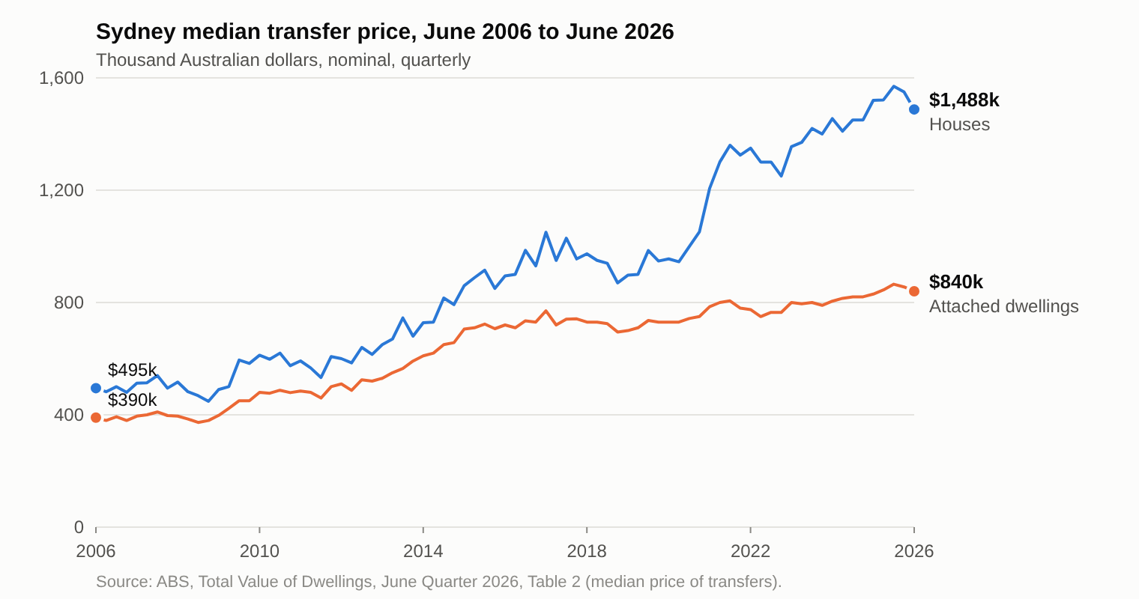
Figure 1. Sydney’s median transfer prices have risen strongly since 2006, though they fell in 2026 (see text).
[2.3] Within this setting the metro station became the trigger for change. The urban design study for Waterloo South calls it “the catalyst for the renewal” (Turner Studio & Turf 2020, Part 1, PDF p. 6), and the planning proposal argues that keeping the site as it is would ignore “the potential catalytic effects of the new Metro station” (NSW Land and Housing Corporation [LAHC] 2020, 92). The estate itself is read through a diagnosis that the state applies to estates in general. Future Directions finds that “many estates experience high levels of crime, unemployment, domestic violence, tenancy management problems, poor educational outcomes and associated child protection issues” (NSW Government 2016, PDF p. 24). The frame explains why the land is wanted. The diagnosis, taken up in section 4, explains why the housing on it is thought to need replacing.
3. Housing: the strategy, and the conflict between home and real estate
[3.1] The housing unit asks what housing is for. Its central contrast is between housing as a lived, social space and housing as an instrument of profit, a conflict between home and real estate (Madden and Marcuse 2016). The strategy for Waterloo shows both sides. In December 2015 the state announced that the estate would be demolished and rebuilt with about 30 per cent social and 70 per cent private housing, the sale of the private dwellings funding the project (Zanardo et al. 2024, 1208), in line with a statewide target of 70:30 (NSW Government 2016, PDF p. 9). The Premier said that no one would want tenants “sitting in run down 1950s-style accommodation” (Gerathy 2015). In November 2019 the planning route changed from a state-led process to a council-led one (Turner Studio & Turf 2020, Part 1, PDF p. 6), and in March 2021 the state took the role of planning authority from the council (NSW Department of Planning and Environment 2022, PDF p. 11). The planning proposal describes the existing properties as “at the end of their economic life” (LAHC 2020, 23), while the same study gives their average age as 44 years against a benchmark life of 60 (Turner Studio & Turf 2020, Part 1, PDF p. 6).
[3.2] The terms then changed (Figure 2). The plan approved in 2022 provides 3,012 dwellings, of which 847 are social housing (NSW Department of Planning and Environment 2022, PDF p. 37). After a change of government in March 2023, the share of social and affordable housing across the estate was raised from 34 to 50 per cent, tenants were promised the right to return, and relocation was to proceed in small stages (NSW Government 2023). In 2024 the government promised at least six months’ notice and dedicated support, and repeated that all residents would be given the right to return (NSW Government 2024). By 2026 a new concept application proposed about 3,300 homes, at least half of them social or affordable (Scully 2026), and fencing began around the first block of about 150 homes, due for demolition by the end of June (Bowring 2026). Seventy social homes at the Waterloo Metro Quarter have been occupied (NSW Government 2025). Descriptions of the estate did not soften with the change of government. Brad Hazzard, a minister under the former government, called it “terrible”, and Rose Jackson, a minister under the present one, “not fit for purpose” (Zanardo et al. 2024, 1208–1209).
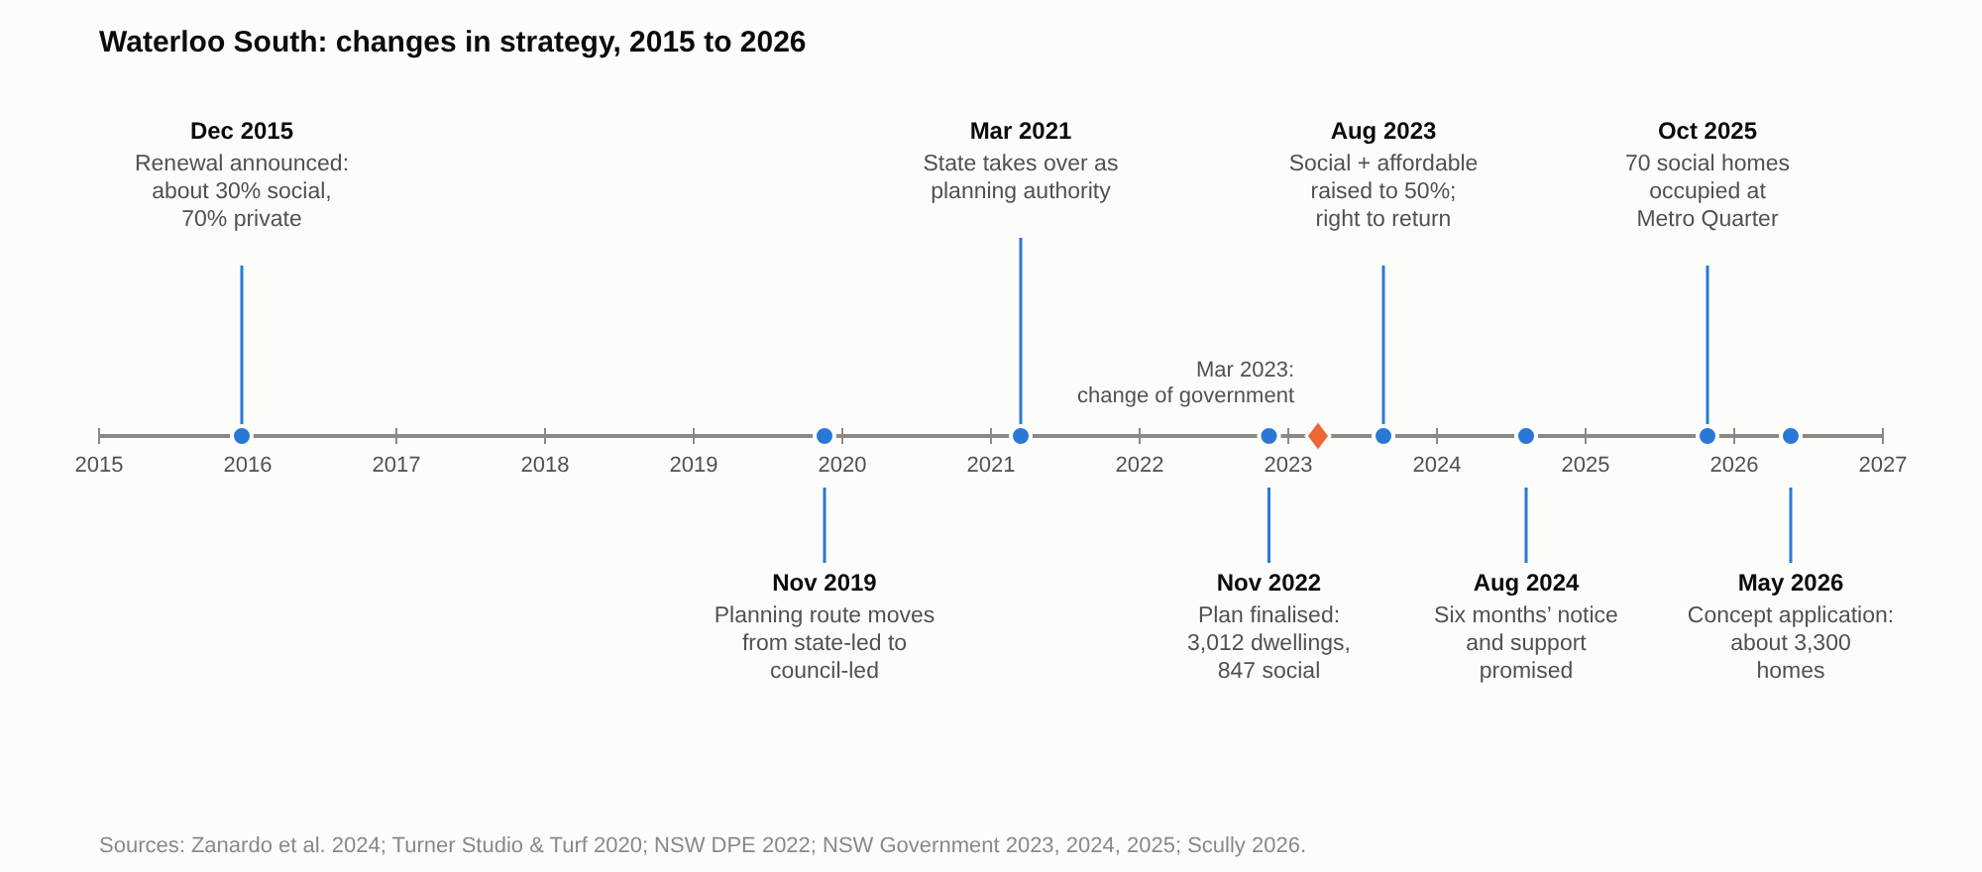
Figure 2. The strategy for Waterloo South changed several times between 2015 and 2026.
[3.3] Read through the unit, the strategy places the estate between the two sides. On the side of real estate, the planning proposal states that the existing controls “would not be capable of supporting a feasible redevelopment of the entire site given the costs of demolition and construction” (LAHC 2020, 92), an early proposal offered extra floor space only if 30 per cent of residential floor area were social housing and 20 per cent affordable (NSW Land and Housing Corporation 2021, Attachment A), and the sale of private dwellings carries the cost. On the side of home, there are the right to return, more social homes in Waterloo South than there are now (Homes NSW 2026), and at least 15 per cent of new social and affordable homes for Aboriginal people (NSW Government 2023). No official document sets out the funding model in these terms. The reading is an application of the unit’s contrast.
4. Segregation: testing the remedy against the chain
[4.1] The segregation unit gives the course’s account of how segregation reproduces itself. Tammaru et al. (2021) describe vicious circles of segregation as the product of the connectedness of social and spatial inequalities in different life domains: advantage breeds advantage and disadvantage breeds disadvantage. The lecture sets out five steps (Figure 3). Disadvantage clusters spatially, neighbourhood effects follow, poor perceptions shape who moves, segregation spreads to other domains such as schools and work, and it becomes immobility across the life course and across generations (Rosengren 2026). The state’s case for renewal follows the same chain. Future Directions finds disadvantage concentrated in estates, says that its effects “can be passed on through multiple generations, reinforcing the cycle of disadvantage” (NSW Government 2016, PDF p. 24), and proposes a ratio of 70:30 of private to social housing “to enable more integrated communities” (NSW Government 2016, PDF p. 9).
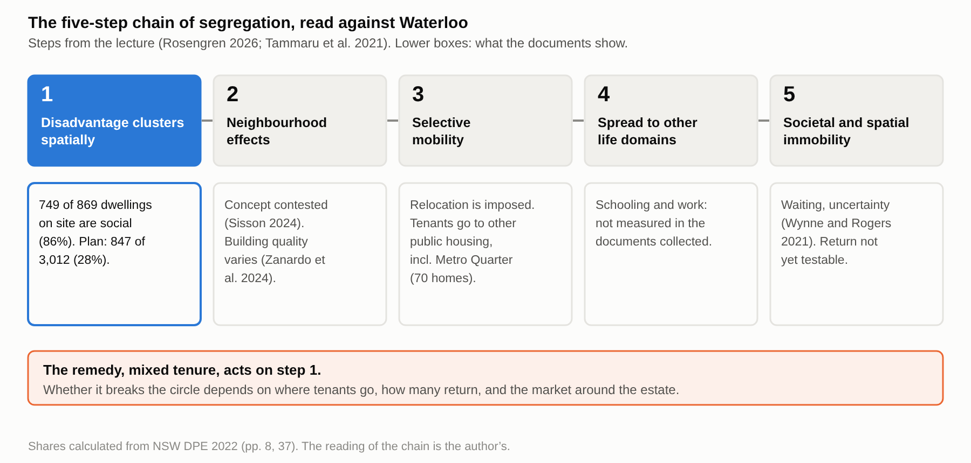
Figure 3. The five-step chain of segregation, read against Waterloo: mixed tenure acts on step 1.
[4.2] The renewal acts most clearly on the first step. Waterloo South now has 749 social and 120 private dwellings, about 86 per cent social housing, and the approved plan has 847 social dwellings among 3,012, about 28 per cent (NSW Department of Planning and Environment 2022, PDF pp. 8, 37; shares calculated from these figures; Figure 4). This is the dilution by social mixing that the lecture names as the way residential segregation becomes less visible. The precedent that the urban design study uses for density says less about mix. Green Square Town Centre is tabulated with 104 social and affordable dwellings among 3,308, about 3 per cent, and Waterloo and Zetland together are shown rising from 143 to 247 people per hectare (Turner Studio & Turf 2020, App. 6, 463–464). The comparison is limited, because the town centre is one part of Green Square and the City’s own target is 7.5 per cent social and 7.5 per cent affordable rental housing across its area (City of Sydney n.d.).
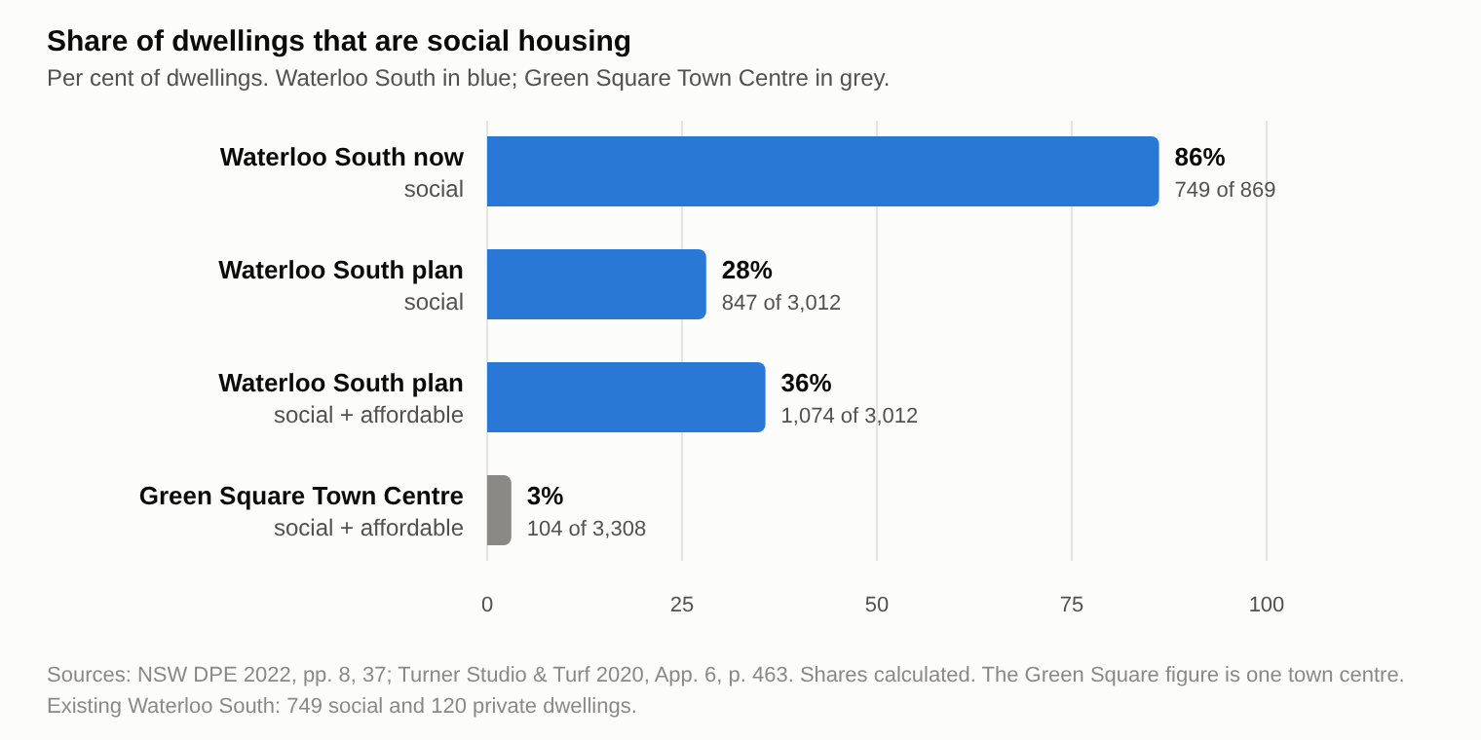
Figure 4. The share of social housing at Waterloo South falls from about 86 to about 28 per cent in the plan; Green Square Town Centre is shown for comparison.
[4.3] Where displaced households go decides whether a cluster is dissolved or moved. Current tenants have been relocated to other public housing, including at least 70 into the new homes beside the Waterloo metro station (Bowring 2026). The government names two local destinations, the 70 social homes at the Metro Quarter and about 95 more at Elizabeth Street, Redfern (Homes NSW 2026), and in 2023 it presented Elizabeth Street as a way for Waterloo South tenants to be relocated in the local area (NSW Government 2023; Figure 5). In the chain’s terms, these place social housing together in separate buildings nearby. The documents do not give the number of tenants at each destination. What can be said is that the first step is diluted on one site while social housing is placed on others.
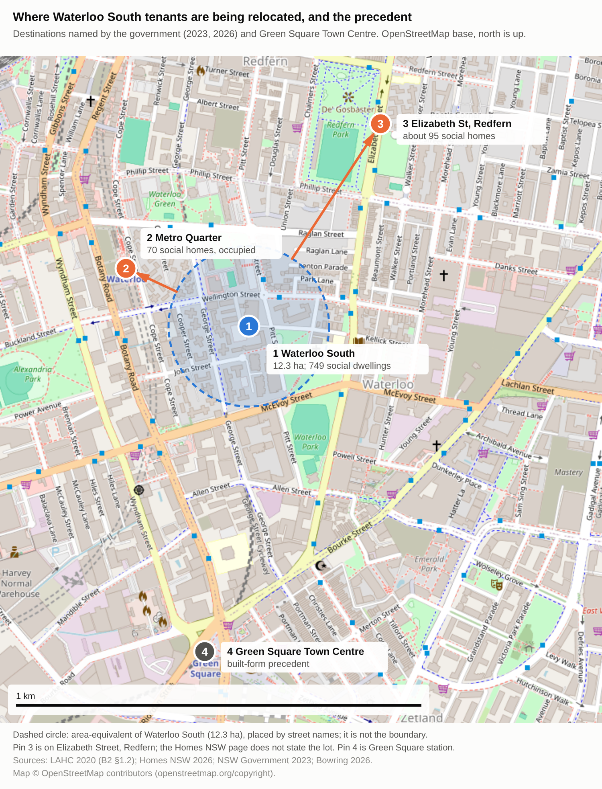
Figure 5. Where Waterloo South tenants are being relocated: the Metro Quarter and Elizabeth Street, Redfern are the destinations named by the government; Green Square Town Centre is the precedent.
[4.4] The later steps rest on evidence that is less settled. Sisson (2024) notes that the concept of neighbourhood effects behind “concentrated disadvantage” “controversially” places the cause in the estate, and Zanardo et al. (2024) conclude that most of the existing buildings, with the possible exception of the slab blocks, could have their lives extended with relatively modest renovation. Tenure mix changes who lives where. It does not by itself change services, schooling or employment, which steps four and five concern. Meanwhile uncertainty already acts on steps three and five. Wynne and Rogers (2021) argue that the threat of eviction “has already done significant damage to their relationship to place” before any move. A resident, Julie, said that she heard of the demolition work when she woke to find fences going up, and that her relocation had been delayed, and another, Karyn Brown, said of the estate, “It is very functional” (Bowring 2026). The planning minister’s release says that the renewal “stalled for years” (Scully 2026). Read through the chain, residents neither choose nor time their mobility, and the wait is part of the circle. This is a reading. The documents do not measure residents’ mobility or opportunities.
5. Gentrification: price, cost and promise
[5.1] The gentrification unit asks who gains when land is reinvested in and who bears the cost. Smith’s rent gap is the disparity between potential ground rent and the rent capitalised under the present use (Smith 1979), and Stein describes gentrification as “planned by the state, produced by the developers and consumed by the condo crowd” (Stein 2019, 41). Zanardo et al. (2024) connect Waterloo to a gap between the ground rents realised by the state and those potentially received through partial privatisation and redevelopment, and Sisson (2024) shows that the Communities Plus program selects high-value sites so that the state can obtain “value for money”. Sydney’s council states that gentrification “has exacerbated relative inequality among those who can and cannot afford housing” and that the market is becoming “virtually inaccessible to those on very low to moderate incomes” (City of Sydney n.d.). For Sydney and Melbourne, Atkinson et al. (2011, 10) found that the displacement rate from gentrified neighbourhoods was around 50 per cent higher than the out-movement rate for equivalent households elsewhere, although their data come from the 2000s.
[5.2] The unit’s critique of social mixing bears on the remedy. Lees (2008) argues that policy treats gentrification as a route to more mixed and less segregated communities on a poor evidence base, and describes social mixing as a positive packaging of gentrification. Yrjänä (2026) shows in Helsinki how an anti-segregation policy can serve state-led gentrification, with a subsidy gap in which the state pays the difference to de-risk private investment. Waterloo’s documents use the language of mixing, and Homes NSW states that “part of the success of mixed housing communities is that social and private housing are indistinguishable” (Homes NSW 2026). The planning documents also cite Green Square as a precedent for built form (LAHC 2020, §5.1.7), and its town centre has about 3 per cent social and affordable housing (Turner Studio & Turf 2020, App. 6, 463). Whether a mix of 28 per cent social housing, within a market-led development, dilutes the cluster or prepares the area for higher-income residents is the question of the unit. The documents describe the intention and do not yet show the result.
[5.3] Protections have grown on paper since 2015. They include the right to return, six months’ notice, staged relocation, more social homes and a share for Aboriginal households (NSW Government 2023, 2024; Homes NSW 2026). The reported gaps are also clear. The plan replaces 749 social dwellings with 847, an increase of 98 (NSW Department of Planning and Environment 2022, PDF pp. 8, 37; difference calculated), the minister could not confirm how much of the 20 per cent affordable housing would be permanent (Bowring 2026), and activists said that at least ten people were still living on the site while the minister said that the remaining people were not tenants (Bowring 2026). No figures are published on how many tenants return or how soon. For the gentrification unit the question is therefore not whether the new buildings will exist but who will live in them and near them in ten years’ time. The documents promise return and do not yet show it.
6. Conclusion and discussion
[6.1] The renewal changes the first step of the chain by diluting the social housing on the site. Whether it breaks the circle depends on three things that the documents leave open: where the displaced tenants live, how many return, and what the market around the estate does. On the evidence assembled here, the renewal places some tenants in other social housing nearby and promises the return of the rest, in a market where gentrification has widened the gap between households in private housing and in public housing estates (City of Sydney n.d.). The reputational gap that Zanardo et al. (2024) and Sisson (2024) describe, a devalued present set against an idealised future, offers one explanation for why the remedy is accepted. The planning documents point to precincts such as Green Square for the future they offer (LAHC 2020, §5.1.7). That reading is mine, and it is the least tested part of the argument.
[6.2] The argument has limits. It rests on documents and published studies rather than interviews, so residents’ experience is represented through other people’s research and single news reports. Relocation destinations are named but not counted. The price series turned in 2026, so the claim concerns two decades of rise and not the present. The five-step chain is a way of reading the case, and the documents do not use it. No official document sets out the land-value funding model, and the rents of Waterloo and Zetland did not rise between the 2016 and 2021 censuses.
[6.3] Several things follow for planning, and each can be checked against the documents. The return promise should be defined and reported: how many tenants return, when, and to the same place or only the same area. The share of social housing should be published alongside the number of social homes, because the number rises while the share falls. The destinations of relocated tenants should be reported. The permanence of the affordable homes should be confirmed. Where the existing buildings can be renovated, retention should be considered (Zanardo et al. 2024). These suggestions do not require that the policy acts in bad faith. They ask that the cost of the remedy to the people it is meant to help be counted.
References
Atkinson, R., M. Wulff, M. Reynolds, and A. Spinney. 2011. Gentrification and Displacement: The Household Impacts of Neighbourhood Change. AHURI Final Report No. 160. Australian Housing and Urban Research Institute.
Australian Bureau of Statistics. 2016a. "2016 Census QuickStats: Waterloo (NSW)." https://www.abs.gov.au/census/find-census-data/quickstats/2016/SSC14183.
Australian Bureau of Statistics. 2016b. "2016 Census QuickStats: Zetland." https://www.abs.gov.au/census/find-census-data/quickstats/2016/SSC14524.
Australian Bureau of Statistics. 2021a. "2021 Census QuickStats: Waterloo (NSW)." https://abs.gov.au/census/find-census-data/quickstats/2021/SAL14201.
Australian Bureau of Statistics. 2021b. "2021 Census QuickStats: Zetland." https://abs.gov.au/census/find-census-data/quickstats/2021/SAL14542.
Australian Bureau of Statistics. 2026. "Total Value of Dwellings, June Quarter 2026." Released September 8, 2026. https://www.abs.gov.au/statistics/economy/price-indexes-and-inflation/total-value-dwellings/latest-release.
Bowring, D. 2026. "Housing Minister Says Waterloo Community ‘Not Functional’ as Demolition Looms for Public Housing Estate." ABC News, May 25, 2026. https://www.abc.net.au/news/2026-05-25/waterloo-public-housing-estate-fenced-off-ahead-of-demolition/106718016.
Chatterjee, P., A. Sisson, J. Condie, and L. Wynne. 2018. "We Still Live Here: Public Housing Tenants Fight for Their Place in the City." The Conversation, November 19, 2018. https://theconversation.com/we-still-live-here-public-housing-tenants-fight-for-their-place-in-the-city-107188.
City of Sydney. n.d. "Planning Proposal: Affordable Housing Review – Green Square Town Centre (Post Exhibition), Attachment B." Accessed November 2026. https://meetings.cityofsydney.nsw.gov.au/documents/s44648/.
Cotality. 2026. Cotality Home Value Index, November 2026. https://discover.cotality.com/hubfs/COTALITY%20HVI%20NOV%202026%20FINAL.pdf.
Gerathy, S. 2015. "Waterloo Public Housing to Be Replaced as Part of New Sydney Metro Station Plans." ABC News, December 16, 2015. https://www.abc.net.au/news/2015-12-16/waterloo-metro-station-plans-to-see-public-housing-replaced/7033404.
Homes NSW. 2026. "Waterloo Renewal Project." Last modified October 21, 2026. https://www.nsw.gov.au/homes-nsw/waterloo.
Lees, L. 2008. "Gentrification and Social Mixing: Towards an Inclusive Urban Renaissance?" Urban Studies 45 (12): 2449–2470.
Madden, D., and P. Marcuse. 2016. In Defense of Housing. Verso.
NSW Department of Communities and Justice. 2026. "Rent and Sales Report: Rent Tables, June 2026 Quarter." https://dcj.nsw.gov.au/about-us/families-and-communities-statistics/housing-and-rent-sales/rent-and-sales-report.html.
NSW Department of Planning and Environment. 2022. Plan Finalisation Report: Waterloo Estate (South), PP-2021-3265. https://shared-drupal-s3fs.s3.ap-southeast-2.amazonaws.com/master-test/fapub_pdf/Keelie+Drupal+Documents/Plan+Finalisation+Report.pdf.
NSW Government. 2016. Future Directions for Social Housing in NSW. NSW Family and Community Services.
NSW Government. 2023. "Waterloo South Social and Affordable Housing Boosted to 50%." Media release, August 21, 2023. https://www.nsw.gov.au/media-releases/waterloo-affordable-housing-boost.
NSW Government. 2024. "Next Step Complete for Australia’s Largest Social Housing Build." Media release, August 9, 2024. https://nsw.gov.au/media-releases/next-step-complete-for-australias-largest-social-housing-build.
NSW Government. 2025. "New Social Homes Delivered above Waterloo Metro Station." Media release, October 29, 2025. https://www.nsw.gov.au/departments-and-agencies/homes-nsw/news/new-social-homes-delivered-above-waterloo-metro-station.
NSW Land and Housing Corporation. 2020. Waterloo South Planning Proposal Report. Attachment B2. https://meetings.cityofsydney.nsw.gov.au/documents/s49951/.
NSW Land and Housing Corporation. 2021. Planning Proposal: Waterloo Estate (South) – Sydney Local Environmental Plan 2012 Amendment. Attachment A. https://meetings.cityofsydney.nsw.gov.au/documents/s49854/.
NSW Planning and Environment. 2014. A Plan for Growing Sydney: A Strong Global City, a Great Place to Live. NSW Government.
Rosengren, K. 2026. "Segregation in a Retrenching Housing Regime." Lecture, Aalto University, January 27, 2026.
Sassen, S. 1991. The Global City: New York, London, Tokyo. Princeton University Press.
Scully, P. 2026. "First Look at New Waterloo South as Renewal Enters Next Stage." Media release, May 7, 2026. https://paulscullymp.com.au/news/media-releases/first-look-at-new-waterloo-south-as-renewal-enters-next-stage/.
Sisson, A. 2024. "Public Housing and Territorial Stigma: Towards a Symbolic and Political Economy." Housing Studies 39 (5): 1199–1218. https://doi.org/10.1080/02673037.2022.2108383.
Smith, N. 1979. "Toward a Theory of Gentrification: A Back to the City Movement by Capital, Not People." Journal of the American Planning Association 45 (4): 538–548.
Stein, S. 2019. Capital City: Gentrification and the Real Estate State. Verso.
Tammaru, T., D. Knapp, S. Silm, M. van Ham, and F. Witlox. 2021. "Spatial Underpinnings of Social Inequalities: A Vicious Circles of Segregation Approach." Social Inclusion 9 (2): 65–76. https://doi.org/10.17645/si.v9i2.4345.
Turner Studio & Turf. 2020. Waterloo Estate – Waterloo South: Urban Design & Public Domain Study. Part 1 and Appendix 6 case studies; planning proposal Attachment 5. City of Sydney meeting papers, Attachments B7a and B7i.
Wynne, L. 2018. "Trying to Stay Local in Sydney’s ‘Global Arc’: Social Housing Tenant Perspectives." Paper presented at the 8th State of Australian Cities National Conference, 1–11. https://opus.lib.uts.edu.au/handle/10453/133423.
Wynne, L., and D. Rogers. 2021. "Emplaced Displacement and Public Housing Redevelopment: From Physical Displacement to Social, Cultural, and Economic Replacement." Housing Policy Debate 31 (3–5): 395–410. https://doi.org/10.1080/10511482.2020.1772337.
Yrjänä, H. 2026. "By Any Means Necessary: The Anti-Segregation Efforts and State-Led Gentrification in Helsinki." Cities 170: 106718. https://doi.org/10.1016/j.cities.2025.106718.
Zanardo, M., A. Sisson, C. Logan, and R. McLaughlan. 2024. "Wilful Ignorance at Waterloo: Public Housing Quality and Political Stigma in Sydney’s Largest Estate Renewal." Planning Perspectives 39 (6): 1207–1239. https://doi.org/10.1080/02665433.2024.2337268.

