Solo Report

Gina Krynski

15 November 2021

Chicago Crime in 2020

The first COVID-19 case in North America was reported on January 20, 2020 and by the end of the year there were over 20 million confirmed cases in the US. With mandatory statewide stay-at-home orders in place in most states, the national crime rate decreased throughout the rest of the year. However, the FBI reported a near 30% increase in homicide from 2019 to 2020. This report will investigate the impact of the Coronavirus Pandemic on crime rates in the City of Chicago, and look further into the conflicting changes in crime rates based on the different types of crime. The main dataset used for the analysis is the Crimes 2001-Present that can be found on the Chicago Data Portal website.

First, let’s look at the how crime in Chicago changed from 2019 to 2020. Below is a plot of the top ten crimes in Chicago and their frequencies for both 2019 and 2020. The top two crimes, theft and battery, both saw significant decreases in frequency, specifically a 34% and 16% decrease respectively. Motor vehicle theft was the only crime to increase out of the ten most frequent crimes, with a 10% increase.

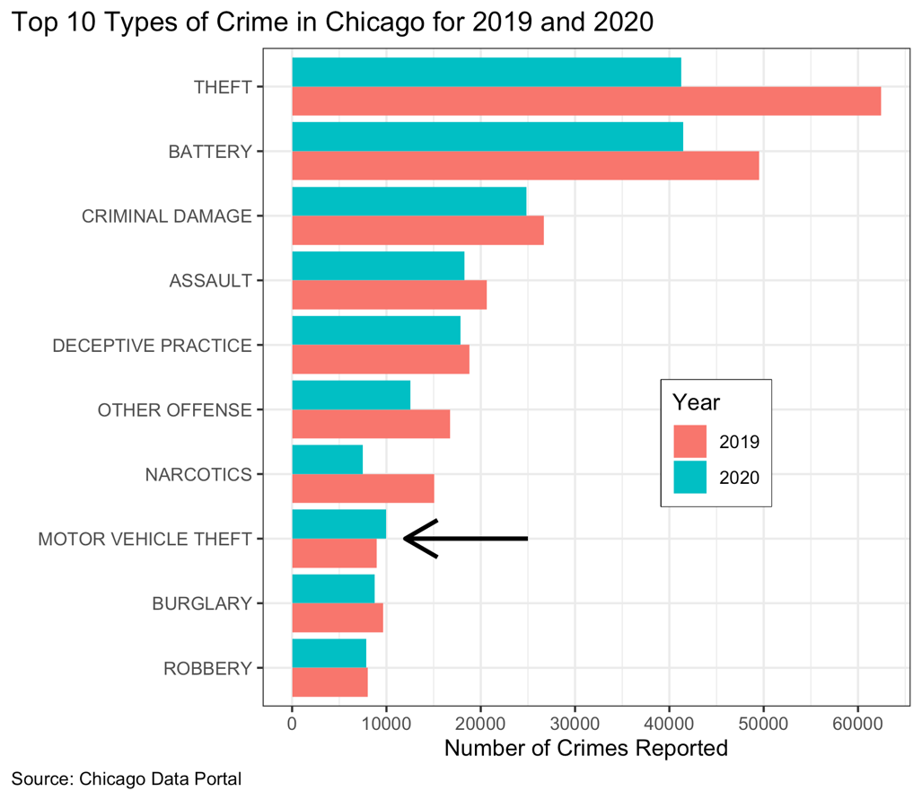

With the exception of motor vehicle theft, the most frequent crimes in Chicago decreased in 2020, so which types of crime saw an increase? This question was answered by calculating the change in frequency from 2019 to 2020 and sorting them in decreasing order. Out of the

thirty-six different types of crime listed in the dataset, only four increased from 2019 to 2020.

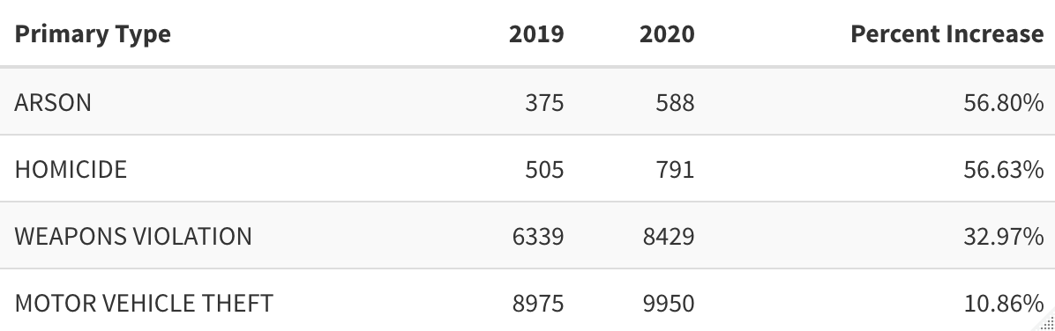

The four types of crime that increased in 2020 were arson, homicide, motor vehicle theft, and weapons violations. Both arson and homicide increased by about 56%, which is shocking when considering that most other crimes decreased during this time period. Also, the homicide rate in Chicago increased by a rate of almost twice as much as the national average, which the FBI reported as being just below 30%.

While the chart above shows how crime changed in 2020, it tells us nothing about how crime had been changing in the city before the pandemic began. The following plot graphs the frequency of the four types of crime listed above since 2010. By looking at how the frequency of these crimes have changed over the past decade, it is easier to see how each trend was impacted by COVID-19.

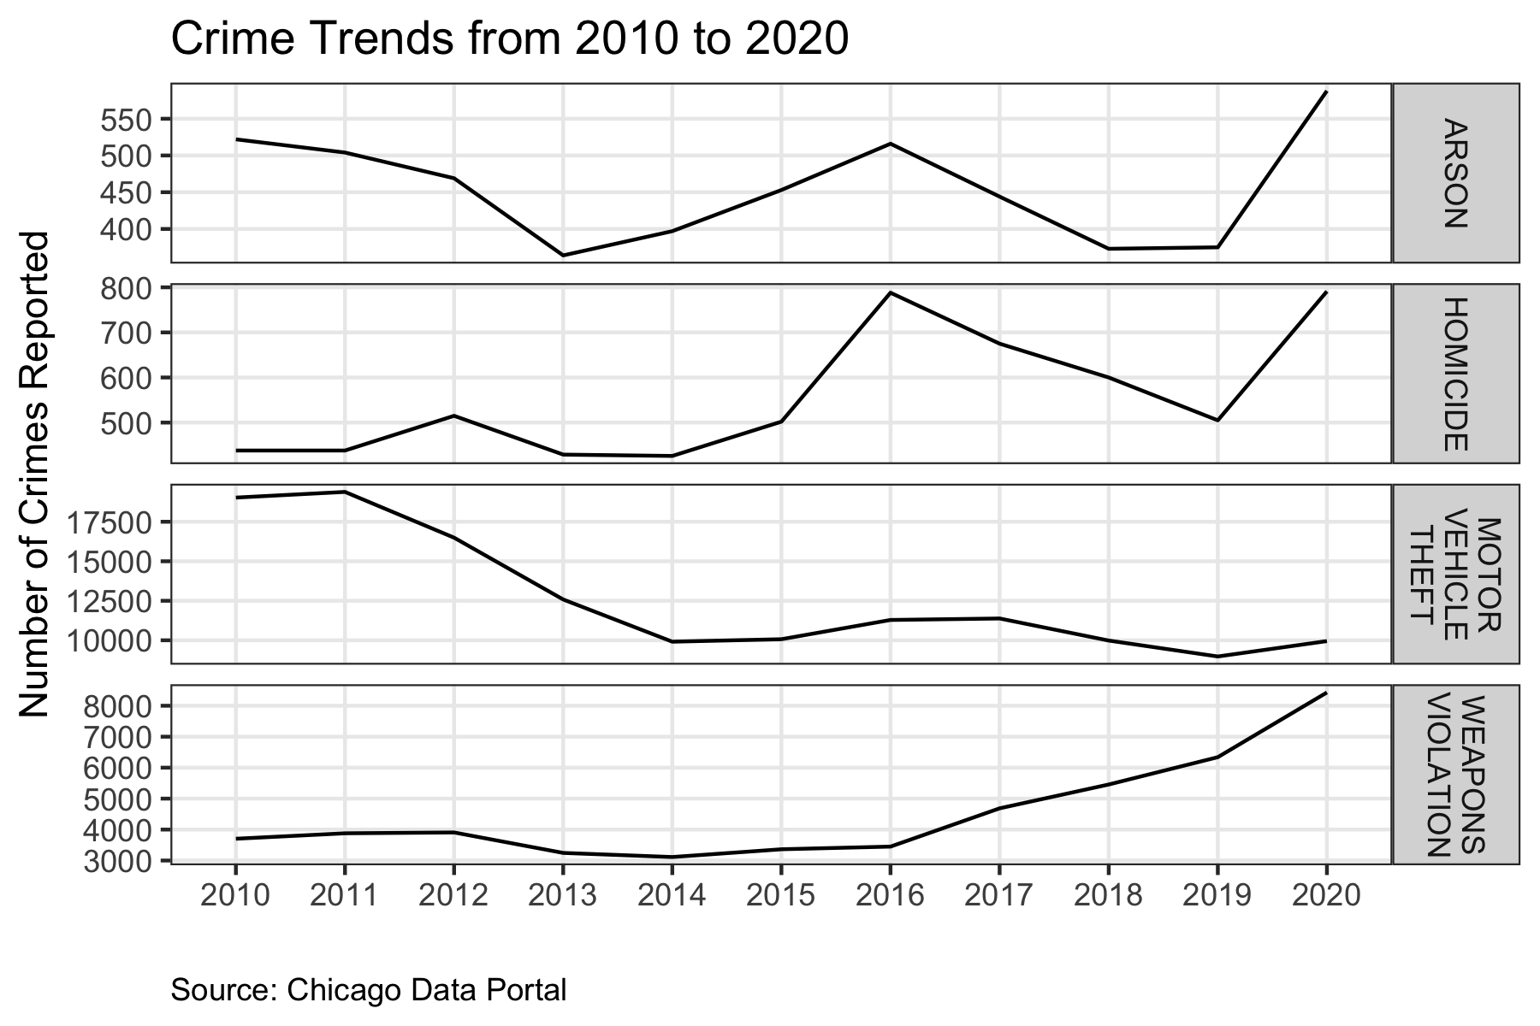

Now that we are able to compare the crime rates over time, it is clear to see that the increased amount of arson and homicide do not follow the trends from the past decade. The 10% increase in motor vehicle theft doesn’t seem like a deviation from the ten-year trend. Weapons violations have increased at a steady rate since 2016. While this is alarming for the city, it does not appear that the increase in 2020 was correlated with the pandemic. However, arson and homicide rates are also at the highest they have been in ten years, even though they have been declining since 2016.

Why was the increase in arson and homicide so drastic that year compared to the rest of the crime rates? To get a better understanding, we will take a deeper dive into the two crimes over the course of 2020.

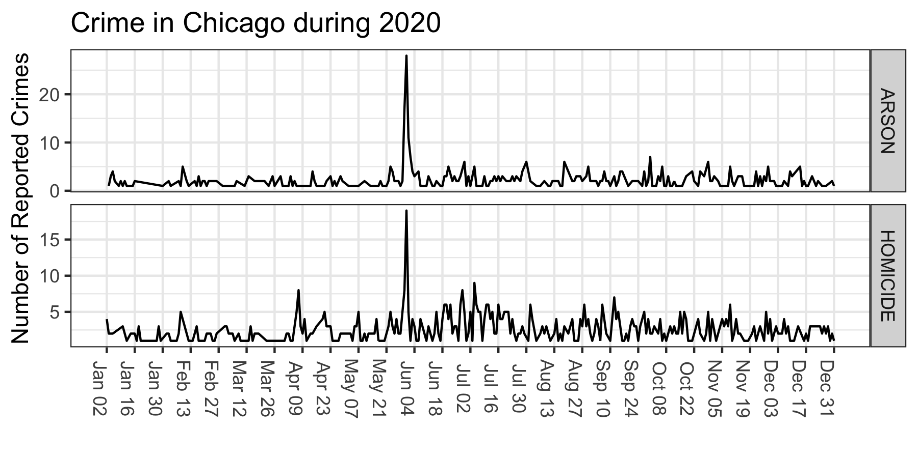

The unusually large spike in both of the two crimes on May 31st lead me to search for common cause or event that could be associated with their high frequencies. On May 25th 2020, George Floyd was killed in police custody by Derek Chauvin of the Minneapolis Police Department. Protests began in Minneapolis on that day and other cities quickly followed suit. In downtown Chicago, protests began on Friday the 29th and continued throughout the weekend. On Sunday, May 31st, governor JB Pritzker activated the Illinois National Guard, but the unrest spread throughout all areas of the city by that night. A total of 18 people were murdered on the 31st, making it the most violent day in Chicago in 60 years.

Lastly, we will take a look at the distribution of arson and homicide throughout the city in 2020. The two maps below show the frequency of crime in the different community areas in Chicago. The community area data was also found on the Chicago Data Portal website.

It is clear that the same community area experienced the highest frequencies of both arson and homicide in 2020. Austin is a community on the north west side of the city, and had a total of 56 reported cases of arson and 83 homicides in 2020.

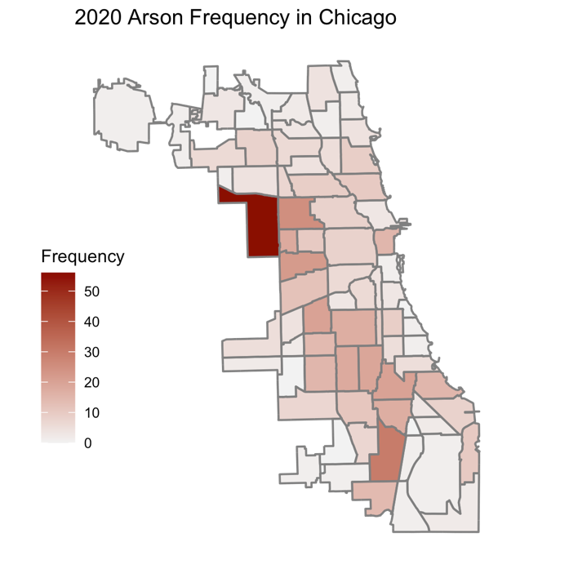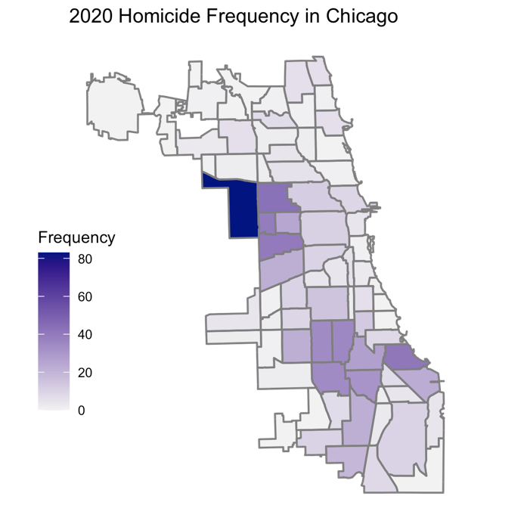

With the exception of Austin, arson appears to be more equally distributed throughout the community areas compared to homicide. While both crimes are more frequent on the west and south sides of the city, homicide has much lower rates on the north side of the city than arson.

Overall, the combination of a global pandemic and widespread protests created a very interesting variation of crime in Chicago during 2020. While the crime rates decreased overall, the city experienced its most violent day in the past 60 years. As 2021 comes to an end, the city will begin to see which trends are more permanent than others, and get a better understanding of 2020’s lasting impact on Chicago crime.

References

Beer, Tommy. “18 People Were Murdered in Chicago on May 31, Making It the City's Single Deadliest Day in 60 Years.” *Forbes*, Forbes Magazine, 9 June 2020, <https://www.forbes.com/sites/tommybeer/2020/06/08/18-people-were-murdered-in-chicago-on-may-31-making-it-the-citys-single-deadliest-day-in-60-years/?sh=4e4c4c867fb7>

Hubbard, Kaia. “FBI: Homicides Increased by Nearly 30% in 2020 | National ...” *U.S. News*, U.S. News, <https://www.usnews.com/news/national-news/articles/2021-09-27/fbi-homicides-increased-by-nearly-30-in-2020>

Jonathon Berlin, Kori Rumore. “How the Weekend Unfolded: Timeline of Chicago Protests, Looting and Unrest.” *Chicagotribune.com*, Chicago Tribune, 2 June 2020, <https://www.chicagotribune.com/news/breaking/ct-viz-george-floyd-protest-chicago-timeline-20200531-lfkd7p6ejbennfezhxk2u5kkmm-story.html>.

Ritchie, Hannah, et al. “United States: Coronavirus Pandemic Country Profile.” *Our World in Data*, 5 Mar. 2020, <https://ourworldindata.org/coronavirus/country/united-states#how-many-tests-are-performed-each-day>

“Timing of State and Territorial COVID-19 Stay-at-Home Orders and Changes in Population Movement - United States, March 1–May 31, 2020.” *Centers for Disease Control and Prevention*, Centers for Disease Control and Prevention, 3 Sept. 2020, <https://www.cdc.gov/mmwr/volumes/69/wr/mm6935a2.htm>