**Lay summary:** Chemicals in waterways can be passed up the food chain and have the potential to affect animal behavior and development. We exposed Fathead Minnows to a toxic algal byproduct for the first 21 days of life and measured the long-term effects of exposure. We found that animal behaviors are consistent and related throughout development, with limited influence of treatment in our behavioral tests, though other impacts to survival are possible.

**Exploring the impact of early-life BMAA exposure on the long-term repeatability of individual behaviors in a common freshwater fish**

Gina F. Lamkaa,b*, Kelsey B. McCuneb, Ally R. Swanka,c, and Jessica L. Warda

aDepartment of Biology, Ball State University, 1600 Ashland Ave, Muncie, IN 47306, USA; bPresent address: College of Forestry, Wildlife, and Environment, Auburn University, 602 Duncan Drive, Auburn, AL 36849, USA; gfl0003@auburn.edu

bCollege of Forestry, Wildlife, and Environment, Auburn University, 602 Duncan Drive, Auburn, AL 36849

aDepartment of Biology, Ball State University, 1600 Ashland Ave, Muncie, IN 47306, USA; cPresent address: Department of Biology, Boston University, 5 Cummington Mall, Boston, MA 02215, USA

aDepartment of Biology, Ball State University, 1600 Ashland Ave, Muncie, IN 47306, USA

*corresponding author

**Abbreviated title:** BMAA exposure and repeatable behaviors

**Funding Sources**

This work was supported by an ASPIRE Research Grant to GFL, Ball State Honors Fellowship to ARS, and a Provost’s Start-up Grant from Ball State University and an Indiana Water Resources Research Center Grant to JLW.

**CRediT authorship contribution statement**

Gina F. Lamka: conceptualization (lead); methodology (lead); funding acquisition (supporting); data curation (lead); investigation (equal); analysis (supporting); visualization (equal); writing - original draft (equal); writing - review & editing (equal).

Kelsey B. McCune: data curation (supporting); analysis (lead); visualization (equal); writing - original draft (equal); writing - review & editing (equal).

Ally R. Swank: conceptualization (supporting); methodology (supporting); funding acquisition (supporting); data curation (supporting); investigation (equal); writing - review and editing (equal).

Jessica L. Ward: funding acquisition (lead); resources (lead); writing - review & editing (equal).

**ACKNOWLEDGEMENTS**

The authors would like to thank the dedicated undergraduates who assisted with daily fish husbandry, especially Hannah Mullinax, Ryan Seymour, Autum Auxier, and Katie Esarey. We would also like to thank CLF Charlie and FC Euchre for their support in the development of this project, Dee Hoffman and Cheryl Wright for their assistance with animal caretaking, and Mary Hagerman (Indiana State Department of Health) for assistance with chemical analysis.

**ABSTRACT**

Behavioral responses to environmental contaminants, such as the cyanotoxin β-methylamino-L-alanine (BMAA), provide avenues for investigation into the subtle mechanisms by which environmental toxins can influence ecosystem dynamics. This study investigates the effects of developmental exposure to BMAA on long-term repeatable individual behaviors in Fathead Minnows, *Pimephales promelas*. After a 21-day exposure period, we tested minnow behavior in an open field assay at multiple benchmarks throughout development to assess whether early-life BMAA exposure alters the repeatability of behaviors indicative of boldness, exploration, and activity over time. Our results showed that all three behaviors were significantly repeatable and correlated to form a behavioral syndrome. While there was no main effect of BMAA exposure, we found that fish in the low BMAA concentration group showed more decline in exploration over time. Similarly, there was no difference in activity level relative to control fish for either the low or high BMAA concentration exposure groups, but the high concentration fish were significantly more active than the low concentration fish, indicating a divergent response to BMAA in these groups. This study suggests that environmentally relevant concentrations of BMAA may not produce lasting behavioral disruptions in Fathead Minnows, though subtle molecular or neurophysiological effects remain possible. Our findings underscore the need for further research into the ecological and evolutionary implications of cyanotoxin exposure in aquatic ecosystems, particularly in light of potential indirect bioaccumulation effects on population dynamics and trophic cascades.

**Keywords:** BMAA, cyanotoxin, repeatability, behavioral syndrome, animal personality, longitudinal study

**INTRODUCTION**

Anthropogenic changes to the environment are widespread and now affect all ecosystems on the planet (Bowler et al. 2020). The impacts on biodiversity of intentional changes to the environment, like habitat destruction for development, are relatively easy to detect and quantify (Aronson et al. 2014). However, we are still learning about the scope and impact on ecosystems of indirect anthropogenic effects such as chemical contamination from agricultural activities or pollution.

Animal behavior is an important indicator of ecosystem stability and function. Changes to the environment, including pollutants and chemical contamination, affect animal populations first by forcing them to adapt their behavior in response to environmental change (Hellou 2011). Many behaviors are plastic, enabling quick adjustments to accommodate changing environmental conditions. Even low concentrations of chemical contamination can cause behavioral change without inducing mortality (i.e., sublethal effects; Saaristo et al. 2018). These minor changes in animal behavior are concerning because they can result in disruptions to ecosystem services or lead to trophic cascades (Wong & Candolin 2015). For example, pesticides cause sublethal behavioral changes in honeybees that decrease the rate of foraging activity and ability to return to the hive, thus resulting in depressed pollination services (Bortolotti et al. 2003). Consequently, one way to evaluate and predict the impact of contamination on the natural environment is to determine the direction and magnitude of changes in animal behavior after exposure (Saaristo et al. 2018).

Growing evidence suggests significant constraints on behavioral plasticity across taxa (Pennisi 2016). In other words, individuals respond surprisingly consistently to different stimuli across time, even if the behavioral response may be maladaptive in a given context (Dall et al. 2012). For example, western bluebird males that are more aggressive in territorial defense, are also more aggressive towards their mate and less likely to contribute parental care (Duckworth & Badyaev 2007). These consistent individual differences (i.e., personality traits) in a given behavior are widespread within and across species. Behavioral plasticity can be further constrained through genetic correlations among personality traits. This idea, referred to as a “behavioral syndrome” means that traits have coevolved and should be considered as a unit, rather than individually (Sih et al. 2004; Reale et al. 2007). Research is beginning to show pervasive effects of environmental contaminants on animal personality traits. However, most studies evaluate the impact of contamination on one behavior in isolation, precluding inferences about the change in behavior in other contexts (Jacquin et al. 2020).

Water eutrophication, often driven by fertilizer runoff and other forms of chemical pollution, is a growing environmental issue with significant consequences in aquatic ecosystems. Increasing incidences of harmful algal blooms following eutrophication have been linked to cyanobacteria-associated health problems in both animals and humans. One compound of interest is the non-protein amino acid, β-N-methylamino-L-alanine (BMAA). BMAA and its isomers have been detected in waterways (Al-Sammak et al., 2014; Wilitsie et al., 2018; Vo Duy et al., 2019) and has been shown to bioaccumulate in several taxa (lobsters, Sandhu et al. 2024; humans, Fiore et al. 2020; zooplankton, mussels, oysters, and fishes, Jonasson et al. 2010; plants, Rosen and Hellenas 2008; Regueiro et al. 2017; Mohamed et al. 2024). Further, early life exposure to BMAA negatively influences neuro-muscular formation, behavioral function, and development, in addition to increased mortality in aquatic vertebrates (Purdie et al. 2009; Carion et al. 2018; Lamka et al. 2023). Although reproductive fitness and behaviors were unaffected by 14 days of sub-lethal exposure to BMAA in mangrove rivulus fish, altered gene expression resulted in long-lasting effects on the brain (*Kryptolebias marmoratus*; Carion et al. 2020).

The Fathead Minnow (*Pimephales promelas*) is an emerging model for studies of anthropogenic effects on behavior (Lavelle and Sorensen 2011; Thunstrom 2017; Vignet and Parrott 2017). This species is easily bred in captivity and can typically reach maturity at 5 months(Leino et al. 2005). Ecologically, the Fathead Minnow serves an important role in the middle of the trophic system. In one study, water contamination with birth control hormones decreased the reproductive success, and therefore population size, of the Fathead Minnow which led to significant indirect effects on the ecosystem; lake trout, a species that predates the Fathead Minnow, sharply declined in the year after hormone additions, but emergence of water-associated insects (the prey of Fathead Minnows) increased (Kidd et al. 2014). Understanding how secondary consumers respond to sublethal levels of toxin exposure can provide valuable insight into the broader implications of neurotoxins within the environment.

In this study, we exposed Fathead Minnow embryos and larva to sublethal concentrations of BMAA during early development to examine the influence of this cyanotoxin on the development of behavioral consistencies. After a 21-day exposure period, minnows were tested at eight benchmarks until maturity to examine if exposed fish exhibit altered behavioral development. Specifically, we focused on asking (1) Does BMAA affect whether fish show consistent individual differences in behavior across time (i.e., personality traits)? (2) Are personality traits significantly correlated to form a behavioral syndrome? (3) How does BMAA exposure affect behavior in the open field test? Longitudinal studies such as this can reveal delayed or progressive effects of toxin exposure, a crucial step in characterizing the risks of BMAA in aquatic ecosystems.

**MATERIALS AND METHODS**

**Subjects and animal care**

The subjects of this study were the progeny of six-month old *P. promelas* purchased from a culturing facility (Environmental Consulting and Testing; WI, USA). Breeding groups, each consisting of two females and one male, were housed in 6-L tanks in a continuous flow-through system (Aquaneering, CA, USA). Each tank contained a spawning tile for clutches to be laid upon. Spawning tiles were monitored twice daily, and clutches were removed on the day they were laid and randomly assigned to a control or one of two treatment groups. The fish were fed live prey items (*Artemia franciscana*; Brine Shrimp Direct, UT, USA) twice daily and were maintained throughout the experiment under a 16 h: 8 h light-dark regime at room temperature (mean ± SD: 20.6°C ± 0.86°C). Mortality events were monitored twice daily. All procedures were approved by the Institutional Animal Care and Use Committee at Ball State University (1142896-1).

**Treatment regime**

Stock solutions were prepared weekly, consisting of serially diluted solutions of powdered β-methylamino-L-alanine (BMAA; Sigma Aldrich, Inc., Germany) dissolved in ultra-pure water (Millipore, MA, USA), and stored in amber glass bottles at 4°C. Treatments with nominal concentrations of 5 or 25 ng/L BMAA (hereafter referred to as BMAALOW and BMAAHIGH) and a control (0 ng/L) were prepared daily by adding an appropriate concentration of stock solution to aged, aerated water. Liquid chromatography-tandem mass spectrometry (LC-MS/MS) was used to measure concentrations of stock solutions at the start of the experiment (Indiana State Department of Health; see Lamka et al. 2023). BMAA has been detected in waterways in concentrations as low as 9 ng/L to as high as 23 µg/L (Al-Sammak et al. 2014; Roy-Lachapelle et al. 2015; Wiltsie et al. 2018; Vo Duy et al. 2019), therefore we used conservative sub-lethal but environmentally relevant stock concentrations of the chemical. The water was exchanged daily using a 50% static renewal protocol to account for degradation (USEPA 2002), as a related experiment indicated substantial degradation of BMAA over 24 h (Lamka et al. 2023).

Fish in the BMAALOW and BMAAHIGH groups were exposed to BMAA for the first 21 days post-fertilization (dpf) and subsequently reared in clean water for the remainder of the experiment. Clutches were maintained on the spawning tile in a 750 mL glass vessel fitted with an airstone for the first 5 dpf before being transferred to individual housing containers (6-well plate; Corning, Inc., NY, USA) where they hatched. The fish were housed separately after hatching due to the inability to mark newly hatched fish (Frederick 1997; Polverino et al. 2016). To avoid developmental impairments due to social isolation (Polverino et al. 2016; Dreosti et al. 2015; Ward and Mehner 2010), we permitted visual contact among fish and introduced chemical cues from the home tanks of fish not used in this experiment. Each fish was transferred to a 750 mL glass vessel at 49 dpf, and then to a 1.8 L tank in a recirculating flow-through system (Aquaneering Inc., CA, USA) at 77 dpf, where they remained for the rest of the experiment.

**Behavioral tests**

We assessed fish behavior via an open field assay eight times throughout development; once during exposure, once at the completion of the exposure period, and an additional six tests every 28 days following exposure to measure long-term effects of the chemical at sequential points of development. Therefore, every fish was tested on 14, 21, 49, 77, 105, 133, 161, and 189 dpf (± 2 d). Tank size has the potential to alter risky behaviors in fish (Stewart et al. 2012; Ingebretson and Masino 2013; Polverino et al. 2016) so arena size increased as the fish did to account for growth; average fish total length was approximately between one quarter and one half of the arena diameter (Table 1).

Trials were conducted in clean, conditioned water under differential lighting in a circular arena placed on a no-heat, LED light pad (Tiktek/A4-DWT) (Figure 1). To begin a trial, we gently introduced a focal larva to the arena via a glass dropper and the trial was started immediately. The free swimming behavior of focal fish was recorded for 6 min using a monochrome GigE camera (Basler AG, Ahrensburg, Germany) mounted above the arena.

**Behavioral analysis**

We analyzed the behavior of each fish in each trial using Ethovision XT software (version 13; Noldus Information Technologies, Inc., Wageningen, Netherlands). First, we divided the arena into two zones. The inner zone, which we considered the “risky” area because fish are swimming in open water with no cover from potential predators (Reale et al. 2007), was approximately half the diameter of the outer zone (Figure 1). Next, we extracted a subset of behavior variables that previous literature suggests represent personality traits (e.g., Cote et al. 2010). We used the R package corrplot (Wei & Simko 2024) to test the correlations among output variables to ensure that the performance behaviors we subsequently analyzed were statistically independent.

Fish behavior variables were classified as one of three animal personality traits: boldness, exploration, and activity. Boldness, defined as the propensity to take risks (Toms et al. 2010), was measured as the latency (s) of the center point of the fish to enter the risky zone. Exploration, defined as the propensity to investigate novelty (Reale et al. 2007), was measured as the cumulative duration (%) of trial time spent in the risky zone. Activity (mobility), defined as the distance covered in a set amount of time (Reale et al. 2007), was measured as the percentage (%) of pixel change detected in the subject from one video frame to the next.

**Statistical analyses**

Personality traits are relatively fixed genetically or developmentally (Wolf & Weissing 2012). As such, these traits should result in performance in the open field test that is consistent across time and context, as quantified through repeatability (Bell et al. 2009). Also known as the intraclass correlation coefficient, repeatability is the proportion of variance attributable to differences among individuals and can be estimated as a ratio of the variance from the random effect of subject ID relative to the total variance (Dingemanse and Dochtermann 2013). We first used the DHARMa package (Hartig 2019) in R to determine the best fitting model for each performance variable and used likelihood ratio tests to evaluate whether covariate interaction effects and additional random effects, such as clutch ID, significantly added to the variance explained by the model. We then extracted the variance components to quantify the repeatability value, confidence intervals and tested whether repeatability differs significantly from random.

Boldness was measured as the latency to enter the risky zone. Latency, and other time-to-event variables, are best modeled using survival analysis because they often contain time-dependent and censored values (Machin et al. 2006). We used a Cox proportional hazards model in the package coxme (Therneau 2015), with fixed effects for treatment (control, low or high) and age (scaled and centered), as well as a random effect for fish ID. We found that an interaction between treatment and age did not significantly add to the variance explained by the model, so it was omitted. We used functions in R developed by McCune and colleagues (2025) to calculate the repeatability estimate, and confidence interval and p-value for that estimate, from the Cox model.

The best fit model to assess repeatability of exploration (proportion of time spent in the risky zone) was a Poisson mixed-effects model with treatment, age, and the interaction between these two as fixed effects, as well as fish ID as a random effect. There were convergence problems with this model when we used the rptR package (Stoffel et al. 2017), as the standard error was zero. Consequently, we instead used MCMCglmm (Hadfield 2010), with weak priors, to extract the variance components from this model to quantify the repeatability value. Then we used a permutation test to assess whether the repeatability value is significantly greater than random. We randomized the data by conducting 1000 iterations where we resampled exploration values from different individuals within treatment without replacement. We reran the model on each randomized data set to compare the observed repeatability value to the distribution of values resulting from the randomized data.

To quantify the repeatability of activity (log-transformed percent pixel change over time), we used a linear mixed-effects model with fixed effects for treatment and age, as well as random effects for fish and Clutch ID. We used this model in the rptR package to estimate the repeatability, as well as the confidence interval and p-value for that estimate.

To evaluate whether exposure to BMAA resulted in acute or long term impacts on the consistency of behavior, we compared repeatability of exploration, activity, and boldness between trials on days 14 - 77 (during exposure or short duration since exposure) to repeatability on trials conducted on days 105 - 189 (long duration since exposure). We therefore modeled repeatability for each personality trait and each treatment separately, using the subset data for short or long duration since BMAA exposure. This resulted in 3 models for each personality trait yielding a repeatability estimate with some associated error. We conducted randomization tests to assess the significance of the difference between repeatability values from short and long duration models, while also accounting for the error associated with each repeatability estimate. For all three traits, we modeled performance as described above, but used a Bayesian framework. From each iteration of the model, we extracted variance components from the posterior distribution to calculate repeatability as variance of Fish ID divided by total variance. Then, we randomly paired short duration and long duration repeatability estimates and quantified the proportion of pairs in which short duration repeatability estimates were lower than long duration estimates. If this proportion was less than 95% then we could not reject the null hypothesis of no difference in repeatability during trials that occurred a short duration compared to a long duration since BMAA exposure.

We tested whether the three personality traits were significantly correlated within individuals to form a behavioral syndrome. We used a multivariate mixed model in MCMCglmm (Hadfield 2010) with uninformative priors to test for significant pair-wise covariation between traits (Houslay & Wilson 2017). We included fixed effects of treatment and age, and a random effect for fish ID. From this model, we estimated the correlation in the among individual variance for each personality trait pairing. We determined that the correlation was statistically significant if the 95% credible interval around the estimate did not overlap with zero.

Finally, to assess the impact of treatment condition on personality traits, we interpreted the coefficients of the fixed effect of treatment from the models used to assess repeatability.

**RESULTS**

**Boldness**

Boldness was repeatable across the experimental timeframe (R = 0.09, CI = 0.05 – 0.13, *p* < 0.01). There was no significant difference in boldness for fish in the BMAALOW (Hazard ratio = 0.98, *p* = 0.87) or BMAAHIGH (HR = 0.92, *p* = 0.39) treatment conditions relative to fish in the control condition (Figure 2a). Boldness showed a significant relationship with age (HR = 1.26, *p* < 0.01), where older fish were 25% faster to enter the center than when fish were younger (Figure 2b). As this is a longitudinal study, age and number of trials are perfectly correlated and thus this effect likely represents habituation to the experimental arena rather than an increase in boldness over time (Reale et al. 2007).

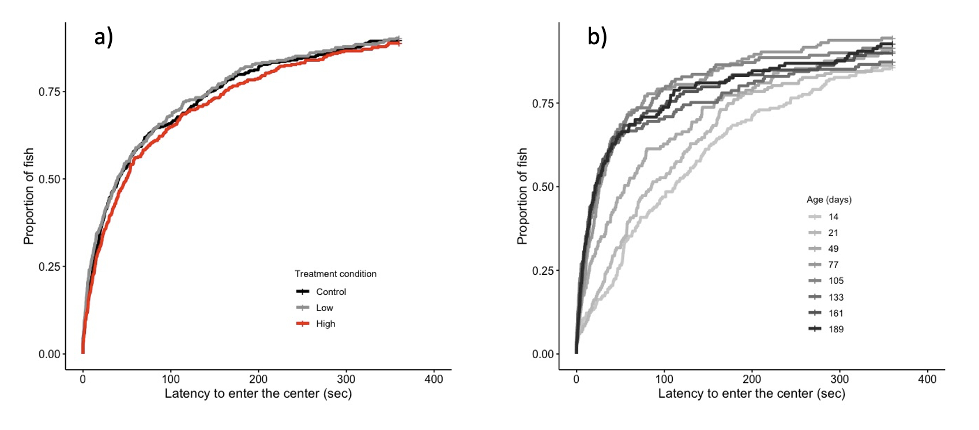

Figure 2: There was no effect of BMAA treatment on boldness (a). As fish got older and experienced more trials, the latency to enter the risky center of the arena decreased (b), potentially reflecting habituation to the arena.

**Exploration**

Exploration was significantly repeatable in fish across time (R = 0.12, CI = 0.06 – 0.19, *p* < 0.05; Figure S1). There was no evidence for a main effect of either treatment condition or age on exploration. However, we detected a significant interaction between the effect of age and the BMAALOW treatment condition on exploration (*ß* = -0.23, *p* = 0.04). Relative to fish in the control and BMAAHIGH treatment conditions, fish in the BMAALOW treatment decreased their exploration more over time (Figure 3).

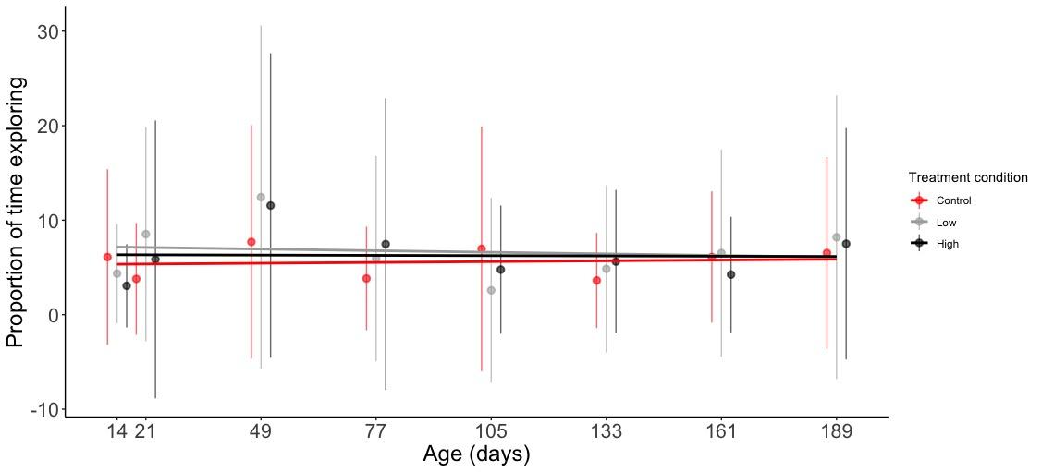

Figure 3: We did not find any main effects of treatment or age on exploration (the proportion of fish spent in the center of the arena). There was a significant interaction between treatment and age where fish in the BMAALOW treatment group decreased their exploration over time. Dots on the plot represent the average value for each treatment at each age, while vertical lines represent the standard deviation.

**Activity**

Activity was also significantly repeatable within fish across time (R = 0.13, CI = 0.08 – 0.18, *p* < 0.01). There was no difference in activity between fish in the BMAALOW (*ß* = -0.14, *p* = 0.12) or BMAAHIGH (*ß* = 0.09, *p* = 0.26) treatment condition relative to the control condition. However, fish in the BMAALOW treatment condition were significantly less active than fish in the BMAAHIGH treatment condition (*ß* = -0.23, *p* = 0.05; Figure 4). Furthermore, fish significantly decreased their activity levels as age increased (*ß* = -0.10, *p* < 0.01; Figure 4).

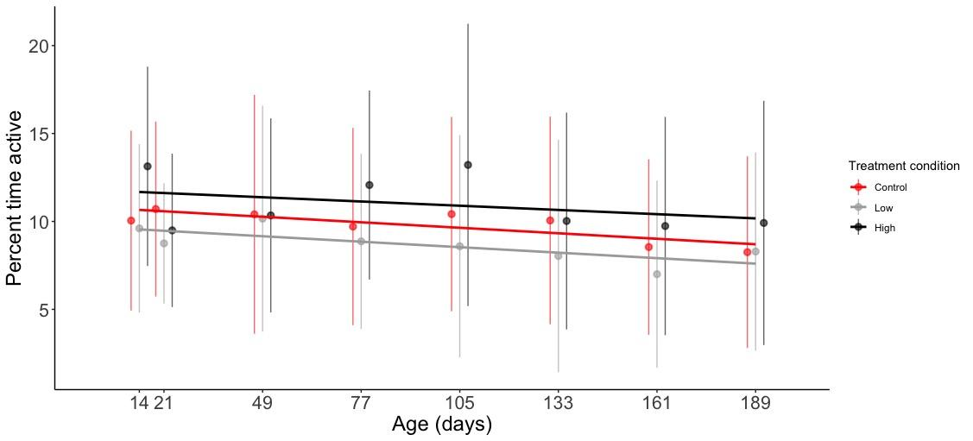

Figure 4: All fish decreased their activity (percent location change per time) as they got older and experienced more trials. Although neither exposure group differed in activity relative to the control group, fish in the BMAALOW treatment group were significantly less active than fish in the BMAAHIGH treatment group.

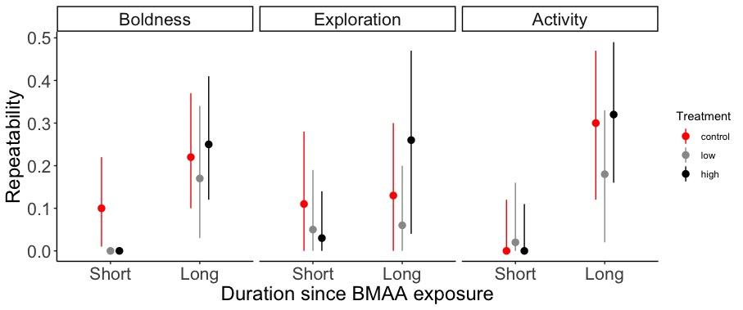

Figure 5: Repeatability of all personality traits was generally lower for fish during and shortly after exposure to BMAA (days 14 - 77) compared to performance during trials at longer time intervals since exposure (days 105 - 189). Exploration of fish in the high BMAA treatment was significantly lower in the short duration period relative to long duration repeatability. However, the trend for boldness and activity included fish in the control condition and thus it does not provide evidence for acute effects of BMAA on repeatability of those traits.

**Behavioral consistency**

We found limited evidence for acute effects of BMAA on consistency of behavior, where repeatability was lower for some personality traits in earlier trials when fish were experiencing BMAA exposure or shortly after, compared to later trials that occurred a longer time since BMAA exposure (Fig. 5). We found that fish in all treatment conditions exhibited less repeatability of boldness in the short duration period relative to the long duration period (control p = 0.001, low p < 0.01, high p < 0.01). For exploration, we found no difference in repeatability for fish in the control or low treatments, but fish in the high treatment had significantly lower repeatability during earlier trials compared to later trials (p = 0.05). We found that fish in the control and high treatment conditions showed significantly lower repeatability of activity in the earlier trials relative to the later trials (control p < 0.01, low p = 0.07, high p = 0.00). Because control fish also showed significant differences in repeatability of boldness and activity, only exploration of fish in the high BMAA exposure treatment demonstrated evidence for acute effects of this toxin.

**Behavioral syndromes**

We found evidence for a behavioral syndrome among some, but not all of the pairwise combinations of the 3 personality traits (Figure 5). The among-individual variation in activity and boldness were correlated where fish that were faster to enter the risky area also spent a greater proportion of time investigating the arena (posterior mean = -0.77, CI = -0.96 – -0.60). Similarly, boldness and exploration were significantly correlated such that fish that were faster to enter the risky area were more likely to show greater changes in location per time (mean = -0.34, CI = -0.65 – -0.02). In contrast, activity and exploration were not correlated (mean = 0.09, CI = -0.23 – 0.43).

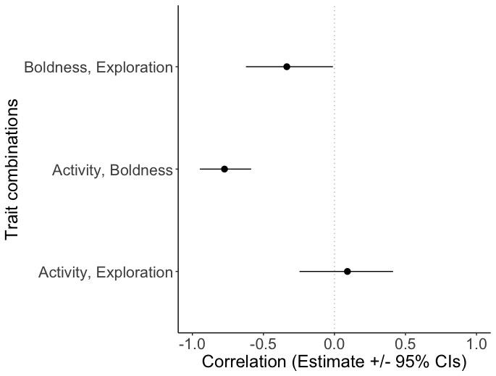

Figure 5: There was evidence for a behavioral syndrome among boldness (latency to enter the center of the arena) and the other two personality traits. Boldness is correlated with activity (percent change in location per time) and exploration (proportion of time spent in the middle of the arena), but activity and exploration were not correlated with each other.

**DISCUSSION**

Our study adds novel and complex information on the impact of exposure to an environmental toxin on the consistency of fish behavior. All three behavioral traits - boldness, exploration, and activity - were significantly repeatable, indicating consistent individual differences in these behaviors. As the number of trials increased with the age of the fish, boldness increased, likely reflecting habituation to the experimental arena, while activity levels decreased. Further, fish in the BMAALOW treatment were less active than those in the BMAAHIGH treatment, but neither treatment was significantly different from control fish. Finally, exploration was unaffected by age and treatment, however, fish in the BMAALOW treatment decreased in exploration over time with an age by treatment interaction effect. These age effects are supported in our analysis testing for behavioral consistency during and shortly after BMAA exposure, relative to trials occurring at longer durations since BMAA exposure. We found limited evidence for acute or long-term effects of BMAA exposure because fish in all conditions, for most behavioral traits, showed lower repeatability in earlier trials. Because fish in the control condition also exhibited this trend, changes in behavioral consistency are more likely due to habituation or development rather than BMAA. The one exception was an acute effect of lower repeatability of exploratory behavior of fish in the high BMAA treatment group. We also identified behavioral syndromes; boldness was inversely correlated with both exploration and activity, but exploration and activity were not correlated with each other. Thus, it is possible that our measure of boldness (latency to enter the risky area) did not reflect an independent trait, but was instead partially influenced by the traits exploration and activity.

Treatment had a limited and mixed influence on behavioral outcomes. In this study, we exposed fish to low, environmentally relevant concentrations of BMAA, then after 21-days, fish were raised in clean water to evaluate the potential for long term consequences of early-life exposure. The lack of strong, acute or long-term impacts to fish behavior with this protocol is consistent with previous research on adult *Kryptolebias marmoratus* after 14 days of BMAA exposure (Carion et al. 2020) and in zebrafish after two and a half years of a BMAA diet (Weeks et al. 2023). However, BMAA and its isomer DABA (2,4 diaminobutyric acid) have been shown to influence irreversible neuron electrical activity in a concentration-dependent manner in leeches (Spasic et al. 2018) and nerve length and swim endurance in zebrafish (Powers et al. 2017). Therefore, it would not be surprising that there could still be underlying long-lasting gene expression and electrophysical differences in exposed fish that were not captured in the open field behavioral tests conducted here.

Previous research has well established that BMAA can negatively influence spinal development, mortality, and mobility of exposed animals (Purdie et al. 2009; Powers et al. 2017; Lopicic et al. 2022). Here, we identified an interesting difference in the treatment effect on activity levels. While neither the high or low BMAA treatment groups showed activity levels different from control fish, fish that were exposed to the higher concentration of BMAA exhibited higher activity rates, measured as an increased frequency of changes in pixel position, relative to fish that were exposed to low BMAA. Due to limitations of the video analysis software, we are unable to determine if this increased mobility is due to an increase in distance moved or because of increased abnormal kinematics that were anecdotally observed in a concurrent exposure experiment (Lamka et al. 2022). Indeed, we found that fish in the high BMAA treatment group were more consistent (fewer abnormal kinematics) in their exploration later in the experiment relative to during and shortly after BMAA exposure. It is possible this results from acute destabilization of behavior, leading to increased individual variation in exploration, during and shortly after exposure to high concentrations of BMAA. These divergent behavioral responses to BMAA exposure concentration merit further investigation in future research.

Toxins can influence ecosystems by changing individual behavioral choices and fitness, leading to cascading changes in ecosystem dynamics. When individual foraging and avoidance behaviors are impaired, emergent impacts on population level fitness can occur (Polivka 2011). For example, acute or chronic effects of toxins on boldness, exploration and activity can alter predation pressure (Brodin et al. 2013; Weis & Candelmo 2012). As a species that occupies an intermediate trophic level, Fathead Minnow populations that either increase or decrease in abundance can lead to further trophic cascades (Kidd et al. 2014). Previously, with the same and higher exposure concentrations, we showed that predator avoidance and prey capture behaviors were negatively affected by developmental exposure to BMAA, including latency to respond to predator cues. Because fish in this study were raised without competition or predation, it is possible that individuals most negatively affected by BMAA exposures were supplemented such that they could survive conditions in the lab that they wouldn’t in the wild, with potential cascading effects. Bioaccumulation of BMAA is possible in toxin-exposed fish (Kim and Rydberg 2020), especially at sublethal levels of exposure. Consequently, Fathead Minnows exposed to BMAA may be more likely to be taken by predators, where BMAA concentrations can accrue. As such, in future research it will be important to evaluate the costs of BMAA contamination in species at higher levels of the food chain (Jonasson et al. 2010; Lage et al. 2015).

Longitudinal studies such as this can have notable limitations. For example, we were unable to evaluate sex differences in behavior in this study because sex determination is difficult in fish larvae. Sex has been hypothesized to influence personality traits, but this is likely species-specific because a recent meta-analysis found no support for a global sex effect (Harrison et al. 2022). Yet, there is evidence for sex differences in BMAA exposure outcomes in rats (Scott and Downing 2018). Furthermore, we had significant drop off of fish due to mortality. However, this was primarily fish in the control group, such that differential mortality due to BMAA is unlikely to confound our results. Future studies that address potential sex-specific differences in the impacts of exposure would be beneficial, especially if exposure is combined with other stressors such as competition for resources. Nonetheless, our study provides valuable insights into the short- and long-term individual behavioral effects of early-life BMAA exposure in a common aquatic species.

We found that activity and boldness, as well as exploration and boldness were correlated to form two separate behavioral syndromes. Consequently, it is likely that performance on our measure of boldness was not influenced by a distinct behavioral trait. Behavioral syndromes suggest that there are genetic correlations among behavioral traits which constrain the ability of populations to adapt to changing environmental conditions, limiting the evolutionary potential of affected populations. This is especially true since BMAA exposure disrupts neural stem cell differentiation and influences epigenetic modifications (Pierozan et al. 2020), so heritable effects on behavioral traits could amplify behavioral changes across generations (Mitchell et al. 2016; Dochtermann et al. 2019). As toxins like BMAA increase in the environment due to anthropogenic activities, it will be important to continue to assess evidence for directional selection for certain behavioral traits.

In conclusion, while we did not identify significant acute or long-term effects of early-life BMAA exposure on Fathead Minnow behaviors, our findings contribute to the complexities of sub-lethal toxin exposure on individual behavior. The lack of pronounced alterations in repeatable personality traits suggests that BMAA exposure may not produce persistent behavioral disruptions in the absence of additional environmental stressors. However, given the potential for subtle, long-lasting effects at the molecular or neurophysiological level, further research is needed to fully understand the ecological and evolutionary consequences of BMAA exposure on aquatic populations, particularly as environmental conditions continue to change.

**FIGURES AND TABLES**

Table 1. Sample (N) and arena sizes (mm) used corresponding to the age of fish on the day of larval testing, subset by BMAA exposure treatment. Reduction in sample size over the course of the experiment was primarily due to mortality, however, errors with the analysis software required removal of some assays throughout the trial period.

|  |  |  |  |  |
| --- | --- | --- | --- | --- |
| **Age** | **Control (N)** | **BMAALOW (N)** | **BMAAHIGH (N)** | **Arena Size (mm)** |
| 14 | 91 | 44 | 61 | 58 |
| 21 | 69 | 38 | 60 | 58 |
| 49 | 51 | 39 | 47 | 58 |
| 77 | 53 | 41 | 50 | 89 |
| 105 | 51 | 44 | 45 | 138 |
| 133 | 51 | 41 | 49 | 138 |
| 161 | 49 | 41 | 49 | 138 |
| 189 | 47 | 41 | 49 | 138 |

Figure 1. Behavioral testing set up during the free swimming, larval testing. The trial was conducted under differential lighting in a circular arena placed on a no-heat, LED light pad with a monochrome GigE camera mounted above. Using Ethovision XT software, the arena is divided into two zones: the inner “risky” zone and the outer zone, depicted with a dotted line. The fish is considered in the risky zone when its point (depicted with a dot) crosses into the zone.

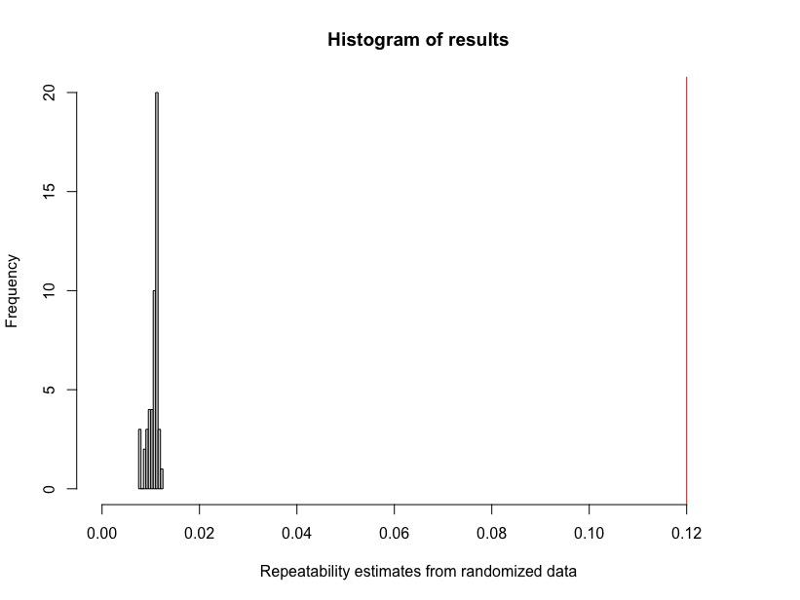

Figure S1: We compared the repeatability estimate from our observed exploration data (red line at 0.12) to repeatability estimates quantified from 1000 iterations of randomized data. Our observed repeatability is significantly greater than that resulting from data where individuals are performing randomly across time.

**Literature Cited**

#####

Wei T, Simko V (2024). R package 'corrplot': Visualization of a Correlation Matrix. (Version 0.94), <https://github.com/taiyun/corrplot>. Taiyun Wei and Viliam Simko (2024). R package 'corrplot': Visualization of a Correlation Matrix (Version 0.95). Available from <https://github.com/taiyun/corrplot>

McCune KB, Williams C, Dochtermann NA, Schielzeth H, & Nakagawa S. 2025. Repeatability and intraclass correlations from time-to-event data: Towards a standardized approach. Animal Behavior, in press.