**INTRODUCTION**

The fathead minnow (*Pimephales promelas*) is an emerging model for studies of anthropogenic effects on behavior (REFS). which can be bred in captivity, and can typically reach maturity at 5 months1.

**MATERIALS AND METHODS**

**Subjects and animal care**

The subjects of this study were the progeny of six-month old *P. promelas* purchased from a culturing facility (Environmental Consulting and Testing; WI, USA). Breeding groups of two females and one male were housed in 6-L tanks in a continuous flow-through system (Aquaneering, CA, USA). Each tank contained a spawning tile for clutches to be laid upon. Spawning tiles were monitored twice daily, and clutches were removed on the day they were laid and randomly assigned to a control or treatment group. The fish were fed live prey items (*Artemia franciscana*; Brine Shrimp Direct, UT, USA) twice daily and were maintained for the entirety of the experiment under a 16 h: 8 h light-dark regime at room temperature (mean ± SD: 20.6°C ± 0.86°C). Mortality events were also monitored twice daily. All procedures were approved by the Institutional Animal Care and Use Committee at Ball State University (1142896-1).

**Treatment regime**

Stock solutions, consisting of serially diluted solutions of powdered β-methylamino-L-alanine (BMAA; Sigma Aldrich, Inc., Germany) dissolved in ultra-pure water (Millipore, MA, USA), were made weekly and stored in amber glass bottles at 4°C. Treatments with nominal concentrations of 5 or 25 ng/L BMAA (hereafter referred to as BMAALOW and BMAAHIGH) and a control (0 ng/L) were prepared each day by adding an appropriate concentration of stock solution to aged, aerated water. BMAA has been detected in waterways in concentrations as low as 100 ng/L to as high as 25 µg/L2,3 (Wilitsie et al. 2018). The water was exchanged each day using a 50% static renewal protocol to account for degradation (USEPA 2002).

Fish in the BMAALOW and BMAAHIGH groups developed in the presence of BMAA for the first 21 days post fertilization (dpf), and in clean water for the remainder of the experiment. Clutches were maintained on the spawning tile in a 750 mL glass vessel fitted with an airstone for 5 dpf before being transferred to individual housing containers (6-well plate; Corning, Inc., NY, USA) where they hatched. The fish were housed separately after hatching because it is not possible to mark newly-hatched fish4,5. Because fish can develop social preferences early in life5,6, we did not obstruct potential visual ability to conspecifics. Similarly, to facilitate chemical interactions so as not to impede development because of social isolation, we introduced chemical cues from tanks containing the clutch of fish not selected in the experiment daily during water exchanges5,7. Each fish was transferred to a glass vessel at 49 dpf, and then to a 1.8 L tank in an Aquaneering Flow Through System at 77 dpf where they remained for the rest of the experiment.

*Embryonic-Exposure Assay*

Fish develop quickly; within 17 hours after fertilization, convulsive behaviors can be detected (CITE). Burst activity reflects the development of the nervous system and is especially useful in understanding how neurological disruption develops as the fish does8,9. Embryos were individually placed in a 3.6 cm diameter petri dish. 60-second videos of larvae were taken using a LED low heat stereo microscope and 5 MP camera (SZM series; AmScope, CA, USA) and recorded via TCapture (Tucsen Photonics Co., Ltd., Jujian, PRC) imaging software at a frame rate of approximately 6 fps. Videos were imported into Danioscope software (Noldus Information, Wageningen, Netherlands) as a compressed AVI file, where activity and burst count measurements were calculated. Burst activity was measured as the percentage of time the embryo was moving from the total test duration. Burst count, or the number of times the embryo moved, was also calculated, along with the burst duration, or the total time spent active. NOTE: I have not written a results section on this until we know that the numbers from Danioscope are correct

**Behavioral tests**

Symptoms of BMAA neurotoxic effects can have a long latency to be expressed following exposure10. We conducted free-swimming personality assays every 28 days following exposure to measure the effects of the chemical at sequential points of development. Starting at 14 dpf until 189 dpf,

Trials were conducted in clean, conditioned water under differential lighting in a circular arena placed on a no-heat, LED light pad (Tiktek/A4-DWT) (Fig XX). To begin a trial, a focal larva was gently introduced to the arena via a glass dropper and the trial was started immediately. The swimming behavior of focal fish was recorded for 6 min using a monochrome GigE camera (Basler AG, Ahrensburg, Germany) mounted XX cm above the arena.

We analyzed the behavior of each fish in each trial using Ethovision XT software (version 13; Noldus Information Technologies, Inc., Wageningen, Netherlands). First, we divided the arena into two zones; an inner zone classified as the “risky” area (Fig XX). We calculated the latency (in s) of fish to enter the center zone, which we classified as a measure of boldness. The fish was also tracked via Ethovision software to determine the total distance traveled (TD), the cumulative duration (CD)of time (s) spent in the center of the arena, and the total percentage of time the fish was active (A). Every fish was tested on 14, 21, 49, 77, 105, 133, 161, and 189 dpf (Fig XX). Tank size has the potential to alter risky behaviors in fish11–13 so to account for growth of the fish, arena size increased as the fish did (Table XX).

*Statistics*

We were particularly interested in the difference in the repeatability of behavior within different substages of development. Therefore, we divided trials into four stages of development with two testing trials per stage: juvenile (14 and 21 dpf), subadult1 (49 and 77 dpf), subadult2 (105 and 133 dpf), and adult (161 and 189 dpf).

Repeatability estimates within and between life stages were calculated with the R package rptR14. Calculated with 1500 bootstrappings and 0 permutations, repeatability estimates, significance levels, and 95% confidence intervals are reported. Repeatability estimates were analyzed within each life stage, for the complete dataset including all test periods (referred to as ‘across life stages’), and including only the first and last test period (referred to as ‘long interval’). The full models across and within life stages were separated by treatment with stage and individual ID as fixed and random effects, respectively.

[insert more on this as needed after we specify that all my analyses were correct] Statistical analyses were conducted via R (R Core Team) using the packages __, __, and __. An α = 0.05 was set as the level of significance for all comparisons.

**RESULTS**

**Repeatability of behavior across life stages**

Repeatability estimates are recorded in Figure XX. Activity (A) and exploration (TD) were repeatable in all treatments across all life stages during the whole measurement period including all test rounds. Boldness (CD and L) were repeatable in the control and BMAAHIGH treatments across all life stages including all test rounds. Fish in the BMAALOW treatment did not have significant repeatability in CD or L tests across all life stages. In all cases except CD, repeatability decreased as BMAA treatment increased. Fish treated with BMAA exhibited L and A behaviors with ~50% lower repeatability than controls. Long interval estimates of repeatability were not significantly different from zero for all comparisons except for L in control fish.

Q2 – Ontogenesis

Over ontogeny, the expression of repeatable behaviors varied over stage and treatment in all traits, with some differences among treatments (Fig. XX). Fish in the BMAALOW group expressed no repeatable behaviors in the juvenile stage. Estimates for repeatability in activity (A) were significant in the young adult and adult life stages in control fish, subadult and young adult life stages in BMAALOW fish, and all life stages in BMAAHIGH fish. Exploration (TD) had significant repeatability emerge at the young adult and adult life stage in control fish, at the young adult stage in BMAALOW, and at the juvenile and adult stages in BMAAHIGH. Boldness (CD) was repeatable for adults in the control and BMAAHIGH treatment, and in the juvenile stage for controls. Boldness (L) was significant for subadult and young adult stages in controls plus significant in young adult and adult BMAAHIGH groups. In both measures of boldness (CD and L), repeatability estimates for BMAALOW fish showed confidence intervals that overlapped with zero at all life stages.

Literature Cited

1. Leino, R. L., Jensen, K. M. & Ankley, G. T. Gonadal histology and characteristic histopathology associated with endocrine disruption in the adult fathead minnow (Pimephales promelas). *Environ. Toxicol. Pharmacol.* **19**, 85–98 (2005).

2. Al-Sammak, M. A., Hoagland, K. D., Cassada, D. & Snow, D. D. Co-occurrence of the cyanotoxins BMAA, DABA and anatoxin-a in Nebraska reservoirs, fish, and aquatic plants. *Toxins (Basel).* **6**, 488–508 (2014).

3. Duy, S. V. *et al.* Analysis of the neurotoxin β-N-methylamino-L-alanine (BMAA) and isomers in surface water by FMOC derivatization liquid chromatography high resolution mass spectrometry. *PLoS One* **14**, 1–23 (2019).

4. Frederick, J. L. Evaluation of fluorescent elastomer injection as a method for marking small fish. *Bull. Mar. Sci.* **61**, 399–408 (1997).

5. Polverino, G., Cigliano, C., Nakayama, S. & Mehner, T. Emergence and development of personality over the ontogeny of fish in absence of environmental stress factors. *Behav. Ecol. Sociobiol.* **70**, 2027–2037 (2016).

6. Dreosti, E., Lopes, G., Kampff, A. R. & Wilson, S. W. Development of social behavior in young zebrafish. *Front. Neural Circuits* **9**, 1–9 (2015).

7. Ward, A. J. W. & Mehner, T. Multimodal mixed messages: The use of multiple cues allows greater accuracy in social recognition and predator detection decisions in the mosquitofish, Gambusia holbrooki. *Behav. Ecol.* **21**, 1315–1320 (2010).

8. Thordstein, M. *et al.* Infraslow EEG activity in burst periods from post asphyctic full term neonates. *Clin. Neurophysiol.* **116**, 1501–1506 (2005).

9. Suresh, J. *et al.* Network burst activity in hippocampal neuronal cultures: The role of synaptic and intrinsic currents. *J. Neurophysiol.* **115**, 3073–3089 (2016).

10. Carion, A. *et al.* Behavior and gene expression in the brain of adult self-fertilizing mangrove rivulus fish (Kryptolebias marmoratus) after early life exposure to the neurotoxin β-N-methylamino-L-alanine (BMAA). *Neurotoxicology* **79**, 110–121 (2020).

11. Stewart, A. M., Gaikwad, S., Kyzar, E. & Kalueff, A. V. Understanding spatio-temporal strategies of adult zebrafish exploration in the open field test. *Brain Res.* **1451**, 44–52 (2012).

12. Ingebretson, J. J. & Masino, M. A. Quantification of locomotor activity in larval Zebrafish: Considerations for the design of high-throughput behavioral studies. *Front. Neural Circuits* **7**, 1–9 (2013).

13. Polverino, G., Ruberto, T., Staaks, G. & Mehner, T. Tank size alters mean behaviours and individual rank orders in personality traits of fish depending on their life stage. *Anim. Behav.* **115**, 127–135 (2016).

14. Stoffel, M. A., Nakagawa, S. & Schielzeth, H. rptR: repeatability estimation and variance decomposition by generalized linear mixed-effects models. *Methods Ecol. Evol.* **8**, 1639–1644 (2017).

Figures and Tables

Table XX. Arena sizes (mm) used corresponding to the age of fish on the day of larval testing.



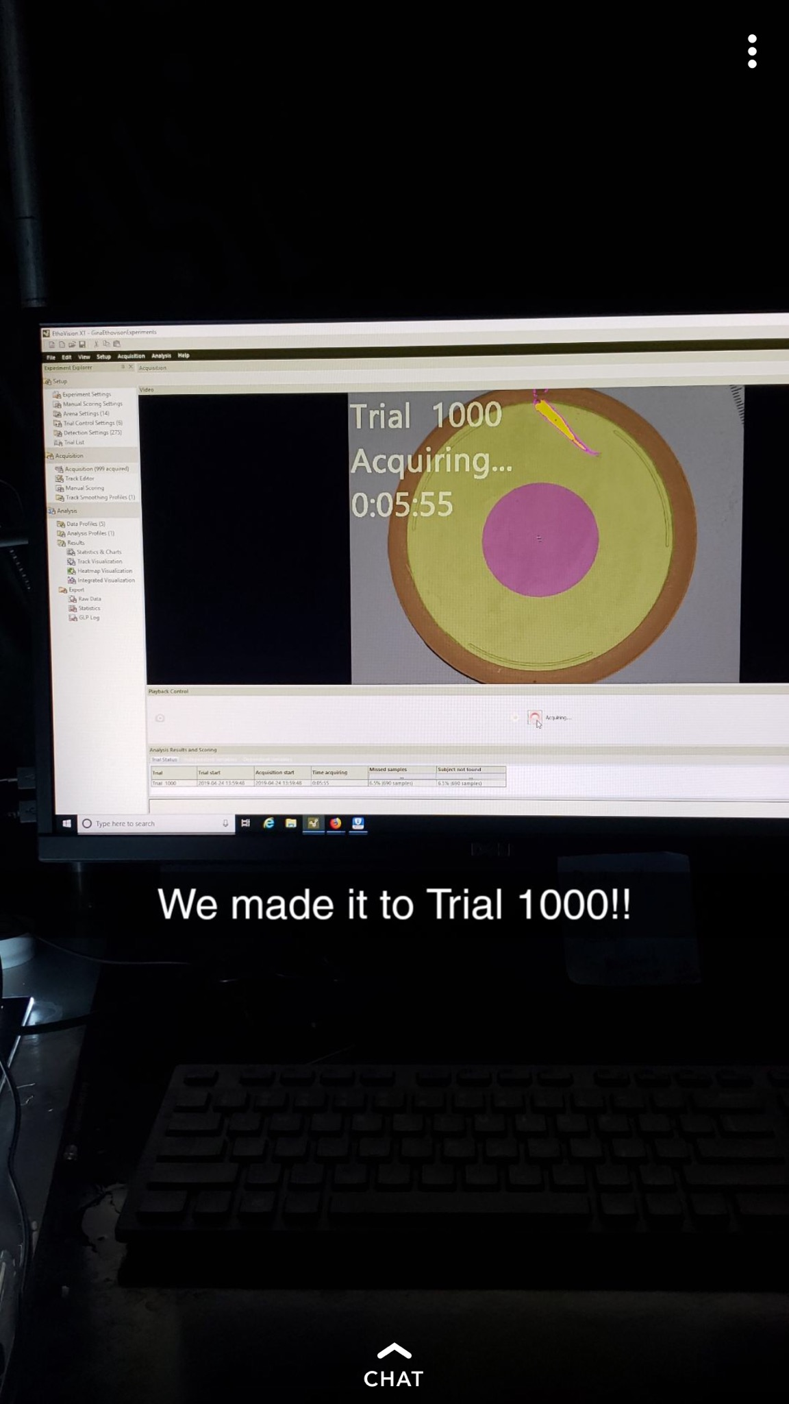

Fig. XX. Arena characteristics during the free swimming, larval testing.

Fig. XX. Timeline of testing, including the dpf in between trials and stages of development.