MySQL Bamazon Database prior to placing order:

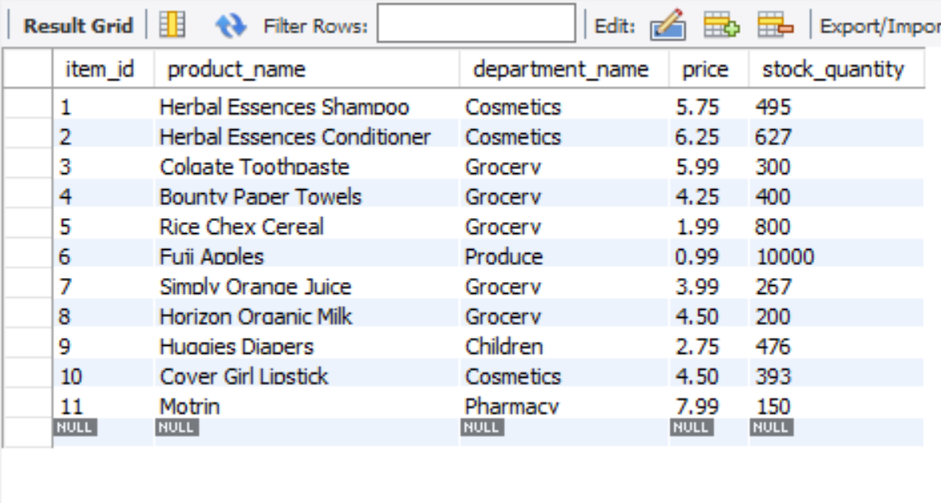

Running the app in node:

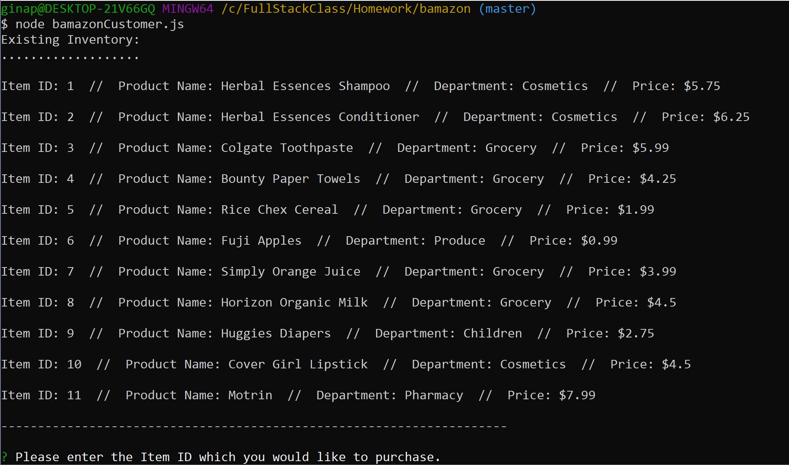

Selecting the ID number and the quantity:

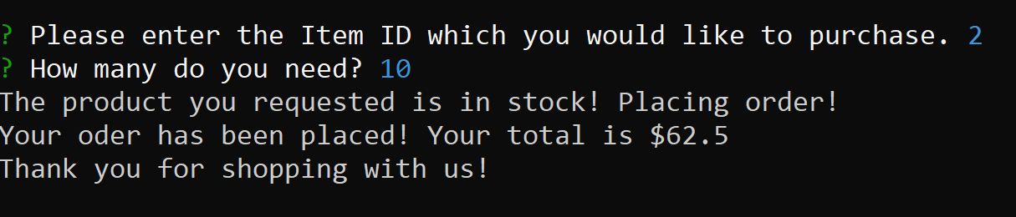

Updated database after purchasing the order:

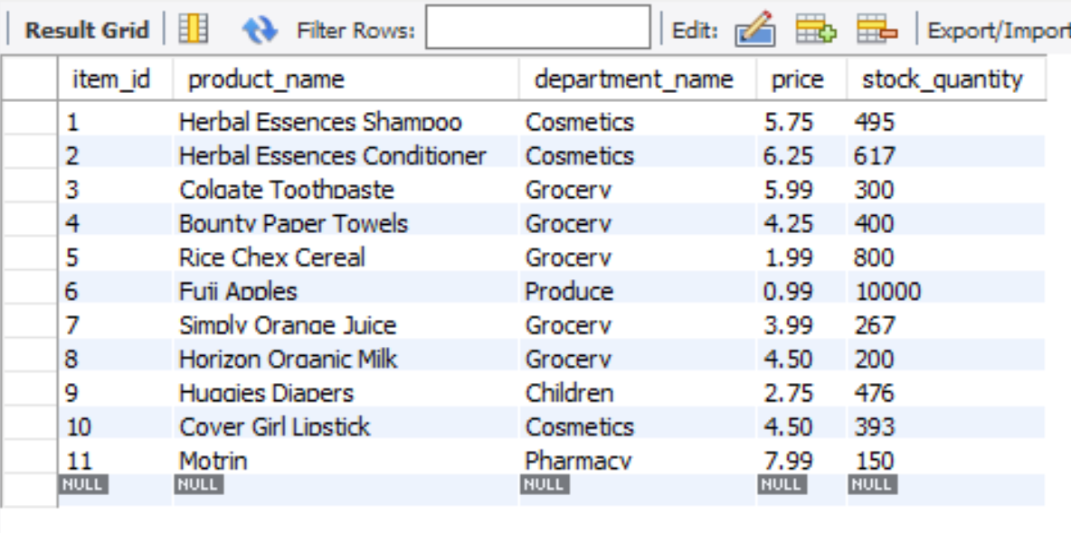

Placing an order for an amount that exceeds what’s in stock:

