To ensure quality with the product, the team has developed a test plan to catch any bugs that may happen. The test plan is detailed in this document while avoiding raw programming terms.
First, the software’s functionality is divided into smaller functions which all work together to eventually produce an optimal bus schedule. Each of these smaller functions has their own tests. To do these tests, sample data for bus schedules are required to be inputted. One is data in which was manually checked, and no errors were found so the expectation upon inputting this data is that it will not return errors. Another is data that was also manually checked and purposely put specific errors to test if certain functions output certain errors. To test each function, we use sample data where the errors are already known and see if the functions can correctly detect such errors. When testing, we input the same file into each function at a time and check the output accordingly. In programming, these are called doctests and they are embedded in the code. We used doctests to verify the validity of our functions using a working data sample along with a one that is manufactured to return a specific error.
As an example, below is the data input of a doctest in Table 1 can be found here along with its output data Figure 1.
Here the function should fill empty lines with the line of the next possible service trip, where the last trip’s line should be -1.
To ensure the function works properly we also used another dataset to check if a function correctly fails as shown in Table 2
bus | start time | line (input) | line (expected output)
1 | 0 |  | 401
1 | 10 | 401 | 401
1 | 20 |  | -1
Table 1 Input data for converting empty lines to next
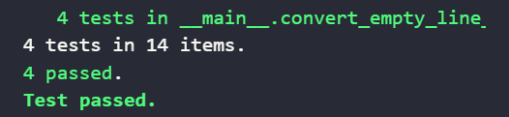
Figure 1 Output for doctest to verify function
bus | start time | line (input) | line (expected output)
1 | 0 |  | 401
1 | 10 | 401 | 401
2 | 0 |  | 502
2 | 10 | 502 | 502
Table 2 Input dataset for checking if a function returns errors correctly
The same process is then repeated over all functions. A test failing means that the function outputs anything that is not expected or beyond a certain threshold detailed in the doctest. If the test fails for any function, the team will make appropriate changes to such function and resume testing until the tests are successful.

