**Page de garde**

**RAPPORT Du Projet JEE**

**NOM :** Mezzi

**PRENOM :** Eya

**GROUPE :** GLID

**Présentation du Projet**

Ce projet est une application web Java EE qui implémente un système d'authentification avec gestion de sessions. L'application suit le modèle MVC et permet aux utilisateurs de se connecter avec un nom d'utilisateur et un mot de passe. Une fois authentifiés, les utilisateurs accèdent à une page de profil affichant leurs informations personnelles ainsi qu'une liste de tâches(To-DoList). L'utilisateur peut ajouter et supprimer des tâches dans sa liste, et ces tâches sont conservées en mémoire pour la session active. Une fonctionnalité de déconnexion est également mise en place, permettant de mettre fin à la session et de retourner à la page de connexion.

**Améliorations apportées :**

* **Ajout d'une gestion dynamique des tâches (To-Do List)** permettant aux utilisateurs de créer et supprimer des tâches après connexion.
* **Amélioration de l'interface utilisateur** avec un affichage structuré et une meilleure ergonomie.
* **Gestion avancée des erreurs** : affichage de messages en cas de connexion incorrecte ou de tentative d'accès non autorisée.
* **Stockage en base de données :** Utilisation d'une base de données MySQL pour enregistrer les utilisateurs et leurs tâches de manière persistante ainsi l’implémentation d'une couche DAO (Data Access Object)
* **Ajout d'une page d'inscription :**Création d'un formulaire d'inscription permettant aux nouveaux utilisateurs de créer un compte ainsi la vérification de l'unicité du nom d'utilisateur avant l'ajout en base de données.

**Structure du projet**

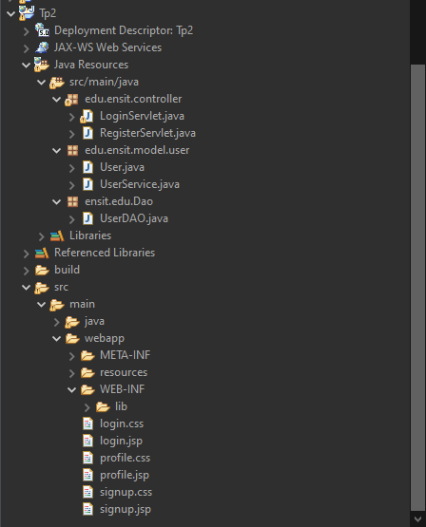

**Code Source**

**LoginServlet.java**

package edu.ensit.controller;

import jakarta.servlet.ServletException;

import jakarta.servlet.annotation.WebServlet;

import jakarta.servlet.http.HttpServlet;

import jakarta.servlet.http.HttpServletRequest;

import jakarta.servlet.http.HttpServletResponse;

import jakarta.servlet.http.HttpSession;

import java.io.IOException;

import java.util.Optional;

import edu.ensit.model.user.User;

import edu.ensit.model.user.UserService;

*@SuppressWarnings*("serial")

*@WebServlet*("/myBook")

public class LoginServlet extends HttpServlet {

protected void doGet(HttpServletRequest request, HttpServletResponse response) throws ServletException, IOException {

HttpSession session = request.getSession();

if (session.getAttribute("user") == null) {

request.getRequestDispatcher("login.jsp").forward(request, response);

} else {

String logout = request.getParameter("logout");

if (logout != null && logout.equals("true")) {

session.invalidate();

request.getRequestDispatcher("login.jsp").forward(request, response);

} else {

request.getRequestDispatcher("profile.jsp").forward(request, response);

}

}

}

protected void doPost(HttpServletRequest request, HttpServletResponse response) throws ServletException, IOException {

HttpSession session = request.getSession();

String action = request.getParameter("action");

User user = (User) session.getAttribute("user");

if (user == null) {

String login = request.getParameter("login");

String psw = request.getParameter("psw");

Optional<User> authenticatedUser = UserService.*getUser*(login, psw);

if (authenticatedUser.isPresent()) {

session.setAttribute("user", authenticatedUser.get());

request.getRequestDispatcher("profile.jsp").forward(request, response);

} else {

request.setAttribute("error", "Nom d'utilisateur ou mot de passe incorrect");

request.getRequestDispatcher("login.jsp").forward(request, response);

}

return;

}

if ("Add Task".equals(action)) {

String todoItem = request.getParameter("todoItem");

if (todoItem != null && !todoItem.trim().isEmpty()) {

user.addTodoItem(todoItem);

}

}

else if ("Remove".equals(action)) {

String removeTask = request.getParameter("removeTask");

if (removeTask != null) {

user.removeTodoItem(removeTask);

}

}

else if ("Edit".equals(action)) {

String oldTask = request.getParameter("oldTask");

String newTask = request.getParameter("newTask");

if (oldTask != null && newTask != null) {

user.updateTodoItem(oldTask, newTask);

}

}

response.sendRedirect("profile.jsp");

}

}

**RegisterServlet.java**

package edu.ensit.controller;

import jakarta.servlet.ServletException;

import jakarta.servlet.annotation.WebServlet;

import jakarta.servlet.http.HttpServlet;

import jakarta.servlet.http.HttpServletRequest;

import jakarta.servlet.http.HttpServletResponse;

import java.io.IOException;

import edu.ensit.model.user.User;

import ensit.edu.Dao.UserDAO;

public class RegisterServlet extends HttpServlet {

private static final long ***serialVersionUID*** = 1L;

/**

* **@see** HttpServlet#HttpServlet()

*/

public RegisterServlet() {

super();

// **TODO** Auto-generated constructor stub

}

/**

* **@see** HttpServlet#doGet(HttpServletRequest request, HttpServletResponse response)

*/

protected void doGet(HttpServletRequest request, HttpServletResponse response) throws ServletException, IOException {

// **TODO** Auto-generated method stub

response.getWriter().append("Served at: ").append(request.getContextPath());

}

/**

* **@see** HttpServlet#doPost(HttpServletRequest request, HttpServletResponse response)

*/

protected void doPost(HttpServletRequest request, HttpServletResponse response) throws ServletException, IOException {

String login = request.getParameter("login");

String psw = request.getParameter("psw");

String firstname = request.getParameter("firstname");

String lastname = request.getParameter("lastname");

String birthday = request.getParameter("birthday");

User user = new User(login, psw, firstname, lastname, birthday);

if (UserDAO.*registerUser*(user)) {

response.sendRedirect("login.jsp?success=1");

} else {

response.sendRedirect("signup.jsp?error=1");

}

}

}

**User.java**

package edu.ensit.model.user;

import java.util.ArrayList;

import java.util.List;

public class User {

private String login;

private String psw;

private String firstname;

private String lastname;

private String birthday;

private List<String> todoList;

public User(String login, String psw, String firstname, String lastname, String birthday) {

this.login = login;

this.psw = psw;

this.firstname = firstname;

this.lastname = lastname;

this.birthday = birthday;

this.todoList = new ArrayList<>();

}

public String getLogin() { return login; }

public String getPsw() { return psw; }

public String getFirstname() { return firstname; }

public String getLastname() { return lastname; }

public String getBirthday() { return birthday; }

public List<String> getTodoList() { return todoList; }

public void addTodoItem(String item) { todoList.add(item); }

public void removeTodoItem(String item) { todoList.remove(item); }

public void updateTodoItem(String oldItem, String newItem) {

int index = todoList.indexOf(oldItem);

if (index != -1 && newItem != null && !newItem.trim().isEmpty()) {

todoList.set(index, newItem);

} else {

System.***out***.println("La tâche à modifier est introuvable ou la nouvelle tâche est invalide.");

}

}

}

**UserService.java**

public class UserService {

public static Optional<User> getUser(String login, String psw) {

User user = UserDAO.*getUserByLoginAndPassword*(login, psw);

return Optional.*ofNullable*(user);

}

}

**UserDAO.java**

package ensit.edu.Dao;

import edu.ensit.model.user.User;

import java.sql.*;

public class UserDAO {

private static final String ***URL*** = "jdbc:mysql://localhost:3306/jee?useSSL=false&serverTimezone=UTC";

private static final String ***USER*** = "root";

private static final String ***PASSWORD*** = "";

public static boolean registerUser(User user) {

String query = "INSERT INTO users (login, psw, firstname, lastname, birthday) VALUES (?, ?, ?, ?, ?)";

try {

Class.*forName*("com.mysql.cj.jdbc.Driver");

try (Connection conn = DriverManager.*getConnection*(***URL***, ***USER***, ***PASSWORD***);

PreparedStatement stmt = conn.prepareStatement(query)) {

stmt.setString(1, user.getLogin());

stmt.setString(2, user.getPsw());

stmt.setString(3, user.getFirstname());

stmt.setString(4, user.getLastname());

stmt.setString(5, user.getBirthday());

int rowsInserted = stmt.executeUpdate();

return rowsInserted > 0;

}

} catch (ClassNotFoundException e) {

System.***out***.println("Erreur : Driver JDBC non trouvé !");

e.printStackTrace();

} catch (SQLException e) {

e.printStackTrace();

}

return false;

}

public static User getUserByLoginAndPassword(String login, String psw) {

String query = "SELECT * FROM users WHERE login = ? AND psw = ?";

try {

Class.*forName*("com.mysql.cj.jdbc.Driver");

try (Connection conn = DriverManager.*getConnection*(***URL***, ***USER***, ***PASSWORD***);

PreparedStatement stmt = conn.prepareStatement(query)) {

stmt.setString(1, login);

stmt.setString(2, psw);

ResultSet rs = stmt.executeQuery();

if (rs.next()) {

return new User(

rs.getString("login"),

rs.getString("psw"),

rs.getString("firstname"),

rs.getString("lastname"),

rs.getString("birthday")

);

}

}

} catch (ClassNotFoundException e) {

System.***out***.println("Erreur : Driver JDBC non trouvé !");

e.printStackTrace();

} catch (SQLException e) {

e.printStackTrace();

}

return null;

}

}

**login.jsp**

<%@ **page** contentType=*"text/html; charset=UTF-8"* %>

<!**DOCTYPE** html>

<**html**>

<**head**>

<**title**>Login</**title**>

<**link** rel=*"stylesheet"* type=*"text/css"* href=*"login.css"*>

<**link** rel=*"stylesheet"* href=*"https://cdnjs.cloudflare.com/ajax/libs/font-awesome/6.0.0-beta3/css/all.min.css"*>

</**head**>

<**body**>

<**div** class=*"login-container"*>

<**h2** style="color: *#ff4b4b*;">Login</**h2**>

<**form** action=*"myBook"* method=*"POST"* class=*"login-form"*>

<**p** class=*"error-message"*>${error}</**p**>

<**div** class=*"form-group"*>

<**label** for=*"login"*>Login:</**label**>

<**input** type=*"text"* id=*"login"* name=*"login"* placeholder=*"Enter your login"* required>

</**div**>

<**div** class=*"form-group"*>

<**label** for=*"psw"*>Password:</**label**>

<**input** type=*"password"* id=*"psw"* name=*"psw"* placeholder=*"Enter your password"* required>

</**div**>

<**button** type=*"submit"* class=*"login-button"*>Login</**button**>

</**form**>

<**p** class=*"register-prompt"*>

Not registered yet? <**a** href=*"signup.jsp"* class=*"register-link"*>Sign up</**a**>

</**p**>

</**div**>

</**body**>

</**html**>

**Login.css**

:root {

--primary-color: *#4a6fa5*;

--secondary-color: *#6c8eba*;

--accent-color: *#ff4b4b*;

--background-color: *#f9f9f9*;

--card-bg-color: *#ffffff*;

--text-color: *#333333*;

--border-color: *#e0e0e0*;

--shadow: *0* *4px* *15px* *rgba(0,* *0,* *0,* *0.1)*;

--input-bg: *#f5f8fc*;

}

* {

margin: *0*;

padding: *0*;

box-sizing: *border-box*;

}

body {

font-family: *'Segoe UI',* *Tahoma,* *Geneva,* *Verdana,* *sans-serif*;

line-height: *1.6*;

min-height: *100vh*;

display: *flex*;

justify-content: *center*;

align-items: *center*;

background-color: *#e6f2ff*;

background-image:

*linear-gradient(120deg,* *rgba(74,* *111,* *165,* *0.1)* *25%,* *transparent* *25%),*

*linear-gradient(240deg,* *rgba(74,* *111,* *165,* *0.1)* *25%,* *transparent* *25%)*;

background-size: *60px* *60px*;

background-attachment: *fixed*;

}

.login-container {

width: *100%*;

max-width: *400px*;

padding: *2.5rem*;

background-color: *var(--card-bg-color)*;

border-radius: *10px*;

box-shadow: *var(--shadow)*;

position: *relative*;

overflow: *hidden*;

transform: *translateY(0)*;

transition: *transform* *0.4s* *ease,* *box-shadow* *0.4s* *ease*;

}

.login-container:hover {

transform: *translateY(-5px)*;

box-shadow: *0* *8px* *25px* *rgba(0,* *0,* *0,* *0.15)*;

}

.login-container::before {

content: *''*;

position: *absolute*;

top: *0*;

left: *0*;

right: *0*;

height: *5px*;

background: *linear-gradient(90deg,* *var(--primary-color),* *var(--accent-color))*;

z-index: *1*;

}

.login-container h2 {

text-align: *center*;

margin-bottom: *2rem*;

font-size: *2rem*;

position: *relative*;

display: *inline-block*;

left: *50%*;

transform: *translateX(-50%)*;

}

.login-container h2::after {

content: *''*;

position: *absolute*;

bottom: *-8px*;

left: *0*;

width: *100%*;

height: *3px*;

background: *linear-gradient(90deg,* *var(--primary-color),* *var(--accent-color))*;

border-radius: *3px*;

}

.login-form {

display: *flex*;

flex-direction: *column*;

gap: *1.5rem*;

}

.form-group {

display: *flex*;

flex-direction: *column*;

gap: *0.5rem*;

}

.form-group label {

font-weight: *600*;

color: *var(--primary-color)*;

font-size: *0.95rem*;

}

.form-group input {

padding: *0.9rem* *1rem*;

border: *1px* *solid* *var(--border-color)*;

border-radius: *5px*;

font-size: *1rem*;

transition: *all* *0.3s* *ease*;

background-color: *var(--input-bg)*;

}

.form-group input:focus {

outline: *none*;

border-color: *var(--secondary-color)*;

box-shadow: *0* *0* *0* *3px* *rgba(108,* *142,* *186,* *0.2)*;

transform: *translateY(-2px)*;

}

.form-group input::placeholder {

color: *#aab7c4*;

}

.login-button {

margin-top: *1rem*;

padding: *1rem*;

border: *none*;

border-radius: *5px*;

background: *linear-gradient(135deg,* *var(--primary-color),* *var(--secondary-color))*;

color: *white*;

font-size: *1.1rem*;

font-weight: *600*;

cursor: *pointer*;

transition: *all* *0.3s* *ease*;

position: *relative*;

overflow: *hidden*;

box-shadow: *0* *4px* *6px* *rgba(0,* *0,* *0,* *0.12)*;

}

.login-button:hover {

background: *linear-gradient(135deg,* *var(--secondary-color),* *var(--primary-color))*;

transform: *translateY(-3px)*;

box-shadow: *0* *6px* *12px* *rgba(0,* *0,* *0,* *0.2)*;

}

.login-button:active {

transform: *translateY(0)*;

box-shadow: *0* *3px* *6px* *rgba(0,* *0,* *0,* *0.1)*;

}

.login-button::after {

content: *''*;

position: *absolute*;

width: *100%*;

height: *100%*;

top: *0*;

left: *-100%*;

background: *linear-gradient(90deg,*

*rgba(255,* *255,* *255,* *0),*

*rgba(255,* *255,* *255,* *0.2),*

*rgba(255,* *255,* *255,* *0))*;

transform: *skewX(-25deg)*;

transition: *all* *0.75s* *ease*;

}

.login-button:hover::after {

left: *100%*;

}

.error-message {

color: *var(--accent-color)*;

text-align: *center*;

font-size: *0.9rem*;

margin-bottom: *0.5rem*;

font-weight: *500*;

min-height: *1.5rem*;

}

@media (max-width: 480px) {

.login-container {

padding: *2rem* *1.5rem*;

margin: *0* *1rem*;

}

.login-container h2 {

font-size: *1.5rem*;

}

.form-group input {

padding: *0.75rem*;

}

.login-button {

padding: *0.85rem*;

}

}

.register-prompt {

text-align: *center*;

font-size: *16px*;

color: *#333*;

margin-top: *20px*;

}

.register-link {

color: *#00bcd4*;

text-decoration: *none*;

font-weight: *bold*;

}

.register-link:hover {

text-decoration: *underline*;

color: *#0097a7*;

}

**Profile.jsp**

<%@ **page** contentType=*"text/html; charset=UTF-8"* %>

<%@ **page** import=*"jakarta.servlet.http.HttpSession"* %>

<%@ **page** import=*"edu.ensit.model.user.User"* %>

<!**DOCTYPE** html>

<**html**>

<**head**>

<**title**>Profile</**title**>

<**link** rel=*"stylesheet"* type=*"text/css"* href=*"profile.css"*>

<**link** rel=*"stylesheet"* href=*"https://cdnjs.cloudflare.com/ajax/libs/font-awesome/6.0.0-beta3/css/all.min.css"*>

</**head**>

<**body**>

<**div** class=*"profile-container"*>

<**header** class=*"profile-header"*>

<**h2**>My Profile</**h2**>

<**a** href=*"myBook?logout=true"* class=*"logout-link"*>

<**i** class=*"fas fa-sign-out-alt"*></**i**> Logout

</**a**>

</**header**>

<**div** class=*"profile-details"*>

<**p**><**strong**>First Name:</**strong**> ${sessionScope.user.firstname}</**p**>

<**p**><**strong**>Last Name:</**strong**> ${sessionScope.user.lastname}</**p**>

<**p**><**strong**>Birthday:</**strong**> ${sessionScope.user.birthday}</**p**>

</**div**>

<**section** class=*"todo-section"*>

<**h3**>To-Do List</**h3**>

<**form** action=*"myBook"* method=*"POST"* class=*"todo-form"*>

<**input** type=*"text"* name=*"todoItem"* placeholder=*"New task"* required>

<**button** type=*"submit"* name=*"action"* value=*"Add Task"* class=*"icon-button add-button"*>

<**i** class=*"fas fa-plus"*></**i**> Add Task

</**button**>

</**form**>

<**ul** class=*"todo-list"*>

<%

User user = (User) session.getAttribute("user");

if (user != null && user.getTodoList() != null) {

for (String item : user.getTodoList()) {

%>

<**li** class=*"todo-item"*>

<**span** class=*"task-text"*><%= item %></**span**>

<**div** class=*"task-actions"*>

<**form** action=*"myBook"* method=*"POST"* class=*"action-form"*>

<**input** type=*"hidden"* name=*"removeTask"* value=*"*<%= item %>*"*>

<**button** type=*"submit"* name=*"action"* value=*"Remove"* class=*"icon-button delete-button"*>

<**i** class=*"fas fa-trash"*></**i**>

</**button**>

</**form**>

<**form** action=*"myBook"* method=*"POST"* class=*"action-form"*>

<**input** type=*"hidden"* name=*"oldTask"* value=*"*<%= item %>*"*>

<**input** type=*"text"* name=*"newTask"* placeholder=*"Edit task"* required>

<**button** type=*"submit"* name=*"action"* value=*"Edit"* class=*"icon-button edit-button"*>

<**i** class=*"fas fa-edit"*></**i**>

</**button**>

</**form**>

</**div**>

</**li**>

<%

}

}

%>

</**ul**>

</**section**>

</**div**>

</**body**>

</**html**>

**profile.css**

:root {

--primary-color: *#4a6fa5*;

--secondary-color: *#6c8eba*;

--accent-color: *#ff4b4b*;

--background-color: *#f9f9f9*;

--card-bg-color: *#ffffff*;

--text-color: *#333333*;

--border-color: *#e0e0e0*;

--shadow: *0* *4px* *15px* *rgba(0,* *0,* *0,* *0.1)*;

--input-bg: *#f5f8fc*;

}

* {

margin: *0*;

padding: *0*;

box-sizing: *border-box*;

}

body {

font-family: *'Segoe UI',* *Tahoma,* *Geneva,* *Verdana,* *sans-serif*;

line-height: *1.6*;

background-color: *#e6f2ff*;

background-image:

*linear-gradient(120deg,* *rgba(74,* *111,* *165,* *0.1)* *25%,* *transparent* *25%),*

*linear-gradient(240deg,* *rgba(74,* *111,* *165,* *0.1)* *25%,* *transparent* *25%)*;

background-size: *60px* *60px*;

background-attachment: *fixed*;

color: *var(--text-color)*;

padding: *2rem* *1rem*;

}

.profile-container {

max-width: *800px*;

margin: *0* *auto*;

background-color: *var(--card-bg-color)*;

border-radius: *10px*;

box-shadow: *var(--shadow)*;

overflow: *hidden*;

position: *relative*;

transform: *translateY(0)*;

transition: *transform* *0.4s* *ease,* *box-shadow* *0.4s* *ease*;

}

.profile-container:hover {

transform: *translateY(-5px)*;

box-shadow: *0* *8px* *25px* *rgba(0,* *0,* *0,* *0.15)*;

}

.profile-container::before {

content: *''*;

position: *absolute*;

top: *0*;

left: *0*;

right: *0*;

height: *5px*;

background: *linear-gradient(90deg,* *var(--primary-color),* *var(--accent-color))*;

z-index: *1*;

}

.profile-header {

background: *linear-gradient(135deg,* *var(--primary-color),* *var(--secondary-color))*;

color: *white*;

padding: *1.5rem*;

display: *flex*;

justify-content: *space-between*;

align-items: *center*;

}

.profile-header h2 {

font-size: *1.8rem*;

font-weight: *600*;

text-shadow: *1px* *1px* *2px* *rgba(0,* *0,* *0,* *0.2)*;

position: *relative*;

}

.profile-header h2::after {

content: *''*;

position: *absolute*;

bottom: *-8px*;

left: *0*;

width: *100%*;

height: *3px*;

background: *rgba(255,* *255,* *255,* *0.3)*;

border-radius: *3px*;

}

.logout-link {

color: *white*;

text-decoration: *none*;

display: *flex*;

align-items: *center*;

gap: *0.5rem*;

padding: *0.5rem* *1rem*;

background-color: *rgba(255,* *255,* *255,* *0.1)*;

border-radius: *5px*;

transition: *all* *0.3s*;

border: *1px* *solid* *rgba(255,* *255,* *255,* *0.2)*;

}

.logout-link:hover {

background-color: *rgba(255,* *255,* *255,* *0.2)*;

transform: *translateY(-2px)*;

box-shadow: *0* *3px* *5px* *rgba(0,* *0,* *0,* *0.1)*;

}

.profile-details {

padding: *2rem*;

border-bottom: *1px* *solid* *var(--border-color)*;

background-color: *var(--card-bg-color)*;

}

.profile-details p {

margin-bottom: *1rem*;

font-size: *1.1rem*;

transition: *transform* *0.2s*;

padding: *0.5rem*;

border-radius: *5px*;

}

.profile-details p:hover {

background-color: *var(--input-bg)*;

transform: *translateX(5px)*;

}

.profile-details strong {

color: *var(--primary-color)*;

display: *inline-block*;

width: *120px*;

font-weight: *600*;

}

.todo-section {

padding: *2rem*;

background-color: *var(--card-bg-color)*;

}

.todo-section h3 {

color: *var(--primary-color)*;

margin-bottom: *1.5rem*;

font-size: *1.4rem*;

padding-bottom: *0.5rem*;

display: *inline-block*;

position: *relative*;

}

.todo-section h3::after {

content: *''*;

position: *absolute*;

bottom: *-3px*;

left: *0*;

width: *100%*;

height: *3px*;

background: *linear-gradient(90deg,* *var(--primary-color),* *var(--accent-color))*;

border-radius: *3px*;

}

.todo-form {

display: *flex*;

gap: *1rem*;

margin-bottom: *2rem*;

}

.todo-form input[type="text"] {

flex-grow: *1*;

padding: *0.9rem* *1rem*;

border: *1px* *solid* *var(--border-color)*;

border-radius: *5px*;

font-size: *1rem*;

outline: *none*;

transition: *all* *0.3s*;

background-color: *var(--input-bg)*;

}

.todo-form input[type="text"]:focus {

border-color: *var(--secondary-color)*;

box-shadow: *0* *0* *0* *3px* *rgba(108,* *142,* *186,* *0.2)*;

transform: *translateY(-2px)*;

}

.todo-form input[type="text"]::placeholder {

color: *#aab7c4*;

}

.icon-button {

display: *flex*;

align-items: *center*;

gap: *0.5rem*;

padding: *0.75rem* *1.25rem*;

border: *none*;

border-radius: *5px*;

font-size: *1rem*;

cursor: *pointer*;

transition: *all* *0.3s*;

font-weight: *500*;

box-shadow: *0* *2px* *4px* *rgba(0,* *0,* *0,* *0.1)*;

}

.icon-button:hover {

transform: *translateY(-2px)*;

box-shadow: *0* *4px* *8px* *rgba(0,* *0,* *0,* *0.15)*;

}

.add-button {

background: *linear-gradient(135deg,* *var(--primary-color),* *var(--secondary-color))*;

color: *white*;

position: *relative*;

overflow: *hidden*;

}

.add-button:hover {

background: *linear-gradient(135deg,* *var(--secondary-color),* *var(--primary-color))*;

}

.add-button::after {

content: *''*;

position: *absolute*;

width: *100%*;

height: *100%*;

top: *0*;

left: *-100%*;

background: *linear-gradient(90deg,*

*rgba(255,* *255,* *255,* *0),*

*rgba(255,* *255,* *255,* *0.2),*

*rgba(255,* *255,* *255,* *0))*;

transform: *skewX(-25deg)*;

transition: *all* *0.75s* *ease*;

}

.add-button:hover::after {

left: *100%*;

}

.delete-button {

background-color: *var(--accent-color)*;

color: *white*;

padding: *0.5rem*;

}

.delete-button:hover {

background-color: *#ff2f2f*;

}

.edit-button {

background-color: *var(--secondary-color)*;

color: *white*;

padding: *0.5rem*;

}

.edit-button:hover {

background-color: *#5a7ba5*;

}

.todo-list {

list-style-type: *none*;

}

.todo-item {

display: *flex*;

justify-content: *space-between*;

align-items: *center*;

padding: *1rem*;

margin-bottom: *0.75rem*;

background-color: *var(--input-bg)*;

border-radius: *5px*;

border-left: *4px* *solid* *var(--secondary-color)*;

transition: *all* *0.2s*;

box-shadow: *0* *2px* *4px* *rgba(0,* *0,* *0,* *0.05)*;

}

.todo-item:hover {

transform: *translateX(5px)*;

box-shadow: *0* *4px* *8px* *rgba(0,* *0,* *0,* *0.1)*;

background-color: *#f0f5ff*;

}

.task-text {

font-size: *1.05rem*;

}

.task-actions {

display: *flex*;

align-items: *center*;

gap: *0.5rem*;

}

.action-form {

display: *flex*;

align-items: *center*;

gap: *0.5rem*;

}

.action-form input[type="text"] {

padding: *0.5rem*;

border: *1px* *solid* *var(--border-color)*;

border-radius: *4px*;

font-size: *0.9rem*;

background-color: *white*;

transition: *all* *0.2s*;

}

.action-form input[type="text"]:focus {

border-color: *var(--secondary-color)*;

box-shadow: *0* *0* *0* *2px* *rgba(108,* *142,* *186,* *0.1)*;

outline: *none*;

}

@media (max-width: 768px) {

.profile-container {

margin: *1rem*;

border-radius: *8px*;

}

.todo-form {

flex-direction: *column*;

}

.todo-item {

flex-direction: *column*;

align-items: *flex-start*;

gap: *1rem*;

}

.task-actions {

width: *100%*;

justify-content: *flex-end*;

}

.profile-details strong {

width: *100px*;

}

}

**Singup.jsp**

<%@ **page** language=*"java"* contentType=*"text/html; charset=UTF-8"* pageEncoding=*"UTF-8"* %>

<!**DOCTYPE** html>

<**html** lang=*"en"*>

<**head**>

<**meta** charset=*"UTF-8"*>

<**meta** name=*"viewport"* content=*"width=device-width, initial-scale=1.0"*>

<**link** rel=*"stylesheet"* type=*"text/css"* href=*"login.css"*>

<**title**>Sign Up</**title**>

</**head**>

<**body**>

<**div** class=*"login-container"*>

<**h2**>Create an Account</**h2**>

<**form** action=*"RegisterServlet"* method=*"post"* class=*"login-form"*>

<**div** class=*"form-group"*>

<**input** type=*"text"* name=*"login"* placeholder=*"Username"* required>

</**div**>

<**div** class=*"form-group"*>

<**input** type=*"password"* name=*"psw"* placeholder=*"Password"* required>

</**div**>

<**div** class=*"form-group"*>

<**input** type=*"text"* name=*"firstname"* placeholder=*"First Name"* required>

</**div**>

<**div** class=*"form-group"*>

<**input** type=*"text"* name=*"lastname"* placeholder=*"Last Name"* required>

</**div**>

<**div** class=*"form-group"*>

<**input** type=*"date"* name=*"birthday"* required>

</**div**>

<**button** type=*"submit"* class=*"login-button"*>Sign Up</**button**>

</**form**>

<**p** class=*"register-prompt"*>

Already have an account? <**a** href=*"login.jsp"* class=*"register-link"*>Log in</**a**>

</**p**>

</**div**>

</**body**>

</**html**>

**Signup.css**

:root {

--primary-color: *#4a6fa5*;

--secondary-color: *#6c8eba*;

--accent-color: *#ff4b4b*;

--background-color: *#f9f9f9*;

--card-bg-color: *#ffffff*;

--text-color: *#333333*;

--border-color: *#e0e0e0*;

--shadow: *0* *4px* *15px* *rgba(0,* *0,* *0,* *0.1)*;

--input-bg: *#f5f8fc*;

}

* {

margin: *0*;

padding: *0*;

box-sizing: *border-box*;

}

body {

font-family: *'Segoe UI',* *Tahoma,* *Geneva,* *Verdana,* *sans-serif*;

line-height: *1.6*;

min-height: *100vh*;

display: *flex*;

justify-content: *center*;

align-items: *center*;

background-color: *#e6f2ff*;

background-image:

*linear-gradient(120deg,* *rgba(74,* *111,* *165,* *0.1)* *25%,* *transparent* *25%),*

*linear-gradient(240deg,* *rgba(74,* *111,* *165,* *0.1)* *25%,* *transparent* *25%)*;

background-size: *60px* *60px*;

background-attachment: *fixed*;

}

.login-container {

width: *100%*;

max-width: *400px*;

padding: *2.5rem*;

background-color: *var(--card-bg-color)*;

border-radius: *10px*;

box-shadow: *var(--shadow)*;

position: *relative*;

overflow: *hidden*;

transform: *translateY(0)*;

transition: *transform* *0.4s* *ease,* *box-shadow* *0.4s* *ease*;

}

.login-container:hover {

transform: *translateY(-5px)*;

box-shadow: *0* *8px* *25px* *rgba(0,* *0,* *0,* *0.15)*;

}

.login-container::before {

content: *''*;

position: *absolute*;

top: *0*;

left: *0*;

right: *0*;

height: *5px*;

background: *linear-gradient(90deg,* *var(--primary-color),* *var(--accent-color))*;

z-index: *1*;

}

.login-container h2 {

text-align: *center*;

margin-bottom: *2rem*;

font-size: *2rem*;

position: *relative*;

display: *inline-block*;

left: *50%*;

transform: *translateX(-50%)*;

}

.login-container h2::after {

content: *''*;

position: *absolute*;

bottom: *-8px*;

left: *0*;

width: *100%*;

height: *3px*;

background: *linear-gradient(90deg,* *var(--primary-color),* *var(--accent-color))*;

border-radius: *3px*;

}

.login-form {

display: *flex*;

flex-direction: *column*;

gap: *1rem*;

}

.form-group {

display: *flex*;

flex-direction: *column*;

gap: *0.5rem*;

}

.form-group label {

font-weight: *600*;

color: *var(--primary-color)*;

font-size: *0.95rem*;

}

.form-group input {

padding: *0.9rem* *1rem*;

border: *1px* *solid* *var(--border-color)*;

border-radius: *5px*;

font-size: *1rem*;

transition: *all* *0.3s* *ease*;

background-color: *var(--input-bg)*;

}

.form-group input:focus {

outline: *none*;

border-color: *var(--secondary-color)*;

box-shadow: *0* *0* *0* *3px* *rgba(108,* *142,* *186,* *0.2)*;

transform: *translateY(-2px)*;

}

.form-group input::placeholder {

color: *#aab7c4*;

}

.login-button {

margin-top: *1rem*;

padding: *1rem*;

border: *none*;

border-radius: *5px*;

background: *linear-gradient(135deg,* *var(--primary-color),* *var(--secondary-color))*;

color: *white*;

font-size: *1.1rem*;

font-weight: *600*;

cursor: *pointer*;

transition: *all* *0.3s* *ease*;

position: *relative*;

overflow: *hidden*;

box-shadow: *0* *4px* *6px* *rgba(0,* *0,* *0,* *0.12)*;

}

.login-button:hover {

background: *linear-gradient(135deg,* *var(--secondary-color),* *var(--primary-color))*;

transform: *translateY(-3px)*;

box-shadow: *0* *6px* *12px* *rgba(0,* *0,* *0,* *0.2)*;

}

.login-button:active {

transform: *translateY(0)*;

box-shadow: *0* *3px* *6px* *rgba(0,* *0,* *0,* *0.1)*;

}

.login-button::after {

content: *''*;

position: *absolute*;

width: *100%*;

height: *100%*;

top: *0*;

left: *-100%*;

background: *linear-gradient(90deg,*

*rgba(255,* *255,* *255,* *0),*

*rgba(255,* *255,* *255,* *0.2),*

*rgba(255,* *255,* *255,* *0))*;

transform: *skewX(-25deg)*;

transition: *all* *0.75s* *ease*;

}

.login-button:hover::after {

left: *100%*;

}

.error-message {

color: *var(--accent-color)*;

text-align: *center*;

font-size: *0.9rem*;

margin-bottom: *0.5rem*;

font-weight: *500*;

min-height: *1.5rem*;

}

.register-prompt {

text-align: *center*;

font-size: *0.95rem*;

color: *var(--text-color)*;

margin-top: *1.5rem*;

}

.register-link {

color: *var(--primary-color)*;

text-decoration: *none*;

font-weight: *600*;

}

.register-link:hover {

text-decoration: *underline*;

color: *var(--secondary-color)*;

}

@media (max-width: 480px) {

.login-container {

padding: *2rem* *1.5rem*;

margin: *0* *1rem*;

}

.login-container h2 {

font-size: *1.5rem*;

}

.form-group input {

padding: *0.75rem*;

}

.login-button {

padding: *0.85rem*;

}

}

**Création de Compte - Formulaire d'Inscription**

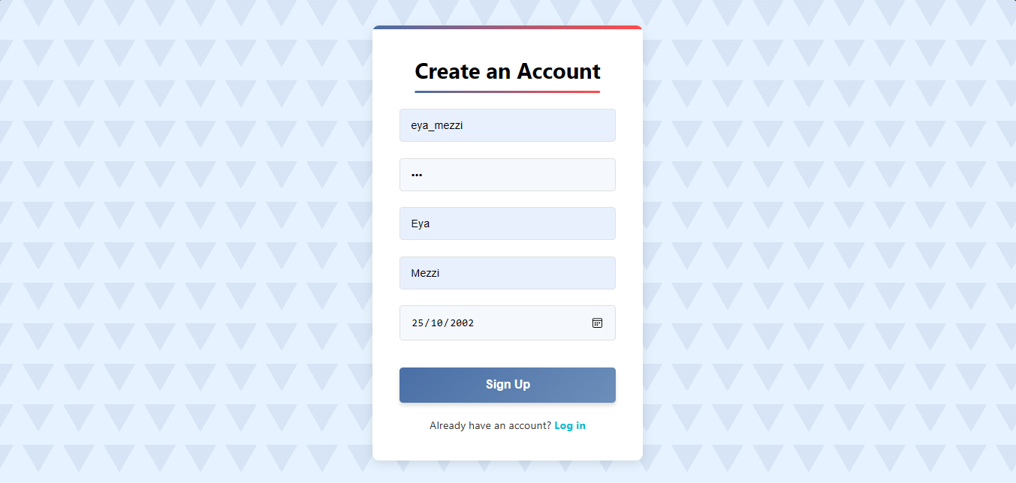

**Page de Connexion**

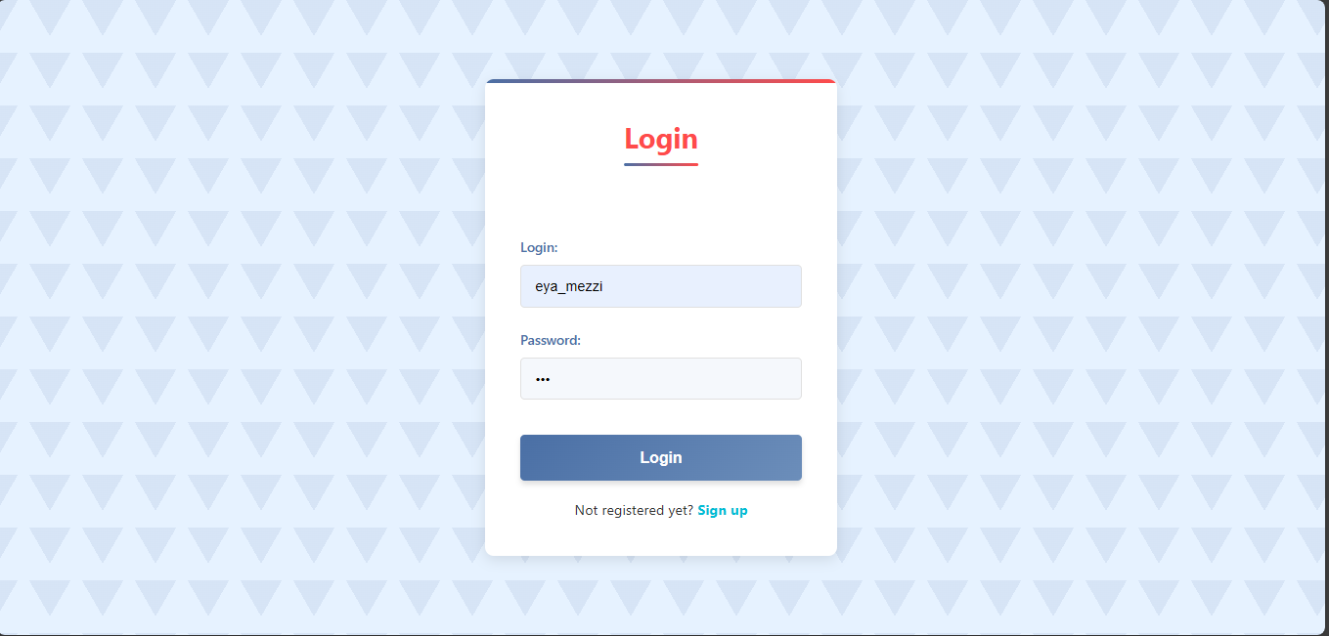

**Page de Connexion - Erreur d'Authentification**

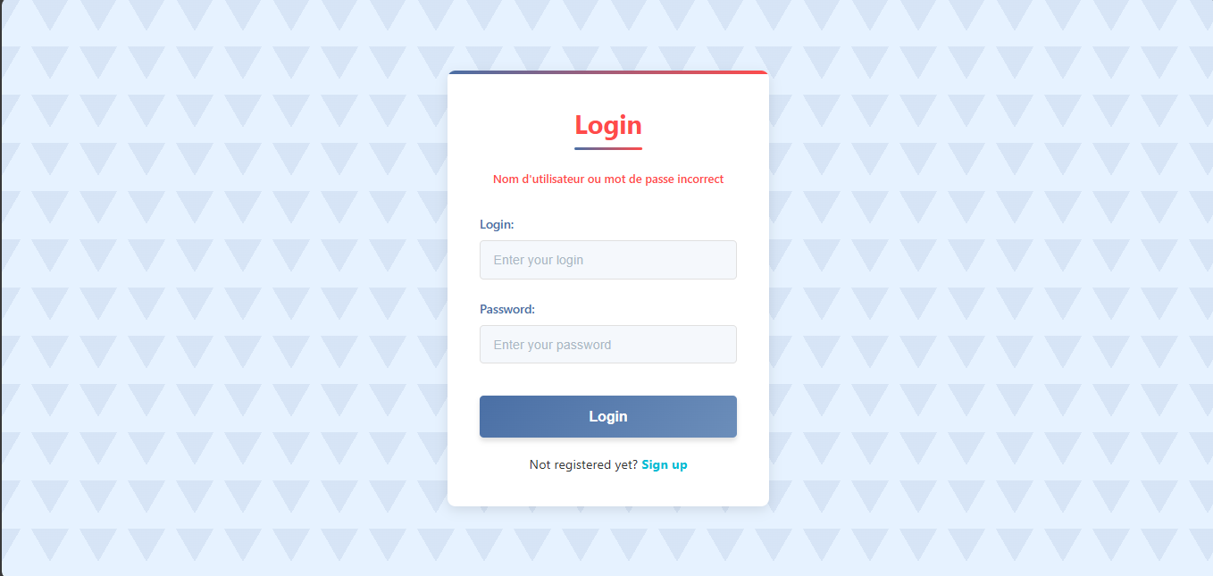

**Profil Utilisateur et Liste de Tâches**

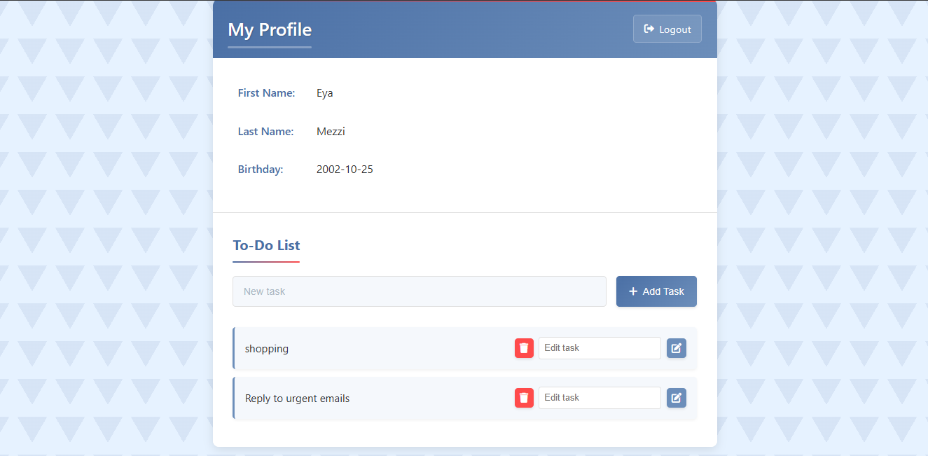

**Modification des Tâches**

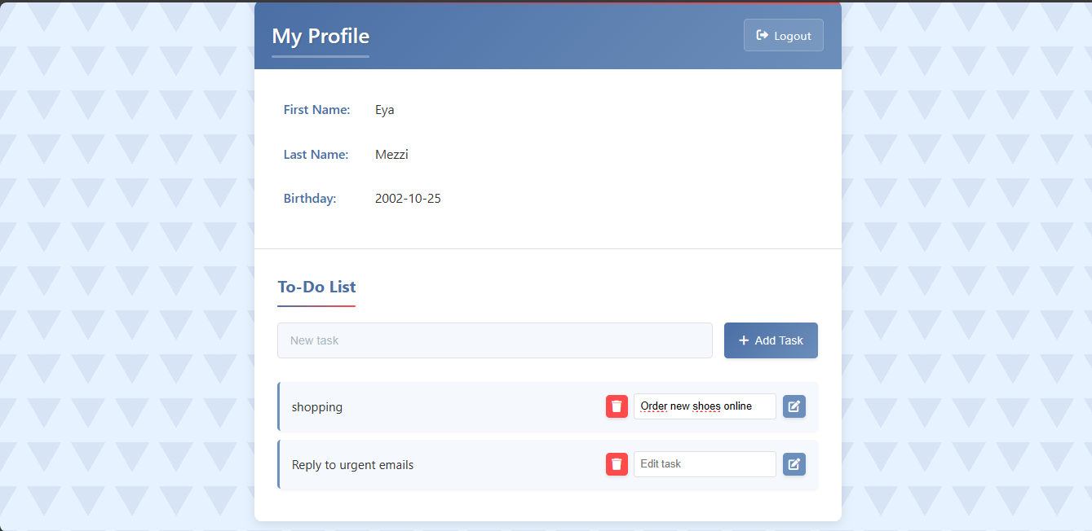

**Apres Modification**

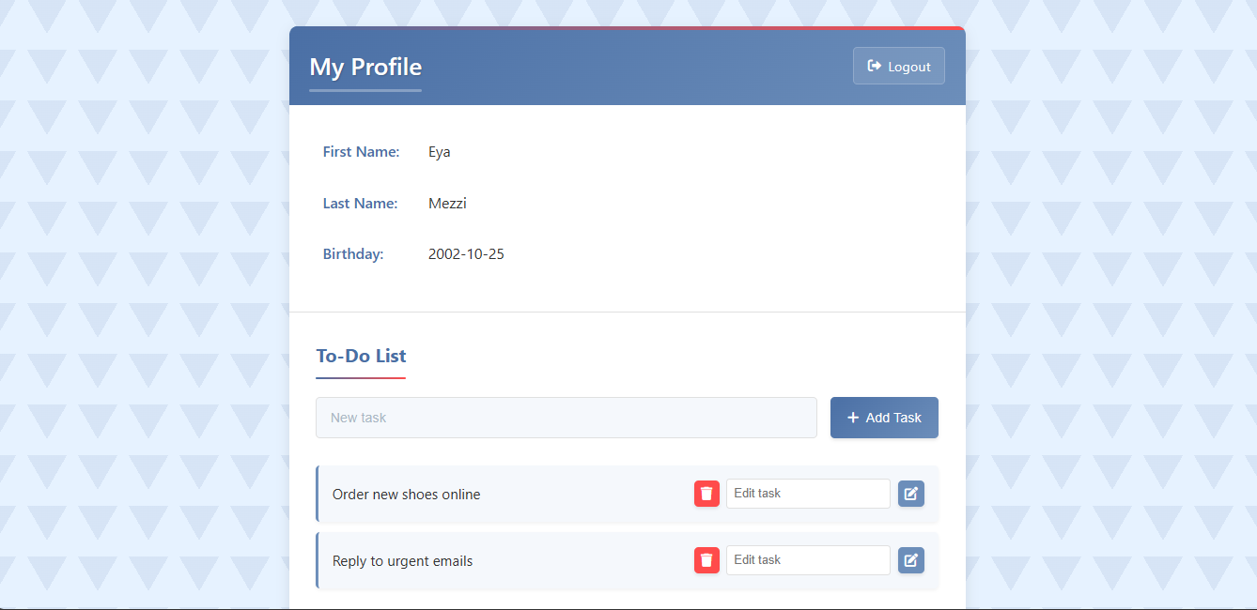

**Table users base de données**

