# Summer school @NTUST

# Taipei, August 17th 2016

## SCHEDULE

|  |  |  |
| --- | --- | --- |
| TIME | LOCATION | ACTIVITIES |
| 08:30 – 09:10 | MA-101 | Welcome Speech: Prof. Shuo-Yan Chou and Prof. Hsien Hui Tang  Lecture: Workshop Briefing from Prof. Hsien Hui Tang. |
| 09:10 – 10:00 | MA-101 | Team Building: Introducing yourself using LEGO & building up your team Mascot. |
| 10:00 – 12:00 | MA-101, MA-417, MA-419 | Discussion and Practice   * Persona & Key activities * Discussing idea, target specs and concept for energy management / conservation application. |
| 12:00 – 12:30 | MA-101, MA-417, MA-419 | Storyboards   * Sharing between groups. * Each group can discuss their idea and concept with other group (3 to 5 minutes each group). |
| 12:30 – 13:30 | TBD | Lunch Break. |
| 13:30 – 13:45 | MA-101 | Quick Introduction and Review about Thingworx and Smart sensor. |
| 13:45 – 16:15 | MA-101, MA-417, MA-419 | Scenario Walkthrough.  Continue to design and develop energy management / conservation application. |
| 16:15 – 16:20 | MA-101 | Break and all the groups gather in MA101 for presentation preparation. |
| 16:20 – 17:20 | MA-101 | Presentation. (each team has 5 minutes for presentation and 3 minutes for Q&A). |
| 17:20 – 17:30 | MA-101 | Closing Speech and Awarding. |

## GROUP MEMBERS

|  |  |  |  |  |  |  |  |
| --- | --- | --- | --- | --- | --- | --- | --- |
| GROUP 1 | GROUP 2 | GROUP 3 | GROUP 4 | GROUP 5 | GROUP 6 | GROUP 7 | GROUP 8 |
| 張麗 | 竹下 颯汰 | 水口 雄紀 | 岡崎 理宏 | 梅岡 優 | 池永 幸次 | 藤田 勇磨 | 織部 鴻太朗 |
| 郡 修平 | 土居直樹 | 礒合 俊輔 | 安井 龍太 | 津田 剛志 | 中田 克彌 | 正田 孝平 | 石曽根 香菜 |
| 東城 宗熙 | 小林 亮介 | 小茂田 岳広 | 宮下 健司 | 仲西 朋也 | 西久保 匠 | Paniti Achararit | 高野 祐樹 |
| 篠山 大輝 | 藤岡 和毅 | 堀田 実 | 栗生 識 | 宮永 隼太郎 | 佐久間 洸平 | 施勗程 | 李姿儀 |
| 許淯維 | 吳明宗 | Zendfiastara | 張紹彥 | 張智欽 | 吳紹暘 | 陳冠仁 | 李嘉文 |
| Eva Yu  游硯雅 | Sallian ​Wang​  王紫綺 | James Ge  葛承恩 | Mark Tasi 蔡炘志 | Yo ​T​zeng​ 曾子祐 | Zen Chang 張育涓 | ​Peiying Lin 林佩穎 | Chenny​ ​Y​ang ​  楊采妮 |
| Ferani Eva | Wira Redi | Dimas Herjuno | M. Akmalul U. | Aditya Budhi | Dwi Yanti | Erick Alwando | Irene Karijadi |

## NOTES

* The program on Wednesday (August 17th 2016) will start at **08:30 AM** in **MA-101** room (Management Building).
* We recommend to bring your Notebook / Laptop during this day session.
* Supplementary modules can be downloaded at <http://tinyurl.com/CITISummerModule> (Please read it in advance).
* During discussion session, Group 1 to Group 4 will remain staying at MA-101, while Group 5 and 6 will move to MA-417 and Group 7 and 8 to MA-419.
* Should you have any inquiries, feel free to contact Joe (+886-978-104149 or LINE @joe1011)

## LOCATION

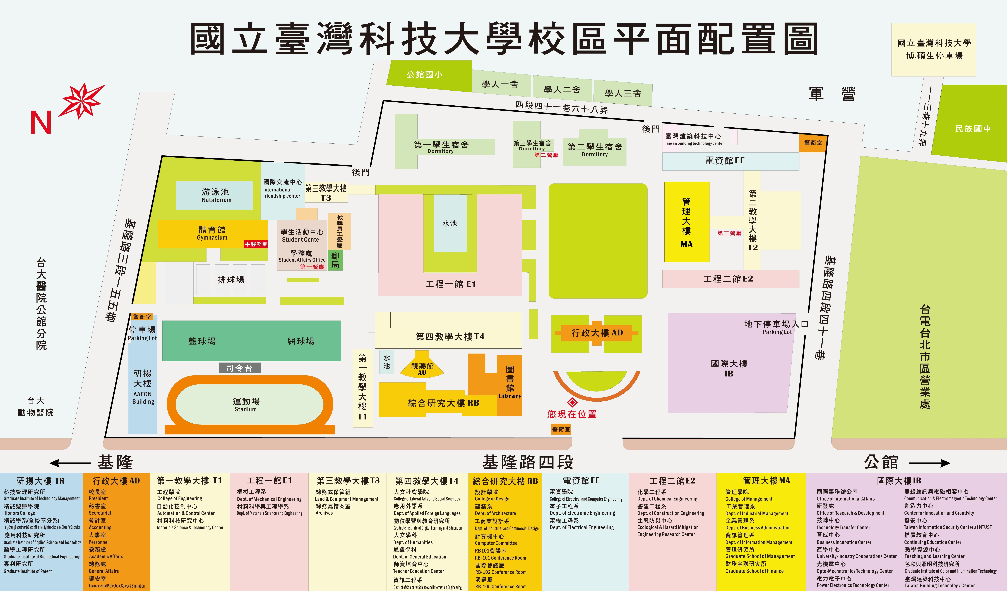

Management Building 1st floor

Room number: MA-101