EEE 309 Software Hardware Integration Project
Lab Report
Project 2
10-Bit Analog-to-Digital Converter (ADC) and Digital Voltmeter GUI
Prepared by
Sara Zor (20261701082)
Iclal [SURNAME] ([STUDENT ID])
Moustafa Al Houssari (20241701003)
Instructor: Dr. Akhtar Saeed
Submission Date: 19 October 2026
Department of Computer Engineering
Kadir Has University
Fall 2026

CONTENTS
1 INTRODUCTION 3
1.1 Objective 3
1.2 Pre-Lab Questions 3
2 EXPERIMENTAL SETUP 4
2.1 Components 4
2.2 Circuit and Setup 4
2.3 Arduino Code 5
3 MEASUREMENTS 6
3.1 Part 1: Arduino Serial Monitor 6
3.2 Part 2: Python Serial Reading 6
4 GUI DESIGN 8
4.1 Design Decisions 8
4.2 Online Mode 8
4.3 Offline Mode 9
5 RESULTS AND ANALYSIS 10
5.1 Measurement Vectors and Ideal ADC 10
5.2 ADC-to-Voltage Conversion 10
5.3 Measured vs Ideal ADC Output 10
5.4 Linearity and INL 11
5.5 Discussion 11
5.6 Bonus: Python GUI 12
6 CONCLUSION 13
REFERENCES 13
APPENDIX A: PYTHON ANALYSIS CODE 14

1 INTRODUCTION
1.1 Objective
The 10-bit ADC of an Arduino Uno is characterized against a multimeter, and a Python GUI voltmeter with online and offline modes is built.
1.2 Pre-Lab Questions
- A potentiometer is a variable resistor that works as an adjustable voltage divider.
- A 10 bit ADC has 2^10 = 1024 levels, so with a 5 V reference one step is about 4.88 mV.
- A GUI lets users control software through visual elements such as buttons and displays. The worst GUI we experienced was a touchscreen ticket machine that only responded when pressed very hard like the printer in H-Block.

2 EXPERIMENTAL SETUP
2.1 Components
- Arduino Uno
- 10 k ohm potentiometer, breadboard and jumper wires
- Digital multimeter
- PC with Arduino IDE and Python
2.2 Circuit and Setup
The potentiometer is connected between 5 V and GND, and its wiper is connected to analog input A0.
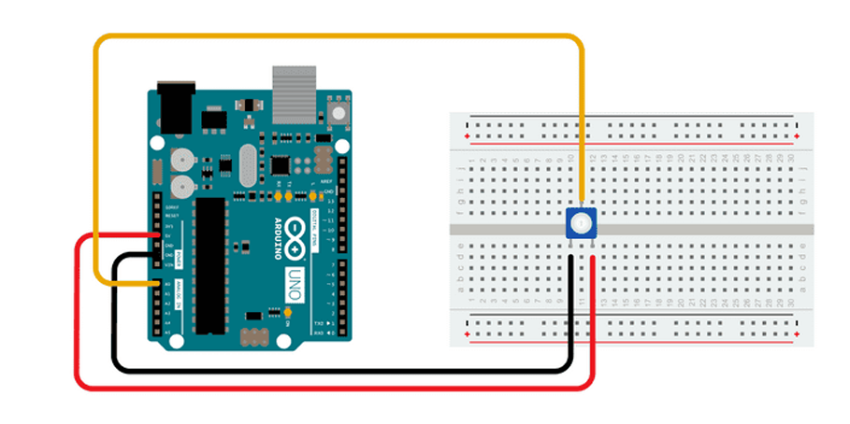
Figure 2.1 Arduino ADC circuit
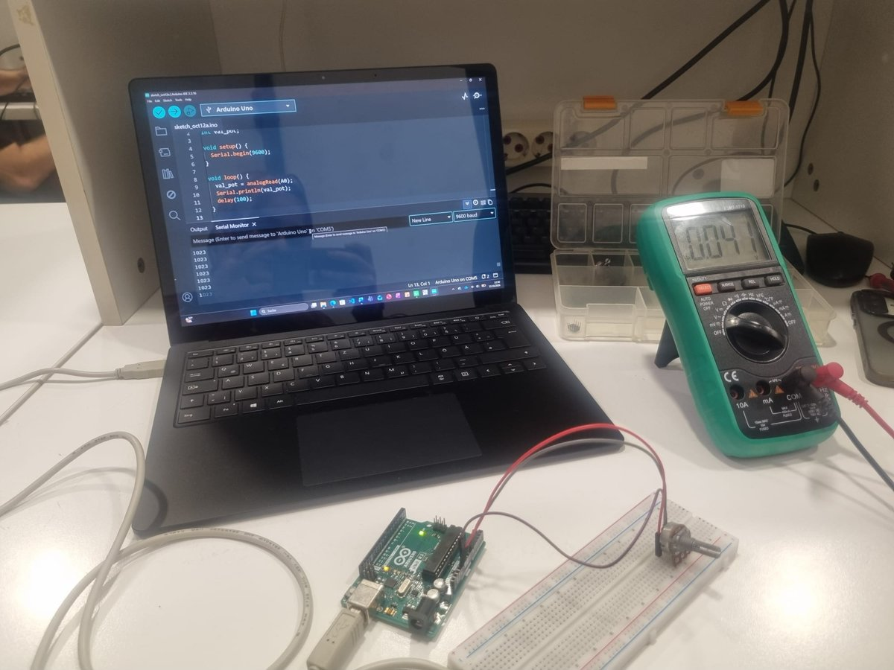
Figure 2.2 Experimental setup
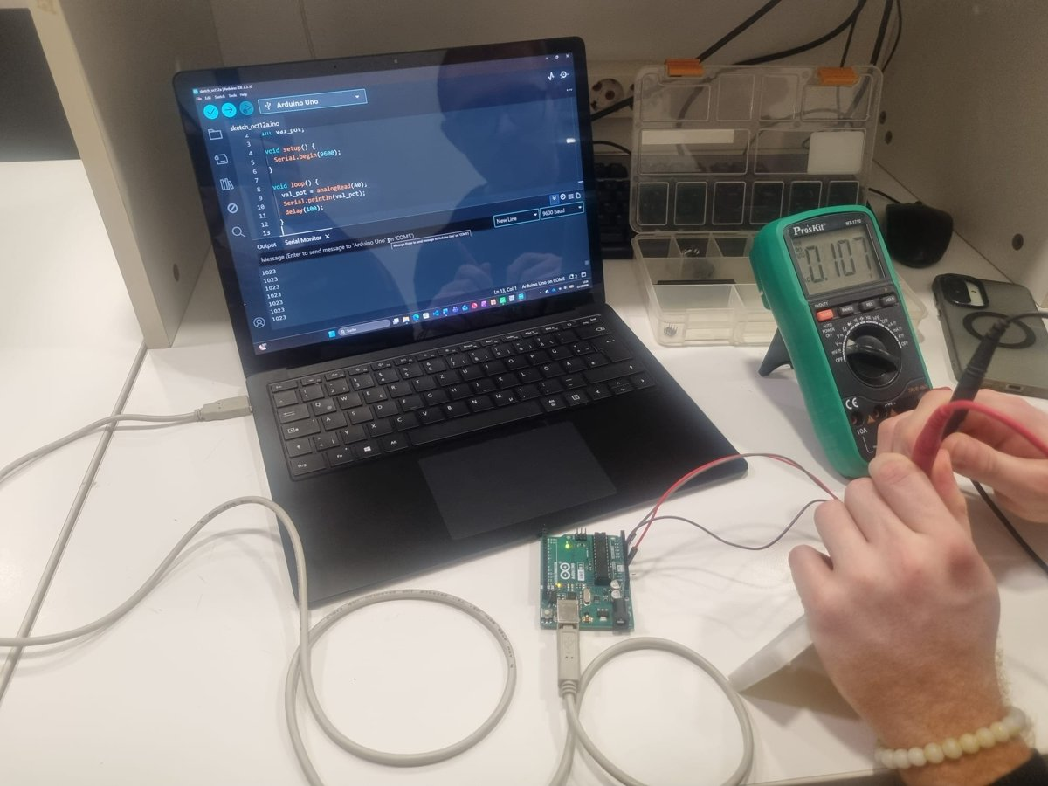
Figure 2.3 Measuring the potentiometer voltage with the multimeter
2.3 Arduino Code
The Arduino reads A0 and sends the ADC value over serial at 9600 baud every 100 ms.
int val_pot;
void setup() {
Serial.begin(9600);
}
void loop() {
val_pot = analogRead(A0);
Serial.println(val_pot);
delay(100);
}
Code 2.1 Arduino code

3 MEASUREMENTS
3.1 Part 1: Arduino Serial Monitor
The potentiometer was set to each multimeter voltage and the ADC value was read from the Arduino Serial Monitor (Experiment 1).
3.2 Part 2: Python Serial Reading
MATLAB was not available, so the measurements were repeated by reading the serial port with Python and converting each value to volts.
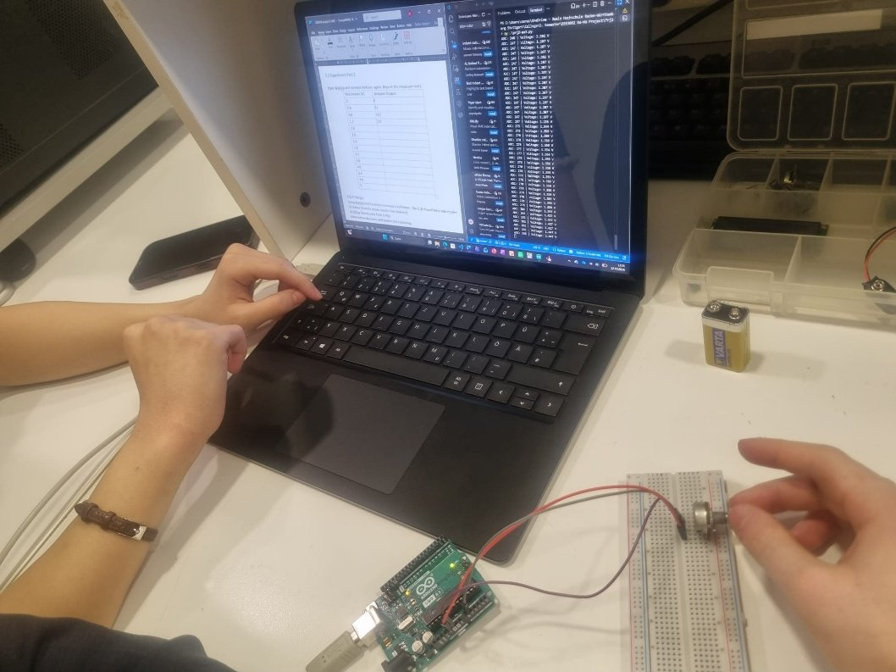
Figure 3.1 Voltage measurement with Arduino and Python
import serial
import time
arduino = serial.Serial('COM5', 9600, timeout=1)
time.sleep(2)
while True:
if arduino.in_waiting > 0:
data = arduino.readline().decode('utf-8', errors='ignore').strip()
try:
adc_value = int(data)
voltage = adc_value * 5.0 / 1023.0
print(f"ADC: {adc_value} | Voltage: {voltage:.3f} V")
except ValueError:
pass
Code 3.1 Python serial reading (prj2-ex2.2.py, shortened)
Table 3.1 Multimeter voltage and ADC output for both experiments
Multimeter (V) | Ideal ADC | Exp. 1 ADC (Serial Monitor) | Exp. 2 ADC (Python) | Exp. 2 Voltage (V)
0.0 | 0.0 | 0 | 0 | 0.000
0.4 | 81.8 | 80 | 83 | 0.406
0.8 | 163.7 | 162 | 165 | 0.806
1.2 | 245.5 | 244 | 247 | 1.207
1.6 | 327.4 | 325 | 327 | 1.598
2.0 | 409.2 | 413 | 410 | 2.004
2.4 | 491.0 | 492 | 490 | 2.395
2.8 | 572.9 | 572 | 573 | 2.801
3.2 | 654.7 | 655 | 656 | 3.206
3.6 | 736.6 | 739 | 737 | 3.602
4.0 | 818.4 | 820 | 817 | 3.993
4.4 | 900.2 | 909 | 902 | 4.409
4.8 | 982.1 | 990 | 983 | 4.804
5.0 | 1023.0 | 1023 | 1023 | 5.000

4 GUI DESIGN
A digital voltmeter GUI was built in Python instead of MATLAB. Online mode shows live values from the Arduino, and offline mode shows values loaded from a CSV file.
4.1 Design Decisions
- Digits: three decimal places are shown, because one ADC step is 4.88 mV, so a third decimal still carries information while a fourth would not.
- Refresh rate: 100 ms, which matches the Arduino sending rate and keeps the display smooth and responsive.
4.2 Online Mode
In online mode the GUI reads the newest ADC value from COM6 every 100 ms and converts it to volts. It was tested by connecting A0 to the Arduino 3.3 V pin, and the GUI showed 3.358 V (ADC = 687).
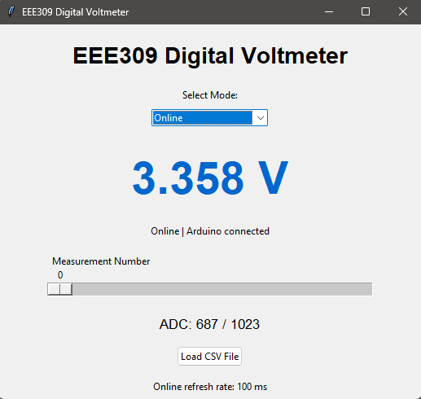
Figure 4.1 Digital voltmeter GUI in online mode, with A0 connected to the Arduino 3.3 V pin
4.3 Offline Mode
In offline mode a slider steps through the stored measurements, and a CSV file with Multimeter_V and ADC columns can be loaded.
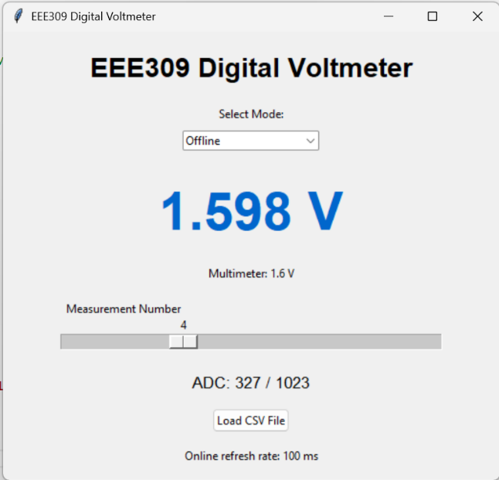
Figure 4.2 Offline mode showing measurement 4 (1.6 V)
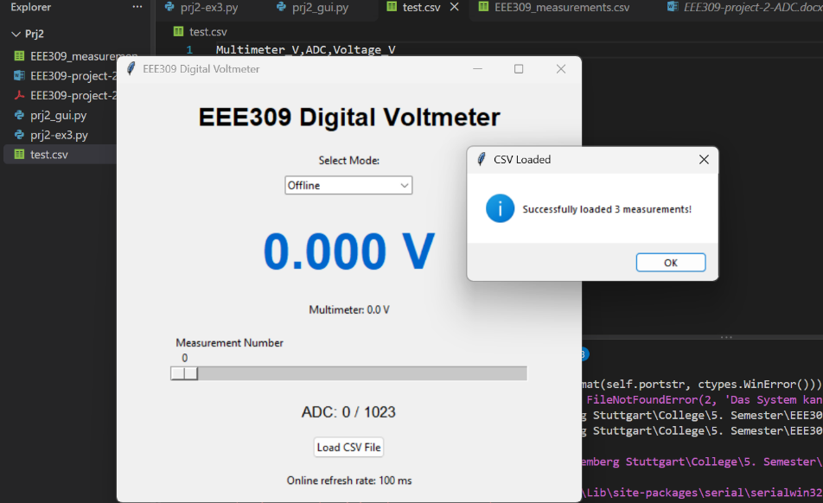
Figure 4.3 Loading a test CSV file in offline mode

5 RESULTS AND ANALYSIS
5.1 Measurement Vectors and Ideal ADC
The measurements were entered as vectors, and the ideal ADC output was calculated from the multimeter reading:
multimeter = [0, 0.4, 0.8, 1.2, 1.6, 2, 2.4, 2.8, 3.2, 3.6, 4, 4.4, 4.8, 5]
experiment1 = [0, 80, 162, 244, 325, 413, 492, 572, 655, 739, 820, 909, 990, 1024]
experiment2 = [0, 83, 165, 247, 327, 410, 490, 573, 656, 737, 817, 902, 983, 1023]
ideal_adc = multimeter × 1023 / 5

5.2 ADC-to-Voltage Conversion
V = ADC × 5 / 1023. The ADC maps 0–5 V onto 0–1023, so dividing by 1023 and multiplying by 5 V gives the full-scale value 1023 = 5 V. For example, ADC = 327 gives 1.598 V, compared with 1.6 V on the multimeter.
5.3 Measured vs Ideal ADC Output
Both experiments follow the ideal line closely (Figures 5.1 and 5.2). The plots were made with Python code written with AI assistance (Appendix A).
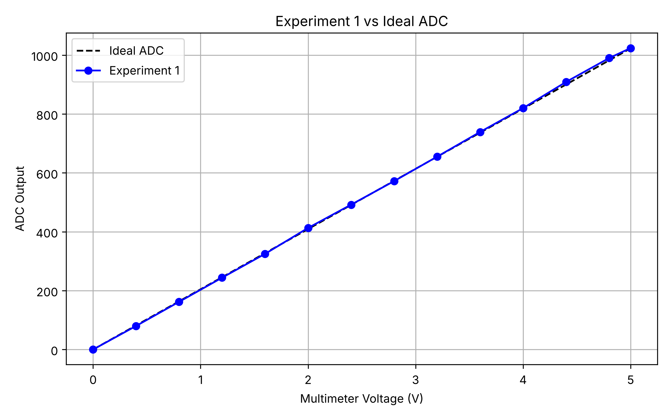  Figure 5.1 Experiment 1 vs ideal ADC | 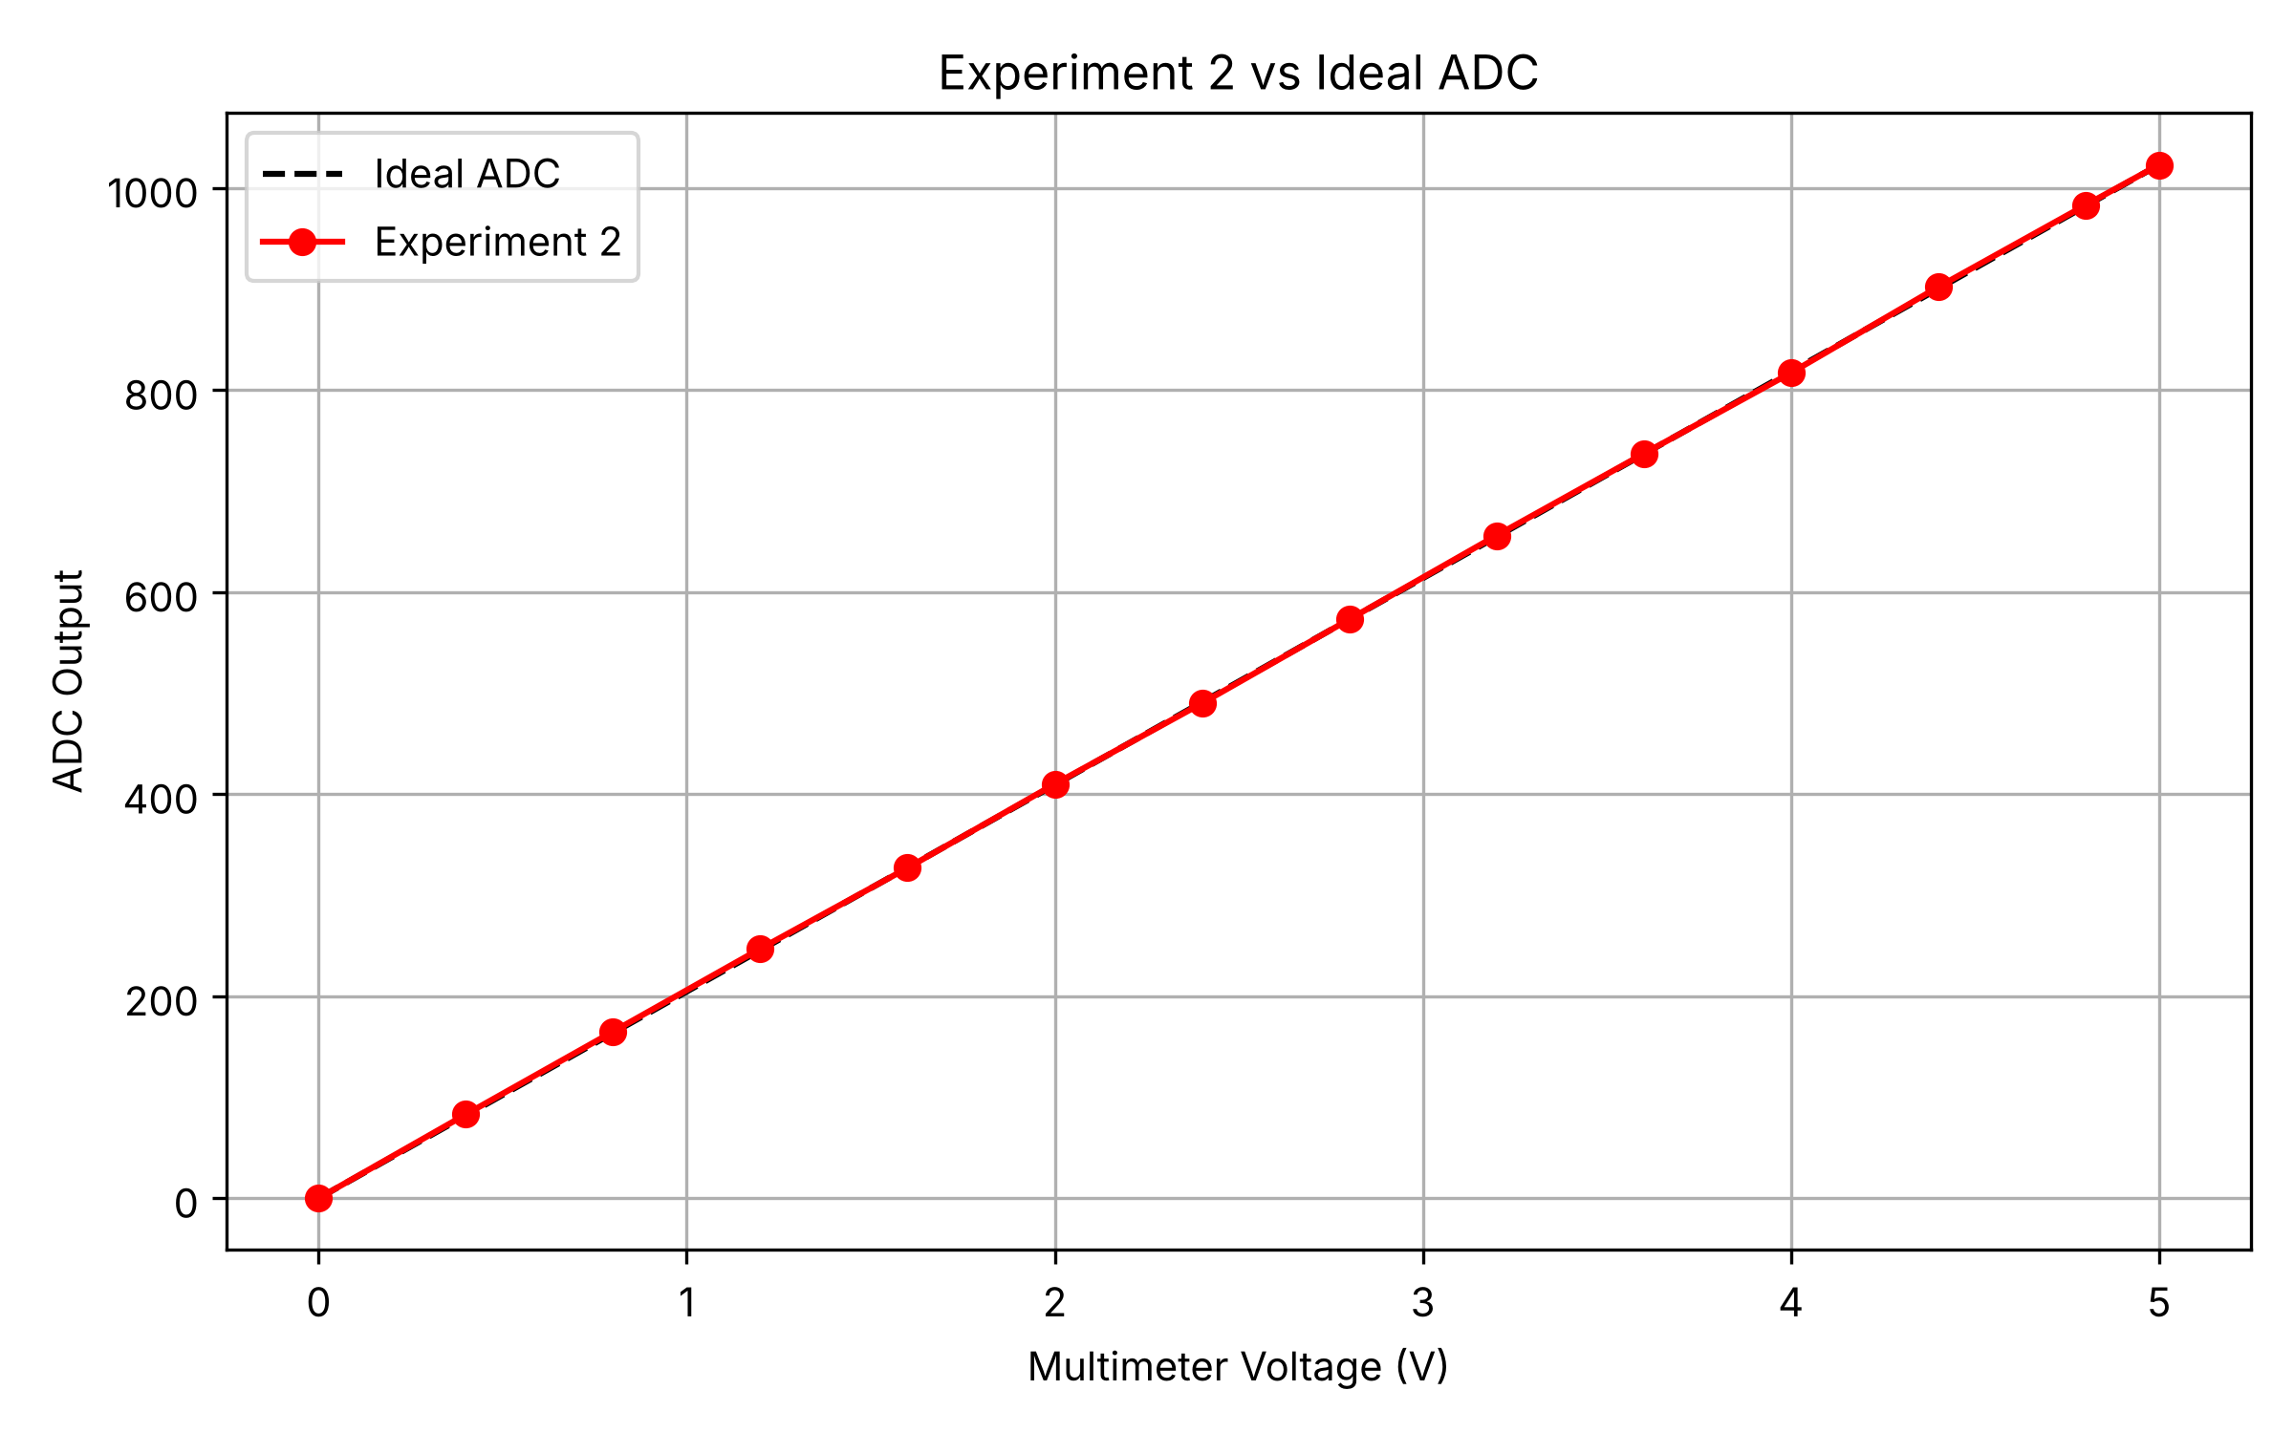  Figure 5.2 Experiment 2 vs ideal ADC
5.4 Linearity and INL
The deviation from the ideal ADC (in LSB) and the endpoint INL (deviation from a straight line between the first and last valid points) were calculated for both experiments.
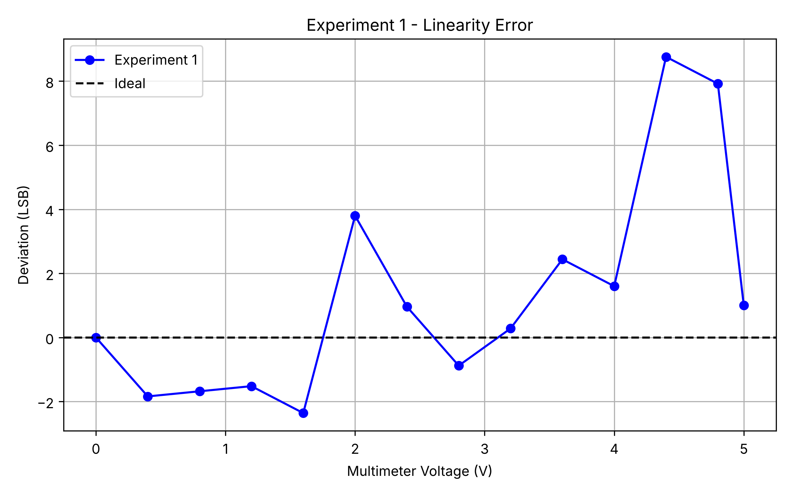  Figure 5.3 Experiment 1 deviation from ideal | 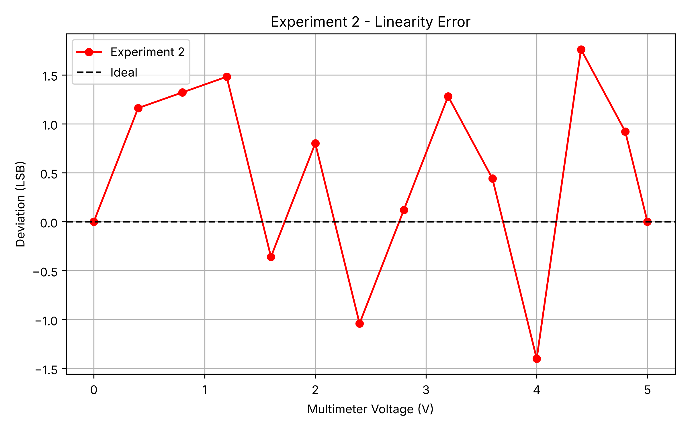  Figure 5.4 Experiment 2 deviation from ideal
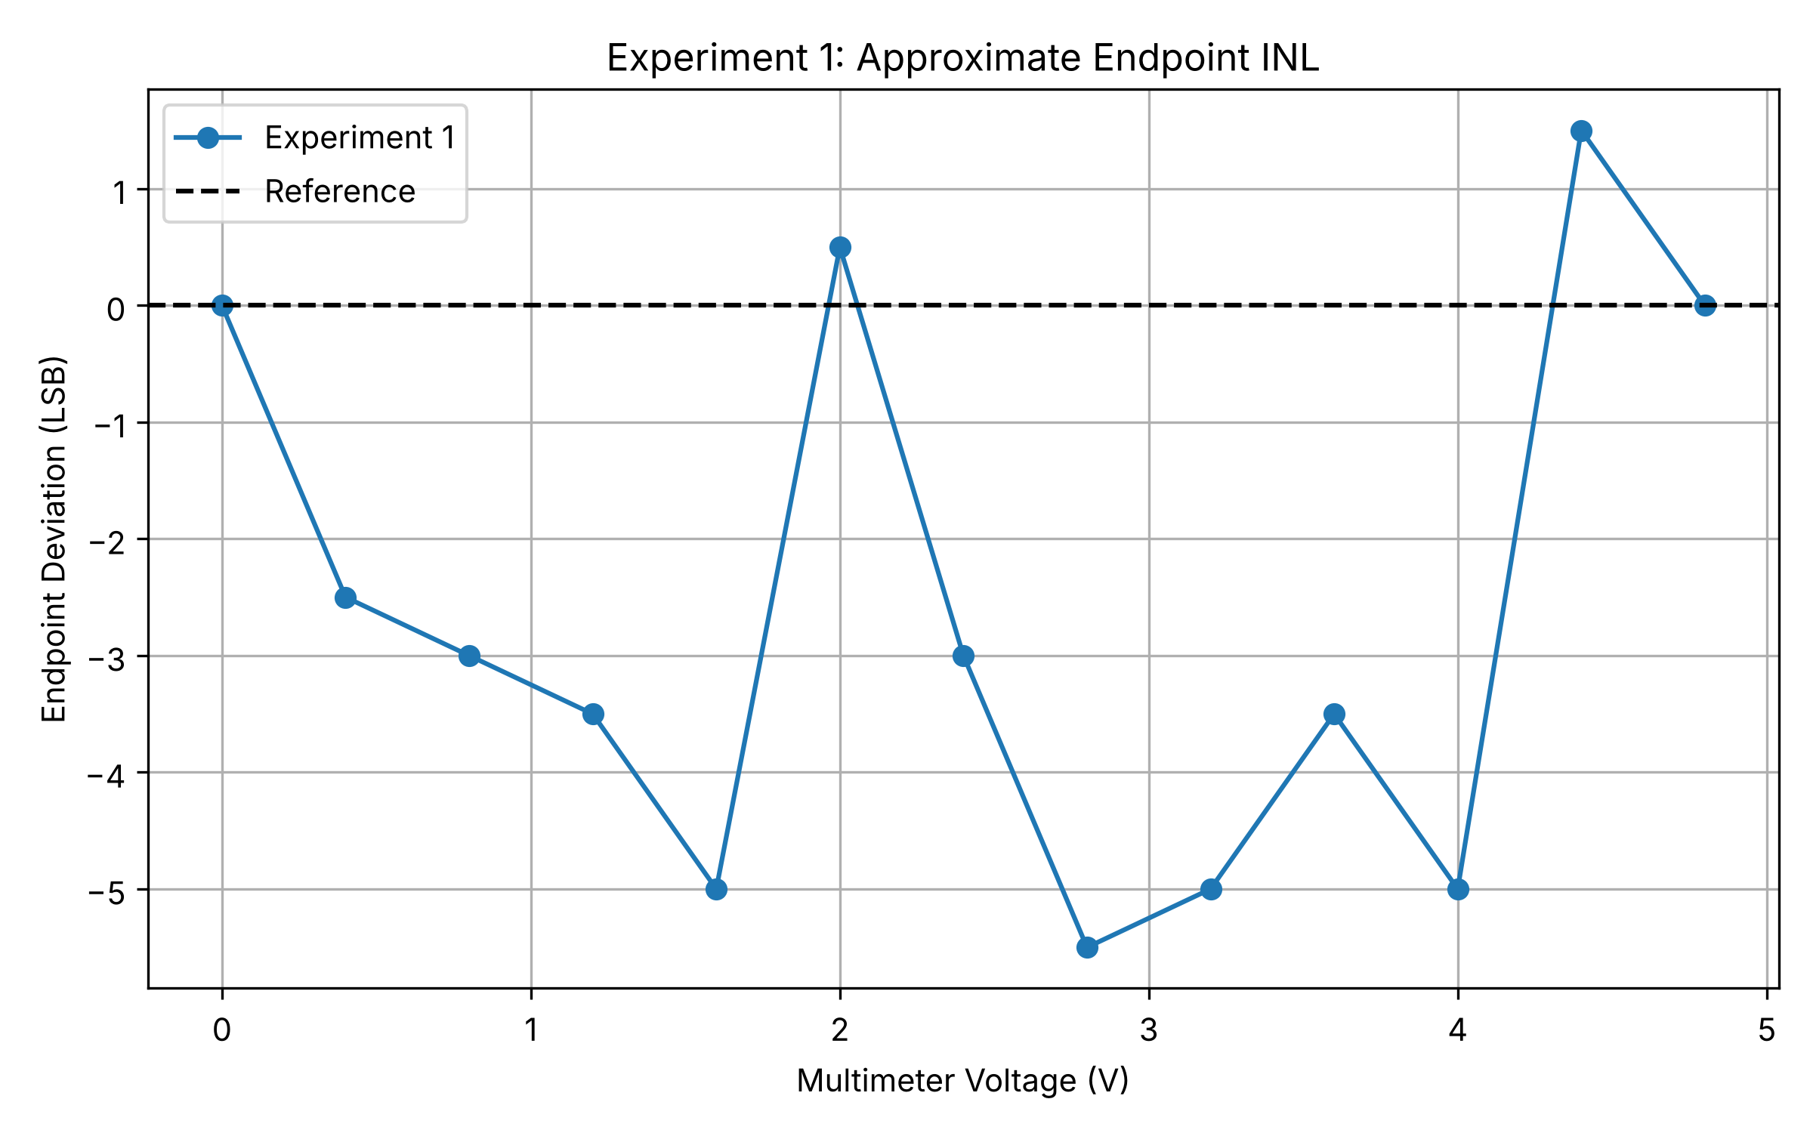  Figure 5.5 Experiment 1 endpoint INL | 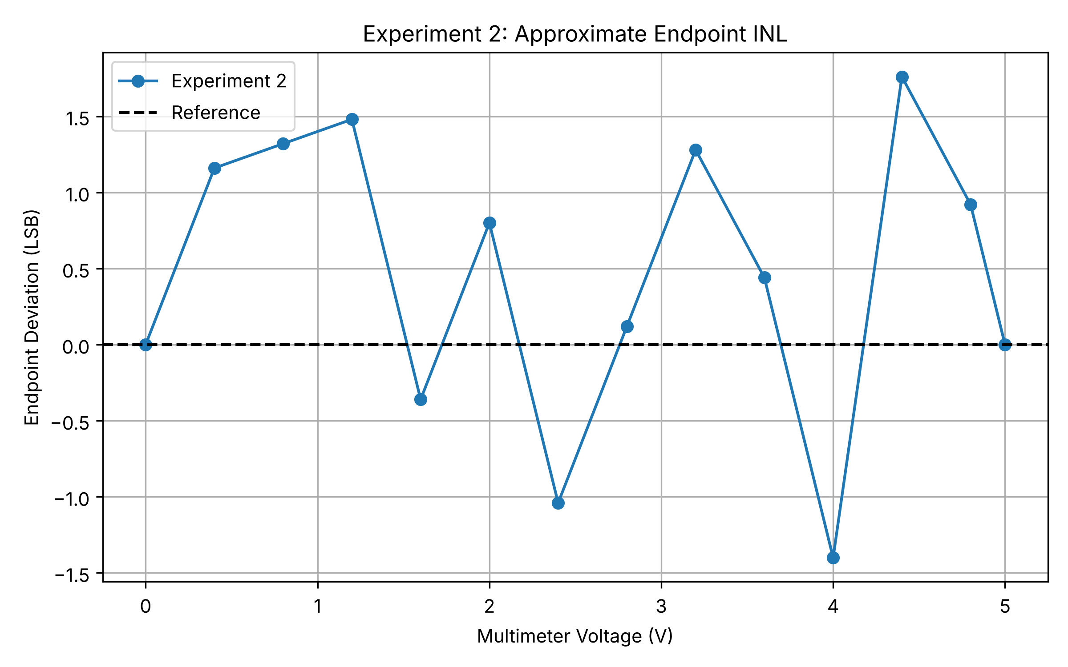  Figure 5.6 Experiment 2 endpoint INL
Table 5.1 Maximum deviations
 | Max deviation from ideal (LSB) | Max endpoint INL (LSB)
Experiment 1 (Serial Monitor) | 8.76 | 5.50
Experiment 2 (Python) | 1.76 | 1.76
Experiment 2 is better: its error stays below 2 LSB (about 9 mV), while Experiment 1 reaches almost 9 LSB at 4.4 V.
5.5 Discussion
The ideal values (hand calculation) and the measurements differ because of ADC quantization (±0.5 LSB), small changes in the 5 V USB reference, noise, and the difficulty of setting the potentiometer exactly to each voltage.
5.6 Bonus: Python GUI
The bonus task was completed: the full digital voltmeter GUI (online and offline modes) was built in Python with Tkinter and pyserial, since MATLAB was not available. It reads live data from the Arduino over the serial port and loads stored measurements from CSV files (Figures 4.1–4.3). AI assistance was used to debug and improve the GUI code.

6 CONCLUSION
The Arduino ADC is close to linear, and the Python measurements stayed within 2 LSB of the ideal. The Python GUI worked in both online and offline modes.
AI Use
AI (Claude, Anthropic) was used to help write the Python analysis and plotting code (Figures 5.1–5.6, Appendix A), to debug the GUI code, and to format this report. All measurements, photos and screenshots were taken by the group.

REFERENCES
[1] EEE 309 Project 2 lab sheet, Kadir Has University, 2026.
[2] Arduino, “analogRead()” reference, docs.arduino.cc.
[3] Python Software Foundation, “tkinter — Python interface to Tcl/Tk,” docs.python.org.
[4] EEE309 Project 2 source code (prj2_gui.py, prj2-ex2.2.py, prj2_analysis.py), GitHub: https://github.com/gingerismisharam/EEE309Project2

APPENDIX A: PYTHON ANALYSIS CODE
This code was written with AI assistance (Claude, Anthropic) and run by the group. The full source code (prj2_gui.py, prj2-ex2.2.py, prj2_analysis.py) is available on GitHub [4].
import numpy as np
import matplotlib.pyplot as plt

multimeter = np.array([0, 0.4, 0.8, 1.2, 1.6, 2.0, 2.4, 2.8, 3.2, 3.6, 4.0, 4.4, 4.8, 5.0])
experiment1 = np.array([0, 80, 162, 244, 325, 413, 492, 572, 655, 739, 820, 909, 990, 1024])
experiment2 = np.array([0, 83, 165, 247, 327, 410, 490, 573, 656, 737, 817, 902, 983, 1023])
ideal_adc = multimeter * 1023 / 5.0

# Figures 5.1 and 5.2: measured vs ideal
for n, exp, c in [(1, experiment1, "bo-"), (2, experiment2, "ro-")]:
plt.figure(figsize=(8, 5))
plt.plot(multimeter, ideal_adc, "k--", label="Ideal ADC")
plt.plot(multimeter, exp, c, label=f"Experiment {n}")
plt.xlabel("Multimeter Voltage (V)")
plt.ylabel("ADC Output")
plt.title(f"Experiment {n} vs Ideal ADC")
plt.legend()
plt.grid(True)

# Figures 5.3 and 5.4: deviation from ideal (LSB)
for n, exp, c in [(1, experiment1, "bo-"), (2, experiment2, "ro-")]:
plt.figure(figsize=(8, 5))
plt.plot(multimeter, exp - ideal_adc, c, label=f"Experiment {n}")
plt.axhline(0, color="black", linestyle="--", label="Ideal")
plt.xlabel("Multimeter Voltage (V)")
plt.ylabel("Deviation (LSB)")
plt.title(f"Experiment {n} - Linearity Error")
plt.legend()
plt.grid(True)

# Figures 5.5 and 5.6: endpoint INL (1024 excluded from Experiment 1)
for n, v, adc in [(1, multimeter[:-1], experiment1[:-1]), (2, multimeter, experiment2)]:
ref = adc[0] + (adc[-1] - adc[0]) / (v[-1] - v[0]) * (v - v[0])
plt.figure(figsize=(8, 5))
plt.plot(v, adc - ref, "o-", label=f"Experiment {n}")
plt.axhline(0, color="black", linestyle="--", label="Reference")
plt.xlabel("Multimeter Voltage (V)")
plt.ylabel("Endpoint Deviation (LSB)")
plt.title(f"Experiment {n}: Approximate Endpoint INL")
plt.legend()
plt.grid(True)

plt.show()

