1. Download the source code

* Go to <https://github.com/gingerlyburningbushes/First>
* Go to “Code” ->Download ZIP

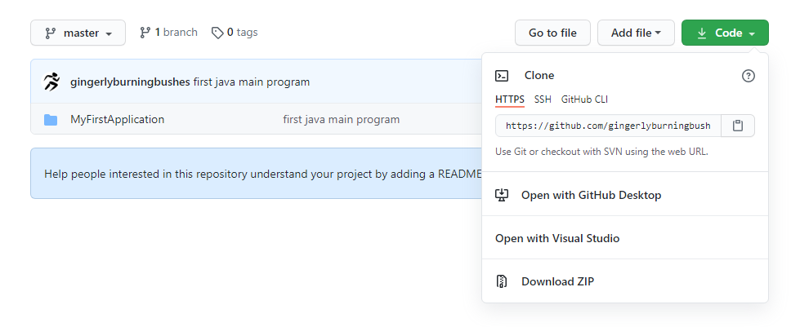

1. Unzip the files to C:\TEMP

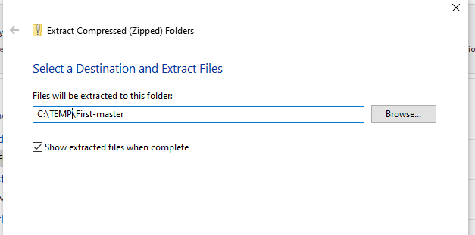

1. Start Android Studio
2. Go to File ->Close Project
3. New Project

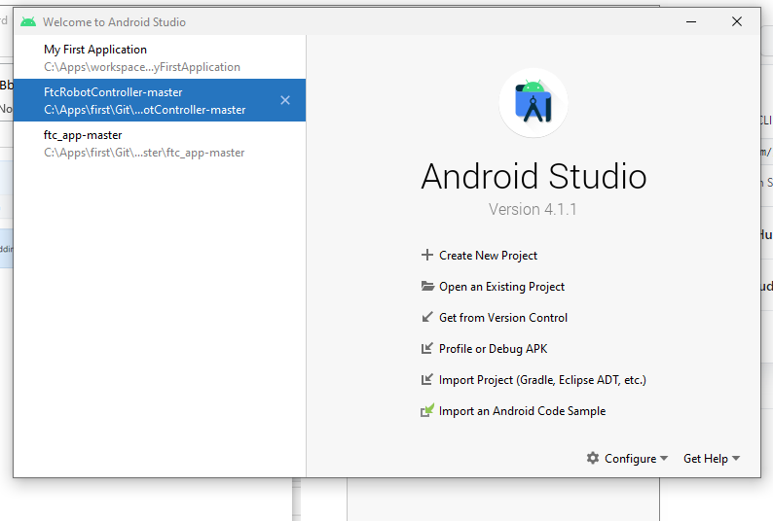

1. Select Import Project, then browse to C:\temp\First-master\First-master\MyFirstApplication, click OK

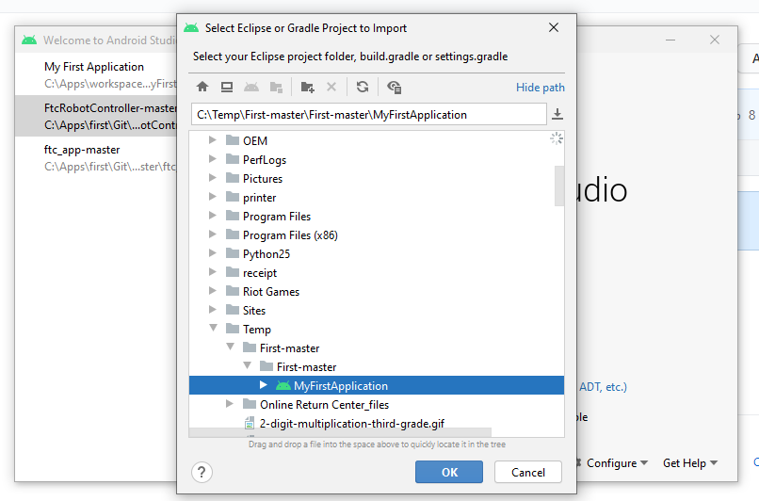

1. Expand MyFirstApplication->src->main->java->foo->foo.java

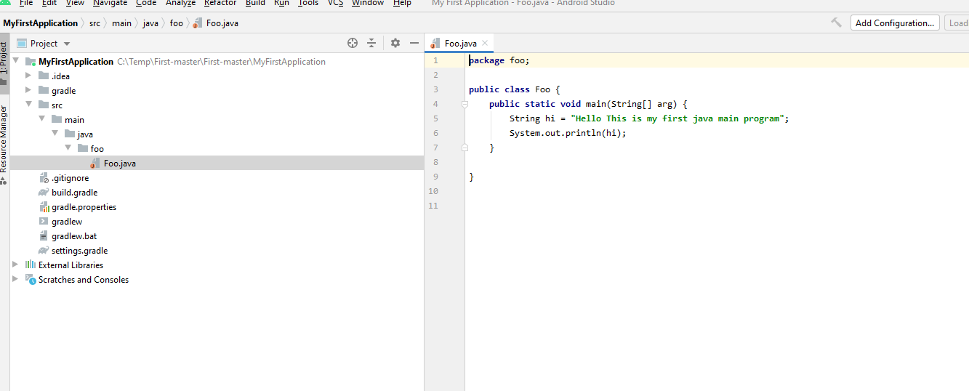

1. Run your program : Run->Run foo