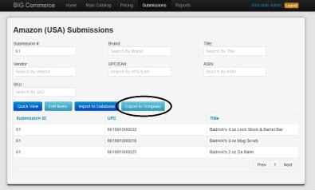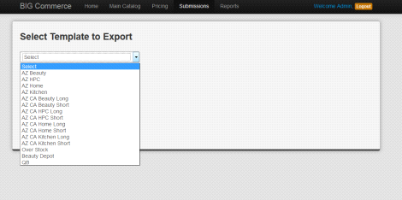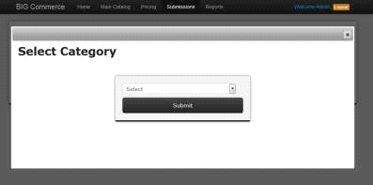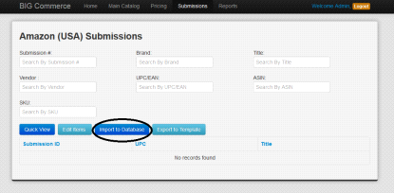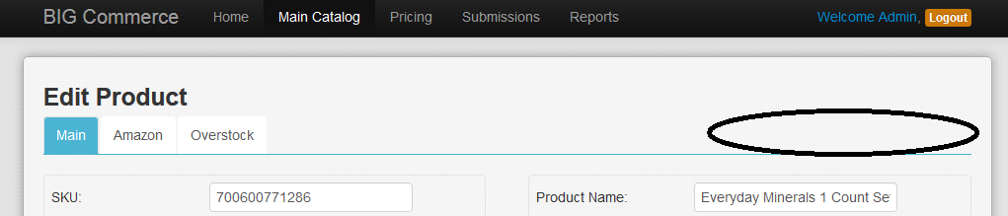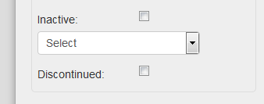**BIG Commerce- Maintenance**

**We are still waiting your answers on few points, we have updated those questions with blue color. Can you please check those up and let us know your inputs.**

* **Import Template:**
* Column, “Submit to AZ CA” mapping incorrectly
* Currently mapping to, “Submit to OS” field instead of “Submit to AZ CA” field
* Column, “Notes” not importing to catalog
* **Import: \*\*\*\*\**HIGH PRIORITY\*\*\*\*\****
* Add a path that allows us to bypass the Pricing Page
* Suggestion-
* Change “Import Items” button (in Main Catalog) to “Import New Items”). This button should bring us to the Pricing Page (as it is currently doing)
* Add “Import Direct” next to “Import New Items” button. This button should allow us to bypass the Pricing Page & automatically import products into the Main Catalog
* NOTE: Fields in template should override fields in database, unless it is auto-calculated in database

**Query : Do you want to save items imported directly in database without any user intervention ? But if few fields are missing in excel which are needed for calculation, what to do in that case?**

**This "import direct" (next to the "import Items") button should enter into the database without user intervention. This is done to save time for the person importing the list of products. If there are products that have fields missing for calculation (hopefully this doesn't happen and all fields are accounted for when using import direct), please allow this to continue and when presenting the calculation fields add "NaN" or some error so we know there is an important field not filled out that is needed to calculate.**

**Query : import direct in auto calculation for proposed amazon discount 20 should be fixed. please confirmed.**

**Yes please use 20 for the autocalculations**

**Is there anyway to override this 20% autocalculation for “direct import” only .**

**This automatic 20% is definitely a problem as prices vary based off of what AZ accepted. We definitely need to find a way to override that when updating or using the "direct import." Is this also a problem for our "Edit Items" feature in the "Submissions" page?**

* Make field, “Submission ID”/”Sub. ID” editable so we can use/import our own IDs
* This field is currently automatically populated but we don’t need it to be
* **Pricing Page:**
* Add a “-5%” button next to the current “5%” button
* This should change the Prop. AZ Discount by increments of -5%
* Add a “Cancel” button next to the “Submit” button if we want to cancel importing products.
* Resize the “AZ”, “OS”, & “DNB” fields so it is smaller (we’d like to be able to view more without having to scroll side to side too much)
* When clicking “Submit”, pop up window confirming, “Are you sure you want to submit?”
* Add checkbox fields for “AZ CA” that fills in field, “Submit to AZ CA” in Main Catalog & maps from “Submit to AZ CA” column in upload template
* Add checkbox that performs “Select All” for “AZ”, “AZ CA”, “OS” & “DNB”
* Any way for us to be able to tab/toggle up & down between rows?

**Query : Please explain in details**.

**When using excel/access etc**. I am able to toggle between rows using shift+up/down…..is there any way to implement a feature similar where we use a hot key to toggle up and down between rows of our product data.

* After submitting, add # of products updated to message, “Products Updated Successfully”
* Ex: “# Product Updated Successfully”
* **Pricing (Maintenance):**
* Make “Pricing (Maintenance)” a drop-down in “Pricing”
* Add drop-down in “Pricing” for “OS Pricing”
* This should be the area we go to price products for OS
* Add drop-down in “Pricing” for “AZ Markdown”
* Add drop-down in “Pricing” for “OS Markdown”
* Add a “-5%” button next to the current “5%” button
* This should change the Prop. AZ Discount by increments of -5%

**Query** : Please explains what functionality perform while select any option “OS Pricing/ AZ Markdown / OS Markdown” from drop-down.

All three of these options are under the "pricing" nav menu item.

For "OS pricing", this is the webpage where we price Overstock items. We have a section in "main catalog" where we upload the Overstock information (overstock.png), we would like this to show up under "OS Pricing" where we can edit and update information for our products on Overstock as well as created new prices for our products on overstock.

**Note : OS pricing page view like as Main Catalog page, they have only product overstock details as like overstock.png. Please confirmed.**

**For now add the dropdown to the Pricing tab with “OS Pricing”. This dropdown page will go to the overstock.png page. Do not remove the feature from the main catalog page where we test. As for the two other dropdown AZ Markdown and OS Markdown, these two features will be implemented at a later date**

For "AZ markdown" and "OS markdown", these will become dropdowns in the pricing nav item.

**Note : Please explain in details how its works ?.**

This -5% button should change discount from 20.00 to 15.00. This we are lowering the discount we are giving for our prices on Amazon.

**Will be implemented at a later date**

* **Exporting Submissions:**
* Column, “Item Name” needs to pull data from field, “AZ Title”
* Currently pulling data from field, “Product Name”

**Query :** this changes apply to all existing templates ?.

All Existing amazon templates only.

* Make sure UPCs are exporting in the correct format
* Currently exporting as scientific notation

**Note: please give that upc number in you got this issue. So we check properly.**

**Please see the attached .xlsx file.  It happens when exporting any Submission into our vendor templates. I've attached an example of an export I just did. I also noticed that there's an issue with the export where most of the fields are being populated with value, "UPC" instead of the assigned value from our catalog. This was a recent change.**

**(ALSO, if you note the file name attached, Beauty is spelled incorrectly - “Beuaty”.**

**Submissions:**

* Add option to submit to QB in the Submissions dropdown
* When clicked, bring us to a QB section where we can select what products we want exported to QB
* Export products to QB template

**Query** : What will be the functionality in QB Submission page? Please explain in details. Please provide QB template for exporting.

Under the submissions nav bar item, there will be a dropdown to “QB”, when you click on the QB dropdown you get to the QuickBooks page. This page will Query our database for a list of products.

We would like to have a check box next to each item and a “submit to Quickbooks” button at the top.

This “submit to quickbooks” button will import the products with a checkbox to quickbooks

Is it possible to first cross query our database with products in quickbooks. If the product is in quickbooks do not display it on this webpage. Only display products that are not in quickbooks.

Finally the button will submit the products to quickbooks and since we have this cross query, will disappear from the list of products to submit to quickbooks.

If it is not possible to do any of this please create a template “QB submit” from the dropdown when you click on QB first….this dropdown template will only appear when you click on QB first. This excel template will include fields needed when you import items via excel into quickbooks. Then we will edit data fields and upload it to quickbooks

Please let me know if you have any questions.

**Note : We create a quickbooks page, view like Pricing(Maintenance), have only “Submit to Quickbooks” button and product listing will have one check box(submit to quickbook).**

**Submit to Quickbooks button click on selected check box products transfer to quickbooks product and will disappear from this page.**

**Please confirmed.**

**This sounds perfectly fine.**

* Choosing Amazon (USA) or Amazon (CA)
* Doesn’t seem to actually affect anything in terms of filtering templates
* Can we have it do the following:
* Allow us to only view templates available for selected sites ONLY (ALL template choices are listed when we click “Export to Template”)





**Query : It is OK to set view templates as per select option from Submissions menu.**

**Example :**

**1) Submission → Amazon → USA → Export to templates**

**→ Select Template Export (drop down)**

**show only USA Template**

**→ Beauty**

**→ HPC**

**→ Home**

**→ Kitchen**

**2) Submission → Amazon → Canada → Export to templates**

**→ Select Template Export (drop down)**

**show only Canada Template**

**→ Beauty Long**

**→ Beauty Short**

**→ HPC Long**

**→ HPC Short**

**→ Home Long**

**→ Home Short**

**→ Kitchen Long**

**→ Kitchen short**

**3) Submission → Amazon → Overstock → Export to templates**

**→ Select Template Export (drop down)**

**show only Overstock Template → Over Stock**

**4) Submission → Amazon → Beauty Depot → Export to templates**

**→ Select Template Export (drop down)**

**show only Beauty Depot Template → Beauty Depot**

**Yes this works perfectly. Only show the dropdowns relevant to the section**

**we clicked on.**



* When we click into Amazon (USA) or Amazon (CA), we are asked to select a category
* This doesn’t seem to affect anything at the moment so can we remove that step?

**Query : Please confirm you want to remove this step or filter anything in submission page?**

**Please remove this step. It is an extra click that doesn’t do anything**

* When clicking “Edit Items” in any of the Submissions pages, BIG C should export the selected items to the new BIG Commerce Import Template
* It is currently exporting products onto the old import template

**Query : What changes you want for “Edit Items” template? We are exporting data to excel that you have provided prior (Compl DB.xlsx).**

I will provide you with the new edititems.xlsx on Monday

Attached is the new template to use for this feature

* After editing items, we should be able to import the sheet back into the database by clicking “Import to Database” & uploading the same template we downloaded when editing (above note)



**Query : You need to select edited excel file when you want to import to template. So user has to select appropriate file. Let me know if you need any changes in it.**

**This works. However is there any way to automatically select the file downloaded (“edit Items”) as the file to import to database. We would like to eliminate a step. Or at least provide a list of recently opened documents to import when you click the import button.**

**Note : It's not possible to provide a list of recently opened document to import.**

**That’s OK disregard this for now**

* **Product Page:**
* Add new categories in drop-down menu: “Electronics”, “Children”, “Apparel”, “Fragrance”, “Pets”
* Add new values for “Weight” drop-down: “Pounds”
* “Submit to” Date should be auto-populated with date the checkbox was clicked; UNLESS date is manually entered
* Can also be filled by importing data from template

**Query : Current Item import template have no column for Submit to AZ Date / Submit to AZ CA Date / Submit to OS Date. You like to add in to templates ?**

**Yes please add this Submit to Date fields based on which template is clicked on. If unpopulated (adds date when submitted) also has the ability to edit to date of choice.**

* Add “In QB” checkbox next to “Professional Only” checkbox
* Once an item has been exported to be uploaded in QB, this box should be automatically checked
* Move “Inactive” checkbox, the Inactive dropdown list & “Discontinued” checkbox to the top right corner of product card



* **Main Catalog:**
* Add function that allows us to select (via checkbox) products & export them to an excel file (using import template to export)

**Query : Please explains in details. How it will work?**

Under main catalog there are buttons “import items” and “peerless inventory”.

Please add “Export Items”. This button will, using the existing checkbox next to each product, allow you to click on each item we want exported and export them to an excel file by populating the import template with the exported data we selected.

**Query: please provide a excel template with details for export/import file.**

**Attached is the import template to use**

* Include column for “AZ CA ASIN”
* “Search Product” should allow us to also search by “AZ ASIN”, “AZ CA ASIN”, “OS SKU”, “Sub. ID”, & “Keyword”

*Place these areas horizontally next to, or under, “Search Product” bar*

* Add to Search: “Vendor” drop-down
* Lists all vendors currently entered
* Once clicked, will filter for products under that vendor
* Add to Search “Category” drop-down
* Lists all categories entered
* Once clicked, will filter for products under that category
* Add to Search “Brand” drop-down
* Lists all brands entered
* Once clicked, will filter for products under that category
* From any filtered list/search, we should be able to click into a product, go to “Edit Product” page & be able to scroll/go to the next or previous product in that list
* Each column in Main Catalog should have the ability to sort the product list
* **Beauty Depot Submissions:**
* “Weight” column in template not exporting
* Currently exporting “0” value
* Need to export from “Weight” field in catalog
* Export function only exporting 20 items from a selected list
* Include Total Product count here so we can compare to # of items we need exported.